Analytical performance and user-friendliness of four commercially available point-of-care devices for C-reactive protein
Lieve Van Hoovels1,2,§,*Bo Massa1,3,§, Anne Stavelin4, Helene De Meyer1, Patricia De Schrijver1, Veroniek Van Laethem1, Dragos Barglazan5, Damien Gruson6, Rogier Hopstaken7, Bart Peeters8, Viviane Van Hoof9, Ann Verdonck3, Jan Y. Verbakel10,11
1. Department of Laboratory Medicine, OLV Hospital Aalst, Aalst, Belgium
2. Department of Microbiology, Immunology and Transplantation, KU Leuven, Leuven, Belgium
3. Department of Laboratory Medicine, University Hospital Leuven, Leuven, Belgium
4. Norwegian Organization for Quality Improvement of Laboratory Examinations (Noklus), Haraldsplass Deaconess Hospital, Bergen, Norway.
5. Laboratoire Hospitalier Universitaire de Bruxelles, Universitair Laboratorium Brussel (LHUB-ULB), Brussels, Belgium
6. Department of Medical Biochemistry, Clinique Saint-Luc, UCLouvain, Woluwe-Saint-Lambert, Belgium
7. GP practice De Kuil, Hapert, The Netherlands
8. Department of Laboratory Medicine, Heilig Hart Hospital Lier, Lier, Belgium
9. Faculty of Medicine and Health Sciences, University of Antwerp, Antwerp, Belgium
10. EPI-Centre, Academisch Centrum Huisartsgeneeskunde, KU Leuven, Leuven, Belgium
11. NIHR Community Healthcare Medtech and IVD cooperative, Nuffield Department of Primary Care Health Sciences, University of Oxford, Oxford, UK
§ Shared first authorship
* Corresponding author: Lieve Van Hoovels, Department of Laboratory Medicine, OLV Hospital, Moorselbaan 164, 9300 Aalst, Belgium; Tel: 0032-53724791; Fax: 0032-53-724588; Email: Lieve.Van.Hoovels@olvz-aalst.be
WORD COUNT: 3.959 (excl. abstract, references, tables, figures)
NUMBER OF TABLES AND FIGURES: 4 Tables and 3 Figures
REFERENCES: 34
SUPPLEMENTARY MATERIAL: 8
KEYWORDS: C-reactive protein, point-of-care tests, respiratory tract infections, general practice
HIGHLIGHTS:
- Correct POCT-CRP implementation in routine practice can decrease the inappropriate use of antibiotics.
- The analytical performance of POCT-CRP devices varied among manufacturers and did not fulfill the minimal allowable limits for clinical application for all instruments, emphasizing the need for quality assurance supervised by a central laboratory.
- The user-friendliness significantly varied among the instruments.

LIST OF ABBREVIATIONS
APS: Analytical Performance Specifications
ASZ: Algemeen Stedelijk Ziekenhuis
CRP: C-reactive protein
CV: Coefficient of variation
ERM: European Reference Materials
GP: General practitioners
IFCC: International Federation of Clinical Chemistry
IRMM: Joint Research Centre Institute for Reference Materials and Measurements
iQC: Internal quality control
ISO: International Organization for Standardization
LRTI: Lower respiratory tract infections
MAU: Maximum fit for purpose allowable MU
MU: Measurement uncertainty
U_{ref}: Uncertainty of reference materials
U_{cal}: Uncertainty of calibrators
U_{rw}: Random variability of measuring systems
NAPAMR: National action plan on antimicrobial resistance
OLV Onze-Lieve-Vrouw
POCT: Point-of-Care testing
r²: Coefficient of determination
rho or ρ: Spearman’s rank correlation
SKUP: Scandinavian evaluation of laboratory equipment for point of care testing

ABSTRACT
Introduction
Proper implementation of Point-of-Care testing (POCT) for C-reactive protein (CRP) in primary care can decrease the inappropriate use of antibiotics, thereby tackling the problem of growing antimicrobial resistance.
Objective
The analytical performance and user-friendliness of four POCT-CRP assays were evaluated: QuikRead go easy, LumiraDx, cobas b 101 and Afinion 2.
Materials and methods
Imprecision was evaluated using plasma pools in addition to manufacturer-specific control material. Trueness was assessed by verification of traceability to ERM-DA474/IFCC in parallel to method comparison towards the central laboratory CRP method (cobas c 503) using i) retrospectively selected plasma samples (n=100) and ii) prospectively collected capillary whole blood samples (n=50). User-friendliness was examined using a questionnaire.
Results
Between-day imprecision on plasma pools varied from 4.5% (LumiraDx) to 11.5% (QuikRead). Traceability verification revealed no significant difference between cobas c 503 CRP results and the ERM-DA474/IFCC certified value. cobas b 101 and Afinion achieved the best agreement with the central laboratory method. LumiraDx and QuikRead revealed a negative mean difference, with LumiraDx violating the criterion of >95% of POCT-CRP-results within ±20% of the comparison method. Regarding user-friendliness, Afinion obtained the highest Likert-scores.
Conclusion
The analytical performance and user-friendliness of POCT-CRP devices varies among manufacturers, emphasizing the need for quality assurance supervised by a central laboratory.

1 INTRODUCTION
Point-of-Care testing (POCT) can be defined as a clinical diagnostic test performed in a health care setting outside a clinical laboratory, bedside or in proximity of the patient usually performed by non-laboratory-trained personnel [1-3]. POCT is widely used in hospital settings and routinely in primary care settings in several Scandinavian countries, the Netherlands and Switzerland. Interest in expanding to more general practice (GP) settings is increasing for C-reactive protein (CRP) testing to guide management of lower respiratory tract infections (LRTI), particularly. The overuse of antibiotics for LRTI is a widespread problem leading to antimicrobial resistance. POCT-CRP appears to be one of the top strategies to reduce inappropriate antibiotic prescribing and to combat increasing antimicrobial resistance in a cost-effective manner in adults [4-6]. The negative predictive value of CRP in combination with clinical signs and symptoms for serious infections can support physicians in clinical work-up, prescribing of antibiotics and follow-up of patients. Various European guidelines recommend POCT-CRP testing to guide treatment in LRTI to improve antimicrobial stewardship in primary care [7, 8]. In Belgium, the use of antibiotics in outpatient care is mainly prescribed by GPs and is higher than the European average. Unfortunately, there is currently no legal framework in place for the use of POCT outside the hospital in Belgium [6]. Therefore, the ‘National Action Plan on Antimicrobial Resistance’ (NAPAMR) study 2020-2024 “Evaluation of the organizational challenges of out-of-hospital implementation of POCT-CRP in adults with cough” was funded to evaluate the application and the economic feasibility of POCT-CRP outside hospitals and the creation of a legal framework with reimbursement for decentralized POCT-CRP in primary care. Evidently, POC-devices must generate accurate and robust results compared to laboratory testing and must comply to analytical performance specifications (APS) stated by (inter)national expert organizations [6, 9-13]. Therefore, patients’ benefit and POCT reimbursement could only be provided and maintained when POCT is performed according to well-defined evidence-based guidelines and is integrated into a quality assurance program supervised by a certified, clinical laboratory [3, 6, 11, 14].
In this study, we aim to evaluate the analytical performance and user-friendliness of four different POCT-CRP assays based on POCT-specific international guidelines [11, 14, 15] and general and CRP-specific APS [9, 10, 16-18].
2 MATERIALS AND METHODS
The analytical performance study was executed by the POCT-team of the OLV Hospital Aalst, a Belgian secondary care hospital with 959 beds.
2.1 CRP measuring systems
Four quantitative POCT-CRP devices used in the FOD project ‘Evaluation of the organizational challenges of out-of-hospital implementation of POCT-CRP in adults with cough’ were evaluated. An overview of the assay characteristics of the different POCT-CRP methods and the specific reagent lot numbers used (one for each POCT-CRP device) are summarized in Table 1. Every POCT-CRP method included in the study protocol, claims traceability to the currently available international CRP-standard, ERM-DA474/IFCC (Table 1) [19, 20].
The Tina-Quant CRP IV performed on cobas c 503 analyzer, routinely performed at the central laboratory of OLV Hospital Aalst and ISO (International Organization for Standardization) 15189 certified (Belgian accreditation system certificate 350-MED), was chosen as the comparison method.
2.2 Validation of the traceability of the comparison method
Measurement uncertainty (MU) of cobas c 503 was calculated towards ERM-DA474/IFCC using ISO 20914:2019 as a practical reference guide [21].
In addition, the traceability of the cobas c 503 CRP-method was verified by the analysis of the ERM-DA474/IFCC [19] in three runs during three consecutive days. The mean CRP result of the ERM, obtained on cobas c 503, is regarded as unbiased, if the combined expanded uncertainty of the certified value includes the difference between the certified value and the measurement result [19].
2.3 Analytical performance evaluation of POCT-CRP devices
2.3.1 TRACEABILITY POCT-CRP TOWARDS ERM-DA474/IFCC
Based on the mean cobas c 503 results of a 5-point dilution series of the ERM with 0.7% phosphate buffered saline, a regression line was calculated plotting the ERM theoretical results on the Y-axis and the cobas c 503 results on the X-axis. As the ERM-DA474/IFCC is not commutable to the POCT-CRP methods, verification of the traceability of the POCT-CRP devices was applied based on the results obtained by the method comparison study (see section 2.3.2). For CRP study results up to 41.2 mg/L (=certified value of the ERM-DA474/IFCC) [19], the c 503-ERM regression equation was used to recalculate the c 503 results of the study samples to more objective ‘ERM’ results.
2.3.2 METHOD COMPARISONS
Retrospectively, 100 left-over samples from lithium heparin plasma routinely sent to the central laboratory of OLV Hospital Aalst for CRP-analysis (Tina-Quant C-Reactive protein IV on cobas c 503 analyzer (Roche Diagnostics, Mannheim, Germany)), were purposively selected, to obtain CRP concentrations spread over the measuring range (e.g. 1 mg/L to 350 mg/L) of the different POCT-CRP devices [15]. Hemolytic, icteric or lipemic samples were excluded. All lithium heparin plasma samples were stored at 2-8°C for less than 5 days after sampling. After selection, all plasma samples were stored at -20°C and thawed prior to POCT-CRP analysis. CRP analyses were spread over at least 5 days for each POC device. Analytical performance was assured by daily iQC measurement.
Additionally, at least 50 capillary blood samples were prospectively collected from patients at the Pneumology and Gastroenterology ward of OLV Hospital Aalst and were immediately analyzed with the POCT-CRP device. All physicians and nurses from the Pneumology and Gastroenterology ward involved, were informed about the study design. The POCT-CRP samples were collected by the POCT-team and within a time frame of 30 minutes, a lithium heparin plasma sample was drawn from the same patient and sent to the laboratory for routine CRP analysis on the cobas c 503 (turnaround time less than 1 hour). All patients in whom capillary samples were collected, gave written informed consent before sample collection during the study period.
2.3.3 IMPRECISION
Imprecision was determined using the manufacturer specific internal quality control material (iQC) with low and high CRP concentration, a patient lithium heparin plasma pool with a low concentration of +/- 20 mg/L and a patient lithium heparin plasma pool with a high concentration of +/- 100 mg/L. All iQC samples and patient pools were measured during 10 consecutive days with each analyzer [17]. Every day a fresh frozen aliquot was used for the patient pools.
2.3.4 STATISTICAL ANALYSIS
Statistical analyses were performed with Excel-Analyse-It (Analysis Software, Ltd, UK) and MedCalc Statistical Software version 19.3 (MedCalc Software Ltd, Ostend, Belgium). Continuous variables are reported as mean value with a standard deviation (SD).
A Passing Bablok regression and Spearman’s rank correlation was used to evaluate agreement between methods. Mean difference was examined using relative Bland–Altman plots for all POCT-CRP devices [13]. The 95% limits of agreement of the mean difference represents the 95% confidence interval [-1.96*SD;+1.96*SD].
2.3.5 ANALYTICAL PERFORMANCE SPECIFICATIONS (APS)
Based on the intended use of the POCT-CRP measuring systems in the FOD project ‘Evaluation of the organizational challenges of out-of-hospital implementation of POCT-CRP in adults with cough’, the APS were set in concordance to the APS used by SKUP, an international and independent POCT expert organization [9, 13]. An acceptable accuracy is obtained when >95% of the CRP results measured on the POCT devices are within +/- 20% of the comparison method [9]. The criterion of an acceptable correlation between the POCT devices and the comparison method is defined as i) a slope and intercept not significantly differing from 1.0 and 0.0, respectively and ii) a Spearman’s rank correlation rho ≥ 0.975. Regarding imprecision, a coefficient of variation (CV%) less than or equal to 10% is defined as acceptable [9].
2.4 User-friendliness
To include all stakeholders’ objectives in the implementation of POCT, a user-friendliness survey was organized for on the one hand the POCT-experts of OLV Hospital Aalst/Asse (n=5/3) and Algemeen Stedelijk Ziekenhuis Aalst (ASZ) (n=2) and on the other hand non-experienced nursing personnel from the OLV Pneumology and Gastroenterology ward (n=6). After a professional instruction of the POCT-CRP device by the manufacturer or a qualified POCT-team member, a 7-point Likert scale (0-6) questionnaire was filled out, comprising questions related to the pre-analytical, analytical, and post-analytical phase. Twenty-three questions were bundled in the following topics: packaging and manipulation of pre-analytical device, blood collection, timespan between collection and analysis, duration of test and error codes. Based upon these categories, radar charts were created. For the POCT-team, 13 additional questions were asked concerning reagents conservation, risk of results misinterpretation and failure detection.
2.5 Ethical approval
The research related to human use complied with all the relevant national regulations, institutional policies and in accordance the Helsinki Declaration. The study has been reviewed and approved by the local ethical committee of OLV hospital Aalst (Belgian registration number B1262023000002).
3 RESULTS
3.1. Validation of the traceability of the comparison method
Primordially, to be considered as a valuable comparison method, MU of cobas c 503 towards ERM-DA474/IFCC was calculated [21]. The estimated combined standard MU for cobas c 503 method was 5.18%, which is lower than the ‘maximum fit for purpose allowable MU’ (MAU) at minimum quality level of 5.64% [16, 18] (Supplemental data 1).
In addition, the traceability of the cobas c 503 CRP-method was verified by the analysis of the ERM-DA474/IFCC (Supplemental data 2) [19]. The absolute difference (Δm) between this measured mean value (41.3 mg/L) and the certified value, i.e. 41.2 mg/L, was 0.1 mg/L, which was lower than the certified combined expanded MU of the material of 2.5 mg/L (Supplemental data 2). Therefore, at a confidence level of 95%, our results revealed no significant difference between the CRP result obtained with cobas c 503 and the certified ERM value [19].
Furthermore, based on the mean cobas c 503 results of a 5-point dilution series of the ERM with 0.7% phosphate buffered saline, a regression line was calculated plotting the ERM theoretical results on the Y-axis and the cobas c 503 results on the X-axis, revealing a very good coefficient of determination (r²= 0.9993) (Supplemental data 2).
3.2 Analytical performance evaluation of POCT-CRP devices
3.2.1 TRACEABILITY POCT-CRP TOWARDS ERM-DA474/IFCC
For CRP study results up to 41.2 mg/L (=certified value of the ERM-DA474/IFCC), the c 503-ERM regression equation (y = 0.986x – 0.437) (Supplemental data 2) was used to recalculate the c 503 results of the study samples to more objective ‘ERM’ results. Results of the four POCT-CRP devices towards ERM-DA474/IFCC are presented in relative Bland-Altman and Passing Bablok plots in in Supplemental data 3 and Supplemental data 4. Overall, similar results were obtained as when compared directly with the cobas c 503 results (see section 3.2.2), with LumiraDx providing a marked and inaccurate underestimation of CRP values.
3.2.2 METHOD COMPARISONS
The results of the four POCT-CRP devices towards the cobas c 503 comparison method are presented in relative Bland-Altman and Passing Bablok plots in Figure 1 and Table 2. Considering the whole measuring range, an acceptable agreement (rho ≥ 0.975) (Figure 1 A-D) and mean difference (Figure 1 E-H) towards the comparison method was obtained for all POCT-CRP devices. The highest relative mean difference was shown for LumiraDx, i.e. -13.66% [-36.68-9.37] (Table 2). The relative Bland-Altman plot elucidates (Figure 1 H) two groups of results, i.e. below 60 mg/L and higher than 6 mg/L, revealing a significantly higher mean difference for results below 60 mg/L. Consequently, LumiraDx obtained an unacceptable percentage of POCT-CRP results within the +/- 20% accuracy criterion, i.e. 66.3%, versus 97.8%, 100.0% and 97.5% for respectively cobas b 101, Afinion 2 and QuikRead go (Table 2).
Regarding the method comparison on capillary blood samples, cobas b 101, Afinion 2 and QuikRead go showed an acceptable agreement with the comparison method (rho ≥ 0.975) (Figure 2 A-C), however LumiraDx had a lower Spearman’s rho compared to the other devices (ρ=0.971) (Figure 2D; Table 3). cobas b 101 and Afinion 2 obtained the best correlation with the reference method as the slope and intercept are the closest to 1.0 and 0.0, respectively (Table 3). The slope of QuikRead go was 0.854, indicating a systemic underestimation of capillary blood CRP-levels. For all devices an acceptable relative mean difference towards the comparison method was obtained. QuikRead go had the highest relative mean difference, being -12.01% [-31.68-7.65] (Table 3). The percentage of POCT-CRP results within the +/- 20% accuracy criterion was 97.2%, 97.2%, 83.7% and 86.0% for respectively cobas b 101, Afinion 2, QuikRead go and LumiraDx (Table 3).
3.2.3 IMPRECISION
With CV% from 1.7% to 8.9% for the manufacturer’s specific iQC samples, imprecision met the criterion of ≤10% for each POCT-CRP device (Supplemental data 5 and 6). In the iQC patient pools, CV% varied among the analyzers from 4.9% to 11.5%. Revealing CV% of 11.5% and 10.2%, QuikRead go exceeded the CV% criterion of 10% for both levels (not significantly, Chi²-test p=0.8 and p=0.9, respectively; Table 4). Consecutively, the imprecision experiment was repeated, using a calibrated pipet for sample application instead of the QuikRead go specific sampling device; CV% significantly dropped to 5.9% and 4.9% for the low and high iQC level respectively.
3.3 User-friendliness
Overall, all POCT-CRP devices were scored user-friendly. QuikRead go easy CRP, Afinion 2 and cobas b 101 had comparable results, with mainly the analytical device, the duration of the test and the time span between the sampling and analysis being assessed as satisfactory (Figure 3). Scoring differences were mainly related to the packaging of reagents and the manipulation of the pre-analytical device, for which Afinion 2 clearly scored best (median Likert-score of 5.25). The ease of sampling was rated highest for Afinion 2 with a median Likert score of 5.75, thanks to its all-in-one system and capillary aspiration system. The sampling with the cobas b 101 disc was somewhat hampered by the protective sheath of the sampling device, only allowing a one-sided sample aspiration resulting in a lower median Likert score of 4.75. Overall, LumiraDx was rated less than the other devices, except for the error messages. However, since only a few error codes were encountered during the validation period, this category was often answered as ‘nor agree, nor disagree’ (median Likert-score of 3), which may have biased this result. The overall results of the POCT-survey were displayed in a radar chart (Figure 3 and Supplemental data 8).
Supplemental data 7 A-D provides the radar charts of every POCT-CRP device individually. The user-friendliness of cobas b 101, Afinion 2 and QuikRead go was scored similarly by all participants (14 for LumiraDx and Quikread go and 16 for Afinion 2 and cobas b 101). For the ‘Aalst POCT’ users however, the time span between sampling and analysis for Afinion 2 was scored lower (median Likert-score of 2). In contrast to the other instruments, this time span according to the manufacturer’s instructions is limited to 1 minute (Table 1), necessitating the proximity of an Afinion 2 instrument during sampling. The ratings of LumiraDx were somewhat depending on the rating group; ‘Aalst POCT’ scored the clarity of the error messages and the time between sampling and analysis better than other participants (median Likert-scores of 5 and 3, respectively) while the nurses and ASZ POCT scored the packaging and manipulation of the pre-analytical device higher (median Likert-scores of 5).

4 DISCUSSION
The usefulness of POCT-CRP in the diagnostic setting of LRTI is substantiated by its implementation in numerous European guidelines [7, 8]. In this setting, the patients’ benefit is guaranteed by the integration of POCT-CRP in the quality assurance program supervised by a central clinical laboratory. Such a program ensures, but is not limited to, the monitoring of the analytical performance according to (inter)nationally available guidelines [2, 6, 9, 11, 14]. This implies the evaluation of measurement uncertainty of the total analysis process from sampling, by means of the collection material supplied by the manufacturer, to result interpretation. In Belgium, there is only a legal framework of the POCT application within hospitals [2, 11] and a proposal was recently submitted to the Ministry of Health to extend this to general practitioners, following the example of the Netherlands [6].
In the present study, we’ve evaluated the analytical performance of four POCT-CRP devices towards APS set by SKUP [9]. These criteria posed were less stringent than APS set for central lab CRP methods [12, 13], but justified considering the (i) specific clinical context in which the POC systems were intended to be used (in routine primary care), (ii) the variability observed in previous studies [22-26], (iii) the inherent biological variation of CRP [27, 28] and (iv) the clinical implications of CRP measurement within our patient population (adults with cough presenting to primary care) [29]. However, which APS to use is always a matter of discussion and we acknowledge that different APS could be preferred by other authors.
To ensure ‘fit-for-purpose’ of the cobas c 503 as a comparison method in our method validation section, we firstly confirmed that both the MU (Supplemental data 1) and verification of the traceability to the ERM-DA474/IFCC (Supplemental data 2) fulfilled the APS stated by (inter)national expert organizations [16, 18]. The cobas c 503’s MU (5.18%) revealed to be lower than the minimum MAU goal of 5.64% as stated by Braga et al. [16]. The lack of selection bias due to the comparison method used was recently confirmed by Borrillo et al. showing that the harmonization of method specific CRP calibration material against this ERM-DA474/IFCC standard, reduces the inter-assay variability of central laboratory CRP methods to less than 10% [16].
As the ERM standard revealed incommutable for the different POCT-CRP instruments [19], traceability to the ERM was verified by a head-to-head comparison to re-calculated ERM test results, based on the cobas c 503-ERM regression equation (Supplemental data 3 and 4). In general, cobas b 101 and Afinion 2 displayed a better alignment with the ERM (for results up to 40 mg/L; Supplemental data 3 and 4) and with the cobas c 503 CRP method (for results covering the whole measuring range; Table 2 and Figure 1) than LumiraDx and QuikRead go, revealing low mean differences and regression equations with slopes and intercepts around 1.0 and 0.0, respectively. Although Brouwer et al. [30] described an underestimation of results obtained with Afinion 2, the findings of most other papers are in line with ours [22, 23, 31].
The imprecision of every device met the pre-established criterion of ≤ 10% [9], both for the manufacturer specific iQC materials (Supplemental data 5 and 6) as for the patient pools (Table 4). Bearing commutability aspects in mind, only the latter iQC materials ensure a correct imprecision evaluation among the different CRP methods. The higher imprecision obtained by QuikRead go could be fully attributed to the imprecision of the sample applicator, as the imprecision significantly improved by performing the sample application using a calibrated pipette. Therefore, the device specific user training should primarily focus on the variability of the sampling.
In previous studies performed in children and adults, QuikRead go seems to provide reliable, precise results with a good agreement with central laboratory values [22, 24-26, 32]. In our method comparison, QuikRead go revealed a wider spread of results and a considerable negative mean difference ranging from -6.34% to -12.01% (Table 2 and 3). The finding of underestimation of CRP-results is concordant with a previous study of Brouwer and colleagues [30]. Similar to the findings of Monteny et al.[33], the mean difference increased for CRP-values < 40mg/L. The wide spread of results in the method comparison study using capillary samples, is reflected by the higher CV in the imprecision study (Table 4) and the lower percentage of samples, i.e. 83.7%, within the +/- 20% accuracy criterion (Table 3).
LumiraDx revealed the highest mean difference towards ERM-traceable results of -20.46% [-38.14;-2.78] (Supplemental data 3 and 4). The use of a calibrated pipette did not improve the underestimation of the results (data not shown), supporting the assumption of a systematic analytical error. Nevertheless, this negative difference was not retained in the prospective method comparison on capillary whole blood samples (Table 3). However, a greater spread of the data was observed, inherent to the larger sample volume required, which complicated sample collection, and resulted in a lower percentage of samples (86.0%) exceeding the +/- 20% accuracy criterion (Table 3). We acknowledge however that in our evaluation, only one reagent lot of test strips was used on two different devices. Additional tests will be performed to exclude any bias due to device and reagent variability. Nevertheless, due to the violation of the APS for both lithium heparin and capillary blood samples, the use of LumiraDx in the FOD project ‘Evaluation of the organizational challenges of out-of-hospital implementation of POCT-CRP in adults with cough’ was temporally discontinued.
A shortcoming of our study is that we could not provide an estimated MU for the different POCT-CRP methods due to i) the unavailability of u_{cal} and ii) the limited u_{rw}, based on only a 14-day time period, a limited number (n=2) of instruments, one reagent lot and a trained POCT-team performing the analyses. A more representative u_{rw} should cover at least a six-month consecutive period, including most changes affecting measuring conditions, such as different lots of reagents, different calibrations, and different users [21]. For the u_{rw} of the cobas c 503 CRP method, the requested time frame was encountered (Supplemental data 1), but the results were based on a third-party quality control material instead of a commutable plasma pool, targeting a CRP concentration of 10 mg/L, indicative for detecting sub-clinical infection [16, 21]. Furthermore, all blood collections and analyses were performed by the POCT team of OLV Hospital Aalst. In routine practice, however, healthcare professionals will perform the POCT analyses. Therefore, although secondary to the analytical performance, the evaluation of the user-friendliness of a POCT method is an essential cornerstone in a POCT performance analysis. The user-friendliness survey showed that each device is acceptable for routine use. Overall, Afinion 2, cobas b 101 and QuikRead go received the highest Likert-scores. However, a (system-dependent) operating point was also retained for each device: e.g. the pre-analytical phase of QuikRead go was quite cumbersome because it consists of different steps, unlike cobas b 101 and Afinion 2, where the pre-analytical device offers an all-in-one solution; the blood collection with cobas b 101 was somewhat difficult given the design of the disc; for Afinion 2, the time between blood collection and the analysis (1 minute) was experienced as too short if the device is not in the vicinity of the patient, which can be resolved by the use of an available appliance battery. LumiraDx obtained the lowest Likert-score within each of the categories. The main comments were related to the three minutes start-up time, a pre-heating time per analysis strip of two minutes, the need of constant proximity of the operator to complete intermediate steps and the larger sample volume needed, which is very difficult to apply from the finger directly on the strip and the capillary delivered is not very practical. Each of these working points were raised in a constructive feedback meeting with the various manufacturers.
Previous studies have shown that point-of-care CRP testing can help reduce antibiotic prescribing and can be used in the ambulatory care setting [22, 29, 34]. Before widespread implementation can be recommended, the devices need to be fit-for-purpose and the analytical performance and user-friendliness should be verified. Especially at clinically relevant thresholds, imprecision and measurement uncertainty can lead to detrimental effects on clinical decision making and ultimately impact quality of care for patients in primary care. Therefore, manufacturers and lab specialists have a shared responsibility in realizing accurate POCT-CRP diagnostics, by, respectively, continuously improving the diagnostic performance of their in-vitro diagnostic medical devices based on increasing insights, and by maintaining a thorough quality assurance program on the devices routinely installed [6, 12, 13]
5 CONCLUSION
In conclusion, the analytical performance and user-friendliness of POCT-CRP devices varies among manufacturers, emphasizing the need for quality assurance supervised by a central laboratory.
Acknowledgments: We thank the manufacturers Abbott, LumiraDx, Aidian and Roche Diagnostics for the in-kind provision of the reagents and the technical training. We are very grateful for the assistance and feedback provided by physicians and nursery personal of the pneumology ward of the OLV hospital Aalst. Finally, we acknowledge UKNEQAS and Sciensano for the cooperation in using of a selection of their external quality control samples and results. The results of this paper were presented by Helene De Meyer as bachelor thesis at the Odisee College (Ghent, Belgium) in order to obtain the bachelor degree of biomedical laboratory technology.
Research funding: The FOD Public Health ‘National Action Plan on Antimicrobial Resistance’ (NAPAMR) study 2020-2024 “Evaluation of the organizational challenges of out-of-hospital implementation of POCT-CRP in adults with cough”.
Author contributions: All authors have accepted responsibility for the entire content of this manuscript and approved its submission.
Competing interests: The funding organization(s) played no role in the study design; in the collection, analysis, and interpretation of data; in the writing of the report; or in the decision to submit the report for publication.
Informed consent: Informed consent was obtained from all individuals included in this study.
Ethical approval: The research related to human use complied with all the relevant national regulations, institutional policies and in accordance the Helsinki Declaration. The study has been reviewed and approved by the local ethical committee of OLV hospital Aalst (Belgian registration number B1262023000002).

Figure 1. Method comparison of lithium heparin plasma samples represented by a Passing Bablok (A-D) and relative Bland-Altman plots (E-H). A-D: the regression line, with corresponding regression equation and Spearman’s ρ is represented by a solid line. The confidence interval for the regression is represented by the dashed lines and x=y is represented by the dotted line. E-H: The mean difference is represented by a solid green line, the 95% confidence interval of the bias by a dotted green line, the total acceptable error (+/- 20%) as solid red line and the acceptable CV (+/-10%) standard error as dotted red line.
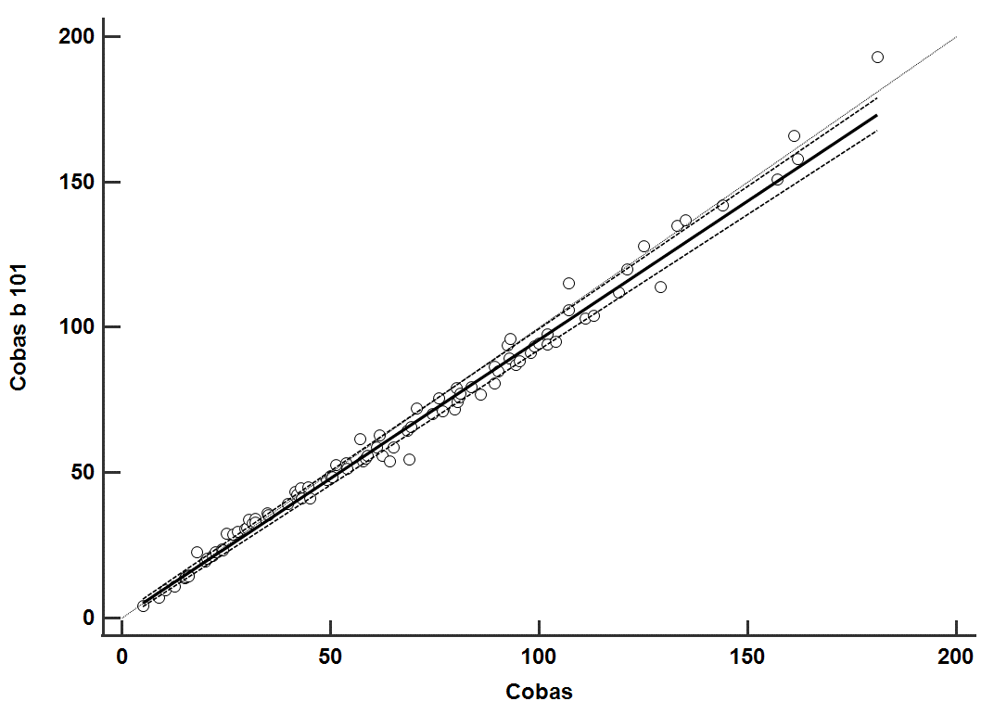
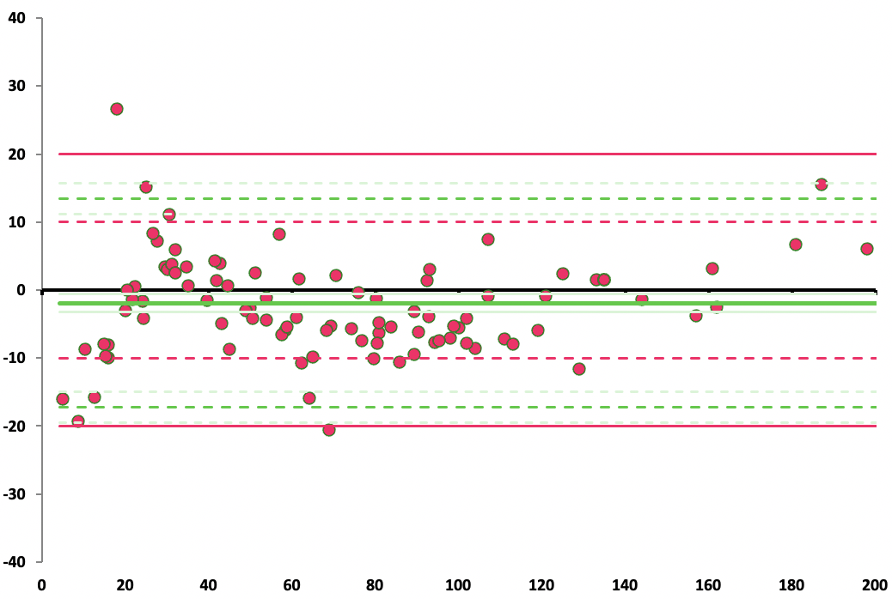
A
E
y=0.954x [0.931-0.980] + 0.4 [-0.7-1.7]
ρ= 0.996

CRP (mg/L) cobas b 101
Difference cobas c 503 and cobas b 101 (%)

CRP (mg/L) cobas c 503
CRP (mg/L) cobas c 503
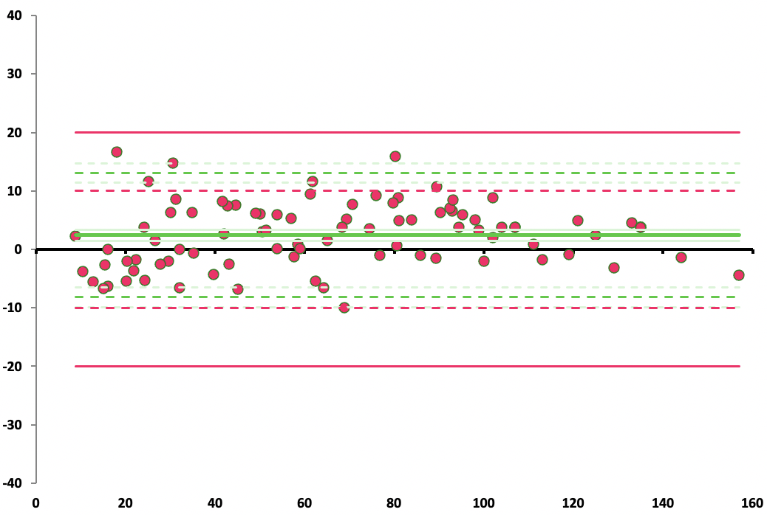
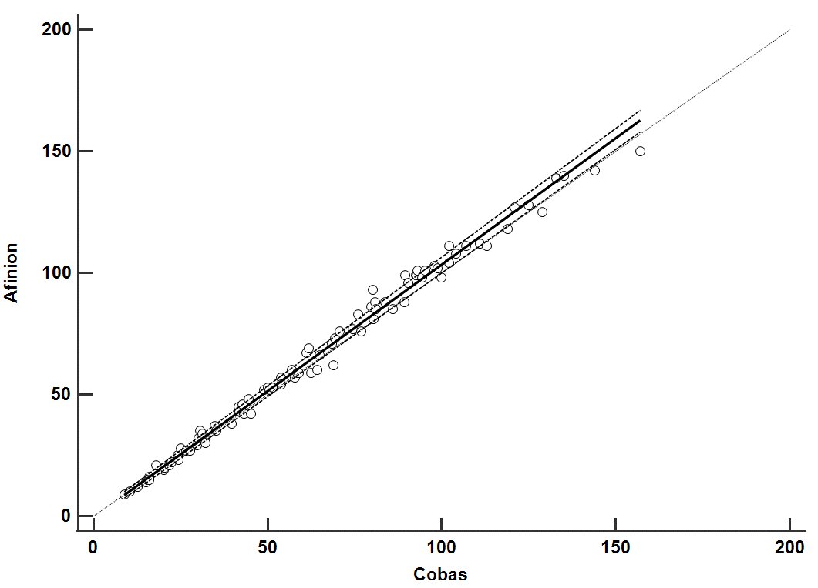
B
F
CRP (mg/L) Afinion 2
y=1.039x [1.016-1.058] – 0.5 [-1.6-0.7]
ρ= 0.996

CRP (mg/L) cobas c 503
CRP (mg/L) cobas c 503
Difference cobas c 503 and Afinion 2 (%)

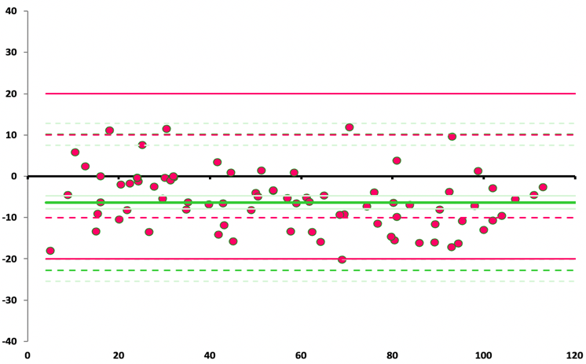
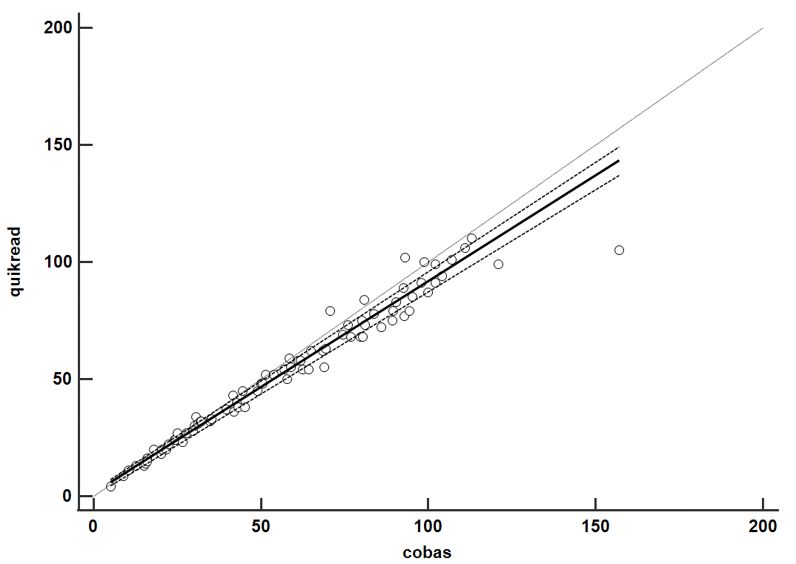
C
G
CRP (mg/L) QuikRead go
y=0.904x [0.872-0.934] – 1.5 [0.1-2.5]
ρ= 0.991

CRP (mg/L) cobas c 503
CRP (mg/L) cobas c 503
Difference cobas c 503 and QuikRead go (%)

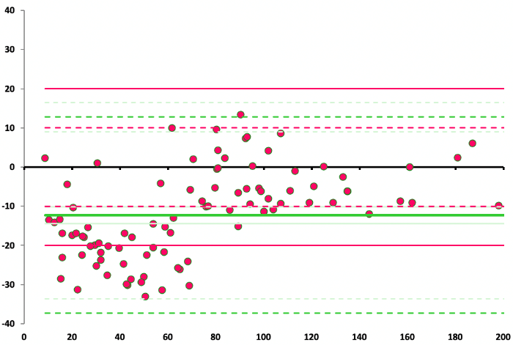
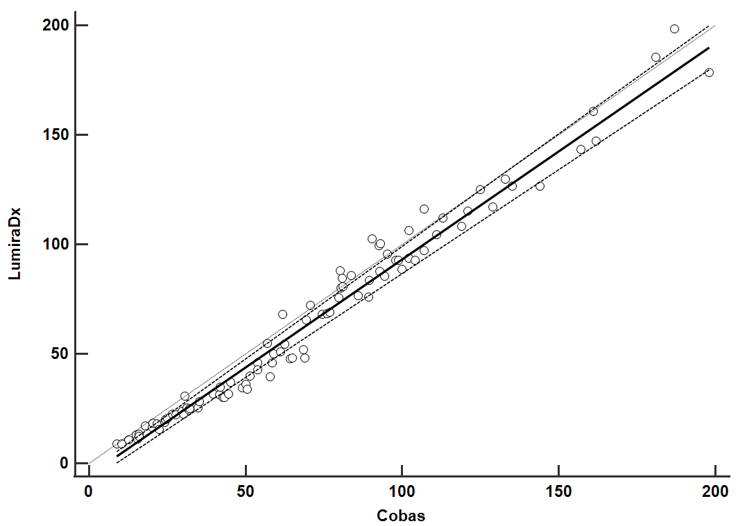
D
CRP (mg/L) LumiraDx
CRP (mg/L) cobas c 503
CRP (mg/L) cobas c 503
Difference cobas c 503 and LumiraDx (%)
H
y=0.987x [0.949-1.028] – 5.5 [-8.2;-3.7]
ρ= 0.992

Figure 2. Method comparison of capillary blood samples (5-200 mg/L) represented by Passing Bablok plots (A-D) and relative Bland-Altman plots (E-H). A-D: the regression line, with corresponding regression equation and Spearman’s ρ, is represented by a solid line. The confidence interval for the regression is represented by the dashed lines and x=y is represented by the dotted line. E-H: The mean difference is represented by a solid green line, the 95% confidence interval of the bias by a dotted green line, the total acceptable error (+/- 20%) as solid red line and the acceptable CV (+/-10%) standard error as dotted red line.
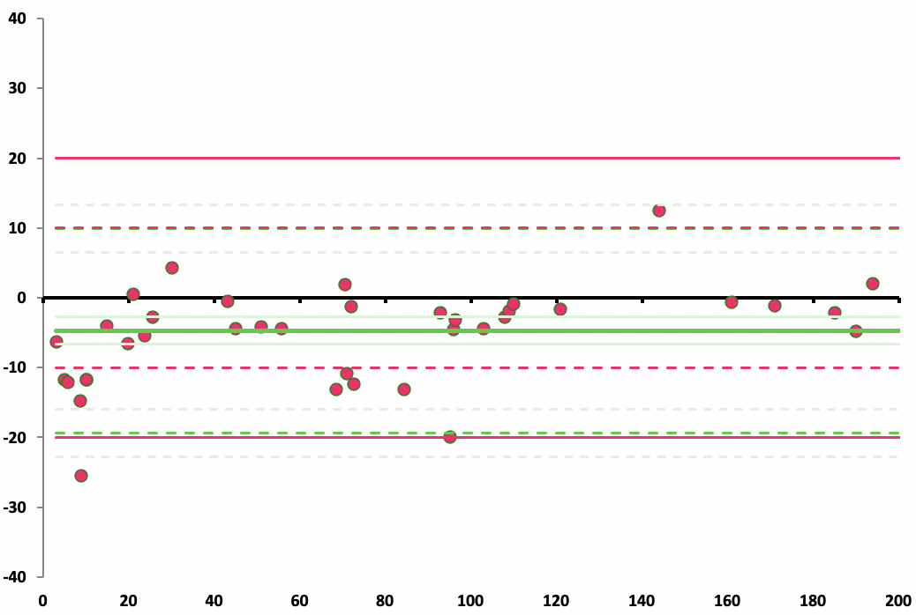
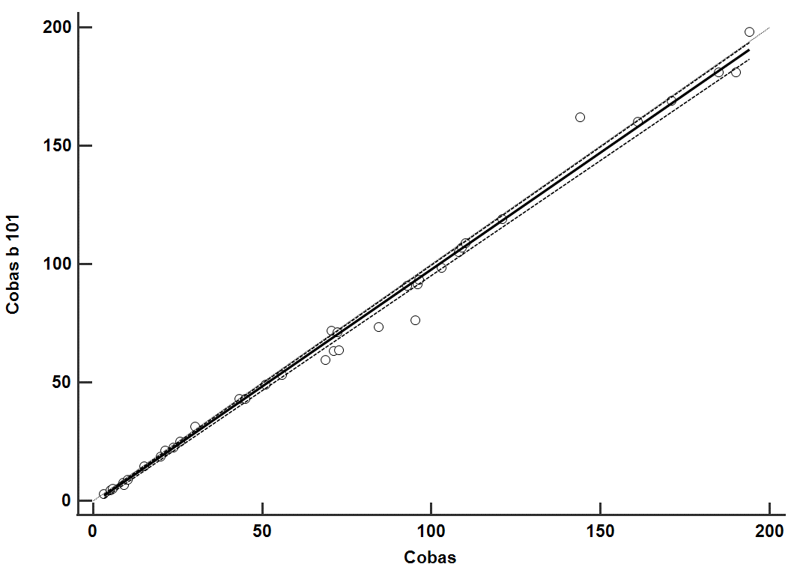
A
E
y=0.988x [0.972-1.000] – 1.0 [-2.0;-0.4]
ρ= 0.998

CRP (mg/L) cobas b 101
Difference cobas c 503 CRP and cobas b 101 (%)

CRP (mg/L) cobas c 503
CRP (mg/L) cobas c 503
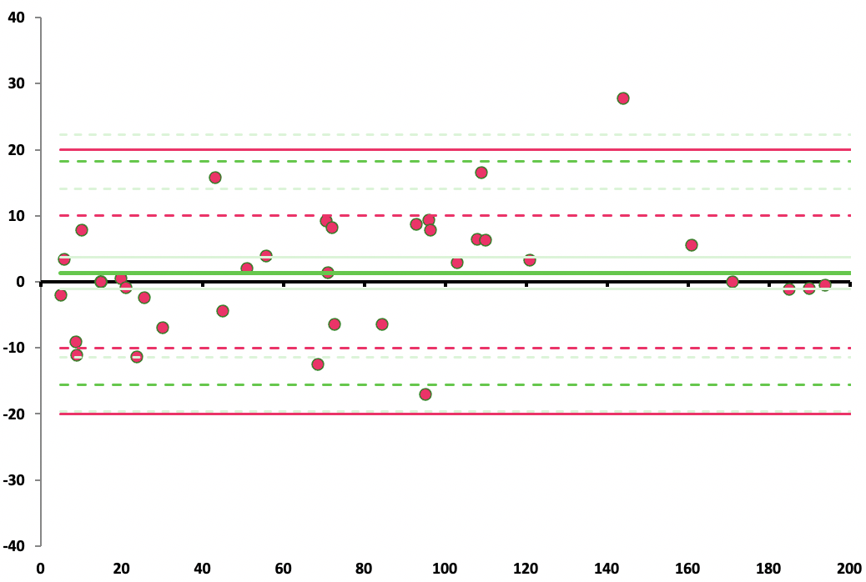
F
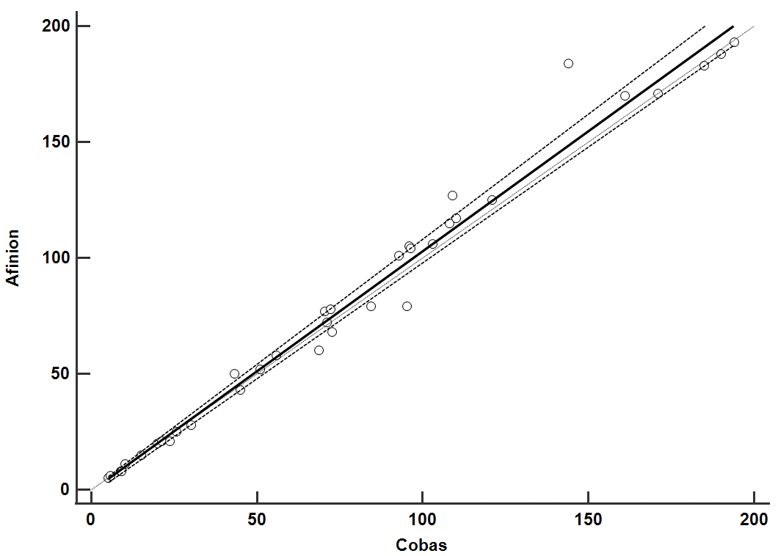
B
y=1.035x [0.999-1.079] – 0.6 [-2.1-0.2]
ρ= 0.995

CRP (mg/L) Afinion 2
Difference cobas c 503 CRP and Afinion 2 (%)

CRP (mg/L) cobas c 503
CRP (mg/L) cobas c 503

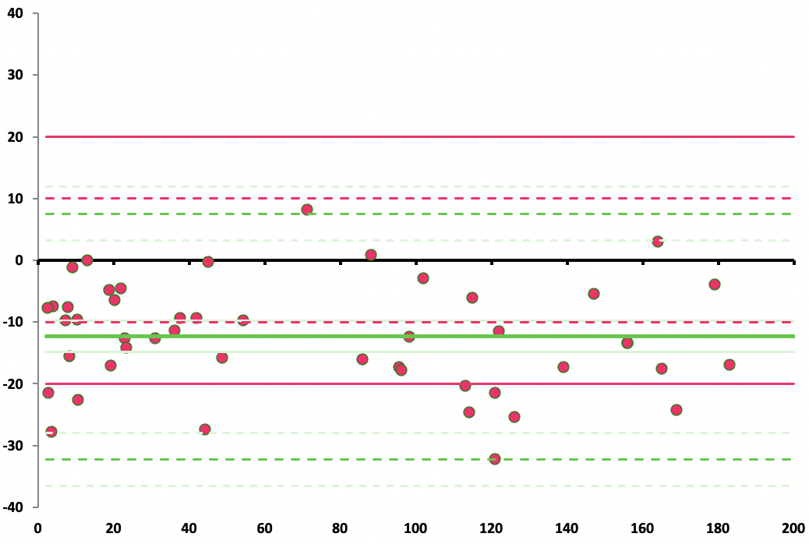
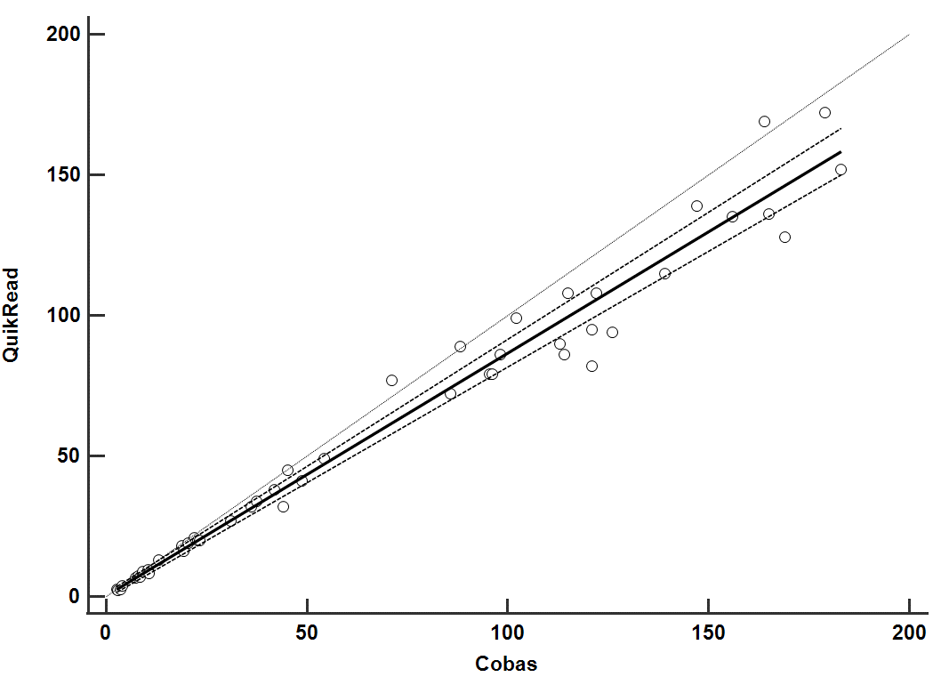
CRP (mg/L) QuikRead go
C
G
y=0.854x [0.817-0.906] – 0.6 [-0.8-1.8]
ρ= 0.985
Difference cobas c 503 CRP and QuikRead go (%)

CRP (mg/L) cobas c 503
CRP (mg/L) cobas c 503

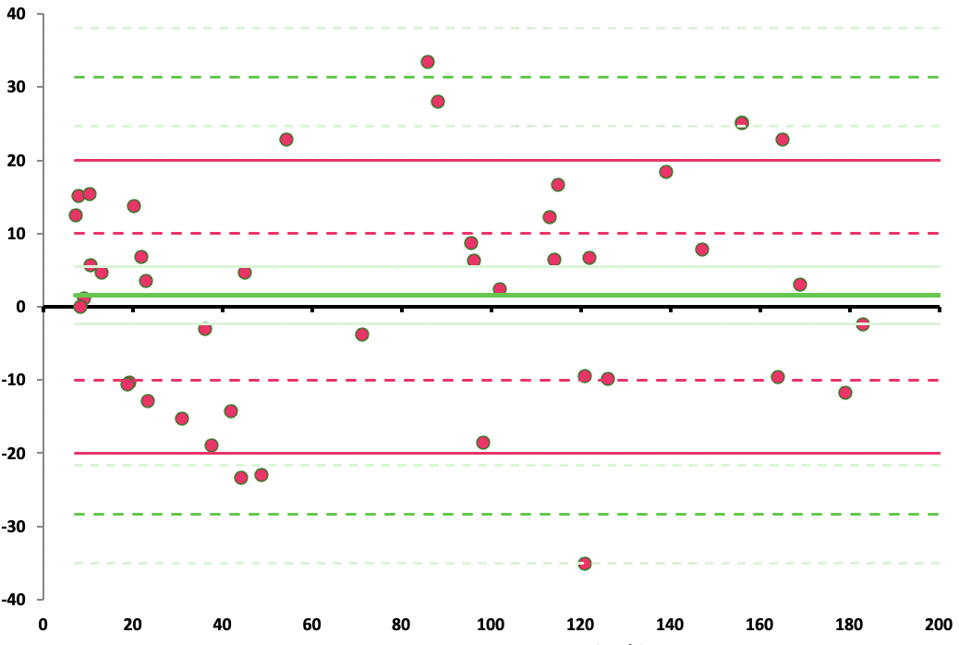
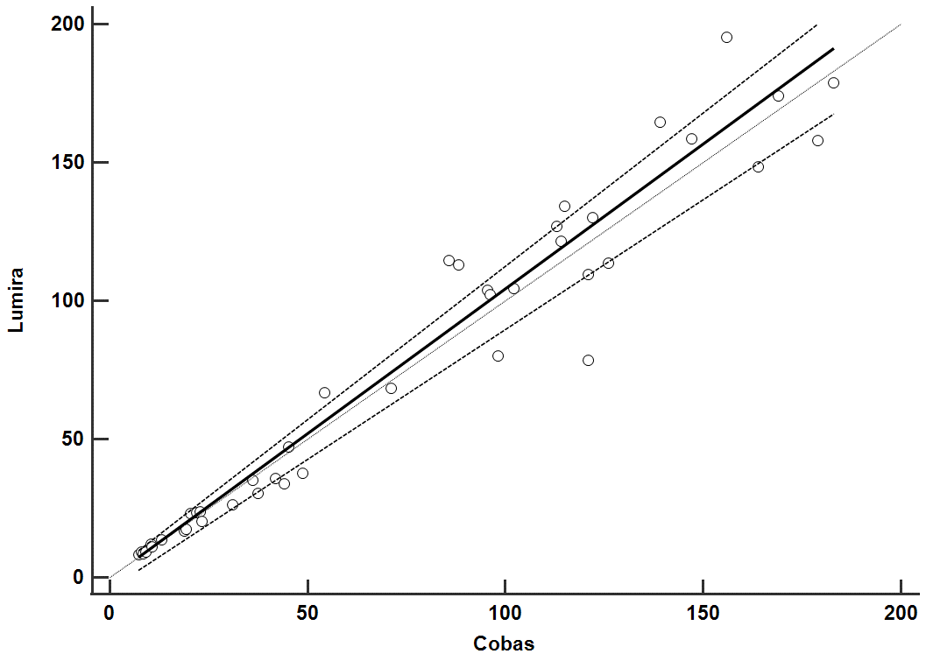
D
H
y=1.047x [0.938-1.108] – 0.3 [-4.2-1.1]
ρ= 0.971

CRP (mg/L) LumiraDx
Difference cobas c 503 CRP and LumiraDx (%)

CRP (mg/L) cobas c 503
CRP (mg/L) cobas c 503

Figure 3. Radar chart of the user-friendliness survey, comprising twenty-three questions covering following topics: packaging and manipulation of pre-analytical device, blood collection, timespan between collection and analysis, duration of test and error codes. The median Likert score obtained from 14 participants for LumiraDx (LumiraDx), and QuidRead go (Aidian Diagnostics) and 16 participants (cobas b 101 (Roche Diagnostics), Afinion 2 (Abbott)) is presented.
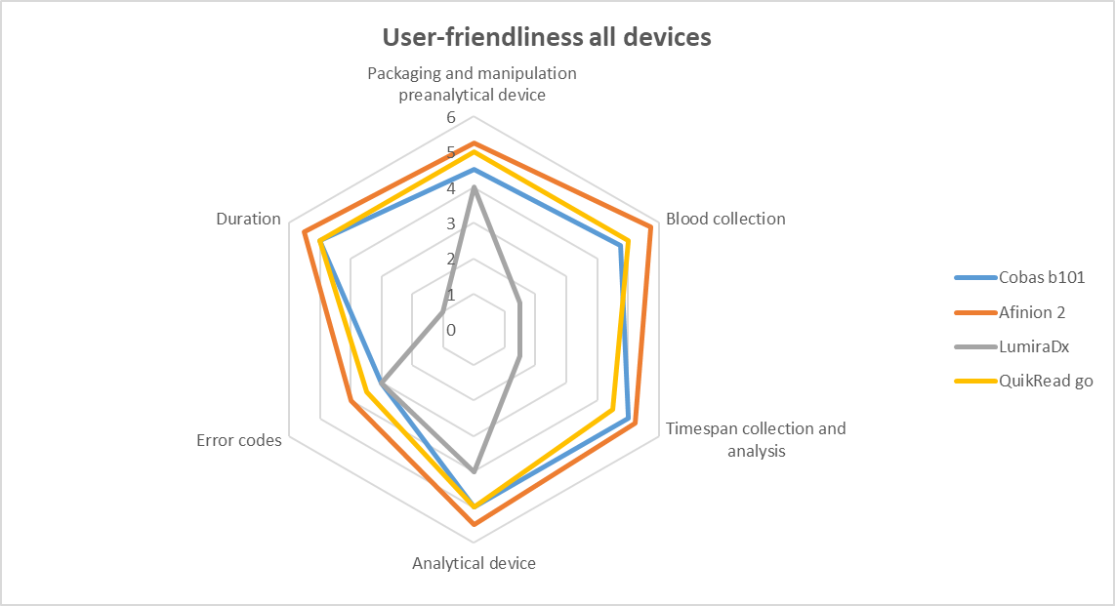

TABLES
Table 1. Assay characteristics of the four POCT-CRP methods.
 | QuikRead go  (Aidian Diagnostics Espoo, Finland) | Afinion 2  (Abbott, Oslo, Norway) | cobas b 101  (Roche Diagnostics, Mannheim, Germany) | LumiraDx CRP  (LumiraDx, Stirling, UK)
Test principle | Immunoturbi-dimetric assay | Solid phase, sandwich-format, Immunochemical assay | Immunoturbi-dimetric assay | Immunofluore-scent assay
Required sample volume | 10 µL | 2.5 µL | 12 µL | 20 µL
Measurement range whole blood | 1-200 mg/L | 5-200 mg/L | 3-400 mg/L | 5-250 mg/L
Measurement range plasma/serum | 1-120 mg/L | 5-160 mg/L | 3-400 mg/L | 5-250 mg/L
Max. time between collection and analysis | 2 hours | 1 min | 2 min | Unspecified
Analysis time | 2 min | 3-4 min | 3-4 min | 4 min
Hematocrit correction | 15%-75% | 20%-60% | 20%-60% | 15%-55%
Traceability | ERM DA 474/IFCC | ERM DA 474/IFCC | ERM DA 474/IFCC | ERM DA 474/IFCC
Lot number iQC low / high | 1911044 /  1910072 | 10214493 / 10214494 | 020143-10 /  020143-20 | 1009000273000161 / 1009000274000162
Lot number reagents | KT87-2 | 10220588 | 218151-01 | 50000752

Table 2. Lithium heparin plasma method comparison versus cobas c 503 (values 5-200 mg/L): results for Passing Bablok regression, Bland-Altman plot analysis (mean percentage difference) and the % of samples within the +/- 20% accuracy criterion.
 | Number of samples | Passing Bablok regression |  |  | Bland-Altman plot | % samples < +/- 20% mean difference
 | Number of samples | Slope  [95% CI] | Intercept  [95% CI] | Spearman’s ρ  [95% CI] | Mean difference (%)  [95% CI] | % samples < +/- 20% mean difference
cobas b 101 | 93 | 0.954  [0.931-0.980] | 0.4  [-0.7-1.7] | 0.996  [0.994-0.997] | -2.58  [-17.19-12.04] | 97.8
Afinion 2 | 87 | 1.039  [1.016-1.058] | -0.5  [-1.6-0.7] | 0.996  [0.994-0.997] | 2.53  [-8.21-13.28] | 100.0
QuikRead go | 81 | 0.904  [0.872-0.934] | 1.5  [0.1-2.5] | 0.991  [0.985-0.994] | -6.34  [-22.82-10.15] | 97.5
LumiraDx | 92 | 0.987  [0.949-1.028] | -5.5  [-8.2;-3.7] | 0.992  [0.987-0.994] | -13.66  [-36.68-9.37] | 66.3

Table 3. Capillary blood method comparison versus cobas c 503 (values 5-200 mg/L): results for Passing Bablok regression, Bland-Altman plot analysis (mean percentage difference) and the % of samples within the +/- 20% accuracy criterion.
 | Number of samples | Passing Bablok regression |  |  | Bland-Altman plot | % samples < +/- 20% mean difference
 | Number of samples | Slope  [95% CI] | Intercept  [95% CI] | Spearman’s ρ  [95% CI] | Mean difference (%) [95% CI] | % samples < +/- 20% mean difference
cobas b 101 | 36 | 0.988  [0.972-1.000] | -1.0  [-2.0;-0.4] | 0.998  [0.995-0.999] | -5.22  [-20.29-9.86] | 97.2
Afinion 2 | 36 | 1.035  [0.999-1.079] | -0.6  [-2.1-0.2] | 0.995  [0.990-0.997] | 1.50  [-15.50-18.49] | 97.2
QuikRead go | 43 | 0.854  [0.817-0.906] | 0.6  [-0.8-1.8] | 0.985  [0.972-0.992] | -12.01  [-31.68-7.65] | 83.7
LumiraDx | 43 | 1.047  [0.938-1.108] | -0.3  [-4.2-1.1] | 0.971  [0.947-0.985] | 1.68  [-28.52-31.88] | 86.0

Table 4. Results of the between-day imprecision study for low- and high-level patient pools (n=10) performed on four POCT-CRP devices with mean and standard deviation (SD) in mg/L and CV in %.
 | Low patient pool  cobas c 503 (mg/L) | Mean (SD) (mg/L) | CV (%)
cobas b 101 | 18.6 | 20.6 (1.01) | 4.91
Afinion 2 | 18.6 | 18.4 (1.39) | 7.56
QuikRead go | 18.6 | 18.1 (2.07) | 11.5
LumiraDx | 18.6 | 16.1 (1.45) | 9.01
 | High patient pool  cobas c 503 (mg/L) | Mean (SD) (mg/L) | CV (%)
cobas b 101 | 98.6 | 93.1 (4.52) | 4.86
Afinion 2 | 98.6 | 98.7 (7.59) | 7.69
QuikRead go | 98.6 | 88.8 (9.04) | 10.2
LumiraDx | 98.6 | 91.3 (4.44) | 4.47

References
[1] Florkowski C, Don-Wauchope A, Gimenez N, Rodriguez-Capote K, Wils J, A. Z. Point-of-care testing (POCT) and evidence-based laboratory medicine (EBLM) - does it leverage any advantage in clinical decision making? Crit Rev Clin Lab Sci 2017; 54: 471-94.
[2] Regulation (EU) 2017/746 of the European Parliament and of the Council of 5 April 2017 on In Vitro Diagnostic Medical Devices and Repealing Directive 98/79/EC and Commission Decision 2010/227/EU.Official J Eur Union 2017; L117: 176-332.
[3] Patel K, Suh-Lailam BB. Implementation of point-of-care testing in a pediatric healthcare setting. Crit Rev Clin Lab Sci 2019; 56: 239-46.
[4] Belgian Healthcare Knowledge Center. KCE Repport 311: proposals for a more effective antibiotic policy in Belgium. Available at: https://kce.fgov.be/nl/publicaties/alle-rapporten/voorstellen-voor-een-effectiever-antibioticabeleid-in-belgie2019 (Accessed December 26th 2023).
[5] Harrington P, Lucey D, O'Brien K, Jordan K, Moran P, Marschall L. C-reactive prooien point-of-care testing (CRP POCT) to guide antibiotic prescribing in primary care settings for acute respiratory tract infections (RTIs). Rapid assessment on other health technologies using the HTA core model for rapid relative effectiveness assessment. EUnetHTA Project ID: OTCA012. Available at: https://www.eunethta.eu/wp-content/uploads/2019/02/EUnetHTA_OTCA012_CRP-POCT_31012019.pdf2019 (Accessed December 26th 2023).
[6] Van Hoof V, Barglazan D, Blairon L, Braekevelt B, Debois R, De Vos NVJ, et al. Organisation and quality monitoring for point-of-care testing (POCT) in Belgium: proposal for an expansion of the legal framework for POCT into primary health care. . Acta Clin Belg. 2022;77(2):329-36.
[7] NICE Guidelines Pneumonia in adults: diagnosis and management. Available at: https://www.guidelines.co.uk/nicepneumonia-guideline/455006.article (Accessed December 26th 2023).
[8] NHG standaard “acuut hoesten”. Available at: https://www.nhg.org/standaarden/volledig/nhg-standaard-acuut-hoesten (Accessed December 26th 2023).
[9] SKUP Scandinavian evaluation of laboratory equipment for point of care testing. Report from the evaluation SKUP/2019/116. cobas b 101 (Roche Diagnostics GmbH), a system for measurement of CRP. Available at: https://skup.org/ (Accessed December 26th 2023).
[10] EPI-Centre, Evaluating Primary Care Innovations. Academisch Centrum voor Huisartsgeneeskunde Leuven. Available at: https://www.epi-centre.be (Accessed December 26th 2023).
[11] Clinical and Laboratory Standards Institute (CLSI). CLSI document POCT04-A: Essential tools for implementation and management of a point-of-care testing program, 3rd edition. Wayne, PA; 2016.
[12] Khan AI, Pratumvinit B, Jacobs E, Kost GJ, Kary H, Balla J, et al. Point-of-care testing performed by healthcare professionals outside the hospital setting: consensus based recommendations from the IFCC Committee on Point-of-Care Testing (IFCC C-POCT). Clin Chem Lab Med 2023; 61: 1572-9.
[13] Stavelin A, Sandberg S. Analytical performance specifications and quality assurance of point-of-care testing in primary healthcare. Crit Rev Clin Lab Sci 2023; epub ahead of print: doi.org/10.1080/10408363.2023.2262029
[14] Clinical and Laboratory Standards Institute (CLSI). CLSI document POCT09-A: Selection criteria for point-of-care testing devices. Wayne, PA; 2010.
[15] Clinical and Laboratory Standards Institute (CLSI). CLSI document EP9-A3: Method comparison and bias estimation using patient samples, 2nd edition. Wayne, PA; 2013.
[16] Braga F, Panteghini M. Derivation of performance specifications for uncertainty of serum C-reactive protein measurement according to the Milan model 3 (state of the art). Clin Chem Lab Med 2020; 58: e263-e5.
[17] Braga F, Panteghini M. The utility of measurement uncertainty in medical laboratories. Clin Chem Lab Med 2020; 58: 1407-13
[18] Borrillo F, Panteghini M. Current performance of C-reactive protein determination and derivation of quality specifications for its measurement uncertainty. Clin Chem Lab Med 2023; 61: 1552-7.
[19] Auclair G, Z, I., Charoud-Got J, Munoz Pineiro A, Hanisch K, Boulo S, et al. EUR 24922 EN: The Certification of the Mass Concentration of C-Reactive Protein in Human Serum - Certified Reference Material ERM ® -DA474/IFCC. Luxembourg; 2011.
[20] Panteghini M, Braga F, Camara JE, Delatour V, Van Uytfanghe K, Vesper HW, et al. Optimizing Available Tools for Achieving Result Standardization: Value Added by Joint Committee on Traceability in Laboratory Medicine (JCTLM). Clin Chem 2021; 67: 1590-605.
[21] ISO/TS 20914: Medical laboratories-practical guidance for the estimation of measurement uncertainty. Available at: https://www.nbn.be.
[22] Minnaard MC, van de Pol AC, Broekhuizen BD, Verheij TJ, Hopstaken RM, van Delft S, et al. Analytical performance, agreement and user-friendliness of five C-reactive protein point-of-care tests. Scand J Clin Lab Invest 2013; 73: 627-34.
[23] Verbakel JY, Aertgeerts B, Lemiengre M, Sutter AD, Bullens DM, Buntinx F. Analytical accuracy and user-friendliness of the Afinion point-of-care CRP test. J Clin Pathol 2014; 67: 83-6.
[24] Hernández-Bou S, Trenchs V, Vanegas MI, Valls AF, Luaces C. Evaluation of the bedside Quikread go® CRP test in the management of febrile infants at the emergency department. Eur J Clin Microbiol Infect Dis 2017; 36: 1205-11.
[25] Papaevangelou V, Papassotiriou I, Sakou I, Ferentinos G, Liapi G, Kyrka A, et al. Evaluation of a quick test for C-reactive protein in a pediatric emergency department. Scand J Clin Lab Invest 2006; 66: 717-21.
[26] Zecca E, Barone G, Corsello M, Romagnoli C, Tiberi E, Tirone C, et al. Reliability of two different bedside assays for C-reactive protein in newborn infants. Clin Chem Lab Med 2009; 47: 1081-4.
[27] Ricós C, Alvarez V, Cava F, García-Lario JV, Hernández A, Jiménez CV, et al. Current databases on biological variation: pros, cons and progress. Scand J Clin Lab Invest 1999; 59: 491-500.
[28] Aarsand AK, Røraas T, Fernandez-Calle P, Ricos C, Díaz-Garzón J, Jonker N, et al. The Biological Variation Data Critical Appraisal Checklist: A Standard for Evaluating Studies on Biological Variation. Clin Chem 2018; 64: 501-14.
[29] Minnaard MC, vdP, A.C., de Groot JA, De Wit NJ, Hopstaken RM, van Delft S, et al. The added diagnostic value of five different C-reactive protein point-of-care test devices in detecting pneumonia in primary care: A nested case-control study. Scand J Clin Lab Invest 2015; 75: 291-5.
[30] Brouwer N, van Pelt J. Validation and evaluation of eight commercially available point of care CRP methods. Clin Chim Acta 2015; 439: 195-201.
[31] Bukve T, Stavelin A, Sandberg S. Effect of Participating in a Quality Improvement System over Time for Point-of-Care C-Reactive Protein, Glucose, and Hemoglobin Testing. Clin Chem 2016; 62: 1474-81.
[32] Calarco S, Fernandez-Carballo BL, Keller T, Weber S, Jakobi M, Marsall P, et al. Analytical performance of 17 commercially available point-of-care tests for CRP to support patient management at lower levels of the health system. PLoS One 2023; 18: e0267516.
[33] Monteny M, ten Brinke MH, van Brakel J, de Rijke YB, Berger MY. Point-of-care C-reactive protein testing in febrile children in general practice. . Clin Chem Lab Med 2006; 44: 1428-32.
[34] Smedemark SA, Aabenhus R, Llor C, Fournaise A, Olsen O, Jørgensen KJ. Biomarkers as point-of-care tests to guide prescription of antibiotics in people with acute respiratory infections in primary care. Cochrane Database Syst Rev 2022; 10: CD010130.

