Occurrence and mechanistic basis of 2n gamete formation in apple (Malus x domestica Borkh.)

H. Palmers^{1,2,} M. Rymenants³ and N. De Storme^{1,2}
¹Plant Genetics and Crop Improvement lab, Leuven, Belgium; ²KU Leuven Plant Institute, Leuven, Belgium; ³Better3fruit NV, Rillaar, Belgium

Abstract
In plants, aberrations in reproductive genome stability can lead to the formation of 2n gametes, which are considered an important driver for polyploidization and speciation. The formation of 2n gametes is often controlled by genetic determinants, nevertheless can also be affected by external factors such as abiotic stress. 2n gametes are highly interesting from a breeding perspective as they form a route for polyploidy induction which often confers beneficial agronomical traits, like increased yield and enhanced stress tolerance. In apple, the existence of several triploid genotypes, including many highly valued commercial cultivars like ‘Jonagold’ and ‘Boskoop’, indicates for the occurrence of 2n gametes in the germplasm, however, little is known about their frequency, specific origin, and mechanistic basis. In order to gain more insights into the occurrence and natural genetic variation in 2n gamete formation in apple, we have screened the REFPOP population, a genetically diverse reference collection of apple cultivars, for alterations in reproductive genome stability via an integrated approach involving pollen size analysis. Accessions showing significant production of 2n gametes are further characterized using cytological analysis of microsporogenesis and –gametogenesis as well as via spore genotyping. In the screen performed in 2021 we have identified multiple apple accessions that produce a significant proportion of larger pollen grains which is indicative for 2n gamete formation. Preliminary cytological characterization of male meiosis of one of these lines has revealed enlarged and doubled tetrads as well as meiocytes with a duplicated chromosome set, indicating for ectopic occurrence of pre-meiotic genome doubling. These results are the first report of the characterization of 2n gamete formation in the apple germplasm, and provide evidence for the occurrence of pre-meiotic doubling as a mechanistic basis underlying 2n pollen production in apple. In addition, the natural variation in 2n gamete formation in the apple germplasm forms a fundamental basis for elucidating underlying cellular and genetic mechanisms, and thus may provide novel insights on the regulation of reproductive genome stability, with implications for apple genome evolution and breeding.

Keywords: apple breeding, sexual polyploidization, diploid gametes, reproductive stability

Introduction
Apple (Malus 𝗑 domestica Borkh.) is the fourth most produced fruit in the world, after tomato, banana and watermelon, with a total production of over 86 million tonnes in 2020 (FAOSTAT, 2022,). While over 10 000 different apple cultivars have been documented, only a limited set is used for commercial production. Most of the older apple cultivars like ‘Golden Delicious’ and ‘Granny Smith’ are chance seedlings resulting from random pollination and empirical selection. Later, specific parent lines were selected and intercrossed in order to obtain progeny with desirable traits (Goulão et al., 2001). While apple breeding was originally focused on good fruit quality and agronomical characteristics, resistance to the most common pathogens like fire blight (Erwinia amylovora), apple scab (Venturia inaequalis) and powdery mildew (Podosphaera leucotricha) is becoming increasingly important (Kellerhals et al., 2008). Additionally, global warming has led to an increase in extreme weather events including drought and extreme temperatures which are important abiotic stress factors that are detrimental to fruit production (Bellard et al., 2012; Mihaljević et al., 2021). Also, the reduced availability of synthetic products, and particularly pesticides, forms a major challenge for guaranteeing fruit quality and productivity in apple in the upcoming decades. Consequently, apple breeding objectives should be constantly updated and also include increased resilience to biotic and abiotic stresses (Kellerhals et al., 2020). In a wide range of plants, polyploids, i.e. plants with three or more chromosome sets, have been observed to show an increased resilience to both biotic and abiotic stresses. Polyploid accessions of citrus (Citrus sp.), Spathiphyllum wallisii and poplar (Populus usseriensis) have been found to have a higher tolerance to drought stress as compared to diploids (Van Laere et al., 2011; Lourkisti et al., 2020; Xu et al., 2019). In citrus it was shown that polyploids also better cope with cold stress (Lourkisti et al., 2020). Triploid cultivars of watermelon (Citrullus lanatus) show an increased resistance to Fruit Blotch Organism as compared to reference diploid cultivars, and triploid lime is more tolerant to Huanglongbing or ‘yellow dragon disease’ (Garret et al., 1995; Sivager et al., 2020). For apple specifically, it has been shown that autotetraploid variants of specific apple cultivars are more tolerant to salt and drought stress compared to their diploid counterparts (Chen et al., 2017; Xue et al., 2015). Autotetretraploid apple cultivars have also been found to be more resilient to major diseases, including apple scab (Venturia inaequalis), Alternaria alternata and Colletotrichum gloeosporioides (Chen et al., 2017; Švara et al., 2021).
The presence of multiple chromosome sets often leads to an increased heterozygosity with associated heterosis effects, and can also lead to more variation in the expression of dosage regulated genes. Additionally, the presence of more than two sets of chromosomes also implicates a strong gene redundancy which may confer masking of recessive alleles, introduce additional intra-locus effects, and trigger gene subfunctionalization (Adams and Wendel, 2005; Comai, 2005; Osborn et al., 2003). Therefore, ploidy breeding could provide an invaluable tool to further exploit the available genepool in order to tackle the challenges posed by climate change and changed legislation to apple production.
Even though tetraploid apple genotypes have an overall increased resilience to biotic and abiotic stresses, these plants are not suited for commercial production due to their weak growth, short shoots, low amount of flowers, and large, watery fruits (Podwyszyńska and Marasek-Ciołakowska, 2021; Ranney, 2009). Therefore, ploidy breeding in apple should be focussed on the generation of triploid genotypes. Triploid apple accessions have been in use for centuries and make up a large part of the current heirloom collections. For example, between 20% and 29% of apple accessions in local collections from Spain, Portugal and the Netherlands are triploid (Ferreira et al., 2016; Ramos-Cabrer et al., 2007; van Treuren et al., 2010). In contrast, only 0.26% of the progeny from (reciprocal) crosses between the diploid cultivars ‘Gala’, ‘Fuji’ and ‘Cripps Pink’ is triploid (Considine et al., 2012). This discrepancy between the spontaneous formation and eventual selection of triploid apple accessions proves that triploid lines have empirically been selected for, i.e. due to certain advantageous characteristics such as larger fruits and strong vigour (Podwyszyńska and Marasek-Ciołakowska, 2021; Sedov et al., 2017). Also, triploid apple seedlings show an increased resistance to apple scab compared to diploid seedlings from the same parental combinations (Sedov et al., 2017).
In general, triploid genotypes can be generated through different methods; including endosperm culture, interploidy crosses and via ectopic production of 2n gametes, although there are no reports of endosperm culture in apple. Interploidy hybridizations, and particular crosses between a diploid and a tetraploid, are typically performed in order to generate triploid progeny, however, only to a limited extent. Most tetraploid apple accessions are the result of somatic genome duplication caused by the application of anti-mitotic agents, such as colchicine and oryzaline (Podwyszyńska and Marasek-Ciołakowska, 2021; Sedov et al., 2017). Triploid genotype formation via interploidy crosses in apple is rather slow and cumbersome compared to crosses made between diploids. At first, somatic duplication is needed in order to produce tetraploid parents. Next, these plants need to be grown and juvenility needs to be overcome in order to enable hybridization with the diploid parent, thereby adding several years to the already lengthy breeding process. Additionally, tetraploid apple trees have major drawbacks for seed production due to their weak growth, short shoot length and often small amount of buds and flowers which make it more difficult to produce large amounts of progeny (Podwyszyńska and Marasek-Ciołakowska, 2021). Finally, since tetraploid parents are often generated by somatic genome doubling, the produced 2n gametes all have a highly similar genotype, and hence do not confer much genetic variability towards the next generation.
The ectopic formation of 2n gametes in diploid plants has been observed in a wide range of plant species and families including the Brassicaceae, Ebenaceae, Musaceae and Rosaceae (Mai et al., 2019; Pécrix et al., 2011; Raboin et al., 2005; De Storme and Geelen, 2011). The formation of 2n gametes is often genetically controlled, i.e. by mutations in genes that are essential for reproductive genome integrity, however, can be strongly affected by environmental factors like for example temperature stress. 2n gametes result from aberrations of meiotic cell division or from whole genome duplication of germ line cells, either before or after meiosis, also referred to as pre- and post-meiotic doubling, respectively. Diplogamete formation via premeiotic doubling has been described in tomato (Solanum lycopersicum) and Arabidopsis thaliana mutants which show alterations in cell plate formation (De Storme and Geelen, 2013a; De Storme et al., 2013a). Postmeiotic doubling, which results in the formation of completely homozygous 2n gametes, has been observed in potato (S. tuberosum) mcd×tbr hybrids (Bastiaanssen et al., 1998). The most common mechanism responsible for the formation of 2n gametes is meiotic restitution in which aberrations occur during meiosis which result in the formation of dyads and triads instead of the regular tetrads (Bretagnolle and Thompson, 1995; De Storme and Geelen, 2013b). Meiotic restitution has been reported in multiple plants species and can occur spontaneously as well as under different stress factors (Mai et al., 2019; Pécrix et al., 2011; De Storme and Geelen, 2011, 2013b). There are different cellular mechanisms of meiotic restitution and these can be subdivided based on the genetic make-up of resulting 2n gametes. In First Division Restitution (FDR) resulting 2n gametes are genetically equivalent to gametes formed by a complete omission of meiosis I. Homologous chromosomes are not segregated while sister chromatids are, hence yielding 2n gametes that retain a large part of the parental heterozygosity, particularly at the centromeres. In Second Division Restitution (SDR) 2n gametes are equivalent to gametes resulting from the omission of meiosis II, i.e. with lack of sister chromatid segregation yielding 2n gametes that loose parental heterozygosity at the centromeres (Bretagnolle and Thompson, 1995; De Storme and Geelen, 2013b).
In apple, little is known about the occurrence and mechanistic basis of 2n gamete formation. However, it is reported that a large part of triploid accessions result from the ectopic formation of a 2n gamete in one of the diploid parents and its subsequent involvement in fertilization (Goulão et al., 2001; Larsen et al., 2017; Muranty et al., 2020; Podwyszyńska and Marasek-Ciołakowska, 2021). In line with this, progeny analysis of crosses between the diploid cultivars ‘Gala’, ‘Fuji’ and ‘Cripps Pink’ yielded a subfraction of triploid (3x) progeny, indicating occurrence of 2n gametes in one or several parents. It was thereby also shown that all unreduced gametes that resulted in triploid progeny were the result of FDR. However, the fraction of 3x progeny only amounted to 0.26%, and additionally aneuploidy appeared more common than eupolyploidy, indicating that parental lines also generate aneuploidy spores (Considine et al., 2012). Up till now, little studies have been performed on the cellular mechanisms underlying meiotic restitution and 2n gamete formation in apple. However, in the apple clone ‘R1-23’, derived from the self-pollination of the cultivar ‘Lowry’, five different restitution mechanisms have been discovered, two of which are equivalent to FDR and three to SDR. In this line, 11.4% of the microspores appeared enlarged, indicating for a higher ploidy level, and a large proportion of the generated progeny after self-pollination was considered triploid (54%) (Zhong et al., 1988).
The goal of this project is to assess the natural genetic variation in reproductive genome instability and 2n gamete formation in the apple germplasm. Accessions that produce a significant fraction of 2n gametes could prove to be interesting germplasm for apple ploidy breeding and will be analysed further on a cytological and genetic level in order to learn more about the underlying cellular defect and the genotypic make-up of resulting 2n gametes.

MATERIALS AND METHODS
Plant material
The apple REFPOP germplasm collection was used for this experiment. This collection consists out of 269 apple accessions from all over the world (Jung et al., 2020). In March and April 2021, flowers in the balloon stage were harvested from 152 REFPOP accessions (50.9652N, 4.8758E). Additionally, flowers were sampled from diploid and tetraploid ‘B3F44’, ‘G58’ and ‘Gala’ trees which were located in the orchards of Better3fruit NV in Rillaar, Belgium (50.9637N, 4.8839E). The autotetraploid lines have previously been generated by anti-mitotic agents, and tetraploidy was confirmed through flow cytometry in earlier experiments.

Pollen size analysis
Flowers were dissected and anthers were dried in a 2ml tube for 24h-48h after which they were stored at -20°C until analysis. Dried frozen anthers were thawed and rehydrated in a pollen collection buffer modified from (Lim et al., 2020) containing 17% sucrose, 1.625mM boric acid, 0.5M EDTA and 0.1% Triton X-100 at pH 7.5. Anthers were allowed to rehydrate at room temperature after which they were grinded manually and the suspension was passed through a 100µm mesh filter to isolate the pollen grains. The resulting pollen suspension was then centrifuged and the supernatant was removed. Afterwards, the pellet was resuspended in 100µl of the aforementioned pollen collection buffer and the suspension was pipetted on a 96 well plate. Individual wells were imaged using the Leica DMi8 microscope system (Leica Microsystems). For each ploidy variant of ‘B3F44’, ‘G58’ and ‘Gala’, 50 hydrated pollen grains were manually measured using ImageJ (Schneider et al., 2012). In order to quantitatively describe the pollen shape, 100 pollen grains were assessed in the polar view. A Welch’s t-test was performed in R software in order to assess for differences in any of the parameters assessed between diploid and tetraploid variants (R Core Team, 2017). Data wrangling and data visualization was obtained via the ‘tidyverse’ function in R (Wickham et al., 2019).

Male meiotic cytology
On March 7th, 15th and 22nd in the year 2021 flower buds were collected from the REFPOP collection and fixed in Clarke’s fixative (3:1 ethanol:acetic acid). In order to analyze the end products of male meiosis, individual anthers were squashed in a drop of 45% (v/v) lacto-propionic orceine in distilled water and visualized using an Olympus BX40 light microscope (Olympus), equipped with a ToupCam camera (ToupTek) for microscopic imaging. For each anther, at least 100 meiocytes in the ‘tetrad’ stage were counted.
In order to further analyze the meiotic chromosome behavior of specific REFPOP accessions, male meiotic chromosomes spreads were generated according to the protocol of Ross et al., (1996) with minor modifications. In brief, individual anthers of buds in BBCH stage 53 (bud burst) (Meier et al., 1994) were washed twice in distilled water and twice in a 10mM citrate buffer. The anthers were then digested by a 0.3% (w/v) mix of cellulase RS and pectolyase Y23 (Sigma) in 10mM citrate buffer for 1h at 37 °C. Digested anthers were washed with 10mM citrate buffer after which they were macerated and spread out on a glass microscopy slide in 10µl of 60% acetic acid on a hot plate. Following sufficient spreading, cells were fixed on the slide by adding copious amounts of fresh Clarke’s fixative, after which they were allowed to dry at room temperature and then stained with a drop of Vectashield mounting medium containing 2µg/ml DAPI (Vector Laboratories). Meiotic chromosome spreads were imaged using the Leica DMi8 microscope (Leica Microsystems).

RESULTS
Effect of ploidy on pollen size and morphology
In a wide range of plant species pollen size is used as a proxy for the pollen ploidy level (Mai et al., 2019; Pécrix et al., 2011; De Storme and Geelen, 2013a). In order to confirm the positive correlation between pollen size and gametophytic ploidy level in apple, pollen grains size and morphology was compared for 3 diploid accessions and their autotetraploid variants.In all three genotypic backgrounds, i.e. ‘B3F44, ‘G58’ and ‘Gala’, the somatic ploidy level has a significant effect on the pollen size, with pollen from tetraploid lines being consistently larger as compared to pollen of their diploid counterparts. Healthy, hydrated pollen grains of diploid ‘B3F44, ‘G58’ and ‘Gala’ measure on average 32.8, 34.3 and 31.6µm in diameter, respectively (Figure 1a, 1b). Pollen grains collected from tetraploid ‘B3F44, ‘G58’ and ‘Gala’ are significantly larger, with healthy pollen grains having a diameter of 40.9, 42.2 and 40.6µm, respectively. These dimensions are similar to earlier reports of pollen sizes from diploid and tetraploid apple lines (Podwyszyńska et al., 2016; Wójcik et al., 2022). Overall, pollen grains from the tetraploid ‘B3F44’, ‘G58’ and ‘Gala’ variants were 1.25, 1.23 and 1.28 times larger than those from their diploid counterparts, respectively, which is similar to the size ratio observed in ornamental roses, Arabidopsis thaliana and persimmon (Diospyros kaki) (Mai et al., 2019; Pécrix et al., 2011; De Storme et al., 2013b).
b
a
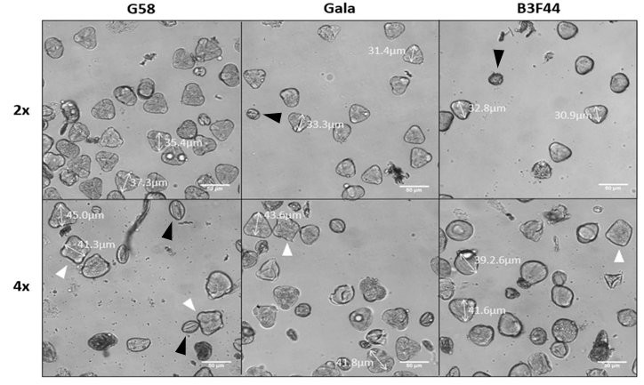
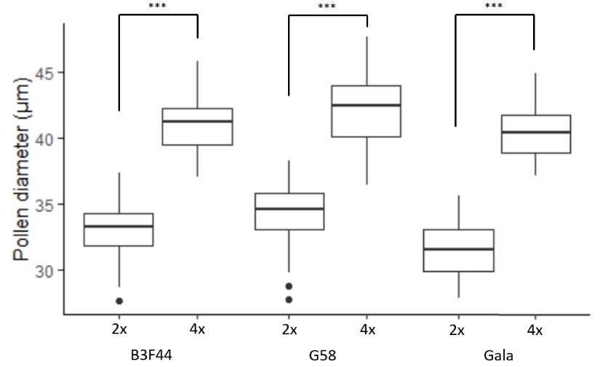

Figure 1. a) Diameter of mature pollen from diploid (2x) and tetraploid (4x) lines of the ‘B3F44’, ‘G58’ and ‘Gala’ apple cultivars. Pollen grains of diploids are significantly smaller than pollen from tetraploids for each of the three accessions (*** p<0.001; Welch t-test). b) Microscopic images of pollen grains of diploid (2x) and tetraploid (4x) ‘B3F44’, ‘G58’ and ‘Gala’. Representative pollen diameter measurements of selected pollen grains are indicated with a double arrow with the corresponding diameter size listed. Full white arrows indicate tetracolpate pollen grains, full black arrows indicate desiccated pollen. Scale bar, 50 µm.

Two-dimensional microscopy imaging revealed that diploid lines of all three apple cultivars, ‘B3F44’, ‘G58’ and ‘Gala’, consistently produce tricolpate-shaped pollen grains with three equally spaced apertures that run parallel to the polar axis of the pollen grain (Simpson, 2010). The tetraploid variants of ‘B3F44’, ‘G58’ and ‘Gala’ also generate this type of pollen grains, however, in parallel also produce pollen grains that have a square-shaped morphology also referred to as tetracolpate pollen, and this at a frequency of 14.0%, 16.1% and 17.9%, respectively (Figure 1b, see arrows). In watermelon, a similar relation between pollen shape and ploidy level was reported with diploid plants producing tricolpate-shaped pollen grains while tetraploids generate square-shaped pollen that contain four colpi, however, it should be noted these tetraploids only produce tetracolpate pollen (Nasr et al., 2004). Next to the altered shaped pollen grains, all three tetraploid apple variants also generated a significantly larger proportion of desiccated pollen grains as compared to their diploid counterparts (Table 1; Figure 1b), indicating increased male gametophytic sterility. This corroborates with previous studies in the apple cv. ‘Redchief’, in which pollen from tetraploid trees were reported to have a lower viability and germination rate compared to pollen from their diploid counterparts (Wójcik et al., 2022).
Table 1. Comparison of fraction desiccated pollen grains between ploidy variants of 3 apple cultivars (* p<0.05, ** p<0.01; Welch t-test).
Accession | Desiccated pollen in 2x | Desiccated pollen in 4x
B3F44 | 22.7±2.5% | 60.7±4.8% **
G58 | 22.8±1.9% | 72.6±7.1% *
Gala | 13.6±1.8% | 28.8±3.2% *

Occurrence of 2n pollen production in the apple REFPOP collection
We have performed microscopy-based pollen size analysis of 152 of REFPOP lines and this analysis revealed that 9 genotypes produced between 2% and 8% of larger pollen grains, indicative for the formation of diploid or higher ploidy pollen. For one of the REFPOP accessions that produced a significant number of larger pollen grains, i.e. genotype MR1 (Male Reproduction 1), fixed flower buds at BBCH stage 53 (Meier et al., 1994) were available for cytological analysis of male meiosis. Tetrad analysis using orceine staining revealed that this accession consistently produces tetrad figures, i.e. with four equally sized spores physically enclosed in the meiotic ‘bag’, indicating for balanced meiotic cell division. However, strikingly, a large subset of tetrad figures, namely 31%, appeared significantly larger than the regular tetrads (Figure 2b), and also a minor fraction of regularly sized tetrads appeared physically linked forming so-called ‘twin tetrads’ (Figure 2c). These tetrad alterations indicate for the occurrence of ectopic genome doubling through defective cell division, either before meiosis in the meiotic progenitor cells or at the start of or even during meiosis. More detailed analysis of male meiosis in this accession using meiotic chromosome spreading showed meiocytes with a doubled chromosome number, indicating for the ectopic induction of tetraploidy, as well as normal diploid meiocytes harbouring 34 chromosomes. In parallel, male meiocytes with different degrees of nuclear fusion were observed throughout all stages of the double cell division (Figure 2e, 2f), indicating that this line exhibits defects in pre-meiotic and meiotic cell division. These observations are similar to the observations made by De Storme and Geelen (2013a) and De Storme et al. (2013a) in the tomato pmcd1 mutant and the A. thaliana et2 mutant, which show premeiotic doubling due to alterations in mitotic cell plate formation.
These findings indicate that the REFPOP line MR1 produces diploid pollen grains through ectopic occurrence of pre-meiotic doubling, and thus is the first report of this type of 2n gamete forming mechanism in apple. However, in order to verify this and to gain more insights into the exact underlying cellular defect and its specific penetrance at different stages in pre-meiotic and meiotic cells, further investigation is needed. It is yet also not clear whether this line also shows defects in female sporogenesis and also generates 2n embryo sacs, nor is it capacity for conferring actual events of sexual polyploidization demonstrated.
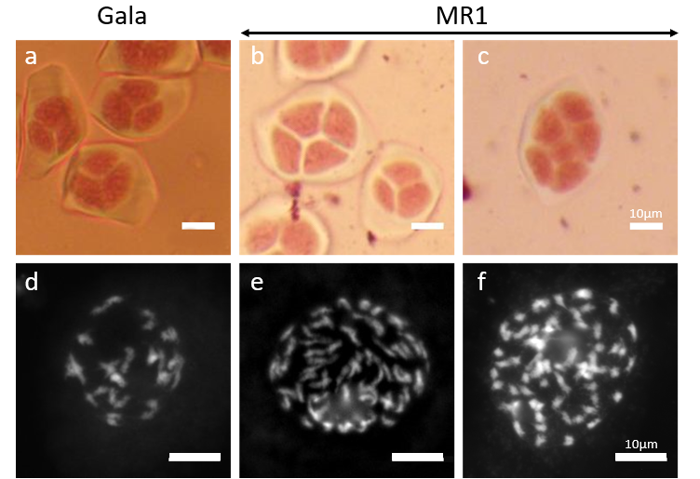

Figure 2. Male meiocytes of MR1 compared to the ‘control’ Gala accession which is reproductively stable. a) ‘Gala’ tetrad. b) Enlarged tetrad and normal sized tetrad of MR1. c) Twin tetrad of MR1. d) Chromosome spread of ‘Gala’ male meioctye in the diakineses stage. e,f) Chromosome spread of MR1 male meiocytes in the diakinesis stage. Scale bar=10µm.
Literature cited
Bastiaanssen, H.J.M., Van den Berg, P.M.M.M., Lindhout, P., Jacobsen, E., and Ramanna, M.S. (1998). Postmeiotic restitution in 2n‐egg formation of diploid potato. Heredity 81, 20–27. https://doi.org/10.1046/j.1365-2540.1998.00370.x.
Bellard, C., Bertelsmeier, C., Leadley, P., Thuiller, W., and Courchamp, F. (2012). Impacts of climate change on the future of biodiversity. Ecol. Lett., 15, 365–377. https://doi.org/https://doi.org/10.1111/j.1461-0248.2011.01736.x.
Bretagnolle, F., and Thompson, J.D. (1995). Gametes with the somatic chromosome number: mechanisms of their formation and role in the evolution of autopolyploid plants. New Phytol. 129, 1–22. https://doi.org/10.1111/j.1469-8137.1995.tb03005.x.
Chen, M., Wang, F., Zhang, Z., Fu, J., and Ma, Y. (2017). Characterization of fungi resistance in two autotetraploid apple cultivars. Sci. Hortic. 220, 27–35. https://doi.org/https://doi.org/10.1016/j.scienta.2017.03.034.
Considine, M., Wan, Y., D’Antuono, M., Zhou, Q., Han, M., Gao, H., and Wang, M. (2012). Molecular genetic features of polyploidization and aneuploidization reveal unique patterns for genome duplication in diploid Malus. PLoS One 7(1), e29449. https://doi.org/10.1371/journal.pone.0029449.
FAOSTAT (2022b). Crop and livestock production. https://www.fao.org/faostat/en/#data/QCL
Ferreira, V., Ramos-Cabrer, A.M., Carnide, V., Pinto-Carnide, O., Assunção, A., Marreiros, A., Rodrigues, R., Pereira-Lorenzo, S., and Castro, I. (2016). Genetic pool structure of local apple cultivars from Portugal assessed by microsatellites. Tree Genet. Genomes 12, 1–15. https://doi.org/10.1007/s11295-016-0997-8.
Garret, J.T., Rhodes, B.B., and Zhang, X. (1995). Triploid Watermelons Resist Fruit Blotch Organism. Cucurbit Genet. Cooperative Report 18, 56–58.
Goulão, L., Cabrita, L., Oliveira, C.M., and Leitão, J.M. (2001). Comparing RAPD and AFLP TM analysis in discrimination and estimation of genetic similarities among apple (Malus domestica Borkh.) cultivars RAPD and AFLP analysis of apples. Euphytica 119, 259–270.
Kellerhals, M., Patocchi, A., Duffy, B., and Frey, J.E. (2008). Modern approaches for breeding high quality apples with durable resistance to scab, powdery mildew and fire blight. Paper presented at: 13th International Conference on Cultivation Technique and Phytopathological Problems in Organic Fruit-Growing: Proceedings to the Conference (Weinsberg, Germany: Boos, Markus), pp. 226-231.
Kellerhals, M., Tschopp, D., Roth, M., and Bühlmann-Schütz, S. (2020). Challenges in apple breeding. Paper presented at: 19th International Conference on Organic Fruit-Growing (Weinsberg, Germany: Föko), pp. 12–18.
Van Laere, K., França, S.C., Vansteenkiste, H., Van Huylenbroeck, J., Steppe, K., and Van Labeke, M.-C. (2011). Influence of ploidy level on morphology, growth and drought susceptibility in Spathiphyllum wallisii. Acta Physiologiae Plantarum 33, 1149–1156. https://doi.org/10.1007/s11738-010-0643-2.
Larsen, B., Toldam-Andersen, T.B., Pedersen, C., and Ørgaard, M. (2017). Unravelling genetic diversity and cultivar parentage in the Danish apple gene bank collection. Tree Genet. & Genomes 13, 14. https://doi.org/10.1007/s11295-016-1087-7.
Lourkisti, R., Froelicher, Y., Herbette, S., Morillon, R., Tomi, F., Gibernau, M., Giannettini, J., Berti, L., and Santini, J. (2020). Triploid citrus genotypes have a better tolerance to natural chilling conditions of photosynthetic capacities and specific leaf volatile organic compounds. Frontiers in Plant Science 11, 330.
Mai, Y., Li, H., Suo, Y., Fu, J., Sun, P., Han, W., Diao, S., and Li, F. (2019). High temperature treatment generates unreduced pollen in persimmon (Diospyros kaki Thunb.). Sci. Hortic. 258, 108774. https://doi.org/https://doi.org/10.1016/j.scienta.2019.108774.
Mihaljević, I., Viljevac Vuletić, M., Šimić, D., Tomaš, V., Horvat, D., Josipović, M., Zdunić, Z., Dugalić, K., and Vuković, D. (2021). Comparative study of drought stress effects on traditional and modern apple cultivars. Plants 10, 561. https://doi.org/10.3390/plants10030561.
Muranty, H., Denancé, C., Feugey, L., Crépin, J.-L., Barbier, Y., Tartarini, S., Ordidge, M., Troggio, M., Lateur, M., Nybom, H., et al. (2020). Using whole-genome SNP data to reconstruct a large multi-generation pedigree in apple germplasm. BMC Plant Biology 20, 2. https://doi.org/10.1186/s12870-019-2171-6.
Pécrix, Y., Rallo, G., Folzer, H., Cigna, M., Gudin, S., and le Bris, M. (2011). Polyploidization mechanisms: temperature environment can induce diploid gamete formation in Rosa sp. J. of Experimental Botany 62, 3587–3597. https://doi.org/10.1093/jxb/err052.
Podwyszyńska, M., and Marasek-Ciołakowska, A. (2021). Ploidy, Genome Size, and Cytogenetics of Apple. In The Apple Genome, S.S. Korban, ed. (Cham: Springer International Publishing), pp. 47–71.
Raboin, L.-M., Carreel, F., Noyer, J.-L., Baurens, F.-C., Horry, J.-P., Bakry, F., Montcel, H.T. du, Ganry, J., Lanaud, C., and Lagoda, P.J.L. (2005). Diploid ancestors of triploid Export banana Cultivars: Molecular identification of 2n restitution gamete donors and n gamete donors. Mol. Breeding 16, 333–341. https://doi.org/http://dx.doi.org/10.1007/s11032-005-2452-7.
Ramos-Cabrer, A.M., Díaz-Hernández, M.B., and Pereira-Lorenzo, S. (2007). Morphology and microsatellites in Spanish apple collections. J. Hortic. Sci. Biotechnol. 82, 257–265. https://doi.org/10.1080/14620316.2007.11512227.
Ranney, T.G. (2009). Polyploidy: From Evolution to New Plant Development. Combined Proceedings International Plant Propagators’ Society, 56, 383–389.
Ross, K.J., Fransz, P., and Jones, G.H. (1996). A light microscopic atlas of meiosis in Arabidopsis thaliana. Chromosome Res. 4, 507–516. https://doi.org/10.1007/BF02261778.
Sedov, E.N., Sedysheva, G.A., Makarkina, M.A., and Serova, Z.M. (2017). Development of Triploid Apple Cultivars as a Priority in Selection. Russian J. of Genet.: Applied Res. 7, 207–213. https://doi.org/10.1134/S2079059717070073.
Simpson, M.G. (2010). 8 - Diversity and Classification of Flowering Plants: Eudicots. In Plant Systematics (Second Edition), M.G. Simpson, ed. (San Diego: Academic Press), p.275–448.
Sivager, G., Calvez, L., Heuget, B., Bruyère, S., Boisne-Noc, R. v, Brat, P., Gros, O., Ollitraut, P., and Morillon, R. (2020). Triploid lime is more tolerant to HLB than diploid lime because specific physiological and anatomical traits associated to better detoxification processes. In Caribbean Science and Innovation Meeting 2019.
De Storme, N., and Geelen, D. (2011). The Arabidopsis mutant jason Produces unreduced first division restitution male gametes through a parallel/fused spindle mechanism in meiosis II. Plant Physiol. 155, 1403–1415. https://doi.org/10.1104/pp.110.170415.
De Storme, N., and Geelen, D. (2013a). Pre-meiotic endomitosis in the cytokinesis-defective tomato mutant pmcd1 generates tetraploid meiocytes and diploid gametes. J. of Experimental Botany 64, 2345–2358. https://doi.org/10.1093/jxb/ert091.
De Storme, N., and Geelen, D. (2013b). Sexual polyploidization in plants – cytological mechanisms and molecular regulation. New Phytologist 198, 670–684. https://doi.org/https://doi.org/10.1111/nph.12184.
De Storme, N., De Schrijver, J., Van Criekinge, W., Wewer, V., Dörmann, P., and Geelen, D. (2013a). GLUCAN SYNTHASE-LIKE8 and STEROL METHYLTRANSFERASE2 are required for ploidy consistency of the sexual reproduction system in Arabidopsis. The Plant Cell 25, 387–403. https://doi.org/10.1105/tpc.112.106278.
De Storme, N., Zamariola, L., Mau, M., Sharbel, T.F., and Geelen, D. (2013b). Volume-based pollen size analysis: an advanced method to assess somatic and gametophytic ploidy in flowering plants. Plant Reproduction 26, 65–81. https://doi.org/10.1007/s00497-012-0209-0.
Švara, A., Ilnikar, K., Carpentier, S., e Storme, N., De Coninck, B., and Keulemans, W. (2021). Polyploidy affects the development of Venturia inaequalis in scab-resistant and -susceptible apple cultivars. Sci. Hortic. 290, 110436. https://doi.org/https://doi.org/10.1016/j.scienta.2021.110436.
van Treuren, R., Kemp, H., Ernsting, G., Jongejans, B., Houtman, H., and Visser, L. (2010). Microsatellite genotyping of apple (Malus × domestica Borkh.) genetic resources in the Netherlands: application in collection management and variety identification. Genet. Resour. Crop Evol. 57, 853–865. https://doi.org/10.1007/s10722-009-9525-0.
Xu, J., Jin, J., Zhao, H., and Li, K. (2019). Drought stress tolerance analysis of Populus ussuriensis clones with different ploidies. J. of Forestry Res. 30, 1267–1275. https://doi.org/10.1007/s11676-018-0729-z.
Xue, H., Zhang, F., Zhang, Z.-H., Fu, J.-F., Wang, F., Zhang, B., and Ma, Y. (2015). Differences in salt tolerance between diploid and autotetraploid apple seedlings exposed to salt stress. Sci. Horti. 190, 24–30. https://doi.org/https://doi.org/10.1016/j.scienta.2015.04.009.
Zhong, Y., Lespinasse, Y. and Salesses, G. (1988). Mise en evidence de quelques anomalies meiotiques conduisant a la formation de gametes males non reduits chez le pommier cultivé. Cytologia 53, 749–755.

