High Implementation Adherence to Lenalidomide in Multiple Myeloma

Avi Leader, MD ^{1,2}, Hila Magen, MD ^{2,3,}, Irina Amitai, MD ^{2,3}, Antoine Pironet, PhD ⁴, Eric Tousset, M.Sc. ⁴, Alon Rozenthal, MD ¹, Sabina De Geest, PhD RN ^{5,6}, Iuliana Vaxman, MD ^{1,2}, Pia Raanani, MD ^{1,2}, Arnon Nagler, MD ^{2,3}

¹Institute of Hematology, Davidoff Cancer Center, Rabin Medical Center, Petah Tikva, Israel;
²Sackler School of Medicine, Tel Aviv University, Israel; ³Division of Hematology, Chaim Sheba Medical Center, Tel Hashomer, Israel; ⁴AARDEX Group, Liège, Belgium; ⁵Institute of Nursing Science, Department Public Health, University of Basel, Switzerland; ⁶Academic Centre of Nursing and Midwifery, Department Public Health and Primary Care, KU Leuven, Belgium

Background: Lenalidomide (LEN) is an oral backbone of multiple myeloma (MM) treatment regimens, given in 21day/7day (ON/OFF) cycles. Non-adherence to oral anticancer therapy occurs in ~30% of cancer patients and is generally associated with adverse outcomes. In chronic myeloid leukemia <90% adherence (measured using electronic monitoring (EM)) to imatinib was associated with inferior outcomes. There is no prospective data on LEN adherence, and no reports on LEN implementation adherence (defined as adherence from first to last dose) using EM, which provides rich sampling and good reliability.
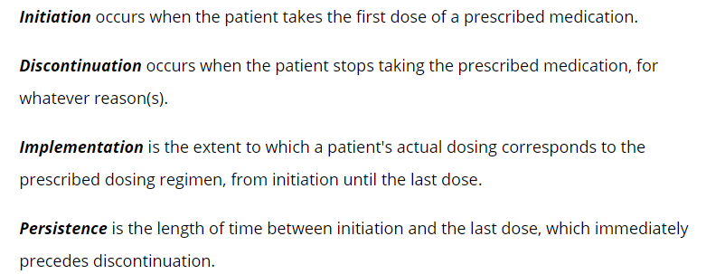

Aims: (1) To determine the period prevalence of EM implementation adherence to LEN; (2) To delineate patterns of ON-OFF cycling.

Methods: Using a prospective observational design including a convenience sample of LEN-naïve adult patients receiving LEN-based regimens for treatment of MM at 2 haematological centers in Israel. (RMC; Data collection: 5/2016-11/2017; CSMC; 4/2018-11/2019).
Implementation adherence to once daily LEN was monitored using EM (MEMS® Caps, AARDEX Group, Belgium) for consecutive 21day ON /7day OFF cycles. The MEMS® Cap automatically records the date and time of each bottle opening, providing an objective proxy for LEN intake. ON and OFF-drug segments were documented in MEMS® Adherence Software by study staff (RMC) or were determined using AARDEX’s proprietary segmentation algorithm (bOAST) and manually curated by the study team (CSMC).
The primary analysis focused on underdosing. Thus, implementation adherence was expressed as the proportion of days with any LEN intakes during ON cycling, independent of dosing timing. In addition, the proportion of prescribed drug taken was calculated (N-intakes/N-monitored-days). The first day of each ON segment was excluded from adherence metrics due to artifacts related to medication refills. Descriptive statistics were used to show the median [interquartile range (IQR)] for continuous variables and percentages for categorical data.

Results: 93 patients enrolled in the study, 85 of whom were included in this analysis (8 excluded due to inability to use the EM device). Selected sample characteristics are as follows: median age, 68 years [IQR 60-74]; 27 (32%) females; median no. of pills per day, 5 [IQR 4-7]; median prior disease duration, 19 months [IQR 5.75 – 45.7]; LEN regimen: LEN-dexamethasone with (n=43, 51%) or without (n=38, 44%) additional drugs (5% missing); treatment line: 1st = 15%, 2nd = 66%, 3rd = 15% (4% missing). The median duration of follow-up was 133 days [IQR 77-152], while the median no. of cycles was 3 [IQR 1-4].
Figure 1 shows the duration of all full, ON and OFF cycles, which lasted a median [IQR] of 28 [28-28], 21 [21-21] and 7 [7-7] days respectively. The cycle duration instructions were followed accurately in 64 subjects (75%) in all cycles. ON cycles shorter than 21 days were associated with a number of doses taken approximately equal to the duration of the cycle (e.g., duration = 20 days, median doses = 19). On the other hand, cycles longer than 21 days approximately corresponded to 21 doses taken, meaning that patients prolonged the ON cycle to make up for missed doses.
Median LEN implementation adherence, expressed as the median proportion of days with intakes, was 99% [IQR: 97%-100%; range: 50%-100%]. Figure 2 shows the proportion of doses taken for each ON segment. All doses were taken by 43 patients (50%). One dose interruption occurred in 18 (21%) subjects, two in 9 (11%), three in 7 (8%), while 8 (9%) had ≥4 dose interruptions. Two or more consecutive doses were missed once in 8 patients (9%) and twice in 2 (2%). Implementation adherence was below 90% in 6 patients (7%).
Overdosing occurred in 64 subjects (75 %), although this could be explained theoretically by bottle openings without taking LEN (although patients were advised not do this).

Conclusions: This pilot study is the first to delineate LEN cycle duration and implementation adherence in patients with MM, using EM. Most patients adhered to the recommended 21day/7day (ON/OFF) cycles. LEN implementation adherence was high. However, at least 50% of patients missed at least one dose and 28% missed multiple doses. While this data is somewhat reassuring, the clinical significance and predictors of the small sub-group of non-adherers remains to be determined in future research.

