Compliance and patients’ perspectives towards nutritional supplementation following bariatric surgery
Steenackers Nª, Vandewynckel Sª, Boedt Tª, Deleus E^{b,c}, Hoekx S^{c}, Lannoo M^{b,c}, Mertens A^{a,c}, Vangoitsenhoven R^{a,c}, Van der Schueren B^{a,c}, Matthys C^{a,c}
ªClinical and Experimental Endocrinology, Department of Chronic Diseases and Metabolism, KU Leuven, Leuven, Belgium; ^{b}Department of Abdominal Surgery, University Hospitals Leuven, Leuven, Belgium; ^{c}Department of Endocrinology, University Hospitals Leuven, Leuven, Belgium;
Contact information authors
Nele Steenackers
Clinical and Experimental Endocrinology
O&N I bis Herestraat 49 - box 902
3000 Leuven, Belgium
Nele.steenackers@kuleuven.be
Sophie Vandewynckel
Clinical and Experimental Endocrinology
O&N I bis Herestraat 49 - box 902
3000 Leuven, Belgium
Tessy Boedt
Clinical and Experimental Endocrinology
O&N I bis Herestraat 49 - box 902
3000 Leuven, Belgium
Tessy.boedt@kuleuven.be
Ellen Deleus
Clinical and Experimental Endocrinology
UZ Herestraat 49 - box 7003 44
3000 Leuven
Ellen.deleus@kuleuven.be
Sien Hoekx
Clinical and Experimental Endocrinology
UZ Herestraat 49 - box 7003 44
3000 Leuven
Sien.hoekx@uzleuven.be
Matthias Lannoo
Clinical and Experimental Endocrinology
UZ Herestraat 49 - box 7003 44
3000 Leuven
Matthias.lannoo@kuleuven.be
Ann Mertens
Clinical and Experimental Endocrinology
UZ Herestraat 49 - box 7003 44
3000 Leuven, Belgium
Ann.mertens@kuleuven.be
Roman Vangoitsenhoven
Clinical and Experimental Endocrinology
UZ Herestraat 49 - box 7003 44
3000 Leuven
Roman.vangoitsenhoven@kuleuven.be
Bart Van der Schueren
Clinical and Experimental Endocrinology
UZ Herestraat 49 - box 7003 44
3000 Leuven, Belgium
Bart.vanderschueren@kuleuven.be
Christophe Matthys (corresponding author)
Clinical and Experimental Endocrinology
UZ Herestraat 49 - box 7003 44
3000 Leuven, Belgium
Christophe.matthys@kuleuven.be
Abstract
Purpose: Nutritional supplementation is recommended as a prophylactic strategy for nutritional deficiencies after bariatric surgery. Little is known regarding compliance and patients’ perspectives. The purpose of the study was to explore supplement intake, compliance and patients’ perspectives (including barriers, facilitators and beliefs) and to examine whether compliance to nutritional supplementation can be predicted after bariatric surgery.
Materials and methods: A questionnaire was developed to explore supplement intake and patients’ perspectives. The Probabilistic Medication Compliance Scale (ProMAS) was included and modified to measure behaviors related to supplementation compliance. Content validity was assessed with an expert and patient panel. Consequently, a cross-sectional survey was conducted among patients that underwent bariatric surgery, who were invited using social media. Descriptive statistics and spearman correlations were applied. Multiple linear regression analysis was performed to predict compliance.
Results: A 58-item questionnaire was developed and content validated, resulting in a scale-content validity index of 0.93. The questionnaire was completed by 402 subjects. 69 subjects reported not consuming any nutritional supplement (n=69; 17.2%). For the supplement users (n=333; 82.8%), a median ProMAS sum score of 11.0 (7.0-15.0) was observed. Increasing age and medicine intake were positive predictors of compliance (age: B=0.058, p=0.01; medicine intake: B=0.39, p<0.001). While experiencing barriers was identified as a negative predictor of compliance (B=-4.637, p<0.001). Top three barriers for supplement use were forgetfulness (n=118; 29.4%), too expensive (n=91; 22.6%) and experiencing side effects (n=61; 15.2%).
Conclusion: Lifelong nutritional supplementation is essential after bariatric surgery, but compliance can be affected by the presence of barriers.
Visual abstract
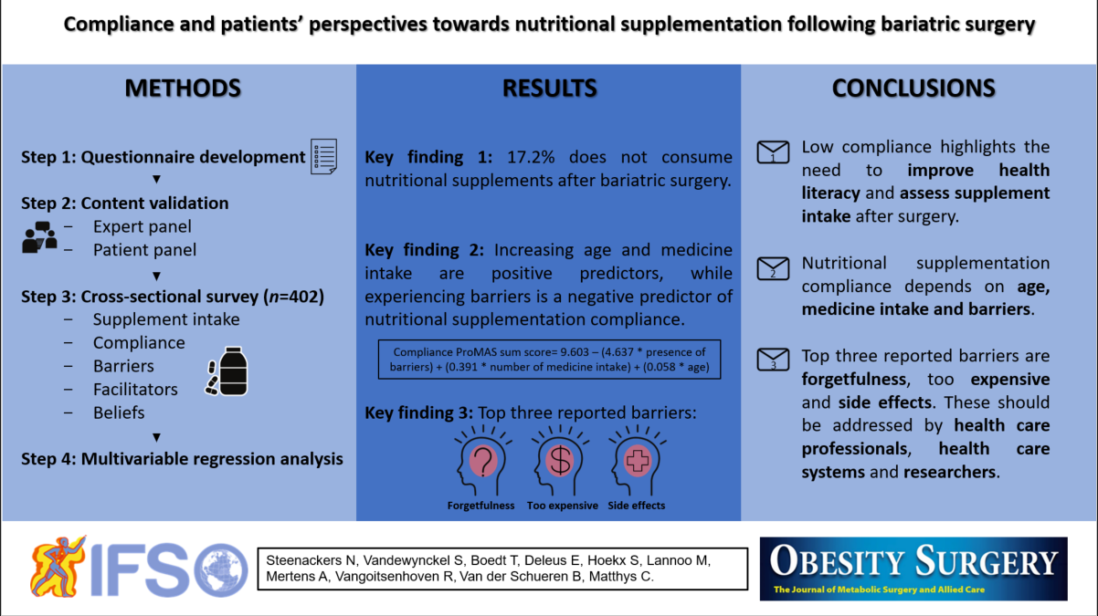
Key points
- Nutritional supplementation compliance is low with 17.2% not consuming supplements.
- Increasing age, increasing medicine intake, and experiencing barriers predicts compliance.
- Top three reported barriers are forgetfulness, too expensive and side effects.
- Health care professionals, systems and researchers should address barriers and side effects.
Key words
Bariatric surgery, nutritional deficiencies, dietary supplements, micronutrients, compliance, adherence.
1. Introduction
Compelling evidence indicates that bariatric surgery predisposes patients to nutritional deficiencies, which can result in mild symptoms (e.g. hair loss) or evolve to more serious complications (e.g. bone loss and subsequently, increased fracture risk) (1-3). Previous research has paved the way for a nutritional supplementation strategy. According to different learned societies, a standard postoperative regimen of supplementation is recommended including daily multivitamin and mineral supplementation containing at least iron, calcium, vitamin D, vitamin B1, vitamin B12 and folic acid in doses adjusted to the type of surgery (referred to as specialized bariatric supplements) (4-6). Nutritional supplementation is advised under the form of tablets or capsules, or chewable preparations to maximize gastrointestinal tolerance (7). Despite the availability of guidelines and specialized bariatric supplements, nutritional deficiencies can arise due to non-compliance (8, 9). Compliance is defined as ‘the extent to which a person’s behavior, including taking medication, following a diet, and/or executing lifestyle changes, corresponds with agreed recommendations from a health care provider’ (10). After bariatric surgery, patients experience difficulties in complying with the behavioral recommendations including regular postoperative follow-up and daily nutritional supplementation (11). Importantly, non-compliance increases the risk of developing nutritional deficiencies (9, 12). A limited body of evidence is available regarding compliance to nutritional supplementation after bariatric surgery (13). In literature, nutritional supplementation compliance has been reported to range between 30 and 45% in real-life settings after bariatric surgery. Moreover, compliance decreases over time with 20 to 32% of patients reporting stopping or never taking their recommended supplements at one year after surgery (13-16). Reasons for suboptimal compliance are largely unknown, but a variety of determinants has been described to affect nutritional supplement use (17).
Hence, a thorough assessment of nutritional supplementation compliance and its determinants could lead to a better understanding of supplementation attrition after bariatric surgery. Moreover, patients’ perspectives towards supplementation barriers, facilitators and beliefs have received little attention so far. Insights are urgently needed to provide patient support in order to improve their short- and long-term nutritional status after bariatric surgery (18). Recently, nutritional supplementation compliance and the prediction thereof have been depicted among the top 40 research priorities within the field of bariatric surgery (19). Therefore, the primary aim of the study was to explore supplement intake, compliance (including its determinants) and patients’ perspectives (including barriers, facilitators and beliefs) towards nutritional supplementation after bariatric surgery. The secondary aim of the study was to examine whether compliance to nutritional supplementation can be predicted after bariatric surgery.
2. Material and methods
The study comprised of three phases with five underlying steps (Figure 1). First, a questionnaire was developed to assess supplement intake, compliance (including its determinants) and patients’ perspectives (including barriers, facilitators and beliefs) towards nutritional supplementation after bariatric surgery. Therefore, a two-step approach was followed consisting of an item generation and item selection phase. Second, the content validity of the developed questionnaire was assessed in two steps by an expert panel and a group of patients that underwent bariatric surgery. Third, the final questionnaire was administered among patients that underwent bariatric surgery through an online survey. During the development and validity phase, concepts were followed as advised by the patient-reported outcomes good research practices task force, by Polit and Beck and by Boateng and colleagues (20-23).
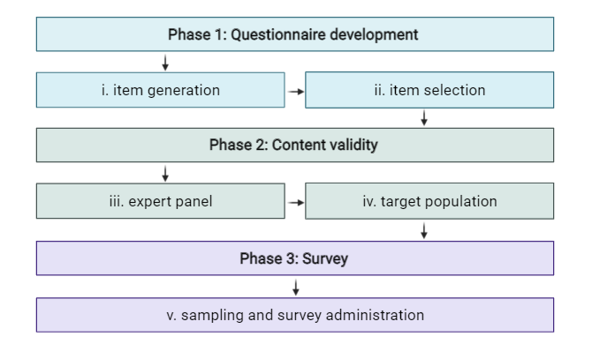
Figure 1. Study design consisting of three phases and five underlying steps (inspired by (24)).
2.1 Questionnaire development
2.1.1 Item generation and selection
To develop the questionnaire, a variety of items was generated using a deductive method through literature review and assessment of existing self-report compliance measures. Next, items were selected through an iterative process of internal review until consensus was reached for every item. Most relevant items were selected in order to reduce the burden for participants. To assess nutritional supplementation compliance, the Dutch version of the Probabilistic Medication Compliance Scale (ProMAS) was included after obtaining consent from the authors. The ProMAS is a validated 18-item scale that measures a variety of behaviors related to medication adherence. ProMAS items were rephrased by converting the word ‘medicine’ in ‘nutritional supplements’ and by rephrasing question 15 (supplementary methods - Table A). The original question examines filling a drug prescription at the pharmacy, which is not applicable for nutritional supplements in Belgium. Nutritional supplements are advised, but not medically prescribed nor reimbursed in Belgium (25, 26).
2.1.2 Content validity by experts and target population
To ensure content validity, an independent panel of experts and a panel of patients that underwent bariatric surgery assessed the developed items without the previously validated ProMAS items. First, nine experts were recruited from various disciplines with at least two years of expertise in different aspects of bariatric surgery including diet, nutrition, endocrinology and abdominal surgery. Experts reviewed the questionnaire quantitatively and qualitatively. Regarding quantitative assessment, experts were asked to score every item on a 4-point Likert scale from 1 to 4 (1 = not relevant, 2 = somewhat relevant, 3 = quite relevant and 4 = highly relevant). Scores were used to calculate the item-content validity index (I-CVI) and scale-content validity index (S-CVI). I-CVI is computed by dividing the number of experts giving a rating of 3 or 4 by the total number of experts for each item. It reflects the proportion of agreement between the experts on the relevance of each item, which ranges between 0 and 1. An item is considered relevant when the I-CVI is higher than 0.78. While an item should be rephrased between 0.70 and 0.78 and deleted below 0.70. Similarly, S-CVI is computed through the average method by calculating the mean I-CVI of all items. A questionnaire is considered relevant when the S-CVI is at least 0.90 (27). Regarding qualitative assessment, experts were asked to critically review the pool of items. If deemed relevant, experts could rephrase items or develop new items. Second, a panel of ten patients that underwent bariatric surgery were recruited. Semi-structured interviews were conducted to examine the comprehension of the questionnaire as well as the comprehensiveness of the content. Every interview was audio-recorded, transcribed and qualitatively analyzed according to Patrick et al. (21). If deemed relevant, items could be rephrased or added based upon subjects’ remarks. After questionnaire development and adjustment, the Flesch Kincaid Grade Level was calculated to estimate the readability of the final questionnaire using the average sentence length and average number of syllables per word (28). The final questionnaire is available in Dutch upon request.
2.2 Survey administration among post-bariatric surgery patients
2.2.1 Study design, setting and participants
A cross-sectional study was conducted using the developed survey that was distributed anonymously among patients that underwent bariatric surgery living in Belgium. The questionnaire was administered via the web-based survey tool Qualtrics© (Qualtrics, Provo, UT). Patients were recruited using a convenience sampling method by sharing the questionnaire among social media (Facebook©, Twitter© and Linkedin©). Using Facebook©, the questionnaire was advertised in a Belgian bariatric support group with over 7500 members. The questionnaire was available during one month. Based upon the population of post-bariatric surgery patients in Belgium (± 200 000), a confidence interval of 95% and a margin of error of 5%, about 384 respondents were needed to accurately reflect the population of post-bariatric surgery patients in Belgium.
2.2.2 Survey measures
After agreeing to participate in the beginning of the survey, respondents were asked to complete the questionnaire that was divided in five modules. The first module questioned sociodemographic characteristics including sex, age, country of residence, nationality, level of education, employment status, average income per year and household composition. The second module questioned a variety of health characteristics including anthropometric measurements (including length, preoperative and current weight), bariatric surgery-related information (including the number, type and date of bariatric surgery procedures) and health-status (including medication intake, their perceived preoperative and current health status). The third module questioned the intake of nutritional supplements. In case of nutritional supplement intake, the ProMAS items were provided and information was collected regarding the type, brand and formulation of nutritional supplement as well as the frequency of dosing. Moreover, patients were questioned on where they buy their nutritional supplements, who recommended the use of these supplements and what they find important when choosing a nutritional supplement. The fourth module questioned whether patients experience barriers to supplement intake (and which barriers), side effects during or after nutritional supplement intake (and which side effects) as well as their thought regarding potential facilitators to improve supplement intake. The final module questioned the beliefs of post-bariatric surgery patients using different statements. These questions were answered on a psychometric 5-point Likert response scale from 1 to 5 (1 = strongly disagree, 2 = disagree, 3 = neither agree nor disagree, 4 = agree and 5= strongly agree). For the majority of questions, multiple responses were possible and patients could provide additional information as free text if an answer option was not included in the list.
2.2.3 Data analysis
Complete responses of subjects above 18 years with a history of bariatric surgery were included. Responses of subjects, who were not living in Belgium, were excluded. For assessing compliance, the ProMAS items were scored on a binary answer scale (1 = ‘yes, true’; 0 = ‘no, not true’). Some items were reverse coded (supplementary methods – Table A). To assess compliance, the total sum score was calculated as a continuous measure (range: 0 – 18). In addition, patients were categorized based on their total sum score: low compliance (0 ≤ score ≤ 4), medium low compliance (5 ≤ score ≤ 9), medium high compliance (10 ≤ score ≤ 14) and high compliance (15 ≤ score ≤18) (25).
2.2.4 Statistical analysis
Descriptive statistics were used to report qualitative (sample (n), percentage (%)) and quantitative questions (median with interquartile range). Difference in postoperative timing between supplement users and non-supplement users was calculated using Mann-Whitney U test. Among supplement users, spearman correlations were calculated to assess associations between the compliance sum score (continuous variable), sociodemographic and health characteristics, and the presence of barriers and side effects (continuous and ordinal variables). Based on the significant variables, multivariable linear regression analysis was performed to predict compliance as a continuous measure using the stepwise elimination method. The presence of multicollinearity was analyzed using the variance inflation factor (VIF). Statistical analysis were two-sided with a significance level of p < 0.05. Data were analyzed using SPSS version 27.0 (SPSS inc., Chicago, USA). Figures were plotted using Graphpad Prism version 9 (GraphPad Software, San Diego, USA).
3. Results
3.1 Questionnaire development
Based upon published research, a first draft of 52 items was developed. After five rounds of internal review, 38 items were selected that were considered most relevant to the research topic. After item generation and selection, expert evaluation revealed three questions with an I-CVI below 0.78. Consequently, one question was excluded based on an I-CVI of 0.3. While, two questions were rephrased based on an I-CVI of 0.70. Overall, the S-CVI was 0.93. Based upon remarks of the expert panel, one more question was excluded and two new questions were added. The target population recommended to rephrase twelve items to maximize understanding. Additionally, answer options were added for five questions and two new items were added. The 18 items of the ProMAS were added to estimate compliance, resulting in a final questionnaire of 58 items. The Flesch-Kincaid Grade Level of the final questionnaire amounted 9.6.
3.2 Survey administration among post-bariatric surgery patients
3.2.1 Sociodemographic and health characteristics
Between November 11th and December 9th, 2020, 490 subjects accepted the online informed consent to complete the survey. Among these, 82 respondents did not complete the entire questionnaire and six respondents were not living in Belgium. Responses were analyzed of 402 subjects living in Belgium. Sociodemographic characteristics are described in Table 1. Respondents had a median age of 43.5 years (34.0-52.0) and a median income of 42600 euros (30000-48000) per year (n=189).
Table 1. Sociodemographic characteristics of all respondents.
Characteristic |  | n | %
Sex | Female | 338 | 84.1
 | Male | 63 | 15.7
 | Unknown | 1 | 0.2
Age group | 18 – 24 years | 20 | 5.0
 | 25 – 34 years | 83 | 20.6
 | 35 – 44 years | 111 | 27.6
 | 45 – 54 years | 114 | 28.4
 | 55 – 65 years | 63 | 15.7
 | ≥ 65 years | 11 | 2.7
Nationality | Belgian | 391 | 97.3
 | Dutch | 6 | 1.5
 | Italian | 3 | 0.7
 | Other | 2 | 0.4
Education level | No education | 11 | 2.7
 | Primary education | 12 | 3.0
 | Secondary education | 169 | 42.0
 | Higher education | 210 | 52.2
Employment status | Employed | 284 | 70.6
 | Unemployed | 89 | 22.1
 | Retired | 29 | 7.2
Household | Living alone | 46 | 11.4
 | Living with partner and/or children | 317 | 78.9
 | Living with parents | 26 | 6.5
 | Other | 13 | 3.2
The majority of subjects underwent a primary bariatric procedure (n=348; 86.6%), while 54 subjects underwent a secondary bariatric procedure (n=54; 13.4%). Among the primary procedures, subjects had undergone a Roux-en-Y Gastric Bypass (n=272; 78.2%), a sleeve gastrectomy (n=70; 20.1%), a gastric band (n=5; 1.4%) or a biliopancreatic diversion with duodenal switch (n=1; 0.3%). Among the secondary procedures, subjects had undergone a combination of the previous procedures. Bariatric surgery was performed between 1.2 month to 25.7 years prior to questionnaire completion with a median of 2.2 years (1.0-4.3). Based on self-reported length and weight, median preoperative and postoperative body mass index was 41.0 kg/m² (38.9-44.3) and 28.0 kg/m² (24.8-31.7), respectively. Self-reported median medicine intake was 1.0 medicine (0.0-3.0) per day. The majority of subjects classified their health status as good (n=214; 53.2%) or very good (n=114; 28.4%), which they perceived to be better (n=154; 38.3%) or much better (n=165; 41.0%) than their preoperative health.
3.2.2 Compliance and nutritional supplementation
Overall, 69 subjects reported not consuming any nutritional supplement in the previous month (n=69; 17.2%). For the remaining supplement users (n=333; 82.8%), compliance was estimated using the ProMAS. A median ProMAS sum score of 11.0 (7.0-15.0) was observed. Counts and percentages per compliance category are summarized in Table 2. Scoring frequencies per ProMAS item are summarized in supplementary results (Table B). Time after surgery did not differ between both groups (supplement users: 2.2 (1.0-4.3) years; non-supplement users: 2.2 (0.9-4.7) years; p=0.86).
Table 2. Self-reported supplement intake and compliance classes.
Category | ProMAS sum score | n | %
No supplement intake | - | 69 | 17.2ª
Supplement intake | - | 333 | 82.8ª
Low compliance | 0 – 4 | 38 | 9.5ª | 11.4^{b}
Low-medium compliance | 5 – 9 | 101 | 25.1ª | 30.3^{b}
Medium-high compliance | 10 – 14 | 94 | 23.4ª | 28.2^{b}
High compliance | 15 – 18 | 100 | 24.9ª | 30.0^{b}
Notes: percentages are calculated among all respondents (n=402)ª or supplement users (n=333)^{b}.
Next to the ProMAS, supplement users (n=333) could provide information regarding their nutritional supplement strategy (Figure 2). More than two-third of the supplement users declared to consume nutritional supplements on daily basis (n=243; 73.0%; Figure 2A), which were in general specialized bariatric supplements (n=235; 70.6%). The majority of subjects reported the use of a multivitamin and –mineral supplement (n=286; 85.9%; Figure 2C), which was most frequently combined with a calcium (n=85; 25.5%), iron (n=56; 16.8%), vitamin D (n=54; 16.2%) or vitamin B12 supplement (n=36; 10.8%). Nutritional supplements were mostly consumed under the form of tablets or capsules (n=277; 83.2%), chewing tablets (n=62; 18.6%) or powder (n=35; 10.5%). Supplement users purchased their nutritional supplements most frequently online (n=208; 62.5%), in the pharmacy (n=123; 36.9%) or the supermarket (n=28; 8.4%). Supplements were most commonly purchased based on the recommendations of the surgeon (n=239; 71.7%), endocrinologist (n=107; 32.1%), general practitioner (n=94; 28.2%), dietician (n=90; 27.0%) and pharmacist (n=13; 3.9%). When choosing a nutritional supplement, the following characteristics were reported to be important: the formulation and the size (n=229; 57.0%), the price (n=227; 56.5%), the taste (n=179; 44.5%) and the composition of the supplement (n=87; 21.6%).
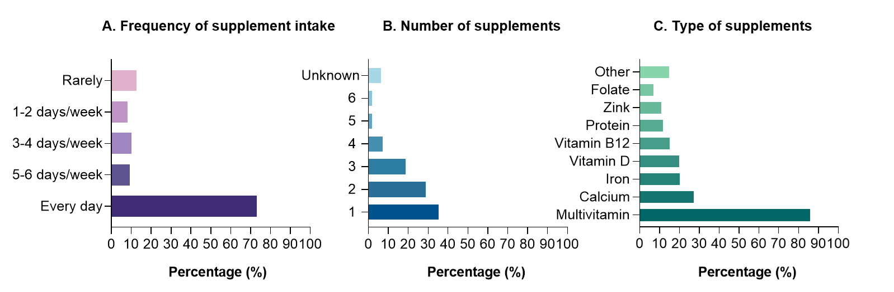
Figure 2. Self-reported frequency (A), number (B) and type of nutritional supplement (C) intake as reported by supplement users.
3.2.3 Barriers, side effects and facilitators of nutritional supplement intake
Among all respondents (n=402), slightly over half indicated that they have not experienced barriers for supplement use (n=207; 51.5%). Most common reported barriers for supplement use were forgetfulness (n=118; 29.4%), too expensive (n=91; 22.6%), experiencing side effects (n=61; 15.2%), swallowing difficulties (n=52; 12.9%) and an unpleasant taste (n=51; 12.7%). More sporadic barriers were the ingestion of too many tablets (n=26; 6.5%), having the perception of supplements being unnecessary (n=29; 7.2%) and the fear of weight regain due to supplement intake (n=4; 1.0%). When explicitly questioned, more than one-third of the respondents indicated to have experienced side effects after the intake of a nutritional supplement (n=160: 39.8%). Side effects were more common in the first six months after bariatric surgery (n=147; 36.6%) compared to beyond six months (n=117; 29.1%). Most common side effects after supplement intake were nausea, abdominal pain and bloating (Table 3).
Table 3. Self-reported presence of side effects in the first six months after bariatric surgery and beyond.
Side effects | First six months |  | Beyond six months
Side effects | n | % | n | %
Abdominal pain | 66 | 16.4 | 70 | 17.4
Bloating | 31 | 7.7 | 19 | 4.7
Constipation | 12 | 3.0 | 16 | 4.0
Diarrhea | 14 | 3.5 | 14 | 3.5
Headache | 16 | 4.0 | 13 | 3.2
Nausea | 98 | 24.4 | 70 | 17.4
Vomiting | 26 | 6.5 | 19 | 4.7
Other | 30 | 7.5 | 27 | 6.7
Subjects’ thoughts to improve supplement intake are listed in Table 4. The following facilitators were most commonly reported: price reduction or reimbursement followed by a supplement reminder tool and a better taste. Other sporadic facilitators included: clear guidelines (n=17; 4.2%), more information available (n=11; 2.7%), calendared blisters (n=1; 0.2%) or were not specifically defined (n=7; 1.7%).
Table 4. Respondents’ thoughts to facilitate supplement intake after bariatric surgery.
Facilitators | n | %
Better taste | 80 | 19.9
Less tablets | 48 | 11.9
Less side effects | 62 | 15.4
Other formulation | 43 | 10.7
Prescription | 19 | 4.7
Price reduction or reimbursement | 130 | 32.3
Supplement reminder tool | 96 | 23.9
Other | 36 | 9.0
3.2.4 Correlations and predictors of compliance scores
Among supplement users (n=333), the ProMAS sum score was positively correlated with age (r=0.375; p<0.01), the number of undergone bariatric procedures (r=0.131; p=0.02) and the number of concomitant medicine intake (r=0.280; p<0.01). While, a significant negative correlation was observed between the ProMAS sum score and being male (r=-0.163; p<0.01), their perceived health status compared to the preoperative situation (r=-0.127; p=0.02), experiencing barriers (r=-0.520; p<0.01) or side effects after supplement intake (r=-0.290; p<0.01) (supplementary results – Table C). Multivariable linear regression was run to investigate whether compliance can be predicted from the significant associations. The results of the model indicate that three variables were statistical significant predictors of compliance, which explains 35.3% of the variance (F(3,327)=59.367; p<0.001; R²=0.353). Age and medicine intake were found to be positive predictors (age: B=0.058, p=0.01, VIF=1.39; medicine intake: B=0.39, p<0.001, VIF=1.20; respectively). While experiencing barriers was identified as a negative predictor of compliance (B=-4.637, p<0.001; VIF=1.17). The final predictive model was: “ProMAS sum score = 9.603 – (4.637 * presence of barriers) + (0.391 * number of medicine intake) + (0.058 * age)”.
3.2.5 Beliefs towards nutritional deficiencies and supplementation
Subjects’ beliefs towards nutritional deficiencies and supplementation are listed in Table 5. Respondents were well aware about the risk of developing nutritional deficiencies after surgery (n=359; 89.3%). Overall, subjects had a positive mindset towards nutritional supplementation. The importance of specialized bariatric supplementation is recognized by the majority of the respondents (n=286; 71.1%). Nonetheless, 10% of the subjects reported that the intake of nutritional supplements is only important in the first year after surgery. Remarkably, 15% of the subjects consider the intake of nutritional supplements unnecessary when eating healthy.
Table 5. Respondents’ beliefs towards nutritional deficiencies and supplementation.
 | Strongly disagree |  | Disagree |  | Neither agree nor disagree |  | Agree |  | Strongly agree
 | n | % | n | % | n | % | n | % | n | %
- I am well informed about the possibility of developing nutritional deficiencies after surgery | 3 | 0.7 | 12 | 3.0 | 28 | 7.0 | 81 | 20.1 | 278 | 69.2
- I am well informed about the intake of nutritional supplements after the operation | 2 | 0.5 | 22 | 5.5 | 34 | 8.5 | 79 | 19.7 | 265 | 65.9
- I have a lifelong risk of developing nutritional deficiencies | 4 | 1.0 | 12 | 3.0 | 54 | 13.4 | 88 | 21.9 | 244 | 60.7
- Nutritional supplements are very expensive | 7 | 1.7 | 17 | 4.2 | 90 | 22.4 | 143 | 35.6 | 145 | 36.1
- The intake of nutritional supplements is not necessary if I eat healthy or when I feel good | 106 | 26.4 | 145 | 36.1 | 92 | 22.9 | 43 | 10.7 | 16 | 4.0
- The intake of nutritional supplements is only important in the first year after surgery | 155 | 38.6 | 139 | 34.6 | 69 | 17.2 | 29 | 7.2 | 10 | 2.5
- Specialized bariatric nutritional supplements are preferred over regular supplements | 9 | 2.2 | 24 | 6.0 | 83 | 20.6 | 91 | 22.6 | 195 | 48.5
- It is detrimental to my health if I do not take a nutritional supplement on a daily basis | 23 | 5.7 | 33 | 8.2 | 83 | 20.6 | 132 | 32.8 | 131 | 32.6
- The intake of nutritional supplements after surgery is just as necessary as taking medication | 7 | 1.7 | 30 | 7.5 | 59 | 14.7 | 119 | 29.6 | 187 | 46.5
4. Discussion
Considering the relation between bariatric surgery and nutritional deficiencies, nutritional supplementation is recommended as a prophylactic strategy. Nonetheless, non-compliance to nutritional supplementation can increase the risk of developing nutritional deficiencies (8, 9, 29). Our data demonstrates that one out of five patients that underwent bariatric surgery did not consume any nutritional supplements in the previous month (17.2% of all respondents). Based on the definition of compliance and the recommendation of lifelong daily nutritional supplementation, these subjects can be considered (extremely) non-compliant. The remaining respondents or supplement users were classified based on their ProMAS sum score with the majority being moderately or highly compliant (58.2% of supplement users; 48.3% of all respondents). When comparing supplement users and non-supplement users, we did not found a difference in timing after surgery. In comparison, previous studies observed compliance rates between 30 and 45% and to decrease over time after bariatric surgery (14-16). The discrepancy between studies can be explained by the differences in design and methodology. Different direct and indirect methods are available to investigate compliance including self-report measures, pill counts, electronic monitoring systems and screening of medical records. However, a gold standard is lacking. (30). Nonetheless, non-compliance was reported by all studies and highlights the necessity of investigating patients’ behavior and perspectives towards supplement intake. In our study, the majority of supplement users adhered to the recommendation of minimal daily multivitamin supplementation under the form of bariatric specialized supplements. While less than one fourth of the supplements adhered to the recommendations of consuming additional supplements containing iron, calcium, vitamin D and vitamin B12. The findings were compared with the current recommendations for nutritional supplementation provided by different learned societies (4-6). However, the evidence underlying these recommendations is still underdeveloped. Until evidence-based guidelines are available, the prudent approach of following these eminence-based guidelines is advised (18). Next to evidence-based guidelines, it would help health care providers to identify patients with low compliance in order to provide appropriate advice (19). In our study, age and the amount of concomitant medicine intake were identified as positive predictors. A possible explanation for medicine intake is that these patients are more likely to remember to take their nutritional supplements when consuming their medicine. In contrast, the experience of barriers after supplement intake was identified as the strongest, negative predictor. Consequently, it is of utmost importance to consider the presence of potential barriers. In our study, the top five barriers for non-compliance concerned patient-related (e.g. forgetfulness), financial-related (e.g. price of nutritional supplements) and therapy-related issues (e.g. unpleasant taste, the presence of side effects and swallowing difficulties). To avoid supplementation attrition, subjects were asked to provide their thought to improve supplement intake. The top five facilitators were in line with the observed patient-related (e.g. supplement reminder tool to overcome forgetfulness), financial-related (e.g. price reduction or reimbursement) and therapy-related issues (e.g. a better taste, less side effects and less tablets). Importantly, a small group of respondents reported that they perceive supplement intake as unnecessary especially when eating healthy or feeling good. These subjects might discontinue the recommendations of health care providers due to patient-related motivational issues as they do not see/feel an immediate impact of nutritional supplementation. This paradigm emphasizes the importance of (recurrent) education to improve health literacy of patients that underwent bariatric surgery to avoid not starting or stopping the nutritional supplementation regimen.
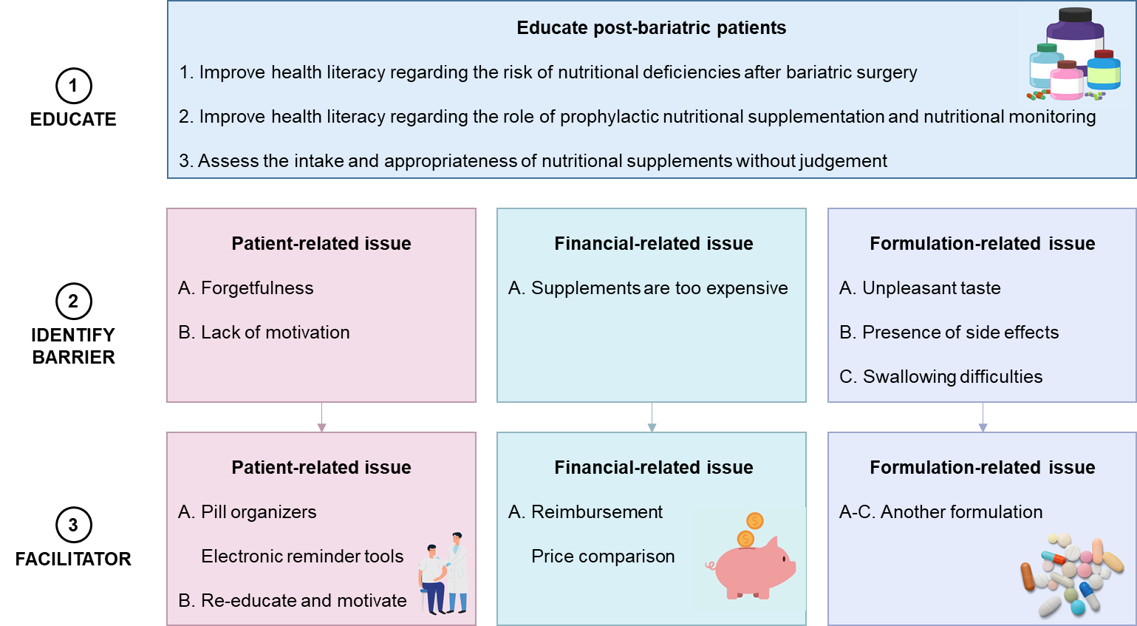
Based on these findings, different implications are proposed for health education and promotion to improve post-operative nutritional care (Figure 3). After bariatric surgery, health care providers should (re)educate patients to improve their health literacy regarding the risk of nutritional deficiencies, the role of prophylactic nutritional supplementation and biochemical monitoring. The intake and appropriateness of the nutritional supplements should be questioned during every postoperative follow-up visit without any judgement. When a low compliance is suspected (e.g. by using the prediction model), caregivers should address potential underlying reasons and encourage to find solutions. First, the use of pill organizers or electronic reminder tools (e.g. mobile application) can be encouraged in case of forgetfulness (31). Second, financial issues can limit the accessibility to health care. Importantly, a lack of reimbursement is a general limitation of bariatric postoperative care on national and international level (e.g. dietician or psychologist consultation) (26, 32). For some patients, financial issues could affect the accessibility of nutritional supplementation. The latter is an issue that needs to be addressed by the health care systems. In the meantime, health care providers can already discuss with patients that underwent bariatric surgery the balance between the prices of nutritional supplements compared to the high costs related to nutritional complications. Third, the presence of side effects or swallowing difficulties might be related to the changes in anatomy and physiology of the gastrointestinal tract after surgery (33). In case of swallowing difficulties, a switch to a different formulation can be made to avoid gastrointestinal intolerance (e.g. liquid formulation). Moreover, the frequency of dosing is known to be inversely related to compliance. A simple dosing regimen for nutritional supplements might help to maximize compliance as previously monitored for medication (e.g. less administrations) (34). Further studies should address the presence of side effects after supplement intake. Fourth, taste changes have been reported to occur after bariatric surgery (35). The use of palatable formulations might improve supplement intake, which can be analyzed using taste panels. In conclusion, a multifactorial approach can support nutritional supplementation compliance after bariatric surgery.
Figure 3. Implications for health education and health promotion.
Our study has several strengths and limitations. Strengths of our study are the sample size, the development and content validation of the survey, and the real-life reflection of the collected data. First, our sample size exceeds the number of subjects needed to accurately reflect the behavior of the population of post-bariatric surgery patients in Belgium. Second, the questionnaire was developed using a mixed method approach and content validated through a group of experts and post-bariatric surgery patients. This process ensures both the relevance of the questions as well as the comprehension of the questions by the target population. Third, a survey investigates subjects’ behavior and perspectives in a real life setting. Consequently, the presence of the Hawthorne effect (behavior change caused by awareness of being observed) is very unlikely due to the cross-sectional design of the survey. Limitations of our study are the recruitment strategy, the self-reporting nature of a survey and the inclusion of the ProMAS as a scale to measure supplementation compliance. First, patients that underwent bariatric surgery were recruited using a convenience sampling method on social media. The latter could bias the results and reduce the generalizability of our results. Support groups on social media might contain a high number of empowered users that are actively seeking and/or exchanging online health information (36). Second, every survey suffers from limitations related to being a self-reporting measure. Social desirability could prevent subjects to accurately report their behavior. In combination with the convenience sampling method using social media, it is possible that our results overestimates supplement intake or compliance among patients that underwent bariatric surgery. Third, the ProMAS is a validated scale that measures compliance by distinguishing between behaviors related to medication adherence rather than nutritional supplementation behavior. Whether behavior related to medication and nutritional supplement intake in post-bariatric surgery patients overlaps, should be corroborated in further studies. Moreover, the external validity of our prediction model should be investigated in a larger population.
5. Conclusion
Lifelong nutritional supplementation is an essential part of clinical care in order to support and improve the short- and long-term nutritional status of patients after bariatric surgery. Our findings provide a better understanding of the real-life nutritional supplementation regimen of post-bariatric surgery patients, which is needed to improve patient care. During postoperative follow-up, health care providers should address supplement intake as well as barriers with potential solutions to ensure that patients that underwent bariatric surgery consume nutritional supplements. In the future, research should focus on developing evidence-based guidelines that take these barriers into account.
6. Conflicts of interest
The authors declare no conflict of interest.
7. Ethics approval and informed consent.
All procedures performed in studies involving human participants were in accordance with the ethical standards of the institutional research committee and with the 1964 Helsinki declaration and its later amendments or comparable ethical standards. The research has been evaluated and approved by Education-Support Committee (MP014674). Informed consent was obtained from all individual participants included in the study.
8. Acknowledgements
We would like to thank all experts that participated in the process of developing the questionnaire.
9. References
1. Bal BS, Finelli FC, Shope TR, Koch TR. Nutritional deficiencies after bariatric surgery. Nat Rev Endocrinol. 2012;8(9):544-56.
2. Ledoux S, Flamant M, Calabrese D, Bogard C, Sami O, Coupaye M. What Are the Micronutrient Deficiencies Responsible for the Most Common Nutritional Symptoms After Bariatric Surgery? Obes Surg. 2020;30(5):1891-7.
3. Corbeels K, Verlinden L, Lannoo M, Simoens C, Matthys C, Verstuyf A, et al. Thin bones: Vitamin D and calcium handling after bariatric surgery. Bone Rep. 2018;8:57-63.
4. Busetto L, Dicker D, Azran C, Batterham RL, Farpour-Lambert N, Fried M, et al. Practical Recommendations of the Obesity Management Task Force of the European Association for the Study of Obesity for the Post-Bariatric Surgery Medical Management. Obes Facts. 2017;10(6):597-632.
5. Parrott J, Frank L, Rabena R, Craggs-Dino L, Isom KA, Greiman L. American Society for Metabolic and Bariatric Surgery Integrated Health Nutritional Guidelines for the Surgical Weight Loss Patient 2016 Update: Micronutrients. Surg Obes Relat Dis. 2017;13(5):727-41.
6. Mechanick JI, Apovian C, Brethauer S, Timothy Garvey W, Joffe AM, Kim J, et al. Clinical Practice Guidelines for the Perioperative Nutrition, Metabolic, and Nonsurgical Support of Patients Undergoing Bariatric Procedures - 2019 Update: Cosponsored by American Association of Clinical Endocrinologists/American College of Endocrinology, The Obesity Society, American Society for Metabolic and Bariatric Surgery, Obesity Medicine Association, and American Society of Anesthesiologists. Obesity (Silver Spring). 2020;28(4):O1-O58.
7. Heber D, Greenway FL, Kaplan LM, Livingston E, Salvador J, Still C, et al. Endocrine and nutritional management of the post-bariatric surgery patient: an Endocrine Society Clinical Practice Guideline. J Clin Endocrinol Metab. 2010;95(11):4823-43.
8. Dogan K, Homan J, Aarts EO, de Boer H, van Laarhoven C, Berends FJ. Long-term nutritional status in patients following Roux-en-Y gastric bypass surgery. Clin Nutr. 2018;37(2):612-7.
9. Ledoux S, Calabrese D, Bogard C, Dupre T, Castel B, Msika S, et al. Long-term evolution of nutritional deficiencies after gastric bypass: an assessment according to compliance to medical care. Ann Surg. 2014;259(6):1104-10.
10. World Health Organization. Adherence to long-term therapies: evidence for action. 2003.
11. Sherf Dagan S, Goldenshluger A, Globus I, Schweiger C, Kessler Y, Kowen Sandbank G, et al. Nutritional Recommendations for Adult Bariatric Surgery Patients: Clinical Practice. Adv Nutr. 2017;8(2):382-94.
12. Karmali S, Brar B, Shi X, Sharma AM, de Gara C, Birch DW. Weight recidivism post-bariatric surgery: a systematic review. Obes Surg. 2013;23(11):1922-33.
13. Zarshenas N, Tapsell LC, Neale EP, Batterham M, Talbot ML. The Relationship Between Bariatric Surgery and Diet Quality: a Systematic Review. Obes Surg. 2020;30(5):1768-92.
14. Modi AC, Zeller MH, Xanthakos SA, Jenkins TM, Inge TH. Adherence to vitamin supplementation following adolescent bariatric surgery. Obesity (Silver Spring). 2013;21(3):E190-5.
15. Brorsson AL, Nordin K, Ekbom K. Adherence to Vitamin Supplementation Recommendations in Youth Who Have Undergone Bariatric Surgery as Teenagers: a Mixed Methods Study. Obes Surg. 2020;30(12):4911-8.
16. Mahawar KK, Clare K, O'Kane M, Graham Y, Callejas-Diaz L, Carr WRJ. Patient Perspectives on Adherence with Micronutrient Supplementation After Bariatric Surgery. Obes Surg. 2019;29(5):1551-6.
17. Smelt HJM, Pouwels S, Smulders JF, Hazebroek EJ. Patient adherence to multivitamin supplementation after bariatric surgery: a narrative review. J Nutr Sci. 2020;9:e46.
18. Neff KJ, le Roux CW. Primum non nocere-first, do no harm with bariatric surgery. Lancet Diabetes Endocrinol. 2021.
19. Stefanidis D, King WC, Puzziferri N, Butler AR, Hutter M, Sudan R. Development of ASMBS research agenda for bariatric surgery using the Delphi methodology. Surg Obes Relat Dis. 2019;15(9):1563-9.
20. Patrick DL, Burke LB, Gwaltney CJ, Leidy NK, Martin ML, Molsen E, et al. Content validity--establishing and reporting the evidence in newly developed patient-reported outcomes (PRO) instruments for medical product evaluation: ISPOR PRO good research practices task force report: part 1--eliciting concepts for a new PRO instrument. Value Health. 2011;14(8):967-77.
21. Patrick DL, Burke LB, Gwaltney CJ, Leidy NK, Martin ML, Molsen E, et al. Content validity--establishing and reporting the evidence in newly developed patient-reported outcomes (PRO) instruments for medical product evaluation: ISPOR PRO Good Research Practices Task Force report: part 2--assessing respondent understanding. Value Health. 2011;14(8):978-88.
22. Polit DF, Beck CT. Nursing Research: Principles and Methods. 7th ed2004.
23. Boateng GO, Neilands TB, Frongillo EA, Melgar-Quinonez HR, Young SL. Best Practices for Developing and Validating Scales for Health, Social, and Behavioral Research: A Primer. Front Public Health. 2018;6:149.
24. Stjernqvist NW, Elsborg P, Ljungmann CK, Benn J, Bonde AH. Development and validation of a food literacy instrument for school children in a Danish context. Appetite. 2021;156:104848.
25. Kleppe M, Lacroix J, Ham J, Midden C. The development of the ProMAS: a Probabilistic Medication Adherence Scale. Patient Prefer Adherence. 2015;9:355-67.
26. Van den Heede K, Ten Geuzendam B, Dossche D, Janssens S, Louwagie P, Vanderplanken K, Jonckheer P.
Bariatric surgery in Belgium: organisation and payment of care before and after surgery. Health Services Research
(HSR) Brussels: Belgian Health Care Knowledge Centre (KCE). 2020. KCE Reports 329. D/2020/10.273/06.
27. Polit DF, Beck CT, Owen SV. Is the CVI an acceptable indicator of content validity? Appraisal and recommendations. Res Nurs Health. 2007;30(4):459-67.
28. DuBay WH. The Principles of Readability. Costa Mesa, California; 2004.
29. Johansson K, Svensson PA, Soderling J, Peltonen M, Neovius M, Carlsson LMS, et al. Long-term risk of anaemia after bariatric surgery: results from the Swedish Obese Subjects study. Lancet Diabetes Endocrinol. 2021;9(8):515-24.
30. Osterberg L, Blaschke T. Adherence to medication. N Engl J Med. 2005;353(5):487-97.
31. Hood MM, Corsica J, Bradley L, Wilson R, Chirinos DA, Vivo A. Managing severe obesity: understanding and improving treatment adherence in bariatric surgery. J Behav Med. 2016;39(6):1092-103.
32. Haute Autorité de Santé. Obesity surgery in adults. 2009.
33. Steenackers N, Vanuytsel T, Augustijns P, Tack J, Mertens A, Lannoo M, et al. Adaptations in gastrointestinal physiology after sleeve gastrectomy and Roux-en-Y gastric bypass. Lancet Gastroenterol Hepatol. 2021;6(3):225-37.
34. Claxton AJ, Cramer J, Pierce C. A systematic review of the associations between dose regimens and medication compliance. Clin Ther. 2001;23(8):1296-310.
35. Ahmed K, Penney N, Darzi A, Purkayastha S. Taste Changes after Bariatric Surgery: a Systematic Review. Obes Surg. 2018;28(10):3321-32.
36. Merolli M, Gray K, Martin-Sanchez F. Health outcomes and related effects of using social media in chronic disease management: A literature review and analysis of affordances. J Biomed Inform. 2013;46(6):957-69.

10. Supplementary methods and results
Table A. The final revised item set of the ProMAS questionnaire including coding.
ProMAS item | Code
- It has happened at least once that I forgot to take (one of) my nutritional supplements. | R
- It happens occasionally that I take (one of) my nutritional supplements at a later moment than usual. | R
- I have never (temporarily) stopped taking (one of my) nutritional supplements. | -
- It has happened at least once that I did not take (one of) my nutritional supplements for a day. | R
- I am positive that I have taken all the nutritional supplements that I should have taken in the previous year. | -
- I take my nutritional supplements exactly at the same time every day. | -
- I have never changed my nutritional supplement use myself. | -
- In the past month, I forgot to take my nutritional supplements at least once. | R
- I faithfully follow my doctor’s prescription concerning the moment of taking my nutritional supplements. | -
- I sometimes take (one of) my nutritional supplements at a different moment than prescribed (e.g. with breakfast or in the evening). | R
- In the past, I once stopped taking (one of) my nutritional supplements completely. | R
- When I am away from home, I occasionally do not take (one of) my nutritional supplements. | R
- I sometimes take less nutritional supplements than prescribed by my doctor. | R
- It has happened (at least once) that I changed the dose of (one of) my nutritional supplements without discussing this with my doctor. | R
- It has happened (at least) once that I was too late with getting my nutritional supplements in home. | R
- I take my nutritional supplements every day. | -
- It has happened (at least once) that I did not start taking a nutritional supplements that was prescribed by my doctor. | R
- I sometimes take more nutritional supplements than prescribed by my doctor. | R
Notes: The adaptations to the original ProMAS items are highlighted in bold. ProMAS items are scored on a binary answer scale (1 = ‘yes, true’; 0 = ‘no, not true’). Items marked with (R) should be reversed coded.
Table B. Scoring frequencies per ProMAS item.
ProMAS item | Yes, true |  | No, not true
ProMAS item | n | % | n | %
- It has happened at least once that I forgot to take (one of) my nutritional supplements. | 223 | 67.0 | 110 | 33.0
- It happens occasionally that I take (one of) my nutritional supplements at a later moment than usual. | 199 | 59.8 | 134 | 40.2
- I have never (temporarily) stopped taking (one of my) nutritional supplements. | 200 | 60.1 | 133 | 39.9
- It has happened at least once that I did not take (one of) my nutritional supplements for a day. | 219 | 65.8 | 114 | 34.2
- I am positive that I have taken all the nutritional supplements that I should have taken in the previous year. | 156 | 46.8 | 177 | 53.2
- I take my nutritional supplements exactly at the same time every day. | 157 | 47.1 | 176 | 52.9
- I have never changed my nutritional supplement use myself. | 199 | 59.8 | 134 | 40.2
- In the past month, I forgot to take my nutritional supplements at least once. | 184 | 55.3 | 149 | 44.7
- I faithfully follow my doctor’s prescription concerning the moment of taking my nutritional supplements. | 178 | 53.5 | 155 | 46.5
- I sometimes take (one of) my nutritional supplements at a different moment than prescribed (e.g. with breakfast or in the evening). | 123 | 36.9 | 210 | 63.1
- In the past, I once stopped taking (one of) my nutritional supplements completely. | 70 | 21.0 | 263 | 79.0
- When I am away from home, I occasionally do not take (one of) my nutritional supplements. | 128 | 38.4 | 205 | 61.6
- I sometimes take less nutritional supplements than prescribed by my doctor. | 98 | 29.4 | 235 | 70.6
- It has happened (at least once) that I changed the dose of (one of) my nutritional supplements without discussing this with my doctor. | 56 | 16.8 | 277 | 83.2
- It has happened (at least) once that I was too late with getting my nutritional supplements in home. | 84 | 25.2 | 249 | 74.8
- I take my nutritional supplements every day. | 227 | 68.2 | 106 | 31.8
- It has happened (at least once) that I did not start taking a nutritional supplements that was prescribed by my doctor. | 35 | 10.5 | 298 | 89.5
- I sometimes take more nutritional supplements than prescribed by my doctor. | 28 | 8.4 | 305 | 91.6

Table C. Spearman’s correlation between compliance (ProMAS score), sociodemographic characteristics, health characteristics, barriers and side effects
 | 1 | 2 | 3 | 4 | 5 | 6 | 7 | 8 | 9 | 10 | 11 | 12 | 13
- ProMAS score | 1
- Sex (male) | -0,163** | 1
- Age | 0,375** | -0,300** | 1
- Net income per month | 0,013 | -0,061 | -0,104 | 1
- Current body mass index | 0,039 | -0,102* | 0,039 | -0,088 | 1
- Preoperative body mass index | 0,067 | -0,031 | -0,051 | -0,129 | 0,496** | 1
- Number of bariatric procedures | 0,131* | 0,026 | 0,203** | -0,039 | 0,058 | -0,009 | 1
- Time after surgery | 0,091 | -0,131** | 0,208** | -0,087 | -0,064 | 0,037 | -0,027 | 1
- Current health status | -0,009 | 0,008 | 0,042 | -0,243** | 0,150** | 0,047 | 0,150** | 0,084 | 1
- Perceived health status comparison | -0,127* | 0,034 | -0,095 | -0,041 | 0,182** | 0,029 | 0,170** | 0,03 | 0,454** | 1
- Medicine intake | 0,280** | -0,142** | 0,409** | -0,282** | 0,127* | 0,005 | 0,157** | 0,151** | 0,374** | 0,120* | 1
- Presence of barriers | -0,520** | 0,176** | -0,353** | 0,029 | -0,032 | 0,046 | -0,107* | -0,058 | 0,149** | 0,130** | -0,102* | 1
- Presence of side effects | -0,290** | 0,202** | -0,197** | -0,049 | -0,062 | 0,025 | -0,039 | -0,028 | 0,160** | 0,125* | -0,006 | 0,411** | 1
Notes: P-values observed: *p < 0.05. **p < 0.01.

