The influence of carrier material on the dominance of polyphosphate-accumulating organism metabolism in the biofilm-based biological phosphorus removal process

Ali Reza Massoompour ª, Mohammad Raie ^{a,}*, S. Mehdi Borghei ^{b}, Lise Appels ^{c},
Raf Dewil ^{c}

ª Sharif University of Technology, Civil Engineering Department, Iran.
^{b} Sharif University of Technology, Chemical and Petroleum Engineering Department, Iran.
^{c} KU Leuven, Department of Chemical Engineering, Process and Environmental Technology Lab, Sint-Katelijne-Waver, Belgium.

* Corresponding Author: Mohammad Raie, Assistant Professor, Water and Environmental Engineering Group, raie@sharif.edu.

Abstract
This study reveals that the type of carrier material affects the stoichiometry of the anaerobic conversion and the metabolism in cultures enriched with polyphosphate-accumulating organisms (PAOs) and helps increase the biological phosphorus removal performance. PAO-enriched biofilms were cultivated in two identical lab-scale sequencing batch reactors containing different carrier types: a typical moving bed bioreactor carrier (MBBR) and a novel carbon-based moving carrier type (CBMC) coated by activated carbon particles. The experiments were conducted at various influent PO₄³⁻ concentrations (14, 17, 20 mg-PO₄³⁻-P/L) and two aeration periods (220 and 460 min) under similar operating conditions. The results showed that due to the particular characteristics of the highly porous CBMC carriers, biomass adhesion increased by approximately 15% compared to the MBBR carriers. It was also found that the CBMC carrier biofilm relied more on intracellularly stored polyphosphate than glycogen (which could be used by glycogen accumulating organisms (GAO)) as a source of energy for anaerobic uptake of organic substrates, which resulted in a greater dominance of PAO metabolism within the biofilm, especially at lower P concentrations. Conversely, a microbial community with mixed PAO-GAO metabolism was observed within the MBBR carrier biofilm, which changed to PAO dominated metabolism with increasing P concentration. Therefore, a higher specific PO₄³⁻ uptake rate was obtained for the CBMC reactor (0.072-0.082 P-mol/C-mol.h), indicating a significant enhancement in the range of 13.1-19.6% compared to the MBBR reactor, depending on the influent P concentration. In addition, better resistance of the CBMC biofilm to prolonged aeration corroborated that although the highly porous structure of the CBMC carriers was effective in achieving a higher P-removal efficiency by 13.5%, the carrier material still played the major role in PAO metabolism dominance.

Keywords: Phosphorus removal; Carriers; Biofilm; Stoichiometry and kinetic rates; PAO metabolism; EBPR performance.

- Introduction
Enhanced biological phosphorus removal (EBPR) is a cost-effective and environmentally friendly biochemical process involving the enrichment of biomass with polyphosphate-accumulating organisms (PAOs) with high phosphorus (P) removal efficiency in wastewater treatment systems [1]. Under anaerobic conditions, PAOs have the unique capability of taking up readily biodegradable organic matter (RBCOD) (for example, volatile fatty acids (VFAs)) and storing RBCOD as intracellular poly-β-hydroxyalkanoates (PHAs) [2,3]. These organisms compete with another group of microorganisms so-called glycogen accumulating organisms (GAOs) that are able to store RBCOD and proliferate under the same conditions [4,5].
The kind and stored amount of PHAs relies on the composition of the VFAs and metabolism connected with the storage. When acetate is the most abundant VFA, the most common stored polymers are polyhydroxybutyrate (PHB) and polyhydroxyvalerate (PHV) [2]. In this case, with the dominance of PAO metabolism, PHB accounts for the largest amount of stored PHAs, approximately 90% [6]. In contrast, for highly enriched GAO cultures, the biomass stores more PHV, resulting in PHB and PHV accumulations of approximately 73% and 26%, respectively [5,7].
For PAOs, the energy required for VFA storage and anaerobic maintenance is mainly supplied by the hydrolysis of intracellularly stored poly-P, which is associated with the release of orthophosphate into the water phase. Glycolysis of stored glycogen also contributes to providing the extra required energy and reducing power for the conversion of VFA [2,8]. In GAO-enriched systems, however, the energy supply is solely provided by the cleavage of the intracellular glycogen pool without any contribution from poly-P [1,7]. Consequently, higher glycogen consumption and higher PHA production are observed in GAO-dominated systems than in PAO-dominated systems.
In the aerobic phase, PAOs oxidize the anaerobically stored PHA as an energy source for replenishment of their intracellular polyphosphate and glycogen pools along with phosphorus uptake. The energy supplied by this transformation also covers biomass growth and aerobic maintenance requirements [2,6]. In the case of GAOs, replenishment is only performed for the glycogen pool. Therefore, GAOs are not involved in phosphorus removal, and their presence is often coupled with a decline or deterioration of EBPR performance.

Most studies on the EBPR process have been conducted based on activated sludge processes. Meanwhile, bioﬁlm-based technologies, such as moving bed biofilm reactors (MBBR), have recently received particular attention due to compact and efficient techniques for the removal of organic matter and nutrients from wastewaters. MBBR systems have certain advantages over conventional activated sludge processes, such as smaller footprints, increased capacity, more tolerance to load fluctuations and toxic shock, improved settling features, and no sludge bulking problems [9-11]. In these systems, the characteristics of the carriers used (e.g., type of material, surface roughness, and surface area) are of significant importance in the attachment and growth of microorganisms, influencing the system performance [10, 12]. In this regard, recent research by Massoompour et al. [13] illustrated that a new carrier called carbon-based moving carrier (CBMC) due to its specific surface characteristics is capable of improving microbial adhesion and growth as well as limiting oxygen penetration inside the biofilm formed on its surface in comparison to the MBBR carrier. A lower dissolved oxygen level inside the CBMC biofilm can cause a drop in GAO activity and provide a competitive advantage for PAOs with higher oxygen affinity over GAOs [4]. Given the discussed subjects, this research was conducted to introduce an efficient EBPR process on a biofilm basis by creating a suitable environment for the accumulation and growth of PAOs using the new CBMC carriers.
In the pursuit of appropriate strategies to support the proliferation of PAOs and the dominance of PAO metabolism in EBPR cultures, extensive research efforts have focused on operational factors over the past years. Oehmen et al. [14] and Lopez-Vazquez et al. [5] reported the effect of temperature, pH and carbon source on the competition between PAOs and GAOs. Based on their research, PAOs are the dominant microorganisms at 10 °C, and when the temperature exceeds 20 °C, the competition between PAOs and GAOs is not favorable for PAOs unless using a combined carbon source (propionate and acetate) or a high pH (7.5). At 30 °C, GAOs tend to be the dominant microorganisms, although the two potential factors mentioned above appear to still be effective in favoring the dominance of PAO metabolism. The effect of temperature and sludge age on PAO-GAO competition was investigated by Whang and Park [15], and the deterioration of the EBPR efficiency was declared with increasing these parameters. Pijuan et al. [16] demonstrated the adverse impact of free nitrous acid on PAO growth, while GAO showed more resistance to the presence of free nitrous acid. In connection with the inhibitory effect of free nitrous acid, Jabari et al. [17] declared that the activity of PAOs in suspended forms was five times more suppressed than in attached forms under aerobic conditions. According to the study on the relationship between the influent P/C and the anaerobic stoichiometry, Welles et al. [1] deduced that an increase in P-influent concentration triggered a metabolic shift toward PAO metabolism. The toxicity effect of Ni(II) on the abundance of PAOs was investigated by Sun et al. [18], who reported that long-term exposure of PAOs to Ni(II), even at a low concentration of 0.1 mg/L, with increasing the transformations of PHV and glycogen, caused the dominance of GAOs species. In addition, Carvalheira et al. [4] corroborated that high dissolved oxygen (DO) levels and high aerobic retention time could favor GAOs over PAOs. In another study, it was indicated that salinity had a negative influence on both PAO and GAO metabolism, but PAO metabolism appeared to be more sensitive to the increase in salinity than GAO metabolism [19]. Despite the pervasive investigations on the effect of several operational parameters on the prevalence of PAOs in EBPR cultures, the effect of carrier material in bioﬁlm-based systems has not yet been addressed.
In this study, to identify the role of this factor on EBPR performance, the impact of the carrier material on the dominance of PAO metabolism and the corresponding kinetics during normal and extended aeration were examined for the first time using novel and conventional carriers. The findings of this study are expected to help enhance EBPR process performance in biofilm-based systems.
The main objectives of this research are to investigate (i) the impact of the novel carriers on PAO-enriched biofilm formation; (ii) the effect of the carrier material on the dominance of PAO metabolism and EBPR performance; and (iii) the role of the new highly porous carrier in diminishing the detrimental effects of overaeration on PAO metabolism dominance.

- Materials and methods
  - Production and specifications of the new carriers
The new carbon-based moving carriers (CBMC) were produced based on the method recently described by Massoompour et al. [ 13], including chemical cleaning of waste activated carbon (A.C) granules with a 3 N NaOH solution, crushing and sieving, followed by coating the carriers with carbon particles through a chemical and thermal process. In this research, the CMBC carriers were produced solely using waste polyethylene granules instead of virgin polyethylene granules, achieving a recycling of waste materials. Furthermore, the following adaptations were applied to the procedure to further optimize the production: using a sieve with openings of 1.19 mm to separate the A.C particles, coating the carriers at a temperature of 110-115 °C with a mixing speed of 50 rpm and a mixing retention time of 610 s. The properties of both carrier materials and waste A.C are displayed in Table 1.

  - Experimental setup description
The tests were implemented in parallel using two biofilm reactors (named MBBR and CBMC reactors). Both reactors had a working volume of 2.5 L. MBBR reactor was filled with classical Kaldnes K2 carriers and CBMC reactor with novel carbon-based moving carriers of similar dimensions and the same physical appearance, both at a filling degree of 55%. Each reactor was equipped with a mixer (100-400 rpm) and a solenoid valve for complete evacuation and was fed from a feed tank using submersible pumps. The reactors were automatically operated in a sequential mode using a PLC controller.

  - Inoculation, formation of PAO-enriched biofilms and operational conditions
Activated sludge was taken from a conventional municipal wastewater treatment plant in Tehran and subjected to an adaptation procedure to obtain suitable inoculation for the reactors. The conventional wastewater treatment plant from which the activated sludge was collected contained an aeration plug flow reactor with an HRT of approximately 5.5-6 h controlled at a DO concentration of approximately 1-1.3 mg/L. Under these operational conditions, insignificant nitrification was observed. In addition, due to the lack of an anaerobic section in the wastewater treatment plant, effluent analysis showed that biological phosphorus removal via polyphosphate-accumulating organisms (PAOs) did not occur, as expected. It should be noted that the effluent from this plant is utilized only for agricultural uses. As a result, acclimatization of the sludge to cultivate a PAO-enriched culture for P removal was necessary in this study. Initially, a PAO-enriched culture cultivated with sodium acetate (Ac) was provided in an individual reactor that was operated in 6 h cycles in anaerobic-aerobic mode at pH and temperature of approximately 7 and 20 °C (phase 0). Afterwards, for the development of biofilm on the CBMC and MBBR carriers, the acclimatized sludge was transferred to the reactors operated under the same operating conditions as those in phase 0, except for the cycle duration (phase 1). This phase lasted nearly 89 and 105 days, respectively. Then, stable effluent concentrations were achieved. During these two phases, synthetic feed including sodium acetate plus phosphorus and nitrogen compounds at average concentrations of 6.25 C-mmol/L, 0.075 P-mol/C-mol, and 0.15 N-mol/C-mol were introduced to the reactors. The detailed procedures of cultivation and biofilm formation are explained in the supplementary material (S.1 and S.2).
During subsequent experimental phases, the sequences were as follows: (i) a 4 min filling stage with N₂ sparging (0.8 L/min), (ii) a 135 min anaerobic stage, (iii) a 220 min aeration stage at a flow rate (1.5 L/min), and (iv) a 1 min supernatant withdrawal stage. The contents of the reactors were stirred at 250-270 rpm during anaerobic and aerobic stages to ensure adequate mixing for better diffusion of the substrate inside the biofilms and desirable detachment of biofilms to achieve a sludge retention time of approximately 10-11 days. Throughout aeration, the maximum level of dissolved oxygen was between 3-3.3 mg/L. At the end of each cycle, no suspended biomass from the preceding cycle remained in the reactors due to the complete withdrawal of the liquid contents, resulting in a hydraulic retention time (HRT) of 6 h. The effluents were finally introduced into two sand beds for solids separation.
Following 55 days from continuous operation of the reactors and ensuring the presence of pseudo steady-state conditions in the system, the tests were executed in four distinct phases (from phase 2 to phase 5). Each phase took 30 days. During the first three phases, the reactors were exposed to various PO₄³⁻ concentrations as the major variable for evaluation of the stoichiometric parameters and kinetic rates of the two carrier types. In the last phase, with the aim of assessing the impact of overaeration on efficiency, the aeration period was prolonged by approximately 2 times. In general, this research was accomplished during a year. The operational circumstances are summarized in Table 2.

  - Sampling and analytical methods
To verify the rate of biofilm formation on both carrier types, three carrier beads from each reactor were removed at 6-9-day intervals to measure the average total attached solids concentration (TAS) and volatile attached solids concentration (VAS). The three sampled carriers were first introduced in 50 mL distilled water and then in 50 mL 2.5 M NaOH solution, after which the mixture was vigorously shaken for several hours to obtain complete biofilm detachment. Afterwards, based on standard methods [20], the mixed liquor suspended solids (MLSS) and volatile suspended solids (MLVSS) concentrations of the samples were determined. Taking into account the fraction of carriers withdrawn related to the total amount of carriers and the liquid volume in each reactor, the concentration of total and volatile attached solids was calculated. During the experiments, the sampling frequency was set to 10-12 days.
The specific surface area and porosity of the carriers and the A.C was determined using a Belsorp II BET apparatus. Using a t-plot, the external specific surface area and the volume of the micropores, using BJH-plot, the mesopore distribution, and using the Brunauer–Emmett–Teller method (BET), the total specific surface area and total pore volume were calculated. Additionally, to inspect the carrier surface, a Mira FE-SEM scanning electron microscope (SEM) was employed.
To determine the parameters of interest during the experimental phases, samples were collected from the reactors at specified time intervals. The sampling frequency was set to every 10 min within the first hour of the anaerobic and aerobic stages and reduced to every 20-30 min for the remaining time. To stop any reaction after sampling, the samples were immediately filtered through 0.45 μm pore size filters and stored in a refrigerator (4 °C) for less than 24 h [2]. Measurements of COD, PO₄³⁻, and NH₄ concentrations were carried out by a DR-5000 spectrophotometer and Hach chemicals, and DO, pH, ORP, and temperature were monitored using Hach analyzers.
The contents of PHB and PHV from freeze-dried biomass (biofilm) were determined by a gas chromatograph using digestion, esterification, and extraction procedures as reported by Van Loosdrecht et al. [2], and the glycogen content was measured by high-performance liquid chromatography (HPLC equipped with a UV–Vis detector (Waters 2410) and C18 column (Nova-Pak 3.9×150 mm×4 µm)) using acid hydrolysis and extraction procedures [2].

  - Kinetic and stoichiometric parameters
For comparison purposes, the maximum specific rates of Ac uptake, PO₄³⁻ release, and PO₄³⁻- uptake were considered as the kinetic parameters of interest. To calculate the rates, the volumetric rates were expressed in terms of the active biofilm concentrations based on the concentration profiles observed in the first 30 min of the experiments. Owing to the dynamic behavior of the stored intracellular compounds in the biomass dealing with PAO cultures, the active biofilm was defined according to the following equation [2]:
Active biofilm = VAS – PHB – PHV – glycogen | (Eq.1)
Bearing in mind the experimentally determined chemical composition of CH_{2.09}O_{0.54}N_{0.20}P_{0.015} for PAOs [21], the concentration of the active biofilm was expressed as C-mmol/L. Furthermore, the stoichiometric parameters related to the biofilms, including the PO₄³⁻ released/Ac-uptake ratio (P/Ac), glycogen-consumed/Ac-uptake (Gly/Ac), PHV/PHB, IAS/TAS (IAS: inorganic attached solids, equal to TAS-VAS), and poly-P/VAS, were compared to each other. Among them, the poly-P/VAS ratio was also derived from the mass balance for phosphorus under pseudo steady-state conditions as follows [8,22]:
f_{P,ppVAS} = (SRT/HRT)*(C_{P,i} – C_{P,e})/VAS – f_{P,npVAS} | (Eq.2)
A detailed description of the expression and the associated nomenclature are given in the supplementary materials.

- Results and discussion
3.1. Characteristics of the CBMC carriers
Based on the data of the BET analysis displayed in Table 1, in contrast to the nonporous structure of the MBBR, the formation of a carbon coating on the CBMC carrier surface created numerous pores with a total volume of approximately 0.002 cm³/g. Among them, micropores constituted a large fraction of the pore size distribution, while mesopores (1 nm<radius<25 nm) and macropores (radius>25 nm) accounted for approximately 11%. The mean pore diameter was approximately 2.55 nm. Additionally, the specific surface area of the CBMC carrier showed a significant increase compared to that of the MBBR carrier (2.82 vs. 0.25 m²/g, respectively). Similarly, SEM observations showed that, unlike the relatively smooth surface of the MBBR, the CBMC surface, with an average coating thickness of approximately 33 µm, encompassed an irregular and highly porous structure and contained the entire pore classification (Figures 1.a-1.e).
Knowing that larger pores are more suitable habitats for microbial populations [23,24], the presence of mesopores and, in particular, macropores on the CBMC carrier surface, even at low percentages, can be considerably advantageous for bacterial adhesion and growth. In addition, the adsorption properties of the carrier surface for organic compounds, regardless of its pore size, which contributes to better microbial attraction, must not be ignored.
Notably, the size of A.C particles and the operating conditions of coating the carriers are important parameters that affect the specific surface area and meso/macropore fraction in the CBMC structure. Accordingly, the changes in the production process of the new carriers performed in this study resulted in an increase in those parameters by approximately 5% and 6.5%, respectively, compared to the study of Massoompour et al. [13], favoring enhanced microbial accumulation. In this regard, choosing waste A.C with better characteristics (such as a higher specific surface area and macropore fraction) is likely to give better results.

3.2. Biofilm formation on the carriers
As demonstrated in Fig.2, although the trend of the formation of PAO-enriched biofilms on both carrier types looks similar, it is evident that the rate of initial adhesion and growth was higher for the CBMC carriers. Within the first 12 days (stage 1), a slow initial bacterial attachment was observed on the CBMC carriers, and the TAS concentration reached approximately 70 mg/L. This was longer for the MBBR and occurred in approximately 20 days. In the next stage (stage 2), biofilm formation accelerated in both reactors, although the growth rate was still higher for the CBMC carriers. For this reason, a TAS concentration of almost 180 mg/L was achieved for the CBMC carriers at the end of this stage on day 24, whereas this concentration was only reached on day 30 for the MBBR. In stage 3, the accumulation of biomass on both carrier types accelerated exponentially, and the TAS concentrations for the CBMC and MBBR carriers reached values of approximately 2800 mg/L and 2300 mg/L after 48 days and 53 days, respectively. During stage 4, the biofilm growth again showed a decreasing trend for both reactors and ended on days 89 and 105 for the CBMC and MBBR carriers, respectively. Finally, with the development of rather stable conditions in both reactors in the last stage, TAS concentrations in the range of 3005 mg/L (±2.3%) and 2610 mg/L (±2.7%) were attained for the CBMC and MBBR reactors, respectively.
As a result, while the TAS concentration increased by approximately 15% using the CBMC carriers, the formation of PAO-enriched biofilm took place in a shorter period (up to 15%), illustrating the role of the carrier in enhancing biofilm growth in PAO cultures. The results were also consistent with SEM observations (Figures 3a-3.f), and the occupation of a wider area for the CBMC over time by biofilm-forming bacteria was visible compared to the MBBR. This advantage can be related to the physicochemical characteristics of the carbon-coated surface of the carrier, including hydrophobicity and surface polarity that affect the interactions between the cells and the carrier surface and facilitate adsorption of cells on the carrier surface. Additionally, the enhanced adsorption capacity and hence higher concentration of organic matter at the carrier surface serves as a food source for the microorganisms and impacts microbial attraction. Apart from these, the highly porous structure of the CBMC carrier provides a better protected environment for cell growth [24-26].
Overall, given that the CBMC carrier provides a more desirable environment for the adhesion and aggregation of cells, the use of CBMC carriers is preferable over MBBR carriers for biological wastewater treatment.

  - Anaerobic conversions
The dynamic pattern of parameters during a typical anaerobic-aerobic cycle in phase 2 performed with the lowest P-influent concentration for each reactor under stable conditions is illustrated in Fig.4. As shown, the Ac concentration profile for the CBMB reactor showed that the organic matter was consumed within the first 50 min of the anaerobic stage. Full Ac uptake for the MBBR was achieved in approximately 55 min. Accordingly, the maximum specific Ac uptake rates of 0.183 C-mol/C-mol.h and 0.152 C-mol/C-mol.h were attained for the CBMC and MBBR reactors, respectively, under similar operating conditions (Table 3). The results demonstrated that while the rate of CBMC was close to the values proposed in the literature for lab-enriched PAO cultures of approximately 0.2 C-mol/C-mol.h, the rate in the MBBR was considerably lower [27-30].
In this stage, along with PHA production, glycogen consumption, and release of PO₄³⁻ into the bulk liquid, the P/Ac ratio in both biofilms indicated values of 0.507 and 0.442 P-mol/C-mol for the CBMC and MBBR reactors, respectively. Referring to the literature [6,31,32], the ratio acquired for the CBMC was consistent with the values reported for PAO-enriched cultures (approximately 0.5 P-mol/Ac C-mol). However, the value obtained for the MBBR did not satisfy the condition perfectly. The increase in P release was correspondingly accompanied by an increase in the maximum specific PO₄³⁻-release rate up to 22.51% for the CBMC reactor.
Conversely, the Gly/Ac ratio showed an increase of almost 29.41% for the MBBR reactor (0.66 C-mol/C-mol against 0.51C-mol/C-mol for the CBMC reactor). Unlike the MBBR, the CBMC covered the range recommended in the literature for PAO-dominated systems (0.35-0.50 C-mol/C-mol) [21,30,31,33]. In addition, the glycogen fractions reached up to 15% and 18.6% of the VAS concentrations (Gly/VAS), with a lower proportion for the CBMC. These percentages implied that only the CBMC showed good compatibility with those declared by some authors for lab-enriched PAO cultures at influent P/C ratios higher than 0.04 mol/mol, i.e., 15% or less [1,31,34]. It was, therefore, apparent that glycogen, as a source of energy, had a higher contribution to energy production in the MBBR biofilm.
In addition to this evidence, the superior presence of PAO-dominated metabolism within the CBMC biofilm was also supported by the relatively low ratio of PHV/PHB (0.115 C-mol/C-mol versus 0.148 C-mol/C-mol for the MBBR biofilm), which was compatible with the ratios often observed in the literature, i.e., approximately 0.1 or less [6,30,31]. The more reduced PHA form (PHV) found in the MBBR biofilm is explained by the fact that this biofilm consumed more glycogen for VFA uptake than the CBMC biofilm.
The results of phase 2 revealed that while PAO metabolism became dominant within the CBMC biofilm, mixed PAO-GAO metabolism (or partial PAO metabolism) was involved in the MBBR biofilm. Detailed information on the anaerobic and aerobic stoichiometry acquired from the intended cycle is given in Table 3.

  - Aerobic conversions
Under aerobic conditions, owing to the higher ash content in the CBMC biofilm, the IAS/TAS ratio at the end of the aerobic stage in phase 2 showed average values of 0.33 mg/mg and 0.28 mg/mg for the CBMC and MBBR, respectively. Likewise, an increase of approximately 11% in the poly-P/VAS ratio was attained for the CBMC biofilm (Table 3). These values indicate that the biofilm formed on the CBMC was more susceptible to intracellular poly-P storage due to the better cellular response of PAOs to the particular physicochemical characteristics of the CBMC carrier surface (as discussed earlier), which gave PAOs a strong competitive advantage over GAOs. In other words, the biofilm of the CBMC carriers was more dependent on poly-P for Ac uptake as a source of energy than the MBBR biofilm. Accordingly, higher poly-P availability led to lower glycogen consumption for supplying energy and the generation of reducing power within the CBMC biofilm under anaerobic conditions [ 19,35].
As a consequence of the more highlighted presence of PAO metabolism, the CBMC reactor exhibited a maximum specific PO₄³⁻-uptake rate of 0.072 P-mol/C-mol.h, whereas a lower rate (0.06 P-mol/C-mol.h) was found for another reactor, indicating an enhancement of approximately 19.6%. Furthermore, a relatively complete P-removal was observed in the CBMC reactor (average efficiency: 95.7%) as opposed to the MBBR reactor with an average efficiency of approximately 85%. In Fig.6, the effluent PO₄³⁻ concentration profile and the phosphate removal efficiency in the reactors are presented throughout the experimental phases.

  - Effect of P-influent concentration on the stoichiometric parameters and kinetic rates
During phases 3 and 4, in response to increasing the P-influent concentration by 21.43% and 42.88%, the IAS/TAS ratios in the CBMC and MBBR reactors increased proportionally, with a steeper slope for the MBBR, and ultimately reached values of approximately 0.41 mg/mg and 0.38 mg/mg, respectively (Fig.5.a). Likewise, the trend of changes in the poly-P/VAS ratio displayed similar behavior, and the difference in the ratios was reduced from 11% in phase 2 to approximately 8.1% and 4.1% in the consecutive phases. This incremental trend in ash content reflected that the bacterial population in both biofilms was keen on replenishing their poly-P pools to a larger extent. Nonetheless, in view of higher poly-P accumulation in the CBMC biofilm during phase 2, the MBBR biofilm showed a higher tendency to compensate for the shortage of its poly-P content at higher P-influent concentrations. For this reason, the difference in the IAS/TAS ratios between the reactors declined progressively during the subsequent phases.
On the other hand, the Gly/VAS ratios followed an inversely proportional pattern with respect to the P-input concentration (Fig.5.a). Accordingly, the glycogen content of the biofilms dropped in the successive phases, with the lowest difference in the Gly/VAS ratios in phase 4. Moreover, while the Gly/VAS ratio for the CBMC biofilm was below 15% for all phases, the ratio for the MBBR biofilm was in the desired range only in phase 4 (14.5%). This means that the MBBR biofilm preferred the storage of higher poly-P over glycogen depending on the P-input concentration, but this occurred within the entire range of P-input concentrations in the CBMC biofilm.
The data analysis also indicated a meaningful correlation between the poly-P content of the biofilms and the stoichiometry of anaerobic transformations in each reactor. With increasing P content, higher values for P release were attained (Fig. 5.b), and the highest P/Ac stoichiometry (0.573 P-mol/C-mol for CBMC vs. 0.524 P-mol/C-mol for MBBR) was experienced in phase 4. This relationship was also in line with the results of the studies of Schuler and Jenkins [31] and Wells et al. [1], which showed higher energy production from poly-P hydrolysis at higher poly-P contents. In this phase, the P/Ac ratio obtained for the MBBR was entirely in compliance with the values reported for PAO-enriched cultures, and the evidence of metabolism shifting from partial PAO metabolism to PAO-dominated metabolism in the MBBR was understandable. In parallel to the increase in P-release, a rise in the specific PO₄³⁻-release rates was observed for both biofilms, although the superiority of 14.14% in the rate was ultimately achieved for the CBMC (Fig.5.e).
Additionally, the rise in the P/Ac ratio caused a linear increase in the Ac uptake rates, irrespective of the carrier type (Fig.5.e). This relationship implied that the energy generation from intracellular poly-P at high poly-P content was not only more accessible than the energy generation from intracellular glycogen but might also be considered a limiting step for the Ac uptake rate. During these two phases, the rate in the CBMC reactor perfectly provided the requirements for PAO-enriched cultures, whereas the rate in another reactor approached the suggested values only in phase 4.
Regarding glycogen consumption and the production of reduction equivalents per Ac uptake, an inverse correlation between P release and the stoichiometry of Gly/Ac, as well as PHV/PHB, was found (Figures 5.c-5.d). Using lower glycogen for the generation of energy in the CBMC biofilm resulted in a lower production of reduction equivalents. These correlations were in accordance with the observations of Wells et al. [1]. During phase 4, the values obtained for the MBBR fell within the prescribed limits reported for PAO metabolism [35,36], confirming a shift in metabolism of the microbial population within the MBBR biofilm. In contrast, due to a higher contribution of poly-P-dependent metabolism within the microbial population of the CBMC carriers, lower values for both ratios were evident for the CBMC in all phases.
The assessment of the stoichiometric parameters in a defined range of P-input concentrations provided evidence that the MBBR biofilm performed a shift in the metabolic pathway from mixed PAO-GAO metabolism toward PAO metabolism by increasing the P/C ratio. In contrast, it seemed that the microbial culture within the CBMC biofilm was not as sensitive to the P/C ratio as the MBBR biofilm for PAO metabolism dominance under similar conditions.
Due to the improvement in the anaerobic stoichiometric ratios, an approximate increase of 21% in the specific PO₄³⁻-uptake rate (0.073 P-mol/C-mol.h) was observed for the MBBR reactor in phase 4 relative to phase 2 under aerobic conditions. However, the continuous dominance of PAO metabolism within the CBMC biofilm resulted in a lower increase in the kinetic rate from phase 2 to phase 4 (14.3%). Hence, a superiority of approximately 13.1% in the specific PO₄³⁻-uptake rate was eventually experienced for the CBMC reactor (Fig.5.f). For the same reason, the phosphorus removal efficiency in the MBBR increased, and a maximum value of 94% was achieved in phase 4. The efficiency of the CBMC reactor was entirely above 94% throughout the phases and reached 98.4% in phase 4 under similar conditions (Fig.6).
On the whole, these findings suggest that in addition to the P-influent concentration, the carrier material in the bioﬁlm-based systems can play a role in the dominance of PAO metabolism in PAO cultures under similar operating conditions, affecting the EBPR performance. In this regard, the CBMC carrier aids in this phenomenon in a broader spectrum of P-input concentrations compared to the MBBR carrier due to its specific physicochemical features and presumably better carrier-to-cell interactions. Nonetheless, the effect of other parameters (e.g., A.C characteristics, carbon source, pH, and temperature) on this interaction cannot be ignored, and further research is needed to elucidate the effects of these variables.

  - The effect of prolonged aeration
In phase 5, with the aim of ascertaining the influence of the new carrier structure on the promotion of PAO-dominated metabolism in PAO cultures under prolonged aeration, the aerobic HRT of the reactors was extended to 7.7 h. As illustrated in Table 4, the evolution of the stoichiometric parameters over time signified that a drastic change in the metabolic behavior within the microbial populations of the two reactors occurred between phases 4 and 5, irrespective of the carrier type. Because of this, the ratios of IAS/TAS and poly-P/VAS declined progressively over time, indicating that the poly-P content of the biofilms was decreasing. As expected, due to limited energy generation from poly-P consumption, glycogen conversion increased gradually, and a shift in the metabolic pathway for energy production became obvious. Simultaneously, anaerobic transformations (including PHA/Ac, PHV/PHB, and PHV/Ac ratios) displayed a gradual increase such that the CBMC and MBBR biofilms finally underwent a decrease of 31.2% and 35.7%, respectively, in the P/Ac ratio in the last cycle.
These triggered a noticeable decline in specific Ac uptake rates and specific PO₄³⁻ release and PO₄³⁻ uptake rates in both reactors compared to the values observed in phase 4 (Table 5). Nevertheless, the difference in the specific rates remained, and increases of approximately 19.5%, 21.4%, and 17.4%, respectively, were obtained for the CBMC reactor at the end of this phase (Fig.5.f). In parallel, due to incomplete P removal during consecutive cycles, the efficiency of the reactors ultimately reached the lowest values of 76.5% and 67.4% for the CBMC and MBBR, respectively (Fig.6). The same correlations associated with excessive aeration were observed in the studies of Carvalheira et al. [4] and Brdjanovic et al. [37].
From the results, it became evident that, regardless of the carrier type, long aeration severely influenced the stoichiometry of anaerobic conversions, leading to EBPR process deterioration. Nonetheless, the adverse impacts on the CBMC biofilm were less pronounced. The better resistance to prolonged aeration can be linked to the highly porous structure of the CBMC carriers with a higher specific surface area and the development of a thicker biofilm at the surface due to the stronger hydrophobic and electrostatic interactions between cells and the carrier surface. Considering the turbulent flow pattern in the bulk, the transport of the substrate and toxic (or inhibitory) substances from the bulk liquid into the biofilms is mainly controlled by diffusion [38]. Therefore, because of much less penetration inside the pores, the microorganisms located in the pores are less exposed to oxidizing agents in the process [39]. On the other hand, the thickness of the biofilm is another factor restricting the diffusion of oxygen [40], which resulted in the depletion of PHB content to a lesser extent inside the CBMC biofilm during the overaeration phase and subsequently a lower drop in the PO₄³⁻ uptake rate, which is kinetically controlled by the PHB fraction [37]. For these reasons, an environment with a higher degree of protection against extended oxidation was provided for the biofilm developed on the CBMC carriers.
Related to the better shielding effect, by comparing the decline in P-removal efficiencies between the two last phases for the two reactors, it was found that the destructive effect of overaeration on the EBPR performance was neutralized by approximately 17% using the CBMC carriers. In other words, less oxygen penetration inside the CBMC biofilm was not fully responsible for the greater dominance of PAO metabolism within the CBMC biofilm enriched with PAO culture, supporting the role of carrier materials in favoring PAO metabolism.
In conclusion, concerning carrier characteristics, the CBMC carrier not only promoted the adsorption and attachment of PAO bacteria in a biological phosphorus removal biofilm system but also assisted the dominance of PAO metabolism within the biofilm, achieving better P-removal efficiency. In addition, the use of CBMC carriers diminished the drawbacks of excessive aeration. Another interesting point for the CBMC carriers is that because of coating the substrate material with a thin layer of carbon, the shape and the specific surface area of the substrate in the CBMC carrier are not as important as those of the MBBR carrier. Thus, unlike the MBBR, the quality and type of the substrate material in CBMC carriers do not influence the biological system performance. All these benefits illustrated the technical advantages of the CBMC carrier over the MBBR carrier. This technique can be utilized for any kind of material, such as waste plastics of any shape in the form of fixed or moving media, as performed in this study. The knowledge of this study can be helpful for bioﬁlm-based wastewater treatment systems.

- Conclusion

In this study, the influence of carrier material on PAO–GAO competition in biofilm reactors under different influent P concentrations (14, 17, 20 mg-PO4³⁻-P/L) and two aeration periods (220 and 460 min) was evaluated using carbon-based carriers (CBMC) and MBBR carriers that were cultivated with PAO-enriched culture. From the experimental results and by comparing different stoichiometric ratios and kinetic rates, the main conclusions are as follows:
- Due to the particular physicochemical characteristics of the CBMC carriers, these carriers provided a more favorable environment for PAO adhesion and growth than the MBBR carriers and hence led to a microbial accumulation increase of approximately 15%.
- The CBMC carrier favored the dominance of PAO metabolism within the biofilm developed on its surface at all P concentrations, whereas the dominance occurred at the highest P concentration for the MBBR carrier biofilm and at other P concentrations. A microbial community with mixed PAO-GAO metabolism was observed. Consequently, the CBMC carrier exhibited a higher specific PO₄³⁻-uptake rate between 13.1% and 19.6% under similar operating conditions, depending on the P-concentration.
- The highly porous structure of the CBMC carriers plus the development of thicker biofilms on these carriers presented a higher protection against the harmful effects of overaeration on the EBPR performance by approximately 17%, indicating that the better shielding effect of the CBMC carrier structure was also responsible for the dominance of PAO metabolism to some extent.
- In a bioﬁlm system, in addition to the P-influent concentration, the carrier material can create a competitive advantage among bacteria in PAO cultures and can be regarded as one of the operational parameters to enhance EBPR performance.

Acknowledgment
Special thanks to the Biochemical and Bioenvironmental Eng. Research Center staff of the Sharif University of Technology for their collaboration, especially Dr. Zahra Ghobadian and Mr. Morteza Fathalizadeh.

References:
[1] L. Welles, B. Abbas, C.M. López-Vázquez, C.M. Hooijmans, M.C.M. van Loosdrecht, and D. Brdjanovic, Metabolic response of Candidatus Accumulibacter phosphatis clade II to changes in P/C ratio in their environment. Frontiers in microbiology, Vol. 7 (2017).
[2] M.C.M van Loosdrecht, H. Nielsen, M. Lopez-Vazquez, and D. Brdjanovic, Experimental methods in wastewater treatment. IWA Publishing, 2016.
[3] M. Henze, M.C.M van Loosdrecht, G.A. Ekama, and D. Brdjanovic, Biological wastewater treatment: principles, modelling and design. ISBN: 9781843391883, IWA Publishing, London, UK, 2008.
[4] M. Carvalheira, A. Oehmen, G. Carvalho, M. Eusébio, and M.A. Reis, The impact of aeration on the competition between polyphosphate accumulating organisms and glycogen accumulating organisms. Water Research, 66 (2014) 296-307.
[5] C.M.Lopez-Vazquez, C.M. Hooijmans, D. Brdjanovic, H.J. Gijzen, and M.C.M. van Loosdrecht, Temperature effects on glycogen accumulating organisms. Water Research, 43 (2009) 2852-2864.
[6] G.J.F. Smolders, J. van der Meij, M.C.M van Loosdrecht, and J.J. Heijnen, Model of the anaerobic metabolism of the biological phosphorus removal process: Stoichiometry and pH influence. Biotechnology and Bioengineering, 43 (1994a) 461-470.
[7] R.J. Zeng, M.C.M van Loosdrecht, Z.G. Yuan, J. Keller, Metabolic model for glycogen-accumulating organisms in anaerobic/aerobic activated sludge systems. Biotechnol. Bioeng. 81 (2003) 92–105.
[8] L. Welles, W.D. Tian, S. Saad, B. Abbas, C.M. Lopez-Vazquez, C.M. Hooijmans, M.C.M. van Loosdrecht, D. Brdjanovic, Accumulibacter clades Type I and II performing kinetically different glycogen-accumulating organisms metabolisms for anaerobic substrate uptake. Water research, 83 (2015) 354-366.
[9] L. Sbardella, A. Fenu, M. Weemaes, J. Comas, I.R. Roda, Advanced biological activated carbon ﬁlter for pharmaceutical active compounds removal from treated wastewater. Sci. Total Environ. 636 (2018) 519–529.
[10] Z. Song, X. Zhang X., H.H. Ngo, W. Guo, P. Song, Y. Zhang, H. Wen, J. Guo, Zeolite powder based polyurethane sponges as biocarriers in moving bed bioﬁlm reactor for improving nitrogen removal of municipal wastewater. Science of the Total Environment 651 (2019) 1078–1086.
[11] H. Ødegaard, Innovations in wastewater treatment: the moving bed biofilm process. Water Sci. Technol., 53 (2006) 17-33.
[12] Y. Mao, X. Quan, H. Zhao, Y. Zhang, S. Chen, T. Liu, W. Quan, Accelerated startup of moving bed biofilm process with novel electrophilic suspended biofilm carriers. Chemical Eng. Journal ,315 (2017) 364-372.
[13] A.R. Massoompour, S.M. Borghei, M. Raie, Enhancement of biological nitrogen removal performance using novel carriers based on the recycling of waste materials. Water research, 170 (2020) 115340.
[14] A. Oehmen, P.C. Lemos, G. Carvalho, Z. Yuan, J. Keller, L.L. Blackall, M.A.M. Reis, Advances in enhanced biological phosphorus removal: From micro to macro scale. Water Research 41 (2007) 2271-2300.
[15] L.M. Whang, J.K. Park, Competition between polyphosphate-and glycogen-accumulating organisms in enhanced-biological-phosphorus-removal systems: effect of temperature and sludge age.Water Environ. Res. 78 (2006).
[16] M. Pijuan, L. Ye, Z. Yuan, Free nitrous acid inhibition on the anaerobic metabolism of poly-phosphate accumulating organisms. Water research 44 (2010) 6063-6072.
[17] P. Jabari, G. Munz, Q. Yuan, J.A. Oleszkiewicz, Free nitrous acid inhibition of biological phosphorus removal in integratedfixed-film activated sludge (IFAS) system. Chemical Eng. Journal, 287 (2015) 38-46.
[18] J. Sun, Q. Yang, D. Wang, S. Wang, F. Chen, Y. Zhong, K. Yi, F. Yao, C. Jiang, S. Li, X. Li, G. Zeng, Nickel Toxicity to the Performance and Microbial Community of Enhanced Biological Phosphorus Removal System. Chemical Eng. Journal, 313 (2016) 415-423.
[19] L. Welles, C.M. López-Vázquez, C.M. Hooijmans, M.C.M. van Loosdrecht, and D. Brdjanovic, Impact of salinity on the anaerobic metabolism of phosphate-accumulating organisms (PAO) and glycogen-accumulating organisms (GAO). Applied Microbiology and Biotechnology, 98 (2014) 7609-7622.
[20] R.B. Baird, A.D. Eaton, E.W. Rice, Standard methods for the examination of water and wastewater. 23rd edition, American Public Health Association, American Water Works Association, Water Environment Federation, 2017.
[21] G.J.F. Smolders, J. van der Meij, M.C.M van Loosdrecht, and J.J. Heijnen, Stoichiometric model of the aerobic metabolism of the biological phosphorus removal process. Biotechnology and Bioengineering, 44 (1994b) 837-848.
[22] Metcalf and Eddy, Wastewater engineering: treatment, disposal and reuse. 4th edition, McGraw-Hill, Boston, 2003.

[23] Z. Lu, W. Sun, C. Li, W. Cao, W. Jing, S. Li, X. Ao, C. Chen, S. Liu, Effect of granular activated carbon pore-size distribution on biological activated carbon ﬁlter performance. Water research, 177 (2020) 115768.
[24] A. Knezev, Microbial activity in granular activated carbon filters in drinking water treatment. Wageningen University, PhD Thesis, 2015.
[25] F. Morgan, and Sagastume, Biofilm development, activity and the modificationof carrier material surface properties in moving-bed biofilm reactors (MBBRs) for wastewater treatment. Critical Reviews in Environmental Science and Technology, vol.0, no.0 (2018) 1–32.
[26] Y. Zhu, Y. Zhang, H.Q. Ren, J.J. Geng, K. Xu, H. Huang, L.L. Ding, Physicochemical characteristics and microbial community evolution of bioﬁlms during the start-up period in a moving bed bioﬁlm reactor. Bioresour. Technol., 180 (2015) 345–351.

[27] T. Kuba, E. Murnleitner, M.C.M van Loosdrecht, and J.J.Heijnen, A metabolic model for biological phosphorus removal by denitrifying organisms. Biotechnology and Bioengineering, 52 (1996) 685-695.
[28] C.M. Lopez-Vazquez, Y.I. Song, C.M. Hooijmans, D. Brdjanovic, M.S. Moussa, H.J. Gijzen, and van M.C.M. Loosdrecht, Short term temperature effects on the anaerobic metabolism of glycogen accumulating organisms. Biotechnology and Bioengineering, 97 (2007) 483-495.
[29] D. Brdjanovic, M.C.M. van Loosdrecht, C.M. Hooijmans, G.J. Alaerst, and J.J. Heijnen, Temperature effects on physiology of biological phosphorous removal systems. ASCE Journal of Environmental Engineering, 123 (1997) 144-154.
[30] C.D.M. Filipe, G.T. Daigger, C.P.L. Jr. Grady, A metabolic model for acetate uptake under anaerobic conditions by glycogen-accumulating organisms: stoichiometry, kinetics, and effect of pH. Biotechnol Bioeng, 76 (2001) 17-31.
[31] A.J. Schuler, D. Jenkins, Enhanced biological phosphorus removal from wastewater by biomass with different phosphorus contents, Part1: Experimental results and comparison with metabolic models. Water Environ. Res., 75 (2003) 485–498.
[32] A. Oehmen, Z. Yuan, L.L. Blackall, J. Keller, Comparison of acetate and propionate uptake by polyphosphate accumulating organisms and glycogen accumulating organisms. Biotechnol. Bioeng., 91 (2005) 162–168.
[33] H. Lu, A. Oehmen, B. Virdis, J. Keller, Z. Yuan, Obtaining highly enriched cultures of candidatus accumulibacter phosphates through alternating carbon sources. Water Research, 40 (2006) 3838–3848.
[34] G.J.F. Smolders, M.C.M van Loosdrecht, and J.J. Heijnen, A metabolic model for the biological phosphorus removal process. Water Science and Technology, 31 (1995) 79-93.
[35] B. Acevedo, A., Oehmen, G. Carvalho, A., Seco, L. Borras, and R. Barat, Metabolic shift of polyphosphate-accumulating organisms with different levels of poly-phosphate storage. Water Res., 46 (2012) 1889-1900.
[36] W.D. Tian, C.M. Lopez-Vazquez, W.G. Li, D. Brdjanovic, M.C.M. Van Loosdrecht, Occurrence of PAOI in a low temperature EBPR system. Chemosphere 92 (2013) 1314-1320.
[37] D. Brdjanovic, A. Slamet, M.C.M. van Loosdrecht C.M. Hooijmans, G.J. Alaerts, J.J. Heijnen, Impact of excessive aeration on biological phosphorus removal from wastewater. Water Res., 32 (1998) 200-208.
[38] M.P. Herrling, G. Guthausen, M. Wagner, S. Lackner, & H. Horn, Determining the flow regime in a biofilm carrier by means of magnetic resonance imaging. Biotechnology and Bioengineering 112 (2015) 1023–1032.
[39] J.P. Bassin, M. Dezotti, Advanced Biological Processes for Wastewater Treatment Emerging, Consolidated Technologies and Introduction to Molecular Techniques. Springer publishing, (2018) 37-74.
[40] M. Piculell, New dimensions of moving bed biofilm carriers. Influence of biofilm thickness and control possibilities. Lund University, PhD Thesis, 2016.

Table 1. Characteristics of the carriers and A.C

Sample | Diameter  cm | Height  cm | Bulk density  kg/m³ | Specific surface area  [BET]  m²/g | Micropore surface area  m²/g | External specific surface area  m²/g | Micropore volume  cm³/g | Mesopore volume  cm³/g | Macropore volume  cm³/g | Mean pore  diameter  nm | Weight  g/ piece
A.C | - | - | 435±3% | 433.06 | 423.9 | 6.499 | 0.1849 | 0.0160 | 0.0046 | 1.86 | -
MBBR | 1 | 1.5 | 0.93-0.96 | 0.248 | 0.248 | trace | 9*10⁻⁵ | 9*10⁻⁵ | - | 0.86 | 0.457-0.464
CBMC | 1 | 1.5 | 0.93-0.98 | 2.82 | 2.655 | 0.165 | 14.3*10⁻⁴ | 7.7*10⁻⁵ | 9.3*10⁻⁵ | 2.55 | 0.470-0.488

Table 2. Operational conditions during the experimental phases

Experimental Phases | Temp.  ºC | pH | Influent  PO₄³⁻  mgPO₄³⁻-P/L | P/C ratio  P-mol/C-mol | Anaerobic Step  min | Aerobic  Step  min | Total Cycle period  min
2 | 20±1 | 7-7.1 | 14 | 0.072 | 135 | 220 | 360
3 | 20±1 | 7-7.1 | 17 | 0.088 | 135 | 220 | 360
4 | 20±1 | 7-7.1 | 20 | 0.103 | 135 | 220 | 360
5 | 20±1 | 7-7.1 | 20 | 0.103 | 135 | 460 | 600

Table 3. Typical anaerobic and aerobic stoichiometric parameters and kinetic rates acquired in phase 2.

Conversions | Symbol | Unit | Values
Conversions | Symbol | Unit | MBBR | CBMC
Anaerobic stoichiometry
P-released to Ac-uptake ratio | Y_{Ac_PO4,An} | P-mol/C-mol | 0.442 | 0.507
PHA production to Ac-uptake ratio | Y_{Ac_PHA,An} | C-mol/C-mol | 1.307 | 1.209
PHV production to PHB production ratio | Y_{PHV/PHB,An} | C-mol/C-mol | 0.148 | 0.115
Glycogen consumption to Ac-uptake ratio | Y_{Gly/Ac,An} | C-mol/C-mol | 0.660 | 0.510
Anaerobic kinetic rates
Maximum volumetric Ac-uptake rate | r_{Ac,An} | C-mmol/L.h | 8.740 | 11.595
Maximum specific Ac-uptake rate | q_{Ac,An} | C-mol/C-mol.h | 0.152 | 0.183
Maximum volumetric PO₄³⁻-release rate | r_{PP_PO4,An} | P-mmol/L.h | 4.225 | 5.700
Maximum specific PO₄³⁻-release rate | q_{PP_PO4,An} | P-mol/C-mol.h | 0.074 | 0.090
Aerobic stoichiometry
Inorganic attached Solids to TAS | IAS/TAS | mg/mg | 0.276 | 0.330
poly-P content of the VAS (calc.) | poly-P/VSS | mg/mg | 0.168 | 0.186
Aerobic kinetic rates
Maximum volumetric PO₄³⁻-uptake rate | r_{PO4_PP,Ox} | P-mmol/L.h | 3.465 | 4.562
Maximum specific PO₄³⁻-uptake rate | q_{PO4_PP,Ox} | P-mol/C-mol.h | 0.060 | 0.072

Table 4. Evolution of the stoichiometric parameters for the MBBR and CBMC carriers during
prolonged aeration in phase 5.
Time  day | IAS/TAS  gr/gr | poly-P/VSS  gr/gr | Gly/Ac  C-mol/  C-mol | PHA/Ac  C-mol/  C-mol | PHV/Ac  C-mol/  C-mol | PHV/PHB  C-mol/  C-mol | P/Ac  P-mol/  C-mol
MBBR biofilm
start | 0.380 | 0.266 | 0.470 | 1.213 | 0.093 | 0.100 | 0.524
10th | 0.344 | 0.243 | 0.517 | 1.251 | 0.113 | 0.126 | 0.459
15th | 0.315 | 0.220 | 0.535 | 1.266 | 0.121 | 0.137 | 0.439
20th | 0.294 | 0.201 | 0.565 | 1.291 | 0.134 | 0.153 | 0.383
30th | 0.256 | 0.189 | 0.605 | 1.324 | 0.152 | 0.176 | 0.337
CBMC biofilm
start | 0.410 | 0.276 | 0.420 | 1.151 | 0.083 | 0.088 | 0.573
10th | 0.380 | 0.256 | 0.453 | 1.180 | 0.095 | 0.103 | 0.516
15th | 0.355 | 0.237 | 0.467 | 1.191 | 0.099 | 0.109 | 0.498
20th | 0.334 | 0.221 | 0.488 | 1.210 | 0.107 | 0.119 | 0.449
30th | 0.298 | 0.206 | 0.525 | 1.243 | 0.120 | 0.136 | 0.394

Table 5. Changes in the kinetic rates for the MBBR and CBMC reactors in phase 5.
Time  day | Specific  Ac-uptake  rate  C-mmol/C-mol.h |  |  | Specific  PO₄³⁻-release  rate  P-mmol/C-mol.h |  |  | Specific  PO₄³⁻-uptake  rate  P-mmol/C-mol.h
 | MBBR | CBMC |  | MBBR | CBMC |  | MBBR | CBMC
start | 177.20 | 197.80 |  | 88.10 | 100.54 |  | 72.90 | 82.37
15th | 147.53 | 171.14 |  | 72.26 | 85.71 |  | 56.22 | 65.98
30th | 113.60 | 135.80 |  | 55.30 | 67.13 |  | 42.01 | 49.32

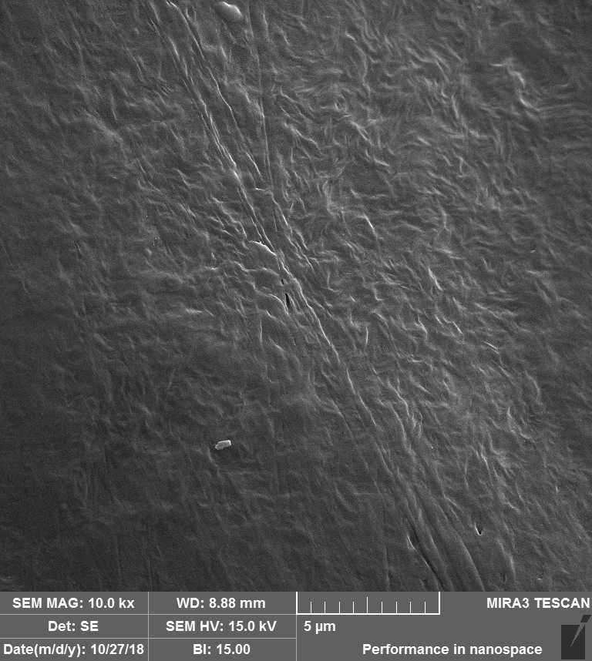 | 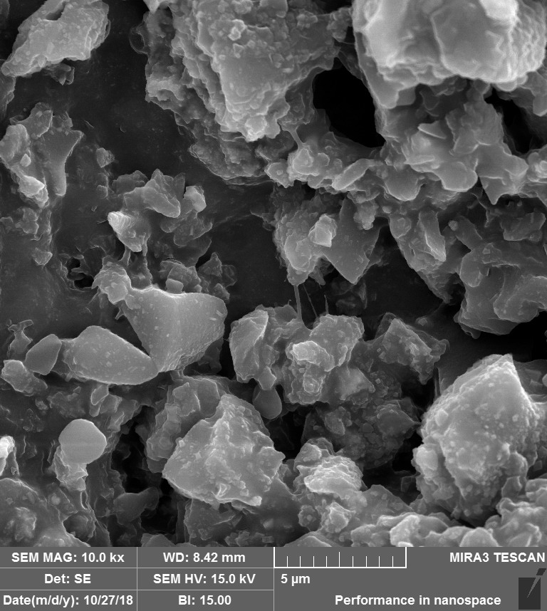
(a) | (b)
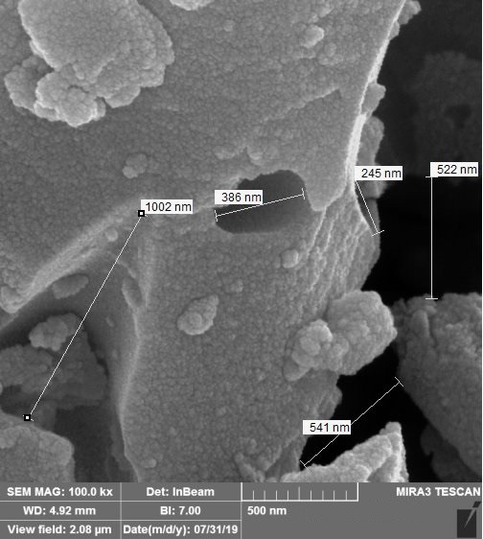 | 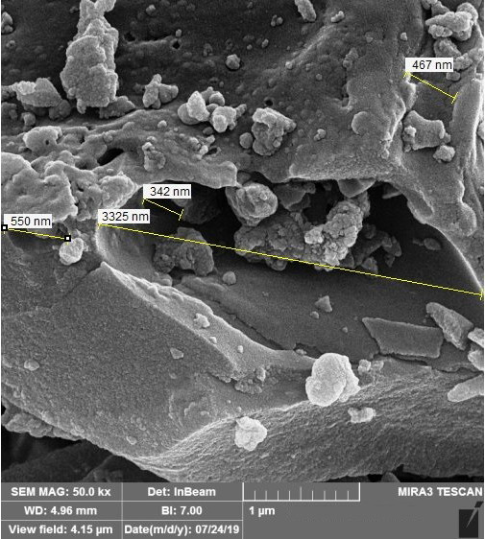
(c) | (d)
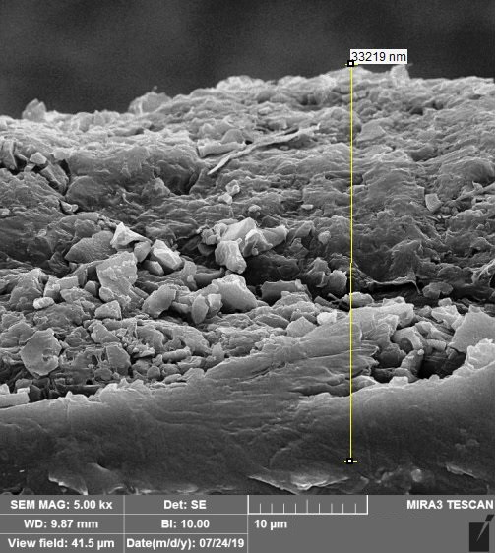
(e)
Fig. 1. Display of the carriers’ surface using SEM, a) smooth surface of the MBBR; b,c,d) rough and porous surface of the CBMC; e) coating thickness of the CBMC carrier.

Fig. 2. The trend of PAO-enriched biofilm formation on the surface of the two carrier types in phase1, based on the average TAS concentrations of three sampling carriers, stage 1: initial microbial attachment; stage 2: accelerated growth stage; stage 3: exponential growth stage; stage 4: decelerated growth stage; stage 5: stationary stage.

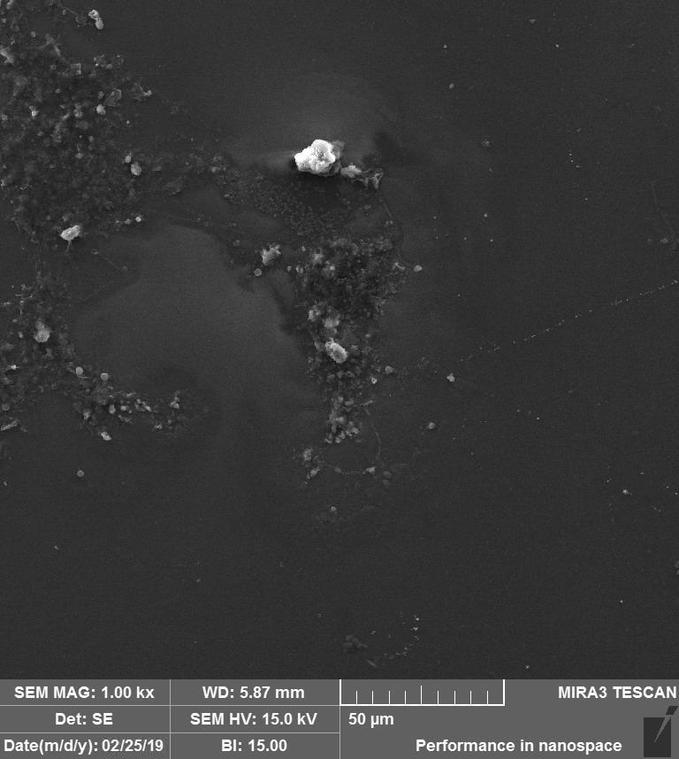 | 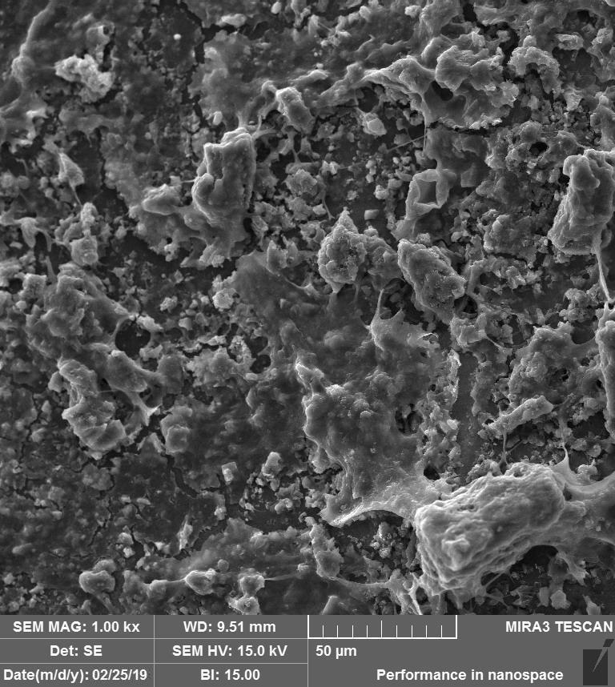
(a) | (b)
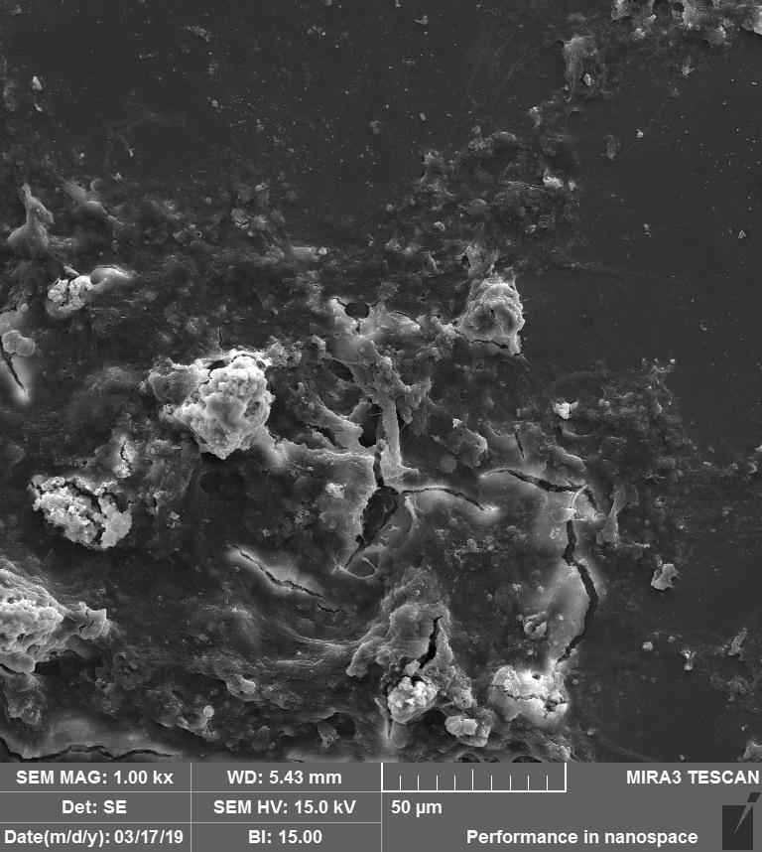 | 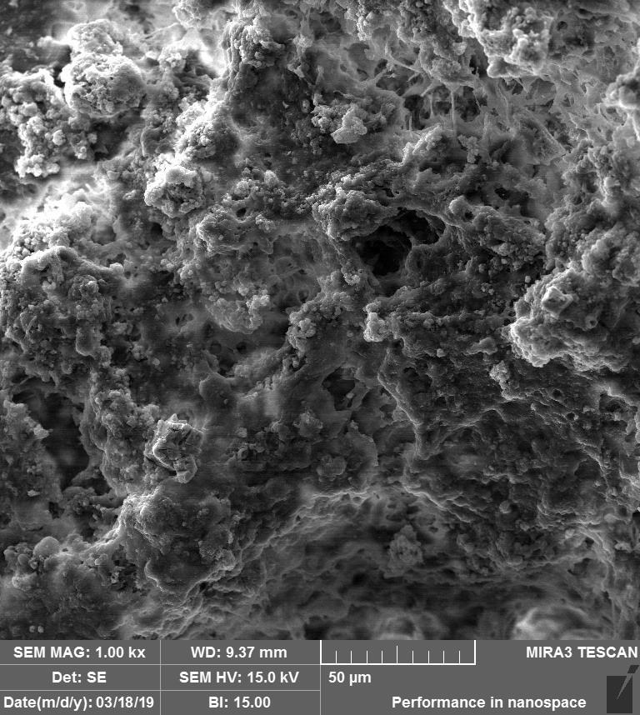
(c) | (d)
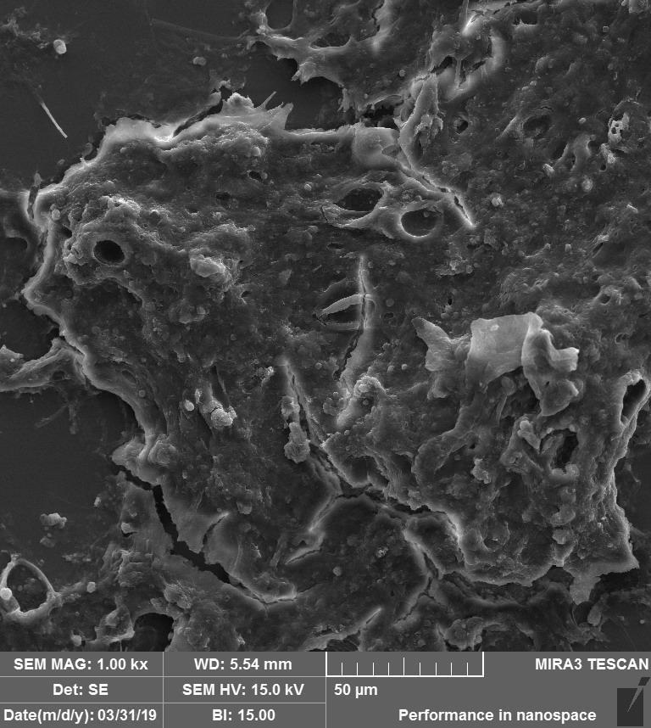 | 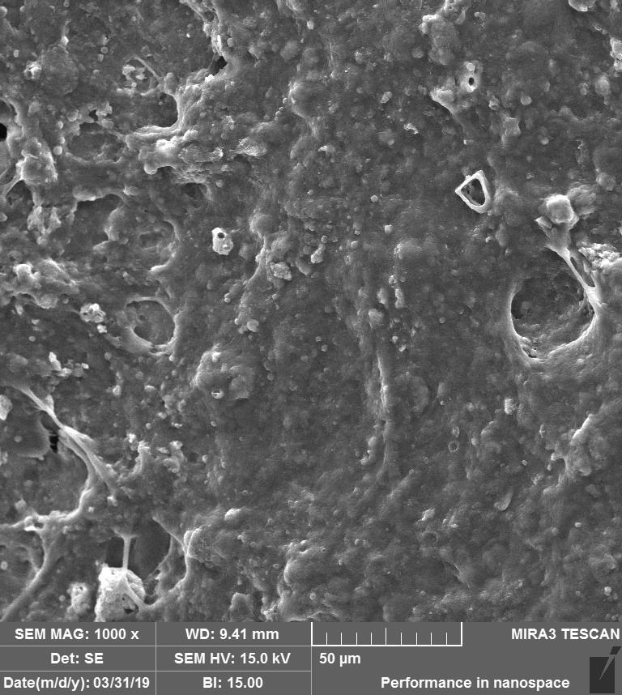
(e) | (f)
Fig. 3. Evolution of biofilm development on the surface of the carriers after 37, 57 and, 70 days, using SEM, a,c,e) MBBR; b,d,f) CBMC.

Fig. 4. Concentration profiles of a typical cycle in phase2, a) MBBR reactor; b) CBMC reactor.

Fig. 5. Anaerobic and anaerobic stoichiometric parameters and kinetic rates of PAO culture cultivated with Ac on the HDPE MBBR carrier and carbon-based CBMC carrier under similar conditions.

Fig. 6. Profile of PO₄³⁻-effluent concentration versus PO₄³⁻-removal efficiency during the various phases in the CBMC and MBBR reactors.

