Principal Polynomial Shape Analysis: a non-linear tool for Statistical Shape Modeling
Duquesne K^{a,b,} ,Nauwelaers N ^{e,f}, and Claes P ^{e,f,g}, Audenaert EA^{a,b,c,d}
ª Department Human Structure & Repair, University Ghent, Ghent, Belgium;
^{b} Department Orthopaedic Surgery & Traumatology, Ghent University Hospital, Corneel Heymanslaan 10, B-9000 Ghent, Belgium;
^{c} Department of Trauma and Orthopedics, Addenbrooke’s Hospital, Cambridge University Hospitals NHS Foundation Trust, Hills Road, Cambridge CB2 0QQ, UK;
^{d} Department of Electromechanics, Op3Mech Research Group, University of Antwerp, Groenenborgerlaan 171, Antwerp 2020, Belgium;
^{e} Medical Imaging Research Center, MIRC, University Hospitals Leuven, Herestraat 49 - 7003, 3000 Leuven, Belgium
^{f} Department of Electrical Engineering, ESAT/PSI, KU Leuven, Kasteelpark Arenberg 10 - box 2441, 3001 Leuven, Belgium
^{g} Department of Human Genetics, KU Leuven, Herestraat 49 - box 602, 3000 Leuven, Belgium
Corresponding Author: Audenaert Emmanuel, Department Human Structure & Repair, University Ghent, Ghent, Belgium, Corneel Heymanslaan 10 , 9000 Ghent, Belgium. emmanuel.audenaert@ugent.be
Word count abstract: 338
Word count main text: 3855
Figures/Tables: 11

Abstract
Background and objectives:
The most widespread statistical modeling technique is based on Principal Component Analysis (PCA). Although this approach has several appealing features, it remains hampered by its linearity. Principal Polynomial Analysis (PPA) can capture non-linearity in a sequential algorithm, while maintaining the interesting properties of PCA. PPA is, however, computationally expensive in handling shape surface data. To this end, we propose Principal Polynomial Shape Analysis (PPSA) as an adjusted approach for non-linear shape analyses. The aim of this study was to assess PPSA’s features, its model boundaries and its general applicability.
Methods:
PCA and PPSA-based shape models were investigated on one verification and three model evaluation experiments. In the verification experiment, the estimated mean of the PCA and PPSA model on a data set of synthetic lower limbs of different lengths in different poses were compared to the real mean. Further, the PCA-based and PPSA shape models were tested for three challenging cases namely for shape model creation of gait marker data, for regression analysis on aging faces and for modeling pose variation in full body scans. For the latter, additionally a Fundamental Coordinate Model (FCM) and a PPSA model on Fundamental Coordinate(FC) space was created. The performances were evaluated based on model-based accuracy, generalization, compactness and specificity.
Results:
In the verification experiment, the scaling error reduced from 75% to below 1% when employing PPSA instead of PCA for a training set with 180° angular variation. For the model evaluation experiments, the PPSA models described the data as accurate and generalized as the PCA-based shape models. The PPSA models were slightly more compact and specific (up to 30%) than the PCA-based models. In regression, PCA and PPSA-based parameterizations explained a similar amount of variation. Lastly, for the full body scans, applying PPSA to parameterizations improved the compactness and accuracy.
Conclusions:
PPSA describes the non-linear relationships between principal variations in a parameterized space. Compared to standard PCA-based shape models, capturing the non-linearity reduced the nonsense information in the shape components and improved the description of the data mean.

Keywords
Statistical Shape Modeling, non-linear PCA, PCA, Principal Polynomial Shape Analysis

1. Introduction

1.1. Background
Humans possess an intuitive perception of shape and their similarity [1]. However, to process the similarity of shapes algorithmically, these need to be formalized [1]. Originally, linear metric measurements of samples were acquired onto which statistics were computed [2,3]. In the early nineties, Cootes and Taylor were the first to draw attention to the statistical definition of shape [4–6]. From then on, statistical shape models (SSMs) arose which describe the variability of geometrical properties of a given set of topological similar shapes based on statistical methods. The earliest technique to create an SSM is the point distribution model (PDM) [5–7].
Initially, the PDM was developed to recognize and locate objects in images. However, within the last decades, a tremendous number of applications arose using SSM building techniques, and it is very likely that new ones will emerge in the future [1]. A prominent example is the use of a three-dimensional (3D) SSM to generate patient-specific bone models employed for in vivo bone motion tracking and computer-aided orthopedic surgeries [8–10]. Single-object and multi-object SSMs can also be utilized to study, diagnose, follow up (commonly referred to as longitudinal shape analysis), and treat diseased anatomical structures [1,3,8–13]. In addition, SSMs may be employed for segmentation tasks where they can automatically reconstruct the geometry, even starting from very sparse or severely disturbed measurements [1,4,14–16]. Moreover, genetic and aging patterns can be discovered by respectively associating SSMs with genetic information and age [17,18]. Furthermore, SSMs are of use in digital design and positioning of implants, face and body recognition, expression and pose recognition, and biometric passwords [9,11,19]. A last noteworthy field of application is education, for example, students can learn to distinguish normal and abnormal variations by hands-on studying the broad spectrum of typical shapes [1].

1.2. PCA-based Statistical Shape Modeling
As indicated above, the PDM method of Cootes and Taylor is the most widespread SSM method [6,7]. The PDM is a landmark-based statistical shape modeling approach, which implies that the surfaces of the objects are represented by a set of points, either in two or three dimensions. This set of points need to be in correspondence, meaning that the points must pointwise match in geometry, function and appearance [20]. A PDM is set up by performing multiple steps. First, the objects need to be aligned in pose (i.e., orientation and position) and the mean of the aligned objects needs to be computed. Subsequently, the mean shape is subtracted from the objects to get the residuals. The PDM is then obtained by applying Principal Component Analysis (PCA) to the residuals, and hence we refer to this approach as a PCA-based SSM [5,6]. This linear method has several appealing features which explain why it remains the principal method for constructing statistical models [1]. First, it is a straightforward, easy-to-apply, and computationally efficient technique [21]. Second, its robustness against noise makes it appliable to a wide variety of input data. Further, PCA is capable of fitting new data which makes it useful for adding data to an existing model or analyzing a sample with respect to the samples contained in the model [21,22]. Moreover, the linearity preserves the Euclidean properties such as distance and angles and the invertibility allows to compute the shapes in the input domain [21]. Lastly, PCA-based SSMs allow for an easy visualization of the variance presented in the data.
Figure 1 Illustration of PCA and PPSA applied to the training data (middle) with non-linear properties. Left: PCA mean (red-single vertical dotted line) and the full range of the first principal component (blue-horizontal straight lines) Right: PPSA mean (blue-single vertical dotted line) and the full range of the first principal component (red-curved horizontal lines).
Figure 1 printed in color
Nevertheless, PCA is hampered by data exhibiting non-linear relations. Articulated shape models are an example in which this disadvantage becomes clear. Suppose an articulated shape model is created from a set of objects which consists of two components connected by a hinge joint. Now, assume the training set consists of several of these objects in which the angle between the first and the second component varies (figure 1 middle). When PCA is applied to this training set, it wrongly estimates the mean and will not capture the non-linearity of rotation (figure 1 left). A real-life example exhibiting this problem are patients' lower limbs scanned in different relative poses. When creating an articulated statistical shape model, non-linearity due to motion artefacts significantly affects the quality of the statistical shape models and as such the classification abilities of the models [23].
Previously, researchers have attempted to reduce the computational impact of such positional variance by either defining statistical transformation models that capture differences in relative pose [24] or by explicitly modeling joint motion through idealized joint models (e.g., spherical in case of the hip or hinged for the knee joint) [25].
Several non-linear approaches to PCA have been developed [26,27]. In particular, for statistical shape modelling several techniques based on geometric as well as physical concepts, have been introduced [28]. However, most of these non-linear techniques do not have a straightforward out-of-sample extension and invertibility, and often come at a higher computational cost [21,27]. Nevertheless, there are some methods which solve (some of) these problems. For example, Von Tycowicz et al. (2018) presented a promising method for which the inverse problem can be solved at linear cost [29]. They derived a physically motivated shape representation based on differential coordinates to take the deformation within local neighborhoods into account. However, their employed representation is not invariant under Euclidean motion. The latter is omitted by the very recently introduced non-linear statistical shape modelling method of Ambellan et al. (2021) [28]. Based on discrete fundamental forms, their method allows for numerically robust processing. Another line of work focusses on modelling the shape in the shell space. Zhang et al. (2015) illustrated the potential of this approach by developing Shell PCA, an alternative to PCA in shell space [30]. However, this method is built in a linear space of vertex displacements. As a consequence, it is not rigid body motion invariant and does not have an underlying Riemannian model. A non-linear rigid body motion invariant version of Shell PCA was introduced by Heeren et al. (2018) [31]. This method shows great potential. However, the computational cost is rather high.
Another potential alternative to PCA was provided by Laparra et al. (2014) [21]. Inspired by the concept of Principal Curves, he developed a simple and efficient sequential algorithm which extracts the non-linear features by building further on PCA [21,27]. By doing so, PPA keeps the simple out-of-sample extension and invertibility of PCA. Laparra et al. (2011) proved that the dimensionality reduction error in PPA is always lower than PCA and that the classification (specificity) features of PPA outperformed those of linear techniques [32]. PPA was designed for the description of complex (multi-dimensional) curves and provides, in a descending order of explained variance, a series of distinct polynomials per data dimension. Surface data is often called High Dimension Low Sample Size (HDLSS) meaning it is of a high dimensionality but only a limited amount of training samples are available. Implementing the technique of Laparra et al. (2014) on surface data with $N$ vertices, would result in a series of $\left(3N−1\right)$ polynomials at the first iteration. Typically, the number of coefficients to be estimated would be far above the number of available training samples. This would provide an underdetermined system and solving the equations would come at the expense of a high memory cost and a high computational cost. We propose an adjusted approach for shape analyses. PPSA uses PCA as a linear dimensionality reduction prior to polynomial fitting. This provides an overdetermined system that can be efficiently solved. PPSA has great potential in (articulated) statistical shape modeling as seen in the example in figure 1. PPSA is, in contrast to PCA, able to estimate the correct mean and to capture the non-linear behavior of the hinge joint (figure 1 right).
This study aims to evaluate PPSA’s features, its model boundaries, and its applicability by performing verification experiments and applying it to real-life examples (i.e., motion capture marker data, age diverse faces and full body scans during jumping jacks).

2. Materials and methods
In this section, first the workflow to construct a PCA-based SSM is recapitulated. Subsequently, the implementation of PPSA, which builds further on PCA-based SSM, is presented. Next, the verification and model evaluation experiments are described together with the used evaluation measures. All the analyses with the exception of the creation of the Fundamental Coordinates Model (FCM), were performed in MATLAB (version 2020b, MathWorks, Natick, MA, USA) on a Laptop PC with Intel® Core™ i9-10885H CPU @ 2.40GHz. The FCM model was created in Python (version 3.9, Python Software Foundation, Beaverton, OR, USA).

2.1 PCA-based SSM
Prior to applying PCA, the point sets on the shapes were brought in correspondence and aligned. Next, the mean point set was determined and subtracted from the aligned and corresponding point sets. The statistical shape model, described by equation 1, was subsequently generated by applying PCA to the residuals of the point sets[6].
 | $$S=\overline{S}+P.b$$ | ( 1 )
with $S$ the shape vector, $\overline{S}$ the average shape, $P=\left(p_{1},p_{2},…,p_{t}\right)$ the matrix of eigenvectors of the covariance matrix ${\left(S−\overline{S}\right)}^{T}\left(S−\overline{S}\right)$ and $b={\left(b_{1},b_{2},…,b_{t}\right)}^{T}$ the vector of weights or loadings. The eigenvectors were orthogonal and ranked in decreasing order according to the $t$ largest eigenvalues. Each of these eigenvectors represented a mode of shape variation as observed over the training data set [16]. A shape of the input domain can be approximated by retaining a limited number $\left(t\right)$ of eigenvectors (equation 2).
 | $$S\overset{lsq}{≅}\left(\overline{S}+\sum_{i=1}^{t}{p_{i}b_{i}}\right)$$ | ( 2 )

2.2 Principal Polynomial Shape Analysis
PPSA introduces non-linearity into the PCA-based SSM by predicting the loadings of the eigenvectors with a lower eigenvalue from the loading of the eigenvector with a higher eigenvalue (=leading vector) and combining the additional predicted shape modes with the shape mode of the leading vector. This was done iteratively. In each step, higher order polynomial regression models were defined between the loadings of the eigenvector of the specific shape mode and the loadings of the eigenvectors with a lower eigenvalue (Figure 2).
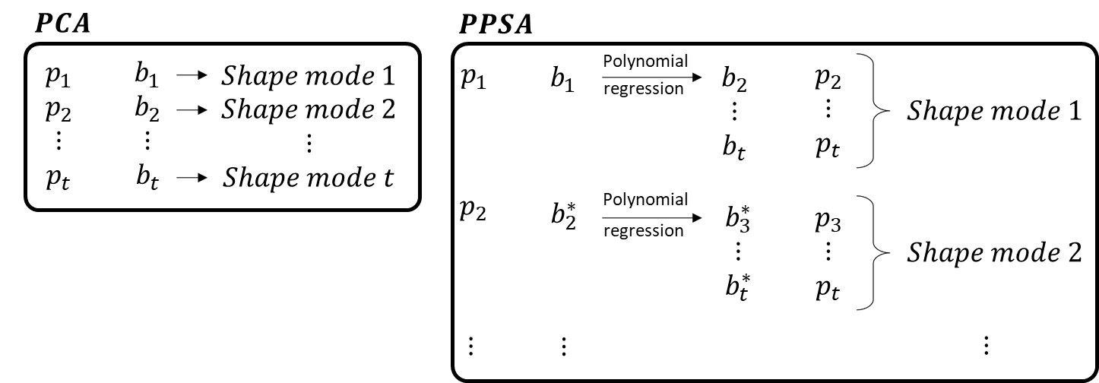
Figure 2 Illustration of the shape vectors included in a shape mode for PCA (left) and PPSA (right).
Figure 2 printed in black/white
For example, from the loadings corresponding to the first eigenvector (= eigenvector with the highest eigenvalue) $b_{1}$ the remaining loadings $b_{2}…b_{t}$ were predicted by polynomial regression of order $n$(equation 3-4).
 | $$\left(\begin{matrix}\begin{matrix}w_{1,1} \\ w_{2,1}\end{matrix} & ⋯ & \begin{matrix}w_{1,n+1} \\ w_{2,n+1}\end{matrix} \\ ⋮ & ⋱ & ⋮ \\ w_{t−1,1} & ⋯ & w_{t−1,n+1}\end{matrix}\right).\left(\begin{matrix}\begin{matrix}1 \\ b_{1,s_{1}}^{1}\end{matrix} & \begin{matrix}⋯ \\ ⋯\end{matrix} & \begin{matrix}1 \\ b_{1,s_{m}}^{1}\end{matrix} \\ ⋮ & ⋱ & ⋮ \\ b_{1,s_{1}}^{n} & ⋯ & b_{1,s_{m}}^{n}\end{matrix}\right)=\left(\begin{matrix}\begin{matrix}b_{2,s_{1}} \\ b_{3,s_{1}}\end{matrix} & ⋯ & \begin{matrix}b_{2,s_{m}} \\ b_{3,s_{m}}\end{matrix} \\ ⋮ & ⋱ & ⋮ \\ b_{t,s_{1}} & ⋯ & b_{t,s_{m}}\end{matrix}\right)$$ | ( 3 )
 | $$w.\left(\begin{matrix}b_{1}^{0} \\ ⋮ \\ b_{1}^{n}\end{matrix}\right)=\left(\begin{matrix}b_{2} \\ ⋮ \\ b_{t}\end{matrix}\right)$$ | ( 4 )
Where $s_{i}$ indicates the different shapes in the training set, $t$ the number of eigenvectors included in the shape model, $n$ the order of the polynomial regression and $w$ the matrix of weights or the coefficients of the polynomial functions. The overdetermined set of linear equations was solved in a least squares sense using the Moore-Penrose pseudoinverse matrix (equation 5).
 | $$w\overset{lsq}{≅}\left(\begin{matrix}b_{2} \\ ⋮ \\ b_{t}\end{matrix}\right).pinv\left(\left(\begin{matrix}b_{1}^{0} \\ ⋮ \\ b_{1}^{n}\end{matrix}\right)\right)$$ | ( 5 )
Subsequently, the first PPSA shape mode was computed by combining the first PCA shape mode and the polynomial predictions of the remaining shape modes (equation 6-7).
 | $${SM}_{1}=p_{1}.b_{1}+p_{2}.\left(w_{1,1}.b_{1}^{0}+w_{1,2}.b_{1}^{1}+w_{1,3}.b_{1}^{2}+…+w_{1,n+1}.b_{1}^{n}\right)+…+p_{t}\left(w_{t−1,1}.b_{1}^{0}+w_{t−1,2}.b_{1}^{1}+w_{t−1,3}.b_{1}^{2}+…+w_{t−1,n+1}.b_{1}^{n}\right)$$ | ( 6 )
 | $${SM}_{1}=p_{1}.b_{1}+\sum_{i=2}^{t}{p_{i}.\sum_{l=0}^{n}{w_{i−1,l+1}.b_{1}^{l}}}$$ | ( 7 )
with $p_{i}$ the eigenvectors of covariance matrix ${\left(S−\overline{S}\right)}^{T}\left(S−\overline{S}\right)$ and $b_{1}$ the loading corresponding to the first eigenvector (= eigenvector with the highest eigenvalue), $n$ the degree of the polynomial and $t$ the number of eigenvectors included in the shape model. The matrix $w$ was the matrix of weights or the coefficients of the polynomial functions. Before estimating the second shape mode, an updated version of the vector $b$ is calculated using equation 8.
 | $$b_{i}^{}=b_{i}−\sum_{l=0}^{n}{w_{i−1,l+1}.b_{1}^{l}}$$ | ( 8 )
With $i=2…t$. The second shape mode was subsequently given by equation 9
 | $${SM}_{2}=p_{2}.b_{2}^{}+\sum_{i=3}^{t}{p_{i}.\sum_{l=0}^{n}{w_{i−2,l+1}^{}.{\left(b_{2}^{}\right)}^{l}}}$$ | ( 9 )
with $w^{}$ estimated using equation 10
 | $$w^{}\overset{lsq}{≅}\left(\begin{matrix}b_{3}^{} \\ ⋮ \\ b_{t}^{}\end{matrix}\right).pinv$$ | ( 10 )
In general, a specific shape mode k could be computed using the following equations:
 | $${SM}_{k}=p_{k}.b_{k}^{\left(k−1\right)}+\sum_{i=k+1}^{t}{p_{i}.\sum_{l=0}^{n}{w_{i−k,l+1}^{\left(k−1\right)}.{\left(b_{k}^{\left(k−1\right)}\right)}^{l}}}$$ | ( 11 )
 | $$b_{i}^{\left(k−1\right)}=b_{i}^{\left(k−2\right)}−\sum_{l=0}^{n}{w_{i−1,l+1}^{\left(k−2\right)}.{\left(b_{k−1}^{\left(k−2\right)}\right)}^{l}}$$ | ( 12 )
 | $$w^{\left(k−1\right)}\overset{lsq}{≅}\left(\begin{matrix}b_{k+1}^{\left(k−1\right)} \\ ⋮ \\ b_{t}^{\left(k−1\right)}\end{matrix}\right).pinv$$ | ( 13 )
Lastly, a shape ($S$) from the training set was reconstructed by
 | $$S^{'}=\overline{S}+\sum_{k=1}^{t}{{SM}_{k}}≅S$$ | ( 14 )
However, it should be noted that the estimated mean shape of PPSA was no longer equal to $\overline{S}$, but could be found by putting all loadings to zero. As a result, the estimated mean shape was computed by:
 | $$\overline{S_{PPSA}}=\overline{S}+\left(p | | 2.w_{1,1}+p_{3}.w_{2,1}+p_{4}.w_{3,1}+…+p_{t}.w_{t−1,1}\right)+\left(p_{3}.w_{1,1}^{}+p_{4}.w_{2,1}^{}+…+p_{t}.w_{t−2,1}^{}\right)+…+\left(p_{t}.w_{1,1}^{\left(t−1\right)}\right)$$ | ( 15 )
 | $$\overline{S_{PPSA}}=\overline{S}+\sum_{i=1}^{t−1}{p_{i+1:t}.w_{i:t−i,1}^{\left(i−1\right)}}$$ | ( 16 )
The implementation of PPSA is freely available at Matlab® file exchange:
https://nl.mathworks.com/matlabcentral/profile/authors/4165925-manu

2.3 Verification experiment: articulated shape model
Positional noise is present in many medical image data sets. Assuming a perfect standardized pose at image acquisition leads to an incorrect average in PCA-based shape models. This was illustrated in the introduction where the PCA-based SSM wrongly estimated the mean when non-linearity was present in the input data. Therefore, the purpose of this verification experiment was to compare the mean shape provided by the standard average used in PCA and the average obtained from PPSA with the actual mean source shape. For this experiment, a data set of different lower limb poses was simulated. To do so, three independent variation features (i.e., scaling and rotation around the hip and ankle) were enforced on a synthetic lower limb. The length of the leg was linearly scaled using a scaling factor ranging from 0.8 to 1.2. The rotation around the hip and the ankle represented pose variation. For each variation feature, 11 different values were chosen and applied. This led to a combined training set of 11*11*11 (n = 1331) cases. PCA-based SSM and PPSA were applied to this training set. Subsequently, the scaling errors on the mean shapes were determined by performing a Procrustes analysis. The error measure was evaluated for increasing amounts of pose variation (hip and ankle flexion ranging from 0 to 180 degrees).

2.4 Model evaluation experiments
PCA-based and PPSA shape models were tested on the following three challenging cases: namely the creation of a shape model of gait marker data from motion capture, a regression analysis on age diverse faces and modeling pose variation in full body scans during a complex motion (i.e., jumping jacks). These cases are known to contain non-linear variance and were therefore selected explicitly. Below first a description of the input data and the specifics of the workflow are presented. Next, the different evaluation measures are outlined.

2.4.1 Data description
For the creation of a shape model of gait marker data, PCA-based SSM and PPSA were applied to 5913 frames of gait data. The data set contained the 3D positions of 51 markers captured at 100Hz of a single subject walking on a treadmill at 1.8m/s. Second order polynomial regressions were used to build the PPSA model.
To evaluate the difference of PCA-based SSM and PPSA (3rd order) in performance for regression analysis, a data set of synthetic 3D facial shapes (n = 1475, n_{men} = 727, n_{women} = 748) of subjects aged between 0.05 and 20 years were created from a large-scale open-access 3D facial ageing model [17]. In this data set, facial shape was represented as x, y and z co-ordinates of 7160 corresponding quasi-landmarks. Faces were aligned to remove non-shape related translational and rotational variation. PCA-based SSM and PPSA were applied to parametrize the face phenotypes within the dataset. To estimate facial variation for age, partial-least-squares (PLS) regression was implemented using age as predictor and respectively the PCA-based SSM and PPSA shape component loadings as responses. In addition, two separate PCA-based and PPSA shape models were produced for the separate sexes.
For the last evaluation experiment, 343 full body scans of a male subject performing jumping jacks were obtained from the Dyna data set ($N_{vertices}=6890$ [33]. For PPSA, 4th order polynomial regression was used. To be able to compare the PPSA on the PCA model with state-of-the-art statistical shape modelling for 3D shapes, we also created a Fundamental Coordinates Model (FCM) [28]. For this, the open-source implementation of Ambellan et al. (2021) was employed. To test whether there were non-linear relations between the principal geodesic curves, PPSA was applied to the coefficients of the principal geodesic curves.

2.4.2 Outcome measures
To quantitatively evaluate and compare the obtained shape models, several aspects were investigated. More specifically, the following ‘goodness’ measures were analyzed: model accuracy, compactness, generalization, specificity and computation time. These are standard aspects to be examined in SSMs [34]. However, these outcome measures, with the exception of computation time, depend on the distance metric used. In biomedical research and medical practice, most often the Euclidean distance measure is utilized as this measure is the most comprehensible. However, a bias would be introduced when only comparing the FCM, PCA and PPSA models based on Euclidean measures as the FCM is not optimized using Euclidean distances. Therefore, we also employed the independent distance metric $W$, elastic deformation energy, introduced by Zhang et al. (2015) for the Jumping Jacks evaluation experiment [28–31]. If we did not explicitly mention which distance metric was employed, the outcome measure was determined using the Euclidean distance metric. The elastic deformation energy $W$ is a notion of distance which expresses the amount of elastic energy required to deform one shape into another. Two factors, namely membrane and bending energy, contribute to the final deformation energy [30]. To compute this distance metric we used the open source implementation of Heeren et al.(2018) [31].
The computation time is the time required to build the SSM with a certain amount of variance. The model accuracy is a measure for how well the shapes from the training set are reconstructed in the model for increasing amounts of total variance retained. For each sample of the training set, the Root Mean Square Error (RMSE) of the distances (Euclidean or elastic deformation energy) between the corresponding points on the sample in the training set and on the reconstructed sample was computed. The average of the absolute differences between the model description and the sample in the training set was the model accuracy.
 | $$Accuracy\left(M\right)=\frac{1}{K}\sum_{i=1}^{K}{{\left\|S_{i}^{'}\left(M\right)−S_{i}\right\|}^{2}}$$ | ( 17 )
With $S_{i}$ a shape from the training set and $S_{i}'\left(M\right)$ the approximation of $S_{i}$ in the model.
The compactness was defined as the cumulative explained variance of the Mth eigenmode obtained by the model’s covariance matrix (${\left(S−\overline{S}\right)}^{T}\left(S−\overline{S}\right)$) decomposition [35].
 | $$Compactness\left(M\right)=\frac{1}{\sum{λ}}\sum_{m=1}^{M}{λ_{m}}$$ | ( 18 )
where $λ_{m}$ is the Mth eigenvalue. The higher the compactness value, the fewer variables are required for the constructed shape model to describe its population variance.
The model’s generalization ability quantifies the capability of the constructed model to represent new shape instances of the same class, which are not part of the original training set. This ability was evaluated by performing leave-one-out tests on the training data with different numbers of shape components retained in the model. More specifically, the shape models were built by using all but one training sample. For the excluded training sample, the constructed model was used to reconstruct the excluded shape $S_{i}$ by progressively fitting an increasing amount of shape modes to define their respective loadings. The approximation error was defined as the RMSE distance between the excluded shape $S_{i}$ and the reconstructed duplicate $S_{i}^{'}\left(M\right)$. The generalization metric was thereafter estimated by averaging the approximation error over the K performed tests.
 | $$Generalization\left(M\right)=\frac{1}{K}\sum_{i=1}^{K}{{\left\|S_{i}−S_{i}^{'}\left(M\right)\right\|}^{2}}$$ | ( 19 )
where the reconstructed shape $S_{i}^{'}\left(M\right)$is defined as a combination of the first M modes of variation.
The last model evaluation metric was model specificity. Loadings of the shape components are typically considered parameters describing independent variation within the data. These are used for labeling, classification and clustering purposes. This implies that the components should represent meaningful information and not “nonsense” synthetic variability. Model specificity is a measure for how realistic a randomly generated shape instance from the model is. This specificity was determined by generating a large set (N) of virtual shape examples using the constructed model. This was done by choosing randomly distributed values for the shape parameter $b$ from the range of the training data set for each shape component [35].
 | $$S_{j}\left(M\right)=\overline{S}+\sum_{m=1}^{M}{b_{m}p_{m}}$$ | ( 20 )
Subsequently, the most similar sample $S_{j}^{'}$ in the training set was determined by equation 21. Thereafter, the distance between the synthetic example and the most similar real example was computed.
 | $$S_{j}^{'}=argmin\underset{k∈\left[1,K\right]}{}\left\|S_{j}\left(M\right)−S_{j}^{'}\right\|$$ | ( 21 )
The specificity metric was then defined as the averaged approximation error of all the generated N shape instances:
 | $$Specificity\left(M\right)=\frac{1}{N}\sum_{j=1}^{N}{{\left\|S_{j}\left(M\right)−S_{j}^{'}\right\|}^{2}}$$ | ( 22 )
A value of N = 1 000 was used to obtain the results reported in this study. The specificity measure was evaluated both at the level of the model (multiple combinations of components) and for the independent variation components within the model separately.

3. Results

3.1 Verification experiment: articulated shape model
In this verification experiment, three independent variation features (i.e., scaling and rotation around hip and ankle) were enforced on a synthetic lower limb. On a total of 1331 cases, the mean shapes provided by the PCA-based SSM and PPSA were determined and compared. Figure 3 illustrates the scaling error for an increasing amount of pose variation for the hip and ankle rotation. In the PCA-based SSM, the error introduced on the mean shape by non-linear pose variation demonstrated an exponential relationship with increasing amount of angular variation in the training set. When PPSA with a second order polynomial was performed, the mean shape scaling error remained below 5% until 110 degrees of angulation (i.e., 220 degrees of total angular variation). PPSA with a 4th order polynomial approximation further reduced the scaling error below 1% up to 80 degrees of angulation (i.e., 160 degrees of total angular variation). An example of the first shape mode of the PCA-based SSM and the PPSA model, illustrating the scaling error, is depicted in figure 4.
Figure 3 The scaling errors introduced in the estimated mean shape of the PCA-based and PPSA shape models (2nd and 4th order) for training sets with different ranges of angular variation for the hip and ankle rotations.
Figure 3 printed in black/white
Figure 4 An illustration of the first shape component of the PCA-based (purple) and PPSA shape model (grey) at the 3rd quantile (left), mean (middle) and 3rd quantile (right) together with the original mean shape (red).
Figure 4 printed in color

3.2 Model evaluation: Gait Marker data
Figure 5 The first PPSA (left) and PCA-based SSM (right) shape component illustrates the non-linearity versus the linearity of the respective techniques.
Figure 5 printed in color
In the first model evaluation experiment, PCA-based SSM and PPSA were applied to reflective marker data obtained from a single subject walking. With the first component, PCA-based SSM managed to capture 89.7% of the data variance. In contrast, PPSA’s first component explained 91.2% of the data variance due to adding non-linear predictions of the other PCA-based SSM components. Although these compactnesses seem close, the visualized shape components differ significantly (figure 5). Further, while PCA-based SSM required 4 shape components to describe 98% of variance, PPSA only needed 3 components. Building this PCA model took 0.016s whereas an additional 0.127s is required to build the PPSA model. The in-sample accuracy for the models which retained 98% of variation was 18.66mm (+/- 5.83 mm) for PCA-based SSM and 18.69 mm (+/- 6.29 mm) for PPSA. The generalization when including 98% of the data variance in the PCA-based SSM and PPSA was respectively 22.02 mm (+/- 7.26 mm) and 22.48mm (+/- 7.61 mm). A larger difference between the two approaches was observed in the model specificity. For the combined components, the model specificity of PPSA was found to be 30.56 (+/- 12.77 mm), whereas for PCA-based SSM a value of 38.35 mm (+/- 13.73 mm) was obtained. Hence, when using PPSA a 21% improvement was achieved while also requiring less components compared to the PCA-based model. Detailed findings of the Euclidean based outcome measures are provided in figure 6.
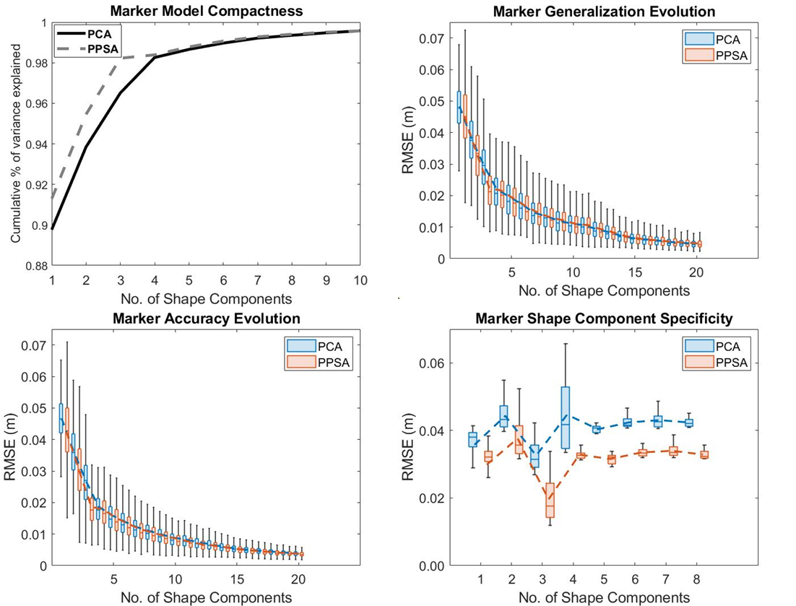
Figure 6 (upper left) the model compactness, (upper right) model generalization and (lower left) model accuracy for different amounts of shape components included and (lower right) the specificity for the different shape components calculated using the Euclidean distance metric.
Figure 6 printed in color

3.3 Model evaluation: Regression on aging faces
As a second model evaluation experiment PCA-based SSM and PPSA were applied to a data set of facial shapes aged between 0.05 and 20 years. Subsequently, PLS regression was implemented with age as predictor and the shape component loadings of the two models as responses. 79.58% and 79.90% of the data variance were described by the first component of respectively the PCA-based model and PPSA model. Building these models took respectively 2.691s and 15.224s. Age was found to correlate most profoundly with the first PCA and PPSA component (r = 0.86, p<0.001). Although PPSA discovered relevant non-linear dependencies between PCA components, it did not significantly improve the age-shape regression predictions. Age was found to account for 59.9 % of face variation using a PCA-based regression as opposed to 60.0% of shape variation when relying on a PPSA-based parametrization. Regression findings are demonstrated in figure 7. In general, facial growth was found to be mainly linear. However, when comparing the differences for both sexes between the linear PCA-based and non-linear PPA-based regression models, two periods of non-linearity or “growth spurts” could be identified. These two noticeable moments of non-linear growth occurred in the first 2 years of life and during puberty. The two sexes are known to exhibit different growth patterns during adolescence [36].
In males, this growth spurt was found to be larger in size and started 2-3 years later as compared to females, which is biologically underpinned [36].
Figure 7 (upper figure) The estimated face shapes from regression between age and the first PPSA modes and the PCA shape modes. The color map indicates the difference between the face shapes of two subsequent ages. (lower figure) The non-linear portion captured in the first PPSA shape mode for the separate female and male models for the different ages.
Figure 7 printed in color

3.4 Model evaluation: Jumping Jacks full body surface models
For the last experiment, full body surface scans of a subject performing jumping jacks were used. PCA-based SSM managed to capture 82.9% of data variance with the first component. PPSA added non-linear relationships between the PCA components which led to 90.8% explained variance for the first component. The first components of the FCM and PPSA on FCM captured respectively 51.5% and 61.0% of the variance. PCA-based SSM, PPSA on PCA shape space, FCM and PPSA on FC (Fundamental Coordinate) shape space described respectively 98.14%, 98.64%, 75.22% and 81.01% of the variance in 4 components. Note that the variances of the first two shape models are computed in different shape spaces than the variances of the last two shape models. Although the value for the compactnesses for PCA and PPSA seem close, the visualized shape components differ significantly (figure 8). Further from this figure, it is clear that the first principal component of the PCA model contains biologically non-plausible shapes. The first principal variation of the FCM and both PPSA models appear feasible. The time to compute the shape models is given in table 1, where the PPSA models were both build using 98% of variance. The PCA-based SSM is clearly the fastest method.
When including 4 components in the shape model, the in-sample accuracy for PCA-based SSM was 33.33mm (+/- 13.55 mm). With the same number of components included, PPSA reduced the in-sample error to 27.96 mm (+/- 12.83 mm). The in-sample accuracy for all 4 shape models with 4 components was also measured in terms of the elastic deformation energy $W$. The results are presented in table 2. Adding the non-linear relationships between the principal variations, decreased the required elastic deformation energy $W$ both in the PCA and FC shape space. Further, the elastic deformation energy $W$ was remarkably lower for the FCM compared to the PCA-based SSM.
The generalization capability did not differ noticeably between the two Euclidean approaches as the out-of-sample error was found to be 51.58 mm (+/- 26.76 mm) for PCA-based SSM and 53.84 mm (+/- 26.84 mm) using the PPSA model. The model specificity, however, demonstrated larger differences with errors up to 87.68 mm (+/- 46.45 mm) for PCA-based SSM and 61.45 mm (+/- 20.86 mm) for PPSA. A 30% improvement in model specificity was therefore achieved using PPSA, using the same amount of components as compared to PCA. Detailed findings of the measures are provided in figures 8 and 9.
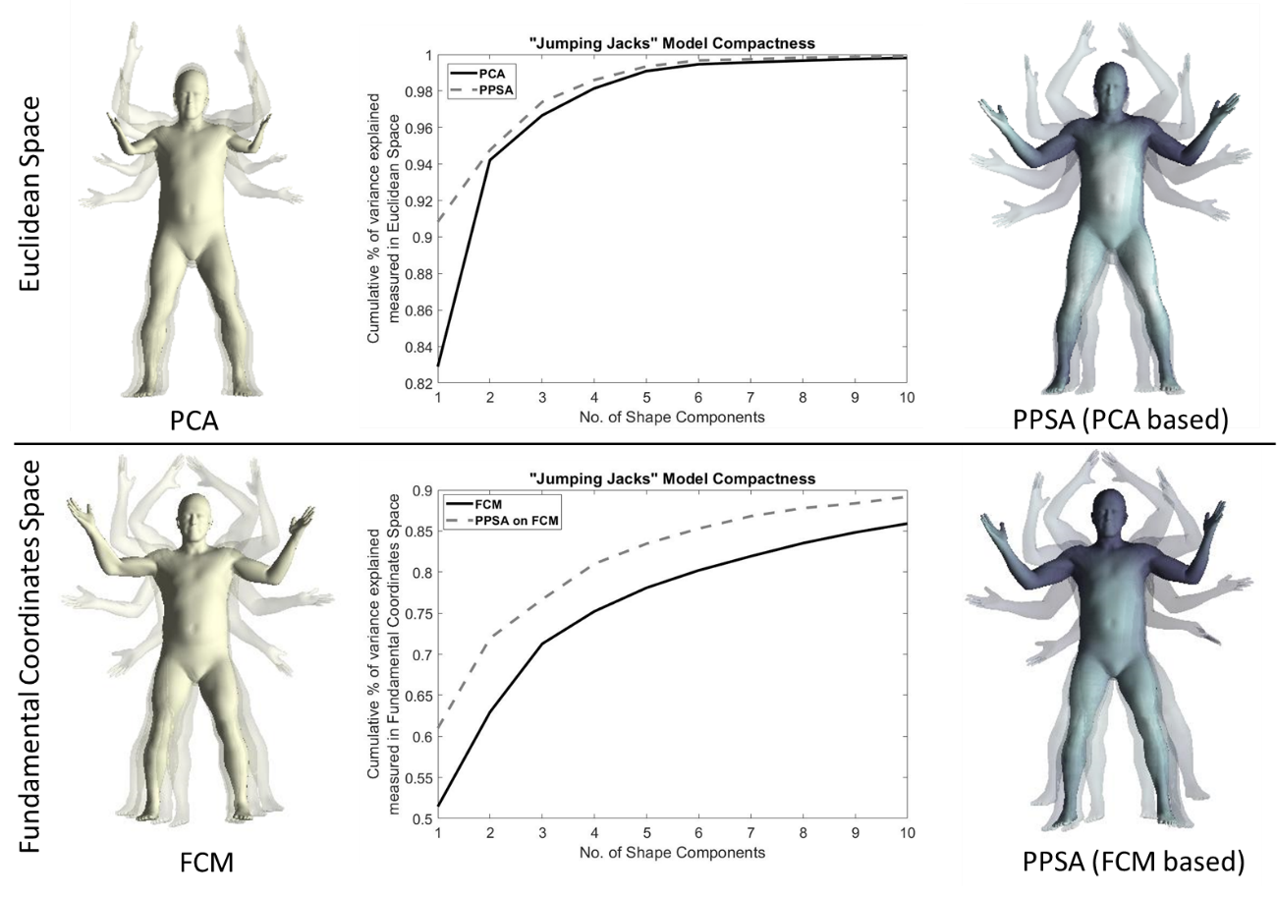
Figure 8 Illustration of the first shape mode at 0% (mean, opaque), ±50% (transparent) and ±100% (transparent) of the maximal loading of the first shape mode (present in the input data) of PCA-based and PPSA (PCA based), FCM and PPSA (based on FCM) shape model. The model compactness (middle figures) calculated in the Euclidean space and the Fundamental Coordinates space for respectively PCA and PPSA (PCA based) and FCM and PPSA (FCM based).
Figure 8 printed in color
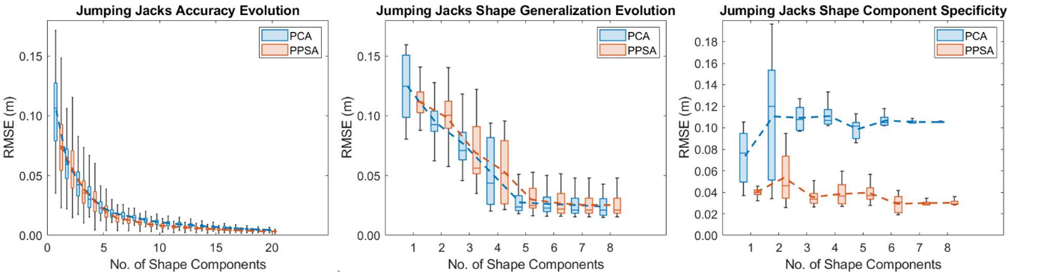
Figure 9 (left) The model accuracy, (middle) model generalization for different amounts of shape components included and (right) model specificity for the different shape components calculated using the Euclidean distance metric.
Figure 9 printed in color

Table 1 Computation times for 4 different Statistical Shape Modelling methods namely: Principal Component Analysis (PCA), Principal Polynomial Shape Analysis (PPSA) on PCA space, Fundamental Coordinate Model (FCM), PPSA on Fundamental Coordinate (FC) space. The + indicates that to build a PPSA model first the underlying PCA or FCM model needs to be computed.
Statistical Shape  Modelling method | Computation  time (s)
PCA | 0.303
PPSA on PCA space | +1.327
FCM | 417.546
PPSA on FC space | +0.170

Table 2 In-sample accuracy of the Statistical Shape Models (PCA-based SSM, PPSA on PCA space, FCM and PPSA on FC space) based on the elastic deformation energy $W$ when 4 components were included.
Statistical Shape  Modelling method | Accuracy based on $W$
PCA | 104.8 (±32.3)
PPSA on PCA space | 84.1 (±30.5)
FCM | 70.7 (±26.4)
PPSA on FC space | 61.6 (±26.4)

4. Discussion
Principal Polynomial Shape Analysis is a method to capture non-linear dependencies between principal variations in a parameterized space. In this study, we illustrated the potential of PPSA in two shape spaces, namely in PCA shape space and Fundamental Coordinate shape space. As PPSA is performed on shape components it is not limited to shapes represented as meshes (i.e., shapes represented with faces and vertices) but can also be performed on simple coordinates (e.g., gait marker data). For PPSA performed in the PCA shape space, PPSA improved the description of the data mean, the compactness of the model and the specificity of the components. By describing the non-linear relationships within the data, PPSA improved the realistic visualization and the interpretability of the independent components. Therefore, PPSA may be more useful for labelling purposes (i.e., are more suitable for classification and clustering purposes). However, in terms of accuracy and generalizability PCA and PPSA in PCA shape space yielded very similar results. Considering PPSA was built on the PCA components, this was expected. Finally, the model compactness remained a difficult parameter to interpret as it does not take the content or (anatomical) plausibility of shape components into account.
Building PCA-based SSMs to describe the biological variance of facial and osteology primitives has become common practice [1,3,8–11]. PCA and other linear approximations are able to parametrize the data well (accuracy and generalizability). However, the linearity of the method has its limitations. One of the most important shortcomings is the misestimation of the mean shape. The verification experiment showed that for the PCA-based model the scaling error in the estimation of the mean increased with increasing pose variation. PPSA reduced the scaling error remarkably. Furthermore, the short upper limbs of the estimated mean shape of the PCA-based SSM on the jumping jack data set illustrated that the mean is not realistic, i.e., is not shape representative.
Another limitation of the PCA method is the interpretability of the individual shape components. PCA-based statistical shape modeling methods are commonly used to describe complex structures or integrated anatomies such as joints or skin models. Nevertheless, these contain non-linearities. For instance, in the femur the established biological variation modes involve mainly torsion, valgus and bending. Another example are medical images. At the time of image acquisition patients typically lay in different poses. Enforcing a linear method on these kinds of applications will produce errors in the residuals. These errors will spread out over lower order shape components. This will result in synthetic variation components which have a reduced correlation with the real variation in the underlaying data. Consequently, the specificity of such models is low which hampers the potential clinical and biological interpretation of the obtained shape components. In addition, this indicates the limited useability of the components for correlation studies. For example, Audenaert et al. (2020) illustrated that remaining positional noise in the training set reduces the correlation between bone shape and gender [23].
PPSA showed to be an alternative for the PCA-based SSM with an improved specificity. Whereas for fitting purposes PCA-based methods perform equally as good with an undefeated computational efficiency, PPSA is an appropriate method to use when non-linearities are included in the data and compactness and/or specificity are of high importance.
Fundamental Coordinates Modelling is a state-of-the-art alternative to PCA-based shape modelling for shapes represented as meshes (i.e. with faces and vertices) [28]. The Jumping Jacks evaluation experiment demonstrated that FCM performed notably better than the PCA-based SSM as the elastic deformation energy is remarkably lower and the visual representation of first principal variation appears biologically plausible. Although applying PPSA to PCA space did not yield an elastic deformation energy as low as achieved with the FCM, PPSA on PCA space is less complex and computationally more efficient. Furthermore, PPSA could also be applied in the FC space. This resulted in an even lower elastic deformation energy with a limited impact on computation time. In addition, determining the non-linear relations between the principal variations in the FC space, improved the model compactness. However, model compactness remains a difficult parameter to interpret for a number of reasons. First, in order to compare the compactnesses between models, it should be computed in the same shape space. As a consequence, one should be cautious in how to interpret the differences in compactness between the models built in the Euclidean versus FC space. Second, compactness does not describe the content or shape transformations encapsulated within the individual shape modes. For example, in the gait marker data set, the cumulative described variance differed minimally between PCA and PPSA, however, the shape components had very different content.
By applying PPSA in the FC space, we illustrated the potential of PPSA to capture non-linear dependencies in parameterized spaces beyond the PCA shape space. Interesting future studies could include applying PPSA to the autoencoder latent space in neural network applications on shape [37].
Nevertheless, there are some limitations to consider. We selected the number of modes based on the percentage of explained variance. For the gait marker and the jumping jacks example , a cut off of 98% explained variance, one of the standard cut offs, was selected. However, the exact percentage is debatable. Statistical tests can be performed to determine which components contain meaningful information and which components contain noise. Nevertheless, depending on which statistical test is employed a different cut off is found [38]. Therefore, here we chose one of the common cut offs. Further, in this study the order of the polynomial regression for a particular application was chosen based on the prior knowledge of the type of input data and some benchmarking experiments. In future research, it is recommended to perform a cross-validation experiment to determine the value of the hyperparameter $n$ and avoid overfitting. In addition, the current implementation of PPSA requires to choose one value for $n$, whereas the best generalizing model would possibly have a different value for $n$ each iteration.

5. Conclusions
Compared to PCA-based SSMs, PPSA improved the description of the data mean. By describing the non-linear relationships within the data, PPSA reduced the nonsense information in the shape components while achieving a very similar accuracy and generalizability. PPSA is not limited to the PCA shape space but can also be used on other parameterized spaces. To conclude, PPSA is an interesting tool for statistical shape modeling of shapes where non-linearity is present, especially in similar cases to the ones presented in this work.

Conflict of interest statement
The authors declare that there is no conflict of interests.

References
[1] F. Ambellan, H. Lamecker, C. von Tycowicz, S. Zachow, Statistical Shape Models: Understanding and Mastering Variation in Anatomy, in: P.M. Rea (Ed.), Biomed. Vis. Adv. Exp. Med. Biol., Springer, Cham, 2019: pp. 67–84. https://doi.org/10.1007/978-3-030-19385-0_5.
[2] C. Woods, C. Fernee, M. Browne, S. Zakrzewski, A. Dickinson, The potential of statistical shape modelling for geometric morphometric analysis of human teeth in archaeological research, PLoS One. 12 (2017) e0186754. https://doi.org/10.1371/journal.pone.0186754.
[3] P. Heutinck, P. Knoops, N.R. Florez, B. Biffi, W. Breakey, G. James, M. Koudstaal, S. Schievano, D. Dunaway, O. Jeelani, A. Borghi, Statistical shape modelling for the analysis of head shape variations, J. Cranio-Maxillofacial Surg. 49 (2021) 449–455. https://doi.org/10.1016/J.JCMS.2021.02.020.
[4] L.G. Johnson, C. Pawliuk, Application of statistical shape modeling to the human hip joint: a scoping review protocol, JBI Evid. Synth. 19 (2021) 1211–1221. https://doi.org/10.11124/JBIES-20-00069.
[5] T.F. Cootes, C.J. Taylor, Active Shape Models — ‘Smart Snakes,’ in: D. Hogg, R. Boyle (Eds.), BMVC92, Springer, London, 1992: pp. 266–275. https://doi.org/10.1007/978-1-4471-3201-1_28.
[6] T.F. Cootes, C.J. Taylor, D.H. Cooper, J. Graham, Active Shape Models-Their Training and Application, Comput. Vis. Image Underst. 61 (1995) 38–59.
[7] A. Eguizabal, P.J. Schreier, D. Ramirez, Model-order selection in statistical shape models, in: 2018 IEEE 28th Int. Work. Mach. Learn. Signal Process., 2018: pp. 1–6. https://doi.org/10.1109/MLSP.2018.8516941.
[8] N. Sarkalkan, H. Weinans, A.A. Zadpoor, Statistical shape and appearance models of bones, Bone. 60 (2014) 129–140. https://doi.org/10.1016/j.bone.2013.12.006.
[9] A.U. Melinska, P. Romaszkiewicz, J. Wagel, B. Antosik, M. Sasiadek, D.R. Iskander, Statistical shape models of cuboid, navicular and talus bones, J. Foot Ankle Res. 2016 101. 10 (2017). https://doi.org/10.1186/S13047-016-0178-X.
[10] K. Plessers, P. Vanden Berghe, C. Van Dijck, R. Wirix-Speetjens, P. Debeer, I. Jonkers, J. Vander Sloten, Virtual reconstruction of glenoid bone defects using a statistical shape model, J. Shoulder Elb. Surg. 27 (2018) 160–166. https://doi.org/10.1016/j.jse.2017.07.026.
[11] W.S. Burton II, I. Sintini, J.M. Chavarria, J.R. Brownhill, P.J. Laz, Assessment of scapular morphology and bone quality with statistical models, Comput. Methods Biomech. Biomed. Engin. 22 (2019) 341–351. https://doi.org/10.1080/10255842.2018.1556260.
[12] J.M. Brown, E. Ross, G. Desanti, A. Saghir, A. Clark, C. Buckley, A. Filer, A. Naylor, E. Claridge, Detection and characterisation of bone destruction in murine rheumatoid arthritis using statistical shape models, Med. Image Anal. 40 (2017) 30–43. https://doi.org/10.1016/j.media.2017.05.006.
[13] E.A. Audenaert, C. Pattyn, G. Steenackers, J. De Roeck, D. Vandermeulen, P. Claes, Statistical Shape Modeling of Skeletal Anatomy for Sex Discrimination: Their Training Size, Sexual Dimorphism, and Asymmetry, Front. Bioeng. Biotechnol. 7 (2019) 302. https://doi.org/10.3389/FBIOE.2019.00302/BIBTEX.
[14] T. Heimann, H.P. Meinzer, Statistical shape models for 3D medical image segmentation: A review, Med. Image Anal. 13 (2009) 543–563. https://doi.org/10.1016/j.media.2009.05.004.
[15] A. Salhi, V. Burdin, A. Boutillon, S. Brochard, T. Mutsvangwa, B. Borotikar, Statistical Shape Modeling Approach to Predict Missing Scapular Bone, Ann. Biomed. Eng. 48 (2019) 367–379. https://doi.org/10.1007/S10439-019-02354-6.
[16] E.A. Audenaert, J. Van Houcke, D.F. Almeida, L. Paelinck, M. Peiffer, G. Steenackers, D. Vandermeulen, Cascaded statistical shape model based segmentation of the full lower limb in CT, Comput. Methods Biomech. Biomed. Engin. 22 (2019) 644–657. https://doi.org/10.1080/10255842.2019.1577828.
[17] H.S. Matthews, R.L. Palmer, G.S. Baynam, O.W. Quarrell, O.D. Klein, R.A. Spritz, R.C. Hennekam, S. Walsh, M. Shriver, S.M. Weinberg, B. Hallgrimsson, P. Hammond, A.J. Penington, H. Peeters, P.D. Claes, Large-scale open-source three-dimensional growth curves for clinical facial assessment and objective description of facial dysmorphism, Sci. Rep. 11 (2021) 12175. https://doi.org/10.1038/s41598-021-91465-z.
[18] D. Baird, D.S. Evans, J.S. Gregory, F.R. Saunders, C.V. Giuraniuc, R.J. Barr, R.M. Aspden, F.K. Kamanu, D.P. Kiel, E.S. Orwoll, S.R. Cummings, N.E. Lane, B.H. Mullins, F.M. Williams, B. Richards, S.G. Wilson, T.D. Spector, B.G. Faber, D.A. Lawlor, T.J. Beck, D.M. Evans, L. Paternoster, D. Karasik, J.H. Tobias, The genetic architecture of hip statistical shape models suggests that endochondral bone formation makes an important contribution to hip shape, in: Osteoarthr. Cartil., W.B. Saunders, 2018: p. S157. https://doi.org/10.1016/J.JOCA.2018.02.340.
[19] A. Brunton, A. Salazar, T. Bolkart, S. Wuhrer, Review of statistical shape spaces for 3D data with comparative analysis for human faces, Comput. Vis. Image Underst. 128 (2014) 1–17. https://doi.org/10.1016/J.CVIU.2014.05.005.
[20] C. Piazzese, M.C. Carminati, M. Pepi, E.G. Caiani, Statistical Shape Models of the Heart: Applications to Cardiac Imaging, in: Stat. Shape Deform. Anal., Academic Press, 2017: pp. 445–480. https://doi.org/10.1016/B978-0-12-810493-4.00019-5.
[21] V. Laparra, S. Jiménez, D. Tuia, G. Camps-Valls, J. Malo, Principal polynomial analysis, Int. J. Neural Syst. 24 (2014) 1440007. https://doi.org/10.1142/S0129065714400073.
[22] L. Mei, M. Figl, A. Darzi, D. Rueckert, P. Edwards, Sample sufficiency and PCA dimension for statistical shape models, in: A. Forsyth, D., Torr, P., Zimmerman (Ed.), Lect. Notes Comput. Sci., 2008: pp. 492–503. https://doi.org/10.1007/978-3-540-88693-8_36.
[23] E.A. Audenaert, J. Van den Eynde, D.F. de Almeida, G. Steenackers, D. Vandermeulen, P. Claes, Separating positional noise from neutral alignment in multicomponent statistical shape models, Bone Reports. 12 (2020) 100243. https://doi.org/10.1016/j.bonr.2020.100243.
[24] J. Boisvert, F. Cheriet, X. Pennec, H. Labelle, N. Ayache, Articulated spine models for 3-D reconstruction from partial radiographic data, IEEE Trans. Biomed. Eng. 55 (2008) 2565–2574. https://doi.org/10.1109/TBME.2008.2001125.
[25] D. Kainmueller, H. Lamecker, S. Zachow, H.C. Hege, An articulated statistical shape model for accurate hip joint segmentation, in: 2009 Annu. Int. Conf. IEEE Eng. Med. Biol. Soc., IEEE Computer Society, 2009: pp. 6345–6351. https://doi.org/10.1109/iembs.2009.5333269.
[26] L.J.P. Van Der Maaten, E.O. Postma, H.J. Van Den Herik, Dimensionality Reduction: A Comparative Review, J. Mach. Learn. Res. 10 (2009) 1–41. https://doi.org/10.1080/13506280444000102.
[27] X. Zhang, M. Kano, Y. Li, Principal Polynomial Analysis for Fault Detection and Diagnosis of Industrial Processes, IEEE Access. 6 (2018) 52298–52307. https://doi.org/10.1109/ACCESS.2018.2870140.
[28] F. Ambellan, S. Zachow, C. von Tycowicz, Rigid motion invariant statistical shape modeling based on discrete fundamental forms: Data from the osteoarthritis initiative and the Alzheimer’s disease neuroimaging initiative, Med. Image Anal. 73 (2021) 102178. https://doi.org/10.1016/J.MEDIA.2021.102178.
[29] C. von Tycowicz, F. Ambellan, A. Mukhopadhyay, S. Zachow, An efficient Riemannian statistical shape model using differential coordinates: With application to the classification of data from the Osteoarthritis Initiative, Med. Image Anal. 43 (2018) 1–9. https://doi.org/10.1016/J.MEDIA.2017.09.004.
[30] C. Zhang, B. Heeren, M. Rumpf, W.A.P. Smith, Shell PCA: Statistical shape modelling in shell space, 2015 IEEE Int. Conf. Comput. Vis. (2015) 1671–1679. https://doi.org/10.1109/ICCV.2015.195.
[31] B. Heeren, C. Zhang, M. Rumpf, W. Smith, Principal Geodesic Analysis in the Space of Discrete Shells, Comput. Graph. Forum. 37 (2018) 173–184. https://doi.org/10.1111/CGF.13500.
[32] V. Laparra, D. Tuia, S. Jiménez, G. Camps-Valls, J. Malo, Principal polynomial analysis for remote sensing data processing, 2011 IEEE Int. Geosci. Remote Sens. Symp. IGARSS 2011 - Proc. (2011) 4180–4183. https://doi.org/10.1109/IGARSS.2011.6050151.
[33] G. Pons-Moll, J. Romero, N. Mahmood, M.J. Black, Dyna: A model of dynamic human shape in motion, ACM Trans. Graph. 34 (2015) 1–14. https://doi.org/10.1145/2766993.
[34] M.A. Styner, K.T. Rajamani, L.P. Nolte, G. Zsemlye, G. Székely, C.J. Taylor, R.H. Davies, Evaluation of 3D Correspondence Methods for Model Building, in: Lect. Notes Comput. Sci., Springer, Berlin, Heidelberg, 2003: pp. 63–75. https://doi.org/10.1007/978-3-540-45087-0_6.
[35] J. Wang, C. Shi, Automatic construction of statistical shape models using deformable simplex meshes with vector field convolution energy, Biomed. Eng. Online. 16 (2017). https://doi.org/10.1186/s12938-017-0340-0.
[36] D.J.J. Farnell, S. Richmond, J. Galloway, A.I. Zhurov, P. Pirttiniemi, T. Heikkinen, V. Harila, H. Matthews, P. Claes, An exploration of adolescent facial shape changes with age via multilevel partial least squares regression, Comput. Methods Programs Biomed. 200 (2021) 105935. https://doi.org/10.1016/J.CMPB.2021.105935.
[37] N. Nauwelaers, H. Matthews, Y. Fan, B. Croquet, H. Hoskens, S. Mahdi, A. El Sergani, S. Gong, T. Xu, M. Bronstein, M. Marazita, S. Weinberg, P. Claes, Exploring palatal and dental shape variation with 3D shape analysis and geometric deep learning, Orthod. Craniofac. Res. 24 (2021) 134–143. https://doi.org/10.1111/ocr.12521.
[38] J. De Roeck, J. Van Houcke, D. Almeida, P. Galibarov, L. De Roeck, E.A. Audenaert, Statistical Modeling of Lower Limb Kinetics During Deep Squat and Forward Lunge, Front. Bioeng. Biotechnol. 8 (2020) 233. https://doi.org/10.3389/fbioe.2020.00233.

