Aeolian Sediment Transport processes in a managed beach-dike system
G. Strypsteen¹ and P. Rauwoens¹
¹ KU Leuven, Department of Civil Engineering, Technology Cluster Construction, Bruges, Belgium glenn.strypsteen@kuleuven.be, pieter.rauwoens@kuleuven.be

Although we have a good understanding of the mechanics of Aeolian sediment transport, quantifying and predicting Aeolian sediment transport in coastal environments remains a major challenge. The interaction between topography, wind flow and supply-limiting factors such as beach width, surface moisture content and armoring effects makes it hard to predict sediment transport. Moreover, humans modify beaches and dunes and Aeolian transport potential by: building structures, walking or driving, extracting resources, accommodating recreation, increasing levels of protection, removing storm deposits, or restoring landforms and habitats.

A two-week monitoring campaign was carried out to measure detailed Aeolian transport, topographical changes and wind on the upper beach of a managed beach-dike system at Mariakerke-Bad, Belgium, located at the southern edge of the North Sea basin in November 2017. Preparing this beach against winter storms, the coastal town orders bulldozers to create an artificial plateau (upper beach), thereby removing an excess of sand from the higher beach seawards, making an artificial cliff at a distance 50-60m from the dike. Moreover, a trench is dug at the toe of the dike to limit Aeolian transport towards the hinterland. A two-hour transport event revealed a rapid change in topography during onshore moderate wind conditions (9 m/s). An increase in sediment transport was measured over the first half of the upper beach (positive gradient, erosion), followed by a decrease in sediment transport towards the dike (negative gradient, deposition). The artificial cliff and upper beach, introduced and managed by the coastal town, changes towards a beach with a more natural slope. Surprisingly, when calculating the total transport rate by the exponential decay function, q(z) = q₀.exp(-B.z), the exponential parameter, B, increases downwind as one moves further of the cliff, meaning that the vertical spreading of sediment transport changes over distance. Variations in vertical flux profiles between traps were larger near the dike region. This can be attributed to the windfield perturbation at the cliff. Furthermore, we measured a drop in shear velocity in the downwind direction, which is confirmed by the observed deposition of sand in the region 30 m in front of the dike. Based on our results, we are able to understand the dynamics of Aeolian sand transport at a managed beach and to quantify the time scales at which sand transport events take place.
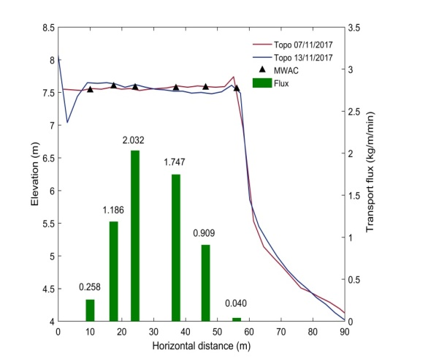
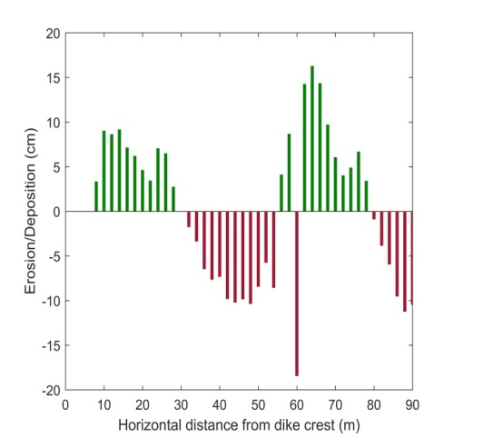
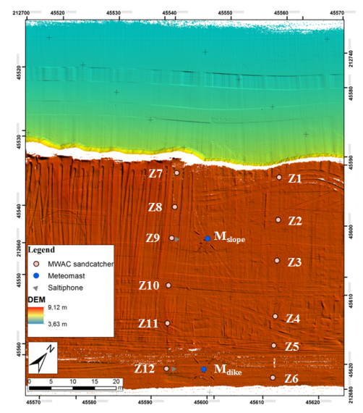

Left panel shows the measurement area with the positions of the MWAC sand traps, meteorological stations and saltiphones. Middle panel shows the topography before and after a two-hour transport event combined with the spatial variation in sediment transport. Right panel shows the difference in topography caused by the transport event. Significant erosion and deposition is measured towards the dike during onshore winds.

