000 / The Energy Journal
The economics of demand-side flexibility in distribution grids/ 000
Copyright © 2022 by the IAEE. All rights reserved.

ª Florence School of Regulation, Robert Schuman Centre for Advanced Studies, European University Institute, Via Boccaccio 121, I-50133 Florence, Italy

^{b} Department of Mechanical Engineering, Division Applied Mechanics and Energy Conversion, KU Leuven, Celestijnenlaan 300 - post box 2421, B-3001 Leuven (Heverlee), Belgium

^{c} Vlerick Business School, Vlerick Energy Centre, Bolwerklaan 21, B-1210 Brussels, Belgium

^{d} EnergyVille, Thor Park 8310, B-3600 Genk, Belgium

*Corresponding author, email: nouicer.athir@gmail.com; Telephone: [+39] 388 77 36 541.

The Energy Journal, Vol. X, No. X. Copyright © 2021 by the IAEE. All rights reserved.

The economics of demand-side flexibility in distribution grids

Athir Nouicer^{a,b}, Leonardo Meeus^{a,c} and Erik Delarue^{b,d}

To avoid unnecessary distribution network investments, distribution tariffs are expected to become more cost-reflective, and DSOs are expected to procure flexibility. This will provide an implicit and an explicit incentive to provide demand-side flexibility. In this paper, we develop a long-term bi-level equilibrium model. In the upper level, the DSO optimizes social welfare by deciding the level of investment in the distribution network and/or curtailing consumers. The regulated DSO also sets a network tariff to recover the network and flexibility costs. In the lower level, the consumers, active and passive, maximize their own welfare. We find that implicit and explicit incentives for demand-side flexibility are complementary regulatory tools, but there are limits. If network tariffs are too imperfect, the resulting consumption profiles can become too expensive to fix with curtailment. We also find that it is difficult to set an appropriate level of compensation because of the reaction by prosumers.
Keywords: Bi-level modelling, Demand-side flexibility, Distribution network investment, Flexibility compensation, Network tariffs, Prosumers.

JEL classification : C7, D61, L94, L97, Q4

1. Introduction
The Clean Energy Package (CEP) Directive (EU) 2019/944 calls on the Member States to develop regulatory frameworks that incentivize distribution system operators (DSOs) to consider the use of flexibility as an alternative to grid expansion. DSOs will have to develop and publish network development plans that make a trade-off between the use of flexible resources and system expansion. How this will be implemented is one of the main open issues in the evolution of electricity markets in Europe (Meeus, 2020).
There are only a few studies that focus on this trade-off. BMWi (2014), a study for the German energy ministry, finds that allowing DSOs to curtail up to 3% of Distributed Generation (DG) would save about 40% of the network expansion cost. ENEDIS (2017) considers the costs and benefits of six flexibility options, both on the demand and supply sides, and finds that they may provide critical net gains by 2030. At the EU level, CE and VVA Europe (2016) developed an impact assessment report for the European Commission that estimates up to €5 billion annual savings in the EU by avoiding distribution investments towards 2030 from both demand and supply sides flexibility. More recently there were several local flexibility projects implemented in EU Member States and the UK, led by DSOs, TSOs, both or independent operators such as Piclo Flex in the UK (Frontier Economics and ENTSO-E, 2021). For DSOs, many use cases are identified in Jarry and Servant (2021), from which the most advanced are for grid planning: investment deferral and permanent embedded solution, and for grid operation: demand congestion, high-voltage injection congestion and outage management. In the UK, Germany, Sweden, the Netherlands and France, 2 GW of flexibility were contracted in 2020. A large part of it is in the UK, with 1463 MW and in Germany with 400 MW (Jarry and Servant, 2021). Some flexibility projects, e.g. the German DSO Mitnetz Strom test case with Nodes marketplace, have already shown the important savings in grid operation that could be realized when procuring flexibility (Anaya and Pollitt, 2020). The regulatory framework governing these flexibility projects is under continuous development following the CEP provisions, and a network code for demand-side flexibility is expected to be developed starting from 2022 to target the regulatory barriers to unlock further benefits (European Commission, 2021).
In the academic literature, Spiliotis et al. (2016) propose a model that assesses the trade-off between grid expansion and demand and DG curtailment. They find that for a congested 24-node radial distribution network, all physical expansions could be avoided with 12% flexible demand. Klyapovskiy et al. (2019) consider flexibility from the demand side and in terms of technical solutions using grid assets and compare them to traditional reinforcement over a period of four years. Asensio et al. (2017) develop a bi-level model for the distribution network and renewable energy expansion planning under a Demand Response (DR) framework. They use a nodal network where the upper-level minimizes generation and network investment cost and the lower-level minimizes the overall payment faced by the consumers. They show how DR can contribute to adequately accommodating renewable generation in joint expansion planning. Additionally, the potential of DR for deferring investments has been successfully demonstrated.
The first contribution of this paper is to assess the interaction between implicit and explicit demand-side flexibility. Implicit demand-side flexibility is when prosumers react to price signals triggered by electricity market prices and network tariffs. Explicit demand-side flexibility is when the DSO curtails consumers' loads for a certain amount of compensation. Two streams of literature can be identified. First, the state-of-the-art papers on network tariff design, such as Abdelmotteleb et al. (2018), Burger et al. (2020), De Villena et al. (2021), and Schittekatte and Meeus (2020), do not consider the interaction with explicit demand-side flexibility. Second, the state-of-the-art papers on explicit demand-side flexibility (also referred to as active grid management in engineering literature), such as Sarker et al. (2015), Spiliotis et al. (2016) and Asensio et al. (2017), do not consider the interaction with network tariffs. To the best of our knowledge, no prior work has been developed to analyze this relationship. In this paper, we model both to study this interaction in order to fill this gap in the literature.
The second contribution of this paper is on the level of compensation for explicit demand-side flexibility. Many studies focus on the level of compensation for supply-side flexibility, but we are not aware of a similar study on demand-side flexibility. CEER (2020) highlights the importance of investigating administrative approaches for DSO’s access to flexibility, especially in case of inefficiency or market failure of market-based approaches.
The third contribution of this paper is through modelling. We develop a long-term bi-level equilibrium model. The upper level (UL) is a regulated DSO optimizes the social welfare deciding on the network investment and/or curtailing consumers as well as setting the network charge level to recover network and flexibility costs. The lower level (LL) consists of consumers, which can be prosumers or passive consumers, that maximize their own welfare. Prosumers can invest in solar PV and battery systems. They react to the network tariffs and to the compensation provided by the DSO for curtailing them. The regulated DSO anticipates the reaction of the consumers when investing in the network and when setting the level of curtailment of passive consumers and prosumers.
The paper is structured in five sections. In section 2, we introduce the modelling approach. In section 3, we detail the results of a numerical example. Then in section 4, we present the limitation of our approach. Finally, in conclusion, we summarize our main findings and their policy implications.

2. Methodology
In this section, we first introduce our modelling approach, picturing the game-theoretical model and summarizing the relevant academic literature. We then present the mathematical formulation with the different players' optimization problems and the underlying assumptions.

2.1 Modelling Approach
To model electricity systems, game theory and agent-based economics are rigorous opponents. In game theory (non-cooperative), there are two generally used solution techniques: dominance arguments and equilibrium analysis (Kreps, 2003). Dominance strategy is when the best strategy will be the same regardless of how other agents act. Nash equilibrium is settled when each agent understands and assumes the other player's optimal strategies when optimizing his own strategy.
Weidlich and Veit (2008) provide a critical survey on the use of agent-based wholesale electricity market models. They conclude that most agent-based models of the electricity market represent the demand-side as a fixed and price-insensitive load. Nevertheless, this approach could allow introducing different assumptions on consumers other than fully rational and active or completely passive (Schittekatte, 2019).
Saguan et al. (2006) provide a discussion between equilibrium and agent-based modelling to study imperfect competition in electricity markets. They show that game theory, which has been widely used to analyze such strategic interactions, allows to easily study very large systems, relying on a set of assumptions. Game theory is convenient for electricity systems as it enables to investigate the strategic behavior of agents with different interests influencing the outcome of other agents. The benefits of game-theoretic models can be categorized into two directions: First, they characterize the incentives for specific market participants to act strategically. Second, they inform market design (Bose and Low, 2019).
In game theory, the Nash Equilibrium solution is found by solving complementarity models that represent the simultaneous optimization problems of one or several agents being all decision-makers. Complementarity formulations can have several variations. We find, for instance, Mixed Complementarity Problems (MCPs) whose conditions include equalities and complementarity conditions. In the case of a situation that encompasses a leader and a follower setting, the formulation is developed as a Mathematical Program with Equilibrium Constraints (MPEC). These problems contain complementarity conditions in the constraint set. When there are several leaders, the problems are formulated as Equilibrium Problems with Equilibrium Constraints (EPECs).
MCPs are typically used for the modelling of market power in the case of an oligopoly. Nevertheless, these models can lead to myopic and contradictory behaviour (Devine and Siddiqui, 2020). MPECs are closely related to Stackelberg (Kaldor and von Stackelberg, 1936). The leader anticipates the reaction of one or several followers.
Over the past two decades, the use of bi-level programming has received growing attention among academics. It can address many real-world problems, as they can be formulated as MPECs. Many academic papers and books have focused on this kind of programming problem (e.g. Luo et al. (1996) and Dempe (2002)). In the electricity sector, in particular, it has also been increasingly applied. The model used in this paper is an extended version of that used in Schittekatte and Meeus (2020), which in turn builds on Schittekatte et al. (2018). It has the same game-theoretical set-up. Schittekatte and Meeus (2020) apply a cost minimization formulation that only looks at distribution tariffs as an implicit demand-side flexibility solution. In this paper, we include explicit demand-side flexibility in a welfare maximization context.
Our stylized model has a so-called bi-level structure. It is formulated as a mathematical program with equilibrium constraints (MPEC) using Karush–Kuhn–Tucker (KKT) optimality conditions. Being a perfectly regulated DSO, the UL maximizes system welfare. The DSO is fully unbundled, meaning that it does not own or operate any generation assets. In the LL, we model electricity consumers, passive consumers and prosumers being active consumers, which are economically rational and maximize their respective surpluses or welfare through DER investment while meeting their electricity demand. The UL feasible set is defined by both a set of constraints and the LL optimization problem, as it anticipates consumers' reactions to its decisions.
The model allows the regulated DSO to calculate the system welfare and the corresponding level of optimal explicit demand-side flexibility. The regulated DSO also decides on the network charges to send the correct signals to consumers, as is schematized in Figure 1.
[[fig 1 about here]]
The model output can be interpreted as a generalized Nash equilibrium of a non-cooperative game between the aforementioned agents, i.e. the regulated DSO and the electricity consumers. In the next subsection, we present the two optimization problems. Further details about the problem-solving are presented in Annex A.
To solve the MPEC problem, we apply the KNITRO solver in GAMS software (GAMS, 2020). The KNITRO options file allows the user to easily set certain computation options, inter alia the multi-start heuristic option, which looks for multiple local solutions in order to locate the global solution. We also include tight variable finite upper and lower bounds to reduce computation time.

2.2 Mathematical formulation
In this subsection, we first introduce the UL optimization problem and then the LL optimization problem.

2.2.1 The upper level: the regulated DSO
The UL problem maximizes system welfare. It is represented, in Eq. 1, as the difference between the gross system welfare and the total system costs. Gross system welfare, in Eq. 2, corresponds to the gross welfare from electricity consumption, valued at the Value of Lost Load (VoLL) levels (ACER, 2018), to which we add a welfare correction being the potential compensation consumers would receive from the DSO for flexibility services (Eq. 3). Total system costs consist of four components: system grid costs, demand-side flexibility costs, energy costs and DER investment costs (Eq. 4). The regulated DSO decides on: the optimal levels of network investment and demand-side flexibility based on the grid parameters; and compensation. It also anticipates the LL strategy. The trade-off between network investment and the use of flexibility is a topic of growing importance in distribution planning.
$MaximiseGrossSystemWelfare−TotalSystemCosts\left(1\right)$
The electricity demand $D_{i,daytype,t}$ is equal for consumers, $i$, regardless of whether they are active or passive. Demand profiles are 24h time series, and $t$ takes a value from 1 to 24. However, it differs according to the $daytype$: normal days or critical days with higher peaks. Their total weight equals the number of days per year. ${PC}_{i}$ corresponds to the proportion of prosumers and passive consumers. The compensation, $COMP$, is considered uniform for the different hours and consumer types and ${WDT}_{daytype}$ is a factor annualizing the values.
$GrossSystemWelfare=\sum_{i=1}^{N}{{PC}_{i}∗\sum_{Daytype=1}^{M}{\sum_{t=1}^{T}{\left(D_{i,daytype,t}− | | {qflex}_{i,daytype,t}\right)∗VoLL∗{WDT}_{daytype}+WelfareCorrection\left(2\right)}}}$
$WelfareCorrection=\sum_{i=1}^{N}{{PC}_{i}∗\sum_{Daytype=1}^{M}{\sum_{t=1}^{T}{COMP∗{qflex}_{i,daytype,t}}}}∗{WDT}_{daytype}\left(3\right)$
$TotalSystemCosts=SystemGridCosts+SystemFlexCosts+SystemDERCosts+SystemEnergyCosts\left(4\right)$
Eq. 5 represents the system grid costs corresponding to the DSO's investment in network expansion. They are assumed to be driven by the coincident peak, meaning that there is no grid at the beginning of the simulation. No sunk costs are therefore included, and neither do they have to be recovered. System grid costs are a function of the coincident peak $\left(cPeak\right)$ and the original demand, $D_{i,daytype,t}$, peak, which is $DPeak$. The extent to which system grid costs are a function of $DPeak$ or $cPeak$ depends on the $WF$, that is, the weighting factor representing the network cost drivers’ proxy. It has values ranging between 0 and 1. A $WF$ equal to zero means that individual consumer actions adapting their consumption will not impact grid investment. Conversely, a value of 1 means that a consumer demand reduction of 1 kW will reduce the system peak by 1 kW and consequently reduce grid investments. A similar approach to grid cost representation is used in Schittekatte and Meeus (2020).
$$SystemGridCosts=IncrGridCosts∗\left(DPeak−WF∗\left(Dpeak−cPeak\right)\right)\left(5\right)$$
The $cPeak$ is determined as the maximum of the demand peak $\left(cPeakDemand\right)$ and injection peak $\left(cPeakInjection\right)$ and is represented by Eqs. 6 to 8. $cPeakDemand$ is the maximum value of consumers' withdrawals from the grid $\left(qw_{i,daytype,t}\right)$ minus injections $\left(qi_{i,daytype,t}\right)$. Both, $qw_{i,daytype,t}$ and $qi_{i,daytype,t}$, are consumer decision variables. The same logic applies to $cPeakInjection$.
$$cPeak=max\left(cPeakDemand,cPeakInjection\right)\left(6\right)$$
$$cPeakDemand≥\sum_{i=1}^{N}{{PC}_{i}∗\left(qw_{i,daytype,t}−qi_{i,daytype,t}\right)}∀t,daytype\left(7\right)$$
$$cPeakInjection≥\sum_{i=1}^{N}{PC_{i}∗\left(qi_{i,daytype,t}−qw_{i,daytype,t}\right)}∀t,daytype\left(8\right)$$
Eq. 9 represents the demand-side flexibility costs, which are the costs of load curtailment. When a volume ${qflex}_{i,daytype.t}$ occurs (in kWh), it is multiplied by its compensation, $COMP$(in €), which is a parameter exogenous to the model. They are then summed for the different time steps and day types and multiplied by the annuity factor.
$$SystemFlexCosts=\sum_{Daytype=1}^{M}{\sum_{t=1}^{T}{\sum_{i=1}^{N}{PC_{i}∗\left(COMP∗{qflex}_{i,daytype.t}\right)}}∗{WDT}_{daytype}}\left(9\right)$$
Prosumers can invest in DERs, which are solar PV and battery systems. Eq. 10 represents the total investment costs in DERs. The decision variable ${is}_{i}$ is for solar PV investment (in kWp) installed by consumer $i$, and $ib_{i}$ is for investment in batteries (in kWh) installed by consumer$i$. $AICS$ and $AICB$are the annualized investment costs for solar PV and batteries, respectively. No maintenance costs or degradation of the DER technologies are assumed.
$$DERCosts=\sum_{i=1}^{N}{{is}_{i}∗AICS+ib_{i}∗AICB}\left(10\right)$$
The system energy costs are calculated using Eq. 11. ${EBP}_{t}$ refers to the fixed purchase price of a kWh of electricity. ${ESP}_{t}$ is the fixed price received for selling a kWh of electricity. We opted for constant energy prices in order to isolate the effect of demand-side flexibility. There are several market issues that could potentially influence the potential of demand-side flexibility. For instance, with Time-of-Use (ToU) prices, there could be arbitrage potential from active consumers to strategically behave and benefit from the difference in electricity prices.
$$EnergyCosts=\sum_{Daytype=1}^{M}{\sum_{t=1}^{T}{\sum_{i=1}^{N}{\left(qw_{i,daytype,t}∗{EBP}_{t}−qi_{i,daytype,t}∗{ESP}_{t}\right)∗{WDT}_{daytype}\left(11\right)}}}$$
The cost recovery equation (Eq. 12) allows the regulated DSO to recover both the explicit demand-side flexibility and network investment costs from the network tariffs. Network tariffs are typically composed of three components; a capacity 𝑐𝑛𝑡 (€/kW), a volumetric 𝑣𝑛𝑡 (€/kWh) and a fixed component 𝑓𝑛𝑡 (€/consumer). The LL decides on $qw_{i,daytype,t}$, $qi_{i,daytype,t}$ and $qmax_{i}$, where $qmax_{i}$ is the maximum of $qw_{i,daytype,t}$ and $qi_{i,daytype,t}$ over the time series.
$$\sum_{Daytype=1}^{M}{\sum_{t=1}^{T}{\sum_{i=1}^{N}{PC_{i}∗\left(COMP∗{qflex}_{i,daytype,t}\right)+IncrGridCosts∗cPeak}}}=vnt∗\sum_{Daytype=1}^{M}{\sum_{t=1}^{T}{\sum_{i=1}^{N}{PC_{i}∗\left(qw_{i,daytype,t}−qi_{i,daytype,t}\right)∗}}{WDT}_{daytype}+cnt∗\sum_{i=1}^{N}{PC_{i}∗qmax_{i}+fnt\left(12\right)}}$$
Eq. 13 provides non-negativity constraints for the upper-level optimization problem.
$$cnt,fnt,vnt,{qflex}_{i,daytype,t}≥0∀i,t,daytype\left(13\right)$$
Please note that, in practice, there are more elements that could intervene in the problem formulation and solution process. A DSO is unlikely to have all information regarding consumers' behavior correctly communicated when solving the model. Communication lines, technological tools such as smart meters as well as commercial arrangements with the LL's consumers such as smart connection agreements may come into play. These tools may create concerns about data access and privacy. In the model, we assume they are in place. The model aims to give insights regarding the potential of demand-side flexibility and enrich the regulatory debate.

2.2.2 The lower level: consumers
In the LL, we model electricity consumers, which can be passive or active. Passive consumers are assumed not to react to flexibility sourcing or network tariffs, while prosumers can invest in DERs to maximize their surpluses. They can also make a trade-off between being curtailed and receiving the corresponding remuneration or investing in DERs to limit the load reduction volumes. A combination of both is, of course, possible. While flexibility allows network costs to be reduced, it harms the consumers' welfare as they value electricity consumption at the VoLL levels.
The consumers are aggregated by type in the LL and they do not recourse to (independent) aggregators to benefit from extra revenues selling their flexibility in our model. We implicitly assume that they have enough information or knowledge, e.g. being very smart, about the demand-side flexibility opportunities themselves.
Each consumer aims to maximize its surplus expressed in Eq.14, which corresponds to the difference between the gross consumer surplus and the costs incurred.
$$MaximiseGr{ossConsumerSurplus}_{i}−Costs_{i}\left(14\right)$$
The gross consumer surplus (Eq.15) corresponds to the value of electricity consumption, that, is every kWh consumed multiplied by the VoLL, to which we add the welfare correction, is the compensation each consumer gets for explicit demand-side flexibility.
$Gr{ossConsumerSurplus}_{i}=\sum_{Daytype=1}^{M}{\sum_{t=1}^{T}{\left(D | | i,daytype,t−{qflex}_{i,daytype,t}\right)∗VoLL∗{WDT}_{daytype}+WelfareCorrection_{i}∀i\left(15\right)}}$
$WelfareCorrection_{i}=\sum_{Daytype=1}^{M}{\sum_{t=1}^{T}{\left(COMP∗{qflex}_{i,daytype,t}\right)∗{WDT}_{daytype}∀i\left(16\right)}}$
We divide the costs that every consumer has to pay into three components: energy costs, network charges and DER costs, as is shown in Eq. 17. The calculation of each component is given by Eqs. 18 to 20.
$$Costs_{i}=EnergyCosts_{i}+GridCharges_{i}+DERCosts_{i}∀i\left(17\right)$$
$EnergyCost_{i}=\sum_{Daytype=1}^{M}{\sum_{t=1}^{T}{\left(qw_{i,daytype,t}∗{EBP}_{t}−qi_{i,daytype,t}∗{ESP}_{t}\right)∗{WDT}_{daytype}∀i\left(18\right)}}$
$Gridcharges_{i}=\sum_{Daytype=1}^{M}{\sum_{t=1}^{T}{\left(qw_{i,daytype,t}−NM∗qi_{i,daytype,t}\right)∗vnt∗{WDT}_{daytype}+cnt∗qmax_{i}}}+fnt∀i\left(19\right)$
$$DERCosts_{i}=is_{i}∗AICS+ib_{i}∗AICB∀i\left(20\right)$$
The consumer's demand balance is shown in Eq. 21.
${qw}_{i,daytype,t}+{is}_{i}∗{SY}_{i,t}+{qbout}_{i,daytype,t}−{qi}_{i,daytype,t}−{qbin}_{i,daytype,t}+{qflex}_{i,daytype,t}−D_{i,daytype,t}=0∀t,daytype,i\left(21\right)$
In order to solve the problem, the LL optimization problem is replaced by Karush-Kuhn-Tucker (KKT) optimality conditions. The full sequence of the mathematical process can be found in Annex A.
Note that, later in the paper, we will run the model stochastically for one of our sensitivity analyses, which entails some formulation changes. By introducing different probabilistic scenarios for the LL, all its variables, e.g. consumer withdrawal $qw_{sc,i,daytype,t}$ scenario dependent parameters, e.g. consumer demand $D_{sc,i,daytype,t}$ and other components will be scenario-indexed, with “sc” referring to the scenario. The UL variables will not be impacted, as the DSO will take a unique decision regarding network investment and curtailment for all the scenarios, taking into account the probability of their occurrence. Such a formulation has been used in Gabriel et al. (2013) and Askeland et al. (2020).

3. Case study and results
This section is divided into three subsections. First, we present the case study and justify the parameters used. Second, we present the results. Finally, we conduct a sensitivity analysis.

3.1 Case study
In this subsection, we introduce the parameters we consider in our model. First, we introduce the demand-related parameters, including the VoLL values. Second, we present the DER parameters, and third, we list the grid parameters together with the flexibility compensation. Finally, we summarize the parameters for the reference scenario.

3.1.1 Demand-related parameters
In our model, we consider a 50%-50% distribution between prosumers and passive consumers in the reference scenario. This may seem quite ambitious today. However, seeing the current trends in the electricity sector, i.e. decreasing DER investment costs and rising electricity bills together with climate awareness and the movement towards reappropriation of the energy transition, more and more passive consumers may become active (Schittekatte and Meeus, 2020). In Belgium, about 38% of the population lives in detached houses and about 40% in semi-detached houses as of 2016, which is above the EU average (Statista, 2017). This makes them potentially able to deploy PV installations on their premises. The option of opting for cooperative approaches remains possible for others. Furthermore, De Villena et al. (2021) run a simulation over ten four-year regulatory periods and show that between 79% and 85% of the potential prosumers have become actual prosumers in Wallonia under a network tariff with a capacity component. This percentage reaches 100% under the net-metering scheme that provides higher incentives to invest in Solar PV.
Both prosumers and passive consumers have similar load profiles. The load profiles we use are divided into two categories: normal days and critical days. The two types of profiles are annualized with different weights. In the reference scenario, we use 350 normal days and 15 critical days. The concept of critical days in network planning is analogous to critical peak pricing (CPP) for electricity network tariffs. For instance, in Australia, CCP retail tariff schemes, in combination with network capacity charge, assume 10 to 15 days with extreme demand (Norris et al., 2014). In France, 22 days are considered critical in retail tariffs offers within the TEMPO programme (EDF, 2019), while for demand curtailment RTE considers 10 to 15 days critical based on weather forecasts (RTE, 2019a) and 10 to 25 days based on system voltage (RTE, 2019b). Demand-side flexibility schemes can be decoupled from electricity retail offers (EnergyAustralia, (2019) and AGL, (2019)) and operated by system operators to ensure reliable supply in extreme weather events. For instance, CRE (2018) summarizes the demand curtailment regulatory framework organized by system operators in France.
We obtain the normal day load profiles from the 2019 Belgian synthetic load profiles (SLPs) of residential consumers (Synergrid, 2019). SLPs reflect the average load, meaning that the peaks are normalized. They are used as input data in the academic literature as, for instance, in Govaerts et al. (2019). The maximum peak load is found during a winter weekend and is $1.6kW$. The maximum peak load during weekdays is also in winter and is slightly lower than the peak load at weekends. On critical days, the two daily peaks are magnified. The maximum peak load on critical days is $5kW$. The high peaks in the critical day' profiles are due to spikes in consumption resulting from weather conditions or other external factors leading to extensive use of appliances with higher power requirements. Hayn et al. (2014) present an illustration of the peak demand for selected household appliances, such as a dishwasher $3kW$, an oven $2.8kW$ and a dryer $2.7kW$. We distribute their use randomly in terms of time, amplitude and duration, with a concentration of use around the two original peaks of normal days, as is shown in Figure 2. In the future, with the integration of electric vehicles and heat pumps it is likely that these technologies will have a huge impact on household' electricity consumption and the load profile peaks. We use a yearly demand of 4000 kWh, which is in the same range as the average residential electricity consumption in Belgium (ENGIE, 2019). Energyprice (2019) states that a medium Belgian household (family of three with electric water heater) consumes about 3500 kWh of electricity per year.
[[fig 2 about here]]
Our modelling approach values the possible discomfort felt by consumers related to demand-side flexibility sourcing, which is expressed through the VoLL and the value of lack of adequacy (VoLA) parameters. The VoLA corresponds to a VoLL with one day's notice. Its value is about 50% less than the VoLL in the different Member States. Using different values of the VoLL can therefore be linked to the time of the announcement of a load reduction event to consumers, which is the notice factor. ACER (2018) gives estimated VoLL and VoLA values for the different EU Member States. We consider a VoLL equal to 5.33 €/kWh in our reference scenario. According to ACER 2018, this corresponds to the annual average VoLA in Belgium. VoLL values differ across Europe. The lowest domestic value is in Bulgaria, with 1.5 €/kWh, and the highest is in the Netherlands, with 22.94 €/kWh. Similarly, VoLA values vary among the Member States, from 0.83 €/kWh in Bulgaria to 12.73 €/kWh in the Netherlands.
It is assumed that consumers are equipped with smart metering systems and two-way communication infrastructures. Smart metering systems are prerequisites allowing consumers to actively control their consumption. Electricity Directive 2009/72/EC introduced an obligation for the Member States to opt for 80% roll-out of consumers by 2020, conditional to a positive Cost Benefits Analysis. Nine EU countries have already reached the 80% target at the end of 2019 (Nouicer et al., 2020). Spain has reached a 100% electricity smart metering roll-out in 2018 (Tounquet and Alaton, 2019). In Belgium, Fluvius, the distribution system operator (DSO) in Flanders, has initiated a 4.3 million smart meter roll-out, reaching 80% of Flemish households by the end of 2024 (Jones, 2020). Therefore it is acceptable to assume that the consumers are already equipped with smart metering systems with two-way communication capabilities as in Meng and Zeng (2016).

3.1.2 DER parameters
We consider that prosumers can invest up to $4kW$ of solar PV. There is no utility-scale PV, and neither are there large battery systems. A European Commission (2017) behavioural study assumes $3.87kW$ to be the average size of residential solar PV installations in Belgium by 2030. Prosumers can also invest up to 8 kWh in battery system capacity.
The installation cost of PV is assumed to be 1200 €/kWp, with a lifetime of 20 years and a discount rate of 5%. For instance, in Germany a small rooftop PV (5-15 kWp) costs in the range between 1200€/kWp and 1400€/kWp (Kost et al., 2018). Worldwide PV investment costs are decreasing, as IRENA (2018) and Solar Power Europe (2018) state. This justifies our choice of PV investment cost projection.
Regarding battery storage, we opt for a 100€/kWh investment cost, with a lifetime of 10 years and a discount rate of 5%. We also use 90% efficiency in charging and discharging and a 2% leakage rate. IRENA (2017) includes a projection of battery storage costs in 2030 of around 140 €/kWh, depending on lithium-ion battery technology. In a JRC report, Steen et al. (2017) state that lithium-ion battery prices were under $140/kWh in 2017, according to different sources. In the US, Tesla has announced that it will reach $100/kWh by 2022 (Lutsey and Nicholas, 2019).

3.1.3 Grid-related parameters
In our analysis, grid costs are assumed to be 100% driven by the coincident peak. No network is assumed at the beginning of the simulation. The aim is to stress the value of the trade-off between grid investment and flexibility, as flexibility contributes to reducing the coincident peak. To obtain the values of the grid cost function parameters (Eq. 5), we first calculate the 'default' network costs of the consumers modelled. In our setting, $IncrGridCosts$ are 400 €/kW. The network tariffs are simple capacity-based tariffs. They are imperfect because they are flat instead of dynamic. In the reference scenario, we use a reasonable proxy for the accuracy of network cost drivers: WF =1. This means that tariffs are deemed to be more cost-reflective of the system state and that prosumers correctly adapt their profiles to price signals. A worse proxy, e.g. 0.5, would mean that consumers will lower their demand at a different time to that needed by the DSO. Introducing an imperfect proxy would also relax the assumption of identical consumer demand profiles (Schittekatte, 2019).
Regarding demand-side flexibility compensation, we choose $COMP=1€/{kWh}$ for the reference scenario. As the procurement of flexibility services has only been tested recently in the electricity sector, there are not many studies that assess demand-side flexibility compensation. Schittekatte and Meeus (2020) and Dronne et al. (2021) discuss the different pioneering flexibility procurement projects at the distribution level in Europe. For the case of UKPN, a DSO in the UK that runs flexibility tenders through the Piclo Flex marketplace, the post-tender report indicates the prices of the different accepted bids in its 2018/19 flexibility tender. The values for utilization payments range between $0.001€/{kWh}$ and $1.28€/{kWh}$ (UKPN 2019). The minimum bid of $0.001€/{kWh}$ includes an availability payment, while the maximum one of $1.28€/{kWh}$ does not. In our model, we only give a utilization (energy) compensation for demand flexibility. It should be noted that UKPN flexibility bid prices reflect the prices of a voluntary market-based mechanism.

3.1.4 The reference scenario
Based on the assumptions above, in Table 1, we summarize the main parameters in our reference scenario.
[[table 1 about here]]

3.2 Results
In this section, we first present the role of demand-side flexibility in saving distribution network investments. We then assess its impact on system welfare in order to find the optimal demand-side flexibility level. Next, we investigate the impact of network tariffs and explicit demand-side flexibility compensation. Finally, we assess the role of some context-related elements in the demand-side flexibility framework.

3.2.1 Distribution network investment savings
In a first step, we run our model to assess the savings in distribution network investments that the DSO can realize by adopting different levels of demand-side flexibility. To do this, we calculate the network investment in the case where no flexibility is procured. In steps, we then integrate the different demand-side flexibility levels, which are calculated as percentages of the annual demand. This forces the model to solve for the flexibility levels indicated. Figure 3 shows the network investment savings for different demand-side flexibility levels that are procured. It resembles the BMWi (2014) system expansion savings curve, which focuses on DG curtailment.
[[fig 3 about here]]
Network cost savings increase rapidly for demand flexibility volumes below 6 %, and then the curve has a less steep incline. We find that a 3% level of demand-side flexibility allows 62% of distribution grid investment savings, and a 5% level allows 75%. The flexibility costs are not taken into account in Figure 3. They are considered as operational expenditures (OPEX), while the savings on grid investment are purely on capital expenditure (CAPEX).

3.2.2 Impact on system welfare
In a second step, we extend our analysis to look at the system welfare (represented in Eq. 1) for different demand-side flexibility levels. This encompasses the introduction of gross welfare, which is measured through the VoLL, valuing the socio-economic loss involved in the non-provision of an electricity unit to the consumer (ACER, 2018). In addition, the different system costs (represented in Eq. 4) are considered. The aim is to have a more holistic view of the impact of demand-side flexibility levels on the opportunity costs of electricity consumption and the different associated costs at the system level.
[[fig 4 about here]]
As in the previous figure, in Figure 4, we integrate the different demand-side flexibility levels in steps and then plot the system welfare levels. We find that for low levels of demand-side flexibility from 0% to 2%, there is an increase in system welfare as demand-side flexibility increases. From 2% onwards, the system welfare starts to decrease. This means that the optimal demand-side flexibility level is between 1% and 3%. The decrease in system welfare for higher demand-side flexibility volumes is driven by two effects: a decrease in gross system welfare and an increase in flexibility costs, and consequently in total system costs.
We then allow the model to decide on the optimal demand-side flexibility level. For the reference scenario, this results in an optimal level of 1.48% demand-side flexibility and €23,816 system welfare, normalized to the (average) consumer. This flexibility allows a €476 annual welfare gain per consumer compared to the case where no demand-side flexibility is introduced. Passive consumers are more curtailed than prosumers, with a 65%/35% ratio of the total flexibility volume, as is shown in Figure 5. Note that the passive consumers do not respond to the implicit signals (by definition), so the only way to reach them is with an explicit mechanism. The active consumers do respond to the implicit signals, but even network tariffs that are trying to be cost-reflective will have simplifications that make them slightly imperfect. The imperfection in the reference case is that the tariff is flat rather than dynamic.
[[fig 5 about here]]
To grasp the underlying contributions of the implicit (network tariffs) and explicit demand-side flexibility, we report, in Table 2, the welfare levels with the different types of demand-side flexibility. First, the table confirms the results of the state of the art literature on network tariffs that argue in favour of more cost-reflective tariffs. By moving from volumetric tariffs to simple capacity tariffs, there is a welfare gain of €531 per year per consumer in our numerical example. If we then also correct the imperfections of the relatively simple implementation of the capacity tariff by using explicit demand-side flexibility, we gain an additional €475 per year per consumer. To achieve this system benefit, the average payment to consumers would be €70 per year per consumer to compensate them for curtailment.
[[table 2 about here]]
The curtailment occurs during the hours where the network is congested. As illustrated in Figure 6, the network is used 100% in 121 hours during the year that we simulate, and the loading of the line also varies significantly in the other hours.
[[fig 6 about here]]
3.2.3 An imperfect proxy for network cost drivers, WF=0.5
In order to assess the interaction with network tariffs in more detail, we introduce an imperfect proxy for the network cost drivers. We consider a 0.5 proxy for network cost drivers, meaning that a 1 kW reduction in the consumer profile peak contributes a 0.5 kW reduction in the system peak. This is also equivalent to having heterogeneous demand profiles among consumers that are optimizing their individual profiles. Passey et al. (2017) find that the correlation coefficient between consumer payments under capacity-based tariffs and responsibility for the network peak is very low, at 0.56.
Under this condition, the optimal demand-side flexibility level drops from 1.48% to only 0.35%. The resulting annual welfare gain per consumer drops too, to € 41.8. Figure 7 shows the load profiles of both types of consumers for a WF equal to 0.5. If network tariffs are too imperfect, the resulting consumption profiles can become too expensive to fix with curtailment. By increasing curtailment, we also increase the network tariffs that are used to recover the costs from compensation, which increases the imperfect signal from the tariff. It can then become relatively cheaper to invest more in the network. In other words, implicit and explicit incentives for demand-side flexibility are complementary regulatory tools, but there are limits. Smart curtailment is not an alternative to tariff reforms, but tariffs will always remain somewhat imperfect, and these imperfections can be remedied with explicit flexibility mechanisms.
[[fig 7 about here]]

3.2.4 The role of prosumers and DER investments
We further expand our assessment by analyzing cases with different prosumers’ shares and types. We find that when all consumers are passive, the optimal demand-side flexibility level stands at 1% while allowing a €313 welfare gain. With 25% prosumers, the overall optimal demand-side flexibility remains the same, while there is a higher welfare gain. In the case of 100% prosumers, on the other hand, the optimal demand-side flexibility level is 0.34%, allowing only €124. When only batteries are allowed, there is a lower optimal demand-side flexibility, as the contribution of prosumers is limited. In Table 3, we present the optimal demand-side flexibility levels and the annual welfare gains per consumer for the different cases.
[[table 3 about here]]
In the case of 100% passive consumers, there is no implicit demand-side flexibility that will change consumer behaviours. The DSO procures 1% of explicit demand-side flexibility. Compared to the reference scenario, the optimal flexibility level is lower. The reason is that, in the reference scenario, the contribution of implicit demand-side flexibility allows more explicit demand-side flexibility, mainly among passive consumers, and leads to more system cost savings. However, with all passive consumers, this difference between profiles is non-existent. For 100% prosumers, there is 0.34% explicit demand-side flexibility, which is also lower than in the reference scenario. The rationale behind this is that prosumers are able to flatten their consumption profiles in reaction to the network tariff signals sent by the DSO. However, with an already flattened profile, there is limited room for further welfare gain, taking into account the effect of the gross consumer welfare loss and the reduction in total system costs. This results in a small welfare gain in the case of 100% prosumers. For the case of 25% prosumers and 75% passive consumers, we find a 1.1% optimal level of explicit demand-side flexibility while creating more welfare gain than in the case with 100% passive consumers due to the prosumers’ contribution to lowering system costs. The case where only battery systems are allowed may reflect a situation where prosumers have no access to an individual rooftop. There is a lower level of optimal demand-side flexibility, being 0.54%. Battery systems are used to cover the day peak for the prosumers that used to be covered by solar PV generation. We include an illustration of the load profiles of this case in Appendix A3. Illustrations.

3.2.5 Strategic behaviours and the impact of compensation levels
Another parameter that is key in the economics of explicit demand-side flexibility in distribution networks is flexibility compensation. In this part, we run the model for different levels of compensation. We set a low compensation, compared to the reference scenario, at €0.5 and a high compensation equal to the VoLL at €5.33. Table 4 shows the demand-side flexibility levels and the annual welfare gains per consumer for the different compensation levels.
We see that with low compensation, the optimal flexibility level decreases, as does the welfare gain, as this compensation is too low for passive consumers. It, therefore, decreases the optimal flexibility level and the related welfare gain. For a compensation equal to the VoLL, the optimal flexibility level remains almost the same. However, the welfare gain is reduced compared to the reference scenario. This is due to strategic behaviour by prosumers, which is shown in their load profiles in Figure 8. We explain this further in the next two paragraphs.
[[table 4 about here]]
Compared to the load profile in the reference scenario (in Figure 5(a)), we see in Figure 8(a) that prosumers use their battery output differently. Indeed at t20, which corresponds to the evening peak, prosumers' battery input is $1.7kW$ instead of $2.9kW$ in the reference scenario. In addition, at t21, there is no battery output from prosumers, compared to $0.6kW$ in the reference scenario. Therefore, the DSO has to curtail more prosumers, including at the night peak, even though we have a perfect proxy for the network cost drivers. Indeed, with this behaviour, prosumers are more curtailed than passive consumers, with a 65%/35% ratio, which is the reverse of the reference scenario.
Another effect that is seen with high compensation is that the prosumer profile has a smaller magnitude in Figure 8(a) than in Figure 5(a). We may think that this is a positive reaction to the perfect proxy for the network cost. However, if we look again at the battery output during and following the night peak, we see that with no or little battery output in these hours, and that there is more curtailment of prosumers.
[[fig 8 about here]]
We may tend to think also that a compensation set at the VoLL will lead to higher welfare gain. However, we find that this does not happen in the case of prosumers as they value electricity consumption less, which leads to them behaving strategically in order to benefit from the relatively high compensation. The rationale behind this is that prosumers and passive consumers value electricity differently. Therefore, the VoLL for prosumers is lower than for passive consumers. Studies on VoLL estimates segment consumers into different groups based on their economic activity, e.g. domestic consumers and industrial consumers (ACER, 2018). However, there is no differentiation between active and passive consumers in the VoLL estimations. For instance, ENW (2019) highlights that vulnerable and low-income electricity consumers have higher VoLLs than average. Further effects of the VoLL will be presented in the next section.

3.2.6 Sensitivity results
In this section, a sensitivity analysis is carried out in order to assess the impacts of four context-specific parameters in the demand-side flexibility framework. These parameters are the VoLL, a cap for maximum allowed curtailment, the frequency of critical days and network investment costs. The sensitivity analysis aims to validate the model results and to highlight the extent to which the potential of demand-side flexibility is context-specific.

A. Impact of VoLL levels
In the first sensitivity analysis, we consider two other VoLL values: 2 €/kWh, which is a low VoLL across the EU Member States, and 9.6 €/kWh, which is high.
[[table 5 about here]]
First, we observe that VoLL levels are inversely proportional to demand-side optimal flexibility levels. For a low VoLL of 2 €/kWh we observe higher levels of demand-side flexibility: 4.4% of the total demand. This is explained by the fact that consumers value electricity consumption less. The lower annual welfare gain per consumer is due to the decrease in gross system welfare caused by higher flexibility levels compared to the reference scenario. In addition, as gross welfare is a product of VoLL multiplication, then a lower VoLL will also lead to lower welfare gain. We include the consumers’ load profiles for the case of a low VoLL in Appendix A3. At a high VoLL of 9.6 €/kWh we see the opposite effect, with a low demand-side flexibility level leading to a relatively high welfare gain.
Another element that impacts the potential of demand-side flexibility is the notice factor. This translates into whether consumers are notified (e.g. via email or SMS) about the curtailment event or not. According to ACER (2018), implementing a notice factor reduces the impact of electricity disruption. It also translates into a reduction of VoLL by about 50%, which is then called VoLA. Indeed, in the case of Belgium VoLL is equal to 9.6 €/kWh, and VoLA is equal to 5.33 €/kWh. This means that the effect of introducing a notice factor is the same as moving from the third to the second column in Table 5. It, therefore, results in higher optimal demand-side flexibility and, more importantly, higher welfare gains.

B. The impact of a cap on hourly curtailment
For the second sensitivity analysis, we introduce a cap on the maximum allowed curtailment by the DSO applied to consumers being 1.5 kWh that translates in the following constraint: ${qflex}_{i,daytype,t}≤1.5kWh$. This could be indeed a real constraint faced by the DSO to not include cases with complete consumers’ disconnection during network planning. This is particularly relevant for the case with a low VoLL, as in this case, there are hours where passive consumers are disconnected (appendix A3). We report the results in the following Table 6.
[[table 6 about here]]
We find that the total flexibility levels are lower for the case of a VoLL equal to 2 €/kWh and for the reference scenario. This is due to the fact that for those two scenarios, there are a few hours where the curtailment ${qflex}_{i,daytype,t}$ is higher than 1.5 kWh when no cap constraint is applied. This is also translated into fewer annual welfare gains per consumer from explicit demand-side flexibility than when no flexibility is allowed. For the case where VoLL is equal to 9.6 €/kWh, there is no change in the flexibility level and in the welfare gain. The reason is that with a high VoLL, there is less curtailment, and it did not exceed 1.5 kWh. The higher welfare gain, in this case, is due to higher VoLL values. We include, in appendix A3, the consumers’ load profiles for the case of a low VoLL with a cap on maximum curtailment.

C. The impact of the frequency of critical days
For the third sensitivity analysis, we choose frequencies of critical days from 5 to 104 days a year (Table 7). The choice of 104 as the maximum frequency corresponds to the frequency of weekend days a year. This is in order to assess how an optimal flexibility volume interacts with the frequency of critical days, inter alia, when they become as frequent as weekend days.
[[table 7 about here]]
We observe that the optimal levels of flexibility are inversely proportional to the frequency of critical days. For low frequencies of critical days, there are higher optimal demand-side flexibility volumes. There are two main reasons behind this observation. First, with low frequencies of critical days, the regulated DSO would need fewer flexibility volumes to reduce the peaks on the critical days. Second, as we increase the frequency of critical days, the total annual demand volume increases. This is natural since the demand during a critical day is higher than on a normal day. Substituting a normal day with a critical one increases the total demand volume. This could be neutralized by reducing the demand on the other normal days. However, we do not change this for practical reasons, as changing the normal day profile may create other unwanted effects. The two above-mentioned effects happen in opposite directions in the two first columns in Table 7. Indeed, for five critical days, there is higher welfare gain and higher optimal levels of flexibility, as it is easier to neutralize the critical day' peaks.
Another observation is that in the case with 104 critical days, meaning that they are as frequent as weekend days, the optimal flexibility level is 0%. This confirms the fact that the variation in demand profiles between weekdays and weekends does not result in the use of explicit demand-side flexibility during weekends. Weekend days usually have different consumption levels and peaks. For instance, in the Belgian SLP of Synergrid (2019), weekend days have slightly higher peaks. With a high frequency of critical days, higher volumes are needed to reduce peaks to realize system cost savings, as these peaks are very frequent, which in turn will impact gross system welfare. Therefore, it is better to fully build the distribution network and size it to fit the critical day's demand without procuring any flexibility.

D. The impact of network investment costs
Network expansion costs are particularly relevant in DSOs network planning. High network expansion costs can incentivize DSOs to further use demand-side flexibility. In order to assess the impact of this, we consider three scenarios with different incremental network costs, as is shown in Table 8.
[[table 8 about here]]
The results confirm that optimal demand-side flexibility volumes increase with higher network expansion costs. With low expansion costs, reinforcing the network is the most logical pathway. Demand-side flexibility of 0.3% is deemed optimal. This will only allow a €55 annual welfare gain per consumer. With low network expansion costs, the regulated DSO will naturally favour network reinforcement as it is not costly. Only a very small part of the consumer's demand is curtailed.
For high network expansion costs, the optimal flexibility levels increase. The rationale behind this is that with these high costs, the contribution of demand-side flexibility to system cost savings is more significant. However, the welfare gain is limited due to higher volumes of demand-side flexibility impacting gross system welfare in comparison with the reference scenario.

E. The Impact of uncertainty
Another sensitivity is the information available to the DSO. In practice, the DSO needs to forecast the demand profile of consumers. For simplicity and computation time, we consider two scenarios for the consumers’ demand during critical days, with a 50-50 probability of occurrence. This is done following the stochastic formulation described at the end of subsection 2.2.
The scenarios differ in the level of the demand peaks during the critical days, i.e. four hours around the daily peak and five hours around the evening peak. The low demand scenario (sc1) has X kWh less demand during the peak hours, while the high demand scenario (sc2) has X kWh more compared to the reference scenario. This means that when averaging sc1 and sc2, we get the reference scenario.
Figure 9 shows the electricity demand profiles per scenario for X=1kWh representing an uncertainty of circa 20% at the highest demand peak. We also run the model for 10% uncertainty, i.e. X= 0.5 kWh.
[[fig 9 about here]]
We show in Table 9 the resulting optimal flexibility level that is used by the DSO and the resulting reduction in network investment compared to the reference scenario.
[[table 9 about here]]
We find that introducing a 10% uncertainty leads to increased network investment of 2% and an optimal level of explicit demand-side flexibility of 3%. While for a 20% uncertainty, the DSO network investment is 6% more than in the reference scenario, and the optimal level of flexibility is 2.3%.
Therefore, with the introduction of uncertainty, the DSO is more conservative regarding network investment. He/she considers the worst-case scenario with the highest demand peaks when building the network. Still, the DSO also continues to use flexibility to reduce the need for network investments, even in scenarios with demand uncertainty as high as 20%.

4. Limitations of our approach
In the next section, we draw conclusions that are based on the relative importance of different effects rather than their absolute values. Note that our model captures key aspects, but of course, it also has its limitations. Some of these limitations imply that we underestimate the value of flexibility, others that we overestimate this value. In what follows, we illustrate two of these limitations.
An illustration of underestimation is that we modelled a long term equilibrium model assessing the trade-off between demand-side flexibility versus distribution network investment and the related welfare gains. We did not integrate the transmission network. Yet, the Transmission System Operators (TSOs) could also potentially benefit from such resources to reduce the required network capacity in coordination with the DSOs. Hadush and Meeus (2018) discuss the different approaches and models for coordinated use of low voltage distribution connected flexibility resources by TSOs and DSOs. Each approach will have an impact on the possible welfare gains. The European Commission (2016) impact assessment on the Market Design initiative shows, for instance, the transmission and distribution network benefits from demand peak reduction. With a greater pool of flexible assets, the TSO will have more options to optimize network planning and operation and consequently realize more welfare gains.
An illustration of overestimation is with regard to the demand profiles peaks of critical days. We used demand profiles where the evening peaks are more pronounced than the day ones, which is the case in many EU Member States. Then in the results section, we found that the prosumers, with capacity-based network tariffs and reasonable compensation, rely on PV output during the day peaks and batteries during the evening peaks. The passive consumers are curtailed more during the evening peak. However, there are also countries where critical days would have more pronounced day peaks, due to higher cooling needs, such as in the MENA region. The maximum output of PV will correspond to the peak demand hours. There would be less needs to use battery storage from prosumers for the evening peaks and less curtailment from passive consumers. This would reduce the needs for explicit demand-side flexibility.
Another limitation of our approach concerns the considered setting with a regulated DSO in the UL and consumers that are assumed perfectly rational in the LL. Indeed it could be arguable that perfectly regulated entities do not exist, and the same for perfectly rational consumers. For the latter, agent-based modelling technics can be further investigated. Also, a switch between the UL and the LL could be investigated in the future. In this case, the consumers would be in the UL while the DSO would be in the LL. This would require the formulation of the model as an Equilibrium Problem with Equilibrium Constraints (EPECs) and is to be further studied.

5. Conclusions and policy implications
In what follows, we summarize our main findings on the interaction between implicit and explicit demand-side flexibility incentives and the appropriate level of compensation for curtailing demand. In addition, we discuss on our sensitivity analysis.
First, the interaction between implicit and explicit demand-side flexibility incentives. We found that this interaction strongly depends on the design of network tariffs. If network tariffs are somewhat cost-reflective, prosumer investments in PV and batteries already consider the cost of network investments. Explicit demand-side flexibility is then mainly used to target passive consumers that do not respond to tariffs. Passive consumers are typically curtailed during critical conditions when it is cheaper to curtail load than to invest in the network to cover the peak. This, of course, only happens if these critical conditions do not occur frequently. If network tariffs are highly imperfect, correcting the consumer profiles with curtailment might become too expensive so that it is relatively cheaper to invest in the network. The policy implication of this result is that we cannot avoid redesigning network tariffs by introducing explicit demand-side flexibility mechanisms. Explicit and implicit incentives for flexibility can complete each other, but only if network tariffs are reasonably cost-reflective. In our numerical example, the welfare gain from going from volumetric network tariffs to capacity-based ones is of the same magnitude as the additional gain we got from combining capacity-based tariffs with curtailment (€531 Versus €475 per year per consumer).
Second, the level of compensation to curtail demand. We found that it is very difficult to set an appropriate level of compensation in a context with prosumers and passive consumers. In case of a low compensation, passive consumers are only partly compensated for their loss. If the compensation is increased towards the VoLL, it becomes so attractive for prosumers that they game the system. They start to use their batteries against system needs, anticipating that they will get curtailed and compensated. They are then generously remunerated at the VoLL, but they only lose load they artificially contributed to. Note that capacity-based network tariffs cannot stop this behaviour because the signal from the potential compensation can be stronger than the signal from the network tariff in some scenarios. The policy implication of this result is that regulators will have a hard time setting a fixed level of compensation for mandatory load curtailment by DSOs. The alternative is to let DSOs procure flexibility at a market price. This would allow demand-side flexibility to compete with supply-side flexibility, and would also avoid the difficulty in setting an appropriate level of compensation. It could, however, create new issues with market parties influencing the market price and/or not providing flexibility when the DSO needs it to remedy congestion. This will be the next step in our research and we look forward to analyzing it.
Third, we performed a sensitivity analysis. Different countries have different VoLL values. The potential for explicit demand-side flexibility will be higher in countries with a lower VoLL. If consumers know in advance that they will be curtailed, their VoLL is also lower. This implies that explicit demand-side flexibility will have more potential if it can be combined with a notification to consumers to warn them before they are curtailed. It could raise the optimal level of explicit demand-side flexibility from 0.2% to 1.48% in our numerical example, increasing the resulting welfare gain. Different countries also have different types of critical conditions. The potential of demand-side flexibility is much higher in countries that have critical conditions that are infrequent. If they become as frequent as weekends (≈104 a year), it will be cheaper to design the network to handle these conditions. If they are less frequent, it can be cheaper to curtail demand under these critical conditions. This, of course, also depends on the cost of expanding the grid, which can also vary among countries and regions.

Appendix

Appendix A: The MPEC model resolution

A1. MPEC Model formulation details:
SETS
i : 1,N: Consumers types, 1 for active and N for passive
t : 1,..,T: Time steps, hours, T=24h
Daytype : normal, critical
PARAMETERS (capitalized)
Upper level
${PC}_{i}:$Proportion of consumer type i
$VoLL$: Value of lost load [€/kWh]
$COMP$: Compensation for flexibility [€/kWh]
$IncrGridCosts$: Incremental annualized grid cost per kW, scaled per average consumer [€/kW]
$D_{i,daytype,t}$: Original demand at (t, daytype)of consumer i [kW]
${WDT}_{daytype}$: annuity factors for the different costs [-]
Lower Level
$Dt$: time step, as a fraction of 60 minutes [-]
${MS}_{i}$ : Maximum solar capacity for consumer i [kW]
${MB}_{i}$ : Maximum battery capacity for consumer i [kWh]
${SY}_{t,i}$: PV panel yield at time step t of consumer i [kWh/kWpeak]
${EBP}_{t}$: Energy price for buying electricity from the grid [€/kWh]
${ESP}_{t}$: Energy price received for injecting in the grid [€/kWh]
$ICS$: investment cost solar PV [€/kWp]
$AFS$: Annuity factor for solar PV investment
$ICB$: Investment cost battery [€/kWh]
$AFB$: Annuity factor for battery investment
$BDRatio$: Ratio of max power output of the battery over the installed energy capacity [-]
$BCRatio$: Ratio of max power input of the battery over the installed energy capacity [-]
$ηout$: Efficiency of discharging the battery [%]
$ηin$: Efficiency of charging the battery [%]
VARIABLES (starting with lower-case letters)
Upper Level
$cnt$: Capacity component of the network tariff [€/kW]
$fnt$: fixed component of the network tariff [€/consumer]
$vnt:$Volumetric component of the network tariff [€/kWh]
${qflex}_{i,daytype,t}$: Demand-side flexibility procured by the DSO[€/kWh]
c𝑃𝑒𝑎𝑘: The coincident peak demand resulting from the model optimization (the highest value of cP𝑒𝑎𝑘𝐷𝑒𝑚𝑎𝑛𝑑 and c𝑃𝑒𝑎𝑘𝐼𝑛𝑗𝑒𝑐𝑡𝑖𝑜𝑛).
c𝑃𝑒𝑎𝑘𝐷𝑒𝑚𝑎𝑛𝑑: The coincident peak demand resulting from the model optimization
c𝑃𝑒𝑎𝑘𝐼𝑛𝑗𝑒𝑐𝑡𝑖𝑜𝑛: The coincident peak injection resulting from the model optimization
$GrossSystemWelfare$: The gross system welfare created from electricity consumption [€]
$WelfareCorrection$: The welfare correction coming from flexibility compensation [€]
$TotalSystemCosts:$ Total annualized system costs, scaled per average consumer [€]
S𝑦𝑠𝑡𝑒𝑚𝐺𝑟𝑖𝑑𝐶𝑜𝑠𝑡 Total annualized grid costs, scaled per average consumer [€]
S𝑦𝑠𝑡𝑒𝑚𝐸𝑛𝑒𝑟𝑔𝑦𝐶𝑜𝑠𝑡𝑠: Total annualized energy costs, scaled per average consumer [€]
S𝑦stemDERCosts: Total annualized DER costs, scaled per average consumer [€]
Lower Level
${qw}_{i,daytype,t}$: Energy withdrawn at (t, daytype) by consumer i [kW]
${qi}_{i,daytype,t}$: Energy injected at (t, daytype) by consumer i [kW]
${is}_{i}:$Installed solar PV capacity by consumer i [kW]
𝑖𝑏𝑖: Installed battery capacity by consumer i [kWh]
${qbout}_{i,daytype,t}$: Discharge of the battery of consumer i at (t, daytype) [kW]
${qbin}_{i,daytype,t}$ : Charge of the battery of consumer i at (t, daytype) [kW]
${soc}_{i,daytype,t}$: State of charge of the battery [kWh]
$Gr{ossConsumerSurplus}_{i}$: The gross system welfare created from electricity consumption for consumer i [€]
$WelfareCorrection_{i}$The welfare correction coming from flexibility compensation, for consumer i [€]
$Costs_{i}$: Annualized costs for consumer i [€]
$EnergyCosts_{i}$: Annualized energy costs for consumer i [€]
$GridCharges_{i}$: Annualized grid charges for consumer i [€]
$DERCosts_{i}$Annualized DER costs, for consumer i [€]

FULL CONSUMER CONSTRAINTS
$$1{qw}_{i,daytype,t}+{is}_{i}∗{SY}_{i,t}+{qbout}_{i,daytype,t}−{qi}_{i,daytype,t}−{qbin}_{i,daytype,t}+{qflex}_{i,daytype,t}−D_{i,daytype,t}=0∀i,daytype,t\left({μ1}_{i,daytype,t}\right)$$
2a.) ${soc}_{i,daytype,t}−{qBin}_{i,daytype,t}∗ηin∗dt+\frac{{qBout}_{i,daytype,t}}{ηout}∗Dt−{soc}_{i,daytype,t−1}∗\left(1−φ∗Dt\right)=0∀i,daytype,t≠1\left({μ2}_{i,daytype,t}\right)$
$2b.{soc}_{i,daytype,T}−{{soc}_{i,daytype,1}–qBin}_{i,daytype,1}∗ηin∗Dt+\frac{{qBout}_{i,daytype,1}}{ηout}∗Dt=0$ $∀i\left({μ2}_{i,normal,1}\right)$
4.) $−{qmax}_{i}+{qw}_{i,daytype,t}+{qi}_{i,daytype,t}≤0∀i,daytype,t\left({λ1}_{i,daytype,t}\right)$
5.) ${soc}_{i,daytype,t}−{ib}_{i}≤0∀i,daytype,t\left({λ2}_{i,daytype,t}\right)$
6.) ${qBout}_{i,daytype,t}−{ib}_{i}∗BDRatio≤0∀i,daytype,t\left({λ3}_{i,daytype,t}\right)$
7.) ${qBin}_{i,daytype,t}−{ib}_{i}∗BCRatio≤0∀i,daytype,t\left({λ4}_{i,daytype,t}\right)$
8.) $−{qw}_{i,daytype,t}≤0∀i,daytype,t\left({λ5}_{i,daytype,t}\right)$
9.) $−{qi}_{i,daytype,t}≤0∀i,daytype,t\left({λ6}_{i,daytype,t}\right)$
10.) ${−soc}_{i,daytype,t}≤0∀i,daytype,t\left({λ7}_{i,daytype,t}\right)$
11.) ${−qBout}_{i,daytype,t}≤0∀i,daytype,t\left({λ8}_{i,daytype,t}\right)$
12.) ${−qBin}_{i,daytype,t}≤0∀i,daytype,t\left({λ9}_{i,daytype,t}\right)$
13.) ${is}_{i}−{MS}_{i}≤0∀i\left({λ10}_{i}\right)$
14.) ${ib}_{i}−{MB}_{i}≤0∀i\left({λ11}_{i}\right)$
15.) $−{is}_{i}≤0∀i\left({λ12}_{i}\right)$
16.) $−{ib}_{i}≤0∀i\left({λ13}_{i}\right)$
17.) $−{qmax}_{i}≤0∀i\left({λ14}_{i}\right)$ implied by equations 4 and 10

A2. Model transformation
THE LAGRANGIAN FORMULATION
L=$\sum_{i=1}^{N}{\sum_{daytype}^{critical}{\sum_{t=1}^{T}{}}}$

KKT conditions
$\frac{∂Γ}{∂{qw}_{i,daytype,t}}={WDT}_{daytype}∗\left({EBP}_{t}+vnt\right)$ $+{μ1}_{i,daytype,t}+{λ1}_{i,daytype,t}{−λ5}_{i,daytype,t}∀i,daytype,t$
$\frac{∂Γ}{∂{qi}_{i,daytype,t}}$ = $−{WDT}_{daytype}∗\left({ESP}_{t}+NM∗vnt\right)$ $−{μ1}_{i,daytype,t}+{λ1}_{i,daytype,t}−{λ6}_{i,daytype,t}∀i,daytype,t$
$\frac{∂Γ}{∂{qmax}_{i}}=cnt−\sum_{daytype}^{critical}{\sum_{t=1}^{T}{{λ1}_{i,daytype,t}∀i}}$
$\frac{∂Γ}{∂{SOC}_{i,daytype,t}}={μ2}_{i,daytype,t}−{μ2}_{i,daytype,t+1}∗\left(1−φ∗Dt\right)+{λ2}_{i,daytype,t}−{λ7}_{i,daytype,t}∀i,daytypet≠\{T\}$
$\frac{∂Γ}{∂{SOC}_{i,daytype,t}}={μ2}_{i,daytype,1}−{μ2}_{i,daytype,T}+{λ2}_{i,daytype,T}−{λ7}_{i,daytype,T}∀i,daytype,t=\{T\}$
$\frac{∂Γ}{∂{qBout}_{i,daytype,t}}={μ1}_{i,daytype,t}+\frac{{μ2}_{i,daytype,t}}{ηout}∗Dt+{λ3}_{i,daytype,t}−{λ8}_{i,daytype,t}∀i,daytype,t$
$\frac{∂Γ}{∂{qBin}_{i,daytype,t}}=−{μ1}_{i,daytype,t}−{μ2}_{i,daytype,t}∗η∈Dt+{λ4}_{i,daytype,t}−{λ9}_{i,daytype,t}∀i,daytype,t$
$\frac{∂Γ}{∂{IS}_{i}}=ICS∗AFS+\sum_{daytype}^{critical}{\sum_{t=1}^{T}{{μ1}_{i,daytype,t}}}∗{SY}_{t,i}+{λ10}_{i}−{λ12}_{i}∀i$
$\frac{∂Γ}{∂{IB}_{i}}=ICB∗AFB−\sum_{daytype}^{critical}{\sum_{t=1}^{T}{{λ2}_{i,daytype,t}}}−\sum_{t}{{λ3}_{i,daytype,t}∗BDRatio}−\sum_{t}{{λ4}_{i,daytype,t}∗BCRatio}+{λ11}_{i}−{λ13}_{i}∀i$

A3. Illustrations
Case with only battery systems:

[[fig 10 about here]]
Case with VoLL = €2:
[[fig 11 about here]]
Case with VOLL = €2, with a cap on maximum hourly curtailment at 1.5 kWh

[[fig 12 about here]]

Acknowledgments

We would like to thank the regulators that participated in the FSR insight event ‘Enabling flexibility in electricity markets and networks’ for helping us to position the paper in the regulatory debate. Additionally, we want to thank Jean-Michel Glachant, Ronnie Belmans and Tim Schittekatte for their help improving earlier drafts of the paper. This paper has benefited from four anonymous reviewers. The PhD research of Athir Nouicer is supported by the European Union’s INTERRFACE Horizon 2020 project (grant agreement No 824330).

Bibliography
Abdelmotteleb, I., T. Gómez, J.P. Chaves Ávila, J. Reneses (2018). “Designing efficient distribution network charges in the context of active customers”. Applied Energy 210(January): 815–826. https://doi.org/10.1016/j.apenergy.2017.08.103
ACER (2018). “Study on the estimation of the value of lost load of electricity supply in Europe”. Retrieved from https://extranet.acer.europa.eu/en/Electricity/Infrastructure_and_network%20development/Infrastructure/Documents/CEPA%20study%20on%20the%20Value%20of%20Lost%20Load%20in%20the%20electricity%20supply.pdf
AGL (2019). “Peak Energy Rewards Program”. Retrieved from https://www.agl.com.au/campaigns/peak-energy-rewards#:~:text=AGL%20Peak%20Energy%20Rewards%20is,grid%20is%20experiencing%20high%20demand.
Anaya, K.L., M.G. Pollitt (2020). “A review of international experience in the use of smart electricity platforms for the procurement of flexibility services (Part 1)”. Retrieved from https://www.eprg.group.cam.ac.uk/report-a-review-of-international-experience-in-the-use-of-smart-electricity-platforms-for-the-procurement-of-flexibility-services-part-1-by-k-anaya-and-m-pollitt/
Asensio, M., G. Muñoz-Delgado, J. Contreras (2017). “Bi-level approach to distribution network and renewable energy expansion planning considering demand response”. IEEE Transactions on Power Systems 32(6): 4298–4309. https://doi.org/10.1109/TPWRS.2017.2672798
Askeland, M., T. Burandt, S.A. Gabriel (2020). “A stochastic MPEC approach for grid tarif design with demand-side fexibility”. Energy Systems. https://doi.org/s https://doi.org/10.1007/s12667-020-00407-7
BMWi (2014). “Moderne Verteilernetze für Deutschland.”
Bose, S., S.H. Low (2019). “Some Emerging Challenges in Electricity Markets.” Smart Grid Control: Overview and Research Opportunities: 29–45. https://doi.org/10.1007/978-3-319-98310-3_2
Burger, S.P., C.R. Knittel, I.J. Pérez-Arriaga, I. Schneider, F. Vom Scheidt (2020). “The efficiency and distributional effects of alternative residential electricity rate designs.” The Energy Journal 41(1). https://doi.org/10.5547/01956574.41.1.sbur
CE, VVA Europe (2016). “Impact assessment support study on: Policies for DSOs, Distribution Tariffs and Data Handling.”
CEER (2020). “DSO Procedures of Procurement of Flexibility.”
CRE (2018). “Effacements”. Retrieved from https://www.cre.fr/Electricite/Reseaux-d-electricite/Effacements.
De Villena, M.M., J. Jacqmin, R. Fonteneau, A. Gautier, D. Ernst (2021). “Network tariffs and the integration of prosumers: the Case of Wallonia.” Energy Policy 150 (March): 112065. https://doi.org/10.1016/j.enpol.2020.112065
Dempe, S. (2002). “Foundations of Bilevel Programming.” Kluwer Academic Publishers.
Devine, M.T., S. Siddiqui (2020). “Modelling an electricity market oligopoly with a competitive fringe and generation investments.” arXiv 2020 arXiv:2001.03526..
Dronne, T., F. Roques, M. Saguan (2021). “Local flexibility markets for distribution network congestion-management: which design for which needs?” Energies 14(14): 4113. https://doi.org/10.3390/en14144113
EDF (2019). “Comprendre mon option”. Retrieved from https://particulier.edf.fr/fr/accueil/gestion-contrat/options/tempo/details.html#:~:text=contrat%20d'%C3%A9lectricit%C3%A9%20%3F-,L'option%20Tempo%2C%20c'est%2022%20jours%20rouges%20o%C3%B9,HC%2FHP%20du%20Tarif%20Bleu.
ENEDIS (2017). “Valorisation économique des Smart Grids Contribution des gestionnaires de réseau public de distribution.”
EnergyAustralia (2019). “PowerResponse”. Retrieved from https://www.energyaustralia.com.au/home/help-and-support/faqs/power-response.
Energyprice (2019). “Five practical tips for estimating your electricity use”. Retrieved from https://www.energyprice.be/blog/calculation-electricity-use/.
ENGIE (2019). “Consommation d’électricité: êtes-vous dans la moyenne belge ?”. Retrieved from https://www.engie.be/fr/blog/conseils-energie/consommation-electricite-moyenne-belge/#:~:text=Les%20m%C3%A9nages%20belges%20consomment%20en,tr%C3%A8s%20marqu%C3%A9es%20entre%20les%20familles.
ENW (2019). “Value of Lost Load to Customers.” Retrieved from https://www.enwl.co.uk/globalassets/innovation/enwl010-voll/voll-general-docs/enwl010-closedown-report.pdf
European Commission (2021). “Tackling rising energy prices: a toolbox for action and support.” Retrieved from https://eur-lex.europa.eu/legal-content/EN/TXT/?uri=COM%3A2021%3A660%3AFIN&qid=1634215984101
European Commission (2017). “Study on “Residential Prosumers in the European Energy Union.” Retrieved from https://ec.europa.eu/info/sites/default/files/study-residential-prosumers-energy-union_en.pdf
European Commission (2016). “Impact Assessment of the Market Design Initiative”. Retrieved from https://ec.europa.eu/energy/sites/ener/files/documents/mdi_impact_assessment_main_report_for_publication.pdf
Frontier Economics and ENTSO-E (2021). “REVIEW OF FLEXIBILITY PLATFORMS.” Retrieved from https://www.entsoe.eu/news/2021/11/10/entso-e-publishes-new-report-on-flexibility-platforms/
Gabriel, S.A., A.J. Conejo, J.D. Fuller, B.F. Hobbs, C. Ruiz (2013). “Complementarity Modeling in Energy Markets.” Springer-Verlag. https://doi.org/10.1007/978-1-4419-6123-5
GAMS (2020). “KNITRO”. Retrieved from https://www.gams.com/latest/docs/S_KNITRO.html.
Govaerts, N., K. Bruninx, H. Le Cadre, L. Meeus, E. Delarue (2019). “Spillover effects of distribution grid tariffs in the internal electricity market: An argument for harmonization?” Energy Economics 84(october): 104459. https://doi.org/10.1016/j.eneco.2019.07.019
Hadush, S.Y., L. Meeus (2018). “DSO-TSO cooperation issues and solutions for distribution grid congestion management.” Energy Policy 120, 610–621. https://doi.org/10.1016/j.enpol.2018.05.065
Hayn, M., V. Bertsch, W. Fichtner (2014). “Electricity load profiles in Europe: The importance of household segmentation.” Energy Research & Social Science 3(September): 30–45. https://doi.org/10.1016/j.erss.2014.07.002
IRENA (2018). “Renewable power generation costs in 2018.” Retrieved from https://www.irena.org/publications/2019/May/Renewable-power-generation-costs-in-2018
IRENA (2017). “Electricity storage and renewables: Costs and markets to 2030.” Retrieved from https://www.irena.org/publications/2017/oct/electricity-storage-and-renewables-costs-and-markets
Jarry, G., L. Servant (2021). “Understanding European Flexibililty markets.” Retrieved from https://www.accenture.com/hk-en/insights/utilities/understanding-european-flexibility-markets
Jones, J.S. (2020). “Fluvius initiates 4.3 million smart meter rollout in Belgium”. Retrieved from https://www.smart-energy.com/industry-sectors/smart-meters/fluvius-initiates-4-3-million-smart-meter-rollout-in-belgium/.
Kaldor, N., H. von Stackelberg (1936). “Marktform und Gleichgewicht.” Economica. https://doi.org/10.2307/2549070
Klyapovskiy, S., S. You, A. Michiorri, G. Kariniotakis, H.W. Bindner (2019). “Incorporating flexibility options into distribution grid reinforcement planning: A techno-economic framework approach.” Applied Energy 254 (November). https://doi.org/10.1016/j.apenergy.2019.113662
Kost, C., S. Shammugam, V. Jülch, H.-T. Nguyen, Th. Schlegl (2018). “LEVELIZED COST OF ELECTRICITY RENEWABLE ENERGY TECHNOLOGIES.”
Kreps, D.M. (2003). “Game Theory and Economic Modelling, Game Theory and Economic Modelling.” https://doi.org/10.1093/0198283814.001.0001
Luo, Z.-Q., J.-S. Pang, D. Ralph (1996). “Mathematical Programs with Equilibrium Constraints, Mathematical Programs with Equilibrium Constraints.” https://doi.org/10.1017/cbo9780511983658
Lutsey, N., M. Nicholas (2019). “Update on electric vehicle costs in the United States through 2030.” The International Council on Clean Transportation.
Meeus, L. (2020). “The evolution of electricity markets in Europe.” Edward Elgar Publishing. https://doi.org/10.4337/9781789905472
Meng, F.L., X.J. Zeng (2016). “A Profit Maximization Approach to Demand Response Management with Customers Behavior Learning in Smart Grid.” IEEE Transactions on Smart Grid 7(3): 1516–1529. https://doi.org/10.1109/TSG.2015.2462083
Norris, M., R. Cliff, R. Sharp, S. Koci, H. Gardner (2014). “Smart Grid, Smart City: Shaping Australia’s energy future national cost benefit assessment.” Retrieved from https://docplayer.net/17794103-Smart-grid-smart-city-shaping-australia-s-energy-future-executive-report.html
Nouicer, A., A.-M. Kehoe, J. Nysten, D. Fouquet, L. Hancher, L. Meeus (2020). “The EU clean energy package (ed. 2020).” https://doi.org/10.2870/58299
Passey, R., N. Haghdadi, A. Bruce, I. MacGill (2017). “Designing more cost reflective electricity network tariffs with demand charges.” Energy Policy 109(October): 642–649. https://doi.org/10.1016/j.enpol.2017.07.045
RTE (2019a). “Méthode de choix des jours PP1.” Retrieved from https://www.services-rte.com/files/live/sites/services-rte/files/pdf/MECAPA/methode_de_choix_des_jours_PP1.pdf
RTE (2019b). “Mécanisme de capacité”. Retrieved from https://www.services-rte.com/fr/decouvrez-nos-offres-de-services/participez-au-mecanisme-de-capacite.html.
Saguan, M., N. Keseric, P. Dessante, J.M. Glachant (2006). “Market power in power markets: Game theory vs. agent-based approach. ” 2006 IEEE PES Transmission and Distribution Conference and Exposition: Latin America, TDC’06. https://doi.org/10.1109/TDCLA.2006.311439
Sarker, M.R., M.A. Ortega-Vazquez, D.S. Kirschen, (2015). “Optimal Coordination and Scheduling of Demand Response via Monetary Incentives.” IEEE Transactions on Smart Grid 6(3): 1341–1352. https://doi.org/10.1109/TSG.2014.2375067
Schittekatte, T. (2019). “Distribution network tariff design and active consumers : a regulatory impact analysis.” Université Paris-Saclay.
Schittekatte, T., L. Meeus (2020). “Least-cost distribution network tariff design in theory and practice.” The Energy Journal 41, 97–133. https://doi.org/10.5547/01956574.41.5.tsch
Schittekatte, T., L. Meeus (2020). “Flexibility markets: Q&A with project pioneers.” Utilities Policy 63 (April) 101017. https://doi.org/10.1016/j.jup.2020.101017
Schittekatte, T., I. Momber, L. Meeus (2018). “Future-proof tariff design: recovering sunk grid costs in a world where consumers are pushing back.” Energy Economics 70, 484–498. https://doi.org/10.1016/j.eneco.2018.01.028
Solar Power Europe (2018). “Global Market Outlook.”
Spiliotis, K., A.I. Ramos Gutierrez, R. Belmans (2016). “Demand flexibility versus physical network expansions in distribution grids.” Applied Energy 182(November): 613–624. https://doi.org/10.1016/j.apenergy.2016.08.145
Statista (2017). “Belgium: housing conditions by dwelling type”. Retrieved from https://www.statista.com/statistics/536534/distribution-of-the-population-in-belgium-by-dwelling-type/.
Steen, M., N. Lebedeva, F. Di Persio, L. Boon-Brett (2017). “EU Competitiveness in Advanced Li-ion Batteries for E-Mobility and Stationary Storage Applications – Opportunities and Actions.” https://data.europa.eu/doi/10.2760/726692
Synergrid (2019). “Synthetic Load Profiles (SLP)”. Retrieved from http://www.synergrid.be/index.cfm?PageID=16896&language_code=FRA.
Tounquet, F., C. Alaton (2019). “Benchmarking smart metering deployment in EU.” European Commission.
UKPN (2019). “UKPN post tender report-bids.”
Weidlich, A., D. Veit (2008). “A critical survey of agent-based wholesale electricity market models.” Energy Economics 30(4): 728–1759. https://doi.org/10.1016/j.eneco.2008.01.003

Figures
Figure 1: Schematic overview of the bi-level model setting

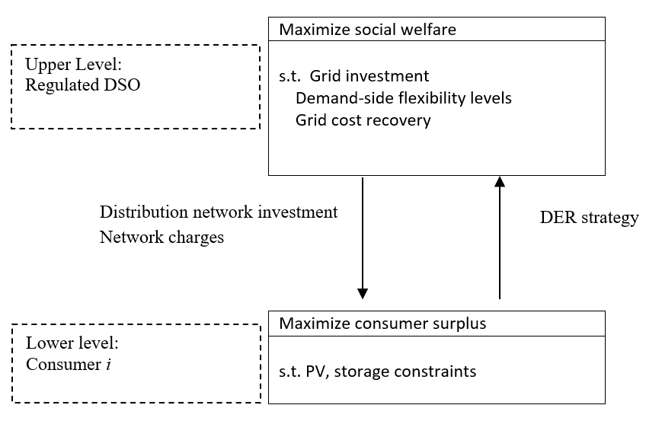

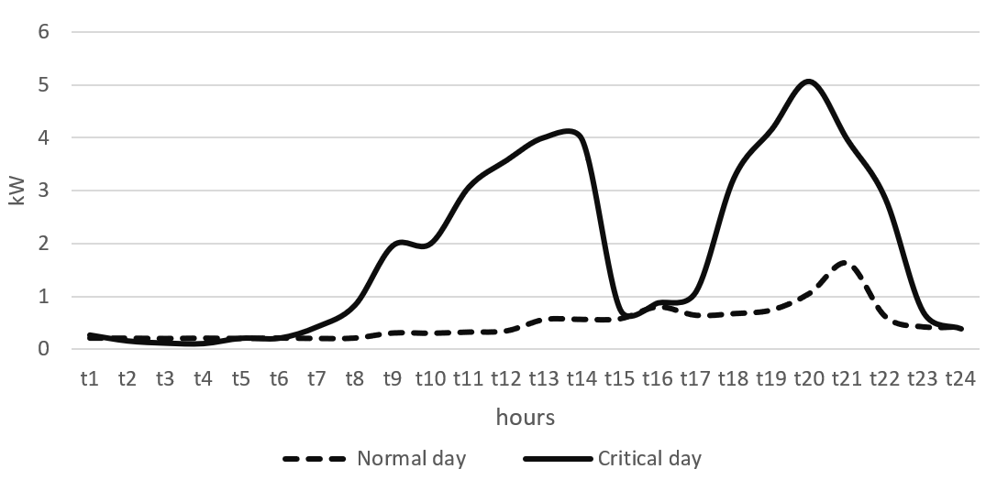
Figure 2: Profiles for normal and critical days

Figure 3: Distribution network investment savings
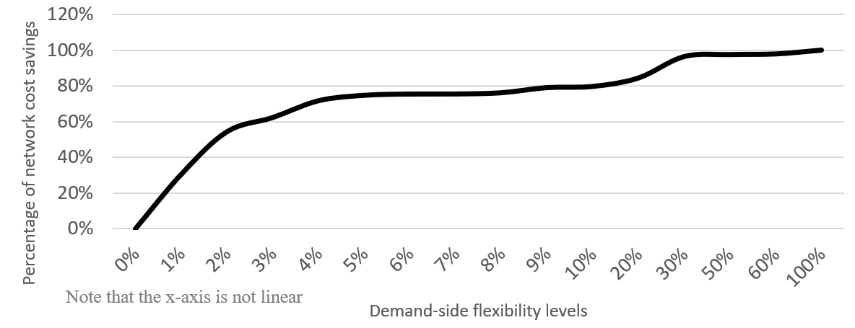
Figure 4: System welfare for different demand-side flexibility levels

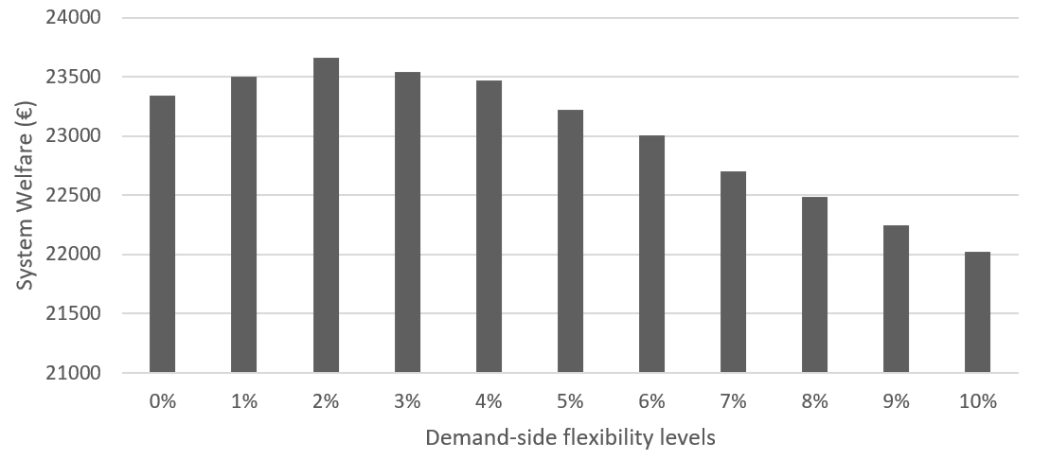

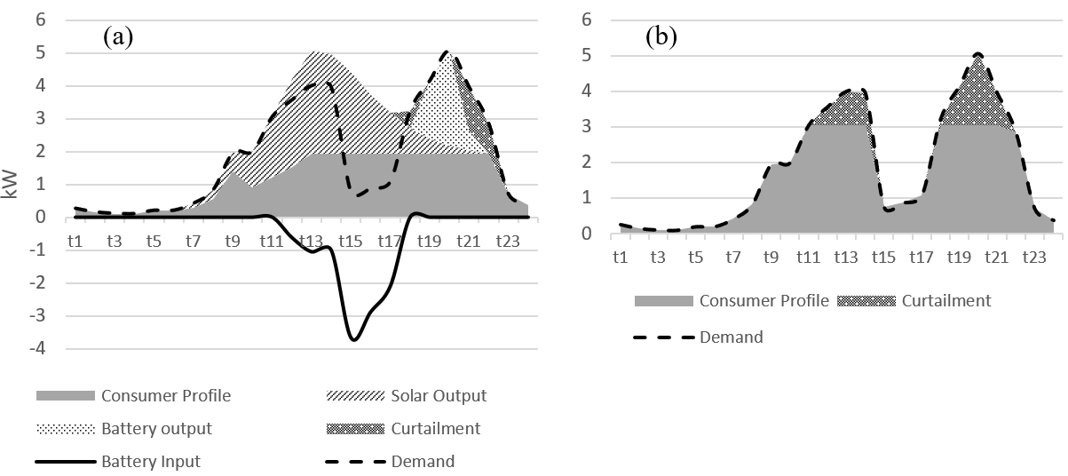
Figure 5: Load profiles for the different types of consumers in the reference scenario: (a) prosumers, (b) passive consumers

Figure 6: Loading of the network
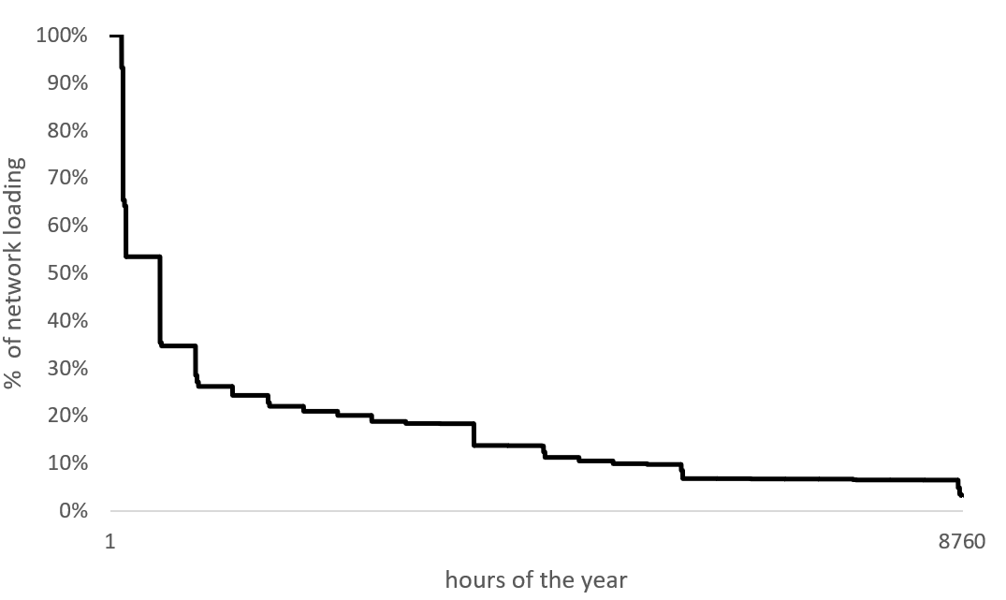

Figure 7: Load profiles for the different types of consumers with WF =0.5: (a) prosumers, (b) passive consumers
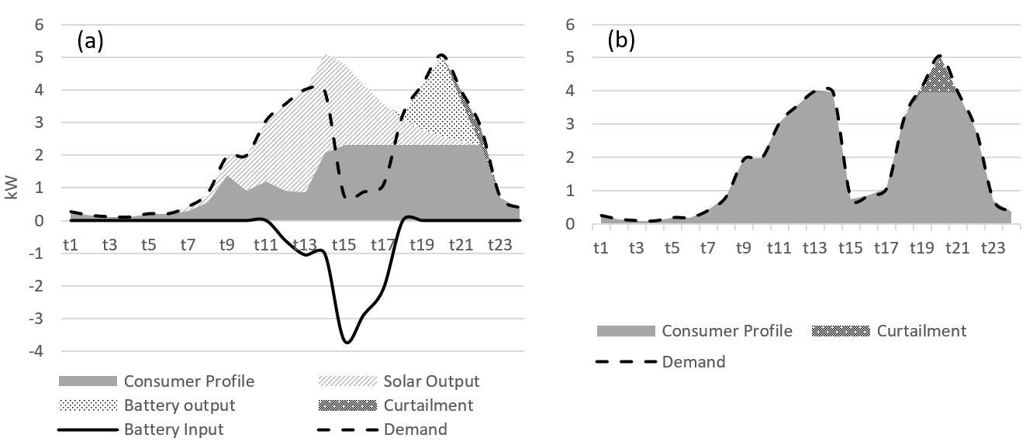

Figure 8: Load profile for the different types of consumers with Comp= €5.33: (a) prosumers, (b) passive consumers

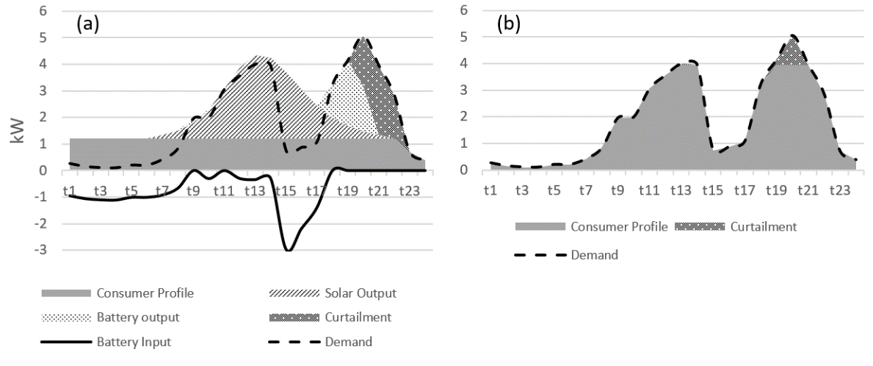

Figure 9: Scenarios for X=1 kWh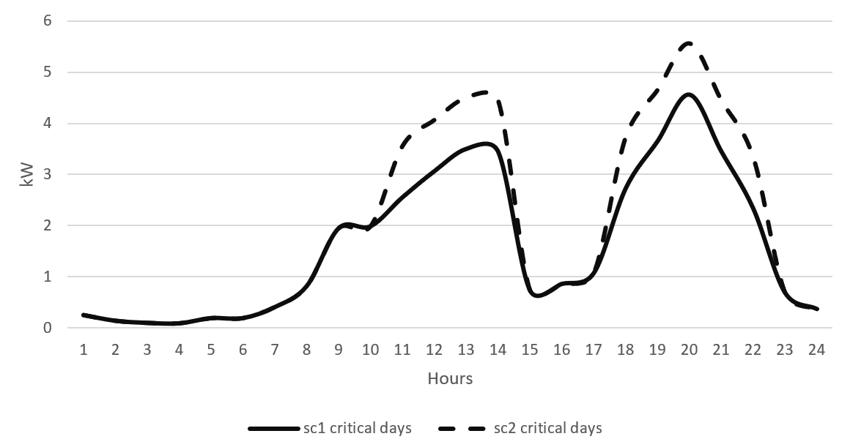
Figure 10: Load profiles for the different types of consumers in the case where only battery investment is allowed (for prosumers): (a) prosumers, (b) passive consumers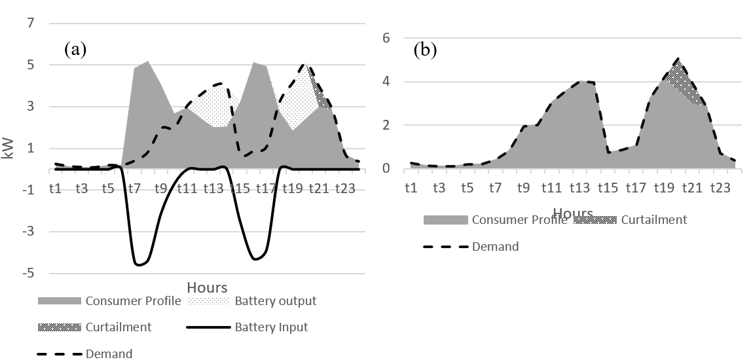

Figure 11: Load profiles for the different types of consumers for the case of a VoLL = € 2: (a) prosumers, (b) passive consumers
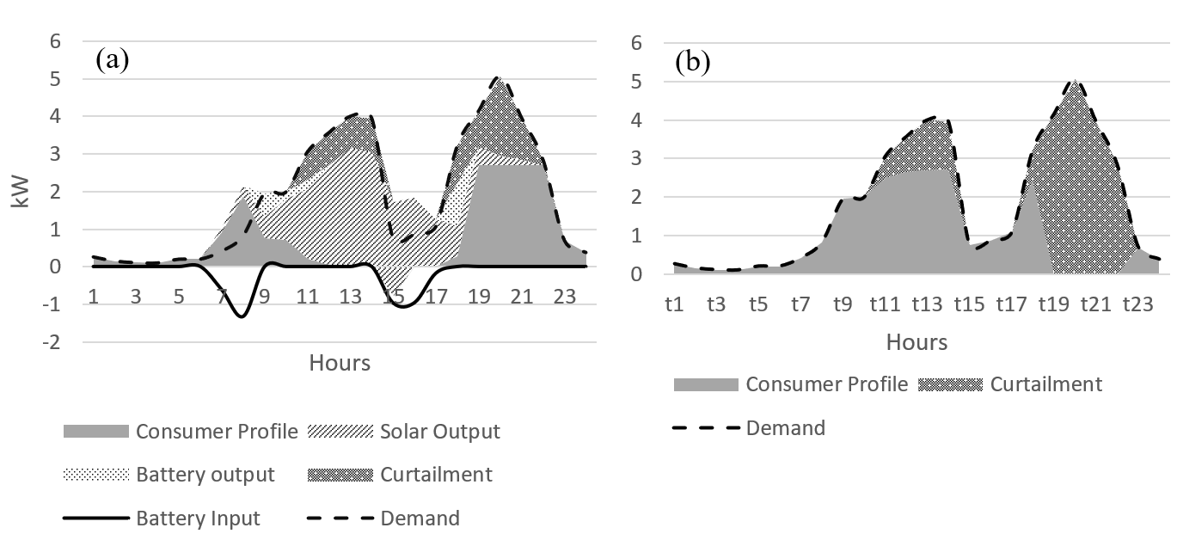
Figure 12: Load profiles for the different types of consumers for the case of a VoLL = € 2 with a cap on maximum hourly curtailment: (a) prosumers, (b) passive consumers

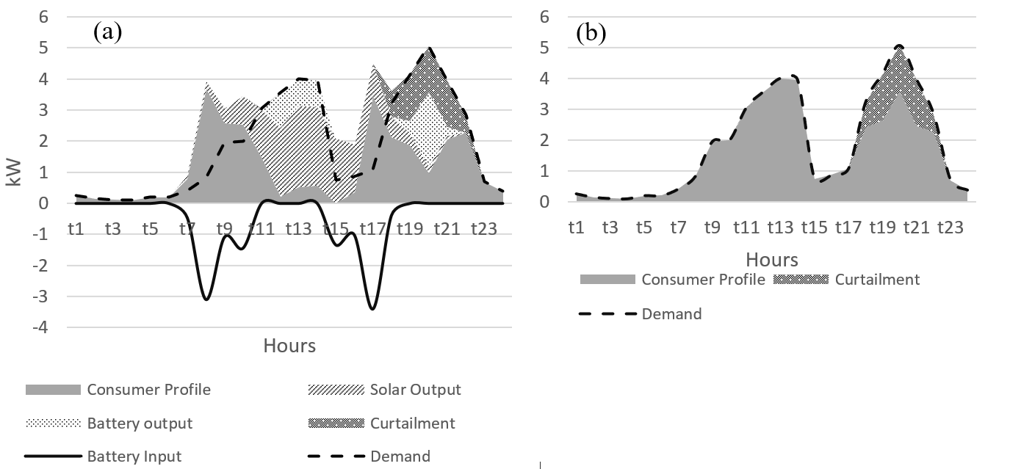

Tables
Table 1: Parameters in the reference scenario
Parameter | Value
VoLL | 5.33 €/kWh (equal to VoLA of Belgium)
Comp | 1 €/kWh
Annual demand | 4000 kWh
Frequency of critical days | 15
Default Load (normal days) | Synthetic Load Profiles (SLP) - Belgium
Incremental network expansion costs | 400 €/kW, no sunk grid costs
WF | 1, i.e. a perfect proxy for the network cost drivers
Network tariffs | $cnt$, its magnitude is decided endogenously for the entire year (no time differentiation)
Solar PV investment cost | 1200 €/kWp
Battery investment cost | 100€/kWh
Electricity withdrawal price ${EBP}_{t}$ | 0.08 €/kWh
Electricity injection price ${ESP}_{t}$ | 0.072 €/kWh

Table 2: Contribution of different types of demand-side flexibility tools
Setting | Volumetric-based tariffs with no flex | Capacity-based tariffs with no flex | Capacity-based tariffs with flex  Reference scenario
System welfare | 22809 | 23340 | 23816

Table 3: Flexibility levels and welfare gains for different shares/types of prosumers
 | 100% Passive consumers | 25% prosumers / 75% passive consumers | 50%-50%  Reference Scenario | 50%-50%  With only battery systems allowed | 100% Prosumers
Flexibility level | 1% | 1.1% | 1.48% | 0.54% | 0.34%
Welfare (Welfare gain) (€) | 23,111 (313) | 23393 (338) | 23,816 (476) | 23411(381) | 23,922 (124)

Table 4: Flexibility levels and welfare gains for different compensation levels
Comp | €0.5 | €1  Reference scenario | €5.33
Flexibility level | 0.8% | 1.48% | 1.49%
Welfare gain | €239 | €476 | €152

Table 5: Flexibility levels and welfare gains for different VoLL levels
VoLL | 2 €/kWh | 5.33 €/kWh  Reference scenario | 9.6 €/kWh
Flexibility level | 4.4% | 1.48% | 0.2%
Welfare gain | €334.5 | €476 | €266.4

Table 6: Capped flexibility levels and welfare gains for different VoLL levels
VoLL | 2 €/kWh | 5.33 €/kWh  Reference scenario | 9.6 €/kWh
Flexibility level | 3.4% | 1.1% | 0.2%
Welfare gain | €230 | €246 | €266.4

Table 7: Flexibility levels and welfare gains for different frequencies of critical days
Frequency of critical days | 5 | 15  Reference scenario | 104
Flexibility level | 2.1% | 1.48% | 0%
Welfare gain | €612 | €476 | €0

Table 8: Flexibility levels and welfare gains for different network expansion costs
Network expansion costs | 200€/kW | 400 €/kW | 600€/kW
Flexibility levels | 0.3% | 1.48% | 3%
Welfare gain | €55 | €476 | €464

Table 9: Impact of uncertainty on DSO's investment and flexibility levels
Uncertainty of the maximum peak | 10% | 20%
Optimal flexibility level | 3% | 2.3%
Investment increase | 2% | 6%

