Thiophene-2-Carboxamide Derivatives of Anthraquinone:
A New Potent Antitumor Chemotype

Yulia L. Volodina^{1,2#}, Alexander S. Tikhomirov^{2#}, Lyubov G. Dezhenkova², Alla A. Ramonova³, Anastasia V. Kononova⁴, Daria V. Andreeva², Dmitry N. Kaluzhny⁵, Dominique Schols⁶, Mikhail M. Moisenovich^{3^}, Andrey E. Shchekotikhin^{2&*}, and Alexander A. Shtil^{1,2&}

¹ Blokhin Cancer Center, 24 Kashirskoye shosse, Moscow 115478, Russia
² Gause Institute of New Antibiotics, 11 B. Pirogovskaya Street, Moscow 119021, Russia
³ Faculty of Biology, Moscow State University, 1 Leninskie Gory, Moscow, Russia
⁴ I.M. Sechenov First Moscow State Medical University, 2 B. Pirogovskaya Street Bld.4,
Moscow 119435, Russia
⁵ Engelhardt Institute of Molecular Biology, Russian Academy of Sciences, 32 Vavilov Street, 119991 Moscow, Russia
⁶ Rega Institute for Medical Research, K.U. Leuven, 3000 Leuven, Belgium

#equal contribution
&shared senior authorship
^deceased author

*Corresponding author: shchekotikhin@gause-inst.ru

Abstract
The anthraquinone scaffold has long been known as a source of efficacious antitumor drugs. In particular, the various chemical modifications of the side chains in this scaffold have yielded the compounds potent for the wild type tumor cells, their counterparts with molecular determinants of altered drug response, as well as in vivo settings. Further exploring the chemotype of anticancer heteroarene-fused anthraquinones, we herein demonstrate that derivative of anthra[2,3-b]thiophene-2-carboxamide, (compound 8) is highly potent against a panel of human tumor cell lines and their drug resistant variants. Treatment with submicromolar or low micromolar concentrations of 8 for only 30 min was sufficient to trigger lethal damage of K562 chronic myelogenous leukemia cells. Compound 8 (2.5 µM, 3-6 h) induced an apoptotic cell death as determined by concomitant activation of caspases 3 and 9, cleavage of poly(ADP-ribose) polymerase, increase of Annexin V/propidium iodide double stained cells, DNA fragmentation (subG1 fraction) and a decrease of mitochondrial membrane potential. Neither a significant interaction with double stranded DNA nor strong inhibition of the DNA dependent enzyme topoisomerase 1 by 8 were detectable in cell free systems. Laser scanning confocal microscopy revealed that some amount of 8 was detectable in mitochondria as early as 5 min after the addition to the cells; exposure for 1 h caused significant morphological changes and clustering of mitochondria. The bioisosteric analog 2 in which the thiophene ring was replaced with furan was less active although the patterns of cytotoxicity of both derivatives were similar. These results point at the specific role of the sulfur atom in the antitumor properties of carboxamide derivatives of heteroarene-fused anthraquinone.
Highlights
A series of anthra[2,3-b]thiophene-2-carboxamides were synthesized and evaluated.
A submicromolar cytotoxicity of compound 8 for wild type and drug resistant cells.
Compound 8 induces rapid cell death via organelle but not DNA targeting.

Keywords: Anthraquinone, thiophene, carboxamide, structure-activity relationship, bioisostere, antiproliferative activity, intracellular targets, cell cycle, cell death.

Graphical Abstract
1. Introduction
The anthraquinone containing antitumor compounds (Figure 1A) represent a number of chemotypes successfully used in many clinical protocols [1-4]. Nevertheless, organ toxicity and emergence of tumor cell resistance remain limiting factors for the efficacy of anthraquinone derivatives. Chemical modifications aimed at optimization of physico-chemical and chemotherapeutic properties have generated a series of new preclinical candidates [5-12]. Earlier we have discovered a strong anticancer potential of heteroarene-fused anthraquinones substituted with a diamine residue linked via the carboxamide group to the 3-position of the heterocycle [13-15]. In particular, the best-in-series anthrafuran-3-carboxamide has demonstrated antitumor efficacy in murine tumor models when administered orally or in an injection form [16,17]. Mechanistic studies revealed multiple targeting, namely, differential DNA binding, inhibition of topoisomerases 1 and 2 (topo 1/2) and individual protein kinases [13-15]. Structure-activity relationship (SAR) studies showed that 4,11-hydroxy groups and a carboxamide spacer greatly increased the potency whereas the heterocyclic core and 2-substituents did not [15]. Furthermore, bioisosteric replacement of the heterocyclic core influenced the cytotoxic responses of cultured tumor cells [14]. Indeed, annelation of the pyrrole ring to anthraquinone enhanced the binding to DNA and topo1 inhibition; subsequently, the acute in vivo toxicity of naphthoindole-3-carboxamides was less pronounced compared to furan-based analogs. On the other hand, replacement of the carboxamide moiety from the position 3 to the position 2 of anthra[2,3-b]furan revealed fundamental differences in the cytotoxicity profiles, drug-DNA complex formation and topo 1 inhibition [18]. Multiplicity of intracellular targets, and therefore the cell death pathways, makes it difficult to predict ‘optimal’ direction of design of new compounds. Nevertheless, this characteristic diversity of anthraquinones is therapeutically valuable.
The replacement of ring oxygen by sulfur in heterocycles has been demonstrated to produce bioisosteric compounds with different activities and chemical properties. These effects can be attributed to a slight enlargement of the ring, enhanced hydrophobicity, changed H-bond-accepting capacity and altered chemical stability. For example, the affinity to dopamine D2 receptor and monoamine oxidase was different in benzofuran and benzothiophene derivatives [19]. Furthermore, the benzothiophene analogs exhibited a better activity as K(ATP) channel openers [20], and 3,1-benzothiazin-4-ones showed an improved stability but reduced protease inhibitory activity than 3,1-benzoxazin-4-ones [21].
Introduction of the sulfur atom to the anthraquinone scaffold (Figure 1B) yields potent derivatives and therefore can be considered a valuable modification [22-29]. Moreover, annelation of the anthraquinone core with thiophene led to one of the most effective sulfur-bearing anthraquinone chemotypes [30-32]. Taking into account the potency of anthra[2,3-b]thiophene-3-carboxamide derivatives, and the fact that regioisomerization of anthra[2,3-b]furancarboxamides was beneficial for cytotoxic properties, we synthesized and evaluated a series of anthra[2,3-b]thiophene-2-carboxamides. Herein, we showed that the lead anthrathiophene-2-carboxamide bearing 3-(S)-aminopyrrolidine (compound 8) was capable of rapidly inducing death of tumor cell lines including adherent and suspension cells of various species and tissue origin. A brief (0.5-2 h) exposure to submicromolar or low micromolar concentrations of 8 was sufficient to evoke lethal cell damage. These effects were attributed not as much to interference with DNA or topo 1, the known targets for anthraquinones including the heteroarene-fused derivatives [33,34] but to the damage of organelles, largely mitochondria.

Figure 1. Structures of clinical antitumor anthraquinone derivatives (A); sulfur-bearing antitumor anthraquinones (B); amides of heteroarene-fused anthraquinones and new lead anthrathiophene-2-carboxamides (C).

2. Results and Discussion
2.1. Chemistry
Carboxylic acids of heteroarene-fused anthraquinone derivatives have been found to be the most convenient starting material for synthesis of amides [13-15,18]. Using the original schemes [35,36] we prepared 4,11-dimethoxyanthra[2,3-b]thiophene-2-carboxylic acid 3 and 4,11-dihydroxy-3-methylanthra[2,3-b]thiophene-2-carboxylic acid 4 in 9 and 7 steps, respectively, from commercially available reagents. 4,11-Dimethoxyanthra[2,3-b]thiophene-2-carboxylic acid 3 was demethylated by heating with sulfuric acid (conc.) to give 4,11-dihydroxyanthra[2,3-b]thiophene-2-carboxylic acid 5 (Scheme 1). Notably, 3-isomeric acids of heteroarene-fused anthraquinone derivatives were converted into amides only after activation with thionyl chloride [13-15]. In contrast, anthrathiophene-2-carboxylic acids easily reacted with primary and secondary amines in the presence of the peptide coupling reagent benzotriazol-1-yl-oxytripyrrolidinophosphonium hexafluorophosphate (PyBOP) [37] yielded the corresponding amides. Cyclic or linear diamine residues transformed into salts contribute to the binding to DNA and topo 1/2 and substantially improve water solubility [38]. Accordingly, treatment of anthrathiophene-2-carboxylic acids 4, 5 with cyclic and linear Boc-protected diamines in the presence of PyBOP followed by purification and cleavage of Boc-protective group with methanesulfonic acid led to a series of 4,11-dihydroxyanthra[2,3-b]thiophene-2-carboxamides 6-18 as the methanesulfonate salts (Scheme 1, Table 1). Nevertheless, replacement of carboxamide moiety from the position 3 to the position 2 (derivatives 2 and 8, respectively) of the thiophene core decreased water solubility several fold. The structure of new derivatives 5-18 was confirmed by NMR and HRMS methods (Figure S1); purity of final samples (≥95%) was analyzed by HPLC.

Scheme 1. Synthesis of anthra[2,3-b]thiophene-2-carboxamides 6-18. Reagents and conditions: (a) 98% sulfuric acid, 100 °C, 1 h, yield of 5 is 80%; (b) PyBOP, DMSO, DIPEA, N-Boc-protected diamine, rt, 15 min; (c) MsOH, CHCl₃, rt.

Table 1. Structures of substituents R¹, NR²R³and yields of anthra[2,3-b]thiophene-2-carboxamides 6-18.
NR²R³
Cmpd | 6 | 7 | 8 | 9 | 10 | 11 | 12 | 13 | 14 | 15 | 16 | 17 | 18
R¹ | H | CH₃ | H | CH₃ | H | H | H | H | H | H | H | H | H
Yield, % | 65 | 67 | 64 | 65 | 69 | 70 | 62 | 70 | 65 | 62 | 35 | 55 | 60

2.2. Biological evaluation
2.2.1. Antiproliferative activity
The antiproliferative potency of new anthra[2,3-b]thiophene-2-carboxamides 6-18 was estimated in a panel of human tumor cell lines including Capan-1 pancreatic adenocarcinoma, NCI-H460 lung carcinoma, DND-41 acute lymphoblastic leukemia, and HL60 acute promyelocytic leukemia. Dox, 3-isomeric anthrathiophene 1 [14], and bioisoric anthrafuran-2-carboxamide 2 [18] were used as reference compounds. Anthrathiophene-2-carboxamide derivatives bearing aminopyrrolidine and aminopiperidine fragments in the amide side chain possess low micromolar or submicromolar potency against a panel of tumor cell lines (Table 2). Among all new compounds the derivatives with 3-aminopyrrolidine (6 and 8) were the most active. The (S)-enantiomer 8 was slightly superior over (R)-enantiomer 6. Introduction of the methyl radical at the position 3 (compounds 7, 9) attenuated the cytotoxic potency. Moreover, coupling of 3-aminopyrrolidine to the anthrathiophene-2-carboxamide scaffold via the primary amino group (isomers 10, 11) led to a 3-15-fold lower cytotoxicity. Introduction of an additional amino group (compound 15), the substitution of cyclic diamine with a linear diamine (ethylenediamine, 17) or both modifications (18) dramatically decreased the cytotoxicity. Similar effects were observed when a bulky 3-aminoquinulidine moiety was used (16).
Table 2. Antiproliferative activity of anthra[2,3-b]thiophene-3-carboxamides 6-18.
Entry | Cmpd | Substituents |  | Capan-1 | NCI-H460 | DND-41 | HL60
Entry | Cmpd | NR²R³ | R¹
1 | 6 |  | H | 1.5 ± 0.3ª | 0.4 ± 0.1 | 0.4 ± 0.0 | 1.1 ± 0.2
2 | 7 |  | Me | 2.0 ± 0.2 | 1.2 ± 0.2 | 1.4 ± 0.3 | 1.8 ± 0.5
3 | 8 |  | H | 0.7 ± 0.1 | 0.4 ± 0.1 | 0.4 ± 0.1 | 0.3 ± 0.0
4 | 9 |  | Me | 2.2 ± 0.4 | 5.0 ± 1.0 | 1.6 ± 0.3 | 0.2 ± 0.0
5 | 10 |  | H | 6.3 ± 1.3 | 3.4 ± 0.5 | 1.0 ± 0.2 | 2.9 ± 0.3
6 | 11 |  | H | 5.8 ± 0.6 | 2.9 ± 4.1 | 1.3 ± 0.1 | 2.7 ± 0.3
7 | 12 |  | H | 0.6 ± 0.1 | 1.4 ± 0.1 | 1.6 ± 0.4 | 3.2 ± 0.2
8 | 13 |  | H | 2.3 ± 0.4 | 1.4 ± 0.2 | 1.0 ± 0.1 | 1.1 ± 0.1
9 | 14 |  | H | 1.2 ± 0.3 | 0.4 ± 0.0 | 0.6 ± 0.1 | 0.4 ± 0.1
10 | 15 |  | H | >20 | 16.1 ± 2.1 | 10.9 ± 1.5 | >20
11 | 16 |  | H | 4.6 ± 0.7 | >20 | 2.4 | 7.3
12 | 17 |  | H | >20 | 8.3 ± 2.2 | 3.7 ± 0.3 | >20
13 | 18 |  | H | 16.8 ± 2.5 | 8.3 ± 1.9 | 3.1 ± 0.5 | 14.1 ± 1.1
14 | 1 |  | - | 2.1 ± 0.4 | 2.1 ± 0.2 | 2.6 ± 0.5 | 5.5 ± 0.4
15 | 2 |  | - | >20 | >20 | 1.5 ± 0.2 | 0.7 ± 0.1
16 | Dox | - | - | 1.7 ± 0.2 | 0.4 ± 0.1 | 0.7 ± 0.1 | 0.2 ± 0.0
ª Values are IC₅₀, µM (mean ± SD obtained in MTT assays after 72 h exposure).
For mechanistic studies we chose anthra[2,3-b]thiophene-2-carboxamide (compound 8, Table 1). Previously we have reported the synthesis and properties of anthra[2,3-b]furan-2-carboxamide 2 (Figure 1) [18]. These two derivatives differ only in one atom in the heteroarene moiety (S in 8 vs O in 2) which allows for interpreting the role of an individual modification. Compound 8 was highly cytotoxic against a panel of tumor cell lines (Tables 2, 3). Mean IC₅₀ values after a 72 h exposure varied from 0.3 µM to 0.8 µM; leukemia cell lines tended to be more sensitive than the adherent HCT116 colon adenocarcinoma and the HCT116p53KO subline with non-functional p53. Importantly, 8 was equally potent (IC₅₀ = 0.3-0.4 µM) for K562 chronic myelogenous leukemia cell line and the K562/4 subline selected for survival in the presence of Dox (MDR1/P-glycoprotein mediated MDR [39]). In contrast, under the same culture conditions 2 killed only the suspension cell lines including K562 and K562/4 (Table 3). None of the tested adherent cell lines such as HeLa, HCT116, HCT116p53KO, B16, C6, MCF7 and MCF7Dox were sensitive to 2 (IC₅₀ > 50 µM) [18].
Table 3. Structures and antiproliferative potencies of 8 and 2.
Cell line |  |  | Dox
Cell line | IC₅₀, µMª
HeLa | 0.4 ± 0.1 | >50.0 | 0.2 ± 0.0
НСТ116 | 0.5 ± 0.1 | >50.0 | 0.1 ± 0.0
НСТ116p53KO | 0.5 ± 0.0  (RI^{b}=1.0) | >50.0  (RI^{b}=1.0) | 0.6 ± 0.1 (RI^{b}=6.0)
U937 | 0.2 ± 0.0 | 2.2 ± 0.3 | 0.1 ± 0.0
K562 | 0.3 ± 0.1 | 0.5 ± 0.1 | 0.1 ± 0.0
K562/4 | 0.4 ± 0.1 (RI^{c}=1.3) | 0.6 ± 0.1 (RI^{c}=1.2) | 13.5 ± 2.5 (RI^{c}=135)
Fibroblasts | 1.4 ± 0.2 | >50.0 | 0.2 ± 0.0

ªMean ± SD obtained in MTT assays after 72 h exposure. ^{b}RI, resistance index: IC₅₀(K562/4)/IC₅₀(K562). ^{c}RI, resistance index: IC₅₀(HCT116p53KO)/IC₅₀(HCT116).
2.2.2. Compound 8 induces early cell lethality
Differential potency of 8 vs 2 was further demonstrated in the analysis of cell cycle distribution of K562 cells. As shown in Figure 2, exposure to 8 (0.5 µM, 24 h) caused a decrease of S phase events concomitant with an increased percentage of nuclei with hypodiploid (subG1) nuclei. These parameters were more pronounced by 48 h whereas no significant changes were detected after treatment with 2. Exposure to 2.5 µM of 8 for 24-48 h dramatically altered phase distribution while 2 was less cytotoxic. Even with 5 µM of 2 the effects on cell cycle distribution were less pronounced compared to 2.5 µM of 8 (Figure 2).
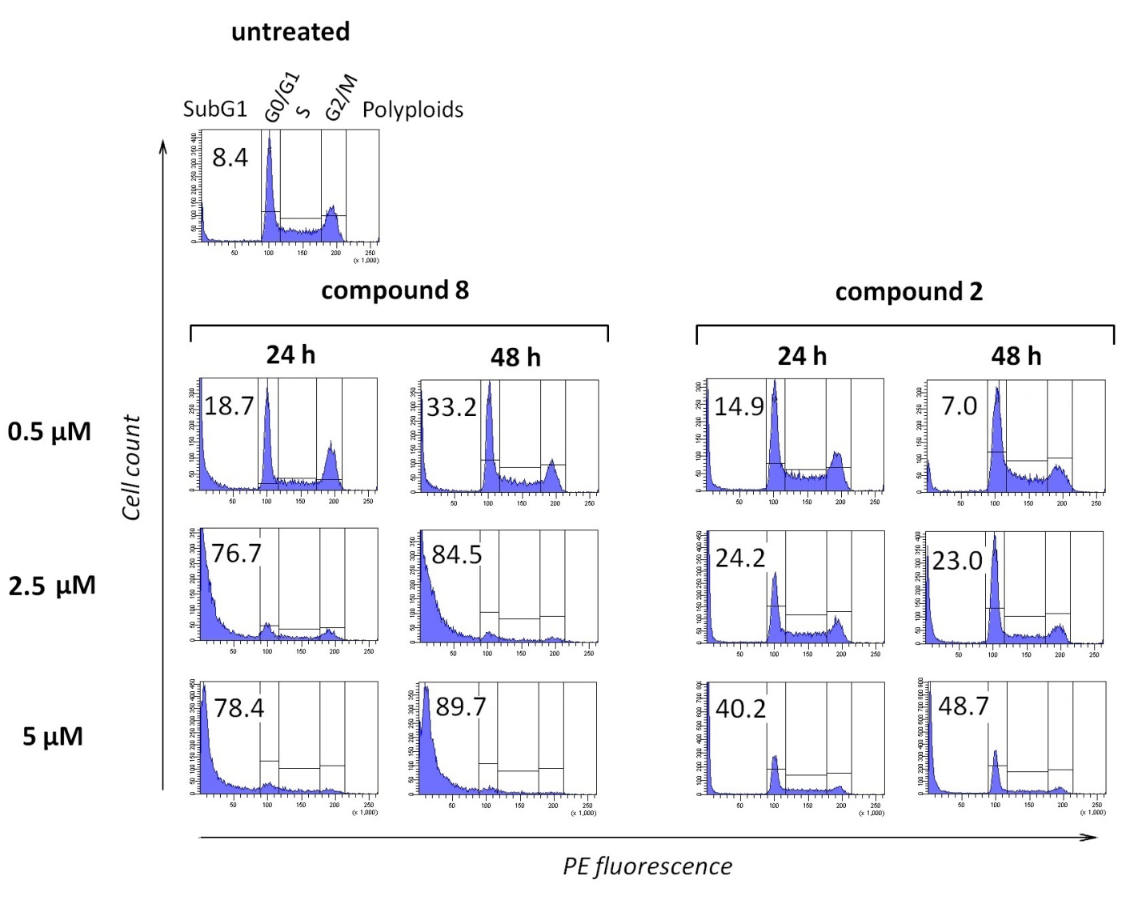
Figure 2. Cell cycle distribution in K562 cells treated with 8 or 2. The histograms of PI fluorescence of cell lysates are shown. Numbers are the percentages of the respective events. Experiments were performed three times with essentially the same results.

Next, we investigated whether 8 triggered K562 cell death after a short-term exposure. A continuous (72 h) treatment with 0.5-2.5 µM of 8 resulted in a significant increase of subG1 (DNA fragmentation) events (Figure 3, A-D). Exposure to 2.5 µM of 8 for only 30 min followed by drug removal was sufficient to kill a big portion of cell population (Figure 3, E, G, J). A pulse with 1 µM for 1 h or with 0.5 µM for 2 h (Figure 3, F and H, respectively) did not alter cell cycle distribution whereas 2 h exposure to 1 µM of 8 caused G1 arrest and DNA fragmentation (Figure 3, I). These results indicated that 8 triggered lethal cell damage even after a short-term exposure.

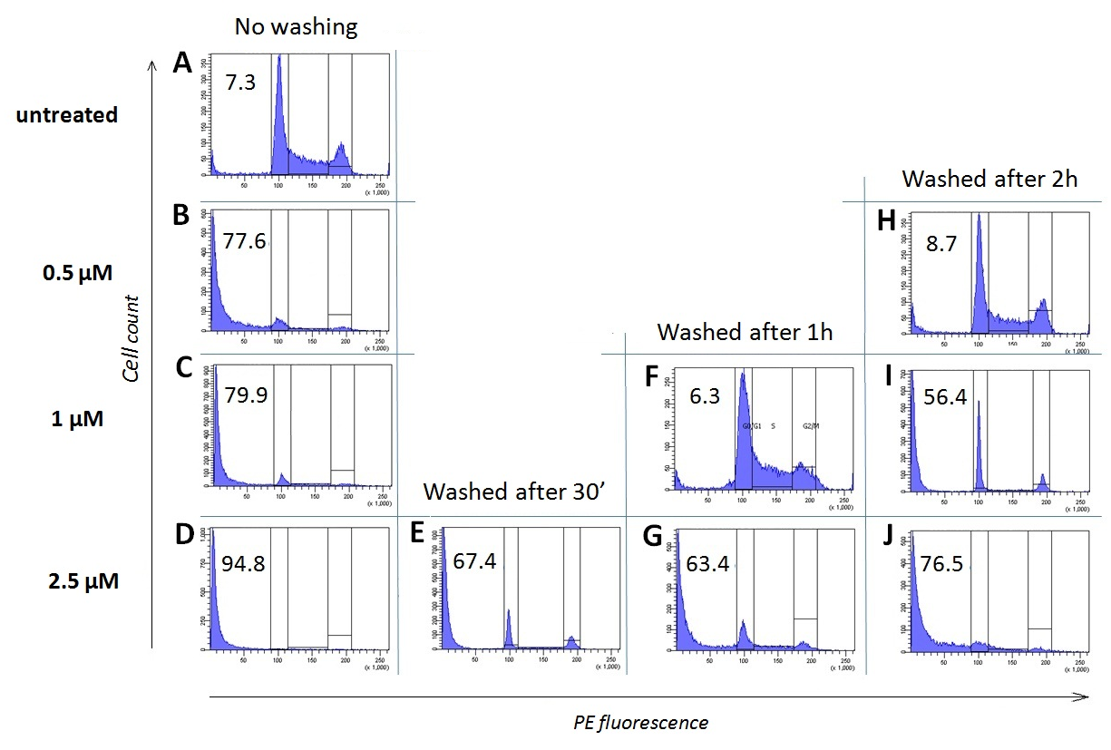
Figure 3. Cytotoxicity of compound 8 after a short-term exposure of K562 cells. Cells were treated with indicated concentrations of 8 for 72 h (A-D) or for 30 min, 1 h or 2 h followed by washing, incubation in drug free medium for up to 72 h (E-J), lysis in the PI containing buffer and analysis of cell cycle distribution by flow cytometry. One representative experiment out of three with similar results is shown.

The cytotoxicity of 8 upon a short-term cell exposure can be ascribed to rapid effects on DNA replication. To address this issue we synchronized K562 cells at G1/S boundary using the double thymidine block procedure followed by removal of thymidine and cell release in the absence or presence of 2.5 µM of 8. Effects of 8 were evaluated by the analysis of cell cycle distribution with PI and bromodeoxyuridine (BrdU) incorporation, a measure of DNA synthesis [40]. We found that compound 8 delayed the re-entry of arrested K562 cells into the cycle (Figure 4). Interestingly, this delay was detectable after a lag period of ~4-6 h. This effect was concomitant with attenuation of DNA synthesis: BrdU uptake decreased by 30-40% after 6 h with 8 (Figure S2). These results suggested that 8 indirectly affected the traverse through S phase.

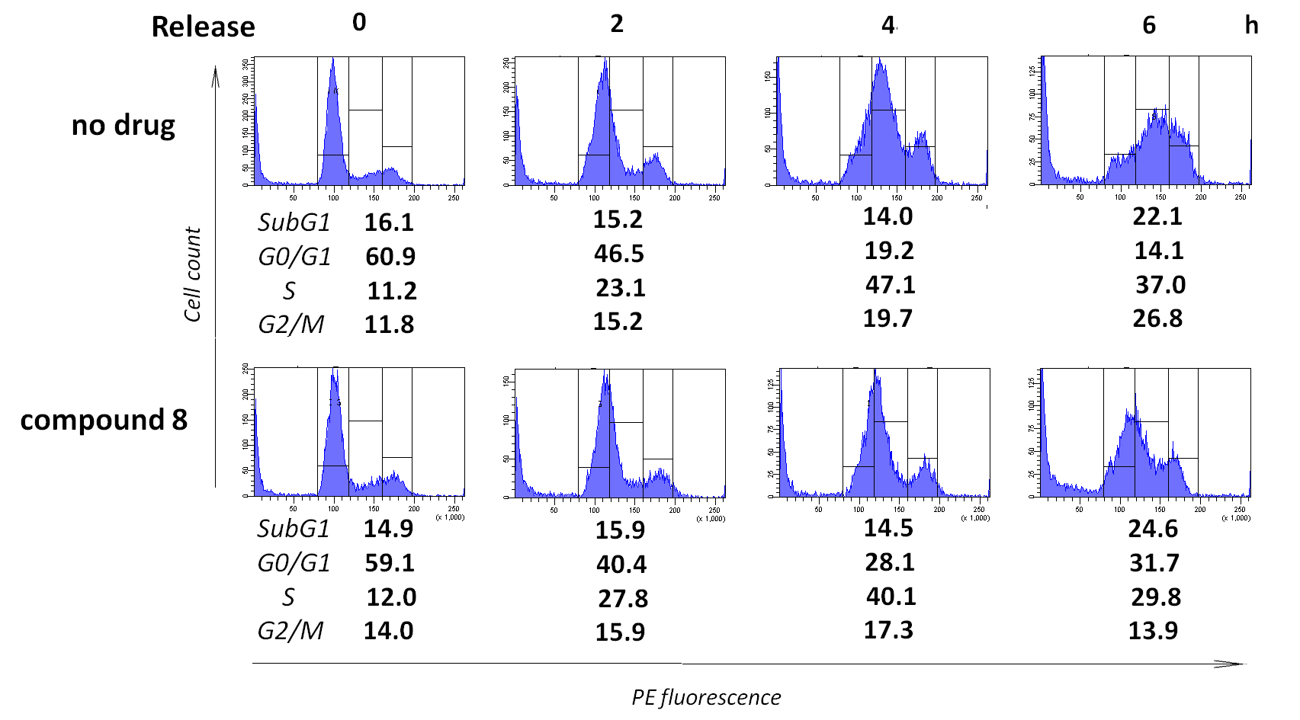
Figure 4. Compound 8 delays cell cycle progression after double thymidine block. The K562 cells were synchronized at G1/S and released in the absence (top panel) or presence (bottom panel) of compound 8 (2.5 µM) for up to 6 h. Note a retardation of the re-entry into the cell cycle by 4-6 h with 8.

2.2.3. Interaction with DNA and intracellular oxidation
Anthraquinone derivatives including heteroarene-fused compounds are the known DNA binders and topoisomerase antagonists, and these properties are critical for the antitumor efficacy [41,42]. It is plausible to suggest that the cytotoxicity of carboxamides of heterocyclic anthraquinone derivatives 2 and 8 might be associated with targeting double stranded DNA (dsDNA). However, 8 demonstrated a weak interaction with dsDNA as determined by spectroscopic techniques (note the absence of stable complex formation in Figure S3, A,B). Compound 2 formed stable complexes with dsDNA although with relatively low binding constant [18]. Moreover, no change of electrophoretic mobility of pBR322 DNA was determined after pre-incubation of the plasmid with up to 20 µM of 8 (Figure S3, C). In line with these data each carboxamide weakly inhibited topo1 mediated unwinding of pBR322 DNA. In the presence of 1-5 µM of 8 only a minor portion of the plasmid was uncoiled whereas 2 was somewhat more potent (compare the abundance of the fast migrating plasmid at the respective concentrations of 8 and 2 (Figure S3, D). These results indicated that 8 did not form stable complexes with dsDNA in vitro. Furthermore, only a moderate increase of the amounts of checkpoint kinases 1 and 2 (Chk1/2) and histone 2A phosphorylation, the early markers of DNA damage [43,44], were detectable within 4-6 h in response to 8 (Figure S4). Accumulation of Chk2 and pH2AX were late events (Figure S4). Altogether, these data argued against a substantial role of DNA interaction or topo 1 targeting in the cytotoxic potency of 8 and 2.
Generation of reactive oxygen species (ROS) as well as interaction with DNA and DNA dependent enzymes are the established mechanisms of antitumor effects of anthraquinone derivatives. Previously we reported that some heteroarene-fused anthraquinones increased intracellular ROS [14,15]. However, neither 8 nor 2 evoked direct intracellular oxidation whereas the reference oxidant H₂O₂ did (Figure S5, A-C). Accordingly, the antioxidant N-acetylcysteine (NAC) did not rescue the cells from cytotoxicity of 8 (Figure S5, D). We concluded that death of K562 cells in response to 2 or 8 was unrelated to intracellular redox status.

2.2.4. Damage of mitochondria by compound 8
Fast cell damage by low micromolar concentrations of 8 can be mechanistically associated with activation of the mitochondrial death pathway [45]. As shown in Figure 4, the mitochondrial electric potential in K562 cells decreased within 3 h with 2.5 µM of 8 (19.8% cells with the lowered potential vs 7.8% in untreated counterparts). This effect further increased by 6 h, with 33.3% cells showing a decreased potential. In contrast, treatment with 7.5 µM of 2 for 6 h had no effect on the mitochondrial membrane potential (not shown) further demonstrating a preferential potency of thiophene 8 over the furan analog 2.

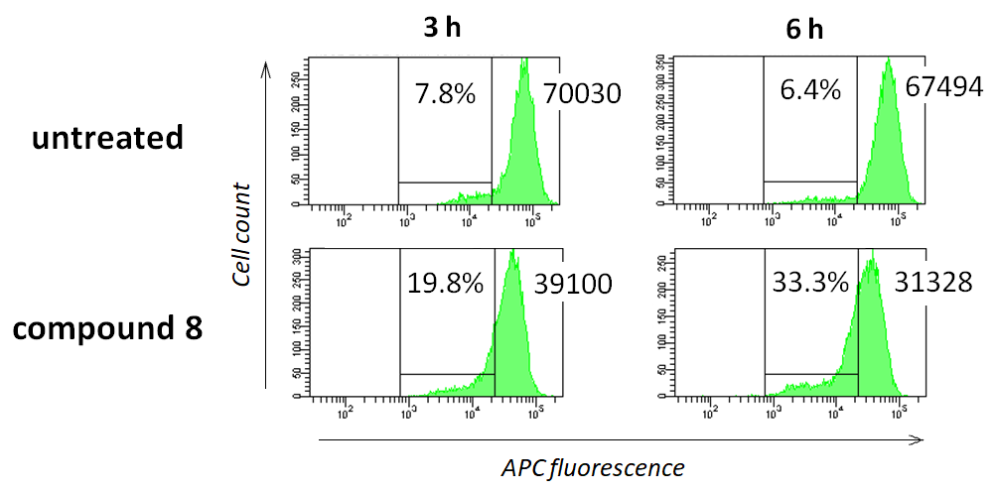
Figure 5. Mitochondrial membrane potential in K562 cells exposed to compound 8. Cells were treated with 2.5 µM of 8 for 3 h or 6 h at 37 ºС, 5% СO₂, washed and incubated in fresh media for 10 min to minimize autofluorescence. Then cells were stained with 0.5 µM of Mitotracker Red for 30 min, 37 ºC, washed with ice cold saline and immediately analyzed by flow cytometry. Shown are the percentages of cells with decreased mitochondrial membrane potential. Values to the right are mean fluorescence intensities of histogram peaks. See Experimental for details.

Next, we determined the intracellular distribution of compounds 2 and 8 by laser confocal microscopy. In these experiments NIH 3T3 fibroblasts were used as an appropriate model [14,18]. As shown in Figure 6, each compound was detectable in the cytoplasm but not in the nuclei. After a 5 min exposure 2 and 8 were detectable in the lysosomes. These patterns remained unchanged by 60 min (Figure 6, top panel). Co-localization with mitochondria after 5 min exposure was either insignificant (compound 8) or not determined (compound 2). After a 60 min exposure with 8 the mitochondria became rounded, some organelles formed clusters co-localized with the compound (Figure 6, bottom panel). In contrast, we found no clear-cut co-localization of 2 in mitochondria. Rather, this compound was present largely in lysosomes (Figure 6, top panel).

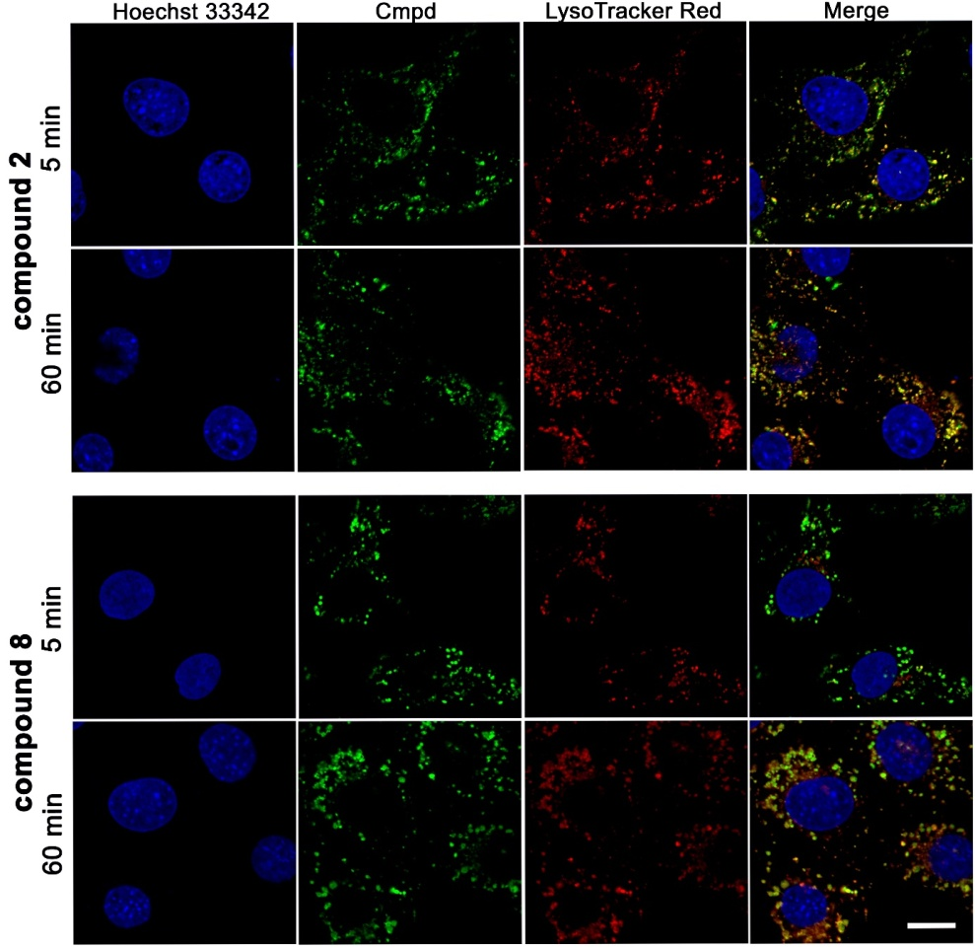
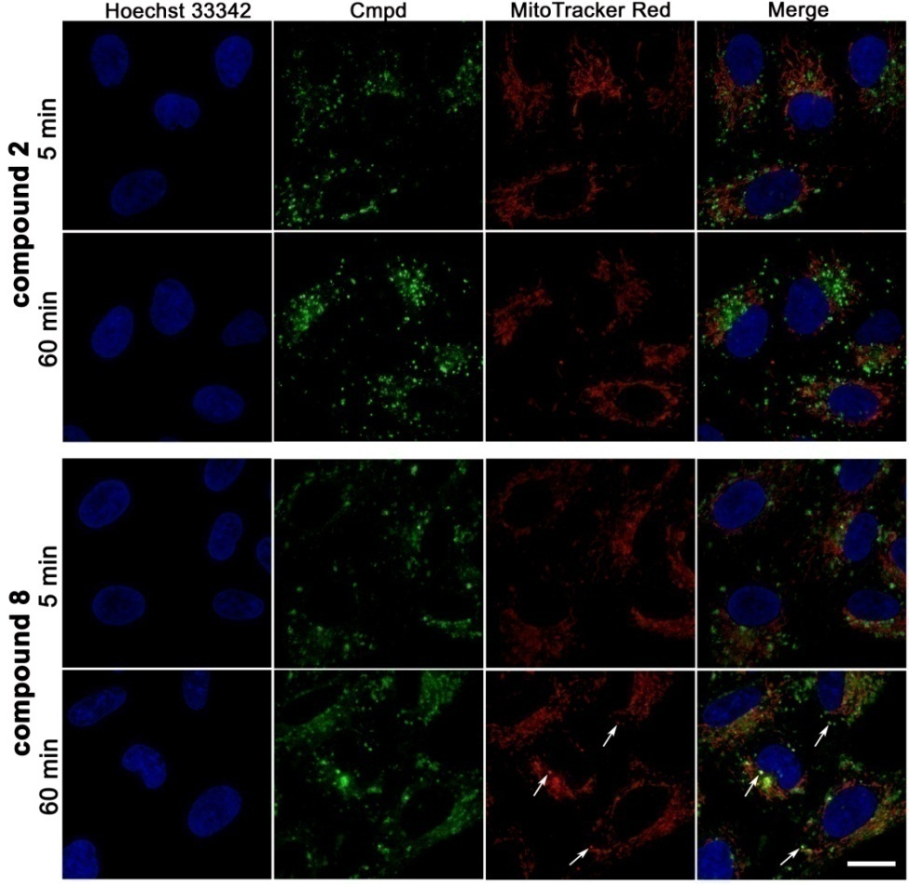
Figure 6. Intracellular distribution of compounds 8 and 2. The NIH 3T3 fibroblasts were treated with 2 or 8 (1 μM each) for indicated time intervals and analyzed by laser confocal microscopy at 37 °C, 5% CO₂. LysoTracker Red (top panel) or MitoTracker Red FM (bottom panel) (0.5 μM each) were added 2 min before image capture. Nuclei were stained with Hoechst 33258. The optical sections at the midst of the nuclei are shown. Arrows indicate rounded mitochondria and the sites of co-localization with 8. Bar, 10 μm.

2.2.5. Annexin V/propidium iodide (PI) staining, caspase activation and PARP cleavage
Death of K562 cells treated with 8 was accompanied by an increase of double positive Annexin V⁺/PI⁺ cells detectable already after 3 h (Figure 7,A). By 24 h the loss of the plasma membrane integrity, a measure of apoptosis outcome (as determined by PI positivity) was detectable in almost entire cell population. Cleavage of caspases 9, 3 and poly(ADP-ribose) polymerase (PARP), events indicative of apoptosis, were revealed by 6 h with 2.5 µM of 8 (Figure 7, B). In contrast, 2 caused a delayed increase of death markers: by 24 h only ~20% Annexin V-positive cells were detectable (Figure S6) whereas activation of caspases 9 and 3 and PARP cleavage did not occur until 24 h (not shown).

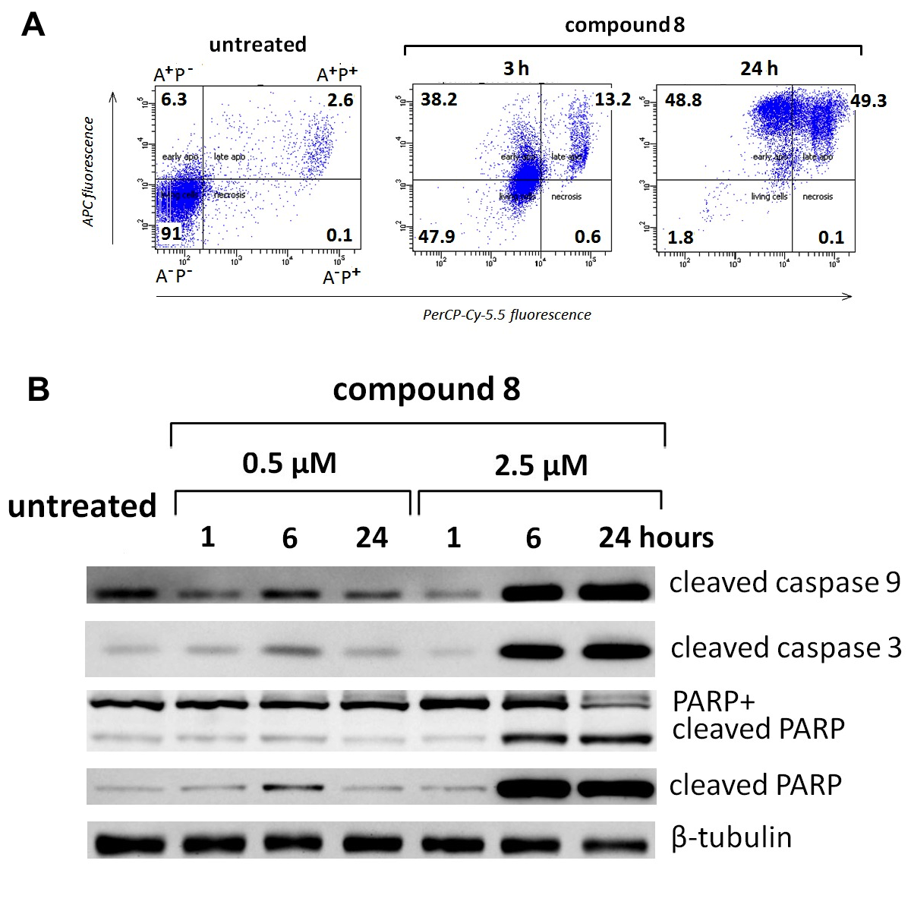
Figure 7. Time course of death markers in K562 cells treated with compound 8. The K562 cells were treated with 8 for indicated time intervals, stained with Annexin V/PI and analyzed by flow cytometry (A) or lysed and processed for immunoblotting (B). Representative experiments out of four with essentially same results are shown.

3. Conclusion
This study demonstrates the potential of the anthraquinone scaffold as novel anticancer drug candidates. In particular, modifications of the ring A (Figure 1) gave rise to the compounds with new properties compared to clinical drugs mitoxantrone and pixantrone [1-4]. Pursuing the modifications of the scaffold’s side chains, a series of derivatives containing a heteroarene moiety annelated to the anthraquinone core have been synthesized and investigated [14,15,18,46-48]. Individual compounds were highly potent in cell culture showing preferential killing of tumor vs non-malignant cells, an activity against drug resistant counterparts, and a therapeutic efficacy in preclinical models at tolerable regimens [16,17].
Heteroarene-fused anthraquinone derivatives vary in their key antitumor characteristics. Formation of stable complexes with dsDNA, interference with topo 1/2 and some protein kinases, and induction of oxidative stress are the established cytotoxic mechanisms for this chemical class. Nevertheless, even minimal modifications such as regioisomerization at the positions 2 and 3 of the 5-membered heterocyclic ring, as well as the change of the heteroatom from O to N (comparison of indole vs furan [14]) and O to S (this study) can switch the intracellular targeting and significantly change individual properties. Differences in distribution of electric charges, hydrophilicity/hydrophobicity, atropoisomeric conversions and spatial flexibility of structural units all make it hard to unambiguously predict how the properties of the complex molecule would change in the course of optimization, therefore leaving the heuristic approach productive. Still, some important considerations can be drawn from SAR analysis.
Since the introduction of substituted amides yielded the carboxamides of heteroarene-fused anthraquinones with advanced properties [14,15,18], one may hypothesize that replacement of the O heteroatom for S would produce potent anthra[2,3-b]thiophenecarboxamides. Indeed, the newly synthesized anthra[2,3-b]thiophene-2-carboxamides demonstrated a submicromolar cytotoxicity in a panel of mammalian tumor cell lines of various tissue origin including the sublines with MDR1/Pgp or non-functional p53. The lead compound in the series, anthra[2,3-b]thiophene-2-carboxamide 8, caused rapid (< 3 h) irreversible cell damage culminated to apoptosis. Interestingly, 8 showed a weak, if any, ability to form stable complexes with dsDNA in vitro, nor did it potently inhibit topo 1 or trigger oxidative burst. Accordingly, compound 8 attenuated DNA replication after a lag period suggesting an indirect mechanism rather than drug-DNA complex formation. Most importantly, an extensive mitochondrial damage by 8 appeared to be an early event in the death cascade. Altogether, 8 emerges as a new promising chemotype whose properties raise further SAR issues.
In particular, what is the role of S heteroatom in the remarkable properties of compound 8? Introduction of the divalent sulphur atom may change the size, electron density, water solubility, lipophilicity and other properties of the anthraquinone scaffold. Redox balance is an established factor of the cytotoxic potency of quinone derivatives. Replacement of the furan ring with the thiophene moiety should further decrease the redox potential and attenuate ROS generation, as has been shown for naphthoquinone analogs [49]. In line with this suggestion we found no pro-oxidative activity of 8. On the other hand, the lack of oxidative stress might be advantageous since anthraquinones are known to induce side effects such as cardiotoxicity. Additionally, a number of substituents in sulfur-bearing heterocycles can form stable conformation due to interactions between σ-holes in S atoms and unpaired electrons in Lewis bases including O and N atoms presented in many structural elements including the amide group [50]. Literature data and our DFT chemical calculations (B3LYP/6-31+G(d,p)) demonstrated a 0.4 kcal/mol preference in a syn-conformation for the thiophene-2-carboxamide moiety in 8 (Figure S7). In contrast, an anti-conformation was more stable for the furan-2-carboxamide 2 (2.1 kcal/mol). A weaker ability to bind to dsDNA and inhibit topo 1 by 8 can be attributed to the change of molecular geometry.
Along with the improved antiproliferative potency the isomerization of anthrathiophene-3-carboxamide 2 into 2-analog 8 led to a drop of water solubility that significantly impend in vivo evaluation of this agent. One explanation is an increased molecular symmetry and a closer packing of crystals, similarly to the furan-fused analogs [18]. Formulations such as drug-β-cyclodextrin (Cavitron) complexes [16] may be useful for parenteral administration for further in-depth evaluation of 8. Also, solubility in the slightly acidic medium (pH 3-4) may provide a possibility of developing compound 8 for oral intake.

4. Experimental section
4.1. Instruments and general information
NMR spectra were recorded on a Varian Mercury 400 Plus instrument operated at 400 MHz (¹H NMR) and 100 MHz (¹³C NMR). Chemical shifts were measured in DMSO-d₆ or CDCl₃ using tetramethylsilane as an internal standard. Analytical TLC was performed on Silica Gel F₂₅₄ plates (Merck) and column chromatography was performed using SilicaGel Merck 60. Melting points were determined using a Buchi SMP-20 apparatus without any modifications. High resolution mass spectra were recorded with electron spray ionization on a Bruker Daltonics microOTOF-QII instrument. UV spectra were recorded on a Hitachi-U2000 spectrophotometer. IR spectra were obtained on a Nicolet-iS10 Fourier transform IR spectrometer (Thermo Fisher Sci., USA) with DTGS detector, splitter KBr and a Smart Performer module equipped with a ZnSe-crystal (ATR). Spectra were run in the range of 3000-650 cm⁻¹ with a resolution of 4 cm⁻¹ and analyzed using the OMNIC-7.0 program package. HPLC was performed on a Shimadzu Class-VP V6.12SP1 system, A: 0.01 M H₃PO₄ pH 2.6, B:MeCN.
The reagents were from Sigma-Aldrich, St. Louis, MO. All solutions were dried over Na₂SO₄ and evaporated at reduced pressure using IKA RV-10 rotary evaporator at a temperature below 45 ºC. All products were vacuum dried at room temperature. All solvents, chemicals and reagents were obtained commercially and used without purification. The purity of final compounds 6-18 was >95% as determined by HPLC analysis.

4.1.1 4,11-Dihydroxy-5,10-dioxo-5,10-dihydroanthra[2,3-b]thiophene-2-carboxylic acid (5). Carboxylic acid 3 (1.50 g, 4.1 mmol) was dissolved in concentrated H₂SO₄ (30 mL), and the solution was stirred for 1 h at 100 °С. The reaction mixture was cooled, then poured into ice. The obtained precipitate was filtered off, washed with water (4×50 mL), and dried. The yield of 5 was 1.11 g (80%) as a red solid, mp >250 °C.¹H NMR (400 MHz, DMSO-d₆) δ 14.13 (br s, 1H, ОН); 13.82 (br s, 1H, ОН); 8.32 (m, 2H, 6,9-Н); 8.19 (s, 1H, 3-H); 8.01 (m, 2H, 7,8-Н). HRMS (ESI) calculated for C₁₇H₇O₆S [M-H]⁻: 338.9969, found 338.9945.

4.1.2. (R)-2-(3-Aminopyrrolidine-1-carbonyl)-4,11-dihydroxyanthra[2,3-b]thiophene-5,10-dione methanesulfonate (6). A mixture of anthra[2,3-b]thiophene-2-carboxylic acid 5 (0.10 g, 0.3 mmol), diisopropylethylamine (0.15 mL, 0.8 mmol), (R)-3-(Boc-amino)pyrrolidine (75 mg, 0.4 mmol) and benzotriazol-1-yl-oxytripyrrolidinophosphonium hexafluorophosphate (PyBOP, 0.20 g, 0.4 mmol) in DMSO (10 mL) was stirred at room temperature for 1 h. The reaction mixture was diluted with water, and the product was extracted with chloroform (2×15 mL). The extract was washed with 5% aqueous solution of HCl, twice with water, dried and evaporated. The residue was purified by column chromatography with chloroform-methanol (1:0→5:1) as eluent. The red solid obtained after evaporation was dissolved in hot chloroform (10 mL). Methanesulfonic acid (50 μL, 0.8 mmol) was added, the mixture was stirred overnight and evaporated. The residue was dissolved in boiling water (1 mL), filtered, and the product was precipitated with acetone-Et₂O mixture (4:1). The red solid was collected by filtration, washed with acetone, Et₂O, n-hexane and dried. The yield of methanesulfonate 6 was 98 mg (65%) as a red solid, mp >250 °C. HPLC (LW=260 nm, gradient B 20→60% (30 min)) t_{R}=21.1 min, purity 99%. ¹H NMR (400 MHz, DMSO-d₆) δ 14.07 (br s, 1H, ОН); 13.78 (br s, 1H, ОН); 8.23-8.21 (m, 2H, 6,9-Н); 8.05 (br s, 3H, NH₃); 8.00 (s, 1H, 3-H); 7.94-7.92 (m, 2H, 7,8-Н); 4.21-4.18 (m, 1H, CH); 4.05-3.91 (m, 2H, CH₂); 3.78-3.64 (m, 2H, CH₂); 2.31 (s, 3H, CH₃); 2.19-2.14 (m, 1H, CH₂); 2.08-2.02 (m, 1H, CH₂). HRMS (ESI) calculated for C₂₁H₁₇N₂O₅S [M+H]⁺: 409.0853, found 409.0868.

4.1.3. (R)-2-(3-Aminopyrrolidine-1-carbonyl)-4,11-dihydroxy-3-methylanthra[2,3-b]thiophene-5,10-dione methanesulfonate (7). This compound was prepared from 4 and (R)-3-(Boc-amino)pyrrolidine as described for 6. A red powder, yield 97 mg (67%), mp >250 °C. HPLC (LW=260 nm, gradient B 20→60% (30 min)) t_{R}=23.1 min, purity 100%. ¹H NMR (400 MHz, DMSO-d₆) δ 8.22-8.17 (m, 2H, 6,9-Н); 8.07 (br s, 3H, NH₃); 7.92-7.90 (m, 2H, 7,8-Н); 3.94-3.90 (m, 1H, CH); 3.84-3.80 (m, 2H, CH₂); 3.70-3.55 (m, 3H, CH_{2,} CH₂); 2.56 (s, 3H, CH₃); 2.31 (s, 3H, CH₃); 2.09-1.98 (m, 1H, CH₂). HRMS (ESI) calculated for C₂₂H₁₉N₂O₅S [M+H]⁺: 423.1009, found 423.1028.

4.1.4. (S)-2-(3-Aminopyrrolidine-1-carbonyl)-4,11-dihydroxyanthra[2,3-b]thiophene-5,10-dione methanesulfonate (8). This compound was prepared from 5 and (S)-3-(Boc-amino)pyrrolidine as described for 6. A red powder, yield 97 mg (64%), mp >250 °C. IR ν_{max} 3422 (NH₃); 1618 (C=O); 1600 (NС=O); 1582 (C=O), cm⁻¹. UV, λ_{max}, nm (lg ɛ): 242 (4.55), 263 (4.52), 453 (3.89). HPLC (LW=260 nm, gradient B 20→60% (30 min)) t_{R}=20.9 min, purity 100%. ¹H NMR (400 MHz, DMSO-d₆) δ 14.09 (br s, 1H, ОН); 13.78 (br s, 1H, ОН); 8.23-8.20 (m, 2H, 6,9-Н); 8.08 (br s, 3H, NH₃); 8.00 (s, 1H, 3-H); 7.96-7.92 (m, 2H, 7,8-Н); 4.24-4.20 (m, 1H, CH₂); 4.09-4.02 (m, 1H, CH₂); 3.99-3.89 (m, 2H, CH₂); 3.80-3.74 (m, 1H, CH); 2.32 (s, 3H, CH₃); 2.20-2.15 (m, 1H, CH₂); 2.08-2.03 (m, 1H, CH₂). ¹³C NMR (100 MHz, DMSO-d₆) δ 184.3 (C=O); 184.1 (C=O); 160.0 (C); 157.7 (C); 155.6 (C); 146.1 (C); 138.3 (C); 137.3 (C); 135.2 (CH); 135.1 (CH); 133.0 (C); 132.9 (C); 126.8 (2CH); 124.3 (CH); 108.6 (C); 108.3 (C); 51.4 (CH₂); 48.6 (CH₂); 46.6 (CH); 40.3 (SCH₃); 30.6 (CH₂). HRMS (ESI) calculated for C₂₁H₁₇N₂O₅S [M+H]⁺: 409.0853, found 409.0856.

4.1.5. (S)-2-(3-Aminopyrrolidine-1-carbonyl)-4,11-dihydroxy-3-methylanthra[2,3-b]thiophene-5,10-dione methanesulfonate (9). This compound was prepared from 4 and (S)-3-(Boc-amino)pyrrolidine as described for 6. A red powder, yield 101 mg (65%), mp >250 °C. UV, λ_{max}, nm (lg ɛ): 266 (4.45), 495 (3.93). HPLC (LW=260 nm, gradient B 20→60% (30 min)) t_{R}=23.1 min, purity 100%. ¹H NMR (400 MHz, DMSO-d₆) δ 14.54 (br s, 1H, ОН); 13.77 (br s, 1H, ОН); 8.17-8.12 (m, 2H, 6,9-Н); 8.09 (br s, 3H, NH₃); 7.88-7.85 (m, 2H, 7,8-Н); 3.94-3.50 (m, 5H, 2CH₂, CH); 2.54 (s, 3H, CH₃); 2.32 (s, 3H, CH₃); 2.29-2.25 (m, 1H, CH₂); 2.06-1.99 (m, 1H, CH₂). HRMS (ESI) calculated for C₂₂H₁₉N₂O₅S [M+H]⁺: 423.1009, found 423.1001.

4.1.6. (S)-4,11-Dihydroxy-5,10-dioxo-N-(pyrrolidin-3-yl)-5,10-dihydroanthra[2,3-b]thiophene-2-carboxamide methanesulfonate (10). This compound was prepared from 5 and (S)-1-Boc-3-aminopyrrolidine as described for 6. A red powder, yield 104 mg (69%), mp >250 °C. HPLC (LW=260 nm, gradient B 20→60% (35 min)) t_{R}=24.7 min, purity 99%. ¹H NMR (400 MHz, DMSO-d₆) δ 13.87 (br s, 1H, ОН); 13.61 (br s, 1H, ОН); 8.98 (d, 1H, J=6.2 Hz, NH); 8.88 (br s, 2H, NH₂); 8.12 (s, 1H, 3-H); 8.01-7.95 (m, 2H, 6,9-Н); 7.78-7.76 (m, 2H, 7,8-Н); 4.49-4.44 (m, 1H, CH); 3.54-3.49 (m, 1H, CH₂); 3.44-3.38 (m, 2H, CH₂); 3.23-3.18 (m, 1H, CH₂); 2.39 (s, 3H, CH₃); 2.28-2.23 (m, 1H, CH₂); 2.08-2.02 (m, 1H, CH₂). ¹³C NMR (100 MHz, DMSO-d₆) δ 183.9 (C=O); 183.8 (C=O); 160.5 (C); 157.6 (C); 155.7 (C); 146.0 (C); 138.6 (C); 137.4 (C); 135.1 (CH); 135.0 (CH); 132.8 (C); 132.6 (C); 126.7 (CH); 126.6 (CH); 123.8 (CH); 108.2 (C); 107.9 (C); 49.6 (2CH₂); 44.5 (CH); 40.2 (SCH₃); 30.04 (CH₂). HRMS (ESI) calculated for C₂₁H₁₇N₂O₅S [M+H]⁺: 409.0853, found 409.0856.

4.1.7. (R)-4,11-Dihydroxy-5,10-dioxo-N-(pyrrolidin-3-yl)-5,10-dihydroanthra[2,3-b]thiophene-2-carboxamide methanesulfonate (11). This compound was prepared from 5 and (R)-1-Boc-3-aminopyrrolidine as described for 6. A red powder, yield 106 mg (70%), mp >250 °C. HPLC (LW=260 nm, gradient B 20→60% (30 min)) t_{R}=23.1 min, purity 100%. ¹H NMR (400 MHz, DMSO-d₆) δ 14.00 (br s, 1H, ОН); 13.73 (br s, 1H, ОН); 9.04 (d, 1H, J=6.2 Hz, NH); 8.82 (br s, 2H, NH₂); 8.29 (s, 1H, 3-H); 8.15-8.10 (m, 2H, 6,9-Н); 7.89-7.84 (m, 2H, 7,8-Н); 4.52-4.45 (m, 1H, CH); 3.52-3.48 (m, 1H, CH₂); 3.41-3.36 (m, 2H, CH₂); 3.24-3.20 (m, 1H, CH₂); 2.35 (s, 3H, CH₃); 2.29-2.20 (m, 1H, CH₂); 2.09-2.01 (m, 1H, CH₂). HRMS (ESI) calculated for C₂₁H₁₇N₂O₅S [M+H]⁺: 409.0853, found 409.0831.

4.1.8. 4,11-Dihydroxy-5,10-dioxo-N-(piperidin-4-yl)-5,10-dihydroanthra[2,3-b]thiophene-2-carboxamide methanesulfonate (12). This compound was prepared from 5 and 4-amino-1-Boc-piperidine as described for 6. A red powder, yield 96 mg (62%), mp >250 °C. HPLC (LW=260 nm, gradient B 20→60% (30 min)) t_{R}=23.2 min, purity 95%. ¹H NMR (400 MHz, DMSO-d₆) δ 14.06 (br s, 1H, ОН); 13.81 (br s, 1H, ОН); 9.04 (d, 1H, J=7.5 Hz, NH); 8.87 (br s, 2H, NH₂); 8.45 (s, 1H, 3-H); 8.20-8.17 (m, 2H, 6,9-Н); 7.92-7.90 (m, 2H, 7,8-Н); 4.08-4.02 (m, 1H, CH); 3.40-3.35 (m, 2H, CH₂); 3.07-3.01 (m, 2H, CH₂); 2.32 (s, 3H, CH₃); 2.05-2.01 (m, 2H, CH₂); 1.86-1.78 (m, 2H, CH₂). HRMS (ESI) calculated for C₂₂H₁₉N₂O₅S [M+H]⁺: 423.1009, found 423.1017.

4.1.9. (R,S)-4,11-Dihydroxy-5,10-dioxo-N-(piperidin-3-yl)-5,10-dihydroanthra[2,3-b]thiophene-2-carboxamide methanesulfonate (13). This compound was prepared from 5 and (R,S)-3-amino-1-Boc-piperidine as described for 6. A red powder, yield 109 mg (70%), mp >250 °C. HPLC (LW=260 nm, gradient B 20→60% (35 min)) t_{R}=25.1 min, purity 99%. ¹H NMR (400 MHz, DMSO-d₆) δ 13.77 (br s, 1H, ОН); 13.53 (br s, 1H, ОН); 8.81 (d, 1H, J=7.4 Hz, NH); 8.71 (br s, 2H, NH₂); 8.02 (s, 1H, 3-H); 7.92-7.84 (m, 2H, 6,9-Н); 7.75-7.68 (m, 2H, 7,8-Н); 4.10-4.06 (m, 1H, CH); 3.31-3.23 (m, 2H, CH₂); 2.92-2.81 (m, 2H, CH₂); 2.39 (s, 3H, CH₃); 1.98-1.92 (m, 2H, CH₂); 1.74-1.60 (m, 2H, CH₂). ¹³C NMR (100 MHz, DMSO-d₆) δ 183.8 (C=O); 183.6 (C=O); 159.8 (C); 157.4 (C); 155.5 (C); 146.1 (C); 138.4 (C); 137.2 (C); 135.0 (2CH); 132.6 (C); 132.4 (C); 126.6 (CH); 126.5 (CH); 123.6 (CH); 108.0 (C); 107.6 (C); 46.5 (CH₂); 44.5 (CH₂); 43.5 (CH); 40.2 (SCH₃); 28.2 (CH₂); 21.2 (CH₂). HRMS (ESI) calculated for C₂₂H₁₉N₂O₅S [M+H]⁺: 423.1009, found 423.1035.

4.1.10. (R,S)-2-(3-Aminopiperidine-1-carbonyl)-4,11-dihydroxyanthra[2,3-b]thiophene-5,10-dione methanesulfonate (14). This compound was prepared from 5 and (R,S)-3-(Boc-amino)piperidineas described for 6. A red powder, yield 101 mg (65%), mp >250 °C. HPLC (LW=260 nm, gradient B 20→60% (35 min)) t_{R}=23.5 min, purity 99%. ¹H NMR (400 MHz, DMSO-d₆) δ 14.09 (br s, 1H, ОН); 13.82 (br s, 1H, ОН); 8.25-8.22 (m, 2H, 6,9-Н); 8.00-7.93 (m, 6H, 3-H, 7,8-Н, NH₃); 4.14-4.11 (m, 1H, CH); 3.85-3.82 (m, 2H, CH₂); 3.44-3.42 (m, 2H, CH₂); 2.30 (s, 3H, CH₃); 2.05-2.00 (m, 1H, CH₂); 1.87-1.81 (m, 1H, CH₂); 1.65-1.62 (m, 2H, CH₂). HRMS (ESI) calculated for C₂₂H₁₉N₂O₅S [M+H]⁺: 423.1009, found 423.1015.

4.1.11. 2-((3R,4R)-3,4-Diaminopirrolidine-1-carbonyl)-4,11-dihydroxyanthra[2,3-b]thiophene-5,10-dione dimethanesulfonate (15). This compound was prepared from 5 and di-tert-butyl (3R,4R)-pyrrolidine-3,4-diyldicarbamate as described for 6. A red powder, yield 97 mg (62%), mp >250 °C. HPLC (LW=260 nm, gradient B 20→60% (35 min)) t_{R}=13.8 min, purity 99%. ¹H NMR (400 MHz, DMSO-d₆) δ 13.81 (br s, 1H, ОН); 13.47 (br s, 1H, ОН); 8.48 (br s, 6H, 2NH₃); 7.99-7.96 (m, 2H, 6,9-Н); 7.81-7.78 (m, 2H, 7,8-Н); 7.78 (s, 1H, 3-H); 4.43-4.41 (m, 1H, CH); 4.13-4.00 (m, 4H, 2CH₂); 3.80-3.77 (m, 1H, CH); 2.44 (s, 6H, CH₃). ¹³C NMR (100 MHz, DMSO-d₆) δ 184.0 (C=O); 183.8 (C=O); 160.1 (C); 157.5 (C); 155.4 (C); 145.0 (C); 138.2 (C); 137.0 (C); 135.2 (CH); 135.1 (CH); 132.7 (C); 132.5 (C); 126.6 (2CH); 124.4 (CH); 108.4 (C); 108.1 (C); 53.4 (CH₂); 51.2 (CH₂); 50.6 (CH); 49.6 (CH); 40.2 (2SCH₃). HRMS (ESI) calculated for C₂₁H₁₈N₃O₅S [M+H]⁺: 424.0962, found 424.0975.

4.1.12. 4,11-Dihydroxy-5,10-dioxo-N-(quinuclidin-3-yl)-5,10-dihydroanthra[2,3-b]thiophene-2-cardoxamide methanesulfonate (16). A mixture of anthra[2,3-b]thiophene-2-carboxylic acid 5 (0.10 g, 0.3 mmol), diisopropylethylamine (0.15 mL, 0.8 mmol), 3-aminoquinuclidine dihydrochloride (80 mg, 0.4 mmol) and PyBOP (0.20 g, 0.4 mmol) in DMSO (10 mL) was stirred at room temperature for 1 h. The reaction mixture was diluted with acetone and Et₂O, and the precipitate was collected by filtration, washed with acetone. The residue was dissolved in hot water (5 mL) with methanesulfonic acid (0.1 mL, 1.6 mmol), and the product was precipitated with acetone-ether mixture (4:1). The red solid was collected by filtration, washed with acetone, Et₂O, n-hexane and dried. The yield of methanesulfonate 16 was 57 mg (35%) as a red solid, mp >250 °C. HPLC (LW=260 nm, gradient B 20→60% (35 min)) t_{R}=26.8 min, purity 95%. ¹H NMR (400 MHz, DMSO-d₆) δ 9.02-9.01 (d, J=5.7 Hz, 1H, NH); 8.42 (s, 1H, 3-H); 8.18-8.15 (m, 2H, 6,9-Н); 7.91-7.88 (m, 2H, 7,8-Н); 4.31-4.29 (m, 1H, CH); 3.75-3.69 (m, 1H, CH₂); 3.35 (m, 2H, CH₂); 3.17 (m, 3H, CH₂, CH₂); 2.33 (s, 3H, CH₃); 2.24-2.22 (m, 1H, CH); 2.15-2.13 (m, 1H, CH₂); 1.95-1.92 (m, 2H, CH₂); 1.81-1.76 (m, 1H, CH₂). HRMS (ESI) calculated for C₂₄H₂₁N₂O₅S [M+H]⁺: 449.1166, found 449.1171.

4.1.13. N-(2-Aminoethyl)-4,11-dihydroxy-5,10-dioxo-5,10-dihydroanthra[2,3-b]thiophene-2-cardoxamide methanesulfonate (17). This compound was prepared from 5 and N-Boc-ethylenediamineas described for 6. A red powder, yield 79 mg (55%), mp >250 °C. HPLC (LW=260 nm, gradient B 20→60% (30 min)) t_{R}=20.8 min, purity 98%. ¹H NMR (400 MHz, DMSO-d₆) δ 14.11 (br s, 1H, ОН); 13.84 (br s, 1H, ОН); 9.20-9.17 (m, 1H, NH); 8.41 (s, 1H, 3-H); 8.27-8.25 (m, 2H, 6,9-Н); 7.97-7.95 (m, 2H, 7,8-Н); 7.84 (br s, 3H, NH₃); 3.57-3.53 (m, 2H, CH₂); 3.07-3.02 (m, 2H, CH₂); 2.32 (s, 3H, CH₃). HRMS (ESI) calculated for C₁₉H₁₅N₂O₅S [M+H]⁺: 383.0696, found 383.0668.

4.1.14. N,N-Bis(2-aminoethyl)-4,11-dihydroxy-5,10-dioxo-5,10-dihydroanthra[2,3-b]thiophene-2-cardoxamide dimethanesulfonate (18). This compound was prepared from 5 and 2-((2-tert-butoxycarbonyl)amino)-1-tert-butoxycarbonyl-aminoethane as described for 6. A red powder, yield 95 mg (60%), mp >250 °C. HPLC (LW=260 nm, gradient B 20→60% (35 min)) t_{R}=12.1 min, purity 95. ¹H NMR (400 MHz, DMSO-d₆) δ 14.10 (br s, 1H, ОН); 13.81 (br s, 1H, ОН); 8.22-8.20 (m, 2H, 6,9-Н); 8.04 (s, 1H, 3-H); 7.93-7.90 (m, 2H, 7,8-Н); 7.86 (br s, 6H, 2NH₃); 3.80-3.76 (m, 4H, 2CH₂); 3.58 (br s, 2H, CH₂); 3.10 (br s, 2H, CH₂); 2.38 (s, 6H, 2CH₃). ¹³C NMR (100 MHz, DMSO-d₆) δ 184.4 (2C=O); 164.3 (C); 157.6 (C); 155.8 (C); 143.2 (C); 138.1 (C); 137.0 (C); 135.3 (2CH); 133.2 (C); 133.0 (C); 126.9 (2CH); 124.5 (CH); 108.7 (C); 108.1 (C); 46.4 (CH₂); 43.4 (CH₂); 40.1 (2SCH₃); 37.2 (CH₂); 35.6 (CH₂). HRMS (ESI) calculated for C₂₁H₂₀N₃O₅S [M+H]⁺: 426.1118, found 426.1145.

4.2. Cell lines, drug treatment and cytotoxicity assays
All wild type cell lines were purchased from the American Type Culture Collection, USA. The Pgp-positive subline K562/4 selected for survival in the continuous presence of Dox was a gift of A. Saprin (Emanuel Institute of Biochemical Physics, Moscow). The HCT116p53KO subline (both p53 alleles deleted) was generated in Vogelstein lab [51], Johns Hopkins University, Baltimore, MD; gift of B. Kopnin. Adherent cells were cultured in Dulbecco modified Eagle’s medium (DMEM; PanEco, Russia) supplemented with 5% fetal calf serum (HyClone, Logan, UT), 2 mM L-glutamine, 100 U/mL penicillin, and 100 µg/mL streptomycin at 37 °С, 5% CO₂ in a humidified atmosphere. Suspension cells were propagated in RPMI-1640 with the same supplements. Cells in logarithmic phase were used in all experiments. The compounds were dissolved in DMSO as 10 mM stock solutions followed by serial dilutions in water immediately before experiments. The cytotoxicity was determined in a formazan conversion assay (MTT-test) [18].

4.3. DNA binding assays
Formation of complexes of compounds 2 and 8 with ctDNA was quantitatively assessed by absorbance spectroscopy. Drug-DNA binding was determined in 100 mM KCl, 10 mM Na phosphate buffer pH 6.0 at 20 °С. Ten µM of compounds were incubated with ctDNA aliquots (5 min) after each DNA addition. Absorbance spectra were recorded with a Jasco V550 spectrophotometer (Japan). The concentration of ctDNA was determined in a sodium phosphate buffered solution at 20 °С using the molar extinction coefficient ε[ctDNA]=13,200 M (base pairs)⁻¹∙cm⁻¹. The concentration of free and bound compounds was determined by changes of ligand absorption upon DNA titration. The method of building the binding isotherm has been reported by us [18]. Binding parameters were determined by McGee-von Hippel approximation of binding isotherms in Scatchard coordinates [52].
The reaction mixture (20 µL) containing 250 ng of pBR322 plasmid (Fermentas, Lithuania) were incubated in a buffer (35 mM Tris-HCl, pH 8.0; 72 mM KCl, 5 mM MgCl_{2,} 5 mM dithiothreitol, 2 mM spermidine, 100 µg/mL bovine serum albumin) in the presence of 0.1% DMSO (vehicle control, data not shown) or compound 8 (0.1-20 µM) at 37 °C for 30 min. DNA was analyzed by electrophoresis in 1% agarose gel (3 h, 60 V) in a buffer containing 40 mМ Tris-base, 1 mМ EDTA, and 30 mМ glacial acetic acid followed by staining of the gel with ethidium bromide and photography under UV light.

4.4. Topo1 assay
The reaction mixture (20 µL) containing 1-2 units of purified topo 1 (Promega, USA) and 250 ng of pBR322 plasmid (Fermentas, Lithuania) were incubated in a buffer (35 mM Tris-HCl, pH 8.0; 72 mM KCl, 5 mM MgCl_{2,} 5 mM dithiothreitol, 2 mM spermidine, 100 µg/mL bovine serum albumin) in the presence of 0.1% DMSO (vehicle control, data not shown) or compounds 1, 2 and 8 at 37 °C for 30 min. The reaction was terminated by the addition of sarcosyl up to 1%. The mixture was treated with 50 µg/mL proteinase K for 30 min at 37 °C. DNA topoisomers were resolved by electrophoresis in 1% agarose gel (3 h, 60 V) in a buffer containing 40 mМ Tris-base, 1 mМ EDTA, and 30 mМ glacial acetic acid. Gels were stained with ethidium bromide and photographed under UV light.

4.5. Cell cycle analysis
The K562 cells were treated with 0.5, 2.5 or 5 µM of 8 or 2 in 6-well plates (10⁵ cells in 3 mL of culture medium) for 24-48 h at 37 °C, 5% CO₂, pelleted and lysed in the solution containing 0.1% sodium citrate, 0.3% NP-40, 50 μg/mL RNAse A, and 10 μg/mL PI. For synchronization at G1/S boundary, К562 cells were treated with 2 mM thymidine for 18 h. Then thymidine was washed off, and cells were incubated in drug free medium for another 9 h, again treated with 2 mM thymidine for 17 h and washed with saline. The synchronized cells were released into either drug free medium or medium containing compound 8 and incubated for up to 6 h. After the completion of incubation cells were analyzed by flow cytometry on a BD FACS Canto II (BD Biosciences, USA) in the PE channel (575/26 nm). Ten thousand ‘events’ were acquired per each sample. Data were analyzed using FACSDiva program (BD Biosci., Franklin Lakes, NJ).
To study BrdU incorporation, K562 cells were synchronized by double thymidine block and released into either drug free medium or medium containing compound 8 as described above. After 3-6 h of incubation cells were pulsed with 30 µg/mL BrdU for 30 min, fixed/permeabilized with 1% paraformaldehyde in saline, treated with 1.5 M HCl for 30 min to hydrolyze DNA, blocked with 1% bovine serum albumin in saline, stained with the antibody (clone Bu20a; BioRad, Hercules, CA), counterstained with goat anti-mouse AlexaFluor 488 conjugate (cat. No. 4408S; Cell Signaling; Danvers, MA) and analyzed by flow cytometry in the FITC channel (530/30 nm). Five thousand fluorescent ‘events’ were acquired per each sample. Data were analyzed using FACSDiva program (BD Biosciences, Franklin Lakes, NJ).

4.6. Mitochondrial membrane potential assay
The K562 cells (2x10⁵ in 3 mL of culture medium) were incubated with 2.5 µM of 8 for 3-6 h, washed, and incubated in fresh media for 10 min to minimize autofluorescence. Then cells were stained with 0.5 µM of the Mitotracker Red FM at 37 °С, 5% СО₂ for 30 min, washed and analyzed by flow cytometry on a BD FACSCanto II (BD Biosciences, USA) in the APC channel (filter 660/20). The percentage of cells with reduced membrane potential was determined based on the shift of APC fluorescence in drug treated vs untreated cells. Also, intracellular oxidation can be expressed as a decrease of mean fluorescence values of the entire cell population. Data were analyzed using FACSDiva program (BD Biosciences). Ten thousand fluorescent ‘events’ were acquired per each sample.

4.7. Cell death assays
Apoptosis was measured using the Annexin V-APC kit (BD Pharmingen, San Diego, CA). The K562 cells (10⁵ in 3 mL of culture medium) were treated with 2.5 µM of 8 for 3-6 h, pelleted, washed with saline, resuspended in 1x binding buffer, stained with Annexin V-APC and PI as recommended by the manufacturer, and analyzed by flow cytometry on a BD FACSCanto II (BD Biosciences, USA) in the APC channel (filter 660/20 for detection of Annexin V-positive cells) and in the PerCP-Cy™5.5 channel (filter 695/40 for PI-positive cells). Because of autofluorescence, cells treated with 8 prior to Annexin V-PI staining were analyzed for the correct gating, i.e., the background fluorescence was subtracted. Ten thousand fluorescent ‘events’ were acquired per each sample. Data were analyzed using FACSDiva program (BD Biosci.).

4.8. Intracellular ROS detection
The K562 cells (2×10⁵ cells in 3 mL of culture medium) were incubated with equitoxic concentrations of 8 (2.5 µM for 15-75 min) or 2 (5 µM for 30-60 min) and 5 mM Н₂О₂ (Ecotex, Russia; a reference ROS inducer) for 30 min, stained with the ROS Deep Red dye (RDR; Cellular Reactive Oxygen Species Detection Assay Kit; Abcam, Cambridge, UK) for 40 min at 37 °C and analyzed on a BD FACSCanto II (BD Biosciences) flow cytometer in the APC channel (filter 660/20). Data were analyzed using FACSDiva program (BD Biosciences). Percentage of ROS-positive cells for each compound was determined based on the shift of RDR fluorescence in drug treated vs untreated cells. Also, intracellular oxidation can be expressed as an increase of mean fluorescence values of the entire cell population (see Supporting information, Figure S6). Ten thousand fluorescent ‘events’ were acquired per each sample.
4.9. Analysis of intracellular drug distribution by laser scanning confocal microscopy
The NIH 3T3 murine fibroblasts were plated on glass coverslips and grown in DMEM supplemented with 10% fetal bovine serum (HyClone) at 37 °С, 5% СО₂ for 48 h to reach 50% confluence. Then cells were exposed to 2 or 8 (1 μM each) for 5 or 60 min followed by washing with warm DMEM and placing into the chamber for live cell analysis. Laser confocal scanning microscopy was performed on an Eclipse Ti-E equipped with the confocal module А1 (Nikon Corporation, Japan) and the objective Apo TIRF 60 × /1.49 Oil at 37 °С, 5% СО₂. Fluorescence of 2 and 8 was excited with a 488 nm solid-state laser. Emission was registered with the 525/50 nm band pass filter. The 532 nm line of solid-state laser and 595/50 nm band pass filter were used to visualize the fluorescence of MitoTracker Red FM or LysoTracker Red (0.5 μM, added 2 min before image capture). Nuclei were stained with Hoechst 33258 (ThermoFisher Sci.). The appropriate set of dichroic mirrors and band pass filters on the emission side were used. The pinholes for high resolution images were set up according to the manufacturer’s instructions.

4.10. Immunoblotting
The K562 cells (1×10⁶ in 10 mL of culture medium) were treated with 8 (0.5 µM and 2.5 µM) for up to 24 h, washed with ice cold saline and lysed for 30 min on ice in the buffer containing 50 mM Tris-HCl pH 7.4, 1% NP-40, 0.1% sodium dodecylsulfate, 150 mM NaCl, 1 mM EDTA, protein inhibitor cocktail and 2 mM phenylmethylsulfonyl fluoride. Total protein concentration in lysates was determined by the Bradford method [50]. Proteins were resolved in SDS-PAGE (30 µg total protein/lane) and transferred onto a 0.2 µm nitrocellulose membrane (GE Healthcare Bio-Sci., USA). Membranes were blocked with 5% skimmed milk. Primary rabbit antibodies against phospho-Chk1 (Ser345), phospho-Chk2 (Thr68) phospho-H2AX (Ser139), the processed caspase 3 (Asp175), caspase 9 (Asp330) and PARP (Asp214), β-actin and β-tubulin (loading standards), as well as secondary goat anti-rabbit antibody conjugated with horseradish peroxidase were from Cell Signaling Tech., Danvers, MA.Proteins were detected using Image Quant LAS 4000 system (GE Healthcare, USA).

4.11. Quantum chemical calculations
Calculations were performed with complete optimization of geometric parameters using the hybrid density functional method B3LYP/6-31G (d) [54] on the Spartan-10 software package [55]. Optimization was carried out according to the standard Pulay DIIS (direct inversion of the iterative subspace) procedure [56].

Author information
* Phone: +74992462228, E-mail: shchekotikhin@gause-inst.ru

Acknowledgments
We are grateful to I.V. Ivanov, E.E. Bykow, and N.M. Malyutina for NMR, HRMS, HPLC and DFT studies. The study was funded in part by the grants Council of the President of the Russian Federation for State support to young scientists of Russia (grant MK-222.2021.1.3 to AST).

Supporting information
NMR spectra, fluorescence and absorption spectra, drug-DNA binding isotherms, cell cycle distribution, in silico calculations, cell death data.

Dedication
When this study was in progress, Dr. Mikhail M. Moisenovich passed away. We dedicate this article to the memory of our long-term friend and colleague.
REFERENCES
- C.H.M. Lima, J.M. Caquito, R.M. de Oliveira, M.S. Rocha, Pixantrone anticancer drug as a DNA ligand: Depicting the mechanism of action at single molecule level, Eur. Phys. J. E. 42 (2019) 130, https://doi.org/10.1140/epje/i2019-11895-6.
- A. Schneeweiss, V. Möbus, H. Tesch, C. Hanusch, C. Denkert, K. Lübbe, J. Huober, P. Klare, S. Kümmel, M. Untch, K. Kast, C. Jackisch, J. Thomalla, B. Ingold-Heppner, J.U. Blohmer, M. Rezai, M. Frank, K. Engels, K. Rhiem, P.A. Fasching, V. Nekljudova, G. von Minckwitz, S. Loibl, Intense dose-dense epirubicin, paclitaxel, cyclophosphamide versus weekly paclitaxel, liposomal doxorubicin (plus carboplatin in triple-negative breast cancer) for neoadjuvant treatment of high-risk early breast cancer (GeparOcto-GBG 84): A randomised phase III trial, Eur. J. Cancer 106 (2019) 181–192, https://doi.org/10.1016/j.ejca.2018.10.015.
- T. Shirono, H. Iwamoto, T. Niizeki, S. Shimose, M. Nakano, M. Satani, S. Okamura, Y. Noda, N. Kamachi, R. Kuromatsu, M. Sakai, M. Nomiyama, T. Kuwano, M. Tanaka, H. Koga, T. Torimura, Epirubicin is More Effective than Miriplatin in Balloon-Occluded Transcatheter Arterial Chemoembolization for Hepatocellular Carcinoma, Oncology 96 (2019) 79–86, https://doi.org/10.1159/000492822.
- C.J. Scheckel, M. Meyer, J.A. Betcher, A. Al-Kali, J. Foran, J. Palmer, Efficacy of mitoxantrone-based salvage therapies in relapsed or refractory acute myeloid leukemia in the Mayo Clinic Cancer Center: Analysis of survival after ‘CLAG-M’ vs. ‘MEC,’ Leuk. Res. 90 (2020) 106300, https://doi.org/10.1016/j.leukres.2020.106300.
- A.S. Tikhomirov, A.A. Shtil, A.E. Shchekotikhin, Advances in the discovery of anthraquinone-based anticancer drugs, Recent Pat. Anticancer Drug Discov. 13 (2018) 159–183, https://doi.org/10.2174/1574892813666171206123114.
- R.L. Switzer, J. Medrano, D.A. Reedel, J. Weiss, Substituted anthraquinones represent a potential scaffold for DNA methyltransferase 1-specific inhibitors, PLoS One 14 (2019) e0219830, https://doi.org/10.1371/journal.pone.0219830.
- T.-C. Chen, J.-H. Guh, H.-W. Hsu, C.-L. Chen, C.-C. Lee, C.-L. Wu, Y.-R. Lee, J.-J. Lin, D.-S. Yu, H.-S. Huang, Synthesis and biological evaluation of anthra[1,9-cd]pyrazol-6(2H)-one scaffold derivatives as potential anticancer agents, Arab. J. Chem. 12 (2019) 2864–2881, https://doi.org/10.1016/j.arabjc.2015.06.017.
- M. Mohamadzadeh, M. Zarei, Anticancer activity and evaluation of apoptotic genes expression of 2-azetidinones containing anthraquinone moiety, Mol. Divers. (2020) 1–11, https://doi.org/10.1007/s11030-020-10142-x.
- W. Tian, J. Li, Z. Su, F. Lan, Z. Li, D. Liang, C. Wang, D. Li, H. Hou, Novel Anthraquinone Compounds Induce Cancer Cell Death through Paraptosis, ACS Med. Chem. Lett. 10 (2019) 732–736, https://doi.org/10.1021/acsmedchemLett.8b00624.
- D. Liang, Z. Su, W. Tian, J. Li, Z. Li, C. Wang, D. Li, H. Hou, Synthesis and screening of novel anthraquinone−quinazoline multitarget hybrids as promising anticancer candidates, Future Med. Chem. 12 (2020) 111–126, https://doi.org/10.4155/fmc-2019-0230.
- P. Awasthi, M. Vatsal, A. Sharma, Structural and biological study of synthesized anthraquinone series of compounds with sulfonamide feature, J. Biomol. Struct. Dyn. 37 (2019) 4465–4480, https://doi.org/10.1080/07391102.2018.1552198.
- A. Anifowose, Z. Yuan, X. Yang, Z. Pan, Y. Zheng, Z. Zhang, B. Wang, Upregulation of p53 through induction of MDM2 degradation: Amino acid prodrugs of anthraquinone analogs, Bioorg. Med. Chem. Lett. 30 (2020) 126786, https://doi.org/10.1016/j.bmcl.2019.126786.
- A.E. Shchekotikhin, L.G. Dezhenkova, V.B. Tsvetkov, Y.N. Luzikov, Y.L. Volodina, V. V. Tatarskiy, A.A. Kalinina, M.I. Treshalin, H.M. Treshalina, V.I. Romanenko, D.N. Kaluzhny, M. Kubbutat, D. Schols, Y. Pommier, A.A. Shtil, M.N. Preobrazhenskaya, Discovery of antitumor anthra[2,3-b]furan-3-carboxamides: Optimization of synthesis and evaluation of antitumor properties, Eur. J. Med. Chem. 112 (2016) 114–129, https://doi.org/10.1016/j.ejmech.2016.01.050.
- A.S. Tikhomirov, V.A. Litvinova, D. V. Andreeva, V.B. Tsvetkov, L.G. Dezhenkova, Y.L. Volodina, D.N. Kaluzhny, I.D. Treshalin, D. Schols, A.A. Ramonova, M.M. Moisenovich, A.A. Shtil, A.E. Shchekotikhin, Amides of pyrrole- and thiophene-fused anthraquinone derivatives: A role of the heterocyclic core in antitumor properties, Eur. J. Med. Chem. 199 (2020) 112294, https://doi.org/10.1016/j.ejmech.2020.112294.
- A.S. Tikhomirov, C.-Y. Lin, Y.L. Volodina, L.G. Dezhenkova, V.V. Tatarskiy, D. Schols, A.A. Shtil, P. Kaur, P.J. Chueh, A.E. Shchekotikhin, New antitumor anthra[2,3-b]furan-3-carboxamides: Synthesis and structure-activity relationship, Eur. J. Med. Chem. 148 (2018) 128-139, https://doi.org/10.1016/j.ejmech.2018.02.027
- H.M. Treshalina, V.I. Romanenko, D.N. Kaluzhny, M.I. Treshalin, A.A. Nikitin, A.S. Tikhomirov, A.E. Shchekotikhin, Development and pharmaceutical evaluation of the anticancer Anthrafuran/Cavitron complex, a prototypic parenteral drug formulation, Eur. J. Pharm. Sci. 109 (2017) 631–637, https://doi.org/10.1016/j.ejps.2017.09.025.
- A.E. Shchekotikhin, H.M. Treshalina, M.I. Treshchalin, E.R. Pereverzeva, H.B. Isakovaa, A.S. Tikhomirov, Experimental evaluation of anti-cancer efficiency and acute toxicity of Anthrafuran for oral administration, Pharmaceuticals 13 (2020) 81, https://doi.org/10.3390/ph13050081.
- Y.L. Volodina, L.G. Dezhenkova, A.S. Tikhomirov, V.V. Tatarskiy, D.N. Kaluzhny, A.M. Moisenovich, M.M. Moisenovich, A.K. Isagulieva, A.A. Shtil, V.B. Tsvetkov, A.E. Shchekotikhin, New anthra[2,3-b]furancarboxamides: A role of positioning of the carboxamide moiety in antitumor properties, Eur. J. Med. Chem. 165 (2019) 31–45, https://doi.org/10.1016/j.ejmech.2018.12.068.
- C. Mattsson, T. Andreasson, N. Waters, C. Sonesson, Systematic in vivo screening of a series of 1-propyl-4-arylpiperidines against dopaminergic and serotonergic properties in rat brain: a scaffold-jumping approach, J. Med. Chem. 55 (2012) 9735-9750, https://doi: 10.1021/jm300975f
- A. Fischer, C. Schmidt, S. Lachenicht, D. Grittner, M. Winkler, T. Wrobel, A. Rood, H. Lemoine, W. Frank, M. Braun, Synthesis of benzofuran, benzothiophene, and benzothiazole-based thioamides and their evaluation as K(ATP) channel openers, ChemMedChem 5 (2010) 1749-1759, https://doi:10.1002/cmdc.201000297.
- U. Neumann, M. Gütschow, 3,1-Benzothiazin-4-ones and 3,1-Benzoxazin-4-ones: Highly Different Activities in Chymotrypsin Inactivation, Bioorg. Chem. 23 (1995) 72-88, https://doi.org/10.1006/bioo.1995.1006.
- M.V. Stasevich, V.I. Zvarich, V.P. Novikov, S.D. Zagorodnyaya, O.Y. Povnitsa, M.A. Chaika, M. V. Nesterkina, I.A. Kravchenko, D.S. Druzhilovskii, V.V. Poroikov, 9,10-Anthraquinone dithiocarbamates as potential pharmaceutical substances with pleiotropic actions: computerized prediction of biological activity and experimental validation, Pharm. Chem. J. 53 (2020) 905–913, https://doi.org/10.1007/s11094-020-02098-x.
- Y. Chang, L. Xing, C. Sun, S. Liang, T. Liu, X. Zhang, T. Zhu, B.A. Pfeifer, Q. Che, G. Zhang, D. Li, Monacycliones G–K and ent -Gephyromycin A, Angucycline Derivatives from the Marine-Derived Streptomyces sp. HDN15129, J. Nat. Prod. 83 (2020) 2749–2755, https://doi.org/10.1021/acs.jnatprod.0c00684.
- S. Busker, B. Page, E.S.J. Arnér, To inhibit TrxR1 is to inactivate STAT3–Inhibition of TrxR1 enzymatic function by STAT3 small molecule inhibitors, Redox Biol. 36 (2020) 101646, https://doi.org/10.1016/j.redox.2020.101646.
- Y.-R. Lee, T.-C. Chen, C.-C. Lee, C.-L. Chen, A.A. Ahmed Ali, A. Tikhomirov, J.-H. Guh, D.-S. Yu, H.-S. Huang, Ring fusion strategy for synthesis and lead optimization of sulfur-substituted anthra[1,2-c][1,2,5]thiadiazole-6,11-dione derivatives as promising scaffold of antitumor agents, Eur. J. Med. Chem. 102 (2015) 661–676, https://doi.org/10.1016/j.ejmech.2015.07.052.
- G. Dong, Y. Fang, Y. Liu, N. Liu, S. Wu, W. Zhang, C. Sheng, Design, synthesis and evaluation of 4-substituted anthra[2,1-c][1,2,5]thiadiazole-6,11-dione derivatives as novel non-camptothecin topooisomerase I inhibitors, Bioorg. Med. Chem. Lett. 27 (2017) 1929–1933, https://doi.org/10.1016/j.bmcl.2017.03.039.
- Y.-K. Liang, Z.-Z. Yue, J.-X. Li, C. Tan, Z.-H. Miao, W.-F. Tan, C.-H. Yang, Natural product-based design, synthesis and biological evaluation of anthra[2,1-d]thiazole-6,11-dione derivatives from rhein as novel antitumour agents, Eur. J. Med. Chem. 84 (2014) 505–515, https://doi.org/10.1016/j.ejmech.2014.07.047.
- V. Alcolea, D. Plano, D.N. Karelia, J.A. Palop, S. Amin, C. Sanmartín, A.K. Sharma, Novel seleno- and thio-urea derivatives with potent in vitro activities against several cancer cell lines, Eur. J. Med. Chem. 113 (2016) 134–144, https://doi.org/10.1016/j.ejmech.2016.02.042.
- V. Alcolea, P. Garnica, J. Palop, C. Sanmartín, E. González-Peñas, A. Durán, E. Lizarraga, Antitumoural Sulphur and Selenium Heteroaryl Compounds: Thermal Characterization and Stability Evaluation, Molecules 22 (2017) 1314, https://doi.org/10.3390/molecules22081314.
- G. Miglietta, S. Cogoi, J. Marinello, G. Capranico, A.S. Tikhomirov, A. Shchekotikhin, L.E. Xodo, RNA G-quadruplexes in Kirsten Ras (KRAS) oncogene as targets for small molecules inhibiting translation, J. Med. Chem. 60 (2017) 9448–9461, https://doi.org/10.1021/acs.jmedchem.7b00622.
- D. V. Andreeva, A.S. Tikhomirov, L.G. Dezhenkova, D.N. Kaluzhny, O.K. Mamaeva, S.E. Solovyova, Y.B. Sinkevich, A.E. Shchekotikhin, Heterocyclic analogs of 5,12-naphthacenequinone 16. Synthesis and properties of new DNA ligands based on 4,11-diaminoanthra[2,3-b]thiophene-5,10-dione, Chem. Heterocycl. Compd. 56 (2020) 727–733, https://doi.org/10.1007/s10593-020-02723-3.
- A.S. Tikhomirov, V.B. Tsvetkov, D.N. Kaluzhny, Y.L. Volodina, G. V. Zatonsky, D. Schols, A.E. Shchekotikhin, Tri-armed ligands of G-quadruplex on heteroarene-fused anthraquinone scaffolds: Design, synthesis and pre-screening of biological properties, Eur. J. Med. Chem. 159 (2018) 59–73, https://doi.org/10.1016/j.ejmech.2018.09.054.
- N.S. Ilyinsky, A.K. Shchyolkina, O.F. Borisova, O.K. Mamaeva, M.I. Zvereva, D.M. Azhibek, M.A. Livshits, V.A. Mitkevich, J. Balzarini, Y.B. Sinkevich, Y.N. Luzikov, L.G. Dezhenkova, E.S. Kolotova, A.A. Shtil, A.E. Shchekotikhin, D.N. Kaluzhny, Novel multi-targeting anthra[2,3-b]thiophene-5,10-diones with guanidine-containing side chains: Interaction with telomeric G-quadruplex, inhibition of telomerase and topooisomerase I and cytotoxic properties, Eur. J. Med. Chem. 85 (2014) 605–614, https://doi.org/10.1016/j.ejmech.2014.08.030.
- A.S. Tikhomirov, A.E. Shchekotikhin, Y.-H. Lee, Y.-A. Chen, C.-A. Yeh, V. V. Tatarskiy, L.G. Dezhenkova, V.A. Glazunova, J. Balzarini, A.A. Shtil, M.N. Preobrazhenskaya, P.J. Chueh, Synthesis and characterization of 4,11-diaminoanthra[2,3-b]furan-5,10-diones: tumor cell apoptosis through tNOX-modulated NAD+/NADH ratio and SIRT1, J. Med. Chem. 58 (2015) 9522–9534, https://doi.org/10.1021/acs.jmedchem.5b00859.
- A.E. Shchekotikhin, Y.N. Lusikov, V.N. Buyanov, M.N. Preobrazhenskaya, Heterocyclic analogs of 5,12-naphthacenequinone 6. Synthesis of 4,11-dimethoxy derivatives of anthra-[2,3-b]thiophene-5,10-dione and anthra[2,3-d]isothiazole-5,10-dione, Chem. Heterocycl. Compd. 43 (2007) 439–444, https://doi.org/10.1007/s10593-007-0063-4.
- D. V. Andreeva, Y.B. Sinkevich, A.S. Tikhomirov, Y.N. Luzikov, A.M. Korolev, A.E. Shchekotikhin, Heterocyclic analogs of 5,12-naphthacenequinone 15. Synthesis of new anthra[2,3-b]thiophene-3(2)-carboxylic acids, Chem. Heterocycl. Compd. 54 (2018) 612–617, https://doi.org/10.1007/s10593-018-2316-9.
- E. Valeur, M. Bradley, Amide bond formation: Beyond the myth of coupling reagents, Chem. Soc. Rev. 38 (2009) 606–631, https://doi.org/10.1039/b701677h.
- D. Gupta, D. Bhatia, V. Dave, V. Sutariya, S. Varghese Gupta, Salts of Therapeutic Agents: Chemical, Physicochemical, and Biological Considerations, Molecules 23 (2018) 1719, https://doi.org/10.3390/molecules23071719.
- M.M. Gottesman, T. Fojo, S.E. Bates, Multidrug resistance in cancer: role of ATP–dependent transporters, Nat. Rev. Cancer 2 (2002) 48–58. https://doi.org/10.1038/nrc706.
- F. Dolbeare, Bromodeoxyuridine: a diagnostic tool in biology and medicine, Part I: Historical perspectives, histochemical methods and cell kinetics, Histochem. J. 27 (1995) 339–369, https://doi.org/10.1007/BF02389022.
- G.N. Hortobágyi, Anthracyclines in the treatment of cancer. An overview, Drugs 54 (1997) 1–7, https://doi.org/10.2165/00003495-199700544-00003.
- X. Liang, Q. Wu, S. Luan, Z. Yin, C. He, L. Yin, Y. Zou, Z. Yuan, L. Li, X. Song, M. He, C. Lv, W. Zhang, A comprehensive review of Topooisomerase inhibitors as anticancer agents in the past decade, Eur. J. Med. Chem. 171 (2019) 129–168, https://doi.org/10.1016/j.ejmech.2019.03.034.
- E.R. Foster, J.A. Downs, Histone H2A phosphorylation in DNA double‐strand break repair, FEBS J. 272 (2005) 3231–3240, https://doi.org/10.1111/j.1742-4658.2005.04741.x
- S. Yang, C. Kuo, J.E. Bisi, M.K. Kim, PML-dependent apoptosis after DNA damage is regulated by the checkpoint kinase hCds1/Chk2, Nat. Cell. Biol. 4 (2002) 865–870, https://doi.org/10.1038/ncb869
- S. Gupta, G. E. N. Kass, E. Szegezdi, B. Joseph, The mitochondrial death pathway: a promising therapeutic target in diseases, J. Cell. Mol. Med. 13 (2009) 1004–1033, https://doi.org/10.1111/j.1582-4934.2009.00697.x.
- A.A.A. Ali, Y.-R. Lee, A.T.H. Wu, V. K. Yadav, D.-S. Yu, H.-S. Huang, Structure-based strategies for synthesis, lead optimization and biological evaluation of N-substituted anthra[1,2-c][1,2,5]thiadiazole-6,11-dione derivatives as potential multi-target anticancer agents. Arabian J. Chem. 14 (2021) 102884, https://doi.org/10.1016/j.arabjc.2020.10.031
- M.L. Stromyer, D.J. Weader, U. Satyal, P.H. Abbosh, W. Youngs, Synthesis, characterization, and biological activity of anthraquinone-substituted imidazolium salts for the treatment of bladder cancer, Bladder Cancer 6 (2020) 471–479, DOI: 10.3233/BLC-200340
- M. Singh, L. Malhotra, M. A. Haque, M. Kumar, A.Tikhomirov, V. Litvinova, A. M.Korolev A.S. Ethayathulla, U, Das, A. E. Shchekotikhin, P. Kaur, Heteroarene-fused anthraquinone derivatives as potential modulators for human aurora kinase B, Biochimie
182 (2021) 152-165, https://doi.org/10.1016/j.biochi.2020.12.024.
- M.O.F. Goulart, C.L.Zani, J.Tonholo, L.R. Freitas, F.C. de Abreu, A.B.Oliveira, D.S. Raslan, S. Starling, E. Chiari, Trypanocidal activity and redox potential of heterocyclic- and 2-hydroxy-naphthoquinones, Bioorg. Med. Chem. Lett. 7 (1997) 2043–2048, https://doi.org/10.1016/S0960-894X(97)00354-5
- B.R. Beno, K.-S. Yeung, M.D. Bartberger, L.D. Pennington, N.A. Meanwell, A survey of the role of noncovalent sulfur interactions in drug design, J. Med. Chem. 58 (2015) 4383–4438, https://doi.org/10.1021/jm501853m
- F. Bunz, A. Dutriaux, C. Lengauer, T. Waldman, S. Zhou, J.P. Brown, J.M. Sedivy, K.W.Kinzler, B. Vogelstein, Requirement for p53 and p21 to sustain G2 arrest after DNA damage, Science 282 (1998) 1497-1501, doi: 10.1126/science.282.5393.1497.
- J.D. McGhee, P.H. von Hippel, Theoretical aspects of DNA-protein interactions: co-operative and non-co-operative binding of large ligands to a one-dimensional homogeneous lattice, J. Mol. Biol. 86 (1974) 469–489, https://doi.org/10.1016/0022-2836(74)90031-X
- M.A. Bradford, Rapid and sensitive method for the quantification of microgram quantities of protein utilizing the principle of protein-dye binding, Anal. Biochem. 72 (1976) 248–254, https://doi.org/10.1016/0003-2697(76)90527-3
- W. Koch, M.C. Holthausen, A chemist’s guide to density functional theory. Second Edition. Wiley-VCH Verlag GmbH, 2001, pp. 78-79.
- Wavefunction, Inc. 18401 Von Karman Avenue, Suite 370 Irvine, CA 92612 U.S.A. www.wavefun.com.
- Spartan Software https://www.wavefun.com/products/spartan.htmL (accessed June 11, 2020).

