Statistical prediction of PM2.5 filtration applied in a case of electrospun membranes with a pore size distribution obtained from SEM

Ales Hrouda^{1, 2}, Jakub Hruza¹, Radek Jirkovec¹, Kathleen Denis², Maarten Vanierschot², Lukas Capek¹
¹ Technical University Liberec, Studentska 1402/2, 460 01 Liberec, Czech Republic
² KU Leuven, Department of Mechanical Engineering, Leuven, Belgium

ABSTRACT

Electrospun membranes are being found in many applications and one of them is filtration. Their performance shows a high filtration efficiency that reaches almost 100% for particles below 2.5 µm. The main focus of this study was to firstly experimentally measure the filtration characteristics of electrospun membrane, i.e. pressure drop as a function of velocity and collected mass and filtration efficiency. Additionally, the pore size distribution was obtained from Scanning Electron Microscopy (SEM). This distribution was imported in the software ANSYS Fluent. Finally, the macroscale simulation was done for the setup of the experimental measurement using the capturing mechanism developed in previous work.

INTRODUCTION

Electrospun membranes can be applied as filters and/or prefilters with a high filtration efficiency even for particles below 2.5 µm (PM2.5), which is positively influenced by the fiber diameter that is below 1 µm. [2-6] Moreover, their pore size has shown a similar range as the particle size. [7] Regarding the pore structure, there have been studies on a structure reconstruction of electrospun membranes. [8] A SEM image is transferred into a binary map by defining a threshold that guides whether it is white or black pixel (air or fiber). [8, 9] There has been study about the threshold value estimation. [10] In a case of a microscale model, the binary map is remodeled as a 3D model. The obtained geometry is then transferred into the computational fluid dynamics as a microscale model. [8, 9] There are a few studies considering the filtration model in macroscale for this type of membranes with an implemented capturing mechanism based on the single fiber efficiency. [9]
The aim of this study is to experimentally measure and simulate filtration characteristics in case of electrospun membranes for PM2.5 removal. Firstly, the experimental measurement of the filtration efficiency and the pressure drop was done. Secondly, the pore size distribution was determined from SEM image and implemented as a pore structure information in the macroscale CFD simulation in the software ANSYS FLUENT (ANSYS, Inc. USA). The implemented capturing mechanism was the statistical prediction based on the pore size distribution previously published by Hrouda et al. [1]

EXPERIMENT AND SIMULATION

Experimental part
The membrane made of polyamide 6 (PA 6) that was used for the experimental part (see Figure 1), was produced by electrospinning technology on a NanoSpider™ device (Elmarco, Czechia). The thickness of the membrane was measured by an Elcometer 456 (Garmin, Czechia) and a sample of the membrane was further analyzed by SEM (Tesca Vega3, Czechia). The SEM image was imported into the software ImageJ [11] and the fiber diameter was determined for 100 fibers with a resultant average fiber diameter of 0.20 ± 0.03 µm.
Figure 1 SEM image of the used membrane
For the experiment of the air filtration process a MFP 1000 HEPA device (Palas GmbH, Austria) was used. During the experiment, the pressure drop and filtration velocity were measured. Using a known pressure drop, filtration velocity, membrane thickness and dynamic viscosity of the fluid (air), the membrane’s solid volume fraction can be estimated from equation 1 including Ogorodnikov’s model [11] (equation 2) by use of Newton’s iterative method.
 | $$Δp=f\left(α\right)⋅μ⋅L⋅\frac{U}{d_{f}^{2}}$$ | (1)
 | $$f\left(α\right)=\frac{16α}{−0.5−0.5ln\left(α\right)+1.15Knf{\left(1−α\right)}^{4}}$$ | (2)
where $α$ is the solid volume fraction, $Δ$p is the pressure drop, L is the membrane thickness, U is the filtration velocity, $μ$ is the fluid viscosity and d_{f} is the fiber diameter and Knf is the ratio between the fiber diameter and the mean free path of the molecules. The characteristics of the membrane are listed in Table 1.
Table 1 Measured membrane parameters
Thickness [$μm$] | Surface density [g/m²] | d_{f} [$μm$
3.45 | 1.34 | 0.2

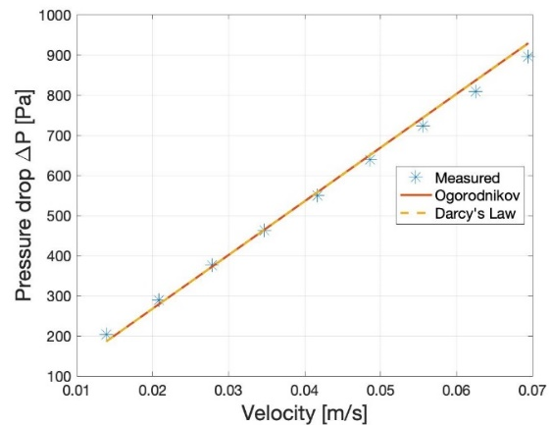
Figure 2 Pressure drop for different velocities
A script determining the packing density of the membrane was written in MATLAB software (MathWorks Inc, USA). The calculated packing density had a value of 23%. One can see that Ogorodnikov’s model corresponds to Darcy’s law from which the initial permeability value k₀ was calculated with a value of 5.53e-15 m².
Once the pressure drop as a function of velocity was measured, the particle injection was set with a filtration velocity of 5.3 cm/s. NaCl particles with a density of 2170 kg/m³ were injected as aerosol particles and the distribution of particles can be seen in Figure 3, the particles shows a lognormal distribution with parameters µ=-1.74 and σ = 0.66. The particle distribution was injected four times during the experiment.
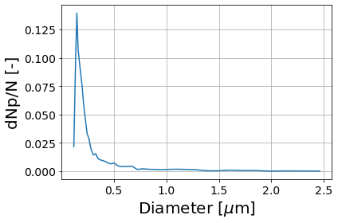
Figure 3 Injected particle distribution

Computational part
A schematic view of the simulation model is shown in Figure 4. The model consists of an upstream, porous and downstream zone.
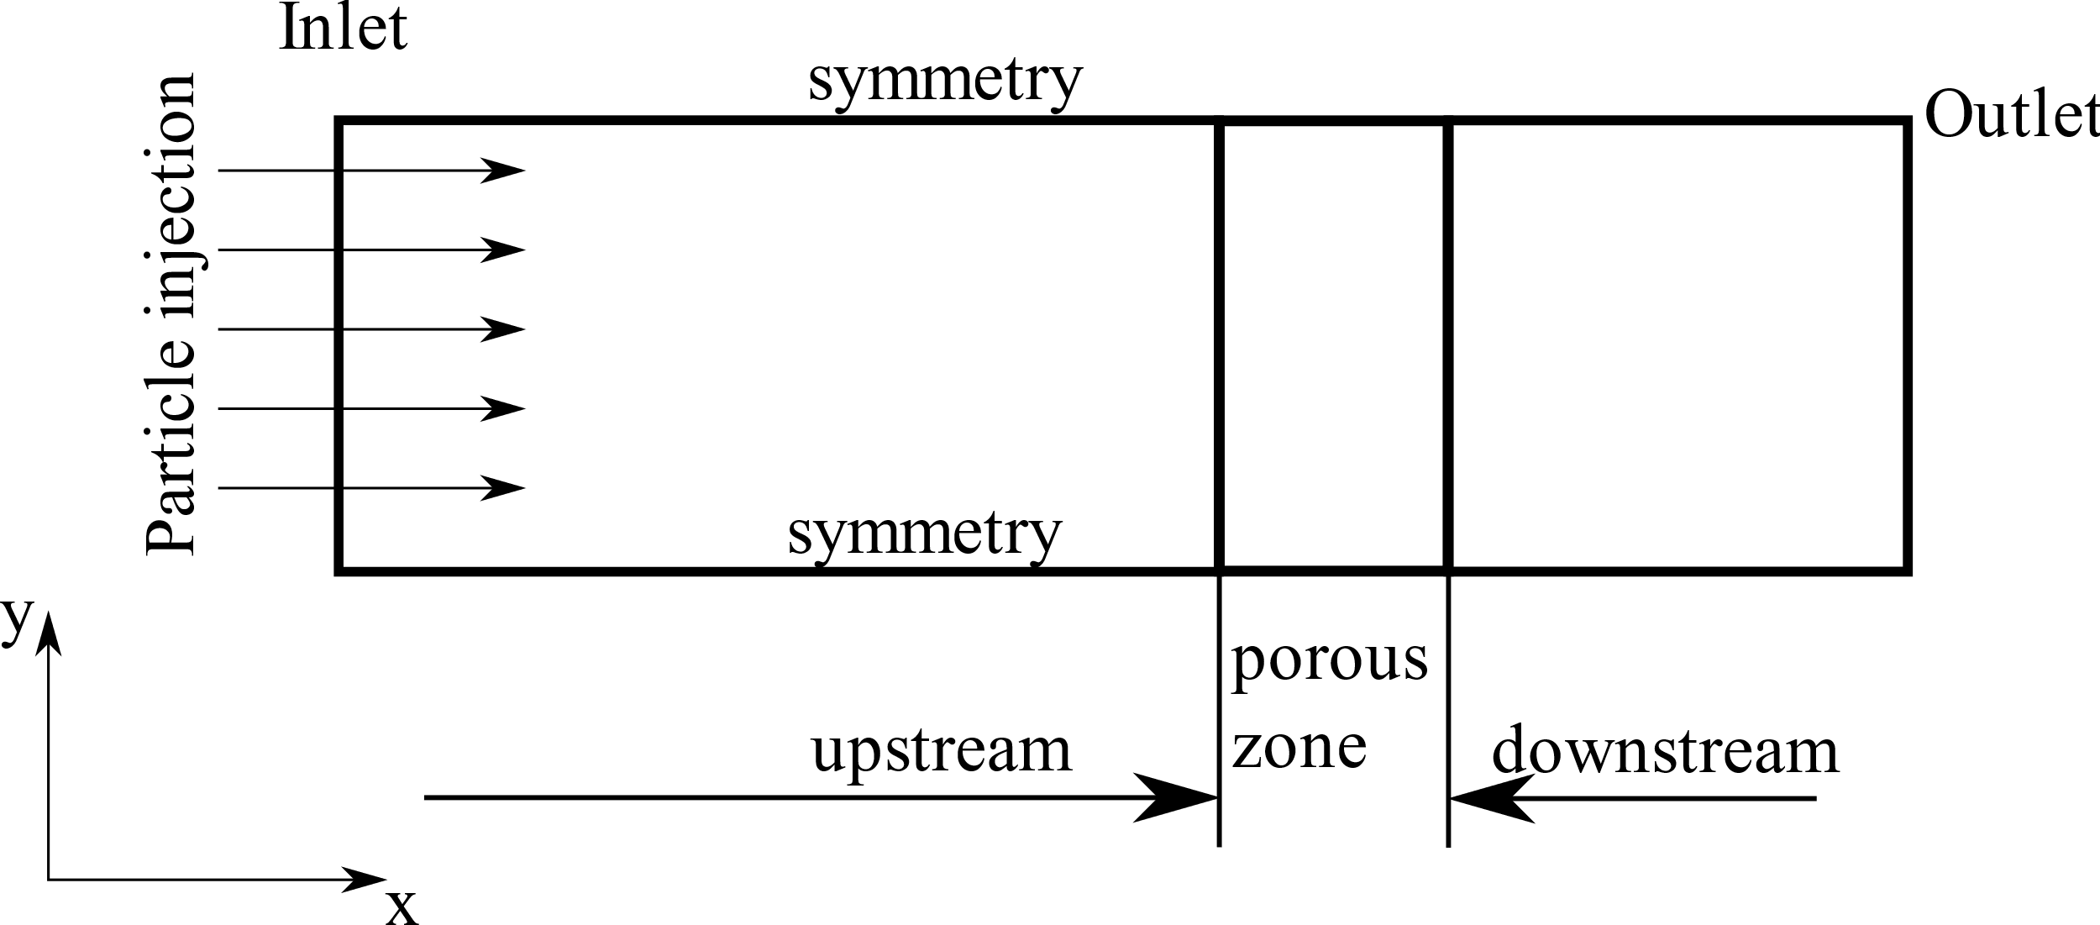
Figure 4 Scheme of the simulation model
For the numerical simulations, the Navier-Stokes equations were solved:
 | $$ρ\left[\frac{∂u}{∂t}+u⋅∇u\right]=∇p+μ∇^{2}u$$ | (3)
 | $$∇⋅u=0$$ | (4)
where u, $ρ$, p are the velocity, density and pressure respectively.
In the simulation, the particle injection was defined at the inlet boundary each time step. Particles were tracked by use of the Lagrange approach from which the speed and position are obtained using equations 5 and 6. To speed up the computational time, each particle was tracked as a cluster of particles with a mass of 1e-13 kg. For each particle diameter a cell memory was defined and in total 43 memories were used according to the particle distribution.
 | $$\frac{du_{p}}{dt}=\frac{18μ}{ρ_{p}⋅d_{p}^{2}}⋅\frac{C_{D}⋅ℜ}{24}\left(u−u_{p}\right)$$ | (5)
 | $$\frac{dx_{p}}{dt}=u_{p}$$ | (6)
where d_{p} is the particle diameter, Re is the particle Reynolds number, u_{p} is the particle velocity and x_{p} is the particle position and C_{D} is the drag coefficient.
As a capturing mechanism, the statistical model developed by Hrouda et al. [1] was implemented. This model is based on the sieve mechanism that follows from the pore size distribution. The pore size distribution was obtained from an image analysis of a SEM image (see Figure 1). In MATLAB software, a script was written for determining the pore size distribution. In the initial stage, this script transfers the grayscale image (Figure 5a) into a binary map. Same as Sambaer [7], the threshold was set at an average value of the grayscale to assure that only the upper layer is visible in the binary map. In the next step, the bitmap image was transferred into AutoCAD (Autodesk Inc, USA) and the damaged fibers were manually reconstructed. The exported image from AutoCAD was imported in MATLAB and the noise in the pore area was cleaned. The calibration was done directly as the scale was included in the image (see Figure 1). In the last step, the script labeled all the pores (white areas) and the pore diameters were obtained by maximizing a radius of the pore. Figure 5b shows the obtained distribution of the first layer with a mean pore diameter of 0.42 ± 0.28 µm. The pore distribution is lognormal with parameters of µ = -1.35 an σ = 0.98.
a | 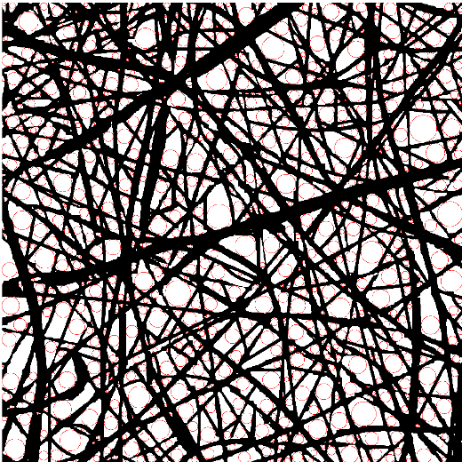 | b | 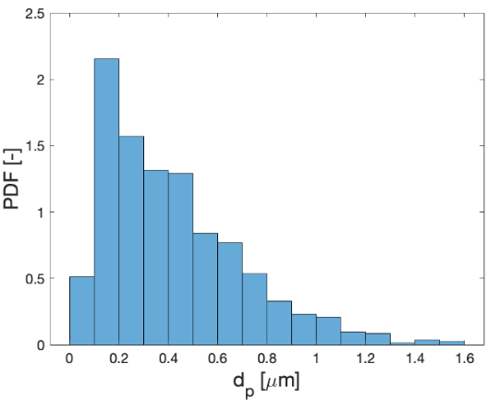
Figure 5 Pore size estimation a) The estimated pore size distribution b) The visualization of pores and fibers
Figure 6 shows the captured particles for a captured mass of 1 µg/m². One can clearly see that the particles are captured by the sieve mechanism.
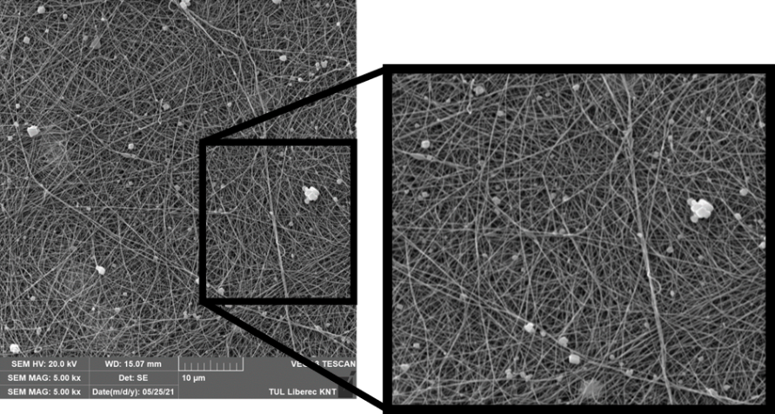
Figure 6 SEM image of particle for the captured mass of 1${μg}/{m^{2}}$
The simulation was performed as 2D with the filtration surface perpendicular to the flow direction. The sieve mechanism is applied for particles that are in the range of the pore size or greater. From the sample taken by SEM (Figure 6), one can clearly see that the particles were captured by the sieve mechanism. The filtration surface was considered as circular and a cell filtration surface varied with a cell location. The filtration surface was calculated for each cell using the following expression:
 | $$S_{c}=\int_{h_{min}}^{h_{max}}{\sqrt{R^{2}−h^{2}}}dh$$ | (7)
where h_{min} is the lower bound of the cell, h_{max} is the upper bound, R is the radius of the membrane and h is the variable height.
The permeability value (equation 9) was derived as a function of captured mass from Novick’s model (equation 8) [12] that was compared with Darcy’s law.
 | $$ΔP=K_{2}⋅m⋅v$$ | (8)
 | $$k=\frac{μ⋅L}{K_{2}⋅m}$$ | (9)
where K₂ is the linear coefficient and m is the captured mass per unit area.
The permeability changed locally according to a captured mass and it was added as a momentum sink in equation (1):
 | $$\frac{1}{k_{tot}}=\frac{1}{k_{0}}+\frac{1}{k}$$ | (10)
Also the porosity of a cell changed locally according to captured particles (equation 11). The maximal allowed solid volume fraction was defined according to Kasper et al. [14] and from the cell memories the mean particle diameter located in the cell was calculated as it was shown in Hrouda et al. [1].
 | $$ϵ=ϵ_{0}−\left(1−\frac{∑n_{i}V_{pi}}{V_{c}}\right)$$ | (11)
where ε₀ is the initial porosity and ni is the number of particles for a particle diameter and Vp is the particle volume and Vc is the cell volume.
The mesh study was done by observation of convergence for the loaded membrane and the resulted mesh consisted of 2000 elements. Figure 7 shows the pressure drop development of a cake layer for different captured mass per unit area.
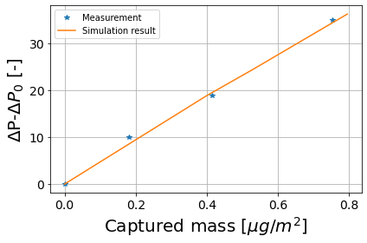
Figure 4 Pressure drop $ΔP−ΔP_{0}$ as a function of collected mass
The filtration efficiency is in a good agreement with the experimental measurement (see Figure 8a. The lowest filtration efficiency was observed for a particle diameter of 0.124 µm where in case of the experimental measurement was 99.8% whereas in the case of simulation it was 99.6%, which shows an error of 0.2%. Due to the thickness of the membrane, it is difficult to experimentally measure the distribution of the collected mass inside the membrane. The computer simulations could give a prediction of captured mass inside the membrane. According to this simulation, the majority of the captured mass was captured in the first layer (see Figure 8b).
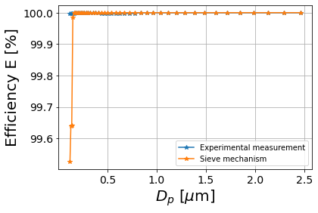 | 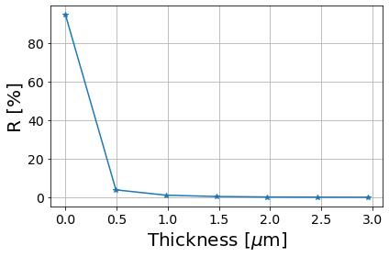
Figure 5 a) Comparison of filtration efficiency obtained from the experimental measurement and the simulation for the captured mass of 1 µg/m² b) The mass distribution inside the membrane

DISCUSSION

The main characteristic that describes the filter performance is the filtration efficiency. The filtration efficiency of electrospun membranes reaches almost 100% even for PM2.5 particles. The used membranes have shown the same performance. The previous simulations of the filtration processes were based on single fiber efficiency and the performance of the simulation was in a good agreement. Nevertheless in this study, the previously implemented capturing mechanism [8] (single fiber efficiency) was substituted by statistical prediction based on a sieve mechanism. It has been shown that the simulation provides sufficient results in filtration efficiency and the pressure drop as a function of collected mass.

CONCLUSIONS
This work was focused on the application of a sieve mechanism that was previously developed by the author’s group [1]. The aim was to experimentally obtain the filtration characteristics of the membranes, i.e. the permeability of unloaded membrane, the filtration efficiency and the pressure drop of the loaded membrane and later to numerically simulate the measured characteristics in the software ANSYS. Initially, the pore size distribution was determined by use of SEM. This distribution was transferred into the software ANSYS Fluent.

REFERENCES

- Hrouda, A., Capek, L., Vanierschot, M., & Denis, K. (2021). Macroscale simulation of the filtration process of porous media based on statistical capturing models. Separation and Purification Technology, 266, 118577.
- Gopal, R., Kaur, S., Ma, Z., Chan, C., Ramakrishna, S., & Matsuura, T. (2006). Electrospun nanofibrous filtration membrane. Journal of Membrane Science, 281(1-2), 581-586.
- Neisiany, R. E., Enayati, M. S., Kazemi-Beydokhti, A., Das, O., & Ramakrishna, S. (2020). Multilayered bio-based electrospun membranes: a potential porous media for filtration applications. Frontiers in Materials, 7, 67.
- Kaur, S., Rana, D., Matsuura, T., Sundarrajan, S., & Ramakrishna, S. (2012). Preparation and characterization of surface modified electrospun membranes for higher filtration flux. Journal of Membrane Science, 390, 235-242.
- Homaeigohar, S. S., Buhr, K., & Ebert, K. (2010). Polyethersulfone electrospun nanofibrous composite membrane for liquid filtration. Journal of Membrane Science, 365(1-2), 68-77.
- Bian, Y., Wang, S., Zhang, L., & Chen, C. (2020). Influence of fiber diameter, filter thickness, and packing density on PM2. 5 removal efficiency of electrospun nanofiber air filters for indoor applications. Building and Environment, 170, 106628.
- Wang, R., Liu, Y., Li, B., Hsiao, B. S., & Chu, B. (2012). Electrospun nanofibrous membranes for high flux microfiltration. Journal of membrane science, 392, 167-174.
- Sambaer, W., Zatloukal, M., & Kimmer, D. (2011). 3D modeling of filtration process via polyurethane nanofiber based nonwoven filters prepared by electrospinning process. Chemical Engineering Science, 66(4), 613-623.
- Cai, R. R., Zhang, L. Z., & Yan, Y. (2017). Performance prediction of PM 2.5 removal of real fibrous filters with a novel model considering rebound effect. Applied thermal engineering, 111, 1536-1547.
- Ghasemi‐Mobarakeh, L., Semnani, D., & Morshed, M. (2007). A novel method for porosity measurement of various surface layers of nanofibers mat using image analysis for tissue engineering applications. Journal of applied polymer science, 106(4), 2536-2542.
- Rasband, W.S., ImageJ, U. S. National Institutes of Health, Bethesda, Maryland, USA, https://imagej.nih.gov/ij/, 1997-2018.
- Ogorodnikov, B. I. (1976). Pressure-drop across FP fiber filters under gas slip-flow and in transition regime. Colloid Journal of the USSR, 38(1), 168-172.
- Novick, V. J., Higgins, P. J., Dierkschiede, B., Abrahamson, C., Richardson, W. B., Monson, P. R., & Ellison, P. G. (1991). Efficiency and mass loading characteristics of a typical HEPA filter media material (No. NUREG/CP--0116-VOL. 2).
- Kasper, G., Schollmeier, S., & Meyer, J. (2010). Structure and density of deposits formed on filter fibers by inertial particle deposition and bounce. Journal of Aerosol Science, 41(12), 1167-1182.

