Chlorine-resistant epoxide-based membranes for sustainable water desalination

Rhea Verbeke,*^{,a,b} Douglas M. Davenport,^{a,b} Timothée Stassin,ª Samuel Eyley,^{c} Marcel Dickmann,^{d} Alexander John Cruz,ª Praveen Dara,^{e} Cody L. Ritt,^{b} Caroline Bogaerts,ª Werner Egger,^{d} Rob Ameloot,ª Johan Meersschaut,^{e} Wim Thielemans,^{c} Guy Koeckelberghs,^{f} Menachem Elimelech,^{b} and Ivo F. J. Vankelecomª

ª Centre for Membrane Separations, Adsorption, Catalysis and Spectroscopy for Sustainable Solutions (cMACS), KU Leuven, Celestijnenlaan 200F, 3001 Leuven, Belgium.
^{b} Department of Chemical and Environmental Engineering, Yale University, New Haven, CT 06511, USA.
^{c} Sustainable Materials Lab, Department of Chemical Engineering, KU Leuven, campus Kulak Kortrijk, Etienne Sabbelaan 53, 8500 Kortrijk, Belgium.
^{d} Institut für Angewandte Physik und Messtechnik, Universität der Bundeswehr München, 85577 Neubiberg, Germany.
^{e} Imec, Kapeldreef 75, 3001 Heverlee, Belgium.
^{f} Laboratory for Polymer Synthesis, Faculty of Chemistry, KU Leuven, Celestijnenlaan 200F, 3001 Leuven, Belgium.
* Corresponding author: Rhea Verbeke | Email: rhea.verbeke@kuleuven.be

Abstract
The hyper-sensitivity of state-of-the-art polyamide-based membranes to chlorine is a major source of premature membrane failure and module replacement in water desalination plants. This problem can currently only be solved by implementing pre- and post-treatment processes involving additional chemical use and energy input, thus increasing environmental, capital, and operational costs. Herein, we report a chlorine-, acid-, and base-resistant desalination membrane comprising a cross-linked epoxide-based polymer selective layer with permanent positive charges. These novel membranes exhibit high mono- and divalent salt rejection (81% NaCl, 87% CaCl₂, 89% MgCl₂) and a water permeance of ~ 2 L m⁻² h⁻¹ bar⁻¹, i.e., desalination performance comparable to that of commercially available nanofiltration membranes. Unlike conventional polyamide-based membranes, this new generation of epoxide-based membranes takes advantage of the intrinsic chemical stability of ether bonds while achieving the polymer and charge density needed for desalination. In doing so, the stability of these membranes opens new horizons for sustainable water purification and many other separations in harsh media in a variety of applications (e.g., solvent recovery, gas separations, redox flow batteries).
TOC Art
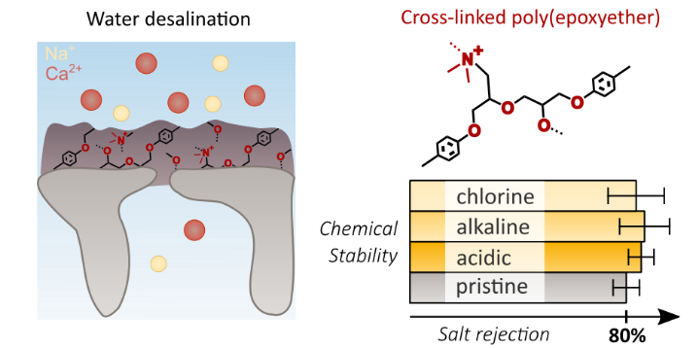
Introduction
Tackling water scarcity is a global challenge as it affects two-thirds of the world population and its natural ecosystems.^{1–5} The interdependence of water production and energy consumption, the so-called water–energy nexus, calls for the use of energy-efficient water treatment technologies.⁶ Pressure-driven membrane desalination using reverse osmosis (RO) and nanofiltration (NF) enables the production of freshwater from saline water sources at an order of magnitude lower energy cost than thermal processes.^{7,8} Since 2000, the number and capacity of membrane desalination plants has increased substantially. Currently, they produce 65.5 million m³ water per day, accounting for 69% of the volume of desalinated water produced worldwide.⁹
State-of-the-art RO membranes exhibit high rejection for monovalent (> 99.4%) and divalent salts (~ 100%), but operate at elevated pressures (~ 60 bar) with a water permeance of ~ 2 L m⁻² h⁻¹ bar⁻¹. Conversely, NF membranes allow a significant fraction of monovalent salts to pass through while largely rejecting divalent salts (> 80%), resulting in higher water fluxes at lower operational pressures (< 20 bar).¹⁰ Typically, RO/NF membranes are thin-film composite (TFC) membranes consisting of a dense polyamide (PA) selective layer on top of a porous support.¹¹
Desalination of seawater or brackish water is one of the most important applications for TFC membranes. Modern desalination plants comprise a number of process steps (Figure 1), including (i) pre-treatment of the feed water for biofouling control using chlorine, an oxidant added in low doses (0.2–2.5 ppm NaOCl);^{12–14} (ii) chlorine removal (to levels < 0.01 ppm) using (meta)sodium bisulfite, to protect the PA membrane;^{13,15} (iii) membrane desalination; and (iv) freshwater rechlorination (1–2 ppm NaOCl) to avoid microbial growth in the utilities network.¹⁴ The chlorine sensitivity of PA membranes requires the use of this chlorination–dechlorination–rechlorination sequence that is inefficient, unsustainable, and difficult to operate. Accidental membrane chlorination due to incomplete dechlorination currently accounts for 18% of all desalination membrane failures.¹⁶ Therefore, the development of chlorine-resistant membranes is a strategic priority as it could reduce total plant costs by 30%¹³ by simplifying the process scheme, avoiding premature replacement of membrane modules, and allowing chlorine to be used as a membrane cleaning agent to avoid another 27% of membrane failures caused by biofouling.¹⁶ By reducing membrane failures and minimizing the quantity of chemicals needed for chlorination, dechlorination, and rechlorination, chlorine-resistant membranes are expected to substantially improve the sustainability of desalination processes.
There has been an ongoing quest for chlorine-resistant membranes since the advent of PA-based membranes in the 1980s.¹⁴ Several approaches have been evaluated, but none could improve chlorine resistance without compromising salt rejection or water flux. These strategies include: using monomers that are less susceptible to chlorine-attack;¹⁵ applying protective coatings;¹⁵ embedding chlorine-quenching nanoparticles in the PA-selective layer;¹⁵ and replacing PA with various polymers.^{17–22} Recently, a polyester membrane with enhanced chlorine stability and performance similar to state-of-the-art RO membranes was developed, but showed signs of ester bond hydrolysis under alkaline conditions.²³ Thus, despite the variety of approaches that have been attempted, a need exists for novel materials that achieve excellent chemical resistance and desalination performance.
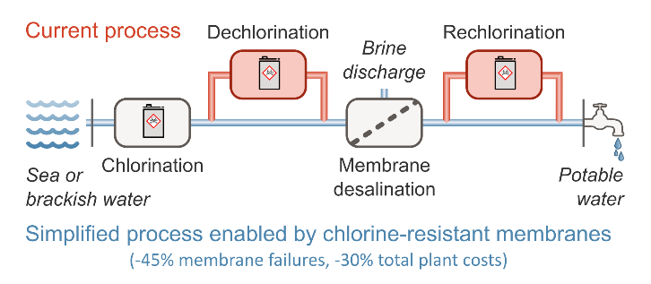
Figure 1. Selected unit operations of a water desalination plant with conventional pre-treatment.^{24–26} Water is chlorinated for biofouling control, dechlorinated to avoid membrane oxidation, and rechlorinated before leaving the desalination plant to prevent microbial growth in the utilities network. The dechlorination and rechlorination steps become obsolete when the membranes are chlorine-resistant, thereby increasing the efficiency and sustainability of the process.
A promising candidate material for chemically stable membranes is based on the use of epoxide chemistry, a versatile and well-established chemistry which yields products with high chemical resistance in applications ranging from protective coatings to adhesives.²⁷ Epoxides can polymerize through their reactive oxirane ring to form poly(epoxyether) (PEE) networks. Recently, epoxides were utilized in membrane synthesis to obtain thin PEE layers using interfacially initiated polymerization (IIP) rather than bulk polymerization.²⁸ Despite the excellent chemical resistance imparted by their ether bonds, this first generation of epoxide-based membranes was unsuitable for desalination because its loose polymer structure did not provide the necessary water–salt selectivity.
Herein, the novel synthesis of water–salt selective and chemically resistant epoxide-based membranes is reported. This new generation of epoxide-based membranes comprises a dense and positively charged cross-linked poly(epoxyether) (XL-PEE) selective layer. Membrane selective layer properties are characterized to demonstrate the role of charge repulsion and size exclusion to reject dissolved ions. These chemically stable membranes achieve excellent water–salt selectivity (i.e., 81% NaCl, 87% CaCl₂, 89% MgCl₂ salt rejection and 2 L m⁻² h⁻¹ bar⁻¹ water permeance), with future development anticipated to yield further improvements in performance. Membrane stability was also demonstrated by confirming desalination performance is unchanged after exposing membranes to harsh conditions (i.e., 200 ppm NaOCl, pH 3 HNO₃, pH 10 NaOH).
Materials and Methods
Epoxide-based membranes with water–salt selectivity were prepared through IIP followed by a cross-linking treatment under conventional and scalable synthesis conditions (Figure 2). Briefly, the porous poly(acrylonitrile) (PAN) support is impregnated with an initiating aqueous tertiary diamine (N,N,N′,N′-tetramethyl-1,6-hexanediamine, TMHD, Figure S1) solution, and exposed to a tetrafunctional epoxide (tetraphenolethane tetraglycidylether, EPON, Figure S1) in toluene solution to initiate the ring-opening polymerization (Figure S2). After surface rinsing with toluene, the membrane is either immersed in water, causing chain termination, to obtain a ‘PEE membrane’, or further subjected to a cross-linking treatment. This treatment comprises contacting the IIP layer with the epoxide in toluene solution, rinsing with toluene, and contacting with the aqueous diamine solution. After a final rinse with toluene and immersion in water, a ‘XL-PEE membrane’ is obtained (Figure 2). The physicochemical properties, water–salt selectivity, and chemical resistance of membranes with (XL-PEE) and without cross-linking (PEE) were investigated to understand the benefits of the cross-linking treatment. For salt-selective membranes, stability in acidic, basic, and oxidizing conditions was then compared to that of commercial NF membranes. Full details on membrane synthesis and characterization techniques are provided in the Supporting Information. In general, cross-linking yielded a denser polymer network comprising more permanent positive charges, properties which contribute to substantially improved water–salt selectivity for XL-PEE membranes.
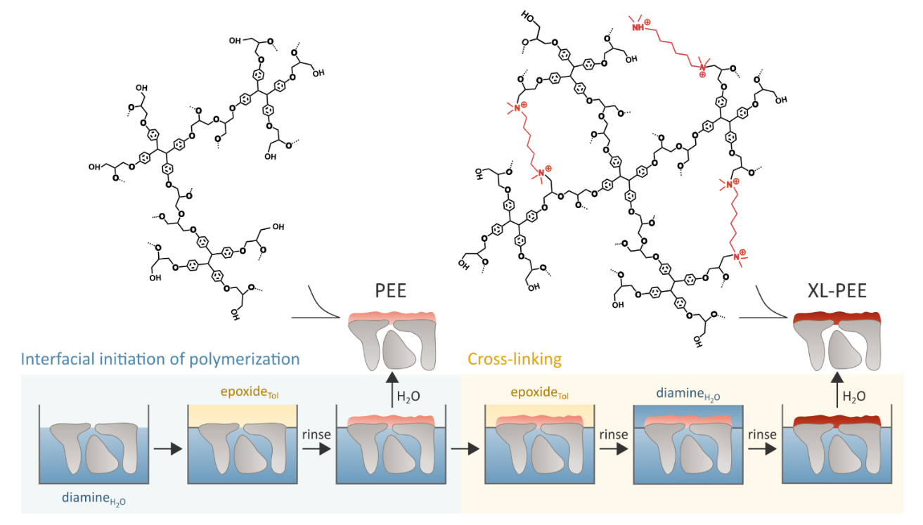
Figure 2. Synthesis scheme of the cross-linked epoxide-based membranes. Interfacially initiated polymerization (IIP) of an epoxide in toluene solution by a diamine in water solution results in the formation of a selective layer on top of a porous support. After rinsing and immersing in water, a thin film composite poly(epoxyether) ‘PEE’ membrane is obtained, of which the hypothesized structure is shown. Cross-linking treatment of the IIP layer consists of sequentially applying a fresh epoxide solution, a toluene wash, and a fresh diamine solution. After rinsing and immersing in water, a cross-linked poly(epoxyether) ‘XL-PEE’ membrane is obtained. The assumed chemical structure of the XL-PEE network is shown, containing ammonium groups from TMHD incorporation and from protonation of the dangling amine groups of TMHD.
Results and Discussion
The membrane chemical structure and composition were studied with infrared spectroscopy, X-ray photoelectron spectroscopy (XPS), and elastic recoil detection (ERD). Infrared spectra demonstrate the presence of a poly(epoxyether) layer on top of a PAN support for both the PEE and XL-PEE membranes (Figure S3). Complete disappearance of the oxirane C-O at 909 cm⁻¹ confirms the successful ring-opening polymerization (Figure S4).²⁹ High-resolution XPS spectra show signals originating from carbon, oxygen, and nitrogen atoms (Table S1-7). Interestingly, ammonium groups (NR₄⁺ and NR₃H⁺) are observed, and their abundance increases drastically from 0.2 at% for PEE to 1.6 at% for XL-PEE (Figure 3a, Table S6). NR₄⁺ groups are expected as the product of the polymerization initiation, through the reaction of an EPON epoxide ring and a TMHD tertiary amine (Figure S2), while NR₃H⁺ groups originate from protonation of dangling tertiary amine groups (pK_{a}~10).³⁰ During the cross-linking treatment, TMHD thus helps to densify the membrane by re-initiating the ring-opening polymerization and may also act as a cross-linker itself while the tetra-functional EPON serves as both monomer and cross-linker. In addition to the effect of crosslinking and selective layer density, the greater presence of ammonium groups in XL-PEE yields a membrane with a permanent positive charge. This charge hinders the transport of positively charged species which increases salt rejection in desalination applications. It should be noted it is possible a charged membrane surface may contribute to increased fouling via electrostatic interactions. Nevertheless, the chemical stability of XL-PEE allows for the use of intensified cleaning procedures which may offset or avoid detrimental fouling.
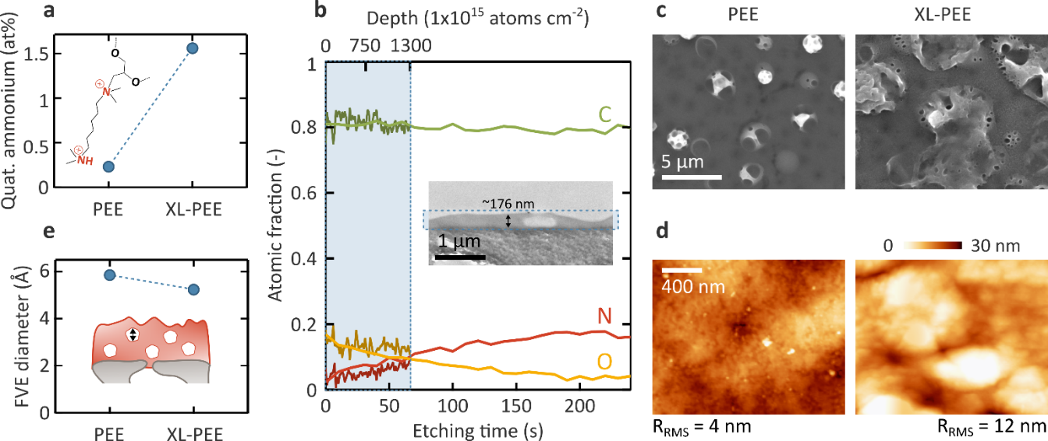
Figure 3. (a) Quaternary ammonium content (NR₄⁺ and NR₃H⁺) of the PEE and XL-PEE membranes as determined by high-resolution X-ray photoelectron spectroscopy (XPS). Standard deviations are based on 4 replicates, but are hidden by the symbols. (b) Elastic recoil detection (ERD) and XPS depth-profile results of the XL-PEE membrane. The ERD data (dark colors) are plotted on the upper x-axis up to a depth of 1300×10¹⁵ atoms cm⁻² (equivalent to ~160 nm), solely probing the selective layer. The XPS data (light colors) are plotted on the bottom x-axis, probing both the selective layer and the support layer. Inset: transmission electron microscopy (TEM) cross-sectional images of the XL-PEE membrane. An average thickness of 176 nm is calculated for the selective layer. A blue box indicating the selective layer position is displayed on both the depth profiles and TEM image. (c) Top-view scanning electron microscopy (SEM) images and (d) atomic force microscopy (AFM) images of the PEE and XL-PEE membranes, with a root-mean-square roughness (R_{RMS}) of 4 and 12 nm, respectively. The SEM and AFM scale bars apply to both images. (e) Diameter of the free-volume elements (FVE) inside the selective layer of the PEE and XL-PEE membranes, as determined via positron annihilation lifetime spectroscopy (PALS) measurements at 1 keV (~30 nm probing depth). Error bars represent standard deviation from the fitting routine, but are hidden by the symbols.
With depth-profiling XPS and ERD, the elemental composition over the XL-PEE membrane thickness was investigated. XPS probed both the selective and support layers while ERD exclusively sampled the selective layer, with the results of both techniques in close agreement (Figure 3b, Figure S5a and b). The decreasing oxygen signal deeper into the selective layer, and concurrent nitrogen signal increase, indicate the transition from the selective layer (C−O−C and C−N⁺−C bonds) to the PAN support layer (C≡N bonds) (Figure S6). The gradual evolution, rather than a step function, is expected for ERD measurements of TFC membranes and has been demonstrated for conventional RO/NF membranes.^{31,32} Nonetheless, the selective layer thickness can be deduced from the O-N signal cross-over point on the XPS and ERD spectra. With depth-profiling XPS, this point is reached after ~ 60 s of sputtering, and with ERD after the detection of ~ 1300×10¹⁵ atoms cm⁻², coinciding with a selective layer thickness around 160 nm (Figure 3b).
Membrane morphology was investigated using scanning and transmission electron microscopy (SEM and TEM), as well as atomic force microscopy (AFM). Top-view SEM images show bulky protrusions on a flat membrane surface (Figure 3c). These protrusions likely originate from the abrupt termination of the living polymerization resulting in loose, hollow vesicles. AFM topography at higher magnification than SEM reveals extremely smooth membrane surfaces exist between these protrusions, with a root-mean-square (RMS) roughness of 4 and 12 nm for the PEE and XL-PEE membranes, respectively (Figure 3d). The low roughness of the epoxide-based membranes is similar to that of some conventional NF membranes (~ 10 nm), and is far lower than that of conventional RO membranes (80–100 nm),³³ offering the potential to reduce fouling for these novel epoxide-based membranes.³⁴ Cross-sectional TEM images show the XL-PEE selective layer fully covers the porous PAN support and has an average thickness of 176 nm, in agreement with XPS and ERD results (inset Figure 3b, thickness in Figure S7), and similar to the thickness of conventional desalination membranes.³³ The PEE membrane could not be imaged due to likely detachment of the relatively loose selective layer from the support during microtome sectioning, as observed elsewhere.³⁵
Positron annihilation lifetime spectroscopy (PALS) was used to investigate the size and abundance of free-volume elements (FVEs) in the selective layer (i.e., ~ 30 nm probed depth). The PEE membrane contains FVEs of 5.9 Å in diameter while those of XL-PEE are 5.3 Å (Figure 3c), providing evidence the cross-linking treatment increased membrane density and reduced FVE size to a value approaching that of conventional RO membranes (i.e., 4.9 Å).^{36,37} The ortho-positronium intensity, linked to the relative abundance of FVEs, is constant (16–19%) (Figure S8). Assuming a similar o-Ps formation probability for both membranes, these data indicate the number of FVEs in the selective layer remains largely unaffected by densification. The reduction in FVE size for XL-PEE increases salt transport resistance which contributes to improved water–salt selectivity as compared to the PEE membrane.
Membrane performance was investigated with respect to RO/NF applications. The pure water permeance (expressed as water permeability coefficient A) of PEE and XL-PEE membranes was found to be 3.2 and 2 L m⁻² h⁻¹ bar⁻¹, respectively, performance comparable to conventional RO membranes (Figure 4a). The reduction in water permeance after cross-linking treatment is consistent with the densification observed with PALS. The XL-PEE membrane further exhibits tremendously improved water–salt selectivity for both mono- and divalent salts compared to the PEE membrane due to its increased selective layer density and charge. Specifically, rejection increased from below 30% to 81% for NaCl, and from below 30% to 89% and 87% for MgCl₂ and CaCl_{2,} respectively (Figure 4b). Compared to commercial NF membranes, the divalent salt rejections are similar,³⁸ but the NaCl rejection is far greater for the XL-PEE membranes (~ 40% NaCl rejection for Filmtec® NF270³⁹ and Synder® NFX⁴⁰). While it is often difficult to classify membrane performance as either NF or RO, salt rejection is considered to be more important than water permeability in making such designations. In light of the monovalent and divalent salt rejection, XL-PEE is therefore categorized as a ‘tight’ NF membrane, and holds great potential for applications such as water softening.¹⁰
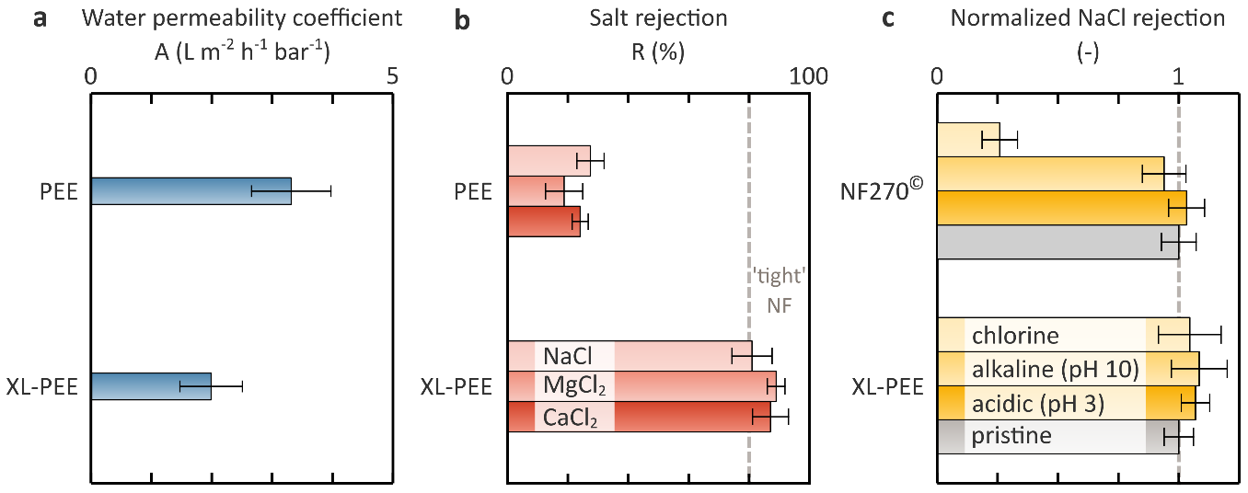
Figure 4. (a) Water permeance, expressed as water permeability coefficient (A), of the PEE and XL-PEE membranes. The value of A for industrial RO applications is highlighted with a vertical dashed line. (b) NaCl, MgCl₂, and CaCl₂ rejection (R) of the PEE and XL-PEE membranes. The minimum required rejection for ‘tight NF’ applications is highlighted with a vertical dashed line. (c) NaCl rejection after chlorine (200 ppm NaOCl, 15 h), acid (HNO₃, pH 3, 15 h) and caustic (NaOH, pH 10, 15 h) treatment of the XL-PEE and polyamide-based NF270 membranes, normalized to the rejection of the pristine membranes. Unaltered performance is highlighted with a vertical dashed line.
The chemical resistance of the epoxide-based membranes was investigated by immersing membranes in acidic (HNO₃, pH 3, 15 h), alkaline (NaOH, pH 10, 15 h), and oxidizing (200 ppm NaOCl, 15 h) solutions prior to filtration. This diverse set of conditions was selected to demonstrate XL-PEE stability across a range of the most important harsh environments. While the acid and alkaline test conditions were limited by the PAN support pH stability,⁴¹ membrane stability is validated in each of these conditions which can be explored further through intensified experiments in future studies. In each harsh condition, the XL-PEE membrane maintained its excellent NaCl rejection owing to its inherently stable ether backbone (Figure 4c). Although a slight change in the average normalized NaCl rejection is observed for XL-PEE, the standard deviations overlap the pristine membrane performance, and thus no significant change in NaCl rejection was observed. No change in the characteristic infrared bands was also observed, further confirming membrane chemical integrity is maintained (Figure S9). Conversely, state-of-the-art Filmtec® NF270, a commercial polyamide membrane with comparable salt rejection, lost 80% of its separation capacity after chlorine treatment. Whereas the polyamide selective layer of NF270 was susceptible to chlorine degradation, the inherently stable ether backbone of XL-PEE imparts excellent chlorine resistance to the epoxide-based membrane.
These results demonstrate that XL-PEE is suitable for NF applications and can withstand severe cleaning conditions with acidic, alkaline, and chlorine solutions to remove a variety of detrimental foulants and scale-forming species. Importantly, chlorine can also be dosed throughout the water treatment process without concern for negatively impacting membrane performance. Further, the ether bonds are expected to remain stable at pH < 3 and pH > 10, enabling opportunities for separations in extremely harsh media when PAN is replaced with alternative support materials for specific applications.
The mechanisms governing salt rejection for the XL-PEE membrane appear to be dominated by the anion (Cl⁻), as relatively similar rejections for monovalent and divalent chloride-containing salts are obtained (81% NaCl, 87% CaCl₂, and 89% MgCl₂) (Figure 4b). These results indicate the strong ion-pairing between chloride anions and permanent positive charges in the membrane contribute substantially to salt rejection, in agreement with ion association models for membranes with fixed charges (detailed information in the Supporting Information).⁴² Additionally, XL-PEE salt rejection is independent of pH (pH 3–11, Figure S10), providing additional evidence for the presence of permanent quaternary ammonium groups inside the network that increase salt rejection.
Several variations on the cross-linking treatment were also performed which highlight the role of crosslinking and charge incorporation to yield a water–salt selective membrane (Figure S11 and S12). Specifically, during the densification of XL-PEE membranes, EPON acts as a monomer and cross-linker to densify the network, while TMHD acts as a polymerization re-initiator, a source of charge-bearing groups, and possibly also as an additional cross-linker. Repeated cross-linking treatments did not yield any further improvements in performance (Figure S13), nor significantly change the membrane physicochemical properties (Table S1–7, Figure S7, S8, and S12).
This work introduces epoxide-based membranes which are able to compete with conventional polyamide membranes for water desalination applications, but with strongly increased chemical resistance. By improving membrane stability, significant cost savings and improved sustainability are expected which may offset any increased cost of using a novel membrane technology. The membranes presented here are the first epoxide-based membranes to demonstrate water–salt selectivity, with additional development anticipated to yield further improvements in desalination performance. A promising approach to the development of chlorine-resistant membranes is demonstrated by synthesizing membranes comprising materials with inherent chlorine stability, such as the ether backbone of the epoxide-based TFC membranes. The results of this study demonstrate how post-treatment of IIP-synthesized layers is a powerful strategy for polymer densification and charge incorporation. The presence of permanent charges is not only key to achieving a high water–salt selectivity, but also offers opportunities for tailored solute–solute selectivity and application as ion-exchange membranes.⁴³ Furthermore, the outstanding chemical resistance of epoxide-based membranes will help enhance the robustness of membrane processes, extend the application window of membrane technology to harsher conditions of extreme pH, and allow application of intensified, thus more efficient, membrane cleaning procedures to improve process sustainability.

Supporting Information
Please refer to the Supporting Information available online for detailed information on materials, synthesis and characterization methods, ion rejection mechanisms, and supporting tables and figures referred to in the main text.

Acknowledgements
R.V. and T.S. thank the Research Foundation Flanders (FWO) for SB-PhD fellowships (1S00917N, 1S53316N) and R.V. also for a research grant at Yale University (V406619N). The authors also thank FWO for support through the G0D5119N and Nanomexico (AIO/150474/SBO) projects, and KU Leuven through C1 (C16/17/005). W.T. and S.E. thank FWO (G0A1219N), KU Leuven (C14/18/061), and the European Union's European Fund for Regional Development, Flanders Innovation & Entrepreneurship (Accelerate³ and EFRO-1316). The authors acknowledge the support by the U.S. National Science Foundation under Grant CBET-1701658 and a Graduate Research Fellowship (DGE1752134) for C.L.R. This project has received funding from the European Research Council (ERC) under the European Union's Horizon 2020 research and innovation program (grant agreement n° 716472, acronym VAPORE). Parts of this work are based on experiments performed at the NEPOMUC PLEPS instrument, operated by FRM II at the Heinz Maier Leibnitz Zentrum (MLZ), Garching, Germany. Funding from the German BMBF (projects 05K16WN1-Positec and 05K19WN1-Posilife) is gratefully acknowledged. Steven De Feyter is thanked for his scientific support.

Conflict of Interest Statement
There are no conflicts of interest to declare.

References

(1) Mekonnen, M. M.; Hoekstra, A. Y. Four Billion People Facing Severe Water Scarcity. Sci. Adv. 2016, 2 (2), 1–7. https://doi.org/10.1126/sciadv.1500323.
(2) Freire-González, J.; Decker, C.; Hall, J. W. The Economic Impacts of Droughts: A Framework for Analysis. Ecol. Econ. 2017, 132, 196–204. https://doi.org/10.1016/j.ecolecon.2016.11.005.
(3) Endo, A.; Tsurita, I.; Burnett, K.; Orencio, P. M. A Review of the Current State of Research on the Water, Energy, and Food Nexus. J. Hydrol. Reg. Stud. 2017, 11, 20–30. https://doi.org/10.1016/j.ejrh.2015.11.010.
(4) Vörösmarty, C. J.; McIntyre, P. B.; Gessner, M. O.; Dudgeon, D.; Prusevich, A.; Green, P.; Glidden, S.; Bunn, S. E.; Sullivan, C. A.; Liermann, C. R.; Davies, P. M. Global Threats to Human Water Security and River Biodiversity. Nature 2010, 467 (7315), 555–561. https://doi.org/10.1038/nature09440.
(5) Richter, B. D.; Bartak, D.; Caldwell, P.; Davis, K. F.; Debaere, P.; Hoekstra, A. Y.; Li, T.; Marston, L.; McManamay, R.; Mekonnen, M. M.; Ruddell, B. L.; Rushforth, R. R.; Troy, T. J. Water Scarcity and Fish Imperilment Driven by Beef Production. Nat. Sustain. 2020, 3 (4), 319–328. https://doi.org/10.1038/s41893-020-0483-z.
(6) Hussey, K.; Pittock, J. The Energy-Water Nexus: Managing the Links between Energy and Water for a Sustainable Future. Ecol. Soc. 2012, 17 (1). https://doi.org/10.5751/ES-04641-170131.
(7) Elimelech, M.; Phillip, W. A. The Future of Seawater Deaslination: Energy, Technology, and the Environment. Science 2011, 333 (August), 712–718. https://doi.org/10.1126/science.1200488.
(8) Koros, W. J.; Lively, R. P. Water and Beyond: Expanding the Spectrum of Large-Scale Energy Efficient Separation Processes. AIChE J. 2012, 59 (4), 215–228. https://doi.org/10.1002/aic.
(9) Jones, E.; Qadir, M.; van Vliet, M. T. H.; Smakhtin, V.; Kang, S. mu. The State of Desalination and Brine Production: A Global Outlook. Sci. Total Environ. 2019, 657, 1343–1356. https://doi.org/10.1016/j.scitotenv.2018.12.076.
(10) Paul, M.; Jons, S. D. Chemistry and Fabrication of Polymeric Nanofiltration Membranes: A Review. Polymer (Guildf). 2016, 103, 417–456. https://doi.org/10.1016/j.polymer.2016.07.085.
(11) Werber, J. R.; Osuji, C. O.; Elimelech, M. Materials for Next-Generation Desalination and Water Purification Membranes. Nat. Rev. Mater. 2016, 16018. https://doi.org/10.1038/natrevmats.2016.18.
(12) Jamaly, S.; Darwish, N. N.; Ahmed, I.; Hasan, S. W. A Short Review on Reverse Osmosis Pretreatment Technologies. Desalination 2014, 354, 30–38. https://doi.org/10.1016/j.desal.2014.09.017.
(13) Gohil, J. M.; Suresh, A. K. Chlorine Attack on Reverse Osmosis Membranes: Mechanisms and Mitigation Strategies. J. Memb. Sci. 2017, 541 (June), 108–126. https://doi.org/10.1016/j.memsci.2017.06.092.
(14) Glater, J.; Hong, S.; Elimelech, M. The Search for a Chlorine-Resistant Reverse Osmosis Membrane. Desalination 1994, 95 (3), 325–345. https://doi.org/10.1016/0011-9164(94)00068-9.
(15) Verbeke, R.; Gómez, V.; Vankelecom, I. F. J. Chlorine-Resistance of Reverse Osmosis (RO) Polyamide Membranes. Prog. Polym. Sci. 2017, 72, 1–15. https://doi.org/10.1016/j.progpolymsci.2017.05.003.
(16) Chesters, S. P.; Pena, N.; Gallego, S.; Fazel, M.; Armstrong, M. W.; Vigo, F. Results from 99 Seawater RO Membrane Autopsies. IDA J. Desalin. Water Reuse 2013, 5 (1). https://doi.org/10.1179/2051645213Y.0000000006.
(17) Park, H. B.; Freeman, B. D.; Zhang, Z.-B.; Sankir, M.; McGrath, J. E. Highly Chlorine-Tolerant Polymers for Desalination. Angew. Chem. Int. Ed. Engl. 2008, 47 (32), 6019–6024. https://doi.org/10.1002/anie.200800454.
(18) Kim, Y.-J.; Shim, H.-S.; Lee, J.-S. Desalination Properties of a Novel Composite Membrane Prepared by Electrospinning Method. Desalin. Water Treat. 2012, 15 (1–3), 84–91. https://doi.org/10.5004/dwt.2010.1671.
(19) Paul, M.; Park, H. B.; Freeman, B. D.; Roy, A.; Mcgrath, J. E.; Riffle, J. S. Synthesis and Crosslinking of Partially Disulfonated Poly(Arylene Ether Sulfone) Random Copolymers as Candidates for Chlorine Resistant Reverse Osmosis Membranes. Polymer (Guildf). 2008, 49, 2243–2252. https://doi.org/10.1016/j.polymer.2008.02.039.
(20) Hong, S.; Kim, I. C.; Tak, T.; Kwon, Y. N. Interfacially Synthesized Chlorine-Resistant Polyimide Thin Film Composite (TFC) Reverse Osmosis (RO) Membranes. Desalination 2013, 309, 18–26. https://doi.org/10.1016/j.desal.2012.09.025.
(21) Geise, G. M.; Lee, H. S.; Miller, D. J.; Freeman, B. D.; McGrath, J. E.; Paul, D. R. Water Purification by Membranes: The Role of Polymer Science. J. Polym. Sci. Part B Polym. Phys. 2010, 48, 1685–1718. https://doi.org/10.1002/polb.22037.
(22) Xue, J.; Jiao, Z.; Bi, R.; Zhang, R.; You, X.; Wang, F.; Zhou, L.; Su, Y.; Jiang, Z. Chlorine-Resistant Polyester Thin Film Composite Nanofiltration Membranes Prepared with Β-Cyclodextrin. J. Memb. Sci. 2019, 584, 282–289. https://doi.org/10.1016/j.memsci.2019.04.077.
(23) Yao, Y.; Zhang, P.; Jiang, C.; DuChanois, R. M.; Zhang, X.; Elimelech, M. High Performance Polyester Reverse Osmosis Desalination Membrane with Chlorine Resistance. Nat. Sustain. 2020, 1–9. https://doi.org/10.1038/s41893-020-00619-w.
(24) Henthorne, L.; Boysen, B. State-of-the-Art of Reverse Osmosis Desalination Pretreatment. Desalination 2015, 356, 129–139. https://doi.org/10.1016/j.desal.2014.10.039.
(25) Voutchkov, N.; Consultants, W. G. Overview of Seawater Concentrate Disposal Alternatives. Desalination 2010, 273, 205–219. https://doi.org/10.1016/j.desal.2010.10.018.
(26) Darwish, M.; Hassabou, A. H.; Shomar, B. Using Seawater Reverse Osmosis (SWRO) Desalting System for Less Environmental Impacts in Qatar. Desalination 2013, 309, 113–124. https://doi.org/10.1016/j.desal.2012.09.026.
(27) Ellis, B. Chemistry and Technology of Epoxy Resins; 1993. https://doi.org/10.1007/978-94-011-2932-9.
(28) Verbeke, R.; Arts, W.; Dom, E.; Dickmann, M.; Egger, W.; Koeckelberghs, G.; Szymczyk, A.; Vankelecom, I. F. J. Transferring Bulk Chemistry to Interfacial Synthesis of TFC-Membranes to Create Chemically Robust Poly(Epoxyether) Films. J. Memb. Sci. 2019, 582 (February), 442–453. https://doi.org/10.1016/j.memsci.2019.02.016.
(29) González González, M.; Cabanelas, J. C.; Baselga, J. Applications of FTIR on Epoxy Resins – Identification, Monitoring the Curing Process, Phase Separation and Water Uptake. In Infrared Spectroscopy - Materials science, Engineering and Technology; 2012; pp 261–284.
(30) Machida, H.; Yamada, H.; Fujioka, Y.; Yamamoto, S. CO2 Solubility Measurements and Modeling for Tertiary Diamines. J. Chem. Eng. Data 2015, 60, 814–820. https://doi.org/10.1021/je500927h.
(31) Verbeke, R.; Bergmaier, A.; Eschbaumer, S.; Mariën, H.; Dollinger, G.; Vankelecom, I. F. J. Full Elemental Depth-Profiling with Nanoscale Resolution: The Potential of Elastic Recoil Detection (ERD) in Membrane Science. J. Memb. Sci. 2019, 572, 102–109. https://doi.org/10.1016/j.memsci.2018.10.045.
(32) Verbeke, R.; Bergmaier, A.; Eschbaumer, S.; Gómez, V.; Dollinger, G.; Vankelecom, I. F. J. Elemental Depth-Profiling of Chlorinated Polyamide-Based TFC-Membranes with Elastic Recoil Detection. Environ. Sci. Technol. 2019, 53, 8640–8648. https://doi.org/10.1021/acs.est.8b07226.
(33) Lin, L.; Feng, C.; Lopez, R.; Coronell, O. Identifying Facile and Accurate Methods to Measure the Thickness of the Active Layers of Thin-Film Composite Membranes – a Comparison of Seven Characterization Techniques. J. Memb. Sci. 2015. https://doi.org/10.1016/j.memsci.2015.09.059.
(34) Ramon, G. Z.; Hoek, E. M. V. Transport through Composite Membranes, Part 2: Impacts of Roughness on Permeability and Fouling. J. Memb. Sci. 2013, 425–426, 141–148. https://doi.org/10.1016/j.memsci.2012.08.004.
(35) Pacheco, F. A.; Pinnau, I.; Reinhard, M.; Leckie, J. O. Characterization of Isolated Polyamide Thin Films of RO and NF Membranes Using Novel TEM Techniques. J. Memb. Sci. 2010, 358, 51–59. https://doi.org/10.1016/j.memsci.2010.04.032.
(36) Fujioka, T.; Oshima, N.; Suzuki, R.; Price, W. E.; Nghiem, L. D. Probing the Internal Structure of Reverse Osmosis Membranes by Positron Annihilation Spectroscopy: Gaining More Insight into the Transport of Water and Small Solutes. J. Memb. Sci. 2015, 486, 106–118. https://doi.org/10.1016/j.memsci.2015.02.007.
(37) Davenport, D. M.; Ritt, C. L.; Verbeke, R.; Dickmann, M.; Egger, W.; Vankelecom, I. F. J.; Elimelech, M. Thin Film Composite Membrane Compaction in High-Pressure Reverse Osmosis. J. Memb. Sci. 2020, 610, 118268. https://doi.org/10.1016/j.memsci.2020.118268.
(38) Wang, J.; Mo, Y.; Mahendra, S.; Hoek, E. M. V. Effects of Water Chemistry on Structure and Performance of Polyamide Composite Membranes. J. Memb. Sci. 2014, 452, 415–425. https://doi.org/10.1016/j.memsci.2013.09.022.
(39) Pontié, M.; Dach, H.; Leparc, J.; Hafsi, M.; Lhassani, A. Novel Approach Combining Physico-Chemical Characterizations and Mass Transfer Modelling of Nanofiltration and Low Pressure Reverse Osmosis Membranes for Brackish Water Desalination Intensification. Desalination 2008, 221 (1–3), 174–191. https://doi.org/10.1016/j.desal.2007.01.075.
(40) Synder Filtration. Product Datasheet Synder NFX Industrial NF Membrane; 2020.
(41) Synder Filtration. Product Datasheet Synder PX PAN Sanitary UF Membrane; 2020.
(42) Freger, V. Ion Partitioning and Permeation in Charged Low-T * Membranes. Adv. Colloid Interface Sci. 2020, 277, 102107. https://doi.org/10.1016/j.cis.2020.102107.
(43) Ritt, C. L.; Werber, J. R.; Wang, M.; Yang, Z.; Zhao, Y.; Kulik, H. J.; Elimelech, M. Ionization Behavior of Nanoporous Polyamide Membranes. Proc. Natl. Acad. Sci. 2020, 117 (48), 202008421. https://doi.org/10.1073/pnas.2008421117.

