The U.S. Essential Air Service Program and SARS C0V-2, 2019-2020

Fuellhart K., Dai L., Grubesic T. & Derudder B.

Highlights
- The Essential Air Service (EAS) network in aggregate maintained greater stability during the CoV2 pandemic than the National Air System (NAS) in total
- The connectivity of EAS communities’ hub airports varied widely
- The Mississippi/Missouri River regions were areas where small and rural communities lost the most air transport capacity.
- EAS communities in the northern Great Lakes region generally performed better than those elsewhere.
- The spatial pattern of impacts on EAS communities, overall, was mixed within and between regions

Abstract

The Essential Air Service (EAS) Program in the United States has provided government-subsidized air service to many small and rural communities for several decades. A program expectation is that it should provide service in light of prevailing market conditions. This paper assesses EAS during the height of the SARS CoV-2 pandemic from three interrelated perspectives: the program in aggregate, individual communities, and EAS connecting hubs. Using a combination of methods, including complex network analysis, we find that, in aggregate, EAS airports performed better than non-EAS airports in preserving seat capacity. However, there was variation in performance between individual EAS communities in particular and some distinct regional geographic patterns in general. We found substantial variation in the hubs’ performance, which connect EAS to the U.S. National Air System.

Key Words:
Essential Air Service, SARS CoV2 pandemic, U.S. domestic air transport, network analysis
- Introduction

This paper examines the government-subsidized U.S. Essential Air Service program (EAS) during one of the most tumultuous periods in air transport history – the SARS-CoV-2 (CoV2) pandemic. We stress from the onset that our research does not attempt to predict the recovery time of supply or demand factors of the U.S. air transport system. Instead, our approach is to examine EAS through 2019 (a year which perhaps represented the high point in air traffic in the United States and globally) and 2020 (a year which saw massive disruptions to air transport both within and between countries as a result of concerns about virus spread). The goal of the research is to analyze the dynamics of EAS during the pandemic in order to evaluate the extent to which the program continued to function as designed by: (1) providing services to small and remote communities; and (2) providing the linkages between the small communities and the National Air System (NAS) via “their” designated hubs. The analysis focuses on domestic travel within the USA.
Because airlines will supply services to markets that will enhance overall marginal profitability, some places risk being left off the route map even if there is some demand (Grubesic and Zook, 2007; Grubesic et al., 2009). This suggests that some cities and towns – particularly small and isolated ones – will be left without services as a result of the nexus of airlines’ limited physical capital and high costs of service on the one hand, and, limited willingness and ability of passengers to pay the high fares to cover them on the other (Wei and Grubesic, 2015). As a result, even in largely deregulated environments, market intervention has occurred to ensure the integration of selected small places into domestic, regional, and global air networks. In the United States, this governmental support takes the form of the Essential Air Service Program.
The rapid diffusion of CoV2 disrupted many industries. For example, air transport both regionally and globally was thrown into extraordinary chaos beginning in the first half of 2020. Fears over the transmission of the virus via travel-related vectors led to an initial (2nd quarter 2020) reduction in global air transport capacity of 60-80% (RDCA, 2021) over pre-pandemic highs (depending on exactly how and where this is measured). While the industry realized some relatively fast capacity rebounds by the fourth quarter of 2020, traffic was much lower than pre-pandemic values. The future timing and nature of an industry recovery continues to be uncertain.
This research examines the EAS during the initial crash (2nd quarter 2020) and then short-term stabilization (4th quarter 2020) of air transport in the USA by comparing the system with reference periods of the companion quarters in 2019. In some ways, the CoV2 pandemic provides an opportunity for a “natural experiment” to examine EAS from at least two dimensions. The first, and more immediate component, is to assess the performance of the EAS system during the pandemic to see, specifically, how the network performed. One expectation of the EAS government assistance scheme is that it will provide stable air services during both solid economic periods and market shocks. The second component is a more general assessment of the EAS policy in light of the disruptions to air transport. The pandemic’s scale, scope, and depth present challenges that were almost certainly not envisioned by the system design – nor explicitly planned for by the global industry at large. Thus, the following three questions guide our research:
- How was the supply of air transport at EAS communities affected in 2020 (CoV2) compared to 2019 (pre-CoV2)?
- Was there a geography of “winners” and “losers” amongst EAS communities or within specific regions?
- How did the key hubs, through which EAS communities connect to the NAS, perform during the study period?
We evaluate these questions using Official Airline Guide (OAG) data provided by RDC Aviation (RDCA 2021) combined with that from the U.S. Department of Transportation (USDOT) and Federal Aviation Administration (FAA). We examine key metrics over time and results from complex network analyses to assess these questions.
The remainder of the paper is organized as follows. Section 2 provides a context for the paper by reviewing the EAS program generally and the emergence of CoV2 in relation to U.S. air transport and previous disruptions to air travel. Section 3 introduces the data and methods used in the analyses. Section 4 presents the findings, and section 5 provides a discussion of the results, their implications, and concluding remarks.

- Context

2.1. The Essential Air Service Program in the United States: A Brief Review

Several well-known and established subsidy programs worldwide ensure the access of smaller and remote places to the larger air-transport network (either through subsidies to carriers, infrastructure improvement, or both). For example, in the European Union, a system of Public Service Obligations is in effect, while in Australia, the Regional Aviation Access Program assists (Australian Government, 2021; Fageda et al. 2019; Hromádka, 2017; RP Erickson, 2015). The Essential Air Service program in the United States is arguably the most well-known of such systems.
EAS is a market manipulation tool developed following the passage of the 1978 Airline Deregulation Act. The concern was that in a free market and without intervention, small and remote places – most with relatively low levels of demand – would lose service that was deemed vital for economic and other reasons. EAS provided a safety net, with the federal government subsidizing routes for eligible communities so that designated origins would be connected to larger hub airports and, critically, to the NAS (USDOT, 2021a; International Transport Forum, 2018).
As of late 2020, there were 169 participating EAS airports (excluding freighter nodes and heliports). Of the total, 60 (36%) are located in Alaska and two in Hawai’i, with the remainder in the contiguous U.S. (USDOT, 2021b). As would be expected, flight capacity is low, especially in Alaska, where the median capacity is about seven seats; the remainder of flights connecting EAS communities have a median capacity of about 30. Flight frequency varies by location, and most EAS routes connect to at least one large or medium hub, as defined by the FAA (2021a). It is important to note that these connections are dynamic and the connecting hubs can and do change over time. The value of an EAS connection is combinatorial. The primary link connects EAS communities to a larger hub airport, but the connections made possible through that hub to the broader NAS is where the actual value of the EAS program lies (FAA, 2021a).
We obtained complete data for 107 EAS airports in 2019 (see details below), and just under 1.6 million passengers boarded aircraft in those communities. A significant number in absolute terms, the figure represents about 0.2% of total U.S. enplanements during that year (FAA, 2021a; USDOT, 2021b). In very generalized terms, as of 2020, an EAS community (USGAO, 2019; Tang, 2018):
- must have been on the subsidized community list between September 2010 and September 2011;
- must be > 70 miles from any medium or large hub;
- may not pay subsidies of more $200 per passenger if the community is less than 210 miles from a large or medium hub, or, more than $1,000 per passenger in any case;
- must have ≥ ten enplanements per day.
An important caveat to these conditions is that EAS communities in Alaska and Hawai’i are exempt from some qualification standards.
Recent research suggests a positive relationship between EAS and local economies, including income, business development, tourism, and related indirect/induced employment. (USGAO, 2019; Özcan, 2014), though such relationships, in general, can be complicated (Wu et al., 2021). However, while EAS has succeeded at least to some degree in connecting small places and passengers, these connections are nuanced (Park and O’Kelly, 2017). It is important to note that reviews of EAS are mixed (USGAO, 2019; U.S. Office of Management and Budget, 2006). Critics of EAS point to redundant geographic coverage, failure to account for normal regional passenger leakage, wasting money, over-politicization, low demand levels, and failure to utilize the most efficient network opportunities available among other complaints (Grubesic et al., 2016; Hall et al., 2015; Grubesic and Wei, 2013; Matisziw et al., 2012; Grubesic and Matisziw, 2011; Vaishnav, 2011; Matisziw and Grubesic, 2010; Bailey, 2006; Cunningham and Eckard, 1987). Moreover, EAS communities sometimes disagree about the most appropriate airline service provider (Miller, 2021; Airline Geeks, 2020).

2.2. Recent Disruptions to U.S. and Global Air Transport

Over the past 25 years, there have been at least three substantial disruptions to air travel, each with different causes, resulting geographies, and lasting implications. They are (1) the terrorist attacks in the USA on September 11, 2001; (2) the global recession from late 2007-2009; and (3) CoV2 during much of 2020, and of this writing, extending for the foreseeable future (for a good review on these, see Hotle and Mumbower, 2021). The EAS program has continued across all of them.
September 11, 2001 changed air transport almost instantly (Fink 2020). Impacts to the United States were disproportionate, and although there is some disagreement on the depth and length of the effects in market terms, passenger demand appears to have rebounded in less than three years (USDOT, 2012; Lee et al., 2005; Lai and Lu, 2005; Ito and Lee, 2005; Guzhva and Pagiavlas, 2004). At the same time, airline industry structure, employment, revenue, profitability, and the supply of seats were more fundamentally altered (Taylor, 2020; USDOT, 2012). Many large airlines felt reductions in revenue, employment, and low-cost carriers gained even more prominence (Taylor, 2020; USDOT, 2012). From the perspective of small and rural communities, there was concern that these changes would lead to losses in service (Reynolds, 2006).
Nevertheless, after 2001, growth in global and U.S. domestic seats and departures continued through 2008, when the great recession of 2008-2009 led to massive but unequal losses in wealth, GDP, and employment worldwide (Arias and Wen, 2015; BLS, 2012). For perspective, consider Figure 1, which shows the number of global airline seats and departures, by month, from January 2006 – December 2020 (indexed: January 2006=1) (RDCA, 2021). In terms of global air transport demand recovery, Pearce (2012) suggests that the major period of disruption had disappeared in less than two years, particularly in international travel. Levi (2015) suggests that regions with more technology-rich employment bases recovered more quickly, while Chi and Baek (2013) saw more general relationships between GDP recovery and air travel. From an industry perspective, change persisted. At least in the United States, industry consolidation continued through mergers (Pallini, 2020), the impact of low-cost carriers continued to intensify (Bachwich and Wittman, 2017), and services to cities were lost (Hotel and Mumbower, 2021). While there were some attempted changes to program structure, community eligibility, and aircraft requirements, the EAS program continued in its familiar form after 2010 (Tang [2018] provides a complete review).

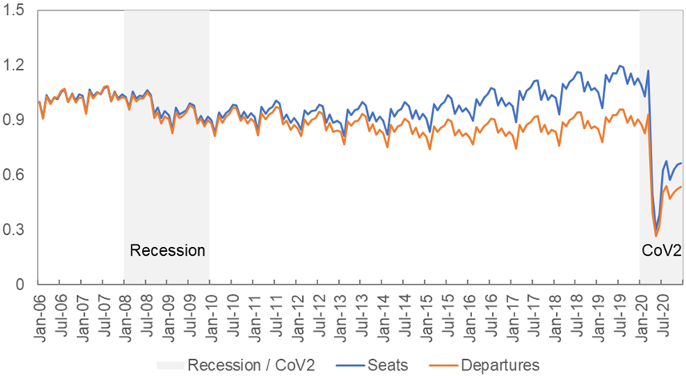

Figure 1 Global air transport seat capacity and departures [Indexed: January 2006 = 1], January 2006- December 2020.
Source: Authors’ calculations on data from RDCA (2021)

The CoV2 virus emerged in late 2019 and early 2020 and quickly diffused across the globe. As shown in Figure 1, by April of 2020, global seat and departure capacity had dropped around 75% compared to July 2019 highs followed by a relatively quick but limited rebound as the world first came to grips with the crisis. Kose and Sugawara (2020) have reported that more than 90% of global economies have realized reductions in GDP per head. Research and information on the air transport impacts of the CoV2 diffusion continue to emerge across regions (see, e.g., Smith et al., 2021). According to the International Civil Aviation Organization (ICAO, 2021), worldwide global airline revenues fell by more than $370 billion in 2020, with 66% and nearly 40% drops in international and domestics capacities, respectively. The organization’s overall forecasts for recovery are grim. Early work into the air transport outcomes in the United States by Hotle and Mumbower (2021) found that larger airports saw more substantial declines in seats and departures than smaller airports during the earlier part of the CoV2 pandemic. The authors also found greater service losses at multiple airport regions in comparison with single airport regions.
As with the earlier disruptions, there is significant conjecture over the shapes the airline industry will take as the immediacy of C0V2 reverberates. For example, Abate et al. (2020) suggest a lengthy recovery period with implications for future competitiveness, as airlines, airport operations, and government aid continue to be intertwined. Ye et al. (2020) express concerns over aggregate recovery measurements, which may overlook the actual impact on particular places. Suau-Sanchez et al. (2020) predict sweeping impacts over the coming years, including consolidation, conflicts over state aid, and differential impacts for communities, airports, and airlines based on size and geographic factors. Gössling et al. (2021), on a positive note, suggests that the period may be an opportunity to bring air transport more in line with sustainable development goals. Some consensus is emerging that leisure travel will recover more quickly requiring airline strategy changes (Accenture 2021; McKinsey 2021).

2.3. Government Aid and EAS in 2020 / 2021

The EAS program is structured to maintain small community air connectivity despite prevailing market conditions. In the deregulated market of the United States, however, most of the industry does not have a similar safety net. However, in light of CoV2, the U.S. Congress passed several pieces of legislation to assist the airline industry more generally, including the hub airports to which EAS communities are connected.
In March 2020, the U.S. Congress enacted the “Coronavirus Aid, Relief, and Economic Security Act,” or, the CARES Act (U.S. Congress, 2020; USDOT, 2020). Sections 4111-4120 of the law spell out the Air Carrier Worker Support scheme. This portion of the legislation provided a variety of federal aid to air carriers, including workforce support with the provision that companies ensure that workers would not be terminated before September 30, 2020. Additional provisions of the law included $10 billion in aid to airports (with the condition that at least 90% of workers retain their jobs) and $56 million to “carry out the essential air service program” (U.S. Congress, 2020: p316). Aid also required “…continuation of certain air service deemed necessary by the Secretary of Transportation…” (Tang, 2020). For the most part, this legislation meant that at least a skeleton of the service provided before March 1, 2020, would be maintained (U.S. Department of Treasury, 2021). Second, in January 2021, the U.S. Congress (2021a) passed the “Consolidated Appropriations Act, 2021.” Among other things, the law extended airline workforce support through March 31, 2021, including a recall of workers laid off from October 1, 2020. Third, in March 2021, the “American Rescue Plan Act of 2021” was signed into law (U.S. Congress, 2021b). Again, this act extended workforce support until September 30, 2022. It included additional aid to airports .
In sum, the EAS program has not only survived multiple system shocks, the passing of more recent legislation also ensured the preservation of the NAS structure more generally. Based upon this historical context, we now extend the analysis to assess the Essential Air Service program and its role in connecting small and rural communities to the NAS during the CoV2.

- Data and Methods

3.1. Construction of U.S. Network and EAS data
Because of the complexities CoV2 unleashed related to international border crossings, this analysis focuses on the U.S. domestic air transport system. We collected data on EAS communities and their characteristics from the U.S. Department of Transportation (USDOT, 2021a). In addition, we collected data on seat capacity from RDC Aviation’s OAG data portal (RDCA, 2021). We also used FAA (2021a) data on passenger enplanements to corroborate OAG information.
Since we employ comparative complex network analysis as a primary method (details below) which is sensitive to large changes in the number of nodes, we created a largely stable network for comparison across 2019 and 2020. Our data set was developed first by utilizing the FAA’s (2021a) “Passenger Boarding (Enplanement) and All-Cargo” data set from 2019 and selecting all 558 commercial service airports. We then matched data from these airports to the Official Airline Guide data provided by RDCA (2021) to refine the information. These multiple data sets were required to analyze detailed point-to-point route information and to ensure the analysis was inclusive of 2020. U.S. government data alone (e.g., DB1B, etc.) were either not yet available or not complete for our purposes (Teixeira and Derudder, 2021). We removed all airports that did not have a temporal match to the 2019-2020 monthly schedules data (seats and departures) as the temporal scale of our analysis relied on specific monthly information. In addition, we removed some airports because they only had seasonal service.
Our final data set consisted of 449 airports and 3,259 nonstop connections in 2019 and 446 airports with 2,894 connections in 2020, representing almost 99% of total U.S. enplanements. Inter-airport connections were calculated as the average of nonstop bi-directional passengers between links since the correlation between the number of passengers in each direction showed high symmetry (r=0.998). Figure 2 shows the U.S. air transport network in the 4th quarters of 2019 and 2020. The changes in scale and density between the two periods is clear.
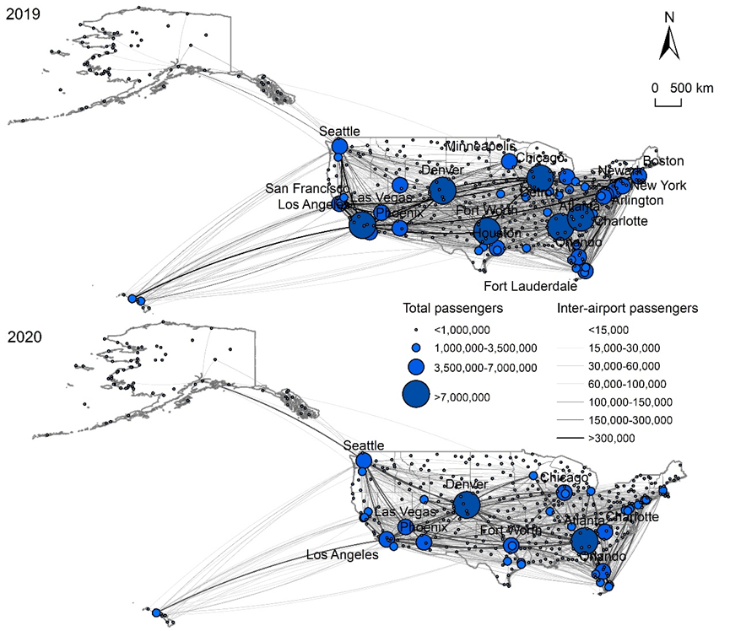
Figure 2 The U.S. domestic air passenger networks, 2019-2020
Sources: Authors’ calculations on data from FAA(2021a) and RDCA (2021)

The data set included 107 EAS airports. While including a greater number of EAS communities would be preferable, the availability of data and a need for data consistency precluded their analysis. Most of the non-represented EAS airports were in Alaska. Each of the EAS airports connects to one or two “hubs” that link it to the NAS, and a total of 30 hubs provide the connecting function. Figure 3 provides a generalized view of the EAS program for 2019-2020 (for clarity only routes between EAS communities and their hubs are shown). The top five hubs (Table 1) account for more than half of the 145 individual routes we identified, with Denver alone accounting for about 16%.

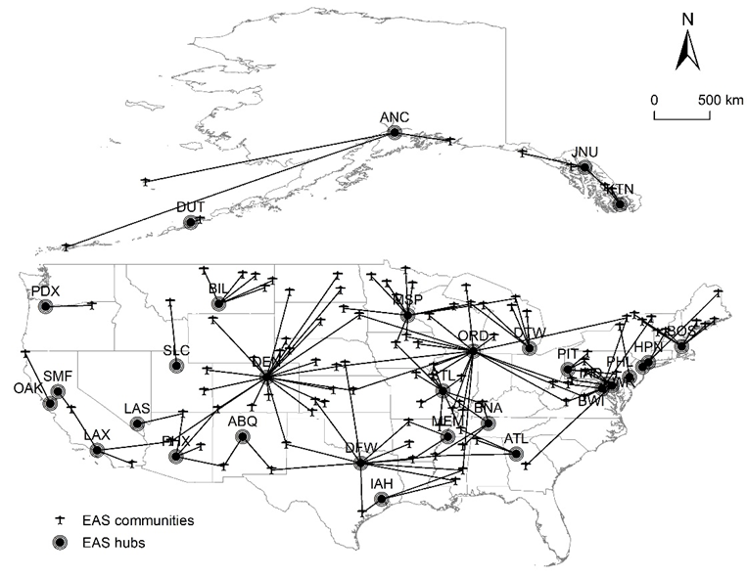
Figure 3 The EAS system, 2019-2020
Source: Authors’ calculations on data from US DOT (2021b), FAA(2021a), and RDCA (2021)

Table 1 Top five connecting hubs for EAS communities
EAS Connecting Hub | Number of Routes (N=145)
Denver | 23 (15.8%)
Chicago (ORD) | 18 (12.4%)
Dallas (DFW) | 11 (7.6%)
Minneapolis-St. Paul | 11 (7.6%)
St. Louis | 10 (6.9%)
Top 5 Total | 73 (50.3%)
Source: Authors’ calculations on data from RDCA(2021) and DOT (2021)

3.2. Methodologies

There are three steps in our analysis of the EAS system during the pandemic. First, we provide an aggregate analysis of small community airports compared to major FAA hub-types across 2019-2020. To do so, we utilize time-series graphs and paired sample t-tests. Second, we examine individual EAS airports, breaking down their relative performance by comparing communities’ performance in comparison to median levels of capacity change and mapping their spatial distribution. Third, we examine the impact of CoV2 on EAS hubs – the airports that provide the network connections to the rest of the NAS. To do so, we use the complex network analysis methods outlined in Dai et al. (2018) to calculate four measures of change between 2019 and 2020. First, we calculated the degree–the overall connectivity of an airport. Next, we calculated the eigenvector score – the importance of an airport, considering the degree of the airport and the degree of its neighbors (an airport with a high eigenvector score means that it connects to many airports with relatively high degree values). Third, we calculated betweenness – the brokerage function of an airport lying on the shortest paths between two indirect-connected airports. Finally, we calculated closeness – a measure of average farness (reciprocal distance) between an airport and all others in the NAS (see also Park and O’Kelly 2017). All measures are weighted by seats. We compare overall changes in the full national network and EAS networks using QAP correlation.

4 Results

4.1 Aggregate EAS Airport Performance

Figure 3 shows domestic seat capacity for five groups of U.S. airports: large hubs, medium hubs, small hubs, non-hubs, and EAS (for definitions, see FAA [2021b]). Data are monthly, from January 2019 – December 2020, and we index values to January 2019 (January 2019 =1). From 2019 to March 2020, the pattern of seat capacity is as expected, with all airport types seeing rises during the summer holiday months. During the second quarter of 2020, the bottom falls out of the system: for large, medium, small, and non-hubs, both seat capacity and departures quickly fall between (roughly) 30-40% of January 2019 values. There is a slight rebound during the third quarter, settling to values of around 50-75% of January 2019 values by the 4th quarter.
The detailed pattern for EAS is distinctly different. First, during 2019 and early 2020 (Before CoV2), EAS does not exhibit the level of seasonality/variability that the non-subsidized airports do. During the initial chaos of the virus diffusion, EAS seats only drop to about 67% - less than half the change in the non-subsidized airports. By the 4th quarter of 2020, seat capacity at EAS communities had stabilized to about 90% of January 2019 levels, respectively.

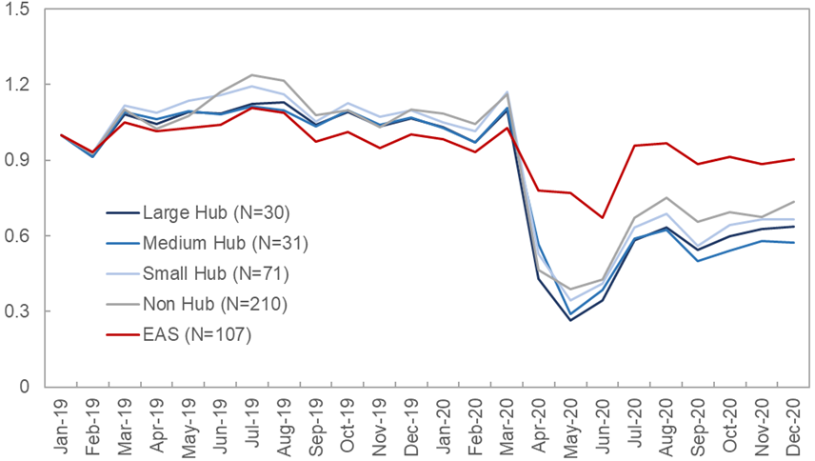
Figure 4 Seat index by airport type (Indexed: January 1, 2006=1), January 2019-December 2020 U.S. Domestic Operations
Source: Authors’ calculations on data from RDC (2021)

We compared seat values for all airport hub types for (a) Q2-2019 vs. Q2-2020 and (b) Q4-2019 vs. Q4-2020 using paired t-tests to confirm the differences evident in these figures. All tests were significant at the 0.01 level or better. In sum, there was less variability in the provision of seat capacity at subsidized EAS airports. Not only did they suffer fewer relative losses in service during the initial shock of the pandemic, but their performance by the end of 2020 was also much closer to previous levels. This was further confirmed through the comparison of QAP correlations between the entire U.S. network in 2019 vs. 2020, and, the network comprising only of the 107 EAS airports and their 30 hubs. The former was 0.917 and the latter 0.932 (both p < 0.01), signifying that the EAS-centered network was more stable.

4.2. Individual EAS Airport Performance

To examine in more detail how specific EAS places performed, we calculated the median percentage change in seats (at EAS airports) for both the initial shock (Q2-2019 vs. Q2-2020) and the fourth quarter period of initial “stabilization” (Q4-2019 vs. Q-4-2020). For quarter 2, the median decline was 19.2% in 2020 compared with 2019. For the fourth quarter of 2020, the median change was 0.0% compared to the previous year.
The distribution of the 107 EAS communities by “performance category” is shown in Table 2. EAS communities were sorted based upon whether they were above or below median declines in seats in both the second and fourth quarters of 2020. Thirty-two (29.9%) communities were below the median in both periods– indicating the most negative immediate-term and longer-term effects. On the other hand, 15 communities (about 14%) did better than the median in both periods, suggesting a more negligible effect of the CoV2 outbreak. Nineteen (17.8%) communities had declines less severe than the median in the initial outbreak, but by Q4 had fallen below the median seat change value of 0.0%. On the other hand, 13 communities had more severe declines during the initial outbreak but rebounded above the median by quarter 4. A total of 28 communities (26.2%) had reverted to precisely the median seat change by the 4th quarter. In sum, 56 communities were at least “stable” by this accounting, while 51 were poor or worse.

Table 2 Performance of EAS airports in second/fourth quarter, 2019 vs 2020
 | 2nd quarter change  < median (-19.2%) | 2nd quarter change  ≥ median (-19.2%)
4th quarter change> median (0%) | 13 (12.2%) [Good] | 15 (14.0%) [Best]
4th quarter change= median (0%) | 8 (7.5%) [Stable] | 20 (18.7%) [Stable]
4th quarter change < median (0%) | 32 (29.9%) [Worst] | 19 (17.8%) [Poor]
Note: Since many communities were precisely at the median (0%) for the 4th quarter of 2020, we created a distinct category.
Source: Authors’ calculations on data from RDCA (2021)

Figure 5 shows the spatial distribution of EAS airports (and by association, routes) by performance category and reveals several spatial patterns. First, there were few regions that were unambiguously better or worse performing. That is, while some regions generally have more EAS airports/routes that performed better or worse, there is also heterogeneity within regions. For example, the Mississippi / Missouri valley areas (stretching from the Dakotas to Louisiana) and the northeast both have a substantial concentration of “poor” and “worst” performing EAS communities. However, interspersed throughout are EAS airports/routes that are “stable” – but almost none that performed “good” or “best”. Meanwhile the southwest has several “poor” or “worst” performing EAS communities, but the region also has a number of “good” and “best” performing places. EAS airports/routes associated with the upper Midwest states of Michigan, Minnesota, and Wisconsin generally did well. An interesting cluster of communities connected to the Billings (MT) hub were “stable”

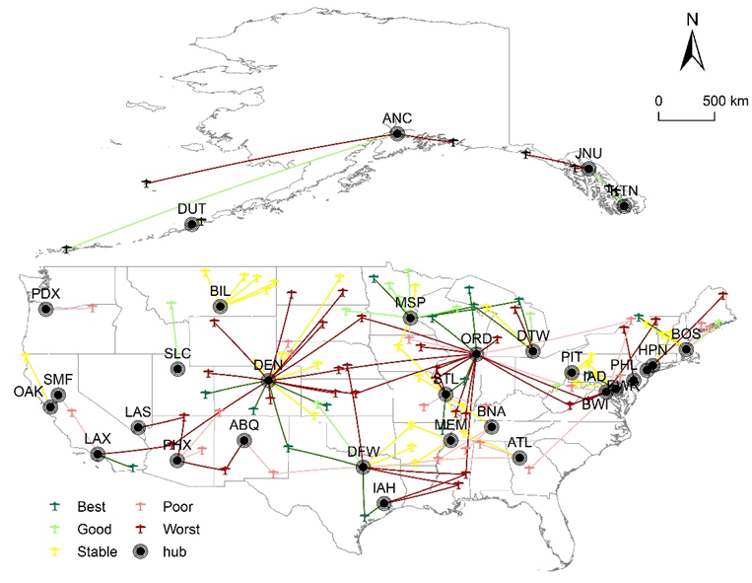
Figure 5 Spatial distribution of EAS communities by performance
Source: Authors’ calculations on data from RDCA (2021)

Tables 3 and 4 detail the 15 best and 32 worst performing EAS communities as defined by seat capacity earlier. To further examine differences between the groups, the table includes actual 2018-2019 passenger enplanement growth, 2020 seat capacity change in Q2 and Q4 vs. 2019, EAS carrier, EAS contract size, and connecting hub(s). While the sample sizes for the two groups are too small for formal statistical analysis, several relationships emerge.
Communities in the best performing group tended to be smaller, with median enplanements in the prior year (2019) of 6,309 vs. 15,392 for the worst-performing group. As Tables 3 and 4 illustrate, 2018-2019 enplanement growth was also greater in the best performing group, at 12.32% vs. 7.02% in the worst. Higher prior performance, therefore, seems to be related to a better outcome during C0V2. SkyWest dominates the EAS market overall, and there is little surprise that the airline is ubiquitous in the best and worst groups. At the same time, the EAS subsidy contract size was roughly similar between the two groups, and the best and worst-performing communities are connected to the NAS across the various hubs and hub sizes.

Table 3 Best performing communities
Region |  | Region Performance |  |  | 2019-2020 Program Details
 |  | Prior Year | CoV2: 2019 vs. 2020
Airport | Community | 2018-2019  Enplanement  Change  [passengers, %] | Q2 vs Q2  Capacity  Change  [seats, %] | Q4 vs Q4  Capacity  Change  [seats, %] | Carrier | Contract [$] | Hub(s)
CMX | Hancock, MI | 3.80 | -14.84 | 0.55 | SkyWest | 2,204,520 | ORD
CIU | Sault Ste. Marie, MI | 4.57 | 0.59 | 7.06 | SkyWest | 2,729,306 | DTW/MSP
EAU | Eau Claire, WI | 1.33 | -11.54 | 1.10 | SkyWest | 2,363,769 | ORD
IMT | Iron Mountain, MI | 13.65 | 0.59 | 6.43 | SkyWest | 3,275,512 | DTW/MSP
CNY | Moab, UT | 17.72 | -1.28 | 19.08 | SkyWest | 2,974,268 | DEN
ALS | Alamosa, CO | 40.97 | 2.00 | 88.24 | Boutique | 2,949,133 | DEN
DEC | Decatur, IL | -10.06 | 34.90 | 81.38 | SkyWest | 2,993,168 | ORD/STL
JST | Johnstown, PA | 44.01 | 6.62 | 28.59 | Boutique | 3,163,097 | BWI/PIT
VCT | Victoria, TX | 107.68 | 1.23 | 85.37 | Boutique | 3,411,412 | DFW/IAH
JBR | Jonesboro, AR | -7.66 | -16.24 | 0.42 | Air Choice One | 2,020,538 | STL
CVN | Clovis, NM | 12.32 | 100.85 | 90.82 | Key Lime/DAC | 4,398,896 | DEN/DFW
TVF | Thief River Falls, MN | 6.14 | 62.13 | 257.79 | Key Lime/DAC | 3,956,517 | MSP
MSS | Massena, NY | 13.29 | -8.38 | 0.72 | Boutique | 3,166,481 | BOS
DDC | Dodge City, KS | 29.16 | 220.51 | 257.79 | SkyWest | 3,774,652 | DEN
IPL | Imperial, CA | -48.68 | -16.35 | 0.32 | Mokulele | 2,488,824 | LAX
Median |  | 12.32 | 0.59 | 19.08 |  | 2,993,168
Source: Authors’ calculations on data from RDCA (2021) and USDOT (2021b).

Table 4
Worst Performing Communities
Region |  | Region Performance |  |  | 2019-2020 Program Details
 |  | Prior Year | CoV2: 2019 vs. 2020
Airport | Community | 2018-2019  Enplanement  Change  [passengers, %] | Q2 vs Q2  Capacity  Change  [seats, %] | Q4 vs Q4  Capacity  Change  [seats, %] | Carrier | Contract [$] | Hub(s)
PBG | Plattsburgh, NY | 4.77 | -34.37 | -49.14 | SkyWest | 3,340,136 | IAD
GRI | Grand Island, NE | 11.39 | -38.55 | -10.91 | American | 389,392 | DFW
PGA | Page, AZ | 63.78 | -40.77 | -39.35 | AEAS/Contour | 4,398,924 | LAS/PHX
COD | Cody, WY | 4.60 | -62.75 | -18.96 | United | 841,000 | DEN
PLN | Pellston, MI | 14.08 | -46.05 | -30.40 | SkyWest | 1,724,962 | DTW
PRC | Prescott, AZ | 168.66 | -42.86 | -1.57 | SkyWest | 3,209,101 | DEN/LAX
DIK | Dickinson, ND | 5.49 | -46.15 | -36.36 | United | 3,650,000 | DEN
ALO | Waterloo, IA | -1.63 | -46.70 | -54.91 | American | 1,659,159 | ORD
ART | Watertown, NY | -5.59 | -44.44 | -13.04 | American | 3,588,908 | PHL
EAR | Kearney, NE | 366.40 | -25.00 | -8.00 | SkyWest | 3,638,264 | DEN/ORD
MEI | Meridian, MS | 2.24 | -61.17 | -13.66 | SkyWest | 3,265,490 | IAH
MKG | Muskegon, MI | 5.40 | -36.37 | -10.50 | SkyWest | 3,174,790 | BWI/PIT
CDV | Cordova, AK | 9.82 | -45.12 | -11.00 | Alaska | 3,480,868 | ANC
PAH | Paducah, KY | -14.10 | -61.24 | -36.77 | SkyWest | 3,117,436 | ORD
SHD | Weyers Cave, VA | 44.38 | -28.99 | -21.39 | SkyWest | 3,238,406 | IAD/ORD
SLN | Salina, KS | 0.31 | -48.72 | -33.33 | SkyWest | 3,310,166 | ORD
HYS | Hays, KS | 23.02 | -42.95 | -50.00 | SkyWest | 3,123,573 | DEN
PIR | Pierre, SD | -51.53 | -56.68 | -8.14 | SkyWest | 3,638,439 | DEN
PQI | Presque Isle, ME | 21.90 | -57.96 | -38.75 | United | 6,838,045 | EWR
LWB | Lewisburg, WV | 24.12 | -21.79 | -8.81 | SkyWest | 3,758,289 | IAD/ORD
YAK | Yakutat, AK | 8.54 | -45.12 | -11.00 | Alaska | 3,783,552 | JNU
VEL | Vernal, UT | 18.76 | -23.72 | -0.63 | SkyWest | 3,060,645 | DEN
PUB | Pueblo, CO | 16.93 | -24.36 | -33.33 | SkyWest | 2,784,664 | DEN
CGI | Cape Girardeau, MO | 29.24 | -47.37 | -28.51 | SkyWest | 3,371,863 | ORD
ATY | Watertown, SD | -3.17 | -32.39 | -13.66 | SkyWest | 3,244,118 | DEN/ORD
PIB | Moselle, MS | 18.60 | -41.21 | -5.95 | SkyWest | 3,066,327 | DFW/IAH
JMS | Jamestown, ND | -5.03 | -29.55 | -0.40 | SkyWest | 3,100,464 | DEN
GST | Gustavus, AK | 0.97 | -48.60 | -48.26 | Alaska Airlines | 517,693 | JNU
UIN | Quincy, IL | -13.75 | -44.50 | -44.64 | Cape Air | 3,059,746 | ORD/STL
BRL | Burlington, IA | -5.61 | -32.60 | -24.94 | Air Choice One | 2,415,564 | ORD/STL
SVC | Silver City, NM | 0.32 | -32.05 | -14.96 | Advanced Air | 3,513,367 | ABQ/PHX
SNP | Saint Paul Island, AK | 17.72 | -87.12 | -51.30 | Corvus | 2,110,170 | ANC
Median |  | 7.02 | -43.70 | -20.18 |  | 3,223,754
Source: Authors’ calculations on data from RDCA (2021) and US DOT (2021b).

4.3. EAS Hub Performance
As noted previously, there is value in routes that connect EAS communities to hub airports. However, the true power of EAS connectivity manifests in routes from the EAS hubs to other destinations. To examine the performance of EAS hubs through the CoV2 pandemic, we conducted a repeated complex network analysis (see Dai et al., 2018) based on scheduled seats for the 449 U.S. airports in our data set. We calculated one analysis for the 4th quarter of 2019 (pre-pandemic) and another for the 4th quarter of 2020 (the period of mild stabilization after the initial shock, see Figure 1). For our purposes, the focus of the analysis is on the 30 airports that act as EAS hubs. We calculated four measures of change between the 2019 and 2020 analyses – in degree, eigenvector score, betweenness, and closeness (see definitions above). Figure 6 shows these results, with hubs sorted from low to high on each measure.

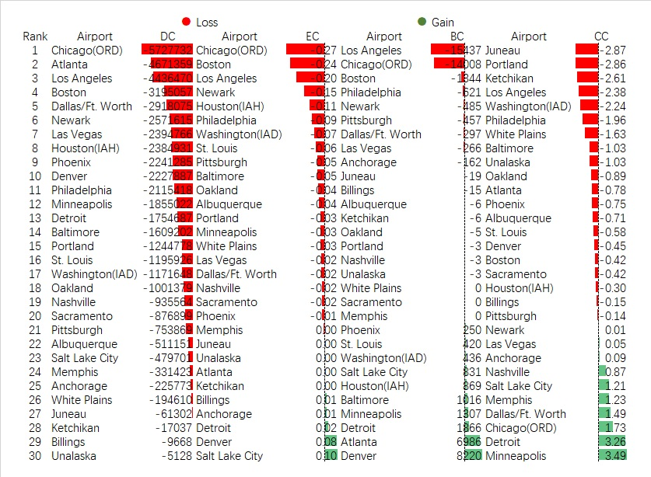
Figure 6 Network centrality analysis of EAS hubs (DC: degree centrality; EC: eigenvector centrality; BC: betweenness centrality; CC: closeness centrality) Source: Authors' Authors’ calculations on data from RDCA (2021) and FAA (2021a).

In terms of degree change, all hubs lost scheduled seats, and as expected, in absolute terms the losses were greatest at many of the country’s largest airports. As for all connecting passengers at those airports, those transferring from EAS communities had less capacity with which to integrate with the NAS. However, it is the other network statistics (eigenvector, betweenness, and closeness) that are more insightful from the perspective of system function.
One way to consider the results is to focus on the most “important” hubs (e.g., see Table 1) which account for more than 50% of all EAS connecting flights. Denver and Minneapolis-St. Paul – which together account for nearly a quarter of all EAS links each had increases (or relatively small decreases) in all three measures, suggesting that their relative prominence in linking passengers through the NAS was generally maintained or even increased a bit during the pandemic. Meanwhile, Chicago (ORD), the second most important EAS hub (12.4% of all EAS links), incurred very large declines in its brokerage function (betweenness) as well as its importance as measured by the degree of its neighbors (eigenvector score). While its closeness actually increased, combined with its massive decrease in seat capacity, Chicago’s network linking function was greatly reduced. Dallas-Fort Worth (8% of links) and St. Louis (7%) of links were relatively unremarkable, on average, in their change in comparison with the other hubs. Boston (the 6th most important hub, 5% of routes) shared a largely similar pattern with Chicago.
There was significant variation in the network changes among “less important” hubs (e.g., those that have relatively few EAS links). For example, Los Angeles and Philadelphia were among the most negatively affected hubs when considering the combination of eigenvector score, betweenness, and closeness. Meanwhile, Detroit, Salt Lake, City and Memphis were among the cities that saw few declines and even increases in the measures due to the pandemic.
In sum, the most impacted EAS communities by CoV2 are those categorized as “worst” or “poor” (see Tables 2, 4) and connected to hubs that saw substantial declines in connecting functions (such as Chicago, Boston, Los Angeles, and Philadelphia). These “losers” include communities such as Grand Island, NE; Waterloo, IA; Meridian, MS; Quincy, IA, Watertown, NYPaducah, KY, among others. On the other hand, EAS communities categorized as “good” or “best” and connected to hubs that were able to better maintain their hubbing function (including Minneapolis, Denver, and Detroit) fared better. These “winners” include communities such as Sault Ste. Marie, MI, Iron Mountain, MI, Moab, UT, and Alamosa, CO. Many EAS regions fell somewhere in-between.

5. Discussion and conclusions

The CoV2 pandemic continues to wreak havoc on many aspects of life. The air transport sector has been one of the hardest-hit industries because of the restraints on both domestic and international travel. These limitations, coupled with fears that flying elevates the risk of virus transmission, resulted in massive changes to the industry.
The EAS program in the United States provides subsidized air travel to remote communities that might not otherwise receive similar services without aid. Over the years, critics have suggested EAS is a waste of taxpayer monies because of its programmatic inefficiencies, suboptimal definitions for community eligibility, high costs, and lack of sensitivity to passenger behavior. Regardless, Congress continues to fund EAS. Considering both the history and criticisms of the program, we evaluated the performance of the EAS during the CoV2 pandemic. Our sample included 107 EAS communities. While not a complete inventory of EAS subsidized carriers or the communities they serve, the reduced set is representative; the data were complete and did not include any seasonal activity. We also evaluated the 30 hubs that served as connectors for the 107 EAS communities. We approached the assessment from three perspectives: (1) the aggregate performance of EAS airports/communities; (2) an examination of individual airports/communities; and (3) an assessment of the hubs which connect EAS airports to the wider air transport network.
Our analysis shows that in aggregate, EAS airports performed much better during the early CoV2 pandemic than their non-subsidized counterparts in terms of the preservation of seats – by the fourth quarter of 2020, small communities in our sample were much closer to pre-pandemic levels in seat capacity than any other group of airports. In that general sense, the program succeeds, even in challenging times. In short, EAS continued to provide essential services to remote cities and towns. While we cannot establish whether the continuance of service matched demand levels or was efficient (in any sense of that term), the program does appear to have successfully contributed to the maintenance of air links, and this finding was confirmed at a network level through QAP correlation analysis. This result may appear counterintuitive, since it could be assumed that small places, such as EAS communities, would be the most vulnerable to massive shocks. However, two factors intervene. First, the EAS program itself is designed to provide services when market factors alone are not sufficient. Second, legislation such as the CARES Act provided additional guarantees that at least minimal services to most places (including non-EAS airports) would be continued, since government assistance was anchored on this condition.
Looking more closely, however, not all EAS communities were affected evenly. About 30% of EAS airports performed very poorly (in terms of seat capacity) during the height of the pandemic’s first wave (2nd quarter -2020), and these communities continued to have less service than the median in the fourth quarter. This lagging group was composed of somewhat larger communities when compared to those that performed better. Further, most exhibited less passenger growth in the year before the pandemic. This finding confirms the general trend suggested by Hotle and Mumbower (2021). However, it is also worth noting that the distribution of “better” and “worse” performing EAS airports was not simple from a spatial perspective. While places in the Mississippi and Missouri Valleys, the Northeast, and Southwest seem to have felt the brunt of CoV2 more than other places, in some areas better outcomes we co-located with worse ones. The implication is that there are more opportunities for refined studies that include detailed community characteristics (e.g., employment base, etc.).
Finally, we examined a sometimes-overlooked portion of the EAS scheme: the function of the “hubs” which link small-community airports to the larger NAS. While maintaining access to an EAS community is important, a critical aspect of the program is the potential for “onward” connections. Our repeated network analysis of the U.S. air transport system, comparing 2019 and 2020, showed substantial differences in hub performance. The hubs with the largest declines in network measures were, generally, some of those that are most internationally focused. Because of the reductions in international travel, domestic connecting travel to these cities was also likely reduced because domestic to international transfers became less important. However, these reductions also had impacts on domestic travel within the NAS as well. Hard-hit EAS communities connecting to these hubs would have likely suffered the worst drops in service. Meanwhile, hub airports that have a more domestic focus (Minneapolis, Salt Lake City, Denver) tended to maintain service. Better-performing EAS communities connecting to hubs including Denver, Salt Lake City, and Detroit would have maintained better linkages.
Several policy issues emerge from the research. First, while the focus of EAS is primarily on the links to the small communities themselves, the values of those links is greatly reduced if the connecting hubs suffer large service losses. It is therefore imperative to look at the system as a whole (both initial routes and hubs) in any evaluation of the program, particularly during market shocks to determine the best ways to preserve key linkages. Second, while it is clear that both CoV2-related legislation and the EAS program itself contributed to the maintenance of the system, a policy-unwinding would be useful to examine how each contributed to the situation. This analysis would help create efficiencies in expenditures and services in the future. Third, a detailed assessment of key routes for each EAS community could be completed to better assure that the most critical links are maintained in difficult circumstances. Since traditional government data sources such as the DB1B database are not likely to be particularly useful for small communities (see Teixeira and Derudder, 2021), a more directed effort by the US DOT, FAA and airlines is in order.
While our study examined the EAS program from three interrelated perspectives, it has several weaknesses that are possible to address in future research. First, because of various data concerns, we were not able to examine all EAS airports. We did not include many of the smallest communities (including a number in Alaska) because of limitations in OAG data (see above). An assessment of these communities will be an important addition to this study. Second, the timing of our study (and limitations on government data) meant that we needed to focus on scheduled capacity and links rather than the actual movement of passengers. Finally, there are opportunities for more formal econometric analyses of the EAS program during the pandemic that bridge the perspectives taken in this research. These shortcomings can be addressed in the future when more complete data sets from the FAA and DOT become available.
EAS remains a controversial policy embedded in the U.S. air transport system. As it has persisted through previous disruptions, it is likely to do so in the aftermath of CoV2.

References

Abate, M., Christidis, P., & Purwanto, A. J. 2020. Government support to airlines in the aftermath of the COVID-19 pandemic. Journal of Air Transport Management, 89, 101931.

Acceenture. 2021. Travel industry recovery: Business or leisure?. Available at: https://www.accenture.com/us-en/insights/travel/leisure-travel-industry-recovery. Accessed July 27, 2021.

Arias, M., & Wen, Y. 2015. Recovery from the great recession has varied around the world. Federal Reserve Bank of St. Louis. Available at: https://www.stlouisfed.org/publications/‌regional-economist/october-2015/recovery-from-the-great-recession-has-varied-around-the-world. Accessed March 16, 2021.

Airline Geeks. 2020. Cape air chosen for Manistee Essential Air Service despite controversy. Available at: https://airlinegeeks.com/2020/08/01/cape-air-chosen-for-manistee-essential-air-service-despite-controversy__trashed/. Accessed March 14, 2021.

Australian Government. 2021. Regional and remote aviation. The Department of Infrastructure, Transport, Regional Development and Communications Available at: https://www.infrastructure.gov.au/aviation/regional/. Accessed March 14, 2021.

Bachwich, A. R., & Wittman, M. D. 2017. The emergence and effects of the ultra-low cost carrier (ULCC) business model in the U.S. airline industry. Journal of Air Transport Management, 62, 155-164.

Bailey, J. 2006. Subsidies keep airlines flying to small towns. The New York Times. October 6, 2006. Available at: https://www.nytimes.com/2006/10/06/business/06boonies.html?. Accessed March 14, 2021.

Bureau of Labor Statistics(BLS). 2012. The recession of 2007-2009. Available at: https://www.bls.gov/spotlight/2012/recession/pdf/recession_bls_spotlight.pdf. Accessed March 16, 2021.

Chi, J., & Baek, J. 2013. Dynamic relationship between air transport demand and economic growth in the United States: A new look. Transport Policy, 29, 257-260.

Cunningham, L. F., & Eckard, E. W. 1987. U.S. small community air service subsidies: Essential or superfluous? Journal of Transport Economics and Policy, 21(3), 255-277.

Dai, L., Derudder, B., & Liu, X. 2018. The evolving structure of the Southeast Asian air transport network through the lens of complex networks, 1979-2012. Journal of Transport Geography, 68, 67-77.

Fageda, X., Suárez-Alemán, A., Serebrisky, T., & Fioravanti, R. 2019. Air transport connectivity of remote regions: the impacts of public policies. Regional Studies, 53(8), 1161-1169.

Federal Aviation Administration(FAA). 2021a. Passenger boarding (enplanement) and all-cargo data for U.S. airports. Available at: https://www.faa.gov/airports/planning_capacity/‌passenger_allcargo_stats/passenger/. Accessed March 14, 2021.

Federal Aviation Administration(FAA). 2021b. Airport categories. Available at: https://www.faa.gov/airports/planning_capacity/categories/. Accessed April 7, 2021.

Fink, J. 2020. 9/11 Timeline: How the September 11 Attacks unfolded at World Trade Center, Pentagon, Flight 93. Newsweek. Available at: https://www.newsweek.com/9-11-timeline-how-september-11-attacks-unfolded-world-trade-center-pentagon-flight-93-1531072. Accessed March 4, 2020.

Gössling, S., Scott, D & Hall, C. 2021. Pandemics, tourism and global change: A rapid assessment of COVID-19, Journal of Sustainable Tourism, 29(1), 1-20.

Grubesic, T., & Matisziw, T. C. 2011. A spatial analysis of air transport access and the essential air service program in the United States. Journal of Transport Geography, 19(1), 93-105.

Grubesic, T., Matisziw, T. C., & Zook, M. A. 2009. Spatio-temporal fluctuations in the global airport hierarchies. Journal of Transport Geography 17(4), 264-275.

Grubesic, T., & Wei, F. 2013. Essential Air Service: A local, geographic market perspective. Journal of Transport Geography, 30, 17-25.

Grubesic, T., Wei, R., Murray, A., & Wei, F. 2016. Essential air service in the United States: Exploring strategies to enhance spatial and operational efficiencies. International Regional Science Review, 39(1), 108-130.

Grubesic, T., & Zook, M. 2007. A ticket to ride: Evolving landscapes of air travel accessibility in the United States. Journal of Transport Geography, 15(6), 417-430.

Guzhva, V. S., & Pagiavlas, N. 2004. U.S. Commercial airline performance after September 11, 2001: Decomposing the effect of the terrorist attack from macroeconomic influences. Journal of Air Transport Management, 10(5), 327-332.

Hall, J., Ross, A., & Yencha, C. 2015. The political economy of the Essential Air Service program. Public Choice, 165(1), 147-164.

Hotle, S., & Mumbower, S. 2021. The impact of COVID-19 on domestic U.S. air travel operations and commercial airport service. Transportation Research Interdisciplinary Perspectives, 9, 100277.

Hromádka, M. 2017. Definition of public service obligation potential in the new E.U. member states. Transport Problems, 12, 5-13.

International Transport Forum. 2018. Government support measures for domestic air connectivity. Available at: https://www.itf-oecd.org/sites/default/files/docs/domestic-air-connectivity_0.pdf. Accessed March 14, 2021.

International Civil Aviation Organization(ICAO). 2021. Effects of Novel Coronavirus (COVID-19) on civil aviation: Economic impact analysis. Available at: https://www.icao.int/‌sustainability‌‌‌/Documents/COVID-19/ICAO_Coronavirus_Econ_Impact.pdf. Accessed March 16, 2021.

Ito, H., & Lee, D. 2005. Assessing the impact of the September 11 terrorist attacks on U.S. airline demand. Journal of Economics and Business, 57(1), 75-95.

Kose, A. & Sugawara, N. 2020. Understanding the depth of the 2020 recession in 5 charts. World Bank Blogs. Available at: https://blogs.worldbank.org/opendata/understanding-depth-2020-global-recession-5-charts. Accessed March 16, 2021.

Lai, S. L., & Lu, W. L. 2005. Impact analysis of September 11 on air travel demand in the USA. Journal of Air Transport Management, 11(6), 455-458.

Lee, S., Oh, C. O., & O’Leary, J. T. 2005. Estimating the impact of the September 11 terrorist attacks on the U.S. air transport passenger demand using intervention analysis. Tourism Analysis, 9(4), 355-361.

Levi, A. 2015. The geography of air passengers and employment
patterns by U.S. core urban area following the great recession, 2009‐2012. Master’s Thesis, University of North Carolina Greensboro. Available at: https://libres.uncg.edu/ir/‌uncg/f/Levi_uncg_0154M_11678.pdf. Accessed March 16, 2016.

McKinsey & Company. 2021. Back to the future? Airline sector poised for change post-COVID-19. Available at: https://www.mckinsey.com/industries/travel-logistics-and-infrastructure/our-insights/back-to-the-future-airline-sector-poised-for-change-post-covid-19#. Accessed July 27, 2021.

Matisziw, T. C., & Grubesic, T. H. 2010. Evaluating locational accessibility to the U.S. air transportation system. Transportation Research Part A: Policy and Practice, 44(9), 710-722.

Matisziw, T. C., Lee, C. L., & Grubesic, T. H. 2012. An analysis of essential air service structure and performance. Journal of Air Transport Management, 18(1), 5-11.

Miller, S. 2021. Alliance, Chadron split choices again on essential air service provider. Available at: https://kneb.com/regional-news/alliance-chadron-split-choices-again-on-essential-air-service-provider/. Accessed March 14, 2021.

Özcan, İ. Ç. 2014. Economic contribution of essential air service flights on small and remote communities. Journal of Air Transport Management, 34, 24-29.

Pallini, T. 2020. The past 2 decades saw the number of major airlines in the U.S. cut in half. See how consolidation in the 2000s left customers with fewer options as profits soared. Business Insider. March 21, 2020. Available at: https://www.businessinsider.com/airline-mergers-and-acquisitions-in-the-us-since-2000-2020-3. Accessed March 16, 2021.

Park, Y., & O’Kelly, M. E. 2017. Exploring accessibility from spatial interaction data: An evaluation of the Essential Air Service (EAS) program in the contiguous U.S. air transport system. Environment and Planning A, 49(4), 930-951.

Pearce, B. 2012. The state of air transport markets and the airline industry after the great recession. Journal of Air Transport Management, 21, 3-9.

RDC Aviation (RDCA). 2021. Apex. Available at: https://my.rdcaviation.com/. Accessed: Various dates, 2020-2021.

Reynolds, M. 2006. Air service to small and rural communities. Senate Subcommittee on Aviation. Available at: https://www.transportation.gov/testimony/air-service-small-and-rural-communities. Accessed March 14, 2006.

R.P. Erickson & Associates. 2015. Comparison of approaches for supporting, protecting & encouraging remote air services. Available at: https://assembly.nu.ca/library/GNedocs‌/2015/001996-e.pdf. Accessed March 14, 2021.

Sardstedt, M., & Mooi, E. (2014). A concise guide to market research (2nd ed.). Berlin: Springer.

Suau-Sanchez, P, A. Voltes-Dorta, & N. Cugueró-Escofet. 2020. An early assessment of the impact of COVID-19 on air transport: Just another crisis or the end of aviation as we know it? Journal of Transport Geography, 86, 102749.

Tang, R. 2020. CARES Act payroll support to air carriers and contractors. Congressional Research Service. Available at: https://crsreports.congress.gov/product/pdf/‌IN/IN11482#:~:text=According%20to%20the%20CARES%20Act,payments%20through%20September%2030%2C%202021%2C. Accessed March 17, 2021.

Tang, R. 2018. Essential air service (EAS). Congressional Research Service. Available at: https://fas.org/sgp/crs/misc/R44176.pdf. Accessed March 14, 2021.

Taylor, C. 2020. Coronavirus impact on airlines ‘has a 9/11 feel,’ analyst says. Available at: https://www.cnbc.com/2020/03/06/coronavirus-impact-on-airlines-has-a-911-feel-analyst-says.html. Accessed March 14, 2021.

Teixeira, F. & Derudder, B. 2021. Revealing route bias in air transport data: The case of the Bureau of Transport Statistics (BTS), Origin-Destination Survey (DB1B). Journal of Air Transport Management, 82, 101745.

United States Congress. 2020. Coronavirus Aid, Relief, and Economic Security Act. Available at. https://www.govinfo.gov/content/pkg/PLAW-116publ136/pdf/PLAW-116publ136.pdf. Accessed March 13, 2021.

United States Congress. 2021a. Consolidated Appropriations Act, 2021. Available at: https://www.congress.gov/116/bills/hr133/BILLS-116hr133enr.pdf. Accessed March 13, 2021.

United States Congress. 2021b. American Rescue Plan Act of 2021. Available at: https://www.congress.gov/117/bills/hr1319/BILLS-117hr1319enr.pdf. Accessed March 13, 2021.

United States Department of Transportation(USDOT). 2021a. Current and historical status reports. Available at: https://www.transportation.gov/policy/aviation-policy/small-community-rural-air-service/essential-air-service. Accessed March 14, 2021.

United States Department of Transportation(USDOT). 2021b. Current and historical status reports. Available at: https://www.transportation.gov/office-policy/aviation-policy/essential-air-service-reports. Accessed March 14, 2021.

United States Department of Transportation(USDOT). 2020. Continuation of certain air service. Available at: https://www.transportation.gov/sites/dot.gov/files/2020-04/CARES%20Final%20Order%20FINAL.PDF. Accessed March 17, 2021.

United States Department of Transportation(USDOT). 2012. Airline travel since 9/11. Available at: https://www.bts.gov/archive/publications/special_reports_and_issue_briefs‌/issue_briefs/number_13/entire. Accessed March 4, 2021.

United States Department of Treasury. 2021. Payroll support program agreement. Available at: https://home.treasury.gov/system/files/136/Form-of-PSP-Agreement.pdf. Accessed March 17, 2021.

United States Government Accountability Office(USGAO). 2019. Commercial aviation: Effects of changes to the essential air service program, and stakeholders views on benefits, challenges, and potential reforms. Available at: https://www.gao.gov/assets/gao-20-74.pdf. Accessed March 14, 2021.

United States Office of Management and Budget. 2006. Program assessment: Essential air service. Available at: https://obamawhitehouse.archives.gov/sites/default/files‌/omb/assets/omb/expectmore/summary/10004013.2006.html. Accessed March 14, 2021.

Vaishnav, M. 2011. Opportunities and obstacles in obtaining air connectivity for residents of federally designated essential air service communities. Transportation Research Record, 2206(1), 84-91.

Warnock-Smith, D., Graham, A., O'Connell, J. F., & Efthymiou, M. 2021. Impact of COVID-19 on air transport passenger markets: Examining evidence from the Chinese market. Journal of air transport management, 94, 102085.

Wei, F. & Grubesic, T. 2015. A typology of rural airports in the United States: Evaluating network accessibility. Review of Regional Studies, 45(1), 57-85.

Wu, H., Tsui, K. W. H., Ngo, T., & Lin, Y. H. 2020. Impacts of aviation subsidies on regional wellbeing: Systematic review, meta-analysis and future research directions. Transport Policy, 99, 215-239.

Ye, J., Ji, P., & Barthelemy, M. 2020. Scenarios for a post-COVID-19 world airline network. arXiv preprint arXiv:2007.02109.

The SARS-CoV-2 pandemic obviously affected air transport globally. However, because of the constraints related to country borders, international travel requires a separate analysis.
Each of these laws is quite complex and lengthy. We have provided illustrative examples of the support provided by the U.S. Federal government to portions of the air transport industry. The actual legislation should be consulted for full details, and other sources listed provide additional summaries.
Due to the rapidly changing air transport environment during 2020, RDC Aviation quality checked data and made amendments by updating information based on airlines' websites.

