Quantifying the environmental impact of clustering strategies in waste management : a case study for plastic recycling from large household appliances
Ellen Bracquené¹, Mariana Gaspar Martinez², Eduard Wagner^{2,3}, Florian Wagner¹, Alexander Boudewijn¹, Jef Peeters¹, Joost Duflou^{1,4}
- KU Leuven, Departement of Mechanical Engineering, Celestijnenlaan 300A Box 2422, 3001 Leuven, Belgium
- Fraunhofer Institute for Reliability and Microintegration IZM, Gustav-Meyer-Allee 25, 13355, Berlin, Germany
- TU Berlin, Reseach Center for Microperipheric Technologies, Gustav-Meyer-Allee 25, 13355 Berlin
- Flanders Make, Gaston Geenslaan 8, 3001 Heverlee, Belgium
Contact info: ellen.bracquene@kuleuven.be
Abstract
The complex composition of waste electrical and electronic equipment (WEEE) plastics represents a challenge during post-consumption plastic recycling. A single WEEE category, e.g. large household appliances (LHA), can contain several different plastic types with overlapping material properties, making the sorting of individual plastics a challenge. Significant increases in plastic recovery rates can be expected by clustering product categories, as clustering can avoid mixing of non-compatible plastics with overlapping material properties. For this purpose, a life cycle assessment (LCA) is conducted to investigate the influence of different clustering strategies on the environmental performance of waste treatment and the production of recycled plastic from LHA waste stream. To assure comparability between waste treatment scenarios a system expansion approach is applied, and to allocate the burden of shared processes over the first and second use cycle of the material partitioning is applied. Results show that an increased separation of product clusters by plastic type can improve the plastic recovery rate from 5.8% to 47.1% and reduce the overall environmental impact, quantified with the ReCiPe (2016) method, by up to 23%. The environmental impacts of using recycled plastics from LHA waste can be reduced by 27 to 38% compared to single-use plastic. The holistic approach used in this study demonstrates (1) the potential benefits of implementing product clustering strategies for LHA plastic recycling, (2) the relevance of different allocation procedures when integrating recycling into an LCA, (3) the importance of using less virgin material and avoiding final waste treatment, and (4) the limitation of the recycling system to reduce the environmental burden associated with products.
Keywords: life cycle assessment, environmental impacts, plastic recycling, waste electrical and electronic equipment

Acronyms
AB Avoided Burden
ABS Acrylonitrile Butadiene Styrene
D Dryer
DW Dishwasher
C&F Cooling and Freezing appliances
EEE Electric and Electronic Equipment
EERA European Electronics Recyclers Association
EI Environmental Impact
EoL End-of-Life
F&F Fridges and Freezers
HDPE High Density Polyethylene
HiPS High impact Polystyrene
KA Kitchen Appliances
LCA Lifecycle Assessment
LCI Lifecycle Inventory
LHA Large Household Appliance
LHA* Large Household Appliances without cooling and freezing appliances
LDPE Low Density Polyethylene
MSWI Municipal Solid Waste Incineration
PA Polyamide
PC Polycarbonate
PoM Put on Market
PP Polypropylene
PS Polystyrene
PUR Polyurethane
PVC Polyvinylchloride
RR Recovery Rate
WEEE Waste Electric and Electronic Equipment
WM Washing Machine

Introduction
Plastics are highly versatile materials that are suitable for numerous applications, such as the production of electric and electronic equipment (EEE) which is the fourth largest plastic application after packaging, construction and automotive. In 2019, EEE represented 6.2 % (3.17 million ton) of the total plastic demand in Europe (PlasticEurope 2020). Plastics used in EEE are largely engineering plastics with a potential higher value than those used in other sectors, such as packaging (EERA 2017; Wagner 2020).
Waste EEE (WEEE) is one of the fastest growing waste streams in the EU (European Commission 2019) and other materials, such as base and precious metals, are today still prioritized during recycling, leaving plastics in the background. Nevertheless, plastics represent the second most prevalent valuable material in WEEE after ferrous metals (Balde et al. 2017). In addition to its economic value, the recovery of plastics from WEEE is encouraged by new policies and regulations. In future, more recycled plastics from WEEE will need to be recovered in order to comply with the strict recycling quotas from the European Union’s Directive 2012/19/EU on WEEE, which cannot be achieved by means of recycling metals and glass only (Maris et al. 2015).
Post-consumer recycling of plastics from WEEE is a complicated task due to, amongst other factors, the complex composition of the plastic fraction. This results in a plastic recycling rate from WEEE of less than 25% (Baxter and Nordisk Ministerråd 2015; Villanueva and Eder 2014) and the remaining fraction ending up in incinerators and land-fills. WEEE contains a diverse mix of plastics with different types of additives, which can modify material properties such as mechanical properties, flame resistance and density (Martinho et al. 2012) and increase the difficulty of post-consumer plastic recovery (Wagner 2020). Previous research has shown the potential benefit of strategic pre-sorting of WEEE products in different product clusters (Duflou et al. 2020; Keshav Parajuly and Henrik Wenzel 2017). Duflou et al. concluded that by clustering product categories significant increases in plastic recovery rates can be expected, as clustering can avoid mixing of non-compatible plastics with overlapping densities, which are for this reason difficult to separate with commonly adopted density based sorting technologies.
In most cases, a product’s composition drives its environmental profile because of the burden associated with raw material extraction and, in general, recycling is stimulated because it saves primary resources. In order to confirm the expected potential benefits, adequately assessing benefits and burdens associated with recycling activities is of increasing importance. However, integrating recycling into a lifecycle assessments (LCA) is not straightforward because it is a multi-functional process. In developed countries, waste management has evolved from landfilling towards more sophisticated recycling facilities. The main goal is no longer limited to efficient waste treatment, but also focusses on generating added value with the production of (high quality) secondary resources. The end-of-life (EoL) management of products has, therefore, become a multi-functional process and the distinction between the initially intended service (waste treatment) as primary function and the generation of recycled material as secondary function is not always clear. The importance of this secondary function will depend on the amount and recoverability of valuable material, which is mostly determined by the product composition and product design.
Dealing with multi-functionality in a recycling context is a challenging issue and has been widely discussed in literature (Boguski, Hunt, and Franklin 1994; Ekvall and Tillman 1997; Ekvall 2000; Werner and Richter 2000; Atherton 2007; Christensen et al. 2007; Heijungs and Guinée 2007; Curran 2007; Nicholson et al. 2009; Dubreuil et al. 2010; Brander and Wylie 2011; Johnson, McMillan, and Keoleian 2013; Koffler and Florin 2013; Allacker et al. 2014; Santero and Hendry 2016). Most commonly applied allocation procedures have also been summarized and discussed by Schrijvers et al. (Schrijvers, Loubet, and Sonnemann 2016). The methodological choice between different approaches for dealing with multi-functionality in a recycling context may significantly impact the final results at individual product level and influence the decision making (Christiansen et al. 1995; Werner and Richter 2000; Nicholson et al. 2009). In such cases, the LCA studies should evaluate the impact of using another allocation approach in a sensitivity analysis. Unfortunately such sensitivity analyses are not often included in waste management related LCA’s (Laurent et al. 2014).
In this paper, the potential benefits of different product clustering strategies for WEEE LHA in terms of environmental burden reduction and increased plastic recovery rates are investigated. First, the composition of the generated LHA waste stream is characterized based on literature data complemented with chemical analyses of collected WEEE samples from recycling facilities in Europe. Second, based on the current state-of-the-art WEEE treatment, transfer-coefficients are proposed to model the fate of different plastic types in commonly adopted recycling process sequences. Third, three different pre-sorting strategies are defined: (1) default situation without pre-clustering, (2) limited clustering ; and (3) enhanced pre-sorting based on expected product composition and presence of targeted plastic types. Fourth, the scope and system boundaries for the lifecycle assessment are defined and inventory data are collected from recycling companies. Finally, the results are presented and discussed.

Material & methods

Recovering and recycling plastics from WEEE

Plastic composition in WEEE LHA
On average, the plastic fraction from WEEE amounts to a quarter (26 w/w%) (Seyring et al. 2015) and contains a diverse range of plastic types that evolves over time. In 2012, high impact polystyrene (HiPS) and acrylonitrile butadiene styrene (ABS) constituted together more than half (51%) of the mixed plastic WEEE stream, but, more recently, their contribution has been reduced to only a third (31%) (Slijkhuis 2020). In addition to the presence of potentially harmful additives such as flame retardants, this increasing complexity in composition is expected to reduce the recovery potential of valuable engineering plastics. In addition, the characterisation from the EERA revealed that the contamination of the mixed plastic stream from WEEE with metals, glass, mineral and wood particles has increased from 6 up to 13% between 2012 and 2020 (Slijkhuis 2020). The plastic composition varies widely depending on the WEEE category considered (Magalini et al. 2018). Large Household Appliances (LHA) is the largest WEEE category (cat. 1) representing 56 w/w % of the total collected WEEE in Europe (European Commission 2019). The LHA stream is estimated to have a plastic fraction of 19.5 w/w %, resulting in around 700 kT of waste plastic generated each year in Europe alone (European Commission 2019; Balde et al. 2017).
Figure 1 shows the composition of the plastic contained in waste generated from LHA. The individual average product compositions are based on available literature (Magalini et al. 2018) and complemented with measurements on WEEE samples from recycling facilities in Europe (Duflou et al. 2020; Accili et al. 2019). The LHA plastic composition depends on the contribution of each product to the waste stream and the individual product composition. The contribution of each product type varies depending on which point of the value chain is considered for determining the composition. Data are available for EEE products put on market (PoM), WEEE generated and WEEE collected (European Union 2019; Balde et al. 2017). The difference between WEEE generated and WEEE collected results from low collection rates (<50%). The product distribution from WEEE generated is used to estimate the plastic composition shown in Figure 1 and the importance of this assumption is later investigated in a sensitivity analysis.
In this paper, the focus is set on the recovery of four valuable plastics that represent about 57% of plastic contained in the LHA stream: unfilled PP, ABS, (Hi)PS, and filled PP. Although considered to be valuable materials, the limited amount of polycarbonate (PC) and polyamide (PA) present in LHA (<1%) is currently not targeted for recovery.

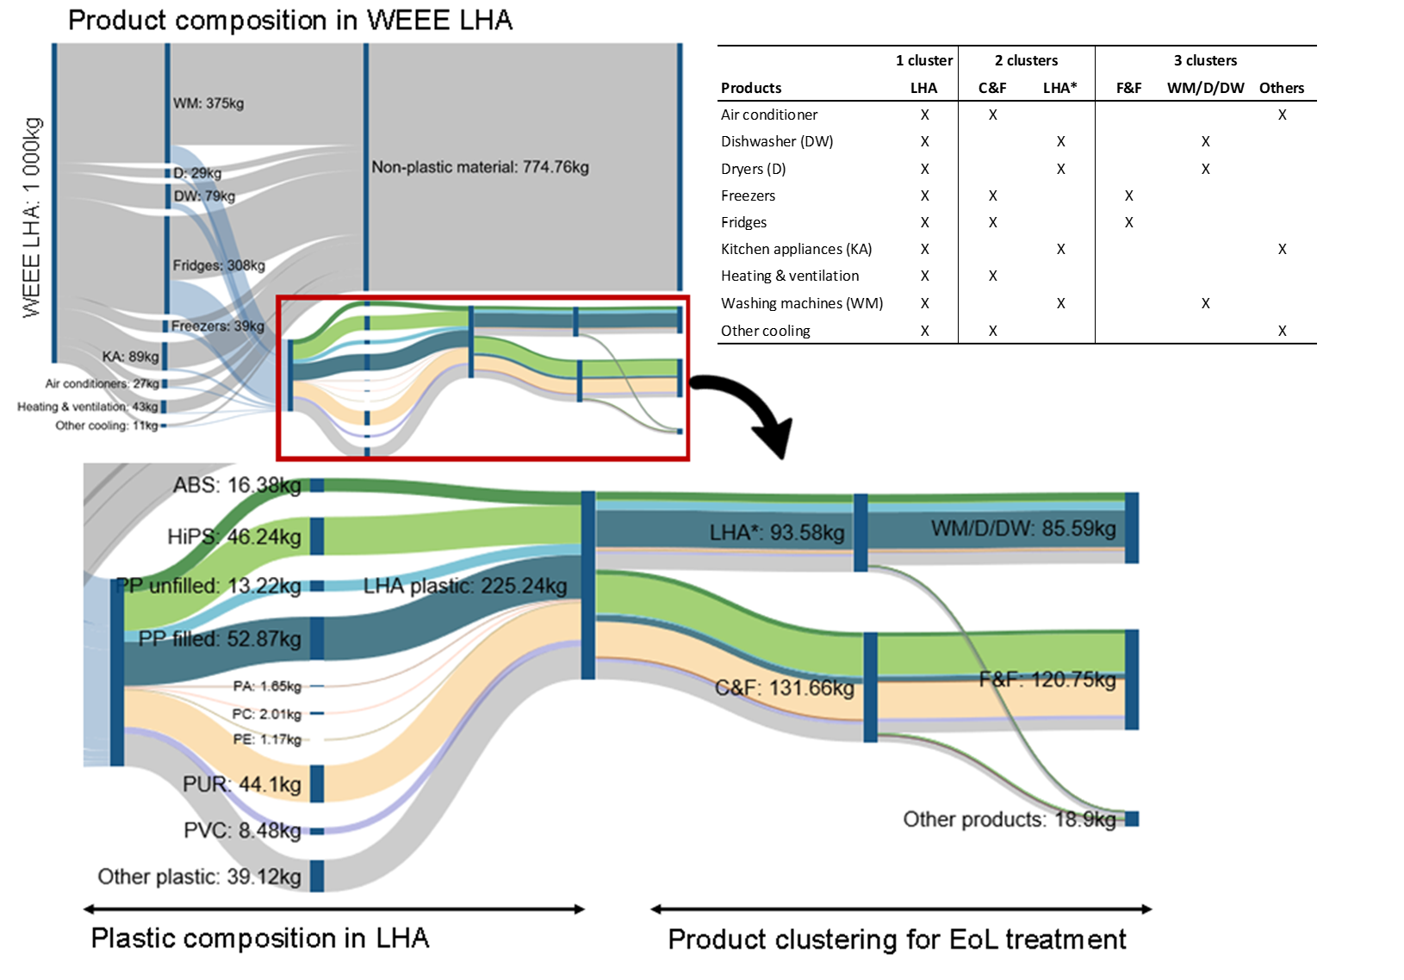
Figure 1: Product and plastic composition in-generated WEEE LHA (Large Household Appliances); C&F (Cooling and Freezing equipment); LHA* (Large Household Appliances without C&F); F&F (Fridge and Freezer); WM/D/DW (Washing Machines/Dryers/Dishwashers); KA (Kitchen Appliances) based on literature: (European Union 2019; Accili et al. 2019; Magalini et al. 2018; Balde et al. 2017)

Recycling operations for plastic from WEEE LHA
The recycling operations required to close the loop for plastics from WEEE LHA can be summarized in five stages (Wagner 2020): (1) collection of EoL products; (2) pre-processing (3) plastic sorting (4) primary (and secondary) compounding; and (5) production of plastic components. The state-of-the-art of different recycling operations is discussed in more detail below. Although increasing the collection rates is an important step toward achieving more circular supply chains, this is not considered, as this paper focusses on the material processing steps of plastic recycling
After collection, WEEE is treated in pre-processing facilities for decontamination and material sorting. Appendix B shows how materials are sorted at a state-of-the-art LHA pre-processing facility in Belgium based on a mass tracking experiment conducted in 2016. In this experiment, around 100 tons of LHA were treated including washing machines (WM), dryers (D), dishwashers (DW) and kitchen appliances (KA). Prior to mechanical treatment, a manual step is included to remove harmful substances (depollution) and the copper-rich fraction in the form of wires. After most metals and minerals are removed, about 19.1% of the input material is sorted as plastic, including foams (4.3%), light plastics (12.1%) and heavy plastics (2.7%). However, only the light plastic fraction is further sorted for plastic recycling and most of the foams (PUR) and heavy plastics (PVC) are sent to incineration.
Unfortunately, not all recyclable plastic ends up in the plastic-rich fraction. Huisman et al. analysed the separability of the main material fraction (ferro and non-ferro metals) from WEEE during pre-processing, but, at the time, plastics were not targeted as recoverable material (Huisman 2003). Nevertheless, based on experimental data Huisman et al. estimated that around 12% of the plastic would end up in the metal fraction by mistake, mostly in the copper fraction since cables are often coated with plastic.
The recovered plastic-rich fraction from pre-processing is further treated to sort different plastic types and remove impurities such as stones, glass, metal and wood. A wide variety of plastic sorting techniques exists, including density sorting, flotation, sensor-based sorting, magnetic sorting and electrostatic sorting. Additional processing steps, such as dust removal, sieving, washing, drying, air classification and size reduction, are also commonly applied to achieve sufficiently pure plastic streams ready for further processing in compounding. Due to the complex plastic composition and overlapping material properties, a well-defined chain of separation processes is necessary to achieve a homogeneous recovery fraction (Wagner 2020).
Density separation will only allow to separate light polymers (PE and PP-unfilled), medium-weight polymers (ABS and (HI)PS) and heavy polymers (PC, PA, PP-filled). Plastics in the density range between 1.08 and 1.15 kg/l are removed in order to minimize risks related to hazardous substances such as brominated flame retardants. To achieve the desired purity (>90%) for the targeted plastic fractions, the plastic flakes are either pre- or post-sorted with sensor-based technology. The efficiency of sensor-based optic sorting varies depending on the colour and size of the plastic pieces that are sorted (Maisel et al. 2020). Nevertheless, an average efficiency of 87% is assumed to be feasible (Bennett et al. 2009) which means that, on average, 87% of the target plastic is successfully identified and removed from the material stream.
As a consequence of this complex separability and the combination of different sorting technologies, modelling the fate of plastics after recycling is not straightforward. Nevertheless, similar to the transfer coefficients determined based on the experimental work of Huismans et al. for the metal fractions recovery (Horta Arduin et al. 2020; Hischier et al. 2007; Huisman 2003), coefficients for the different targeted polymer fractions are theoretically defined as presented in Table 1. These coefficients are derived based on optical sorting efficiencies and overlapping material densities, as shown in Appendix A. Although the liberation of material from EoL products will be influenced by the product design, this is not taken into account in proposed transfer coefficients.
Table 1: Assumed transfer coefficient for plastic sorting
 |  | Output fraction (target plastic)
 |  | ABS | (HI)PS | PP-filled | PP-unfilled | Non-target
Input fraction | ABS | 73% | 11% | 0% | 0% | 16%
Input fraction | (HI)PS | 1% | 81% | 8% | 0% | 10%
Input fraction | PA | 0% | 0% | 11% | 0% | 89%
Input fraction | PC | 0% | 0% | 3% | 0% | 97%
Input fraction | PE | 0% | 0% | 0% | 13% | 87%
Input fraction | PP-filled | 0% | 4% | 88% | 0% | 8%
Input fraction | PP-unfilled | 0% | 0% | 0% | 97% | 3%
Input fraction | PUR | 0% | 0% | 0% | 1% | 99%
Input fraction | PVC | 0% | 0% | 2% | 0% | 98%
Input fraction | Others | 5% | 24% | 24% | 0% | 47%

Based on these transfer coefficients and the assumed material composition of the input stream (Figure 1), the recovery yield $M\left(Output\right)$ per target plastic can be calculated with the following equation:
$M\left(Output\right)=\sum{T_{Input}^{output}M\left(input\right)}$ (1)
The input mass $M\left(input\right)$ of each plastic fraction is multiplied by the appropriate transfer coefficient ($T$) indicating the likelihood of a plastic type ending up in a specific output fraction $M\left(output\right)$ for each of the targeted plastics.
After sorting, plastic flakes with a purity above 90% can be further processed into plastic granulates. During compounding, typically 5% of additives are added to improve the properties of the granulates and about 3% material loss occurs (Gaspar Martinez and Finkbeiner 2019). The recycled-plastic granulates can be used for injection moulding of product parts and are typically mixed with virgin-plastic granulates to achieve the desired recycled-content.

Improved plastic recovery from LHA through product clustering
Smaller recycling facilities often treat all LHA together, after manual depollution, in order to maximize their machine utility. In larger pre-processing facilities, limited product clustering occurs as cooling and freezing appliances (C&F) are often treated separately from the remainder LHA stream (LHA*). Although measurements and statistical evidence are still lacking, according to the plastic recyclers this product clustering is known to have a positive influence on both the recycling operation and the achieved recycled plastic quality (Caris 2020).
The discarded product streams could be further clustered in order to reduce the number of target plastics per cluster, while increasing their concentration at the same time. In the LHA* stream, washing machines (WM), dryers (D) and dishwashers (DW) have a similar composition which is very different from kitchen appliances (KA) such as ovens and furnaces. In the C&F stream, fridges and freezers (F&F) have a similar composition that is different from other cooling equipment. Therefore, the potential benefits of treating WEEE LHA in three separate product clusters in term of environmental burden reduction and increased plastic recovery rates are further investigated in this paper. Figure 1 provides an overview of the different clustering strategies that are assessed and compared.

LCA
A Life Cycle Assessment (LCA) is a systematic tool to evaluate the environmental impact (EI) of products or processes within a pre-defined system boundary. The international series of standards ISO 14040 defines the method and requirements for conducting an LCA (ISO 2006, 14040). LCA studies quantify the potential environmental burdens associated with a particular product or service throughout the entire life cycle and the burdens associated with each stage are aggregated together and allocated to a particular functional unit. In this study, an LCA model is built with SimaPro 9.1 and the environmental impact assessment is performed using the ReCiPe method using the hierarchist perspective (Huijbregts et al. 2016).
The overall goal of the study is to investigate the influence of different product clustering strategies on the environmental burden associated with both the waste treatment of plastic in WEEE and the production of recycled plastic. Although waste treatment and recycling activities are closely related, the considered perspective influences the considered system boundary and related functional unit (Wäger and Hischier 2015). Therefore, both approaches are covered in this paper.
When investigating the environmental performance of the waste management system, the functional unit is typically described as a service (treatment of waste) and the reference flow is determined by the input side of the process (amount of waste treated). The functional unit is described as the waste treatment of the plastic fraction contained in 1 ton of waste LHA. In this case, the focus is on documenting inventory data for the different processing steps shown in Figure 2 (a). Furthermore, the recycled feedstock recovered from plastic recycling and the energy and heat produced from plastic incineration are considered as by-products of the main function which remains waste treatment. System expansion (without substitution) avoids the need for allocation procedures and is most in line with the holistic approach targeted by LCA. For this reason, the generated co-products (recycled material and energy) are added to the defined functional unit by using a ‘basket of products’.
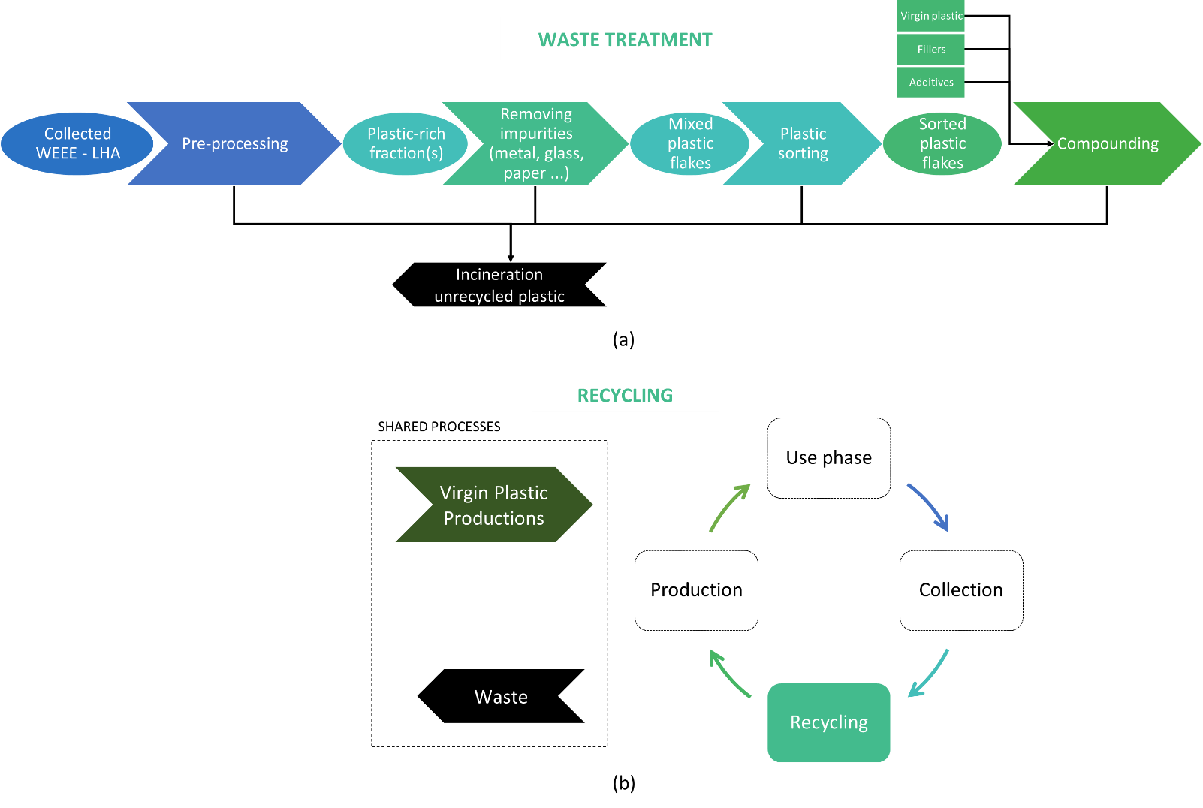
Figure 2: System boundary (a) for waste treatment of LHA and (b) for the production of recycled plastics
When investigating the environmental performance of recycled material, the reference flow is determined by the output of the recycling process (amount of recycled material produced). The functional unit is described as the use of 1 ton of recycled plastic. In this case, a broader perspective is taken as shown in Figure 2 (b). In a recycling system, both the material recoverability at end of life and reusability in similar products must be accounted for. In such a circular supply chain, where material quality is preserved, an appropriate allocation procedure is to partition the environmental burden equally over different use cycles. The virgin material production and final waste disposal are then considered ‘shared processes’ that must be allocating across the different ‘use’ cycles of the material. If the potential application of the material is limited for the next use cycle due to quality degradation or properties changes, a correction factor can be applied.
Although the allocation procedure applied in this study is not novel as such, this equal partitioning over the different use cycles is not often applied in existing literature. In many cases, either the cut-off approach or the avoided burden (AB) method is applied to solve the multi-functionality of recycling (Ekvall and Tillman 1997; Norgate 2004; Atherton 2007; Frischknecht 2010; Dubreuil et al. 2010; Laurent et al. 2014; Schrijvers, Loubet, and Sonnemann 2016). Nevertheless, the choice of the allocation approach may significantly affect the final results and influence the ranking of alternatives (Nicholson et al. 2009). Therefore, in this research, the importance of using different allocation procedures when integrating recycling into an LCA is investigated in a sensitivity analysis. The commonly applied allocation procedures are briefly explained in the next paragraphs and their potential influence on the LCA results is investigated in the sensitivity analysis.
The cut-off approach implies that the waste material is assumed to be ‘burden-free’ and only impacts related to the recycling process are attributed to the next life cycle (Schrijvers, Loubet, and Sonnemann 2016). This means that the environmental burden associated with virgin material production is entirely allocated to the first material use cycle, which could be seen as ‘unfair’ as the secondary material would not be available if the virgin material was never produced. In contrast, the final waste treatment is entirely allocated to the final use cycle, which could also be seen as ‘unfair’ as this is a consequence of the virgin material production. In general, the cut-off rule tends to favour the use of recycled material because the burden associated with virgin production is usually much higher than final waste treatment.
The AB approach redistributes credits and burdens related to avoided processes. When considering the re-use of material, two main processes are avoided: the virgin material production and the final waste disposal. The credits can be awarded in different ways: (1) the EoL recycling approach method awards credits to the supplier of recycled material based on the avoided virgin material production, (2) the waste mining method awards credits to the user of recycled material based on avoided final waste disposal, and (3) the 50/50 approach combines both approaches.
A summary of the lifecycle inventory (LCI) data used to model the different waste treatment processes is included in Appendix C. The additives used for compounding are antioxidants that prevent plastic deterioration at high compounding temperature. Based on supplier data, they are modelled as a mixture of stearic acid, methyl acrylate, phosphorous trichloride and 2,4 di-tertbutylphenol. Background data from the ecoinvent 3.6 database are used to account for the waste treatment infrastructure and related process emissions. The (unrecycled) plastic waste is treated by municipal incineration with fly ash extraction (Waste plastic, consumer electronics | treatment of, municipal incineration with fly ash extraction | APOS, U). This study focusses on the treatment of the plastic fraction of WEEE LHA excluding other recoverable materials such as metals from the system boundaries.

Results

Environmental impact of different WEEE treatment strategies
Figure 3 (a) shows the sorted plastic yields and recovery rates for the different clustering strategies. The maximum overall plastic recovery rate (RR) is 57% as only part of the plastics present in the LHA are targeted while other plastics are present in small concentrations (PA, PC and PE), considered as not recyclable (PUR) or lost during pre-processing (PVC). The achieved recovery rate for the target plastics (RR target) is also shown in Figure 3 (a) and only accounts for those plastics that have been identified as recyclable in this specific case. Appendix D shows the obtained purity of the different output streams and, as expected, the obtained purity notably improves with increasing the number of clusters. Although the improvement in terms of RR is rather limited for the scenario with three clusters compared to the scenario with two clusters, the enhanced clustering does allow to recover all four targeted plastics including the ABS material which is associated with a high cost and environmental burden in the production phase.

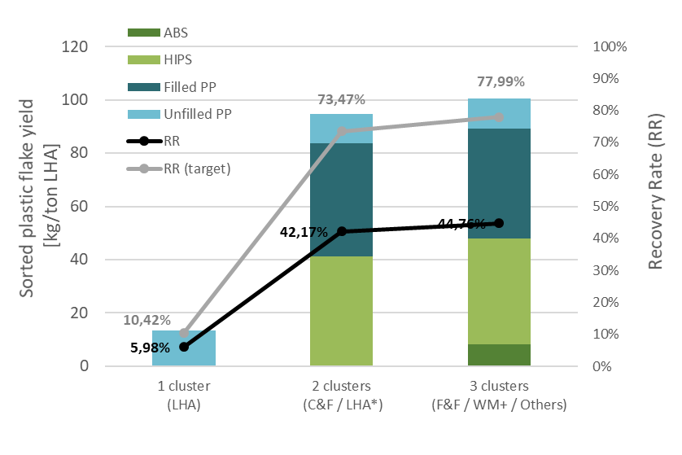
(a)
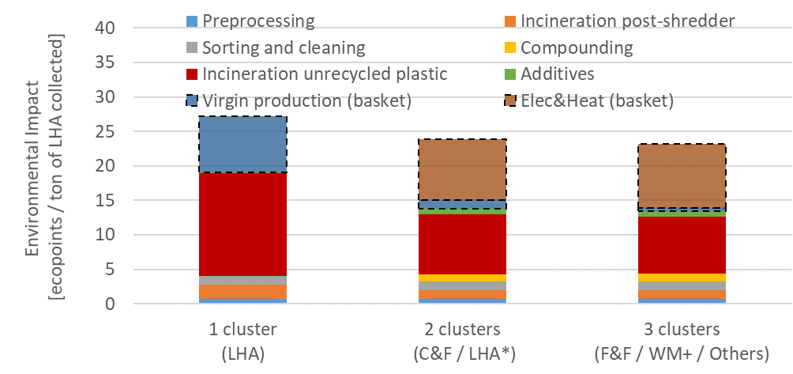
(b)
Figure 3: Assessment results for different waste treatment strategies: (a) Yields and recovery rates (RR) for different clustering strategies (b) environmental impact (EI) using ReCiPe endpoint method

Figure 3 (b) shows the weighted LCA results for the different clustering scenarios. System expansion (ISO 14040:2006) is used to assure comparability of different considered scenarios. All systems must provide the same ‘basket of products’ which is indicated in the rightmost column of Table 2. Primary production of plastics, electricity and heat is assumed to complement the basket of products in case the waste treatment scenario does not yield the considered output. A calorific value of 31 MJ/kg is assumed as an average for mixed plastic waste streams, which is known to vary between 27.9 and 38.4 MJ/kg (Tsjamis and Castaldi 2016). This embedded energy is valorised to produce power and heat at a gross efficiency, for which default values from ecoinvent have been used: 26% and 13% for heat generation and electricity generation respectively, hence yielding 4.0 MJ of electricity and 8.1 MJ of heat per kg of incinerated plastic (Wäger and Hischier 2015).
Table 2: Output generated by the different treatment strategies and definition of a common basket of products
 | Default  1 cluster  (LHA) | Limited clustering  2 clusters  (LHA*/C&F) | Enhanced clustering  3 clusters  (F&F/WM+/Others) | Basket of products
 | Primary function
Amount of plastic treated [kg] | 225 | 225 | 225 | 225
 | By-products
Recycled ABS [kg] | 0 | 0 | 8 | 8
Recycled HiPS [kg] | 0 | 41 | 39 | 41
Recycled PP unfilled [kg] | 13 | 11 | 11 | 13
Recycled PP-filled [kg] | 0 | 42 | 41 | 42
Electricity production [MJ] | 844 | 520 | 500 | 844
Heat production [MJ] | 1699 | 1047 | 1006 | 1699

Climate change and particulate matter formation are the impact categories with the highest contribution for all considered waste treatment scenarios, representing together between 74 and 76% of the overall environmental burden. In addition, human toxicity also contributes between 20 and 22% to the overall environmental burden while all other impact categories contribute less than 5%.
Incineration of unrecycled plastic has the highest contribution to the environmental burden of waste treatment of plastic from LHA in all scenarios representing between 37-58% of the environmental burden. In contrast, the contribution of recycling (pre-processing, sorting and cleaning, compounding and use of additives) to the overall environmental impact is limited. Even when recycling efforts are increased, they only represent 14% of the total environmental burden in the enhanced clustering scenario. Obviously, generating virgin plastic and producing electricity (EU average) and heat to realize the same basket of goods have an important influence on the results. The system expansion represents between 30 and 44% of the total environmental impact.
Overall, the results show that increasing the number of product clusters has a positive influence on the environmental burden associated with waste treatment of plastics in WEEE LHA. Avoiding the treatment of all LHA together and introducing two product clusters (C&F and LHA*), lowers the environmental burden by almost 20%. Removing products with a different plastic composition, such as kitchen appliances and air conditioners, lowers the environmental burden further with an additional 3%.
Appendix E shows how the results are influenced by the uncertainty related to the assumed sorting efficiency and the assumed plastic composition of the input stream. This sensitivity analysis shows that the one-cluster and three-clusters scenarios are not sensitive to the optic sorting efficiency nor the input material composition. However, the scenario with two clusters is very sensitive to the assumed optic sorting efficiency: below 85%, the RR is reduced by at least 40%; and above 95% , the RR is increased by 10%.
Products belonging to the ‘other’ product cluster (air conditioner, kitchen appliances, heating & ventilation and other cooling) contain many non-target plastics which make recovering target plastics more difficult. Therefore, the remaining product cluster (‘others’) has an important influence on the results. The sensitivity analysis revealed that the performance of the two cluster option is highly dependent on the input material composition. When the contribution of ‘other’ products is reduced from 17 to 9.4%, the RR of target plastic increases with 7.1% and the EI is reduced by 3.5%. When the contribution of ‘other’ products is increased to 24.5%, the RR of target plastic reduces with 39.6% and the EI is increased by 15.5%.

Embedded burden of recycled plastic
Figure 4 (a) compares the impact of using plastic in a system without recycling (single use of virgin plastic) with using plastic in a circular economy (CE) system where the plastic is recycled. The amount of virgin plastic required to produce 1 kg of recycled plastic depends on the recycling efficiency which is different for each plastic type. For this analysis, the enhanced clustering scenario is assumed resulting in the following recycling rates: 49% for ABS; 84% for HiPS; 83% for PP unfilled ; and 77% for PP filled. Overall, the environmental impact of recycled plastic is reduced by 27 to 38% compared to single use plastic.
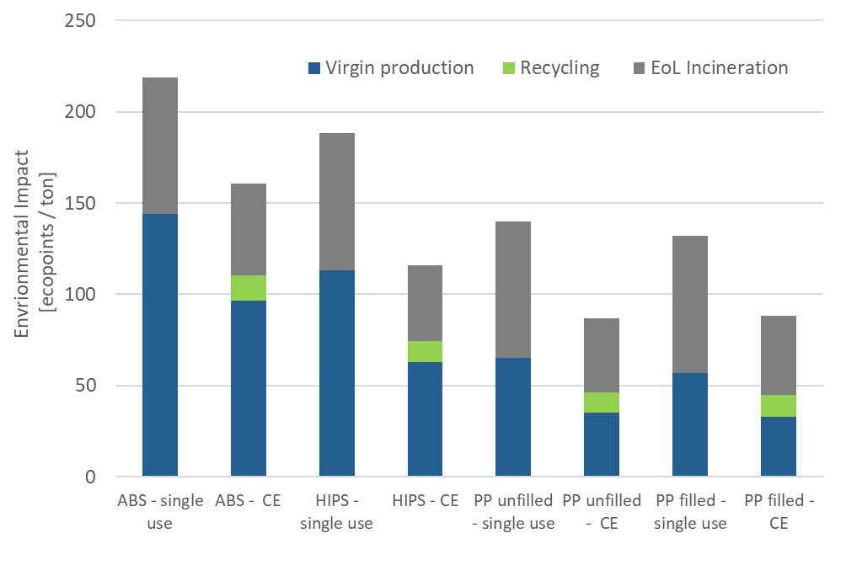
(a)
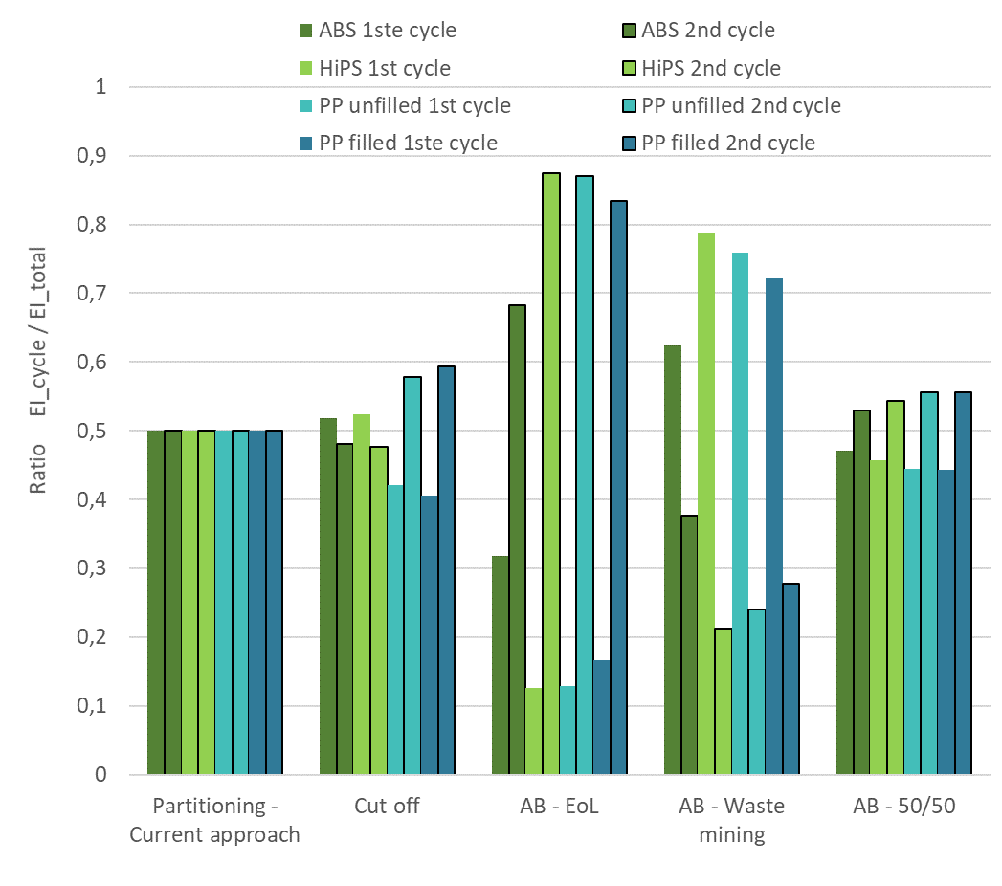
(b)
Figure 4: (a) Comparing the environmental impact of single use virgin plastic and secondary use recycled plastic (b) Influence of allocation procedure on the allocation of the EI over first and second use cycle

Although the overall environmental impact of a recycling system will not change, the allocation of the burden over the first and second cycle will depend on the approach taken by the LCA practitioner. Figure 4 (b) shows the influence of the different allocation procedures on the results for the first and second use of plastic material compared to the current approach. The AB EoL and waste mining approach clearly differentiate between the first and second use cycle. The cut-off rule slightly favours the second cycle as long as the environmental burden of EoL treatment is lower than virgin production. However, this approach favours the first use cycle when the EI of EoL exceeds the EI of virgin production. Although the AB 50/50 method favours the second use cycle, the difference between the impact attributed to the different use cycles remains limited.
In conclusion, current commonly used allocation procedures redistribute the environmental burden based on the relative difference between virgin production and final waste treatment. In addition, defining the specification of the avoided processes is often problematic (Rigamonti et al. 2020) because in many cases what is being avoided is essentially not there (Heijungs and Guinée 2007). Therefore, considering shared processes and evenly distributing the burden is a more appropriate approach as long as the material quality is preserved. If relevant, a material quality correction factor, that reflects the potential limitations for the next use, is the most suitable approach to distribute the burden between the use cycles.

Environmental performance of plastic component with recycled content
Figure 5 (a) shows the environmental impact of producing a plastic component with injection moulding as a function of the recycled content for filled PP. The results show that the environmental impact of such a part can be reduced by up to 24% when using only recycled feedstock. The results take a number of limitations into account related to the considered recycling system, such as the number of use cycles (two) and recycling rate (77% for filled PP).
Although the contributions of virgin plastic production and final waste treatment (EoL) significantly decrease when the amount of recycled content increases, they still represent 56% of the environmental burden of a product with 100% recycled content. On the other hand, the additional burden from recycling activities, which are also considered shared processes for all use cycles, remains limited (<10%).
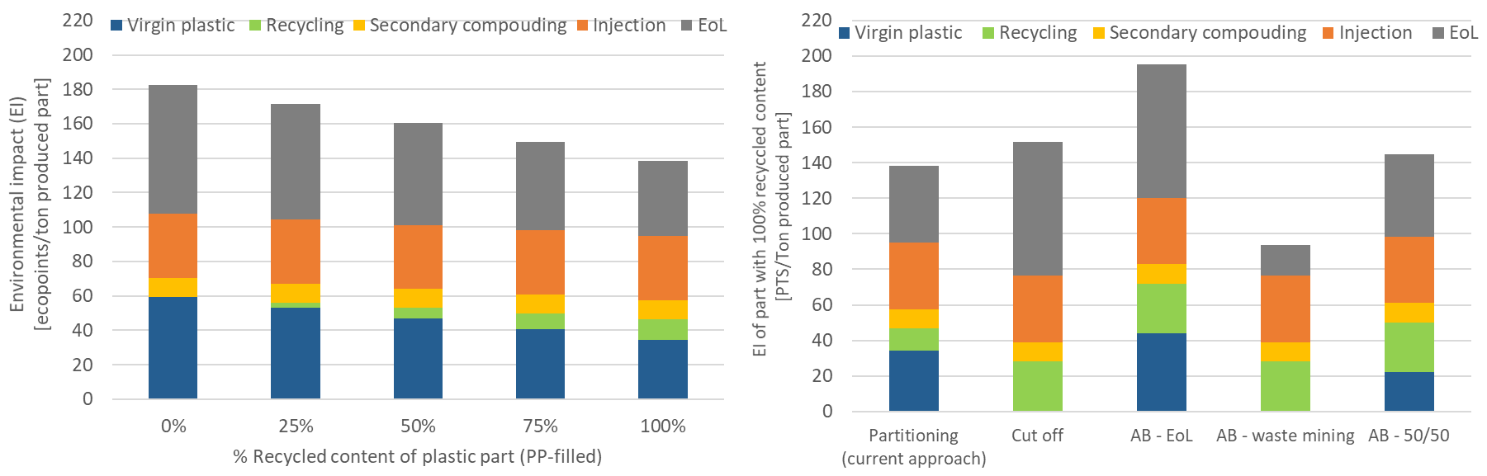
(a) (b)
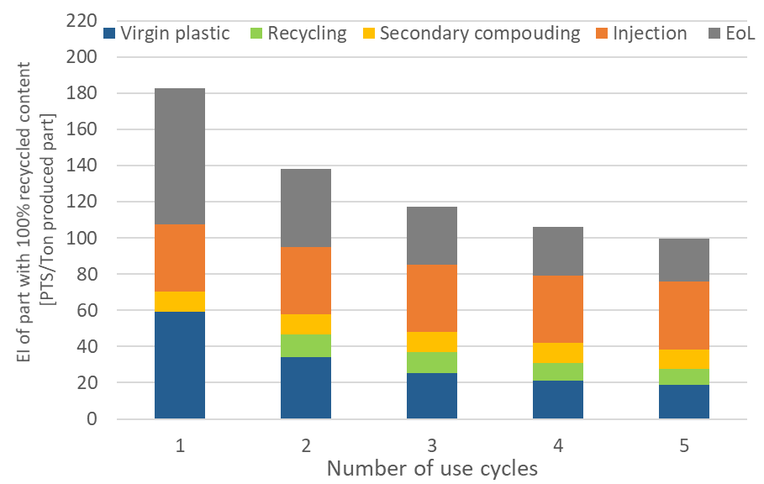
(c)
Figure 5: Environmental impact of producing a plastic component with injection moulding (a) as a function of the recycled content for filled PP and (b) as a function of the applied allocation procedure for a part with 100% recycled content (c) as a function the number of cycles assuming 100% recycled content

Figure 5 (b) shows the influence of the allocation procedure on the LCA results for a product (or part) produced with 100% recycled feedstock. For all allocation procedures, except partitioning, the environmental burden related to recycling activities is entirely allocated to the second use cycle. The avoided burden method, considering virgin production as avoided process (AB – EoL), provides credits to the first use which results in an increase of the environmental burden associated with the second use cycle when the use of recycled feedstock is increased.
Figure 5 (c) shows the influence of the number of material use cycles on the environmental burden associated with a part manufactured from 100% recycled content. The observed reduction is caused by the increased use of the plastic which can be calculated as follows for more than two use cycles:
$U_{n}=\frac{1}{RR}+1+\sum_{i=3}^{n}{{RR}^{\left(i−2\right)}}$ (2)
The recovery rate (RR) of each target plastic not only determines the amount of virgin plastic required to produce 1 kg of recycled plastic after the first use ($\frac{1}{RR}$ but also how much material is recovered for reuse in the subsequent cycles. Although the environmental burden further decreases with each additional use cycles, most benefits are achieved moving from single to secondary use of plastic. Although the quality of recycled plastics seems to decrease in multiple recycling processes (Boldizar and Möller 2003; Kuram, Ozcelik, and Yilmaz 2016), the observed degradation after re-processing remains limited because the use of additives such as impact modifiers in compounding restores most of the mechanical properties (Wagner 2020).

Discussion
In this section, the results obtained are compared to the existing body of knowledge which contains similar previous research studies.
Wäger and Hishier (2015) investigated the life cycle environmental impacts of post-consumer plastics production from mixed, plastics-rich WEEE treatment residues in the Central European plant of a plastics recycler, both from the perspective of the customers delivering the residues and the customers buying the obtained post-consumer recycled plastics (Wäger and Hischier 2015). The main differences with the current study are (1) different alternative waste treatment strategies are considered in the presented research; (2) no credits are taken for the metal impurities in the recovered plastic stream from WEEE; (3) transport is excluded from our system boundaries; and (4) some processes are considered shared processes to all material use cycles, such as virgin production and final waste treatment. Similar to our results, the life cycle assessment results from Wäger and Hishier (2015) also show that from both perspectives plastics recycling is superior to the alternatives considered (i.e. municipal solid waste incineration (MSWI) and single use virgin plastic). However, the benefits of using recycled plastic are assumed to be even more significant compared to the results presented in this research which is mainly due to the different allocation approach taken (cut-off) and the assumed credits for the metal impurities. Although different allocation factors for the WEEE separation step are considered by the authors in the sensitivity analysis, further upstream environmental impact from primary resource production is excluded from the system boundaries (incoming WEEE material is considered ‘burden-free’) .
Gu et al. (2017) also investigated the environmental impact related to mechanical plastic recycling for a specific facility (Gu et al. 2017). However, the investigated facility is located in China and only operates with a limited type of input stream. For example, from the WEEE stream, only specific parts are accepted for further treatment, such as plastic shelves from refrigerator and drums from washing machines. A zero-burden (cut-off) approach was taken and in addition the authors attributed credits for avoided virgin production to the use of recycled plastic. According to Schrijvers et al., credits for avoiding virgin production are usually attributed to the product system generating the secondary resource (Schrijvers, Loubet, and Sonnemann 2016). In the study of Gu et al., the amount of credits depends on the recycled content (substitution ratio) in the next application. The assumed recycled content varied according to the authors between 10 and 50% which suggests that the quality of the recycled material is lower compared to virgin. Therefore, the substitution of virgin material is overestimating the benefits of recycled plastic. Furthermore, Gu et al. (2017) does not account for waste treatment of unrecycled plastics, which the results presented in previous section indicate as an important driver for minimizing the environmental burden.
Compared to the previous research, the current study covers a different geography (e.g. Europe vs China) and a more general approach (WEEE treatment strategies vs specific company). In addition, more attention is spent to the allocation procedures to deal with multi functionality in recycling systems. Although these decisions are often taken for granted, the comparison of our results to similar studies available in literature shows they can have an important influence on the final results.

Conclusion
Overall, the results show that increasing the number of product clusters has a positive influence on the environmental burden associated with waste treatment of plastics in WEEE LHA. Avoiding the treatment of processing all EoL devices in one single cluster (LHA) and introducing two product clusters (C&F and LHA*), lowers the environmental burden by almost 20%. While in state-of-the-art large scale facilities these fractions (C&F and LHA*) are often treated separately, in many smaller facilities this is often not the case. In those cases, LHA is treated together after the mandatory depollution has been performed.
Removing products with a different plastic composition, such as kitchen appliances and air conditioners, lowers the environmental burden further with an additional 3%. Although the scenario with two clusters performed well in the baseline results, the sensitivity analysis revealed that the enhanced clustering scenario is highly sensitive to both the sorting efficiency and the input material composition.
The presented results also demonstrate that the environmental impact of plastics in a circular supply chain is reduced by 27 to 38% compared to single use plastic. In addition, the results in this study show that the potential environmental impact of a plastic component produced by injection moulding with recycled feedstock is reduced by 24% compared to single use plastic. Furthermore, different allocation procedures for the first and second use of plastic material have been compared to the current approach. In this study, from a circular economy perspective that envisions quality preservation, the burden is evenly distributed between the first and second use. The EoL and waste mining avoided burden methods clearly favour either the first or second material cycle. Although, in theory, an EoL approach is more appropriate for a product system delivering high quality recycled feedstock, and a waste mining approach is more suitable for a product system using low grade recycled material, in practice, it is left to the LCA practitioner to decide. The cut-off and 50/50 approaches redistribute the burden differently depending on environmental impact of other processes such as virgin production and final waste treatment, which are not directly related to the recycling activity. Therefore, if the quality of the material deteriorates during recycling, a quality correction factor is more appropriate to adequately distribute the burden over the different lifecycles.
In conclusion, the findings of this study demonstrate (1) the potential benefits of implementing clusters during LHA plastic recycling, (2) the importance of using less virgin material and avoiding final waste disposal, (3) the limitation of recycling systems to reduce the overall burden associated with products, and (4) the relevance of different allocation procedures when integrating recycling into an LCA.

Acknowledgements
The research for this paper is part of the Post-Consumer High-tech Recycled Polymers for a Circular Economy (PolyCE) project, funded by the European Union Horizon 2020 programme under grant agreement No 730308.

References
Accili, A., L. Compadello, N. Vincenti, A. Amadei, G. Arienti, and M. Sala. 2019. “Quantification of Material Flows Along the Entire Chain - PolyCE: Post-Consumer High-Tech Recycled Polymers for a Circular Economy.”
Allacker, K., F. Mathieux, S. Manfredi, N. Pelletier, C. De Camillis, F. Ardente, and R. Pant. 2014. “Allocation Solutions for Secondary Material Production and End of Life Recovery: Proposals for Product Policy Initiatives.” Resources, Conservation and Recycling 88 (July): 1–12. https://doi.org/10.1016/j.resconrec.2014.03.016.
Atherton, John. 2007. “Declaration by the Metals Industry on Recycling Principles.” The International Journal of Life Cycle Assessment 12 (1): 59–60. https://doi.org/10.1065/lca2006.11.283.
Balde, C. P, V. Forti, R. Kuehr, P. Stegmann, United Nations University, International Telecommunication Union (ITU), and International Solid Waste Association (ISWA). 2017. The Global E-Waste Monitor – 2017 Baldé, C.P., Forti V., Gray, V., Kuehr, R., Stegmann,P.
Baxter, John and Nordisk Ministerråd. 2015. WEEE Plastics Recycling: A Guide to Enhancing the Recovery of Plastics from Waste Electrical and Electronic Equipment. Nordic Council of Ministers.
Bennett, Mike, Leigh Edwards, Lidia Goyos-Ball, Robin Hilder, Phillip Hall, Liz Morrish, Roger Morton, and Nicola Myles. 2009. “Separation of Mixed WEEE Plastics.” WRAP.
Bill, Andreas, Michael Gasser, Arthur Haarman, and Heinz Böni. 2019. Processing of WEEE Plastics - A Practical Handbook. Switzeland: Empa.
Boguski, Terrie K., Robert G. Hunt, and William E. Franklin. 1994. “General Mathematical Models for LCI Recycling.” Resources, Conservation and Recycling 12 (3): 147–63. https://doi.org/10.1016/0921-3449(94)90003-5.
Boldizar, Antal, and Kenneth Möller. 2003. “Degradation of ABS during Repeated Processing and Accelerated Ageing.” Polymer Degradation and Stability 81 (2): 359–66. https://doi.org/10.1016/S0141-3910(03)00107-1.
Brander, Matthew, and Charlotte Wylie. 2011. “The Use of Substitution in Attributional Life Cycle Assessment.” Greenhouse Gas Measurement and Management 1 (3–4): 161–66. https://doi.org/10.1080/20430779.2011.637670.
Caris, Tom. 2020. Discussion with a recycling company on plastic recovery from WEEE - (Coolrec).
Christensen, T. H., G. Bhander, H. Lindvall, A. W. Larsen, T. Fruergaard, A. Damgaard, S. Manfredi, A. Boldrin, C. Riber, and M. Hauschild. 2007. “Experience with the Use of LCA-Modelling (EASEWASTE) in Waste Management.” Waste Management & Research 25 (3): 257–62. https://doi.org/10.1177/0734242X07079184.
Christiansen, K, Y Virtanen, V Juntilla, OJ Hanssen, A Ronning, Tomas Ekvall, and G Finnveden. 1995. LCA-NORDIC Technical Reports 1-9. Edited by Lars-Gunnar Lindfors. TemaNord Environment, 1995:502. Copenhagen: Nordic Council of Ministers.
Curran, M. 2007. “Co-Product and Input Allocation Approaches for Creating Life Cycle Inventory Data: A Literature Review” Vol.12 (pp 65-78).
Dubreuil, Alain, Steven B. Young, John Atherton, and Thomas P. Gloria. 2010. “Metals Recycling Maps and Allocation Procedures in Life Cycle Assessment.” The International Journal of Life Cycle Assessment 15 (6): 621–34. https://doi.org/10.1007/s11367-010-0174-5.
Duflou, J.R., A. Boudewijn, D. Cattrysse, F. Wagner, A. Accili, G. Dimitrova, and J.R. Peeters. 2020. “Product Clustering as a Strategy for Enhanced Plastics Recycling from WEEE.” CIRP Annals 69 (1): 29–32. https://doi.org/10.1016/j.cirp.2020.04.080.
EERA. 2017. “EERA’s Comments and Proposals for the EU Plastics Strategy 2017,” 2017. https://www.eera-recyclers.com/publications.
Ekvall, Tomas. 2000. “A Market-Based Approach to Allocation at Open-Loop Recycling.” Resources, Conservation and Recycling 29 (1–2): 91–109. https://doi.org/10.1016/S0921-3449(99)00057-9.
Ekvall, Tomas, and Anne-Marie Tillman. 1997. “Open-Loop Recycling: Criteria for Allocation Procedures.” The International Journal of Life Cycle Assessment 2 (3): 155. https://doi.org/10.1007/BF02978810.
European Commission. 2019. “Waste Electrical & Electronic Equipment (WEEE).” 2019. http://ec.europa.eu/environment/waste/weee/index_en.htm.
European Union. 2019. “Eurostat - European Statistics - Waste Electrical and Electronic Equipment (WEEE) by Waste Management Operations [Env_waselee].” 2019. http://ec.europa.eu/eurostat/data/database.
Frischknecht, Rolf. 2010. “LCI Modelling Approaches Applied on Recycling of Materials in View of Environmental Sustainability, Risk Perception and Eco-Efficiency.” The International Journal of Life Cycle Assessment 15 (7): 666–71. https://doi.org/10.1007/s11367-010-0201-6.
Gaspar Martinez, Mariana, and Matthias Finkbeiner. 2019. “Comparative Life Cycle Assessment of Post-Consumer Recycled Plastics from Waste Electrical and Electronic Equipment and Virgin Plastics.” Berlin: Technische Universitat Berlin. 360683.
Gu, Fu, Jianfeng Guo, Wujie Zhang, Peter A. Summers, and Philip Hall. 2017. “From Waste Plastics to Industrial Raw Materials: A Life Cycle Assessment of Mechanical Plastic Recycling Practice Based on a Real-World Case Study.” Science of The Total Environment 601–602 (December): 1192–1207. https://doi.org/10.1016/j.scitotenv.2017.05.278.
Heijungs, Reinout, and Jeroen B. Guinée. 2007. “Allocation and ‘What-If’ Scenarios in Life Cycle Assessment of Waste Management Systems.” Life Cycle Assessment in Waste Management 27 (8): 997–1005. https://doi.org/10.1016/j.wasman.2007.02.013.
Hischier, R., M. Classen, M. Lehmann, and W. Scharnhorst. 2007. “Life Cycle Inventories of Electric and Electronic Equipment: Production, Use and Disposal.” Ecoinvent report 18. Dübendorf: Empa.
Horta Arduin, Rachel, Fabrice Mathieux, Jaco Huisman, Gian Andrea Blengini, Carole Charbuillet, Michelle Wagner, Cornelis Peter Baldé, and Nicolas Perry. 2020. “Novel Indicators to Better Monitor the Collection and Recovery of (Critical) Raw Materials in WEEE: Focus on Screens.” Resources, Conservation and Recycling 157 (June): 104772. https://doi.org/10.1016/j.resconrec.2020.104772.
Huijbregts, M.A.J., Z.J.N. Steinmann, P.M.F. Elshout, F. Verones, M.D.M. Vieira, A. Hollander, M. Zijp, and R. van Zelm. 2016. “ReCiPe 2016 - A Harmonized Life Cycle Impact Assessment Method at Midpoint and Endpoint Level Report I: Characterization.” RIVM Report 2016-0104. The Netherlands: National Institute for Public Health and the Environment. https://www.rivm.nl/bibliotheek/rapporten/2016-0104.pdf.
Huisman, Jacob. 2003. “The Qwerty/Ee Concept: Quantifying Recyclability and Eco-Efficiency for End-of-Life Treatment of Consumer Electronic Products.” Delft: University of Technology.
ISO. 2006. “ISO 14040: Environmental Management—Life Cycle Assessment—Principles and Framework.” The International Organization for Standardization (ISO), Geneva.
Johnson, Jeremiah X., Colin A. McMillan, and Gregory A. Keoleian. 2013. “Evaluation of Life Cycle Assessment Recycling Allocation Methods: The Case Study of Aluminum.” Journal of Industrial Ecology, September, n/a-n/a. https://doi.org/10.1111/jiec.12050.
Keshav Parajuly and Henrik Wenzel. 2017. “Product Family Approach in E-Waste Management: A Conceptual Framework for Circular Economy.” Sustainability 9 (5): 768. https://doi.org/10.3390/su9050768.
Koffler, Christoph, and Julia Florin. 2013. “Tackling the Downcycling Issue—A Revised Approach to Value-Corrected Substitution in Life Cycle Assessment of Aluminum (VCS 2.0).” Sustainability 5 (11): 4546–60. https://doi.org/10.3390/su5114546.
Kuram, Emel, Babur Ozcelik, and Faruk Yilmaz. 2016. “The Effects of Recycling Process on Thermal, Chemical, Rheological, and Mechanical Properties of PC/ABS Binary and PA6/PC/ABS Ternary Blends.” Journal of Elastomers & Plastics 48 (2): 164–81. https://doi.org/10.1177/0095244315576239.
Laurent, Alexis, Julie Clavreul, Anna Bernstad, Ioannis Bakas, Monia Niero, Emmanuel Gentil, Thomas H. Christensen, and Michael Z. Hauschild. 2014. “Review of LCA Studies of Solid Waste Management Systems – Part II: Methodological Guidance for a Better Practice.” Waste Management 34 (3): 589–606. https://doi.org/10.1016/j.wasman.2013.12.004.
Magalini, F., R. Kuehr, J. Huisman, O. Deubzer, and D. Sinha Khetriwal. 2018. “Material Flows of the Home Appliance Industry.” United Nations University, UNU - VIE SCYCLE. http://www.materialflows.eu/assets/Material_Flows_of_the_HA_Industry_LR.pdf.
Maisel, Franziska, Perrine Chancerel, Gergana Dimitrova, Johanna Emmerich, Nils F. Nissen, and Martin Schneider-Ramelow. 2020. “Preparing WEEE Plastics for Recycling – How Optimal Particle Sizes in Pre-Processing Can Improve the Separation Efficiency of High Quality Plastics.” Resources, Conservation and Recycling 154 (March): 104619. https://doi.org/10.1016/j.resconrec.2019.104619.
Maris, Elisabeth, Pierre Botané, Philippe Wavrer, and Daniel Froelich. 2015. “Characterizing Plastics Originating from WEEE: A Case Study in France.” Minerals Engineering 76 (May): 28–37. https://doi.org/10.1016/j.mineng.2014.12.034.
Martinho, Graça, Ana Pires, Luanha Saraiva, and Rita Ribeiro. 2012. “Composition of Plastics from Waste Electrical and Electronic Equipment (WEEE) by Direct Sampling.” Waste Management 32 (6): 1213–17. https://doi.org/10.1016/j.wasman.2012.02.010.
Nicholson, Anna L., Elsa A. Olivetti, Jeremy R. Gregory, Frank R. Field, and Randolph E. Kirchain. 2009. “End-of-Life LCA Allocation Methods: Open Loop Recycling Impacts on Robustness of Material Selection Decisions.” In , 1–6. IEEE. https://doi.org/10.1109/ISSST.2009.5156769.
Norgate, T.M. 2004. “Metal Recycling: An Assessment Using Life Cycle Energy Consumption as a Sustainability Indicator.” In DMR-2616. Victoria, Australia.
PlasticEurope. 2020. “Plastics: The Fract 2019 - An Analysis of European Plastics Production, Demand and Waste Data.”
Rigamonti, L., S.E. Taelman, S. Huysveld, S. Sfez, K. Ragaert, and J. Dewulf. 2020. “A Step Forward in Quantifying the Substitutability of Secondary Materials in Waste Management Life Cycle Assessment Studies.” Waste Management 114 (August): 331–40. https://doi.org/10.1016/j.wasman.2020.07.015.
Santero, Nicholas, and Josh Hendry. 2016. “Harmonization of LCA Methodologies for the Metal and Mining Industry.” The International Journal of Life Cycle Assessment 21 (11): 1543–53. https://doi.org/10.1007/s11367-015-1022-4.
Schrijvers, Dieuwertje L., Philippe Loubet, and Guido Sonnemann. 2016. “Developing a Systematic Framework for Consistent Allocation in LCA.” The International Journal of Life Cycle Assessment 21 (7): 976–93. https://doi.org/10.1007/s11367-016-1063-3.
Tsjamis, D.A., and M.J. Castaldi. 2016. “Determining Accurate Heating Values of Non-Recycled Plastics.” https://plastics.americanchemistry.com/Energy-Values-Non-Recycled-Plastics.pdf.
Villanueva, Alejandro, and Peter Eder. 2014. End-of-Waste Criteria for Waste Plastic for Conversion: Technical Proposals : Final Report. Luxembourg: Publications Office. http://dx.publications.europa.eu/10.2791/13033.
Wäger, Patrick A., and Roland Hischier. 2015. “Life Cycle Assessment of Post-Consumer Plastics Production from Waste Electrical and Electronic Equipment (WEEE) Treatment Residues in a Central European Plastics Recycling Plant.” Science of The Total Environment 529 (October): 158–67. https://doi.org/10.1016/j.scitotenv.2015.05.043.
Wagner, Florian. 2020. “Closing Material Loops for Plastics from Waste Electrical and Electronic Equipment (WEEE).” Leuven: KU Leuven.
Werner, Frank, and Klaus Richter. 2000. “Economic Allocation in LCA: A Case Study About Aluminium Window Frames.” The International Journal of Life Cycle Assessment 5 (2): 79–83. https://doi.org/10.1007/BF02979727.

