Acute warming increases pesticide toxicity more than transgenerational warming by reducing the energy budget
Shandong Meng ^{a,*,1}, Tam T. Tran ^{a,b,1}, Khuong Van Dinh ^{b}, Vienna Delnat ª, Robby Stoks ª

ª Laboratory of Evolutionary Stress Ecology and Ecotoxicology, University of Leuven, 3000, Leuven, Belgium
^{b} Institute of Aquaculture, Nha Trang University, Khanh Hoa, Vietnam

¹ Joint first authors
* Corresponding author: Shandong Meng, shandong.meng@kuleuven.be, Deberiotstraat 32, 3000 Leuven, Belgium

Abstract
There is increasing awareness that the toxicity of pesticides can to a large extent be modulated by warming, and that temporal exposure scenarios may strongly affect the impact of two stressors. Nevertheless, we lack information on how the exposure duration to warming may shape pesticide toxicity under warming. Furthermore, despite that bioenergetic responses have the potential to generate mechanistic insights in how toxicants interact with warming, this has been understudied in ecotoxicology. To investigate whether warming duration modifies pesticide toxicity, mosquito larvae were exposed to a control temperature at 20 ℃ or three warming treatments at 24 ℃ (acute, developmental and transgenerational warming), and to four pesticide treatments (solvent control, and three chlorpyrifos concentrations) in a full factorial design. Chlorpyrifos increased mortality, growth rate and the energy consumed, and reduced the AChE (acetylcholinesterase) activity, the energy available, and the net energy budget (estimated as cellular energy allocation). The warming treatments did not affect mortality, AChE activity, and the energy consumed. However, acute warming increased the growth rate and decreased the energy available, while both acute and developmental warming decreased the cellular energy allocation. A first key finding was that the lethal and sublethal effects of chlorpyrifos were less strong under warming because of a higher degradation in the medium under warming. A second key finding was that, among the warming treatments, the pesticide toxicity was more increased under acute warming than under transgenerational warming. This could be explained by the negative impact of acute warming but not transgenerational warming on the net energy budget. The results in this study provide mechanistic insights that the exposure duration to warming can play an important role in modulating the impact of pesticides under warming. Therefore,including ecologically relevant temporal scenarios of exposure to warming is important in ecotoxicological studies.
Key words: Degradation rate, energy budget, global warming, temporal scenario, transgenerational effect

Introduction
Freshwater ecosystems are increasingly exposed to multiple stressors that moreover may interact with each other (Birk et al., 2020). Pesticides applied in agriculture can enter freshwater ecosystems through runoff and cause adverse ecological effects on non-target communities (Beketov et al., 2013; Schulz et al., 2021). Another anthropogenic stressor that can cause biodiversity loss is global warming (Heino et al., 2009). The net impact of pesticides under warming is typically not additive. On the one hand, warming magnifies the toxicity of many pesticides (Moe et al., 2013; Hooper et al., 2013; Noyes and Lema, 2015) due to a higher metabolic rate, a higher uptake, or a faster internal conversion of pesticides to a more toxic metabolite (Harwood et al., 2009; Noyes et al., 2009; Hallman and Brooks, 2015). On the other hand, warming can speed up the external degradation rate of pesticides and may buffer or even overrule the warming-induced higher toxicity. While the latter mechanism has been predicted (Hooper et al., 2013) and is important in assessing the net combined effects, it has still rarely been documented (but see Op de Beeck et al., 2017). Note that under both scenarios, warming on its own may not be necessarily stressful to the organism. In other words, these scenarios may operate without warming itself reducing fitness and performance.
The temporal exposure scenarios to two stressors are of importance in driving the direction and strength of their combined impact, and therefore are getting increasing attention in multistressor studies (overviews in Gunderson et al., 2016, Orr et al. 2020, Jackson et al., 2021). Despite the fact that warming can strongly affect the toxicity of pesticides (e.g. Delnat et al., 2019; Meng et al., 2020a&b; overview in Noyes and Lema, 2015), no study so far tested whether different exposure durations to warming differ in modulating the toxicity of pesticides. While pesticides are typically applied as acute pulse-like stressors, warming may go from an acute to a chronic stressor. Different exposure durations to warming may generate different plastic responses (Sgro et al., 2016). In general, three types of exposure scenarios to warming are identified: acute warming (typically hours to days), developmental warming (typically weeks), and transgenerational warming (where warming already occurs in the previous generation). Transgenerational warming is especially relevant for organisms with a short life cycle (Sgro et al., 2016). Since under developmental and transgenerational warming, organisms may already be acclimated to warming, these warming scenarios may be experienced as less energetically demanding compared to acute warming (Leung et al., 2021; Veilleux et al., 2015; Sørensen et al., 2003). Synergistic interactions with pollutants are more likely to occur when the second stressor is energetically costly (Liess et al., 2016). One could therefore hypothesize that acute warming may be more likely to magnify the toxicity of pesticides than developmental and transgenerational warming.
Despite the widely different modes of action about how stressors operate, they all tend to reduce the overall energy budget and to increase the allocation of energy to defense and repair mechanisms away from other functions such as growth and development (Calow and Sibly 1990; Sokolova, 2013; Verberk et al. 2020), as described in the dynamic energy budget theory (Nisbet et al., 2000; Sousa et al., 2008). Therefore, information on how stressors singly and in combination affect the energy budget is important to understand the multistressor impact on organismal fitness (Kaunisto et al., 2016; Liess et al., 2016; Verberk et al., 2020). Nevertheless, the potential of bioenergetic responses to advance mechanistic insights in multistressor effects is still underexplored in ecotoxicology (but see e.g. Verheyen and Stoks, 2020; Meng et al., 2020a; Wu et al., 2021).
This study investigated whether and how the duration of exposure to warming can predictably modify pesticide toxicity, and thereby contrasted the effects of acute, developmental, and transgenerational warming on the toxicity of chlorpyrifos in larvae of the mosquito Culex pipiens form molestus (Forskal, 1775). The aquatic larvae of mosquitoes can serve as an important food source in aquatic food webs since they can reach a high biomass (Becker et al., 2010). The organophosphate chlorpyrifos was chosen since it lists in the top ten of hazardous chemicals that pose threats to aquatic organisms (Johnson et al., 2017). While recently banned in some countries, it is still widely used (Rahman et al., 2021). Chlorpyrifos has been shown to be more toxic at higher temperatures (Buchwalter et al., 2003; Tran et al., 2018; Meng et al., 2020a). In a companion study (Meng et al., 2021), it has been shown that the degradation rate of chlorpyrifos was faster under warming, and that transgenerational warming made the larvae less sensitive to chlorpyrifos compared to acute warming in terms of heat tolerance and antipredator behaviour. Here, this study was extended to pesticide toxicity: effects on survival, growth, and the inhibition of acetylcholinesterase (the target enzyme of chlorpyrifos). Moreover, the effects on bio-energetic variables were quantified to obtain mechanistic insights. We have two key predictions. First, it is expected that chlorpyrifos will have less impact under warming because of a faster external degradation. Second, assuming higher energetic costs of acute warming (Veilleux et al., 2015; Sørensen et al., 2003), it is expected that of the three warming treatments the toxicity of the pesticide will be highest under acute warming and lowest under transgenerational warming.
Materials and methods
Experimental setup
To examine how the sensitivity of mosquito larvae to the pesticide chlorpyrifos under warming is regulated by different types of thermal plasticity, a two-generation experiment was conducted where mosquito larvae were exposed to one of the 16 temperature-by-chlorpyrifos treatment combinations (four temperature treatments crossed by four chlorpyrifos treatments) as shown in Figure 1. The chlorpyrifos exposure was only applied for four days in L4 (final instar) larvae in the offspring generation. Exposure of L4 larvae is recommended by WHO (2005) as this is the most tolerant mosquito stage. The four temperature treatments consisted of a temperature control at 20 °C and three warming treatments at 24 °C (acute, developmental and transgenerational warming). In the temperature control, both the parents and their offspring never experienced warming (temperature parents – offspring until L4 – offspring during L4: 20-20-20). Under acute warming (20-20-24), the offspring were only exposed to warming in L4 during the pesticide exposure period. Under developmental warming (20-24-24), exposure to warming started from the egg stage. Finally, under transgenerational warming (24-24-24) both the parents and their offspring were continuously exposed to warming. The four-day pesticide treatments started in the offspring generation once the larvae entered the L4 stage. Mosquito larvae then were exposed to the solvent control or a chlorpyrifos concentration either at 20 °C in the temperature control (20-20-20), or at 24 °C in each of the three warming treatments. The temperature of 20 °C reflects the current mean summer water temperature of ponds in Germany where the mosquito culture originated from (Tran et al., 2016), while 24 ℃ represents the temperature expected by 2100 under a 4 ℃ increase in mean temperature based on IPCC (2014) scenario RCP 8.5.
To start the parental generation, 144 egg rafts were obtained from a lab culture that was housed at 20 ℃. The freshly hatched larvae (less than 24h old) were pooled and transferred in sets of 100 to 2-L containers where they were kept till the pupal stage. The 2-L containers were put at 20 or 24 ℃ in temperature-controlled rooms based on the temperature treatment. When the pupation started, groups of three 2-L containers at each temperature were randomly selected and combined into white trays containing 5 L dechlorinated tap water which were covered by netting to avoid the escape of adults. The emerged adults from three white trays were moved to one insectary and fed with a 6% glucose solution. For both temperatures (20 and 24 ℃) in the parental generation, we installed 27 2-L containers resulting in nine white trays, hence three insectaries.
To start the offspring generation, egg rafts were collected from all three insectaries at each temperature. The hatched larvae were reared in 2-L containers as in the parental generation and placed at 20 or 24 ℃ based on the temperature treatment. The egg rafts or larvae from different parental temperature treatments were never mixed. When the larvae entered L4, the acute warming treatment and the pesticide exposure were started. The L4 larvae were exposed in groups of 25 in 210 mL glass vials containing 125 mL solvent control or pesticide medium for 96 h, with a refreshment of the medium after 48 h. Each treatment combination was replicated in 18-31 vials (in total 352 vials, 8800 larvae).
Throughout the experiment, larvae were daily fed with a food mixture consisting of Olvarit® 7 cereal flakes, Supradyn® vitamins and wheat germs at a high food level (0.313 mg per larva per day) (Beketov and Liess, 2007).
Pesticide exposure concentrations
To determine nominal concentrations that caused low, moderate and high mortality, a pilot experiment was conducted where freshly moulted L4 larvae were exposed to a range of chlorpyrifos concentrations for 96h at 20 ℃ with the medium refreshed after 48h. Based on the results of the pilot experiment, three (0.32, 0.34, and 0.36 μg/L) nominal concentrations were chosen which induced ~15%, ~30%, and ~40% mortality, respectively. The three concentrations cover a narrow range but induced considerable differences in mortality because of the steep dose-response curve of chlorpyrifos in the study species (see in the companion study Meng et al., 2021; see also Delnat et al., 2021). The chosen concentrations are environmentally realistic as they are within the range of measured chlorpyrifos concentrations in European surface waters (Stehle and Schulz, 2015). The measured chlorpyrifos concentrations in the experimental vials for the three nominal concentrations were 0.262 ± 0.021 (mean ± SE), 0.297 ± 0.037, and 0.345 ± 0.023 μg/L at the start of the exposure. Concentrations were quantified using UPLC-MS/MS with Triple Quadrupole Mass Spectrometry based on two pooled samples of 10 vials per temperature. The chlorpyrifos medium was prepared from a stock solution of 100 μg/mL which was made by dissolving chlorpyrifos powder (purity > 99%) in absolute ethanol and was stored in the dark at 4 °C. Ethanol (3.6 μL/L) was added to the solvent control at the same concentration as in the high pesticide concentration (0.36 μg/L).
Life history variables
The number of dead larvae was recorded daily per vial during the 4-day pesticide exposure period and used to quantify the total mortality across the exposure period. Growth rate was quantified based on the increase in wet body mass (weighed to the nearest 0.01 mg) during the 4-day exposure period. At the start, the average body mass of 20 sets of five freshly molted L4 larvae was used as the start mass (SM). After the 4-day exposure period, the average mass of five pooled larvae from each experimental vial was used as end mass (EM). Growth rate was calculated per vial using the formula [ln(EM) − ln(SM)]/4. After weighing, the set of five larvae per vial was stored at −80 °C for physiological measurements.
Physiological variables
The activity of acetylcholinesterase (AChE) was quantified as this is the target enzyme inhibited by chlorpyrifos (Domingues et al., 2010), and a set of bio-energetic variables was determined to estimate the net energy budget. For the latter, the activity of the electron transport system (ETS) as an indicator of metabolic rate, and the body contents of the three major storage molecules (total proteins, total fat, and total carbohydrates) were measured. The cellular energy allocation (CEA) was calculated as an estimate of the total net energy budget (De Coen and Janssen, 1997), which was obtained as the energy availability (Ea) divided by the energy consumption (Ec) (Pestana et al., 2009). To quantify the energy availability (Ea), the total energy stored in the three major storage molecules was integrated following the energetic equivalents with the enthalpy of combustion of 39,500 mJ.mg⁻¹ for lipids, 24,000 mJ.mg⁻¹ for proteins, and 17,500 mJ.mg⁻¹ for glycogen (De Coen and Janssen, 2003). The energy consumption (Ec) was determined based on ETS activity by transforming the total amount of O₂ consumed per larva to energetic equivalents with the oxyenthalpic equivalent of 484 kJ.mol⁻¹ for a mixture of the average lipid, protein and carbohydrate molecules (De Coen and Janssen, 2003). Both Ea and Ec were reported in mJ/mg larval mass.
All variables were quantified using spectrophotometry based on protocols adapted for mosquito larvae (Delnat et al., 2019). Physiological variables were quantified using the collected sets of five larvae per vial. The detailed physiological assays can be found in Appendix A.
Statistical analyses
All statistical analyses were done using R v4.0.2 (R Core Team, 2020) with the following packages: “lme4” (v1.1-23, Bates et al., 2015), “afex” (v0.28-0, Singmann et al., 2017), “car” (v3.0-9, Fox and Weisberg, 2018), and “emmeans” (v1.5.1, Lenth et al., 2019).
The effect of temperature during the pesticide exposure period on the measured concentration 48h later was analyzed using a general linear model, including temperature (20 and 24 ℃), nominal concentration, and their interaction as factors. The effects of the temperature and chlorpyrifos treatments, and their interaction on mortality (binary data) were analyzed using a generalized linear mixed model with a binomial error distribution and the logit-link function. The number of larvae that died and were alive in each vial was binary coded, and the experimental vial was included as a random factor to take into account that each vial started with 25 larvae. The main effects of the temperature and chlorpyrifos treatments, and their interaction on the other response variables (growth rate, AChE activity, Ea, Ec, and CEA) were analyzed separately using general linear models. Significant interactions between temperature and chlorpyrifos treatments were further analyzed using contrasts between treatment combinations, and the associated p-values were false discovery rate (FDR) corrected.
Results
Pesticide concentrations
The measured concentrations of chlorpyrifos 48h after the start (just before refreshing the medium) were ~3× lower under warming at 24 ℃ than in the temperature control at 20 ℃ (main effect Temperature: F_{1,6} = 14.96, P = 0.008; Figure 2), and this was so for all the three nominal concentrations (contrasts: all P < 0.001). There was no interaction between temperature and the nominal concentration (F_{2,6} = 2.51, P = 0.161).
Life history variables
In the absence of chlorpyrifos, mortality was very low (0.2%) and was not affected by warming. Chlorpyrifos exposure caused mortality and this strongly depended on the temperature treatment (Chlorpyrifos × Temperature, Table 1, Figure 3A). At 20 ℃, chlorpyrifos caused mortality gradually going up to 52.6% at the highest concentration of 0.36 µg/L. In the three warming treatments at 24 °C, the chlorpyrifos-induced mortality also increased with increasing concentrations, but remained considerably lower than at 20 ℃ (Chlorpyrifos × Temperature). Across the three warming treatments, chlorpyrifos-induced mortality was consistently higher under acute warming (up to 17.4 % at 0.36 µg/L), lower under developmental warming (up to 11.4% at 0.36 µg/L), and lowest under transgenerational warming (up to 10.1% at 0.36 µg/L) (Figure 3A).
In the absence of chlorpyrifos, the growth rate was increased by acute warming, but not by developmental and transgenerational warming. Chlorpyrifos exposure increased the growth rate but this strongly depended on the temperature treatment (Chlorpyrifos × Temperature, Table 1, Figure 3B). At 20 ℃, chlorpyrifos exposure already increased the growth rate at the low concentration going up to an increase of 58.4% at the highest concentration. In the three warming treatments, chlorpyrifos only increased the growth rate at the highest concentration (0.36 μg/L) under acute warming (+23.1%), but never under developmental and transgenerational warming.
Physiological variables
In the absence of chlorpyrifos, warming did not affect the AChE activity. Chlorpyrifos exposure inhibited the AChE activity, especially at 20 °C (Chlorpyrifos × Temperature, Table 1, Figure 4A). At 20 ℃, chlorpyrifos decreased the AChE activity, especially at the two high concentrations. At 24 °C, the chlorpyrifos-induced reduction in AChE activity at 0.34 μg/L was less under acute (-42.4%) and developmental (-24.8%) warming than at 20 ℃ (-61.6%), and at 0.36 μg/L less under acute warming (-43.2%) than at 20 ℃ (-64.1%).
In the absence of chlorpyrifos, the energy consumed (Ec) was not significantly affected by warming (Figure 4C), while the available energy (Ea) was decreased by acute warming, but not by developmental and transgenerational warming (Table 1, Figure 4B). This resulted in the net energy budget (CEA) being reduced by acute warming and slightly by developmental warming, but not by transgenerational warming (Figure 4D). Chlorpyrifos exposure generally increased the energy consumed (Ec) (main effect Chlorpyrifos, Table 1, Figure 4C), which was not affected by the temperature treatments. Instead, chlorpyrifos reduced Ea at 20 °C but not in the warming treatments (Chlorpyrifos × Warming, Table 1, Figure 4B). This resulted in chlorpyrifos reducing CEA at 20 °C, but not under the three warming treatments (Chlorpyrifos × Warming, Figure 4D).
Discussion
As expected, the used chlorpyrifos concentrations caused mortality and affected all studied sublethal variables. A first key finding was that warming, by inducing a faster external degradation of the pesticide, reduced the impact of chlorpyrifos. Indeed, the chlorpyrifos-induced lethal and sublethal effects were only present or more pronounced in the absence of warming. A second key finding was that the chlorpyrifos-induced toxicity predictably depended on the type of warming. Indeed, the pesticide-induced mortality and the sublethal effect on growth were less strong under transgenerational warming than under acute warming. Related to this, while acute warming decreased the net energy budget, this was not the case for transgenerational warming. In next parts, we first discuss the effects of single exposure to either warming or chlorpyrifos, then focus on the overall combined effects of warming and chlorpyrifos exposure (first key finding), and finally discuss how the exposure duration to warming shaped the pesticide toxicity (second key finding).
The effects of warming in the absence of chlorpyrifos
In the absence of the pesticide, the 4 °C warming did not induce mortality and acute warming even increased the growth rate. This confirms previous work on the study species (Delnat et al., 2019) and other semi-aquatic insects (e.g. damselflies: Dinh Van et al., 2014) that 4 °C warming is not lethal and may even be beneficial for growth. This matches the general pattern in terrestrial ectotherms that ambient temperatures in temperate regions are lower than the optimal temperatures for fitness (Deutsch et al., 2008). In line with this, the AChE activity and the energy consumed were also not negatively affected by warming. The higher growth under acute warming may explain the reduced energy available and the net energy allocation under acute warming. Indeed, a faster growth is often associated with less energy storage (e.g. Janssens and Stoks, 2020). In addition, the energy budget was measured only four days after larvae of the acute warming treatment were switched to 24 °C, hence their lower budget may reflect the ongoing investment to adjust at the molecular/physiological level to the 4 °C higher temperature. The longer exposure duration to warming may have resulted in the disappearance of the effects of transgenerational warming on the energy-related variables (except for a smaller reduction in energy budget under developmental compared to acute warming). Related to this, the energetically costly upregulation of heat shock proteins has been shown only under acute warming but not under developmental and transgenerational warming (overview in Chen et al., 2018; Sørensen et al., 2003; Veilleux et al., 2015).
In contrast with acute warming, the larvae did not increase their growth under developmental and transgenerational warming. This suggests these larvae had enough time to acclimate to the higher temperature, resulting in the disappearance of the potential beneficial effect on growth compared to acute warming (Schulte et al., 2011; Rohr et al., 2018). This may further explain the absence of (under transgenerational warming) or a smaller (under developmental warming) decrease in the net energy budget.
The effects of chlorpyrifos in the absence of warming
As expected, chlorpyrifos exposure at 20 ℃, especially at high concentrations, increased mortality, growth rate and the energy consumed, and decreased AChE activity, the energy available and the cellular energy allocation. The chlorpyrifos-induced mortality may partly be explained by the chlorpyrifos-induced inhibition of AChE activity (Domingues et al., 2010) as shown before in the study species (e.g. Delnat et al., 2019). In addition, chlorpyrifos increased the energy consumed, and reduced the energy availability and the net energy budget as also recorded before (damselfly larvae: Verheyen and Stoks, 2020; for the study species: Meng et al., 2020a), resulting in less energy available for detoxification. Furthermore, the increased energy consumption by chlorpyrifos can also have generated more reactive oxygen species (Milatovic et al., 2006), hence increased oxidative stress, which may also have contributed to the lethal effect (Tripathi and Shasmal, 2010; Kumar et al., 2011). Despite the concentration-dependence of the increase in mortality, this was less so for the energy availability and the cellular energy allocation, which might be caused by survival selection removing the weakest larvae with the lowest energy available and the lowest cellular energy allocation.
Despite the chlorpyrifos-induced mortality and the negative effects on physiological variables at the cellular level, chlorpyrifos caused an adaptive increase in growth rate at 20 ℃. Accelerated growth caused by chlorpyrifos has been recorded several times in the study species (e.g. Meng et al., 2020b; Delnat et al., 2019) and other semi-aquatic insects (for damselfly larvae: Janssens and Stoks, 2013), and regarded as an adaptive response of semi-aquatic organisms to escape exposure to toxicants in the aquatic environment (Rohr et al., 2011). In addition, survival selection induced by chlorpyrifos may also have contributed to the increased growth by removing the weakest larvae with the slowest growth rate.
The overall effects of warming on chlorpyrifos toxicity
A first key finding was that the chlorpyrifos-induced lethal and sublethal effects were less strong under warming, and this is irrespective of the exposure duration to warming. Indeed, chlorpyrifos caused considerably less mortality at 24 °C than at 20 °C. This seems in contrast with the “climate change-induced toxicant sensitivity” (CITS) concept stating that many pesticides (including organophosphates) become more toxic at higher temperatures (Hooper et al., 2013; Moe et al., 2013; Noyes and Lema, 2015). This apparent deviation can, however, be explained by the here observed warming-induced higher external degradation rate overruling the warming-induced higher toxicity of chlorpyrifos. A similar pattern of lower toxicity of chlorpyrifos under warming because of faster degradation was recorded by Op de Beeck et al. (2017) in a study on damselfly larvae. Related to this, under warming chlorpyrifos inhibited the AChE activity less and increased the growth rate less. Also the chlorpyrifos-induced reductions in energy availability and in the net energy budget did not occur under warming, allowing more energy to be allocated to detoxification.
The effects of the exposure duration to warming on chlorpyrifos toxicity
A second key finding was that, while in each of the three warming treatments the animals were exposed to chlorpyrifos at 24 °C for the same four-day period, acute warming caused a higher toxicity than developmental and transgenerational warming. In the three warming treatments, chlorpyrifos-induced mortality was indeed highest under acute warming, intermediate under developmental warming, and lowest under transgenerational warming. Similarly, when combined with warming, the chlorpyrifos-induced adaptive increase in growth only occurred under acute warming but not under developmental and transgenerational warming. The same pattern was also observed for chlorpyrifos-induced reductions in heat tolerance and in antipredator behaviours in the companion study (Meng et al., 2021). These different effects of the three warming treatments on chlorpyrifos sensitivity cannot be explained by a different degradation rate of chlorpyrifos because the chlorpyrifos solution in all the three warming treatments was exposed to 24 ℃ for the same duration (two days in between renewals). Our bio-energetic results suggest that under developmental and transgenerational warming, the larvae had already acclimatized to the higher temperature, hence experienced less combined energetic stress during the chlorpyrifos exposure period at 24 °C. Indeed, long-term warming did not (under transgenerational warming) or did less (under developmental warming) reduce the energy budget compared to acute warming as explained above. Instead, under acute warming, the larvae suffered from both chlorpyrifos exposure and a switch to a higher temperature (and associated lower energy budget) when they entered the L4 stage, which may explain that acute warming caused a higher toxicity.
Conclusions
While warming can magnify the toxicity of pesticides (overview in Noyes et al., 2009 and Moe et al., 2013), we here provide rare evidence that warming, by increasing the external degradation, can lower the lethal and sublethal impact of a pesticide. Moreover, while studies are increasingly highlighting the importance of temporal exposure scenarios (Orr et al., 2020; Jackson et al., 2021), no studies so far tested the role of exposure duration to warming in modulating the toxicity of pesticides under warming. By exposing mosquito larvae for three durations (acute, developmental, and transgenerational) to warming and the pesticide chlorpyrifos, it was found that under acute warming the larvae suffered more from chlorpyrifos compared to under transgenerational warming. This could be explained by the lowered energy budgets available for detoxification under acute warming. The results in this study provide evidence and mechanistic insights that the exposure duration to warming can play an important role in modulating the toxicity of pesticides under warming. This study thereby further highlights the importance of integrating ecologically relevant temporal scenarios of exposure to warming, and of the added value of quantifying bio-energetic variables in ecotoxicological studies.
Acknowledgements
We thank Floor Van Hooreweghe and Ria Van Houdt for assisting in the experiment. Personal funding was provided by the China Scholarship Council (Grant 201706300124) to S.M., and by the KU Leuven to V.D. The study was financially supported by KU Leuven (Grant C16/17/002) and FWO (Grant G.0524.17).
References
Bates, D., Mächler, M., Bolker, B., & Walker, S. (2015). Fitting linear mixed-effects models using Lme4. Journal of Statistical Software, 67, 1-48. https://doi.org/10.18637/jss.v067.i01
Becker, N., Petric, D., Zgomba, M., Boase, C., Madon, M., Dahl, C., & Kaiser, A. (2010). Mosquitoes and their control. Springer Science & Business Media. https://doi.org/
10.1007/978-3-540-92874-4
Beketov, M. A., Kefford, B. J., Schäfer, R. B., & Liess, M. (2013). Pesticides reduce regional biodiversity of stream invertebrates. Proceedings of the National Academy of Sciences, 110(27), 11039-11043. https://doi.org/10.1073/pnas.1305618110
Beketov, M. A., & Liess, M. (2007). Predation risk perception and food scarcity induce alterations of life‐cycle traits of the mosquito Culex pipiens. Ecological Entomology, 32(4), 405-410. https://doi.org/10.1111/j.1365-2311.2007.00889.x
Birk, S., Chapman, D., Carvalho, L., Spears, B. M., Andersen, H. E., Argillier, C., ... & Hering, D. (2020). Impacts of multiple stressors on freshwater biota across spatial scales and ecosystems. Nature Ecology & Evolution, 4(8), 1060-1068. https://doi.org/10.1038/s41559-020-1216-4
Buchwalter, D. B., Jenkins, J. J., & Curtis, L. R. (2003). Temperature influences on water permeability and chlorpyrifos uptake in aquatic insects with differing respiratory strategies. Environmental Toxicology and Chemistry, 22(11), 2806-2812. https://doi.org/10.1897/02-350
Calow, P., & Sibly, R. M. (1990). A physiological basis of population processes: ecotoxicological implications. Functional Ecology, 283-288. https://doi.org/10.2307/2389587
Chen, B., Feder, M. E., & Kang, L. (2018). Evolution of heat‐shock protein expression underlying adaptive responses to environmental stress. Molecular Ecology, 27(15), 3040-3054. https://doi.org/10.1111/mec.14769
De Coen, W. M., & Janssen, C. R. (1997). The use of biomarkers in Daphnia magna toxicity testing. IV. Cellular energy allocation: a new methodology to assess the energy budget of toxicant-stressed Daphnia populations. Journal of Aquatic Ecosystem Stress and Recovery, 6(1), 43-55. https://doi.org/10.1023/A:1008228517955
De Coen, W. M., & Janssen, C. R. (2003). The missing biomarker link: Relationships between effects on the cellular energy allocation biomarker of toxicant‐stressed Daphnia magna and corresponding population characteristics. Environmental Toxicology and Chemistry, 22(7), 1632-1641. https://doi.org/10.1002/etc.5620220727
Delnat, V., Janssens, L., & Stoks, R. (2019). Whether warming magnifies the toxicity of a pesticide is strongly dependent on the concentration and the null model. Aquatic Toxicology, 211, 38-45. https://doi.org/10.1016/j.aquatox.2019.03.010
Delnat, V., Verborgt, J., Janssens, L., & Stoks, R. (2021). Daily temperature variation lowers the lethal and sublethal impact of a pesticide pulse due to a higher degradation rate. Chemosphere, 263, 128114. https://doi.org/10.1016/j.chemosphere.2020.128114
Deutsch, C. A., Tewksbury, J. J., Huey, R. B., Sheldon, K. S., Ghalambor, C. K., Haak, D. C., & Martin, P. R. (2008). Impacts of climate warming on terrestrial ectotherms across latitude. Proceedings of the National Academy of Sciences, 105(18), 6668-6672. https://doi.org/10.1073/pnas.0709472105
Dinh Van, K., Janssens, L., Debecker, S., & Stoks, R. (2014). Temperature‐and latitude‐specific individual growth rates shape the vulnerability of damselfly larvae to a widespread pesticide. Journal of Applied Ecology, 51(4), 919-928. https://doi.org/10.1111/1365-2664.12269
Domingues, I., Agra, A. R., Monaghan, K., Soares, A. M., & Nogueira, A. J. (2010). Cholinesterase and glutathione‐S‐transferase activities in freshwater invertebrates as biomarkers to assess pesticide contamination. Environmental Toxicology and Chemistry, 29(1), 5-18. https://doi.org/10.1002/etc.23
Fox, J., & Weisberg, S. (2018). An R companion to applied regression. Sage publications. https://doi.org/10.1177/0049124105277200
Gunderson, A. R., Armstrong, E. J., & Stillman, J. H. (2016). Multiple stressors in a changing world: the need for an improved perspective on physiological responses to the dynamic marine environment. Annual Review of Marine Science, 8, 357-378. https://doi.org/10.1146/annurev-marine-122414-033953
Hallman, T. A., & Brooks, M. L. (2015). The deal with diel: temperature fluctuations, asymmetrical warming, and ubiquitous metals contaminants. Environmental Pollution, 206, 88-94. https://doi.org/10.1016/j.envpol.2015.06.005
Harwood, A. D., You, J., & Lydy, M. J. (2009). Temperature as a toxicity identification evaluation tool for pyrethroid insecticides: toxicokinetic confirmation. Environmental Toxicology and Chemistry, 28(5), 1051-1058. https://doi.org/10.1897/08-291.1
Heino, J., Virkkala, R., & Toivonen, H. (2009). Climate change and freshwater biodiversity: detected patterns, future trends and adaptations in northern regions. Biological Reviews, 84(1), 39-54. https://doi.org/10.1111/j.1469-185X.2008.00060.x
Hooper, M. J., Ankley, G. T., Cristol, D. A., Maryoung, L. A., Noyes, P. D., & Pinkerton, K. E. (2013). Interactions between chemical and climate stressors: A role for mechanistic toxicology in assessing climate change risks. Environmental Toxicology and Chemistry, 32(1), 32-48. https://doi.org/10.1002/etc.2043
IPCC. (2014). Climate Change 2013: The Physical Science Basis: Working Group I Contribution to the Fifth Assessment Report of the Intergovernmental Panel on Climate Change. Cambridge University Press.
Jackson, M. C., Pawar, S., & Woodward, G. (2021). The temporal dynamics of multiple stressor effects: From individuals to ecosystems. Trends in Ecology & Evolution, 36(5), 402-410. https://doi.org/10.1016/j.tree.2021.01.005
Janssens, L., & Stoks, R. (2013). Fitness effects of chlorpyrifos in the damselfly Enallagma cyathigerum strongly depend upon temperature and food level and can bridge metamorphosis. PloS One, 8(6), e68107. https://doi.org/10.1371/journal.pone.0068107
Janssens, L., & Stoks, R. (2020). Oxidative stress mediates rapid compensatory growth and its costs. Functional Ecology, 34(10), 2087-2097. https://doi.org/10.1111/1365-2435.13616
Johnson, A. C., Donnachie, R. L., Sumpter, J. P., Jürgens, M. D., Moeckel, C., & Pereira, M. G. (2017). An alternative approach to risk rank chemicals on the threat they pose to the aquatic environment. Science of the Total Environment, 599, 1372-1381. https://doi.org/10.1016/j.scitotenv.2017.05.039
Kaunisto, S., Ferguson, L. V., & Sinclair, B. J. (2016). Can we predict the effects of multiple stressors on insects in a changing climate?. Current Opinion in Insect Science, 17, 55-61. https://doi.org/10.1016/j.cois.2016.07.001
Kumar, N., Prabhu, P. A. J., Pal, A. K., Remya, S., Aklakur, M., Rana, R. S., ... & Jadhao, S. B. (2011). Anti-oxidative and immuno-hematological status of Tilapia (Oreochromis mossambicus) during acute toxicity test of endosulfan. Pesticide Biochemistry and Physiology, 99(1), 45-52. https://doi.org/10.1016/j.pestbp.2010.10.003
Lenth, R., Singmann, H., Love, J., Buerkner, P., & Herve, M. (2019). emmeans: Estimated Marginal Means, aka Least-Squares Means (Version 1.3. 4). Retrieved from https://CRAN.R-project.org/package=emmeans
Leung, J. Y., Russell, B. D., Coleman, M. A., Kelaher, B. P., & Connell, S. D. (2021). Long-term thermal acclimation drives adaptive physiological adjustments of a marine gastropod to reduce sensitivity to climate change. Science of The Total Environment, 771, 145208. https://doi.org/10.1016/j.scitotenv.2021.145208
Liess, M., Foit, K., Knillmann, S., Schäfer, R. B., & Liess, H. D. (2016). Predicting the synergy of multiple stress effects. Scientific Reports, 6(1), 1-8. https://doi.org/10.1038/srep32965
Meng, S., Delnat, V., & Stoks, R. (2020a). The exposure order strongly modifies how a heat spike increases pesticide toxicity. Environmental Science & Technology, 54(18), 11476-11484. https://doi.org/10.1021/acs.est.0c03848
Meng, S., Delnat, V., & Stoks, R. (2020b). Mosquito larvae that survive a heat spike are less sensitive to subsequent exposure to the pesticide chlorpyrifos. Environmental Pollution, 265, 114824. https://doi.org/10.1016/j.envpol.2020.114824
Meng, S., Tran, T. T., Delnat, V., & Stoks, R. (2021). Transgenerational exposure to warming reduces the sensitivity to a pesticide under warming. Environmental Pollution, 284, 117217. https://doi.org/10.1016/j.envpol.2021.117217
Milatovic, D., Gupta, R. C., & Aschner, M. (2006). Anticholinesterase toxicity and oxidative stress. The Scientific World Journal, 6, 295-310. https://doi.org/10.1100/tsw.2006.38
Moe, S. J., De Schamphelaere, K., Clements, W. H., Sorensen, M. T., Van den Brink, P. J., & Liess, M. (2013). Combined and interactive effects of global climate change and toxicants on populations and communities. Environmental Toxicology and Chemistry, 32(1), 49-61. https://doi.org/10.1002/etc.2045
Nisbet, R. M., Muller, E. B., Lika, K., & Kooijman, S. A. L. M. (2000). From molecules to ecosystems through dynamic energy budget models. Journal of Animal Ecology, 913-926. https://www.jstor.org/stable/2647153
Noyes, P. D., & Lema, S. C. (2015). Forecasting the impacts of chemical pollution and climate change interactions on the health of wildlife. Current Zoology, 61(4), 669-689. https://doi.org/10.1093/czoolo/61.4.669
Noyes, P. D., McElwee, M. K., Miller, H. D., Clark, B. W., Van Tiem, L. A., Walcott, K. C., ... & Levin, E. D. (2009). The toxicology of climate change: environmental contaminants in a warming world. Environment International, 35(6), 971-986. https://doi.org/10.1016/j.envint.2009.02.006
Op de Beeck, L., Verheyen, J., & Stoks, R. (2017). Integrating both interaction pathways between warming and pesticide exposure on upper thermal tolerance in high-and low-latitude populations of an aquatic insect. Environmental Pollution, 224, 714-721. https://doi.org/10.1016/j.envpol.2016.11.014
Orr, J. A., Vinebrooke, R. D., Jackson, M. C., Kroeker, K. J., Kordas, R. L., Mantyka-Pringle, C., ... & Piggott, J. J. (2020). Towards a unified study of multiple stressors: divisions and common goals across research disciplines. Proceedings of the Royal Society B, 287(1926), 20200421. https://doi.org/10.1098/rspb.2020.0421
Pestana, J. L., Loureiro, S., Baird, D. J., & Soares, A. M. (2009). Fear and loathing in the benthos: responses of aquatic insect larvae to the pesticide imidacloprid in the presence of chemical signals of predation risk. Aquatic Toxicology, 93(2-3), 138-149. https://doi.org/10.1016/j.aquatox.2009.04.008
Rahman, H. U., Asghar, W., Nazir, W., Sandhu, M. A., Ahmed, A., & Khalid, N. (2021). A comprehensive review on chlorpyrifos toxicity with special reference to endocrine disruption: Evidence of mechanisms, exposures and mitigation strategies. Science of The Total Environment, 142649. https://doi.org/10.1016/j.scitotenv.2020.142649
Rohr, J. R., Civitello, D. J., Cohen, J. M., Roznik, E. A., Sinervo, B., & Dell, A. I. (2018). The complex drivers of thermal acclimation and breadth in ectotherms. Ecology Letters, 21(9), 1425-1439. https://doi.org/10.1111/ele.13107
Rohr, J. R., Sesterhenn, T. M., & Stieha, C. (2011). Will climate change reduce the effects of a pesticide on amphibians?: partitioning effects on exposure and susceptibility to contaminants. Global Change Biology, 17(2), 657-666. https://doi.org/10.1111/j.1365-2486.2010.02301.x
Schulte, P. M., Healy, T. M., & Fangue, N. A. (2011). Thermal performance curves, phenotypic plasticity, and the time scales of temperature exposure. Integrative and Comparative Biology, 51(5), 691-702. https://doi.org/10.1093/icb/icr097
Schulz, R., Bub, S., Petschick, L. L., Stehle, S., & Wolfram, J. (2021). Applied pesticide toxicity shifts toward plants and invertebrates, even in GM crops. Science, 372(6537), 81-84. https://doi.org/10.1126/science.abe1148
Sgro, C. M., Terblanche, J. S., & Hoffmann, A. A. (2016). What can plasticity contribute to insect responses to climate change?. Annual Review of Entomology, 61, 433-451. https://doi.org/10.1146/annurev-ento-010715-023859
Singmann, H., Bolker, B., Westfall, J., & Aust, F. (2017). afex: Analysis of factorial experiments. R package version.
Sokolova, I. M. (2013). Energy-limited tolerance to stress as a conceptual framework to integrate the effects of multiple stressors. Integrative and Comparative Biology, 53(4), 597-608. https://doi.org/10.1093/icb/ict028
Sørensen, J. G., Kristensen, T. N., & Loeschcke, V. (2003). The evolutionary and ecological role of heat shock proteins. Ecology Letters, 6(11), 1025-1037. https://doi.org/10.1046/j.1461-0248.2003.00528.x
Sousa, T., Domingos, T., & Kooijman, S. A. L. M. (2008). From empirical patterns to theory: a formal metabolic theory of life. Philosophical Transactions of the Royal Society B: Biological Sciences, 363(1502), 2453-2464. https://doi.org/10.1098/rstb.2007.2230
Stehle, S., & Schulz, R. (2015). Pesticide authorization in the EU—environment unprotected?. Environmental Science and Pollution Research, 22(24), 19632-19647. https://doi.org/10.1007/s11356-015-5148-5
Tran, T. T., Janssens, L., Dinh, K. V., Op de Beeck, L., & Stoks, R. (2016). Evolution determines how global warming and pesticide exposure will shape predator–prey interactions with vector mosquitoes. Evolutionary Applications, 9(6), 818-830. https://doi.org/10.1111/eva.12390
Tran, T. T., Janssens, L., Dinh, K. V., & Stoks, R. (2018). Transgenerational interactions between pesticide exposure and warming in a vector mosquito. Evolutionary Applications, 11(6), 906-917. https://doi.org/10.1111/eva.12605
Tripathi, G., & Shasmal, J. (2010). Reparation of chlorpyrifos-induced impairment by thyroxine and vitamin C in fish. Ecotoxicology and Environmental Safety, 73(6), 1397-1401. https://doi.org/10.1016/j.ecoenv.2010.07.022
Veilleux, H. D., Ryu, T., Donelson, J. M., Van Herwerden, L., Seridi, L., Ghosheh, Y., ... & Munday, P. L. (2015). Molecular processes of transgenerational acclimation to a warming ocean. Nature Climate Change, 5(12), 1074-1078. https://doi.org/10.1038/nclimate2724
Verberk, W. C., Buchwalter, D. B., & Kefford, B. J. (2020). Energetics as a lens to understanding aquatic insect's responses to changing temperature, dissolved oxygen and salinity regimes. Current Opinion in Insect Science, 41, 46-53. https://doi.org/10.1016/j.cois.2020.06.001
Verheyen, J., & Stoks, R. (2020). Negative bioenergetic responses to pesticides in damselfly larvae are more likely when it is hotter and when temperatures fluctuate. Chemosphere, 243, 125369. https://doi.org/10.1016/j.chemosphere.2019.125369
WHO. (2005). Guidelines for laboratory and field testing of mosquito larvicides. World Health Organization, Genève, Switzerland, pp. 1-41.
Wu, F., Sokolov, E. P., Dellwig, O., & Sokolova, I. M. (2021). Season-dependent effects of ZnO nanoparticles and elevated temperature on bioenergetics of the blue mussel Mytilus edulis. Chemosphere, 263, 127780. https://doi.org/10.1016/j.chemosphere.2020.127780

Table 1. The effects of chlorpyrifos exposure and the temperature treatments on life history and physiological variables in larvae of the mosquito Culex pipiens. Significant P-values (P < 0.05) are indicated in bold. Ea = energy available, Ec = energy consumed, CEA = cellular energy allocation.
 | Mortality |  |  |  | Growth rate |  |  |  | AChE activity
 | χ² | Df | P |  | F | Df | P |  | F | Df | P
Chlorpyrifos | 186.06 | 3 | < 0.001 |  | 8.06 | 3,331 | < 0.001 |  | 59.13 | 3,320 | < 0.001
Temperature | 22.73 | 3 | < 0.001 |  | 18.33 | 3,331 | < 0.001 |  | 2.88 | 3,320 | 0.036
Chlorpyrifos × Temperature | 17.07 | 9 | < 0.001 |  | 2.52 | 9,331 | 0.008 |  | 2.37 | 9,320 | 0.013
 | Ea |  |  |  | Ec |  |  |  | CEA
 | F | Df | P |  | F | Df | P |  | F | Df | P
Chlorpyrifos | 4.91 | 3,288 | 0.002 |  | 6.68 | 3,298 | < 0.001 |  | 4.45 | 3,266 | 0.005
Temperature | 19.35 | 3,288 | < 0.001 |  | 1.77 | 3,298 | 0.152 |  | 22.20 | 3,266 | < 0.001
Chlorpyrifos × Temperature | 1.94 | 9,288 | 0.046 |  | 0.66 | 9,298 | 0.741 |  | 2.18 | 9,266 | 0.023

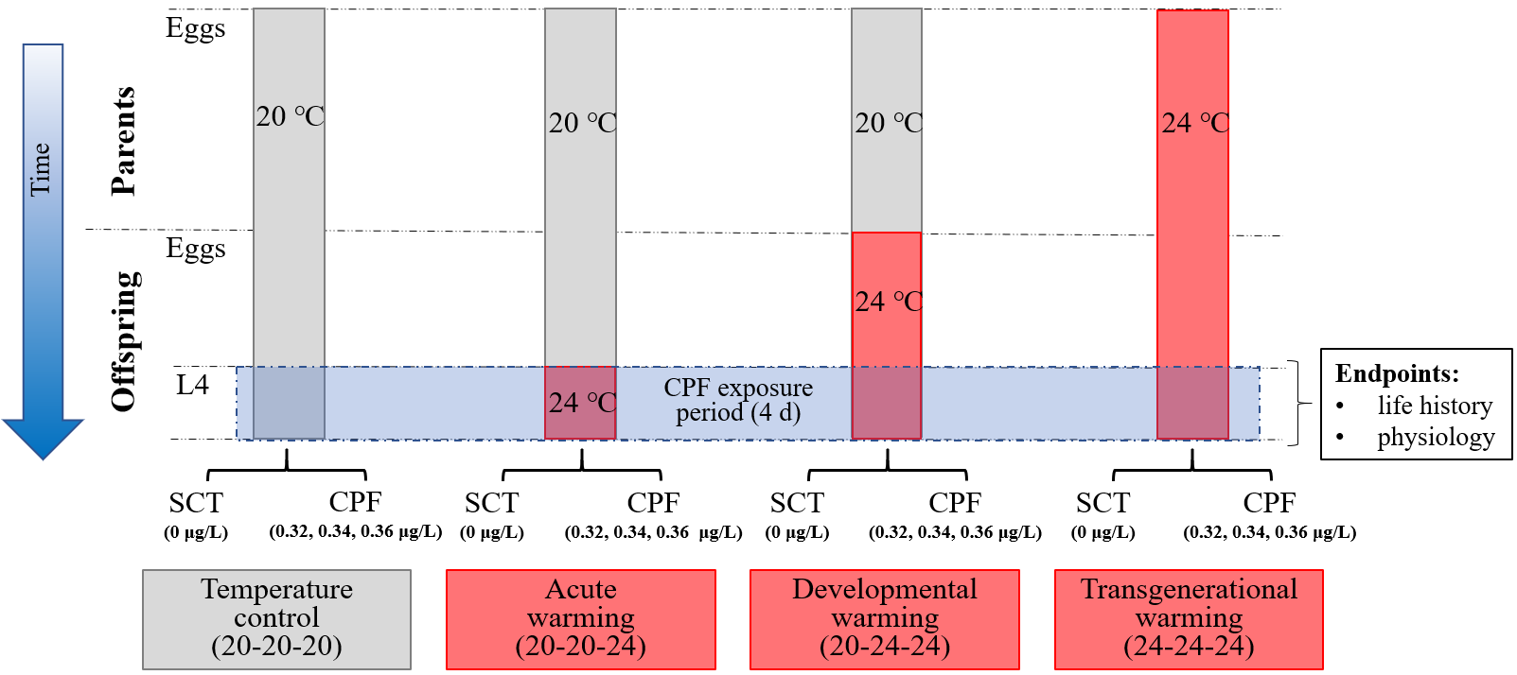
Figure 1. Scheme of the experimental design to test the effects of different exposure durations to warming on the sensitivity to chlorpyrifos. In the offspring generation, freshly moulted L4 (final instar) larvae were exposed to the solvent control (SCT) or one of the three chlorpyrifos (CPF) concentrations (0.32, 0.34, or 0.36 µg/L). In the temperature control (20-20-20), both the parents and their offspring always stayed at 20 ℃. In the three warming treatments, exposure to 24 ℃ started from the L4 stage in the offspring generation for acute warming (20-20-24), from the egg stage in the offspring generation for developmental warming (20-24-24), or already from the egg stage of the parental generation for transgenerational warming (24-24-24).

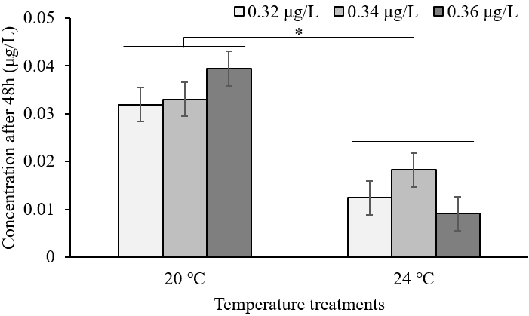
Figure 2. The effect of temperature during the chlorpyrifos exposure period on the measured concentrations of chlorpyrifos in the experimental vials for the three nominal start concentrations (0.32, 0.34 and 0.36 μg/L) 48h after the start of the exposure. Means were based on two pooled samples of 10 vials and are shown with standard error. Significant differences (P-value < 0.05) are coded as *.

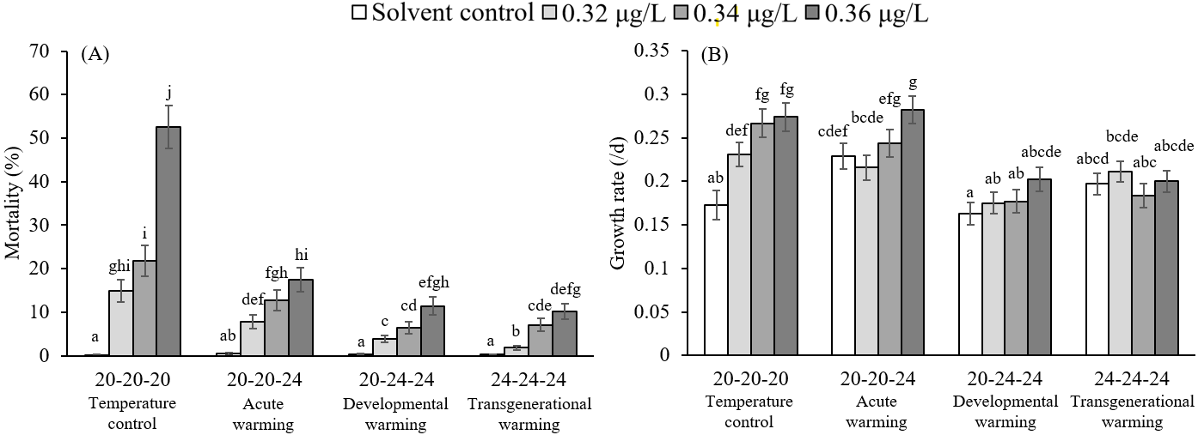
Figure 3. The effects of chlorpyrifos exposure and the temperature treatments on life history variables of L4 larvae of the mosquito Culex pipiens: (A) mortality and (B) growth rate. Means are shown with standard error. Different letters above the bars indicate significantly different means (false discovery rate corrected P < 0.05).

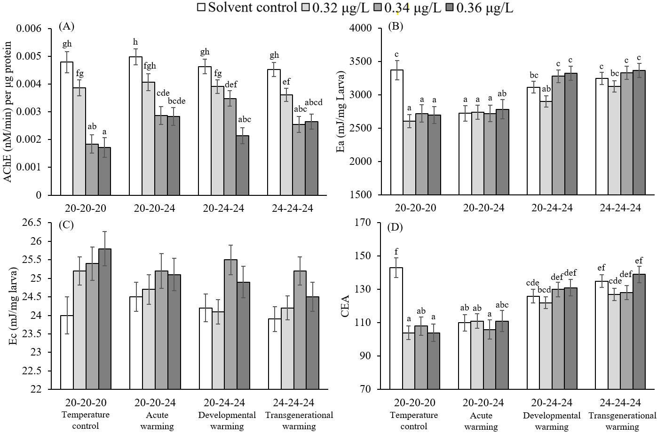
Figure 4. The effects of chlorpyrifos exposure and the temperature treatments on physiological variables of L4 larvae of the mosquito Culex pipiens: (A) AChE (acetylcholinesterase) activity, (B) Ea (the energy available), (C) Ec (the energy consumed), and (D) CEA (cellular energy allocation). Means are shown with standard error. Different letters above the bars indicate significantly different means (false discovery rate corrected P < 0.05).

