Population pharmacokinetics of cefazolin in maternal and umbilical cord plasma, and exposure in term neonates

Omar Elkayal¹, MSc; Karel Allegaert^{1,2,3}, MD, PhD; Isabel Spriet^{1,4}, PharmD, PhD; Anne Smits^{2,5}, MD, PhD; Seghaye Marie-Christine⁶, MD, PhD; Corinne Charlier⁷, MD, PhD; Erwin Dreesen^{1,8}, PharmD, PhD

¹ Department of Pharmaceutical and Pharmacological Sciences, KU Leuven, Leuven, Belgium
² Department of Development and Regeneration, KU Leuven, Leuven, Belgium
³ Department of Clinical Pharmacy, Erasmus MC Rotterdam, Rotterdam, the Netherlands
⁴ Pharmacy Department, University Hospitals Leuven, Leuven, Belgium.
⁵ Neonatal Intensive Care Unit, University Hospitals Leuven, Leuven, Belgium
⁶ Pediatrics. NDB, Centre Hospitalier Universitaire de Liège, Liège, Belgium
⁷ Department of Toxicology, Centre Hospitalier Universitaire de Liège, Liège, Belgium
⁸ Department of Pharmacy, Uppsala University, Uppsala, Sweden

Corresponding author: Erwin Dreesen
O&N II Herestraat 49 - box 820
3000 Leuven, Belgium
Tel.: +32 16 37 27 53
Email: erwin.dreesen@kuleuven.be

ORCID: Omar Elkayal https://orcid.org/0000-0001-5708-9497
Isabel Spriet https://orcid.org/0000-0001-6342-0676
Karel Allegaert https://orcid.org/0000-0001-9921-5105
Anne Smits https://orcid.org/0000-0002-0710-6698
Marie-Christine Seghaye https://orcid.org/0000-0002-7720-0313
Corinne Charlier https://orcid.org/0000-0002-5414-2544
Erwin Dreesen https://orcid.org/0000-0002-0785-2930
Word count: 2,465
Table/Figure count: 2/5
Number of references: 26
Journal: Journal of Antimicrobial Chemotherapy

Synopsis
Background: Intrapartum cefazolin is used to prevent Group B Streptococcus (GBS) vertical transmission in mothers allergic to penicillin without history of anaphylaxis.
Objectives: To investigate maternal cefazolin dose-exposure relationship and subsequent maternal and neonatal target attainment at delivery.
Methods: Data were obtained from 24 healthy, GBS colonised pregnant women (20-41 years), giving vaginal delivery (gestational age ≥37 weeks). During labour, all women received a 2g cefazolin intravenous infusion. Eight hours later, eight women received another 1g infusion since delivery did not occur yet. Next to maternal plasma concentrations (up to ten per dosing interval, until delivery), venous and arterial umbilical cord concentrations were determined at delivery. Target attainment in maternal/neonatal plasma was set at 1mg/L for 60% of the dosing interval (unbound cefazolin, worst-case clinical breakpoint). A population pharmacokinetic (popPK) model was build (NONMEM 7.4).
Results: At delivery, maternal blood and arterial umbilical cord unbound cefazolin were >1 mg/L in 23/24 (95.8%) and 11/12 (91.7%), respectively. The popPK of cefazolin in pregnant women was described by a two-compartment model with first-order elimination. Two additional compartments resembled the venous and arterial umbilical cord. Cefazolin target attainment was adequate in the studied cohort, where delivery occurred no later than 6.5 hours after either the first or the second dose. PopPK simulations showed adequate exposure for 12 hours following the first dose.
Conclusion: PopPK simulations showed that standard pre-delivery maternal cefazolin dosing provided adequate target attainment at time of delivery.

Introduction
Group B Streptococcus (GBS) bacteria is one of the leading causes of maternal infections during pregnancy and postpartum, as well as in the neonate.^{1,2} GBS is a coloniser of the gastrointestinal or genitourinary tract in about 20% of pregnant women.³ Vertical GBS transmission from the mother to the neonate occurs during labour or birth in 36% of colonised mothers, which may lead to meningitis, sepsis and other infections in the neonate.³ Therefore, antibiotic regimens are administered in mothers, to provide intrapartum GBS prophylaxis. The antimicrobial of choice for prophylaxis against GBS infections is penicillin G or amoxicillin. Both are deemed equally effective.⁴ However, for women that have penicillin allergy without a history of anaphylaxis, cefazolin is a safe and effective alternative in this setting.^{4–6}
Cefazolin is a first-generation cephalosporin that works by inhibiting bacterial cell wall synthesis. It is only available for intravenous (IV) and intramuscular (IM) administration. Besides GBS prophylaxis, cefazolin is a standard prophylactic antimicrobial agent for various surgical interventions, including delivery-related interventions like caesarean section, owing to its broad-spectrum activity against most gram-positive bacteria and some gram-negative bacteria.⁷ It is highly bound to serum albumin (75%-85%), but only unbound cefazolin displays pharmacological activity.^{8–12} The efficacy of cefazolin, in line with other beta-lactams, depends on the time that the unbound drug concentration is above the MIC for 60-70% of the dosing interval, which is generally less than 1 mg/L for GBS bacteria.^{13,14}
Several population PK models (popPK) of cefazolin have been developed in different clinical settings. Two models described the PK of cefazolin during pregnancy.^{11,12} Three other models described the cefazolin PK during caesarean delivery.^{15–17} There are some data suggesting that labour influences the PK of antibiotics.¹⁸ However, no model described the PK of cefazolin during labour and subsequent vaginal delivery. Also, the subsequent post-delivery early neonatal exposure is unknown. Therefore, a popPK model will be of relevance, providing insight into the intra-partum neonatal protection against GBS infections.
The objectives of our work were (i) to build a popPK model of cefazolin based on maternal and umbilical cord plasma concentrations obtained from women undergoing vaginal delivery, (ii) to investigate target attainment (time above 4x the epidemiological cut-off (ECOFF) of 0.25 mg/L) in the mothers during labour, and (iii) to investigate the early postpartum cefazolin exposure in the newborn.

Patients and Methods

Patients and Data Collection
Data were obtained from a prospective study. In this study, healthy singleton pregnant women were recruited. All women were colonised with GBS and were admitted for vaginal delivery. During labour, the women received a 2 g cefazolin intravenous infusion over 30 minutes. If no delivery occurred eight hours after infusion, a second 1 g cefazolin infusion was given over 15 minutes. Maternal blood samples were obtained following a fixed sampling scheme with maximally ten samples per dosing interval (until delivery), plus an additional sample right after delivery. Besides maternal blood samples, arterial and venous umbilical cord blood samples were collected at delivery. Additional data collected were gestational age, maternal age, maternal bodyweight, and birthweight. The two parents’ informed consents were collected according to the Ethics Committee approval of the Centre Hospitalier Universitaire de Liège before sample collection.

Analytical Procedures
All heparinised blood samples were centrifuged immediately after sampling (10 minutes, 1200 × g, ambient temperature), plasma was stored at -80°C until further analysis. Cefazolin total plasma concentrations were measured using high-performance liquid chromatography coupled with a diode array detector (HPLC-DAD) with a lower limit of quantification (LLOQ) of 0.5 mg/L.

Pharmacokinetic/pharmacodynamic Target
An unbound cefazolin concentration above the MIC throughout at least 60% of the dosing period (i.e., 60% fT>MIC) was used as an optimal PK/PD target.¹⁹ In the absence of a MIC for cefazolin in GBS, we use the 0.25 mg/L epidemiological cut-off value (ECOFF) of amoxicillin for S. agalactiae.^{20,21} To avoid selecting resistant bacteria, a worst-case target of at least 60% fT>4×ECOFF was assumed.
Unbound cefazolin concentrations in maternal plasma were calculated from the measured total concentrations assuming 75% protein-binding (lower limit of the 75%-85% interval because albumin is known to decrease at the later stage of pregnancy).^{11,12}

Population Pharmacokinetic Modelling

Software
Dataset formatting and exploration were performed using R (version 3.5.1, R Core Team, Vienna, Austria) using custom scripts based on packages including dplyr and ggplot2.^{22,23} PopPK analysis was performed using NONMEM (version 7.4; ICON Development Solutions, Gaithersburg, MD, USA), with a GNU Fortran 95 compiler and the Perl-speaks-NONMEM (PsN; version 4.7.0) toolkit on the interface software Pirana (version 2.9.7; Certara, Inc., Princeton, NJ, USA).

Model Development
Parameter estimation was performed using first-order conditional estimation with interaction (FOCE-I) and differential equation solver ADVAN 13. The precision of the parameter estimates was evaluated based on the root squared error (RSE).
A base popPK model was developed. Different structural models with varying numbers of compartments were explored. Individual PK parameters were assumed to be log-normally distributed, which was achieved using an exponential function. Magnitudes of differences of individual parameters from the typical value (interindividual variability) and differences between observed values and model predicted values (residual variability) were quantified. The parametrization was performed using an exponential formula. For example, the clearance (CL) parametrization followed this equation:
${\text{CL}}_{\text{i}}\text{ = TVCL × }\text{exp}\left({\text{η}}_{\text{i}}\right)\text{with }{\text{η}}_{\text{i}} \text{∝} \text{N}\text{(0,}{ \text{ω}}^{\text{2}}\text{)}$ (Eq. 1)
with CL_{i} the clearance of subject i, TVCL the typical population value of the clearance, η_{i} the individual subject’s deviation from the typical value, and ω² is the variance of inter-subject variability.
The base model was selected based on objective function value (OFV) comparisons (difference ≥3.84 points; P ≤0.050), plausibility and precision of parameter estimates, and goodness-of-fit plots. A final model, including covariate effects, was built via a two-way stepwise covariate modelling procedure (forward inclusion α=0.010; backward elimination α=0.001). The tested covariates were gestational age and maternal bodyweight.

Final Model Evaluation
The final model was evaluated using a prediction-corrected visual predictive check (pcVPC; n=1,000 simulated replicates of the original dataset). Furthermore, bootstrapping was performed to obtain nonparametric estimates of uncertainty in parameter estimates (n=2,000 bootstraps).

Simulations in Newborns
Neonatal exposure after birth in our study cohort was predicted using Monte Carlo simulations. These simulations were based on the popPK model-predicted arterial umbilical cord concentrations at birth. Subsequent cefazolin exposure in the new-borns was predicted from the cefazolin popPK model of De Cock et al.²⁴ The cefazolin PK was simulated 1,000 times for each new-born. Missing neonatal serum albumin was multiply imputed (n=1,000) with values sampled from a uniform distribution within the range reported by Smits et al. (28.2 g/L to 43.7 g/L).⁹ Postnatal age was set to zero, current weight was set equal to the registered birthweight in the current cohort of mother-newborn data.²⁴

Maternal and Arterial Umbilical Cord Simulations
PK simulations were performed during standard pre-delivery maternal cefazolin dosing (see Patients and Data Collection). The maternal exposure and the probability of target attainment (PTA) in arterial umbilical cord plasma were calculated up to 12 hours after the first infusion. Arterial umbilical cord plasma concentrations were considered foetal plasma concentrations since arterial cord blood originates directly from the foetal circulation. Based on previous literature, protein-binding was assumed 75% in maternal plasma (see Pharmacokinetic/pharmacodynamic Target) and 60% in neonatal plasma.^{11,12,24}

Results

Patient Characteristics
Data were obtained from 24 healthy pregnant women (20 to 41 years, bodyweight 70.5 kg to 89.7 kg), colonised with GBS, giving vaginal delivery (gestational age ≥37 weeks). A summary of the participant’s characteristics is presented in Table 1. During labour, all women received a 2 g cefazolin IV infusion over 30 minutes for prophylaxis against GBS. In 16 women, delivery occurred within six and a half hours after the infusion (median [interquartile range; IQR] 4.6 [3.3-5.6] hours). Eight hours after the first administration, the remaining eight women received a second cefazolin infusion (1 g) over 15 minutes.
Altogether, the women contributed 245 plasma samples to the analysis, 24 of which were matched venous and arterial umbilical cord samples from 12 women (Figure 1). At time of delivery, the maternal unbound cefazolin plasma concentrations were above the 1 mg/L target in 23/24 (95.8%) women (5.82 [1.89-5.86] mg/L) (Supplementary Figure 1). The unbound 1 mg/L target was achieved in 11/12 (91.6%) arterial umbilical cord samples (3.21 [3.56-2.23] mg/L).

Population Pharmacokinetic Model

Model development
A two-compartment popPK model with linear elimination best described the maternal cefazolin concentration data. Two additional compartments were added to represent the venous and arterial umbilical cord concentrations, with blood flowing from the maternal central compartment to the venous umbilical cord compartment, then to the arterial umbilical cord compartment, and then back to the maternal central compartment with the placenta as a barrier between both (Figure 2).
Interindividual variability was estimated on the maternal clearance (43% coefficient of variation [CV]), central volume of distribution (67%CV), and peripheral volume of distribution (68%CV). A mixed error model was selected to describe the residual variability based on goodness-of-fit plots and the OFV.
Gestational age and body weight were tested as covariates but did not significantly improve the OFV nor improved the parameter estimation accuracy. Therefore, these covariates were not retained in the final model. Parameter estimates from the final model are shown in Table 2.

Model Evaluation
Goodness-of-fit plots showed that the final model adequately described the observed data (Supplementary Figure 2). A pcVPC showed the good predictive capacity of our model, where the median values and the 95% CIs of the prediction-corrected observed data fell within the 95% of the model prediction intervals (Figure 3). Median values of the nonparametric bootstrap were in good agreement with point estimates (Table 2).

Simulations in New-borns
The PK simulations showed adequate neonatal antimicrobial exposure for protection against GBS in neonates at birth in our study cohort (3.58 [2.50-4.84] mg/L) (N=24) (Figure 4). Unbound cefazolin is predicted to remain detectable for at least 24 h after birth.

Maternal and Arterial Umbilical Cord Simulations
The PK simulations showed that the median maternal unbound cefazolin plasma is above the therapeutic target of 1 mg/L for the entire 12-hour simulation period (Figure 5A). The PTA of neonatal unbound cefazolin concentrations slowly increases and reaches 90% or more after approximately one hour of the infusion start (Figure 5B).

Discussion
In this study, we performed a popPK modelling and simulation study of cefazolin in healthy women undergoing vaginal delivery and their new-borns. We obtained a better understanding of the pre-delivery maternal cefazolin dose-exposure relationship and subsequent post-delivery duration of neonatal target attainment. Although PK variability is large, fixed 2 g cefazolin dosing – followed by 1 g cefazolin eight hours later if delivery had not occurred yet – provided adequate unbound cefazolin exposure in the mother and in the neonate at the time of birth.
A two-compartment model with linear elimination best described the maternal and umbilical cord concentration data. No popPK model of cefazolin in women in labour and subsequently undergoing vaginal delivery has been published before. However, there are two popPK models describing the cefazolin PK in women during pregnancy (gestational age range 17-40 weeks, foetal surgery or caesarean).^{11,12} Additionally, three popPK models are available describing cefazolin PK in women undergoing caesarean delivery.^{15–17} Two of the previous models (both caesarean delivery models) used a one-compartment model to describe the cefazolin popPK.^{15,16} This structural difference can be owing to the sparse sampling schemes in these studies, as well as the physiological difference between vaginal and caesarean deliveries (different volume of distribution and clearance). In the previously published models, the most common covariates were maternal bodyweight, gestational age, and maternal albumin. Bodyweight and gestational age were tested but not withheld in our model, while serum albumin concentrations were not available in our study dataset.
Muller et al. suggested that physiological changes during labour and subsequent vaginal delivery may influence the maternal PK of antibiotics (mainly distribution characteristics), as well as its placental transfer and subsequent foetal and neonatal exposure.¹⁸ Comparing our cefazolin PK parameters during labour to those reported by others during pregnancy and caesarean delivery, no clear differences could be observed.^{16,25} However, a future popPK model meta based analysis is warranted to obtain further insight into potential differences.
Besides maternal PK, Muller et al. also indicated the need to document foetal and neonatal exposure.¹⁸ Our data set included samples from the umbilical cord (venous and arterial) at the time of cord clamping. Unfortunately, no postnatal observations in the newborns of the mothers recruited were available in our study. However, similar to Muller et al., we postulated that the arterial umbilical cord concentrations reflect the neonatal concentrations at birth.²⁶ Starting from these model-predicted arterial umbilical cord concentrations, subsequent neonatal exposure was simulated with the De Cock et al. model. Unbound cefazolin was predicted to remain detectable for at least 24 h after birth. Consequently, a blood culture collected within this time frame, for example because of suspected early onset sepsis in the new-born, is more likely to remain false negative.
Although target attainment was adequate in our study cohort, delivery occurred no later than six and a half hours after the first infusion and four hours after the second infusion in all women. Therefore, we performed PK simulations, calculating the PTA at delivery across the entire 12 hours after the first dose. These simulations showed that the unbound cefazolin concentration in the maternal plasma remains above the therapeutic target for the entire 12-hour period following the first cefazolin dose. Furthermore, the simulations also illustrated the slow increase of neonatal (arterial umbilical cord) unbound cefazolin concentrations so that 90% PTA is reached approximately one hour after the start of the first infusion.
Our study had several strengths. First, our dataset included rich sampling, which enabled the accurate capture of the structural elements of the popPK model. Second, our data included umbilical cord samples, which enabled us to have insight into the neonatal target attainment. Despite these strengths, this study had some limitations. First, we were limited with the covariates included in our dataset. Only two covariates were tested in the popPK model building (gestational age and maternal bodyweight), and both were not retained. In future research, it would be of interest to test other covariates like estimated glomerular filtration rate (eGFR) and albumin on the cefazolin PK in this clinical setting. Another limitation is that our dataset only included total cefazolin concentrations. The unbound concentrations were not measured. This limitation hindered our ability to fully explore the cefazolin maternal protection. Instead, we postulated a cefazolin protein-bound fraction of 75% in the maternal blood as previously published.^{10,11}
To conclude, we showed that the standard pre-delivery maternal cefazolin dosing provided adequate maternal and neonatal antimicrobial protection against GBS in our patient cohort. In addition, we developed a popPK model to describe the cefazolin PK in women during labour with subsequent vaginal delivery. This popPK model was used for simulations that showed that standard pre-delivery cefazolin dosing provides adequate unbound cefazolin concentrations during the entire 12-hour time window after the first infusion.

Acknowledgements
We thank Prof. Catherijne Knibbe for kindly sharing the NONMEM model code of the neonatal cefazolin model by De Cock et al.

Funding
IS is funded by the Clinical Research Fund of the University Hospitals Leuven. AS research activities are supported by the Clinical Research and Education Council of the University Hospitals Leuven. ED is a postdoctoral research fellow of the Research Foundation – Flanders (FWO), Belgium (grant number 12X9420N) ….

Transparency
Is received consultancy support and lecture fees from argenx, Pfizer, Merck, and Cidara. ED received consultancy fees from argenx and Janssen (all honoraria/fees paid to the University). … For the remaining authors, none were declared.

References
1. Nanduri SA, Petit S, Smelser C, et al. Epidemiology of Invasive Early-Onset and Late-Onset Group B Streptococcal Disease in the United States, 2006 to 2015. JAMA Pediatr 2019; 173: 224–33.
2. Pass MA, Gray BM, Dillon HC. Puerperal and perinatal infections with group B streptococci. Am J Obstet Gynecol 1982; 143: 147–52.
3. Colbourn T, Gilbert R. An overview of the natural history of early onset group B streptococcal disease in the UK. Early Hum Dev 2007; 83: 149–56.
4. Verani JR, McGee L, Schrag SJ, Division of Bacterial Diseases, National Center for Immunization and Respiratory Diseases, Centers for Disease Control and Prevention (CDC). Prevention of perinatal group B streptococcal disease--revised guidelines from CDC, 2010. MMWR Recomm Rep Morb Mortal Wkly Rep Recomm Rep 2010; 59: 1–36.
5. Briody VA, Albright CM, Has P, Hughes BL. Use of Cefazolin for Group B Streptococci Prophylaxis in Women Reporting a Penicillin Allergy Without Anaphylaxis. Obstet Gynecol 2016; 127: 577–83.
6. Verani JR, McGee L, Schrag SJ, Division of Bacterial Diseases, National Center for Immunization and Respiratory Diseases, Centers for Disease Control and Prevention (CDC). Prevention of perinatal group B streptococcal disease--revised guidelines from CDC, 2010. MMWR Recomm Rep Morb Mortal Wkly Rep Recomm Rep 2010; 59: 1–36.
7. Gyssens IC. Preventing postoperative infections: current treatment recommendations. Drugs 1999; 57: 175–85.
8. Decroix MO, Zini R, Chaumeil JC, Tillement JP. Cefazolin serum protein binding and its inhibition by bilirubin, fatty acids and other drugs. Biochem Pharmacol 1988; 37: 2807–14.
9. Smits A, Kulo A, Verbesselt R, et al. Cefazolin plasma protein binding and its covariates in neonates. Eur J Clin Microbiol Infect Dis 2012; 31: 3359–65.
10. Vella-Brincat JWA, Begg EJ, Kirkpatrick CMJ, Zhang M, Chambers ST, Gallagher K. Protein binding of cefazolin is saturable in vivo both between and within patients. Br J Clin Pharmacol 2007; 63: 753–7.
11. Allegaert K, Van Mieghem T, Verbesselt R, et al. Cefazolin plasma protein binding saturability during pregnancy. Methods Find Exp Clin Pharmacol 2009; 31: 25–8.
12. van Hasselt JGC, Allegaert K, van Calsteren K, Beijnen JH, Schellens JHM, Huitema ADR. Semiphysiological versus Empirical Modelling of the Population Pharmacokinetics of Free and Total Cefazolin during Pregnancy. BioMed Res Int 2014; 2014: 1–9.
13. de Hoog M, Mouton JW, van den Anker JN. New dosing strategies for antibacterial agents in the neonate. Semin Fetal Neonatal Med 2005; 10: 185–94.
14. Drusano GL. Prevention of resistance: a goal for dose selection for antimicrobial agents. Clin Infect Dis Off Publ Infect Dis Soc Am 2003; 36: S42-50.
15. Grupper M, Kuti JL, Swank ML, Maggio L, Hughes BL, Nicolau DP. Population Pharmacokinetics of Cefazolin in Serum and Adipose Tissue From Overweight and Obese Women Undergoing Cesarean Delivery: Journal of Clinical Pharmacology. J Clin Pharmacol 2017; 57: 712–9.
16. Elkomy MH, Sultan P, Drover DR, Epshtein E, Galinkin JL, Carvalho B. Pharmacokinetics of Prophylactic Cefazolin in Parturients Undergoing Cesarean Delivery. Antimicrob Agents Chemother 2014; 58: 3504–13.
17. Eley VA, Christensen R, Ryan R, et al. Prophylactic Cefazolin Dosing in Women With Body Mass Index >35 kg·m−2 Undergoing Cesarean Delivery: A Pharmacokinetic Study of Plasma and Interstitial Fluid. Anesth Analg 2020; 131: 199–207.
18. Muller AE, Dörr PJ, Mouton JW, et al. The influence of labour on the pharmacokinetics of intravenously administered amoxicillin in pregnant women. Br J Clin Pharmacol 2008; 66: 866–74.
19. Guilhaumou R, Benaboud S, Bennis Y, et al. Optimization of the treatment with beta-lactam antibiotics in critically ill patients—guidelines from the French Society of Pharmacology and Therapeutics (Société Française de Pharmacologie et Thérapeutique—SFPT) and the French Society of Anaesthesia and Intensive Care Medicine (Société Française d’Anesthésie et Réanimation—SFAR). Crit Care 2019; 23.
20. Mouton JW, Muller AE, Canton R, Giske CG, Kahlmeter G, Turnidge J. MIC-based dose adjustment: facts and fables. J Antimicrob Chemother 2018; 73: 564–8.
21. Anon. MIC EUCAST. Available at: https://mic.eucast.org/search/show-registration/12248
22. Wickham H, François R, Henry L, Müller K, RStudio. dplyr: A Grammar of Data Manipulation. 2020. Available at: https://CRAN.R-project.org/package=dplyr. Accessed July 2, 2020.
23. Bunn A, Korpela M. An Introduction to dplR. : 16.
24. De Cock RFW, Smits A, Allegaert K, et al. Population pharmacokinetic modelling of total and unbound cefazolin plasma concentrations as a guide for dosing in preterm and term neonates. J Antimicrob Chemother 2014; 69: 1330–8.
25. Allegaert K, van Mieghem T, Verbesselt R, et al. Cefazolin pharmacokinetics in maternal plasma and amniotic fluid during pregnancy. Am J Obstet Gynecol 2009; 200: 170.e1-170.e7.
26. Muller AE, Oostvogel PM, DeJongh J, et al. Pharmacokinetics of Amoxicillin in Maternal, Umbilical Cord, and Neonatal Sera. Antimicrob Agents Chemother 2009; 53: 1574–80.

Tables
Table 1. Summary of patient characteristics
Parameter | Value
Demographics
Patients, n | 24
Age (years), median [IQR] | 30 [26-32.3]
Gestational age (weeks), median [IQR] | 39 [39-40]
Maternal bodyweight at first cefazolin dose (kg), median [IQR] | 80.5 [70.5-89.7]
Birthweight (kg), median [IQR] | 3.5 [2.7-4.6]
Cefazolin dosing
Cefazolin first dose (mg), median [IQR] | 2,000 [2,000-2,000]
Cefazolin second dose (mg), median [IQR] | 1,000 [1,000-1,000]
Number of cefazolin first doses, n | 24
Number of cefazolin second doses, n | 8
Delivery
Time between first cefazolin dose and delivery (hours), median [IQR], n | 4.6 [3.3-5.6], 16
Time between second cefazolin dose and delivery (hours), median [IQR], n | 0.5 [0.1-1], 8
Sampling information
Number of plasma samples, n | 254
Number of plasma samples/patient, median [IQR] | 10 [9-11]
Number of umbilical cord plasma samples, n [arterial/venous] | 24 [12/12]
Number of plasma samples below the lower limit of quantification, n (%) | 0 (0)
Cefazolin measurements
Cefazolin maternal concentrations (mg/L), median [IQR] | 61 [23.3-99.4]
Cefazolin arterial umbilical concentrations (mg/L), median [IQR] | 12.8 [8.9-14.3]
Cefazolin venous umbilical concentrations (mg/L), median [IQR] | 12.1 [9- 14.35]
IQR: interquartile range.
Table 2. Population parameter estimates
Parameter | Estimate (%RSE) [%shrinkage] | Bootstrap Median (95% CI)
Typical Values
CL_{maternal} (L/h) | 7.15 (10) | 6.99 (3.41-9.03)
V_{c} (L) | 6.23 (19) | 6.25 (3.81-8.82)
Q₁ (L/h) | 26.1 (19) | 27.75 (18.56-45.95)
V_{p} (L) | 6.95 (23) | 7.05 (4.04-9.71)
Q₂ (L/h) | 2.61 (16) | 2.77 (1.04-6.86)
V_{venous umbilical cord} & Varterial umbilical cord/neonatal (L) | 6.97 (15) | 8.87 (2.57-34.7)
Q₃ (L/h) | 4.48 (12) | 4.85 (1.84-12.48)
Q₄ (L/h) | 5.47 (14) | 5.49 (2.27-10.91)
CL_{neonatal} (L/h) | 0 FIXED | 0 FIXED
Interindividual variability model
on CL (%CV) | 42.9 (16) [10] | 45.8 (26.3-80.8)
on V_{c} (%CV) | 66.6 (25) [8] | 65.3 (17.9-114.1)
on V_{p} (%CV) | 67.9 (33) [26] | 71.8 (22.5-158.3)
Residual variability
Additive residual variability (mg/L) (maternal) | 0.082 (30) [9] | 0.075 (0.034 -0.124)
Proportional residual variability (%CV) (maternal) | 14.7 (43) [9] | 19 (5.7-69.9)
Additive residual variability (mg/L) (venous) | 0.021 (58) [23] | 0.014 (2.44×10⁻⁶-0.043)
Proportional residual variability (%CV) (venous) | 0 FIX | 0 FIX
Additive residual variability (mg/L) (arterial) | 0 FIX | 0 FIX
Proportional residual variability (%CV) (arterial) | 9.16 (47) [5] | 8.21 (0.43-17.81)
CL: clearance; CV: coefficient of variation calculated as $\sqrt{\text{exp}\left({\text{ω}}^{\text{2}}\right)\text{-1}}\text{×100\%}$; V_{c}: central volume of distribution; V_{p}: peripheral volume of distribution.

Figure Legends
Figure 1. Total cefazolin concentration versus time after dose. Grey dots: maternal plasma concentrations; blue crosses: venous umbilical cord plasma concentrations; red diamonds: arterial umbilical cord plasma concentrations.
Figure 2. Schematic representation of the pre-delivery maternal-umbilical cord population pharmacokinetic model. art: arterial; CL: clearance; neo: neonatal; Q: blood flow; umb: umbilical cord; V: volume of distribution; ven: venous.

Figure 3. Prediction-corrected visual predictive check of the final model. The observed prediction-corrected total cefazolin concentrations are represented by circles. The black solid and dash lines represent the median and the 2.5th and 97.5th percentile of the prediction-corrected observations. The shaded areas indicate the 90% prediction intervals of the median and 2.5th and 97.5th percentile of the simulated values.
Figure 4. Neonatal unbound cefazolin concentrations versus time since birth. The blue lines each represent the median of 1,000 simulations based on one of the predicted neonatal concentrations from the developed model. The thick black line represents the median trend.
Figure 5. (A) Neonatal probability of target attainment at birth (PTA) versus time since the start of infusion. The horizontal line indicates the 90% PTA cut-off. (B) Maternal unbound cefazolin concentrations versus time after the start of the infusion. The black line represents the median of 1,000 simulations. The shaded area indicates the 95% prediction intervals of the median.

Figures
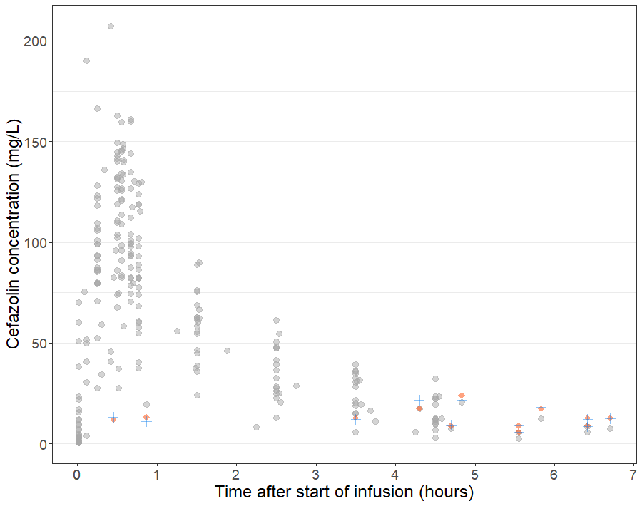
Figure 1.

Vc
Vp
Vven-umb
Vart-umb/neo
Q1
CLmaternal
Q2
Q4
Q3
CLneonate
Figure 2.
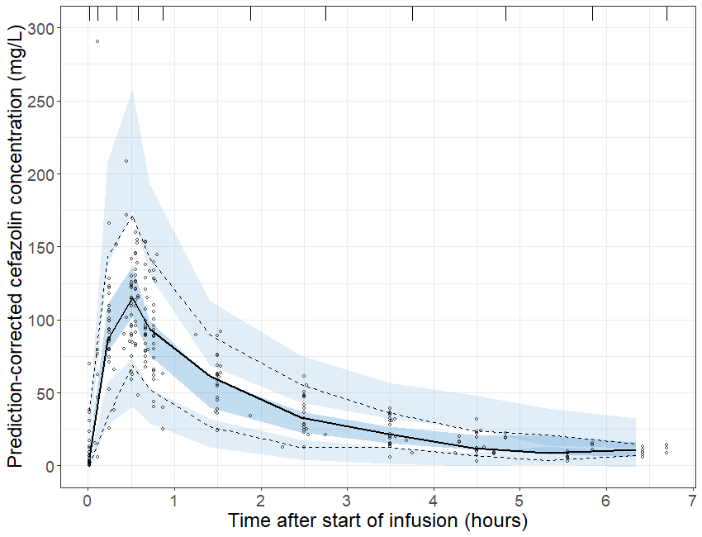
Figure 3.
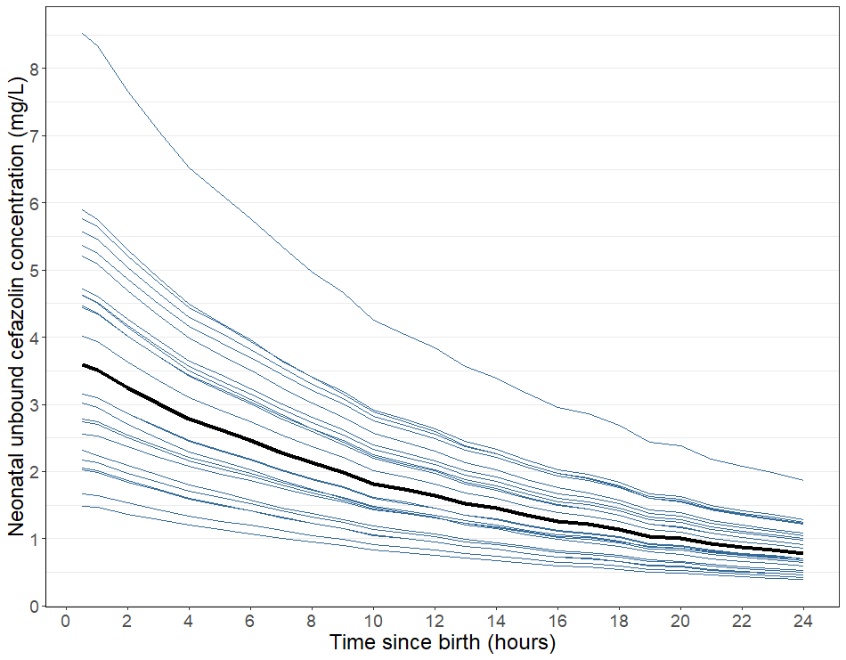
Figure 4.
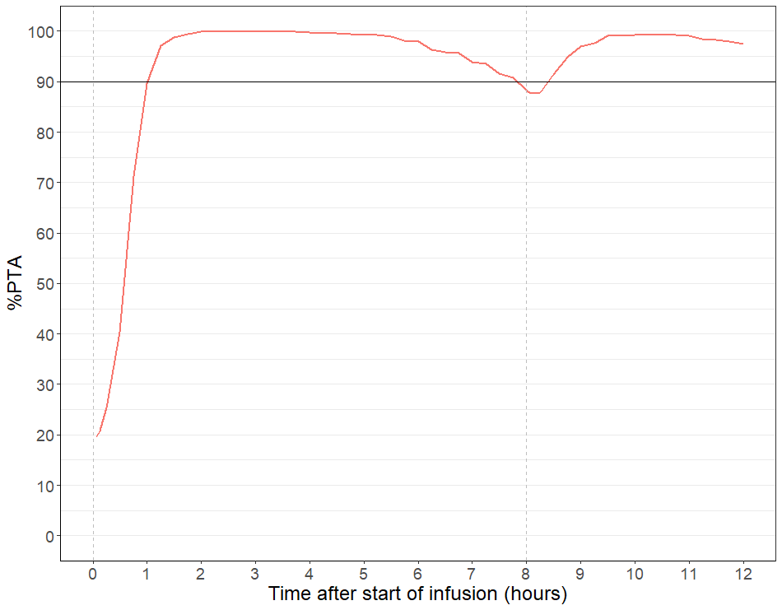
A
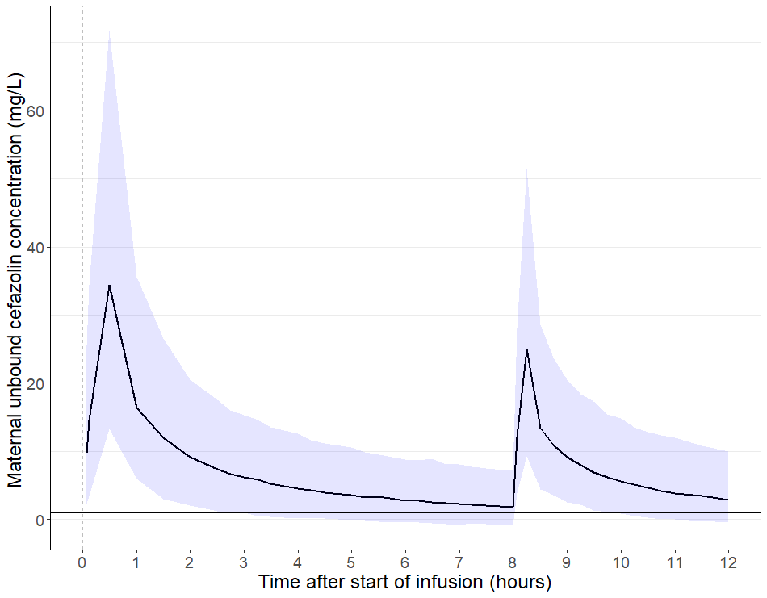
B
Figure 5.

Supplementary material
Supplementary Figures
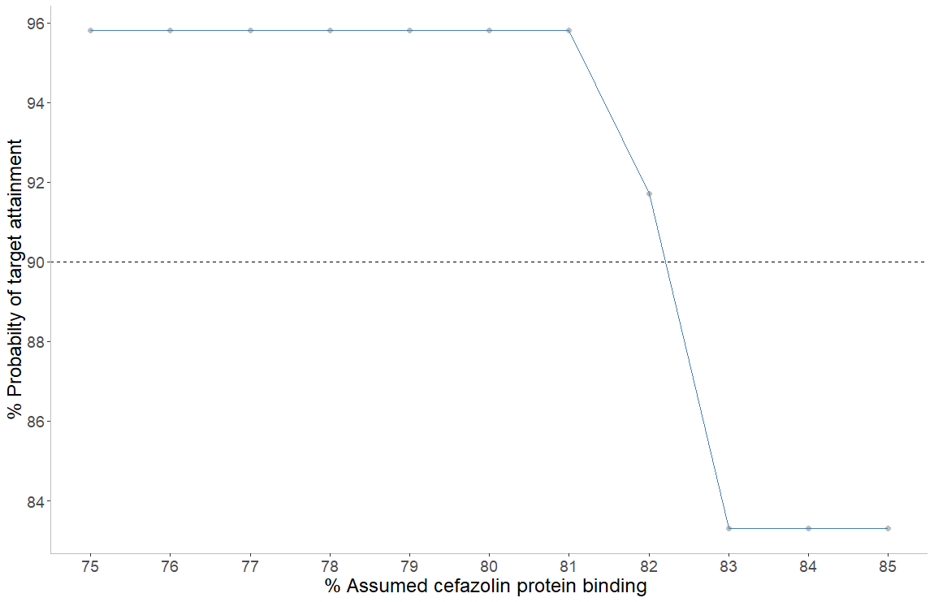
Supplementary figure 1. Attainment of the 1 mg/L unbound cefazolin concentration target (%) in the maternal blood samples in the observed data population at time of delivery versus assumed cefazolin protein binding (%) in the mother.
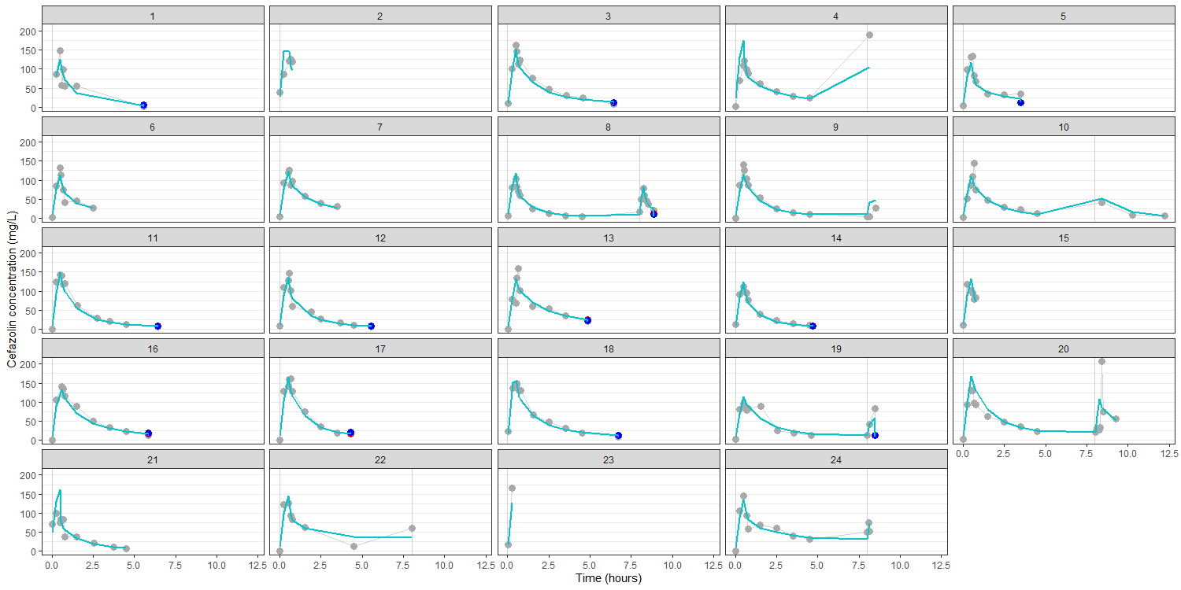
Supplementary Figure 2. Individual fit plots for each subject. The model predictions (green line) are overlapped with the observations (grey dots are maternal concentrations; blue dots are venous umbilical cord concentrations and red dots are the arterial umbilical cord concentrations). Vertical grey lines indicate cefazolin infusion.
NONMEM code
$PROBLEM Cefazolin popPK
$INPUT ID ; patient identifier
OCC ; dosing occasion
TIME ; time, in hours
TAD ; time after dose, in hours
MDV ; missing data value
DVTYPE ; DV type: 1: maternal blood, 2: umbilical cord venous,
; 3: umbilical cord arterial
DV ; dependent variable, in mg/L
CMT ; compartment in which DV is observed: 1: (maternal blood), 2: (venous umbilical cord blood), 3: (arterial umbilical cord blood)
EVID ; event identifier: 1 is dosing event, 0 is observation event
AMT ; amount of cefazolin administered, in mg
RATE ; infusion rate, in mg/hour
AGE ; mother age, in years
WGT ; mother body weight, in kg
GA ; gestational age, in weeks
$DATA DSMAT.csv IGNORE=@
$SUBROUTINES ADVAN13 TOL=9
$MODEL NCOMPARTMENTS=4
COMP = (CENTRAL, DEFDOSE)
COMP = (PERIPH)
COMP = (ART)
COMP = (VEN)
$PK TVCL =THETA (1)
TVV1 =THETA (2)
TVQ =THETA (3)
TVV2 =THETA (4)
TVV3 =THETA (5)
TVV4 =THETA (5)
TVQ2 =THETA (6)
TVQ3 =THETA (7)
TVQ4 =THETA (8)
TVCLn =THETA (9)
CL =TVCL*EXP(ETA(1))
V1 =TVV1*EXP(ETA(2))
Q =TVQ
V2 =TVV2*EXP(ETA(3))
V3 =TVV3
V4 =TVV4
Q2 =TVQ2
Q3 =TVQ3
Q4 =TVQ4
CLn =TVCLn
K10 =CL/V1
K12 =Q/V1
K21 =Q/V2
K13 =Q2/V1
K34 =Q3/V3
K41 =Q4/V4
Kn =CLn/V3
S1 =V1
S2 =V2
S3 =V3
S4 =V4
$DES DADT(1) = -K10*A(1) +K21*A(2) -K12*A(1) +K41*A(4)-K13*A(1)
DADT(2) = -K21*A(2) +K12*A(1)
DADT(3) = K13*A(1)-K34*(3)-Kn*A(3)
DADT(4) = K34*A(3)-K41*A(4)
$ERROR Cm = A (1)/V1
Ca = A (3)/V3
Cv = A (4)/V4
IF (CMT.EQ.1) IPRED= Cm
IF (CMT.EQ.3) IPRED= Ca
IF (CMT.EQ.4) IPRED= Cv
IF (CMT.EQ.1) W= SQRT (SIGMA (1,1) *IPRED**2 + SIGMA (2,2))
IF (CMT.EQ.3) W= SQRT (SIGMA (3,3) *IPRED**2 + SIGMA (4,4))
IF (CMT.EQ.4) W= SQRT (SIGMA (5,5) *IPRED**2 + SIGMA (6,6))
IF (CMT.EQ.1) Y= IPRED * (1+ EPS (1)) + EPS (2)
IF (CMT.EQ.3) Y= IPRED * (1+ EPS (3)) + EPS (4)
IF (CMT.EQ.4) Y= IPRED * (1+ EPS (5)) + EPS (6)
IRES= DV-IPRED
IWRES= IRES/W
$THETA (0, 7); CL
(0, 6); V1
(0, 22); Q
(0, 10); V2
(0,8); V3 & V4
(0,3.3); Q2
(0,5); Q3
(0,30); Q4
0 FIX; CLn

$OMEGA 0.1; IIV on CL
0.1; IIV on V1
0.1; IIV on V2
$SIGMA 0.1
0.1
0.1
0 FIX
0 FIX
0.1

$ESTIMATION METHOD=1 INTERACTION MAXEVAL=9999 NSIG=3 SIGL=9 PRINT=1 POSTHOC NOABORT
$COVARIANCE PRINT=E

