Mechanical and self-healing properties of cementitious materials with pH-responsive semi-synthetic superabsorbent polymers

Arn Mignon. Jolien Vermeulen . Didier Snoeck . Peter Dubruel .
Sandra Van Vlierberghe . Nele De Belie

Abstract Cracks are one of the main problems in mortar and concrete leading to need of reparations and additional costs. One of the recent innovative solutions are superabsorbent polymers (SAPs). SAPs can swell up to several hundred times their own weight, can block the cracks and aid in healing them. Polysaccha- rides can offer a more sustainable alternative for synthetic SAPs. Functional monomers have been combined with cross-linkable methacrylated polysac- charides to incorporate them in the polysaccharide networks. These polymers have been chemically
· · ·

A. Mignon J. Vermeulen D. Snoeck N. De Belie (&) Magnel Laboratory for Concrete Research, Department of Structural Engineering, Ghent University, Tech Lane Ghent Science Park, Campus A, Technologiepark Zwijnaarde 904, 9052 Ghent, Belgium
e-mail: Nele.DeBelie@ugent.be
A. Mignon
e-mail: Arn.Mignon@ugent.be
J. Vermeulen
e-mail: Joliever.Vermeulen@gmail.com
D. Snoeck
e-mail: Didier.Snoeck@ugent.be
A. Mignon P. Dubruel S. Van Vlierberghe Polymer Chemistry and Biomaterials Research Group,
· ·
Department of Organic and Macromolecular Chemistry, Ghent University, Krijgslaan 281, Building S4-bis, 9000 Ghent, Belgium
e-mail: Peter.Dubruel@ugent.be
S. Van Vlierberghe
e-mail: Sandra.VanVlierberghe@ugent.be
characterized in previous research by measuring among other their moisture and swelling capacity, where the pH-responsiveness leads to better control of these parameters. The current manuscript deals with the effect these polymers exhibit on the bending and compressive strength of mortar samples on the one hand and on the crack closure and self-healing of cracks on the other hand. The obtained results have been benchmarked with commercial SAPs and indi- cated that methacrylated alginate combined with acrylic acid, both with high as well as low degree of substitution gave rise to a strong self-healing capacity. They did induce a substantially lower effect on the compressive strength of mortars compared to com- mercial SAPs. Methacrylated chitosan combined with dimethylaminopropyl methacrylamide also gave very promising self-healing results, coming close to those of the best commercial SAP, although they induced a slightly more severe effect on the mortar strength than this commercial polymer.

Keywords Concrete · Polysaccharides · Acrylates ·
Self-healing · Crack closure · Compressive strength

- Introduction

One of the main issues in mortar and concrete remains cracks, occurring due to shrinkage, freeze/thaw cycles or aggressive agents. They lead to a substantial

decrease in durability. Concrete shows autogenous healing [1] due to further hydration of unhydrated cementitious materials and the formation of Ca(OH)₂ and CaCO₃. Water entering the crack leads to new formed calcium silicate hydrates (C–S–H) and cal- cium carbonate to fill the crack [2, 3]. The latter only aids in complete healing of small cracks up to
30–50 lm depending on the environmental conditions
and composition of the mortar or concrete [3–5]. To aid autogenous healing and to increase the healing of larger cracks, autonomous solutions can be used. One of these solutions includes the use of superabsorbent polymers (SAPs) [2, 6, 7]. SAPs have the interesting property that they can swell up to several hundred times their own weight [8]. The introduction of polysaccharides (alginate, agarose and chitosan) in SAPs for natural or semi-synthetic SAPs offers a valuable alternative to pure synthetic SAPs due to the incorporation of environmental-friendly materials. Indeed, these natural materials are derived from brown (alginate) and red algae (agarose) and exoskele- tons of invertebrate’s such as crabs and shrimps (chitosan). Additionally, the carboxylate and amine functionalities from the polysaccharides create an additional pH-responsiveness in the system.
Previous research from our group has shown that addition of ionically cross-linked calcium alginate led to only a minimal effect on the compressive strength of mortar (decrease of 15% by addition of 1 m% SAP) [9]. Interestingly, methacrylation of the polysaccha- ride incorporates double bonds. These enable copoly- merization with functional monomers and to create a stronger, covalent network instead of an ionic one. Additionally, the use of pH-responsive materials could offer an even more valuable solution. These ‘smart’ systems will swell less when mixed in fresh mortar (very alkaline pH around 12.5–13) and will swell to greater extent when cracks are occurring and water enters these crevices (pH of 7) [10]. Depending on the type (acidic or basic) of responsiveness, the functional groups become negatively (acidic) or positively (ba- sic) charged with an increasing or decreasing pH respectively. This will cause a stronger affinity for water uptake. This will lead to less macro-pore volume during the mixing and still a strong swelling when cracks are occurring. In our previous research, differ- ent polysaccharides have been methacrylated and combined with pH-responsive monomers. On the one hand, two methacrylated alginate (algMOD)
derivatives with varying degree of substitution (DS) were copolymerized with acrylic acid (AA) [and acrylamide (AM)] and their chemical properties were evaluated together with their swelling capacity [11]. A similar investigation has already been performed on methacrylated alginate, agarose and chitosan com- bined with the amine-based monomer dimethy- laminoethyl methacrylate (DMAEMA) [12]. The pH-responsive nature of DMAEMA (increasing swel- ling with decreasing pH) led to interesting swelling properties (up to 75 times their own weight at a pH of 3) [12].
In the current manuscript, the algMOD based materials with a low DS and chiMOD and agaMOD with the strongest swelling property at a low pH (\ pH 7) have been selected (see Table 1, based on previous research [11, 12]). In a first step, these materials were incorporated in mortar. After 28 days, these mortar prisms were tested for their bending and compressive strength to compare the effect of the incorporation of the different SAPs (see Table 1 for the list of materials). Additionally, a four-point-bending test was performed. By this method, the crack width over time can be measured which enables to visually determine the closing capacity of mortars by SAPs. Additionally, different parameters to quantify the self- healing capacity can be determined based on the stress–strain curves recorded during initial loading and during reloading after healing. The self-healing of mortar with SAPs improves due to an increased CaCO₃ formation as already proven for pH-responsive synthetic SAPs as proven in previous research by the authors [13]. The strength properties and self-healing capacity have been compared with mortars containing two commercial SAPs [6, 7]. SAP A is a cross-linked copolymer of acrylamide and sodium acrylate, while SAP B is a cross-linked potassium salt polyacrylate.

- Materials and methods

  - Materials

Agarose (Aga), ammonium persulfate (APS), chitosan (Chi), dimethylaminopropyl methacrylamide (DMAPMA), hydrochloric acid (HCl), methacrylic anhydride (MAAH), sodium alginate (NaAlg) and sodium hydroxide (NaOH) were puchased at Sigma- Aldrich (Bornem, Belgium). Dimethyl sulfoxide

Table 1 Chemical composition and degree of substitution (DS) of the developed SAPs
Sample | Polysacch: (g/g) | AA (mol%) AM (mol%) DMAPMA (mo |  |  | l%) DS (/repeating unit)
p(alg(1)_AA₁₀₀(7))_H | 1/7 | 100 | 0 | 0 | 37
p(alg(1)_AA₁₀₀(7))_L | 1/7 | 100 | 0 | 0 | 18
p(alg(1)_AA₇₅/AM₂₅(7))_H | 1/7 | 75 | 25 | 0 | 37
p(alg(1)_AA₇₅/AM₂₅(7))_L | 1/7 | 75 | 25 | 0 | 18
p(aga(1)_PMA(3)) | 1/3 | 0 | 0 | 100 | 14ª
p(chi(1)_PMA(7)) | 1/7 | 0 | 0 | 100 | 7

Monomers

Commercial SAP A Cross-linked copolymer of acrylamide and sodium acrylate Commercial SAP B Cross-linked potassium salt polyacrylate
ªRepeating unit of agarose is a disaccharide, while for the others this is a monosaccharide

(DMSO), acrylic acid (AA) and N,N,N⁰,N⁰-tetram- ethylethylene-diamine (TEMED) were obtained from Acros Organics (Geel, Belgium). Acrylamide (AM) was purchased from Janssen Chimica (Geel, Bel- gium). Commercial cross-linked SAP A and SAP B were obtained from BASF (BASF Construction Chemicals GmbH, Trostberg, Germany). Poly(viny- lalcohol) (PVA) fibers, 1.2% oil-coated were bought at Kuraray, Japan. Fly ash class F comes from OBBC Belgium. Superplasticizer Glenium 51 (35% conc.) is bought at BASF.
In total, eight different SAPs were compared of which four methacrylated alginates (algMOD) com- bined with acrylic acid (AA) and possibly acrylamide (AM). In parallel, methacrylated chitosan (chiMOD) and methacrylated agarose (agaMOD) with dimethy- laminopropyl were also evaluated. The above-men- tioned samples were compared with two commercial SAPs based on a copolymer of acrylamide and sodium acrylate on the one hand and a cross-linked potassium salt polyacrylate (see Table 1). The chemical charac- terization (infrared, gel fraction, particle size distri- bution, moisture and water uptake capacity) of the six synthesized SAPs can also be found in the previous research (see Table 2 for a summary of the most useful parameters [11, 12]). A short summary of the synthesis of the polymers: the polysaccharides were methacry- lated by dropwise addition of methacrylic anhydride and additionally also sodium hydroxide to control the pH. The DS of the modified polysaccharide was calculated using ¹H-NMR spectroscopy. These poly- mers were dissolved in water and mixed with the monomers in a three-neck flask. To this system APS

Table 2 Revision of the swelling capacity and particle size distribution of the synthesized SAPs Data from previous research [11, 12]

Sample Swelling (g/g_{water}) d₅₀ (lm)

p(alg(1)_AA₁₀₀(7))_H | 99 ± 5 (pH 12) | 34
p(alg(1)_AA₁₀₀(7))_L | 630 ± 31 (pH 12) | 26
p(alg(1)_AA₇₅/AM₂₅(7))_H | 132 ± 14 (pH 12) | 20
p(alg(1)_AA₇₅/AM₂₅(7))_L | 371 ± 17 (pH 12) | 28
p(aga(1)_PMA(3)) | 59.2 ± 3.3 (pH 3) | 56
p(chi(1)_PMA(7)) | 75 ± 11 (pH 3) | 30
SAP A | 305.0 ± 3.7 (pH 7) | 100
SAP B | 283.2 ± 2.4 (pH 7) | 477
To receive pH 12 a sodium hydroxide aqueous solution was used. For pH 3 this was a hydrochloric acid aqueous solution

and TEMED were added as redox system for a solution polymerization. The system was flushed with nitrogen to avoid oxygen acting as inhibitor to this system. The formed polymers were then freeze-dried and ground.

  - Incorporation of the semi-synthetic SAPs in mortar

The influence of the incorporation of SAPs on the bending and compressive strength on mortar samples was investigated, made by a standard mortar mixing procedure as described in EN 196-1. First, 450 g ordinary Portland cement and the required amount of SAP (0, 0.5 or 1.0 m% with respect to the added amount of cement, corresponding respectively to 0,

2.25 or 4.5 g SAP) were mixed using a standard mortar mixer. Then 225 mL water (W/C = 0.5) and option- ally an additional amount of water (corresponding to the added amount of SAP, see further Table 3), added on top of the total mixture to have a constant workability around 21 cm [2, 14] was added to the dry mixture and mixed at 140 rpm for 30 s. The additional W/C will change the total W/C but not the eventual effective W/C (remaining 0.5) as this addi- tional water is taken up by the SAPs [15]. A high W/ C was used to really investigate the negative effect of the macro pore formation. In lower W/C systems, there is also the positive effect of internal curing. Subse- quently, 1350 g silica sand 0/2 (diameter between 0 and 2 mm, Norm sand EN 196-1) was steadily added during the next 30 s with the same rotational speed. The mixer was brought to a high speed (285 rpm) for an additional 30 s. The mixing was subsequently
stopped for 90 s. The first 30 s, the mortar was scraped from the bowl and then left resting for 60 s. After- wards, the mixing was continued for 60 s at high speed. The workability was measured by means of a jolting table as described in EN 12350-5. The samples were then molded as described in EN 196-1. The resulting samples (160 9 40 9 40 mm³) were stored in a climate room with a relative humidity of 95 ± 5% and a temperature of 20 ± 2 °C during 28 days, after which the measurements were performed by a three- point-bending test combined with a compression test on the resulting parts following NBN EN 196-1 and described in [13].
Visual closure is related to the possibility of the SAPs to block the cracks and as such stop the entrance of aggressive agents dissolved in solution or gases which can attack the reinforcements. Self-healing is related to the strength regain after healing cracks. At

Table 3 Comparative study of the bending and compressive strength of mortar samples upon SAP addition

Sample | SAP conc. (m%) | Additional | Total | Bending strength | Compressive | Batch
 |  | W/C | W/C | (MPa) | strength (MPa)
Reference | 0.0 | 0 | 0.5 | 7.7 ± 0.4 | 65.4 ± 3.2 | 1
 |  |  |  | 8.6 ± 0.2 | 68.4 ± 1.1 | 2
 |  |  |  | 7.6 ± 1.1 | 67.3 ± 1.9 | 3
 |  |  |  | 7.6 ± 0.5 | 73.1 ± 1.6 | 4
 |  |  |  | 8.4 ± 0.4 | 63.2 ± 1.3 | 5
p(alg(1)_AA₁₀₀(7))_H | 0.5 | 0.03 | 0.53 | 6.8 ± 0.4 (- 11%) | 68.9 ± 1.6 (- 6%) | 4
 | 1.0 | 0.07 | 0.57 | 7.6 ± 0.3 (/) | 68.3 ± 0.6 (- 7%) | 4
p(alg(1)_AA₁₀₀(7))_L | 0.5 | 0.06 | 0.5 | 8.2 ± 0.1 (- 2%) | 64.2 ± 1.9 (/) | 5
 | 1.0 | 0.13 | 0.63 | 8.0 ± 0.4 (/) | 55.0 ± 1.2 (- 18%) | 3
p(alg(1)_AA₇₅/AM₂₅(7))_H | 0.5 | 0.06 | 0.56 | 8.3 ± 0.3 (- 2%) | 56.9 ± 1.4 (- 17%) | 2
 | 1.0 | 0.09 | 0.59 | 7.5 ± 0.3 (- 13%) | 49.3 ± 2.0 (- 28%) | 2
p(alg(1)_AA₇₅/AM₂₅(7))_L | 0.5 | 0.07 | 0.57 | 7.1 ± 0.7 (- 7%) | 49.1 ± 0.9 (- 27%) | 3
 | 1.0 | 0.18 | 0.68 | 5.9 ± 0.5 (- 22%) | 35.8 ± 1.4 (- 47%) | 3
p(aga(1)_PMA(3)) | 0.5 | 0.09 | 0.59 | 7.3 ± 0.3 (- 13%) | 51.6 ± 1.1 (- 18%) | 5
 | 1.0 | 0.16 | 0.66 | 7.2 ± 0.1 (- 14%) | 43.6 ± 1.2 (- 31%) | 5
p(chi(1)_PMA(7)) | 0.5 | 0.07 | 0.57 | 8.1 ± 0.1 (- 6%) | 58.1 ± 1.4 (- 15%) | 2
 | 1.0 | 0.09 | 0.59 | 7.3 ± 0.4 (- 15%) | 51.8 ± 1.3 (- 24%) | 2
SAP A | 0.5 | 0.16 | 0.66 | 7.8 ± 0.0 (/) | 41.7 ± 0.9 (- 35%) | 1
 | 1.0 | 0.31 | 0.81 | 6.6 ± 0.1 (- 14%) | 28.9 ± 1.7 (- 55%)
SAP B | 0.5 | 0.04 | 0.54 | 8.0 ± 0.1 (/) | 51.2 ± 1.1 (- 20%) | 1
 | 1.0 | 0.09 | 0.59 | 7.7 ± 0.1 (/) | 51.3 ± 0.4 (- 20%)
The strength reduction with respect to the used reference has been assessed. The additional W/C and total W/C have been indicated, however it should be noted that the effective W/C did not change and remained 0.5 as the additional water was absorbed by the SAPs during the mixing. ‘‘/’’ indicates these values have not been calculated by Snoeck et al.

first, a four-point-bending test was performed to induce multiple cracking when the samples were at the age of 28 days. The area between the point loads will contain the majority of the cracks and will be used to investigate the visual closure potential. Multiple cracking occurs up to the point of critical damage where one crack starts to develop further and leads to total failure of the mortar sample. The test samples were thinner compared to the samples made for flexural and compressive tests (10 mm instead of 40 mm) to limit the needed amount of force to break the specimens [16]. On top of this, fibers have been used to create multiple cracking and limit the crack width. Several parameters of the mortar samples have been determined: the first-cracking strength r_{fc}, the regain in r_{fc} and amount of multiple cracking multiple cracking (MC). All tests have been performed at least in triplicate. For all SAP materials, 0.5 and 1 m% in function of the amount of cement has been added. For one material (p(alg(1)_AA₁₀₀(7))_L) it has been tested what the effect would be to add a slightly higher amount (0.7 and 1.3 m%) of SAP.
For the closure of cracks and self-healing of mortars with additional SAP, a method described by Snoeck et al. has been used [16]. SAPs were added to the reference mixture in the amounts 0.5, 0.7, 1.0 and
1.3 m% with respect to the cement weight. First, the cement (334.0 g), the fly ash (334.0 g) and, if applicable, the SAPs were shortly dry-mixed. Then, the water (200.6 g) and polycarboxylate superplasti- cizer (3.0 g) were added and mixed for 30 s at 140 rpm. Next, fine silica sand (234.0 g) was added during the following 30 s while mixing. Subsequently, the speed was increased up to 285 rpm for 30 s, after which the mixture was scraped from the edges of the mixing bowl for 30 s. Then, a rest period of 60 s was included. Finally, poly(vinylalcohol) (PVA) fibers (14.3 g) were added during 30 s while mixing at a speed of 140 rpm, after which the speed was increased again to 285 rpm for another 60 s. The synthetic PVA microfibers have already proven their improvement in combination with commercial SAPs in terms with autogenous healing [14]. They limited the crack widths by causing multiple cracking and act as nucleation sites for CaCO₃ crystallization [2, 5]. The molds with dimensions of 160 9 40 9 10 mm³, were filled and after compaction, the samples were stored in a climate chamber for 24 h at a RH of 95 ± 5% and a temperature of 20 ± 2 °C. The samples were
demolded and stored until the age of 28 days in the climate chamber. At the age of 28 days, multiple cracks were formed in the samples by use of a four- point-bending test powered by a servo-hydraulic testing system (Walter ? Bai DB 250/15). This test is shown schematically in Fig. 1. For the bending and compressive strength tests no fly ash, superplasticizer and synthetic fibers were added to calculate the effect of SAPs on mortar strength solely. Microfibers would possible increase the strength but are needed to limit the crack width and to induce strain-hardening and multiple cracking.
The displacement rate was fixed at a low value of 0.0015 mm/s to simulate a quasi-static load. Three samples per test series were loaded until failure occurred and the maximum possible strain was reached at the bottom side of the specimen. Four other samples were subjected to the quasi-static load until achieving a strain equal to 1% at the bottom side. This strain was theoretically calculated from the curvature and vertical displacement during loading. After cracking, all samples were subjected to wet–dry cycles for 28 days (alternately stored in water for 12 h, followed by a period of 12 h at a RH of 60%). At the age of 56 days, the four samples that were loaded until a strain of approximately 1% were reloaded in the same four-point-bending test to the point of failure. As such, a loading and reloading cycle were obtained for each of these samples.
In addition, optical microscopy was used to study all seven samples to evaluate the effect of autogenous healing on the closure of cracks for a variety of crack widths using a Leica S8 APO microscope with a DFC 295 camera. Images of all cracks were captured with a
6.39 optical zoom, after which they were analyzed

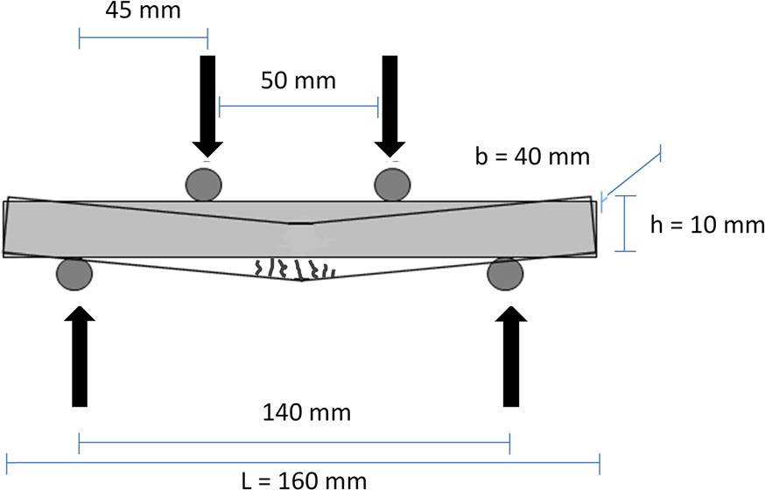

Fig. 1 Schematic representation of the four-point-bending test

with software package ImageJ. Every crack was measured at five different locations, always with the same spacing between the measuring points. The samples exposed to 1% strain were investigated after crack formation and at specific time intervals during the wet–dry cycles, more specifically after 3, 7, 14 and 28 days. The samples that were broken from the start were only studied immediately after failure and at the age of 56 days.
The combination of the crack formation and reloading cycle after healing (see Fig. 2) provides the possibility to compare different mechanical prop- erties. The most important parameters comprise the first-cracking strength r_{fc}, the regain in first-cracking strength r_{rfc} and the amount of MC immediately after failure. Equations (1)–(3), by using the points indi- cated in Fig. 2, were used to identify these properties for all specimens. In Eq. (2), point 4 is taken as the end of the elastic region of the reloading to compare to the same point for the crack formation to measure the regain. As point 1 is where the cracking starts and 3 where the cracking stops and the sample starts to its strength, the difference is a measurement for the multiple cracking in Eq. (3).
First-cracking strength:
- Results and discussion

  - Effect of the SAPs on the flexural
and compressive strength upon incorporation in mortar

All SAPs have been incorporated in mortar at a concentration of 0.5 and 1 m% with respect to the added amount of cement. Bending and compressive strength tests were performed on the mortars to investigate the effect of the SAP addition (see Table 3). For the algMOD based SAPs, the bending strength was only affected to a minor extent, except upon addition of 1 m% p(alg(1)_AA₇₅/AM₂₅(7))_L) for which the strength reduction amounted 22%. Generally, when using p(alg(1)_AA₇₅/AM₂₅(7)), the effect on the mortar strength was more pronounced compared to the p(alg(1)_AA₁₀₀(7)) SAPs. This could be related to the shielding effect of the carboxylates in alginate and AA due to the presence of the divalent cations (Ca^{2?} and Mg^{2?}), which is not occurring for AM, causing the AA/AM-based SAPs to swell more, thereby creating larger macro-pores. This was also observed by the amount of additional water needed, which was higher [80 vs. 60 mL for addition of 1 m%

rfc ¼ r½1
Regain in first-cracking strength:
r ₄
r ¼
½
rfc
r
½1
Multiple cracking:
ð1Þ

ð2Þ
p(alg(1)_AA₇₅/AM₂₅(7)) and p(alg(1)_AA₁₀₀(7)) respectively] when comparing equal DS values. The latter was also reflected in the compressive strength, as indicated by the observed reduction of 47% which is unacceptable for the targeted application. When looking at the compressive strength of the other algMOD SAPs, p(alg(1)_AA₁₀₀(7))_H performed

emc ¼ e½3 - e½1 ð3Þ
excellent upon addition of even 1 m% with respect to cement mass, followed by p(alg(1)_AA₁₀₀(7))_L.
Upon addition of 0.5 m% p(aga(1)_PMA(3)) (with respect to the added amount of cement), a bending

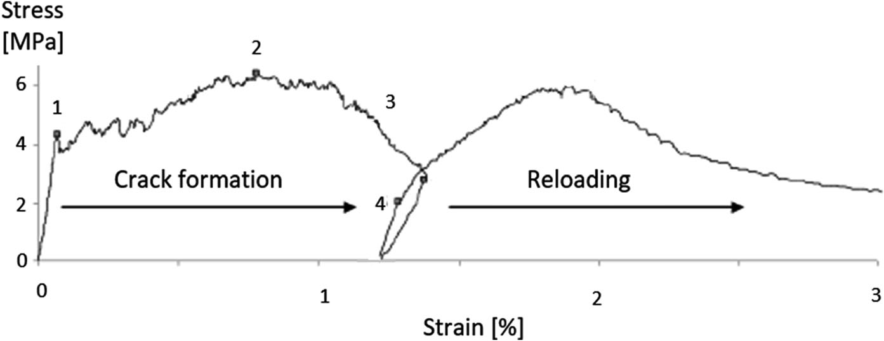

Fig. 2 Stress–strain curve of a specimen cracked up to approximately 1% strain and reloaded after a healing period of 28 days [15]

strength reduction of 13% and a compressive strength reduction of 18% were obtained. Upon increasing the SAP amount, the bending strength did not further decrease, yet the compressive strength was reduced with 31%. This reduction was more limited for p(chi(1)_PMA(7)) for which 15 and 24% compressive strength reduction were observed upon adding 0.5 and 1 m% SAP respectively. The bending strength reduc- tion associated with the use of 0.5 m% p(chi(1)_PMA(7)) was very limited. The more severe decrease associated with the use of p(aga(1)_PMA(3)) can be related to the higher amount of additional water required to create mortar with an equal workability compared to the reference sample without SAPs.
The obtained results were compared with strength tests performed upon incorporation of commercially available SAPs [15]. The tests indicated that addition of SAP A led to a decrease of the compressive strength by 35 and 55% compared to the reference upon addition of 0.5 and 1 m%, respectively [17]. Even though the synthesized SAPs have a smaller particle size and are thus more abundant present for the same weight addition [15], all synthesized SAPs exhibited a significantly smaller effect on the compressive strength compared to SAP A, although the strength reduction of p(alg(1)_AA₇₅/AM₂₅(7))_L is in the same range. SAP B on the other hand resulted in a strength reduction of 20% upon introducing 0.5 and 1 m% SAP [17].
P(alg(1)_AA₁₀₀(7))_H and p(alg(1)_AA₁₀₀(7))_L performed superior compared to SAP B (when con- sidering additions up to 1 m% SAP) while p(alg(1)_AA₇₅/AM₂₅(7))_H, p(aga(1)_PMA(3)) and p(chi(1)_PMA(7)) performed similar to when 0.5 m% was incorporated. As high amounts up to 1 m% are required for the envisaged application of closure and self-healing of cracks, it is particularly interesting to investigate those SAPs that have a low impact on the mortar strength.

  - Closure of cracks in fiber containing mortar samples by addition of SAPs

The samples with and without SAPs (reference) were loaded until a strain of 1% to measure the closure of small cracks. In function of the crack width, (after cracking and after 3, 7, 14 and 28 days of wet–dry cycles) the visual closure of cracks is depicted by presenting a cumulative curve where is indicated what
percentage of the cracks sealed completely (w = 0 lm) and which amount of cracks is decreased in diameter and is smaller than a certain width w. On the other hand, samples were also loaded until failure.
This provides an idea of the closing potential of SAPs for larger cracks. A total number of 5–10 cracks were visualized and investigated over time for all samples cracked until 1% strain. For the samples until failure this number of cracks was in average between 15 and 30 for mortar samples containing SAPs, while this was only between 5 and 10 for the reference samples. This latter indicates the multiple cracking behavior of using SAPs. Figure 3 indicates the closure of cracks of the reference mortars loaded until a strain of 1% (top left) and until failure (top right). It also shows as an example the crack closure of p(alg(1)_AA₇₅₋ AM₂₅(7))_H (0.5 m% SAP, middle left and 1 m% SAP, middle right) for samples loaded until 1% strain and p(chi(1)_PMA(3)) (0.5 m% SAP, bottom left and 1 m% SAP, bottom right) for samples loaded until failure. For completeness, Table 4 gives an overview of visual crack closure behavior of all mortars containing semi-synthetic SAPs.
The reference samples loaded until 1% strain showed that, despite having only small cracks (90% smaller than 38 lm), a closure of only 51% of the cracks was obtained after 28 days of wet/dry cycles.
Mortars containing p(alg(1)_AA₁₀₀(7)), while having larger cracks (90% smaller than 50–70 lm), induce a similar or increased crack closure up to 75%,
especially for addition of 1 m% SAP of both the high and low DS with closure. For p(alg(1)_AA₁₀₀(7))_L, a small increase in amount of SAP (0.7 and 1.3 m%) was also tested. This however did not lead to an increase in crack closure (compared to 0.5 and 1 m% respectively).
The p(alg(1)_AA₇₅/AM₂₅(7)) SAPs led to very strong crack closure up to 88% after 28 days for
0.5 m% p(alg(1)_AA₇₅/AM₂₅(7))_L. An increased closure was observed for the samples with 0.5 m% SAP which could be explained by the smaller crack- size in general compared to the 1 m% samples. Interestingly, mortars with 1 m% p(alg(1)_AA₇₅/ AM₂₅(7))_H and with 0.5 m% p(alg(1)_AA₇₅/ AM₂₅(7))_L led to 60% crack closure after 3 days already. The stronger closure of the AA/AM SAPs is related to the superior swelling in solutions with a high quantity of cations compared to pure AA based SAPs. This is related to the presence of AM which is

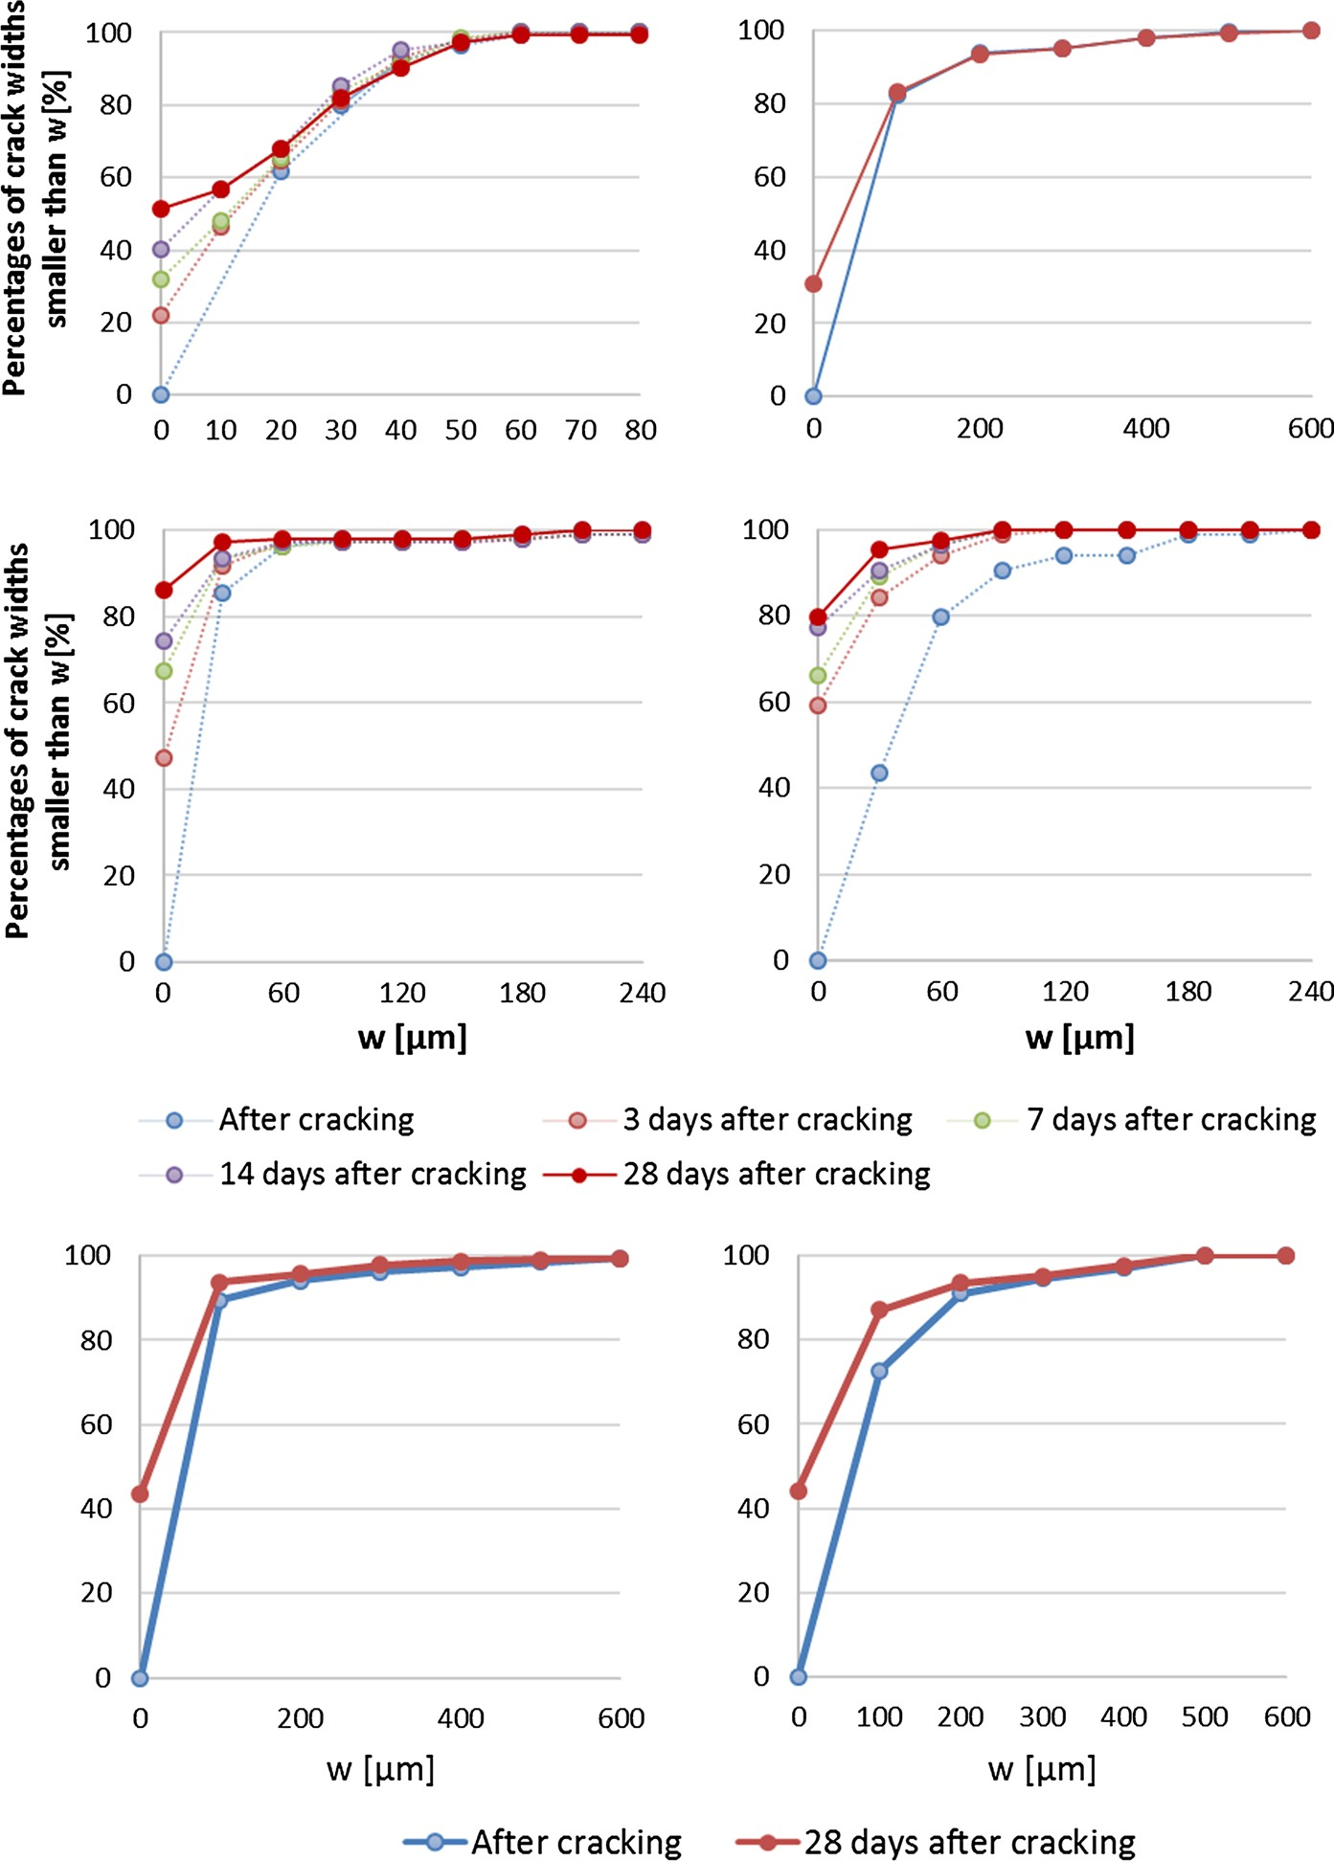

Fig. 3 Crack closure after wet–dry cycles for the reference mortar after loading until 1% strain (top left) and until failure (top right). As an example for crack closure after loading until 1% strain of mortars containing SAPs, results for p(alg(1)_AA75AM25(7))_H (0.5 m% SAP, middle left and
1 m% SAP, middle right) are shown. Additionally, for crack closure after wet–dry cycles following loading until failure, results of mortars containing SAPs p(chi(1)_PMA(3)) (0.5 m% SAP, bottom left and 1 m% SAP, bottom right) are presented

hydrophilic but not interactive with the cations (compared to the carboxylates in AA or alginate). Indeed, a higher swelling of the SAP will cause a more easily blocked crack and as such stronger closure.
To assess the visual closure capacity of larger cracks, the crack-widths of samples loaded until failure were investigated. The general boundary for partial closure of cracks with alginate-based SAPs was
found to be around 150 lm and even up to 200 lm for

Table 4 Overview of visual crack closure behavior of mortars containing semi-synthetic SAPs

Sample | Amount of SAP | 90% of cracks smaller than 9  lm | % completely closed after 3 days | % completely closed after 28 days
Reference | 0 | 38 | 22 | 51
p(alg(1)_AA₁₀₀(7))_H | 0.5 | 65 | 38 | 72
 | 1 | 52 | 53 | 68
p(alg(1)_AA₁₀₀(7))_L | 0.5 | 57 | 22 | 48
 | 0.7 | 58 | 29 | 56
 | 1 | 40 | 20 | 75
 | 1.3 | 73 | 29 | 71
p(alg(1)_AA₇₅/ | 0.5 | 35 | 47 | 86
AM₂₅(7))_H | 1 | 85 | 59 | 80
p(alg(1)_AA₇₅/ | 0.5 | 29 | 60 | 88
AM₂₅(7))_L | 1 | 54 | 37 | 70
p(aga(1)_PMA(3)) | 0.7 | 31 | 79 | 93
 | 1.3 | 39 | 44 | 89
p(chi(1)_PMA(7)) | 0.5 | 30 | 54 | 82
 | 1 | 43 | 46 | 79

some cracks of p(alg(1)_AA₁₀₀(7))_L. This was more limited for the reference where only cracks smaller than 100 lm showed partial closure.
SAPs block the cracks in their swollen state, reducing the washout of healing products, thus ameliorating the healing conditions. The mortars with p(alg(1)_ AA₁₀₀(7))_H performed superior to p(alg(1)_AA₇₅/ AM₂₅(7))_H. A similar trend was observed for addition of 1 m% of p(alg(1)_AA₁₀₀(7))_L and p(alg(1)_AA₇₅/ AM₂₅(7))_L.
For p(chi(1)_PMA(7)), 0.5 and 1 m% (compared to cement amount) were added to the mortar samples. However, as the swelling was lower for p(aga(1)_PMA(3)) in aqueous solutions with around neutral pH (i.e. 34.5 ± 1.0 g_{water}/g_{SAP} for p(aga(1)_PMA(3)) vs. 48.3 ± 3.9 g_{water}/g_{SAP} for p(chi(1)_PMA(7)) at pH 6 respectively), a higher amount of SAP (i.e. 0.7 and 1.3 m%) was introduced to mortar to realize similar closure and self-healing. However, results described above for p(alg(1)_AA₁₀₀(7))_L indicated that a small variation of the amount of SAP (0.5–0.7 and 1–1.3 m%) did not lead to a significant variation in the mechanical parameters, which makes it possible to compare the results obtained for p(aga(1)_PMA(3)) and p(chi(1)_PMA(7)).
With similar cracks as the reference (90% of cracks smaller than 30–43 lm), the p(aga(1)_PMA(3)) and
p(chi(1)_PMA(7)) SAPs led to crack closure up to even 93% [0.7 m% p(aga(1)_PMA(3))], and 81% [0.5 m% p(chi(1)_PMA(3))] after 28 days. A gradual closure process over the 28 days was found for both quantities. An increase with respect to the added SAP amount did not result in a further increase in the total degree of closed cracks. Agarose is a very hydrophilic polysaccharide, which doesn’t have the carboxylates that alginate has. This leads to an increased possibility to absorb water.
When looking at the samples loaded until failure, for p(aga(1)_PMA(3)), crack widths up to 150 lm were partially closed. For p(chi(1)_PMA(7)), cracks up to 150 lm (0.5 m% SAP) or even 200 lm (1 m% SAP) showed partial to full crack closure. Addition of any amount of p(chi(1)_PMA(7)) outperformed the reference.
Overall it could be concluded that multiple crack- ing behavior is enhanced by the inclusion of superab- sorbent polymers [16, 18]. Indeed, even though minimalized, the SAPs form macro pores. These macro pores act as initial flaws and promote multiple cracking [14, 18]. Thus, an additional number of cracks will be formed, thereby facilitating crack closure. In case of introduction of higher SAP amounts, the latter phenomenon was not enhanced, probably due to a more extensive formation of macro- pores.

An increase of the SAP amount resulted in partial closure of larger cracks when mortars were loaded until 1% strain. There was however no clear indication that an increase in the amount of SAP would lead to a stronger crack closing behavior. By taking into account that more SAP led to a more severe strength reduction, combined with the results obtained regard- ing the visual closure capacity, it could be concluded that any tested addition of SAP leads to a stronger closure than the reference samples and an addition of a low amount of SAP already showed a high crack closure potential. However, an increase in the amount of SAP did not lead to a further increased closure, rather a small decrease, which could be related to the increased macro-pore formation which could lead to pathways for the cracks to manifest. This makes it more difficult for the SAPs to completely fill up the crevices.

3.3 Self-healing of mortar samples by addition of SAPs

Table 5 provides an overview of the mechanical parameters measured for the mortars to indicate the self-healing potential obtained by addition of SAPs. All measurements were performed at least in tripli- cate, except for MC of p(alg(1)_AA₁₀₀ (7))_H (1 m%)
and p(alg(1)_AA₇₅/AM₂₅ (7))_L (0.5 m%) for which one of the samples had broken on first contact. SAPs may have two opposite effects on the strength. They could increase the strength upon further hydration of the matrix during the hardening phase by releasing mixing water (internal curing) [19, 20]. However, due to the formation of macro-pores they could also decrease the strength of mortars [14, 21].
First, the first-cracking strength r_{fc} was decreased for most SAPs, albeit not significant for all samples except the ones with a high DS (p(alg(1)_AA₁₀₀(7))_H and p(alg(1)_AA₇₅/AM₂₅(7))_H). This significant decrease could be explained by a combination of the two afore-mentioned effects. No significant decrease was found upon addition of the commercial SAPs [14]. Additionally, when investigating the multiple crack- ing (MC), the value of the reference was similar as what was obtained by Snoeck et al. [14] (i.e.
2.9 ± 0.6%). The obtained values for any addition of SAP to mortar led to an increase of the MC, albeit not significant. This trend was compared to the commercial SAPs and could be related to an increase in the ductility of mortar due to the addition of SAPs. The polymers induces flaws which facilitates MC [22]. The most important parameter is the regain in r_{fc}, which is a value indicating the self-healing potential of the SAP [14]. P(alg(1)_AA₁₀₀(7))_H showed the

Table 5 Mechanical properties indicating self- healing capacity of mortars by adding SAPs
Sample | SAP conc. (m%) | r_{fc} (MPa) Regain in r_{fc} (%) MC (%)
Reference | 0.0 | 6.1 ± 0.9 | 40.2 ± 7.9 | 3.1 ± 0.9
p(alg(1)_AA₁₀₀(7))_H | 0.5 | 5.4 ± 0.9 | 62.7 ± 4.3 | 2.3 ± 0.1
 | 1.0 | 4.7 ± 0.6 | 59.0 ± 6.7 | 3.1 ± 0.0
p(alg(1)_AA₁₀₀(7))_L | 0.5 | 5.2 ± 0.6 | 53.9 ± 8.6 | 3.4 ± 0.2
 | 0.7 | 6.3 ± 1.0 | 46.4 ± 4.4 | 3.1 ± 0.6
 | 1.0 | 4.9 ± 0.4 | 55.7 ± 6.6 | 3.8 ± 0.4
 | 1.3 | 5.7 ± 0.3 | 49.2 ± 7.2 | 4.1. ± 1.6
p(alg(1)_AA₇₅/AM₂₅(7))_H | 0.5 | 5.1 ± 0.4 | 57.2 ± 4.2 | 3.6 ± 0.8
 | 1.0 | 4.7 ± 0.7 | 57.0 ± 6.8 | 3.3 ± 1.7
p(alg(1)_AA₇₅/AM₂₅(7))_L | 0.5 | 5.6 ± 0.8 | 53.4 ± 10.9 | 4.2 ± 0.7
 | 1.0 | 6.7 ± 1.3 | 38.2 ± 4.2 | 2.8 ± 0.4
p(aga(1)_PMA(3)) | 0.7 | 5.0 ± 0.6 | 50.8 ± 4.3 | 3.1 ± 1.3
 | 1.3 | 4.4 ± 0.5 | 66.9 ± 5.8 | 4.4 ± 2.1
p(chi(1)_PMA(7)) | 0.5 | 4.4 ± 0.4 | 64.5 ± 8.7 | 4.5 ± 2.7
 | 1.0 | 4.8 ± 0.6 | 56.7 ± 7.8 | 3.3. ± 1.6
SAP A | 0.5 | 4.9 ± 1.5 | 64.5 ± 1.9 | 3.5 ± 0.4
SAP B | 0.5 | 5.1 ± 1.1 | 68.6 ± 3.0 | 3.5 ± 0.3
 | 1 | 4.9 ± 0.9 | 86.2 ± 8.3 | 3.8 ± 0.4

Results of commercial SAPs obtained by Snoeck et al. [14]

strongest self-healing potential of the algMOD-based SAPs with values up to 63% (compared to 40% for the reference). There was no significant difference (p [ 0.05) observed upon addition of 0.5 m% SAP B (69% for SAP B). The results for p(alg(1)_AA₁₀₀(7))_H were significantly different (p \ 0.05) compared to when 1 m% SAP B was added [59% for 1 m% p(alg(1)_AA₁₀₀(7))_H com- pared to 86% for SAP B]. The p value indicates a significance level, here of 0.05. If the value is lower, it means the values are significantly different. The results can be considered very promising given the current high healing potential. Noteworthy is that other materials involved in this study (0.5 m% p(alg(1)_AA₇₅/AM₂₅(7))_H, 1 m% p(alg(1)_AA₇₅/ AM₂₅(7))_H and p(alg(1)_AA₁₀₀(7))_L] reached a regain in r_{fc} up to 55%. They were not significantly different from the samples containing 0.5 m% SAP A. The lower regain in r_{fc} upon addition of 0.7 and
1.3 m% p(alg(1)_AA₁₀₀(7))_L is related to the higher r_{fc}, which would lead to similar regains for compa- rable strengths.
The semi-synthetic SAPs containing basic mono- mers [p(aga(1)_PMA(3)) and p(chi(1)_PMA(7))] showed strength regains up to 67 and 65% respec- tively. The slightly increased amounts of p(aga(1)_PMA(3)) can be compared as they have similar r_{fc}. These high strength regain values are still lower (p \ 0.05) than mortar samples containing 1 m% SAP B but were similar to the values obtained for p(alg(1)_AA100(7))_H, p(alg(1)_AA75/ AM25(7))_H and 1 m% p(alg(1)_AA100(7))_L.

4 Conclusion

The current manuscript deals with the effect of pH- responsive semi-synthetic SAPs based on methacry- lated polysaccharides combined with acidic or basic monomers. The bending and compressive strength of mortar samples on the one hand and the crack closure and self-healing of cracks on the other hand were investigated. In general, SAPs are very interesting for self-healing properties as they facilitate multiple cracking. The obtained results have been bench- marked with commercial SAPs and indicated that methacrylated alginate combined with acrylic acid, both with high as well as low degree of substitution gave rise to a strong self-healing capacity. They did
induce a substantially lower effect on the compressive strength of mortars compared to commercial SAPs. Indeed, these SAPs possess a large amount of carboxylate moieties which leads to a limited swelling during mixing, thus smaller macro pores and a more limited effect on the compressive strength. Methacry- lated chitosan combined with the basic monomer dimethylaminopropyl methacrylamide and methacry- lated alginate combined with acrylic acid and acry- lamide also gave very promising self-healing results coming close to those of the best commercial SAP, although they induced a slightly more significant effect on the mortar strength than this commercial polymer. They are, however, still interesting espe- cially also due to their more environment-friendly aspect compared to the synthetic commercial types.

Acknowledgements A. Mignon would like to thank the FWO (Research Foundation Flanders) for project funding (Grant No. 3G019012, Effect of tunable hydrogels on concrete microstructure, moisture properties, sealing and self-healing of cracks). Conflict of interest: as a Postdoctoral Research Fellow of the Research Foundation-Flanders (FWO-Vlaanderen), D. Snoeck would like to thank the foundation for the financial support (research Grant No. 12J3617N).

References

- Edvardsen C (1999) Water permeability and autogenous healing of cracks in concrete. Mater J 96(4):448–454
- Snoeck D, Dewanckele J, Cnudde V, De Belie N (2016) X-ray computed microtomography to study autogenous healing of cementitious materials promoted by superab- sorbent polymers. Cem Concr Compos 65:83–93
- Van Tittelboom K, De Belie N (2013) Self-healing in cementitious materials—a review. Materials 6(6):2182–2217
- Yang Y, Lepech MD, Yang E-H, Li VC (2009) Autogenous healing of engineered cementitious composites under wet– dry cycles. Cem Concr Res 39(5):382–390
- Snoeck D, De Belie N (2015) From straw in bricks to modern use of microfibres in cementitious composites for improved autogenous healing—a review. Constr Build Mater 95:774–787
- Snoeck D, Steuperaert S, Van Tittelboom K, Dubruel P, De Belie N (2012) Visualization of water penetration in cementitious materials with superabsorbent polymers by means of neutron radiography. Cem Concr Res 42(8):1113–1121. https://doi.org/10.1016/j.cemconres. 2012.05.005
- Snoeck D, Van Tittelboom K, Steuperaert S, Dubruel P, De Belie N (2014) Self-healing cementitious materials by the combination of microfibres and superabsorbent polymers. J Intell Mater Syst Struct 25(1):13–24. https://doi.org/10. 1177/1045389X12438623

- Mignon A (2016) Effect of pH-responsive superabsorbent polymers on the self-sealing and self-healing of cracks in concrete. PhD, Ghent University
- Mignon A, Snoeck D, D’Halluin K, Balcaen L, Vanhaecke F, Dubruel P, Van Vlierberghe S, De Belie N (2016) Algi- nate biopolymers: counteracting the impact of superab- sorbent polymers on mortar strength. Constr Build Mater 110:169–174
- Ji Y-s WuM, Ding B, Liu F, Gao F (2014) The experimental investigation of width of semi-carbonation zone in car- bonated concrete. Constr Build Mater 65:67–75
- Mignon A, Vermeulen J, Graulus G-J, Martins J, Dubruel P, De Belie N, Van Vlierberghe S (2017) Characterization of methacrylated alginate and acrylic monomers as versatile SAPs. Carbohydr Polym 168:44–51
- Mignon A, Devisscher D, Vermeulen J, Vagenende M, Martins J, Dubruel P, De Belie N, Van Vlierberghe S (2017) Characterization of methacrylated polysaccharides in combination with amine-based monomers for application in mortar. Carbohydr Polym 168:173–181
- Mignon A, Snoeck D, Schaubroeck D, Luickx N, Dubruel P, Van Vlierberghe S, De Belie N (2015) pH-responsive superabsorbent polymers: a pathway to self-healing of mortar. React Funct Polym 93:68–76
- Snoeck D (2015) Self-healing and microstructure of cementitious materials with microfibres and superabsorbent polymers. PhD thesis, Ghent University
- Snoeck D, Schaubroeck D, Dubruel P, De Belie N (2014) Effect of high amounts of superabsorbent polymers and additional water on the workability, microstructure and
strength of mortars with a water-to-cement ratio of 0.50. Constr Build Mater 72:148–157
- Snoeck D, De Belie N (2015) Repeated autogenous healing in strain-hardening cementitious composites by using superabsorbent polymers. J Mater Civ Eng 28(1):04015086
- Snoeck D, Dubruel P, De Belie N (2014) How to seal and heal cracks in cementitious materials by using superab- sorbent polymers. In: Proceedings of the international RILEM conference on application of superabsorbent poly- mers and other new admixtures in concrete construction, Sept 14–17, 2014, Dresden, Germany, pp 375–384. PRO 95
- Yao Y, Zhu Y, Yang Y (2012) Incorporation superabsorbent polymer (SAP) particles as controlling pre-existing flaws to improve the performance of engineered cementitious com- posites (ECC). Constr Build Mater 28(1):139–145
- Jensen OM, Hansen PF (2001) Water-entrained cement- based materials I. Principles and theoretical background. Cem Concr Res 31(4):647–654
- Jensen OM, Hansen PF (2002) Water-entrained cement- based materials II. Experimental observations. Cem Concr Res 32(6):973–978
- Hasholt MT, Jensen OM, Kovler K, Zhutovsky S (2012) Can superabsorbent polymers mitigate autogenous shrink- age of internally cured concrete without compromising the strength? Constr Build Mater 31:226–230
- Mechtcherine V, Reinhardt H-W (2012) Application of super absorbent polymers (SAP) in concrete construction: state-of-the-art report prepared by Technical Committee 225-SAP, vol 2. Springer, New York

