The dielectric behavior of human ex vivo cochlear perilymph
Tristan Putzeys
Research Group Experimental Oto-rhino-laryngology
Department of Neurosciences
KU Leuven, Belgium
and
Laboratory for Soft Matter and Biophysics
Department of Physics and Astronomy
KU Leuven, Belgium

Anastasiya Starovoyt and Nicolas Verhaert
Research Group Experimental Oto-rhino-laryngology
Department of Neurosciences
KU Leuven, Belgium
Michael Wübbenhorst
Laboratory for Soft Matter and Biophysics
Department of Physics and Astronomy
KU Leuven, Belgium

ABSTRACT
This work details the acquisition, handling, and measurement of microliters of perilymph, the fluid inside the human hearing organ, using dielectric relaxation spectroscopy and the correlation of the molecular relaxations to the physiological composition. Comparing between ex-vivo fresh, fresh-frozen and fixed sources reveals that dielectric absorption of the pulses is due to alpha- and beta- charge transfer relaxation related to the geometry of white blood cells, lymphocytes, in the perilymph. Interestingly, comparing the presence of molecular relaxations and the amplitude of dielectric absorption, perilymph obtained from fixed temporal bones matches fresh perilymph better than when obtained from fresh frozen source, due to the importance of well-preserved cell geometry.
Index Terms — Implantable electrodes, Biological cells, Dielectric measurements, Biological liquids

INTRODUCTION
Perilymph is the extracellular fluid that fills the scala tympani and scala vestibuli compartments of the cochlea. It acts as a pressure wave medium and has a specific ionic composition to regulate electrochemical pulses of auditory hair cells required for hearing. It is produced within the inner ear [1], is similar to cerebrospinal fluid and contains several proteins related to metabolism and immune response in the cochlea [2].
In normal hearing individuals, sound waves travel to the ear and are guided in the ear canal, where they vibrate the tympanic membrane. The ossicles attached to the tympanic membrane then amplify these vibrations and pass them on as pressure waves to the perilymph, which in turn actuates auditory hair cells. These hair cells convert mechanical motion to electrical pulses to the auditory nerve [3]. A Cochlear Implant (CI) is a hearing device that is implanted in the scala tympani and can directly stimulate the auditory nerve fibers in the human cochlea with electrical pulses. It bypasses the conventional pathway and is therefore an established solution for patients with acquired or congenital severe hearing loss (> 70dB) or deafness.
Manuscript received on 29 December 2020, in final form xx Month 20yy, accepted xx Month 20yy. Corresponding author: T. Putzeys.

Successful working of a CI relies on an efficient transfer of electromagnetic pulses from the implanted electrode array to nearby neurons [4]. The implant is surgically inserted in one of the cochlear ducts, the scala tympani, via either the round window membrane or via a cochleostomy, an artificial opening in the cochlea, to be close to the auditory nerve. The electric pulses need to travel through the surrounding fluid, the perilymph, where it can be attenuated through absorption via dielectric relaxations before they can trigger an action potential in the auditory nerve endings [5]. While previous studies mainly focus on the chemical composition of perilymph [6] or on the electrical impedance [7], little is known on the dielectric properties of perilymph and the influence it has on the attenuation of EM pulses in the frequency range of a CI, useful in the active field of cochlear implant design [8-10] and related (impedance-based) [11-13] measurements with CIs.

Dielectric spectrum
A dielectric spectrum displays the frequency dependency of the complex dielectric constant, i.e. the relative permittivity $ε^{}=ε^{'}−iε^{''}$. Here, the real part represents the reversible energy storage, the capacitance, of a material while the imaginary part, the dielectric loss, relates to the energy absorbed. Peaks in the imaginary part of the spectrum correspond to electromagnetically absorbing processes such as molecular relaxations or charge transfer mechanism [14].
This manuscript presents the spectrum of extracted perilymph in a parallel plate capacitor setup. The parallel geometry allows for accurate calculation of the complex dielectric permittivity.
The dielectric relaxations in biological tissue are usually denoted as alpha, beta and gamma relaxation [15], from lowest frequency relaxation to highest frequency. A schematic representation is given in Figure 1. The alpha relaxation is the least well understood and is thought to relate to the geometry of the cells and the double layer of charges that can accumulate around it while in the presence of a homogenous electric field [16]. The beta relaxation is related to the transport of charges across the membrane of a cell or cell wall. The gamma process is assigned to the relaxation of water molecules in- or surrounding the cell membrane. The latter occurs at a timescale of nanoseconds and will not feature in the dielectric absorption with a CI. The gamma relaxation is an important factor in the absorption of microwaves.
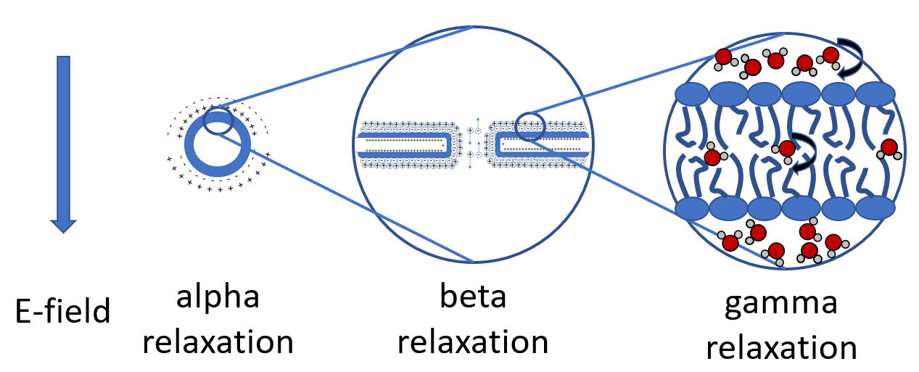
Figure 1. Schematic representation of the three common dielectric relaxations in biological tissue, the alpha, beta and gamma relaxation, related to the geometry, the membrane thickness and the water surrounding the lipid bilayer respectively. The length scale at which the relaxation occurs also relates to the frequency of the relaxation. Alpha at the lowest frequencies, beta in middle frequencies and gamma at the highest. Figure based on figures and description by W. Kuang and S.O. Nelson [14].

Methodology
The acquisition, handling and measurement of human perilymph imposes time and temperature constraints to obtain accurate measurements, as detailed below.

Sample acquisition
The human inner ear is well encapsulated by bone and difficult to reach for cellular and molecular analysis. Moreover, the fluid from the inner ear cannot be sampled for micro-physical- and -chemical analysis from human individuals in vivo, as fluid extraction poses a high risk for irreversible hearing loss. Therefore, we studied samples from recently deceased individuals where extraction occurred within 48 hours, further referred to as ‘fresh’, and samples from individuals who were frozen within 48 hours at -21°C and thawed for extraction, further referred to as ‘fresh frozen’. ‘Fixed’ samples originate from embalmed specimens. The temporal bones in our study were harvested and used in accordance with the Helsinki declaration from individuals who gave informed consent. The experimental protocols were approved by the Medical Ethics Committee of the University Hospitals of Leuven, approval Number NH019 2016-06-04. No biographical donor data are known.
Each perilymph extraction was obtained through the round window membrane of the cochlea. The round window membrane is opened by a small incision and a micropipette with a small diameter needle (25gauge) is inserted via the round window membrane in the tympanic duct to extract the perilymph present. This extraction occurs slowly to prevent damaging internal structures and prevent unwanted mixing of perilymph with endolymph. A typical yield is in the order of 3 to 10 µL.

2.2 Sample preparation
The sample holder is a liquid crystal sample cell (LC cell) with polyimide coated Indium-Tin-Oxide (ITO) electrodes . The extracted perilymph is deposited as a droplet near the opening of the LC cell. A slow decrease of the ambient pressure using an oil-less vacuum pump removes air from the LC cell and will force the perilymph in the LC cell upon slow return to atmospheric pressure. The small opening of the LC cell greatly reduces evaporation of the small volume during measurements. The polyimide coating prevents direct contact of the cell toxic ITO with the perilymph. The transparent nature of the ITO coating allows for visual inspection of the fill level of the LC cell. A 1 µL droplet of the liquid is also placed on a microscope slide, treated with CytoRich Red fixing solution and stained with eosin and hematoxylin for high magnification visual inspection.

Dielectric spectroscopy
The dielectric spectrum is recorded using a Novocontrol Alpha-AN Analyzer with a range of up to 20 MHz. It uses a dual lock-in technique to measure potential and current to determine the complex capacitance and a set of reference capacitors (ZGS Alpha Active Sample Cell) to reduce phase angle inaccuracy. The sample cell is placed in a cryostat, also functioning as a Faraday cage, which regulates the LC cell temperature via dry nitrogen gas and is controlled by a Novocontrol Quatro Cryosystem. The spectrum is recorded in the frequency range of 10⁻¹ to 10⁷ Hz, spaced equally on a logarithmic scale with a factor of √2. The alternating electric potential is 65 mV_{RMS}, both to remain in the linear response regime and to simulate later in-vivo conditions where an (unwanted) action potential in neurons can be avoided at these low potentials.
The measurement is limited both in time and temperature due to ongoing evaporation and cell lysis (non-programmed cell death). Measurements are stopped after 8 hours, and the measurement temperature typically does not exceed 40 °C.
Recorded spectra are exported using the Windeta software (Novocontrol) and analyzed with Matlab. The imaginary parts of the spectra are fitted against a sum of dielectric relaxation functions (Debye, Cole-Cole or Havriliak-Negami) and a power law representing electrode polarization at the liquid-electrode interface.

2.4 Microscopy
Microscopy photos were taken using a Biolux trinocular microscope and a Nikon D7200 digital camera after fixing the cells with ethanol and applying H&E staining.

Results
Perilymph sourced from human temporal bones, preserved via three different methods (fresh, fresh-frozen and fixed) are compared in terms of dielectric absorption. The fresh sourced perilymph is further analyzed for molecular relaxations and their associated temperature and time dependence.

Comparing sources
The dielectric permittivity is recorded for three different samples of human perilymph with different origin. The spectrum at 37°C, physiological temperature, is displayed in Figure 2. The upper part displays the real part of the permittivity, a measure of electrical energy stored in the sample, while the lower part displays the imaginary part, a measure for the electrical energy lost during a cycle.
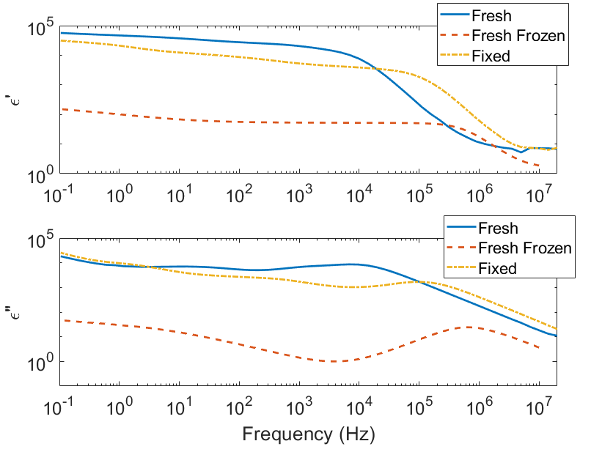
Figure 2. Dielectric permittivity for human perilymph at 37°C, aspirated from three different sources. The top figure displays the real part of the relative permittivity, the bottom figure displays the imaginary part.

Molecular relaxations

A fitting using three Havriliak-Negami relaxations and one electrode polarization relaxation for the fresh perilymph sample is given in Figure 3. The electrode polarization (EP) is due to incomplete charge transfer between electrode and liquid and is fitted as a frequency dependent power law.
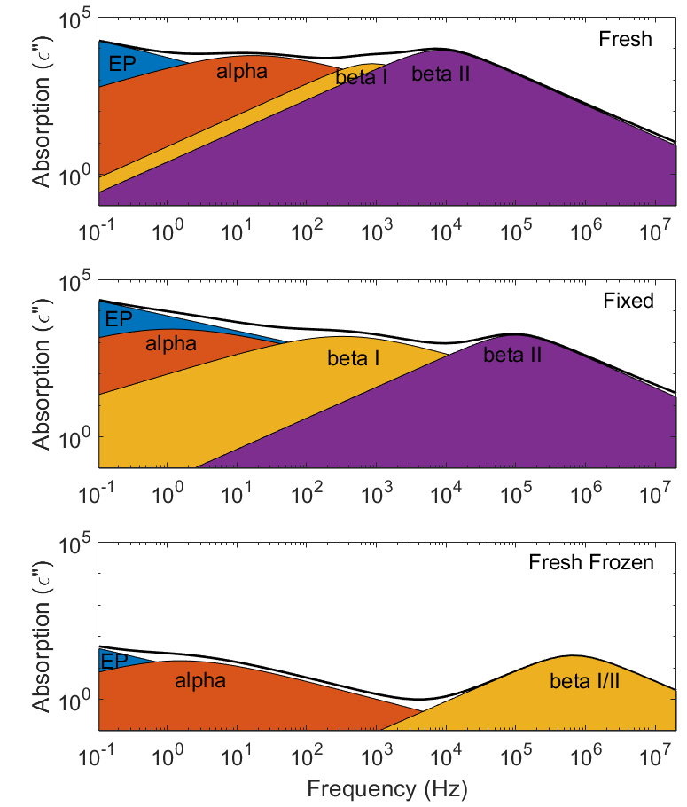
Figure 3. Molecular relaxations in fresh, fixed, and fresh-frozen perilymph at 37°C. Electrode Polarization (EP) is visible alongside three dielectric relaxations, alpha, beta I and beta II.

Temperature dependence
A 3D representation of the dielectric loss is given as a surface plot in Figure 4 to visualize the temperature dependence of the spectrum for a fresh source. For the fresh sample, the activation energy was calculated for each relaxation based on the Arrhenius law behavior of the frequency of the relaxation. Activation energy was calculated from a linear fit after transforming the data to the natural logarithm of the frequency in function of the inverse of the temperature expressed in Kelvin.
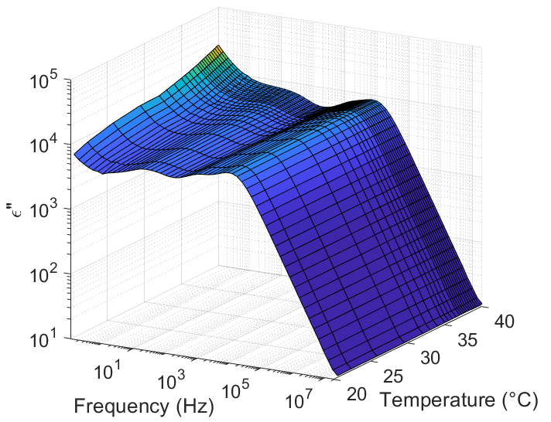
Figure 4. Temperature and frequency dependence of the imaginary part of the relative permittivity of perilymph. Electrode Polarization has the strongest temperature dependence.

Time dependence
After extraction, the liquid with living cells is in an isolated system and has no means of obtaining nutrition or disposing of waste material. To observe any time-dependence, the fresh perilymph was monitored for 12 hours at 37°C after the initial temperature variation of 30 to 40 °C. After 12 hours, the sample temperature was increased to 60 °C and held there for 30 minutes, to induce thermal lysis of cells. These results are displayed in Figure 5, the spectrum of fresh frozen perilymph is added as a reference.
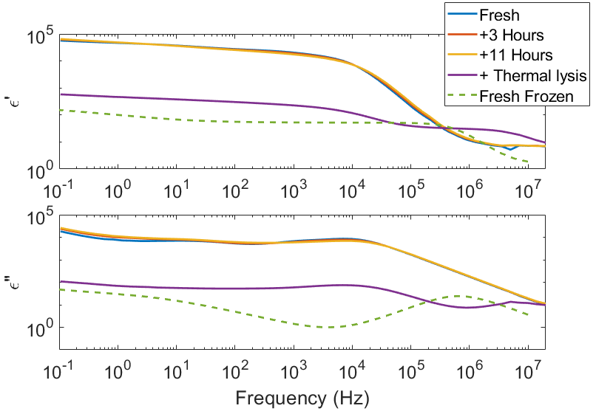
Figure 5. Time evolution of the dielectric permittivity and loss at 37°C and after thermal lysis. The spectrum of fresh-frozen perilymph is added as a reference.

Microscopic inspection
Stained slides were prepared by fixing the cells with CytoRich Red and staining with eosin and hematoxylin. A comparison between fresh and fresh-frozen perilymph samples is given in Figure 6. Due to the staining process, which includes fixation, no distinction can be made between fresh and fixed. In the fresh sample, lymphocytes can be identified. In the fresh-frozen sample, no cells were found, and prolonged staining only revealed tiny, stained fragments, possibly of cells. Staining visualizes the presence of purple-stained lymphocytes responsible for the alpha and beta I and II absorption. In the fresh frozen they are not found as complete cells, corresponding to the lack of an associated alpha and beta relaxation in the recorded spectrum
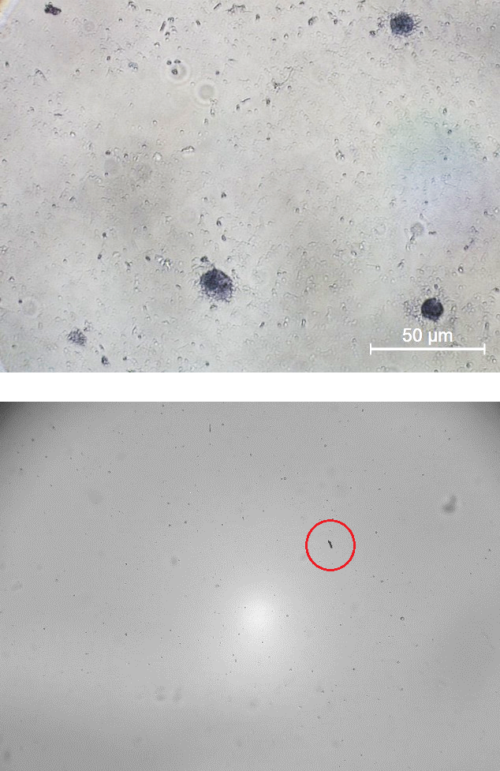
Figure 6. Microscope photograph of (top) stained fresh perilymph where dark blue/purple lymphocytes are visible and (bottom) stained fresh frozen perilymph, only small fragments of dye are visible (Red circle), no cells were found.

Discussion
Of the three dielectric relaxations expected in biological tissue, the alpha, beta and gamma relaxation. The gamma relaxation occurs at a frequency higher than what can be measured with the described setup and would not normally be present in the frequency range of operation of a CI.

Comparing sources
When comparing the dielectric spectra to fresh perilymph, the fresh-frozen perilymph yields a very deviant spectrum while the phenol-fixed solution seems more comparable to fresh perilymph. This is rationalized by the importance of cell geometry, rather than their viability. Freezing and thawing of the perilymph destroys the membranes of the cells, which are present in the liquid, as they are being expanded, stretched and punctured during the freezing and subsequently deflated and ruptured during the thawing. Therefore, the alpha relaxation, which presumably relates to cell geometry, can no longer take place and only small fragments of membrane can contribute to the beta relaxation. In a fixed solution the geometry of the cells is maintained, and they can exhibit both alpha and beta relaxation, albeit at slightly different frequencies due to small changes in cell geometry attributed to the dehydrating and gelling effect the fixing solution.

Molecular relaxations
Three molecular relaxations can be identified in the fresh perilymph spectrum alongside an apparent EP. No strong EP effect is expected at an AC amplitude of 65 mV and this cannot be distinguished from an even lower frequency relaxation, such as charge transfer between the electrode and the polyimide or the polyimide and the perilymph liquid. It should be noted that the location for the beta-peak contains two relaxation peaks, here labelled beta I and beta II. While the alpha peak cannot be resolved further. The frequency of the alpha relaxation is dependent on the volume of the cell [16-17]] while the exact geometry, i.e. oblate or prolate, changes the amplitude of the alpha relaxation. The beta relaxation is more sensitive to the thickness of the cellular membrane, as it affects both the time required for the charges to cross the membrane and the capacitance of the charges separated by the membrane. This could indicate the presence of two different types of cells with similar volume, but different membrane characteristics. This coincides with a recent study that identified two types of lymphocytes, CD4 and CD8 T-helper cells in the stria vascularis of the cochlea [18].

Temperature dependence
The activation energy can be calculated from the Arrhenius temperature dependence of the frequency of molecular relaxation, as displayed in Figure 7. For the alpha and beta I relaxation these are 19 kJ/mol and 8.1 kJ/mol respectively. The Beta II relaxation has an apparent negative activation energy, implying it is not a true relaxation energy barrier in the range of 30 to 40°C, this might be rationalized by either time-dependent changes in the system, e.g. a thinning of the membrane due to dehydration of the cell or a different reaction to the isolated environment, or by a phase transition, such as observed in the dielectric spectra of lipid vesicles [19].
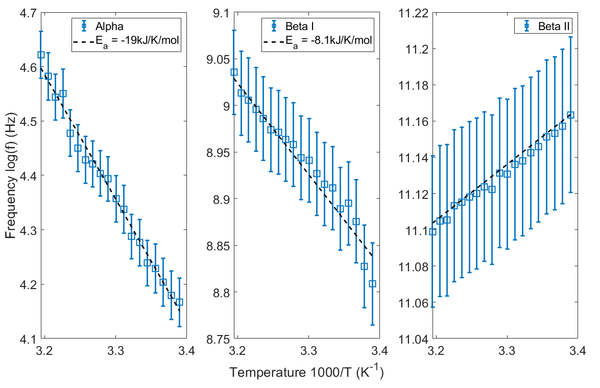
Figure 7. Temperature dependence and Arrhenius activation energy of the three identified molecular relaxations.

4.4 Time dependence
From the time dependence graphs, the geometry of the cells does not change much in the period of 12 hour. The alpha relaxation decreases in amplitude due to deformation of the cells as part of the non-programmed lysis. Both beta relaxations shift to higher frequencies as the membrane thickness changes. After thermal lysis, the amplitude of all relaxations is decreased by 2 orders of magnitude, indicating significant changes in both the shape of the cells and the quantity of membrane surface. Surprisingly, the freezing and thawing of the temporal bone is more disruptive to the composition of the perilymph than the thermal lysis step.

ConclusionS
Comparing the presence of molecular relaxations and the amplitude of dielectric absorption, perilymph aspirated from fixed temporal bones matches fresh perilymph better than when aspirated from fresh frozen sources.
The dominating factor in dielectric absorption in human perilymph sampled from recently deceased individuals is cell geometry and the presence of cell bilipid layers in the fluid. The dielectric spectrum indicates the presence of two different types of cells with similar geometry, most likely the CD4 and CD8 lymphocytes. Freezing and thawing of the perilymph ruptures the cells and decreases the dielectric absorption, to a similar level observed after thermal lysis.
In terms of operating frequency for Cochlear Implants, the absorption only decreases greatly above 10 kHz. Above the operating range of current commercial Cis. There are no regions with a significant lower absorption in the range of 10 Hz to 10 kHz.

ACKNOWLEDGMENT
TP is grateful for funding by the Research Foundation − Flanders (FWO) (mandate No.: 12Y6919N). NV acknowledges funding by FWO (project No.: 1804816N). AS acknowledges funding by FWO (project No.: Nr 1S78519N). MW acknowledges funding from the FWO (project No.: G0B3218N). The authors are grateful for M. Vanherck, M Franssens and P. Leemans for the H&E staining.

References
[1] E. Arrer, G. Oberascher, and H. J. Gibitz, “Protein distribution in the human perilymph: A comparative study between perilymph (post mortem), CSF and blood serum,” Acta Otolaryngol., vol. 106, no. 1–2, pp. 117–123, 1988.
[2] J. Edvardsson Rasmussen, G. Laurell, H. Rask-Andersen, J. Bergquist, and P. O. Eriksson, “The proteome of perilymph in patients with vestibular schwannoma. A possibility to identify biomarkers for tumor associated hearing loss?,” PLoS One, vol. 13, no. 6, p. e0198442, Jun. 2018.
[3] J. G. Neely, “Mechanisms of hearing: Cochlear physiology,” Ear, Nose Throat J., vol. 64, no. 6, pp. 40–68, 1985, Accessed: May 20, 2020. [Online]. Available: https://pubmed.ncbi.nlm.nih.gov/4006808/.
[4] B. S. Wilson and M. F. Dorman, “Cochlear implants: A remarkable past and a brilliant future,” Hear. Res., vol. 242, no. 1–2, pp. 3–21, Aug. 2008.
[5] A. van Wieringen, O. Macherey, R. P. Carlyon, J. M. Deeks, and J. Wouters, “Alternative pulse shapes in electrical hearing,” Hear. Res., vol. 242, no. 1–2, pp. 154–163, Aug. 2008.
[6] I. Thalmann, R. I. Kohut, J. Ryu, T. H. Comegys, M. Senarita, and R. Thalmann, “Protein profile of human perilymph: In search of markers for the diagnosis of perilymph fistula and other inner ear disease,” Otolaryngol. - Head Neck Surg., vol. 111, no. 3 I, pp. 273–280, Nov. 1994.
[7] C. Jiang, S. R. De Rijk, G. G. Malliaras, and M. L. Bance, “Electrochemical impedance spectroscopy of human cochleas for modeling cochlear implant electrical stimulus spread,” APL Mater., vol. 8, no. 9, p. 091102, Sep. 2020.
[8] J. Wouters, H. J. McDermott, and T. Francart, “Sound coding in cochlear implants: From electric pulses to hearing,” IEEE Signal Process. Mag., vol. 32, no. 2, pp. 67–80, Mar. 2015.
[9] J. H. L. Hansen et al., “CCi-MOBILE: Design and Evaluation of a Cochlear Implant and Hearing Aid Research Platform for Speech Scientists and Engineers,” May 2019.
[10] F. G. Zeng, S. Rebscher, W. Harrison, X. Sun, and H. Feng, “Cochlear Implants: System Design, Integration, and Evaluation,” IEEE Rev. Biomed. Eng., vol. 1, pp. 115–142, 2008.
[11] P. Aebischer, S. Meyer, M. Caversaccio, and W. Wimmer, “Intraoperative Impedance-Based Estimation of Cochlear Implant Electrode Array Insertion Depth,” IEEE Trans. Biomed. Eng., pp. 1–1, Jul. 2020.
[12] C. K. Giardina, E. S. Krause, K. Koka, and D. C. Fitzpatrick, “Impedance measures during in vitro cochlear implantation predict array positioning,” IEEE Trans. Biomed. Eng., vol. 65, no. 2, pp. 327–335, Feb. 2018.
[13] B. Somers, C. Long, and T. Francart, “EEG-based diagnostics of the auditory system using cochlear implant electrodes as sensors,” bioRxiv, p. 2020.07.16.206250, Jul. 2020.
[14] F. Kremer and A. (Andreas) Schönhals, Broadband Dielectric Spectroscopy. Springer Berlin Heidelberg, 2003.
[15] W. Kuang and S. O. Nelson, “Low-Frequency Dielectric Properties of Biological Tissues: A Review with Some New Insights,” Trans. ASAE, vol. 41, no. 1, pp. 173–184, 1998.
[16] A. Di Biasio, L. Ambrosone, and C. Cametti, “The Dielectric Behavior of Nonspherical Biological Cell Suspensions: An Analytic Approach,” Biophys. J., vol. 99, no. 1, pp. 163–174, Jul. 2010.
[17] K. Asami, T. Hanai, and N. Koizumi, “Dielectric Approach to Suspensions of Ellipsoidal Particles Covered with a Shell in Particular Reference to Biological Cells,” Jpn. J. Appl. Phys., vol. 19, no. 2, pp. 359–365, Feb. 1980.
[18] W. Liu and H. Rask-Andersen, “Super-resolution immunohistochemistry study on CD4 and CD8 cells and the relation to macrophages in human cochlea,” J. Otol., vol. 14, no. 1, pp. 1–5, Mar. 2019.
[19] A. Gennaro, O. Deschaume, H. Pfeiffer, C. Bartic, P. Wagner, and M. Wübbenhorst, “Understanding the Dehydration Stress in Lipid Vesicles by a Combined Quartz Crystal Microbalance and Dielectric Spectroscopy Study,” Phys. status solidi, vol. 217, no. 13, pp. 1900986, Jul. 2020.

