Title: Beneath the XNA world: Tools and targets to build novel biology

Authors:
Paola Handal-Marquez ^{1,}*, Anupama Anupama^{1,} *, Valerie Pezo ², Philippe Marliere ³, Piet Herdewijn ¹ and Vitor B. Pinheiro ^{1 ,}**

* authors have contributed equally to the review
** corresponding author: v.pinheiro@kuleuven.be

Affiliations:
¹ KU Leuven, Rega Institute for Medical Research, Medicinal Chemistry, Herestraat 49 – Box 1041, 3000 Leuven, Belgium
² Génomique Métabolique, Genoscope, Institut François Jacob, CEA, CNRS, Univ Evry, Université Paris-Saclay, 2 Rue Gaston Crémieux 91057 Evry, France
³ TESSSI, The European Syndicate of Synthetic Scientists and Industrialists, 81 rue Réaumur, 75002, Paris, France.

TESSSI, The European Syndicate of Synthetic
Scientists and Industrialists, 81 rue Réaumur, 75002,
Paris, France.

Highlights:
- Unnatural bases in vitro and in vivo can replace or expand DNA coding capacity.
- Polymerase engineering has enabled development of increasingly orthogonal XNAs.
- Metabolic synthesis of XNA triphosphates is needed for an XNA metabolism.
- Improved directed evolution tools are essential for further development.

Abstract (100-120 words)
By assembling biological systems from synthetic components, Xenobiology probes the limits of natural biology. In doing so, it also permits deeper understanding of all levels in biology as well as development of novel applications. Xenobiotic nucleic acids test how information can be maintained, whether enriching natural DNA or replacing it. While the field has progressed significantly over the past 10 years, by focusing on the development of XNA polymerases and ligases, more is needed to tackle experimental bottlenecks and to better integrate the insights being gained. Here, we summarise the recent advances towards artificial genetic materials and highlight the areas likely to provide the next XNA advances.

Graphical abstract:

Introduction
Despite its inherent diversity, life on Earth is constrained, with “frozen accidents” having pushed Biology towards the known universally conserved processes. Lack of viable evolutionary paths between different functions, together with the lack of evolutionary advantage, has blocked Biology from sampling all possible chemistries and from exploring all the possible combinations of naturally available enzymes. Therefore, we can only describe a small fraction of the possible solutions for catalysis and biology. It is now well-established that enzymes, pathways and even universally conserved biological processes can be reshaped.
A major goal in Xenobiology is to explore how far biology can be reshaped – what changes are tolerated and how systems can be adapted towards further changes – with the aim of establishing artificial systems that can operate alongside biology but with minimal interference (i.e. orthogonal). Pioneering results from the expansion of the genetic code [1], orthogonal ribosomes [2] and synthetic genetic materials [3] are encouraging and point the way to a deeper understanding of biology on all scales, as well as a plethora of new applications.
Still, the field is in its infancy. Some of the technologies being developed for Xenobiology are spreading to other scientific areas but even more important are the many technologies and methodologies being developed in other areas that are now ready to be adopted by the Xenobiology field for significant advancement. Focusing on the development of xenobiotic nucleic acids (XNAs) as synthetic genetic materials, we highlight how the field has changed in the last 5 years, the technologies that could enable faster progress and the challenges ahead. It has not been possible to cover all the advances in this short review and we therefore apologize to our colleagues whose works have not been included.
Xenobiotic nucleic acids and synthetic genetic materials
Two complementary approaches towards establishing xenobiotic nucleic acids (XNAs) have been pursued from the field’s outset: one optimizing nucleic acid chemistry towards incorporation by natural enzymes [4], and the other engineering DNA polymerases to improve XNA synthesis and replication [5,6]. More recently, balanced strategies are also being pursued – whether by optimising “problematic” XNA nucleobases [7] or by stepwise modification of DNA allowing polymerases (and organisms) to “catch up” [8].
Replicative DNA polymerases are highly selective of their substrates and have evolved multiple mechanisms to selectively exclude the incorporation and extension of non-canonical substrates. However, not all constraints lie within the polymerase itself. Although all biological systems require an aqueous environment and despite water playing an important role in enzyme-catalysed reactions, its role is commonly overlooked. Natural nucleoside triphosphates are highly polar molecules and strongly hydrated in solution at the phosphate groups, at the sugar moiety and at the edge of the nucleobases. During polymerase-catalysed DNA synthesis, triphosphate interactions with water are replaced with interactions to the amino acids (and template) lining the enzyme active site. Polar interactions are there also further complemented by hydrophobic ones with both polymerase and with the nucleobases in the priming strand. As synthesis progresses, the process is reversed when amino acid interactions are again replaced with water interactions as the nascent duplex emerges from the enzyme. The entropic contribution of water to those processes can be substantial, making them potentially energetically neutral processes and that can be significantly affected by modified substrates[9]. Consequently, chemical optimization of unnatural substrates is constrained to phosphate, sugar and nucleobase analogues that can be tolerated in a duplex helix with minimal deviation from what is expected of a natural DNA duplex, but may be further limited by the impact of altered hydration (e.g. by establishing a maximum density of modification incorporations).
Most successful have been analogues that retain the phosphodiester and (deoxy)ribose moieties, introducing novel base pairs (or self-pairing bases) [10]. By optimizing the chemistry, Benner, Romesberg and colleagues have made the most significant steps towards establishing viable genetic systems with increased coding capacity and with potential to be introduced in vivo [11,12].

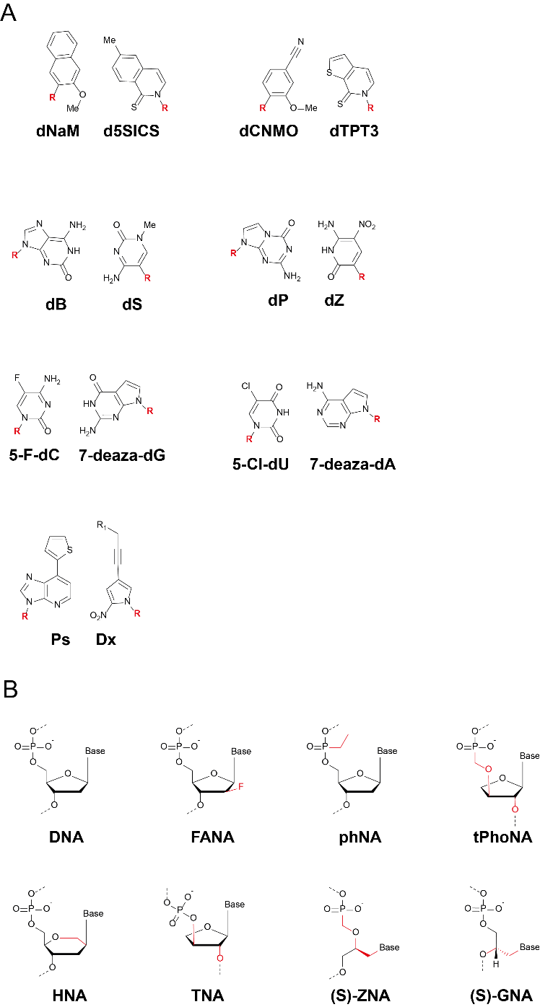

Romesberg and colleagues have for over two decades designed hydrophobic base pairs and explored their chemical neighbourhood, screening for efficient in vitro incorporation by A-family thermostable DNA polymerases like Taq. Single instances of base pairs such as d5SICS:dNaM were shown to be replicated with high efficiency, in different sequence contexts, and well retained (on average above 90% after 84 cycles of PCR) [14]. Crystal structures of KlenTaq incorporating these unnatural nucleobases showed an induced fit mechanism that allowed these bases to form a planar Watson-Crick-like base pair in the active site of the DNA polymerase but which, upon extension, quickly slipped into intercalation [15], a consequence of their altered interaction with water in solution.
Exogenously expressing an algal nucleotide triphosphate transporter (Phaeodactylum tricornutum PtNTT2), that could efficiently import d5SICS and dNaM triphosphates, Romesberg and colleagues went on to demonstrate that a single synthetic base pair could be maintained in vivo in a plasmid for more than 24 cell divisions [11]. More recently, through optimization of the triphosphate importer and by using CRISPR-Cas9 to remove mutants that lose the unnatural bases, Romesberg and colleagues have shown nearly 100% retention of the unnatural bases after over 100 cell divisions [16]. In vivo utilization of synthetic nucleobases must overcome two challenges: polymerase optimisation and synthetic nucleotide import into the cell.
First, the E. coli ortholog of Taq (Pol I) is not the main cellular replicase, although it can be involved in the initial stage of replication of some plasmids. While DNA polymerase active sites are structurally conserved, the chemical optimization of d5SICS:dNaM could not have been so extreme as to pick out family-specific structural differences in polymerases. Second (and discussed further below), there is no cellular machinery to phosphorylate synthetic nucleosides forcing the triphosphate nucleotides to be imported into the cell, which is not naturally done by E. coli. Either of those challenges may explain why other well-established hydrophobic base-pairs, such as Ds:Px [17], have not been successfully implemented in vivo. Romesberg and colleagues have since also further optimised the synthetic nucleosides in vivo, picking out better combinations (e.g. dCNMO:dTPT3 [18]), which may at least in part be preferred due to more efficient import of the triphosphates [19].
In a parallel development, Benner and colleagues have focused on nucleobases that mimic the natural Watson-Crick nucleobases but display a modified pattern of hydrogen bonding – also referred to as artificially expanded genetic information systems (AEGIS)[20]. The different hydrogen bonding patterns can in theory allow six base-pairs (of which 2 are the natural patterns), but not all are accessible due to tautomerization (which would reduce the fidelity of the system) or epimerization (which can affect the stability of the nucleobases).
Among the proposed AEGIS combinations, the dP:dZ pair has been extensively characterised with their impact on the duplex structure assessed in isolation [21] or in the active site of an engineered DNA polymerase capable of efficient dP:dZ replication [22]. Although natural polymerases can incorporate dP:dZ base-pairs [23] and duplex structure is maintained within the natural parameters [21], further engineering can be used to change the efficiency of their incorporation [24]. Other base-pairs have also been explored, and more recently combined, to create an 8-base nucleic acid, harbouring dP:dZ and dS:dB in addition to the four natural bases [12]. Although this system has not yet been implemented in vivo, steps towards the in vivo phosphorylation of AEGIS nucleotide precursors (discussed further below) have been reported [25].
The complementary strategy towards new synthetic genetic materials has been to select a particular XNA chemistry, based on the expected properties or a given envisaged application, and engineer DNA (or RNA) polymerases towards accommodating (i.e. incorporating, extending and templating from) the new chemistry. Bar a few exceptions [26], this approach has focused on retaining the natural nucleobases (partly due to technical limitations with polymerase selection), thus giving it a slightly different aim: not towards increasing the coding potential of DNA but towards establishing alternative codes altogether. In addition, while Holliger, us and colleagues have made the most significant recent advances in the synthesis of novel XNAs (i.e. DNA → XNA), progress towards XNA replication (i.e. XNA → XNA) remain limited – achieved only through partial substitutions [27], with chemistries that are structurally close to DNA, such as functionalised DNA [28], FANA (fluoro-arabino nucleic acids) [3] and L-DNA [29], or limited to only a few incorporations such as HNA [30].
Holliger and colleagues, using a combination of modelling and selection, engineered a thermostable polymerase based on the Thermococcus gorgonarius DNA polymerase capable of synthesising an alkyl-modified phosphonate nucleic acid (phNA). In phNA, one of the non-bridging oxygens of the phosphodiester backbone of DNA was replaced with methyl- and ethyl- groups, de facto removing the negative charge from the phosphate backbone [31]. The lack of backbone negative charge weakened duplex stability with DNA, with each phNA:DNA base pair providing a thermal stabilization of approximately 0.13°C (instead of 0.56°C of a natural DNA:DNA base-pair). The lack of backbone charge, analogous to hydrophobic bases [32], has a significant impact on hydration of substrate and resulting polymer, but highlight that there is ample design space within the water solubility barrier.
The weaker interaction with DNA is of interest because it can provide a degree of orthogonality between phNA and DNA (even when compatible Watson-Crick bases are used), as reported for glycol nucleic acids or GNA [33]. On the other hand, removal of the polyanionic backbone that contributes to the extended conformation of natural nucleic acids may cause phNA, analogously to proteins, to be more likely to fold, enabling the development of aptamers that are not stabilized exclusively by base-pairing.
Our efforts focused on a different phosphonate nucleic acid, threosyl methoxyphosphonate nucleic acids (tPhoNA) [34], in which a carbon is inserted between phosphate and a bridging oxygen. Recent reports on closed ternary structures of Thermococcus kodakariensis DNA polymerase with natural [35] and with a threosyl [36] nucleotide in their active sites, encouraged us to take a structure- and knowledge-guided approach to the evolve a tPhoNA synthetase based on the closely-related T. gorgonarius enzyme. Although a tPhoNA polymer retains the polyanionic backbone, the change to phosphonate is expected to significantly affect the surface electrostatics of the polymer, making it less likely to interact with nucleic acid binding proteins and processing enzymes. The resulting polymerase, Tgo harboured nine mutations in residues previously implicated in XNA activity – across different domains and at a range of distances from the active site of the enzyme.
In vivo transliteration assays, which test the organism’s capacity to convert a short XNA segment into DNA, showed that tPhoNA-encoded information cannot be easily accessed, making it a promising candidate for orthogonal in vivo XNA systems [34]. Another nucleic acid chemistry with great potential for orthogonality is (S)-ZNA, an acyclic phosphonate backbone that retains chirality and that can be synthesised from readily available phosphonomethylglycerol nucleoside precursors [37]. Similar to tPhoNA, (S)-ZNA is poorly transliterated in vivo. Like GNA (another acyclic XNA), (S)-ZNA is able to base-pair efficiently but it shows a weaker interaction with DNA [37].
Nonetheless, hybrid alternatives are also emerging, such as the approach by Chaput and colleagues to threosyl nucleic acids (TNA). TNA synthesis with engineered archaeal DNA polymerases consistently display a high rate of G→C transversions due to misincorporation of tGTP against a dG template [7,38], highlighting that changes in backbone (whether cross-chemistry DNA→XNA or within a novel chemistry XNA→XNA) can lead to changes in the informational optima of the nucleobases [38]. For TNA, modifying the guanosine analogue to a 7-deaza-guanosine [7] or a 7-deaza-7-substituted guanosine [39] stops a Hoogsteen interaction in which the incoming tGTP assumes a syn-conformation [39].
Started by the wholesale in vivo replacement of thymine with 5-chloro-deoxyuracil [8], Herdewijn, Marliere and colleagues have begun to explore whether a new orthogonal genetic system can be achieved through the incremental development of (increasingly unnatural) new base pairs [40] and backbones[41], validated in vitro and in vivo optimized. For instance, the modified nucleic acid (also named DZA – part of a move to bring greater clarity and precision to XNA nomenclature [13]) uses 5-chloro-dU:7-deaza-dA and 5-fluoro-dC:7-deaza-dG. It is efficiently amplified by DNA polymerases in vitro and shown to be resistant to a wide range of endonucleases. In vivo, while it remains less efficient than DNA, it can be accessed by a natural host [42] and, therefore, it is a suitable starting point for the same in vivo optimization carried out for 5-chloro-deoxyuracil [8].
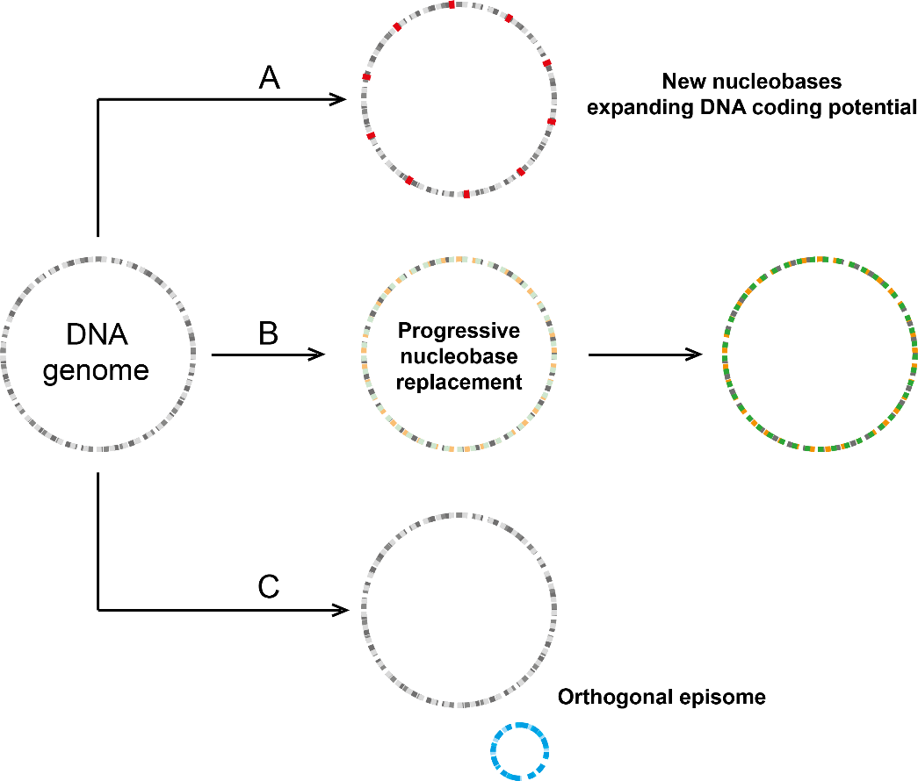
Figure 2: Three main routes towards introducing XNA in vivo. Nucleobase-modified XNAs that are tolerated by the natural replication and transcription machinery can be introduced directly into an organism genome, increasing the coding potential of DNA (A), or through replacement of natural bases (B). XNA chemistries that are not well-tolerated, i.e. most sugar- and backbone-modified XNAs, can be introduced in vivo through episomes that are self-contained and independent of the host genome (C).

While research in synthetic genetic materials has considerable potential to improve our understanding of Biology and to generate a whole new repertoire of in vivo and in vitro applications of the technologies, the area is hindered by two key challenges: the generation of the required compounds and the methodology to identify analogous XNA enzymes that have never existed in nature.
Towards XNA metabolism
Chemical synthesis of XNA precursors, including triphosphates and oligonucleotides, has up to now underpinned the field. While using broadly similar strategies used in DNA synthesis, the synthesis of most XNA precursors is significantly more challenging. Although progress has been made to improve precursor synthesis chemically, such as through improvements in the scalability of nucleoside phosphorylation [43], precursors remain an expensive and limiting resource in XNA research.
Enzymatic synthesis of such precursors is possible but rely on the isolation or on the engineering of enzymes capable of activity on XNA precursors. For instance, in the case of the dP:dZ novel base pair, Benner and colleagues showed that while the natural E. coli nucleoside diphosphate kinase can add the gamma-phosphate to dP and dZ nucleotide diphosphates [44], E. coli enzymes cannot efficiently install the alpha-phosphate on a dP or dZ nucleoside. For that, Benner and colleagues turned to a Drosophila deoxynucleoside kinase, known to have a more relaxed substrate specificity. The wild-type kinase was shown to be able to phosphorylate dP but additional engineering was required for efficient phosphorylation of both dP and dZ substrates [25]. Nonetheless, the pursuit of enzymatic synthesis of XNA precursors can also be applied to develop XNA systems in vivo, whether establishing XNA precursor producers or fully-fledged XNA-based organisms – the latter with consequences towards how XNAs can be used for biocontainment [45].
As discussed above, the simplest possible in vivo XNA system is the use of chemically synthesised nucleoside triphosphates, imported directly into the cellular milieu and implemented as the expansion of the genetic alphabet. While natural triphosphate importers may be limited in their substrate spectrum, Pezo, Marliére and colleagues have demonstrated that those proteins are amenable to engineering [46]. By disabling key enzymes in E. coli dTMP metabolism [thymidylate synthase (thyA) and thymidine kinase (tdk)], the authors constructed a strain that requires exogenous supply of dTTP for survival. That establishes a powerful selection platform not only for the evolution of transporters but also for the systematic substitution of the natural nucleobases in vivo, as discussed above.
Such systems, however, do not address the chemical synthesis of the precursors, which remain chemically synthesised at scale. Nevertheless, they can be used as the starting point towards the systematic development of alternative pathways that rely on earlier (and thus more readily synthesised) chemical precursors, as shown in Figure 3.
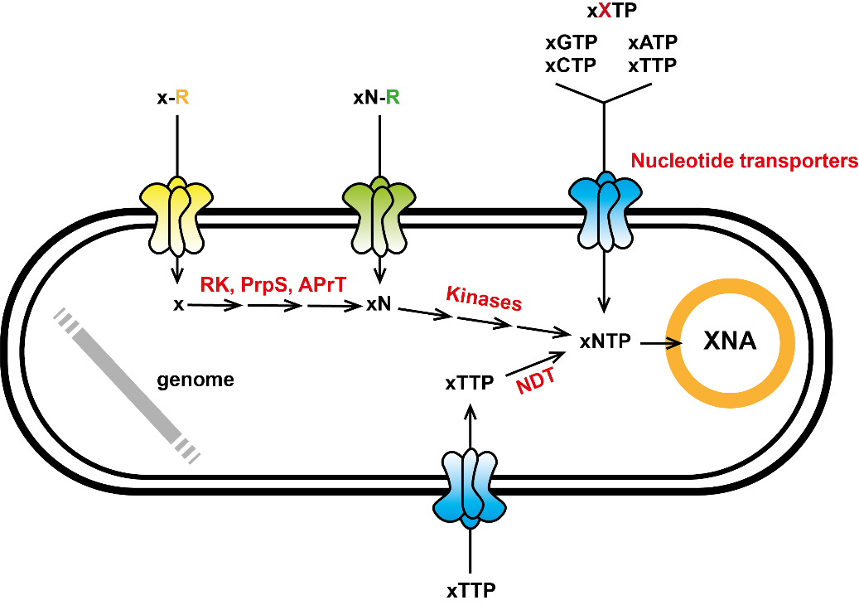
Figure 3: Reverse assembling an XNA metabolism. Maintenance of an expanded genetic code has been demonstrated through the direct import of modified triphosphates, requiring low mM concentrations of these compounds in the bacterial medium. The same strategy can be adopted for the development of orthogonal XNA episomes. In addition, earlier XNA precursors can be used in vivo as starting points for the semi-biological synthesis of these compounds, whether using nucleoside deoxyribosyltransferases (NDT) to allow XNA triphosphate synthesis to focus on a single nucleotide; kinases such as deoxynucleoside kinase to allow the conversion of nucleosides (which may be more efficiently imported into the cell) to nucleotide triphosphates; or enzyme cascades (ribokinase - RK, phosphoribosylpyrophosphate synthetase - PrpS, and adenine phosphoribosyltransferase – AprT) that can phosphorylate and selectively attach nucleobases to XNA sugars.

Esipov and colleagues have demonstrated that it is possible to harness Thermus enzymes to establish a multi-enzyme cascade in vitro to convert D-pentose into dAMP, installing both phosphate and nucleobase onto the sugar. Notably, the enzymes selected (ribokinase, phosphoribosylpyrophosphate synthetase, and adenine phosphoribosyltransferase) could catalyse synthesis not only of dAMP but also 2’-fluoro and 2’-chloro analogues, with conversions rates exceeding 25% in 24 hours, showing that these enzymes have at least a limited substrate spectrum and that they can be used in the synthesis of those nucleic acid analogues [47]. Further adaptation of this pathway to other sugars may also be feasible since ribokinase, essential for the initial sugar activation, is part of a superfamily of conserved structure but that can use a wide range of sugar substrates.
An alternative, proposed by Kaminski and Labesse, has been to harness nucleoside deoxyribosyltransferases (NDT) for the synthesis of nucleobase-modified nucleotides. In nature, this family of enzymes can exchange the nucleobase in deoxynucleotide triphosphates, thus allowing a modified nucleobase to be transferred directly into a naturally assembled triphosphate. Fernandez-Lucas and colleagues have recently reported an NDT from Archaeoglobus veneficus, which in addition to being thermostable was able to start the reaction from 2’-fluoro and 2’-chloro deoxyguanosine, pointing again to at least a limited substrate spectrum that can be further expanded via engineering.
Although an analogous strategy can be applied to synthesise precursors for backbone- and sugar-modified XNAs that are not incorporated by natural polymerases (e.g. TNA, HNA and tPhoNA), the expected engineering challenge is greater. The desired precursors require more significant jumps away from the natural systems and the absence of an in vivo XNA system, further restricts the methods that can be used for their systematic engineering.
A further anticipated design constraint is the likely interference with natural nucleotide metabolism. Cells are replete with natural nucleotide analogues resulting from the turnover of highly modified RNA and to a lesser extent DNA, leading to a variety of specific proofreading or degradation systems being recruited and implemented in evolution to prevent their deleterious incorporation into canonical nucleic acids. Very little is known about enzymes degrading modified nucleotides or correcting their incorporation and there is likely much to be gained from accurate annotation of genomes in designing XNA metabolism.

Accelerating component evolution
Directed evolution is firmly established as a protein engineering methodology that can bypass gaps in knowledge, as required for the development of enzymes capable of synthesising molecules not made in biological systems [48]. Engineering of novel XNA processing enzymes, to date, has focused on thermostable XNA polymerases applying selection methodologies that sample a wide sequence space (> 10⁷ variants per experiment) to isolate improved variants.
Emulsion based in vitro selection methods, such as compartmentalised self-replication (CSR) [49] or variations thereof [3,50], remain the most successful approach towards the selection of XNA polymerases. Holliger and colleagues have recently established a new variant, termed compartmentalised bead labelling (CBL), in which streptavidin-coated paramagnetic beads serve as anchor for both genotype (the plasmid encoding the polymerase variant gene) and phenotype (a primer-template system that can be directly linked to polymerase activity) [51]. CBL was used to improve a previously isolated reverse transcriptase [3], curtailing its ability to hop between templates and increasing its processivity and fidelity [51], with evolved enzymes capable of DNA synthesis against XNA chemistries not tested previously. By decoupling genotype recovery from phenotypic readout, the system is an improvement over compartmentalised self-tagging [3] as it allows selections not only of XNA RTs (XNA → DNA) but also synthetases (DNA → XNA) and replicases (XNA → XNA).
Chaput and colleagues have focused on adapting the emulsion-based selection platforms towards microfluidic systems [52]. The droplet-based optical polymerase sorting (DrOPS), makes use of monodisperse emulsions and can be coupled to XNA-specific extension assays [53] providing a high-throughput platform that has been exploited to systematically screen point mutant libraries of KOD in search of TNA synthesis improvements [54].
We have recently reported the development of a selection platform based on bacterial cell display for the evolution of novel XNA processing enzymes [55]. In addition to the platform’s key advantage of being able to select mesophilic enzymes without the interference of cellular components [56], it is compatible with multiple selection strategies (e.g. capture or cell sorting) and readily adaptable to multiple functionalities (e.g. DNA binding, ligases, polymerases). Following a similar strategy, Schwaneberg and colleagues have recently demonstrated the engineering of the Klenow fragment of E. coli DNA polymerase I towards improved 2’-OMe-NTP incorporation [57].
Engineering of novel XNA processing enzymes has to date focused on XNA polymerases [3] and ligases [58], and it has been heavily biased towards methods that sample a wide sequence space (in excess of 10⁸ per experiment) to isolate individual mutants with improved activity. Nonetheless, multiple transdisciplinary approaches are being reported that are applicable across the directed evolution cycle (Figure 3) and that considerable promise, particularly towards the rational design of novel polymerases.
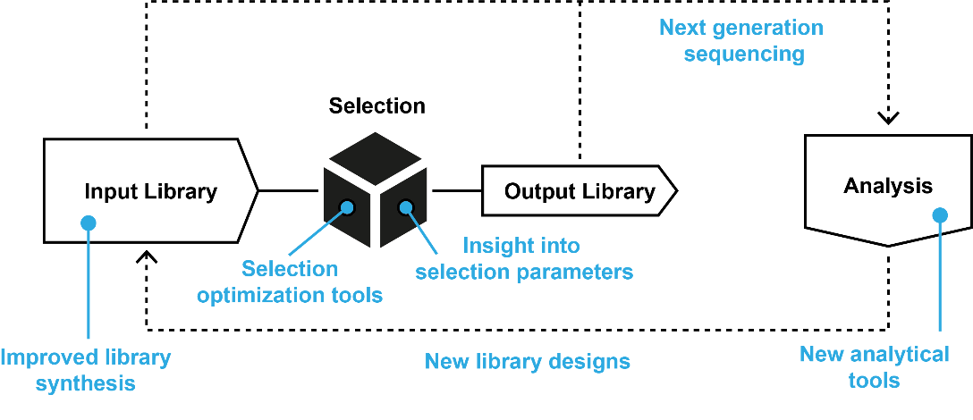

Figure 4: Turning directed evolution into an engineering cycle. While a systematic stepwise approach to directed evolution is customary when analysing small libraries, it is less widely carried out when dealing with large libraries (> 10⁶ variants). However, improvements (shown in blue) are available, or are being developed, which would allow similar approaches to be systematically applied to large libraries, further maturing directed evolution as a tool for discovery and optimization.

Sequence-based design, based on multiple sequence alignments and phylogenetic approaches, has long been the staple strategy for DNA polymerase engineering. While higher complexity sequence-based engineering strategies have been implemented, such as using statistical coupling analysis for the design of the first XNA reverse transcriptase [3], such methods have not been more widely adopted by the field and have not yet been able to recapitulate the richness of design-relevant data generated for other enzymes [59].
Structure-based design of XNA polymerases has been boosted by multiple recent structures depicting the polymerase across different steps of the reaction cycle with both natural [60] and unnatural substrates [36], providing detailed knowledge on the role of active site plasticity [61,62] finger subdomain dynamics [63] and the impact of unnatural bases on polymerase conformation [60]. By comparing structures of binary and ternary complex conformations, numerous residues involved in indirect yet critical roles for exonucleolysis and polymerization activities have been identified [64,65] as well as the role of domains and subdomains on polymerase dynamics [35,63,66]. Although structure-based approaches have been implemented in the recent engineering of an XNA polymerase capable of tPhoNA synthesis [34] as well as in developing more efficient and higher fidelity reverse transcriptases [51], those examples still relied on simple tools and extensive polymerase expertise to succeed.
Both sequence- and structure-based strategies above are invariably integrated into bioinformatics pipelines that are now expanding to incorporate additional strategies, such as molecular dynamics [58], protein biophysical profiles [67,68] and machine learning – computation-intensive methodologies that are becoming more accessible and that predict, infer and analyse potential dynamic elements of proteins towards their function. Structure based prediction tools such as structural position correlation analysis (SPCA) have been implemented to reveal functional communication networks and allosteric interactions in proteins [69]. Programs such as SCide allow the identification of stabilisation centre elements (SCEs), residues involved in noncovalent cooperative long-range contacts, which have shown to be involved in maintaining the 3D structure and thermal stability of proteins [70,71].
Still, improved designs need to be efficiently translated into viable libraries for selection, an area that has been extensively developed in the protein engineering field [72] and increasingly more accessible from commercial suppliers. Other parts of the cycle that are being actively investigated include novel metrics towards quantifying and comparing selection platforms [73], as well as the wider adoption of next generation sequencing to analyse the output of selection [74], with a view towards minimising the number of selection cycles required for the identification of an improved variant and minimising the screening bottleneck in the field.
Deep mutational scanning can bypass screening limitations and facilitate the identification of potential gain-of-function mutations from a single round of selection. Additionally, these measures of fitness can be used to map functional-sequence landscapes that can guide the next engineering steps [75]. This approach has facilitated the identification of unexpected mutations or combination of mutations enhancing novel ligand binding, catalysis, cellular fitness and mutations with significant impacts on thermostability and enzymatic activity [76]. Directed evolution experiments can generate large-scale data sets that could and should be used to identify intrinsic polymerase properties and signs of epistasis that can be used to better understand polymerase function to improve their engineering. Deep mutational scanning can also reveal library construction biases, sampling biases and could be implemented to test the effect of selection parameters on populations and fine-tune selection conditions according to the desired output.
Arnold and colleagues have recently reported the use of a machine learning-assisted directed evolution approach where partial-characterisation of a library was used to train neural networks to predict the functional impact of other mutations present in the library. Most-fit sequences predicted were then subjected to directed evolution. This approach has shown its potential to navigate the functional sequence space efficiently in vitro, narrowing down the regions of interest for further in vivo analysis[77].
Conclusions
Although significant progress has been achieved in the generation of novel synthetic genetic materials both in vitro and in vivo, there remains numerous bottlenecks in the field, particularly regarding the difficult and expensive synthesis of chemical precursors, the large-scale XNA manufacture and the development of XNA chemistries that are orthogonal to nature.
The most obvious path forward seems now to expand the engineering effort of an XNA world towards other necessary components beyond synthetases, reverse transcriptases and ligases. Enzymatic synthesis of XNA triphosphates proposes itself as the next obvious target benefiting from multiple advances in systems and synthetic biology, but a significant risk remains since some of the enzymes needed have never been the focus of engineering.
Even if their engineering is possible, the current tools amount to little more than black boxes that require years to develop and require extensive know-how to apply. The seemingly independent developments along the engineering cycle of directed evolution work together pushing that field into a new level of maturity, which, like Synthetic Biology, will strive for standardization and popularization of approaches towards more general adoption and that will also foster an evolutionary angle in other disciplines. The season of tool sharpening is not yet over but hold high promise for the path ahead.

References
* of special interest
** of outstanding interest
1. Chin JW, Martin AB, King DS, Wang L, Schultz PG: Addition of a photocrosslinking amino acid to the genetic code of Escherichia coli. Proc Natl Acad Sci U S A 2002, 99:11020–11024.
2. Rackham O, Chin JW: A network of orthogonal ribosome·mrna pairs. Nat Chem Biol 2005, 1:159–166.
3. Pinheiro VB, Taylor AI, Cozens C, Abramov M, Renders M, Zhang S, Chaput JC, Wengel J, Peak-Chew SY, McLaughlin SH, et al.: Synthetic genetic polymers capable of heredity and evolution. Science (80- ) 2012, 336:341–344.
4. Dhami K, Malyshev DA, Ordoukhanian P, Kubelka T, Hocek M, Romesberg FE: Systematic exploration of a class of hydrophobic unnatural base pairs yields multiple new candidates for the expansion of the genetic alphabet. Nucleic Acids Res 2014, 42:10235–10244.
5. Coulther TA, Stern HR, Beuning PJ: Engineering Polymerases for New Functions. Trends Biotechnol 2019, 37:1091–1103.
6. Pinheiro VB: Engineering-driven biological insights into DNA polymerase mechanism. Curr Opin Biotechnol 2019, 60:9–16.
7. Dunn MR, Larsen AC, Zahurancik WJ, Fahmi NE, Meyers M, Suo Z, Chaput JC: DNA polymerase-mediated synthesis of unbiased Threose Nucleic Acid (TNA) polymers requires 7-deazaguanine to suppress G:G mispairing during TNA transcription. J Am Chem Soc 2015, 137:4014–4017.
8. Marlière P, Patrouix J, Döring V, Herdewijn P, Tricot S, Cruveiller S, Bouzon M, Mutzel R: Chemical evolution of a bacterium’s genome. Angew Chemie - Int Ed 2011, 50:7109–7114.
9. Lescrinier E, Esnouf R, Schraml J, Busson R, Heus H, Hilbers C, Herdewijn P: Solution structure of a HNA–RNA hybrid. Chem Biol 2000, 7:719–731.
10. Anosova I, Kowal EA, Dunn MR, Chaput JC, Horn WDV, Egli M: SURVEY AND SUMMARY the structural diversity of artificial genetic polymers. Nucleic Acids Res 2016, 44:1007–1021.
11. Malyshev DA, Dhami K, Lavergne T, Chen T, Dai N, Foster JM, Corrêa IR, Romesberg FE: A semi-synthetic organism with an expanded genetic alphabet. Nature 2014, 509:385–388.
12. Hoshika S, Leal NA, Kim M-J, Kim M-S, Karalkar NB, Kim H-J, Bates AM, Watkins NE, SantaLucia HA, Meyer AJ, et al.: Hachimoji DNA and RNA: A genetic system with eight building blocks. Science (80- ) 2019, 363:884–887.
13. Chaput JC, Herdewijn P: What Is XNA? Angew Chemie Int Ed 2019, 58:11570–11572.
14. Malyshev DA, Dhami K, Quach HT, Lavergne T, Ordoukhanian P, Torkamani A, Romesberg FE: Efficient and sequence-independent replication of DNA containing a third base pair establishes a functional six-letter genetic alphabet. Proc Natl Acad Sci 2012, 109:12005–12010.
15. Betz K, Malyshev DA, Lavergne T, Welte W, Diederichs K, Romesberg FE, Marx A: Structural insights into dna replication without hydrogen bonds. J Am Chem Soc 2013, 135:18637–18643.
16. Zhang Y, Lamb BM, Feldman AW, Zhou AX, Lavergne T, Li L, Romesberg FE: A semisynthetic organism engineered for the stable expansion of the genetic alphabet. Proc Natl Acad Sci 2017, 114:1317–1322.
17. Yamashige R, Kimoto M, Takezawa Y, Sato A, Mitsui T, Yokoyama S, Hirao I: Highly specific unnatural base pair systems as a third base pair for PCR amplification. Nucleic Acids Res 2012, 40:2793–2806.
18. Feldman AW, Romesberg FE: In Vivo Structure–Activity Relationships and Optimization of an Unnatural Base Pair for Replication in a Semi-Synthetic Organism. J Am Chem Soc 2017, 139:11427–11433.
19. Feldman AW, Fischer EC, Ledbetter MP, Liao J-YY, Chaput JC, Romesberg FE: A Tool for the Import of Natural and Unnatural Nucleoside Triphosphates into Bacteria. J Am Chem Soc 2018, 140:1447–1454.
20. Piccirilli JA, Benner SA, Krauch T, Moroney SE, Benner SA: Enzymatic incorporation of a new base pair into DNA and RNA extends the genetic alphabet. Nature 1990, doi:10.1038/343033a0.
21. Georgiadis MM, Singh I, Kellett WF, Hoshika S, Benner SA, Richards NGJ: Structural Basis for a Six Nucleotide Genetic Alphabet. J Am Chem Soc 2015, 137:6947–6955.
22. Singh I, Laos R, Hoshika S, Benner SA, Georgiadis MM: Snapshots of an evolved DNA polymerase pre- and post-incorporation of an unnatural nucleotide. Nucleic Acids Res 2018, 46:7977–7988.
23. Yang Z, Chen F, Alvarado JB, Benner SA: Amplification, mutation, and sequencing of a six-letter synthetic genetic system. J Am Chem Soc 2011, doi:10.1021/ja204910n.
24. Laos R, Shaw R, Leal NA, Gaucher E, Benner S: Directed evolution of polymerases to accept nucleotides with nonstandard hydrogen bond patterns. Biochemistry 2013, 52:5288–5294.
25. Chen F, Zhang Y, Daugherty AB, Yang Z, Shaw R, Dong M, Lutz S, Benner SA: Biological phosphorylation of an Unnatural Base Pair (UBP) using a Drosophila melanogaster deoxynucleoside kinase (DmdNK) mutant. PLoS One 2017, 12:e0174163.
26. Jang MY, Song XP, Froeyen M, Marlière P, Lescrinier E, Rozenski J, Herdewijn P: A synthetic substrate of DNA polymerase deviating from the bases, sugar, and leaving group of canonical deoxynucleoside triphosphates. Chem Biol 2013, 20:416–423.
27. Chen T, Hongdilokkul N, Liu Z, Adhikary R, Tsuen SS, Romesberg FE: Evolution of thermophilic DNA polymerases for the recognition and amplification of C2’-modified DNA. Nat Chem 2016, 8:556–562.
28. Jäger S, Rasched G, Kornreich-Leshem H, Engeser M, Thum O, Famulok M: A versatile toolbox for variable DNA functionalization at high density. J Am Chem Soc 2005, 127:15071–15082.
29. Jiang W, Zhang B, Fan C, Wang M, Wang J, Deng Q, Liu X, Chen J, Zheng J, Liu L, et al.: Mirror-image polymerase chain reaction. Cell Discov 2017, 3:17037.
30. Pochet S, Kaminski PA, Van Aerschot A, Herdewijn P, Marlière P: Réplication in vivo et ex vivo de l’analogue hexitol des acides nucléiques. Comptes Rendus - Biol 2003, 326:1175–1184.
31. Arangundy-Franklin S, Taylor AI, Porebski BT, Genna V, Peak-Chew S, Vaisman A, Woodgate R, Orozco M, Holliger P: A synthetic genetic polymer with an uncharged backbone chemistry based on alkyl phosphonate nucleic acids. Nat Chem 2019, 11:533–542.
32. Krueger AT, Kool ET: Model systems for understanding DNA base pairing. Curr Opin Chem Biol 2007, 11:588–594.
33. Schlegel MK, Peritz AE, Kittigowittana K, Zhang L, Meggers E: Duplex Formation of the Simplified Nucleic Acid GNA. ChemBioChem 2007, 8:927–932.
34. Liu C, Cozens C, Jaziri F, Rozenski J, Maréchal A, Dumbre S, Pezo V, Marlière P, Pinheiro VB, Groaz E, et al.: Phosphonomethyl Oligonucleotides as Backbone-Modified Artificial Genetic Polymers. J Am Chem Soc 2018, 140:6690–6699.
35. Kropp HM, Betz K, Wirth J, Diederichs K, Marx A: Crystal structures of ternary complexes of archaeal B-family DNA polymerases. PLoS One 2017, 12:1–20.
36. Chim N, Shi C, Sau SP, Nikoomanzar A, Chaput JC: Structural basis for TNA synthesis by an engineered TNA polymerase. Nat Commun 2017, 8:1–17.
37. Luo M, Groaz E, Froeyen M, Pezo V, Jaziri F, Leonczak P, Schepers G, Rozenski J, Marlière P, Herdewijn P: Invading Escherichia coli Genetics with a Xenobiotic Nucleic Acid Carrying an Acyclic Phosphonate Backbone (ZNA). J Am Chem Soc 2019, 141:10844–10851.
38. Pinheiro VB, Loakes D, Holliger P: Synthetic polymers and their potential as genetic materials. BioEssays 2013, 35.
39. Mei H, Liao JY, Jimenez RM, Wang Y, Bala S, McCloskey C, Switzer C, Chaput JC: Synthesis and Evolution of a Threose Nucleic Acid Aptamer Bearing 7-Deaza-7-Substituted Guanosine Residues. J Am Chem Soc 2018, 140:5706–5713.
40. Eremeeva E, Abramov M, Margamuljana L, Herdewijn P: Base‐Modified Nucleic Acids as a Powerful Tool for Synthetic Biology and Biotechnology. Chem – A Eur J 2017, 23:9560–9576.
41. Nguyen H, Abramov M, Eremeeva E, Herdewijn P: In Vivo Expression of Genetic Information from Phosphoramidate–DNA. ChemBioChem 2020, 21:272–278.
42. Eremeeva E, Abramov M, Margamuljana L, Rozenski J, Pezo V, Marlière P, Herdewijn P: Chemical Morphing of DNA Containing Four Noncanonical Bases. Angew Chemie Int Ed 2016, 55:7515–7519.
43. Liao JY, Bala S, Ngor AK, Yik EJ, Chaput JC: P(V) Reagents for the Scalable Synthesis of Natural and Modified Nucleoside Triphosphates. J Am Chem Soc 2019, doi:10.1021/jacs.9b04728.
44. Matsuura MF, Shaw RW, Moses JD, Kim HJ, Kim MJ, Kim MS, Hoshika S, Karalkar N, Benner SA: Assays to Detect the Formation of Triphosphates of Unnatural Nucleotides: Application to Escherichia coli Nucleoside Diphosphate Kinase. ACS Synth Biol 2016, doi:10.1021/acssynbio.5b00172.
45. Torres L, Krüger A, Csibra E, Gianni E, Pinheiro VBB: Synthetic biology approaches to biological containment: Pre-emptively tackling potential risks. Essays Biochem 2016, 60.
46. Pezo V, Hassan C, Louis D, Sargueil B, Herdewijn P, Marlière P: Metabolic Recruitment and Directed Evolution of Nucleoside Triphosphate Uptake in Escherichia coli. ACS Synth Biol 2018, 7:1565–1572.
47. Esipov RS, Abramchik YA, Fateev I V., Konstantinova ID, Kostromina MA, Muravyova TI, Artemova KG, Miroshnikov AI: A Cascade of Thermophilic Enzymes As an Approach to the Synthesis of Modified Nucleotides. Acta Naturae 2016, doi:10.32607/20758251-2016-8-4-82-90.
48. Tizei PAG, Csibra E, Torres L, Pinheiro VB: Selection platforms for directed evolution in synthetic biology. Biochem Soc Trans 2016, 44.
49. Ghadessy FJ, Ong JL, Holliger P: Directed evolution of polymerase function by compartmentalized self-replication. Proc Natl Acad Sci U S A 2001, 98:4552–4557.
50. Ellefson JW, Gollihar J, Shroff R, Shivram H, Iyer VR, Ellington AD: Synthetic evolutionary origin of a proofreading reverse transcriptase. Science (80- ) 2016, 352:1590–1593.
51. Houlihan G, Arangundy-Franklin S, Porebski BT, Subramanian N, Taylor AI, Holliger P: Discovery and evolution of RNA and XNA reverse transcriptase function and fidelity. Nat Chem 2020, doi:10.1038/s41557-020-0502-8.
52. Larsen AC, Dunn MR, Hatch A, Sau SP, Youngbull C, Chaput JC: A general strategy for expanding polymerase function by droplet microfluidics. Nat Commun 2016, 7:1–9.
53. Nikoomanzar A, Dunn MR, Chaput JC: Evaluating the Rate and Substrate Specificity of Laboratory Evolved XNA Polymerases. Anal Chem 2017, 89:12622–12625.
54. Nikoomanzar A, Vallejo D, Chaput JC: Elucidating the Determinants of Polymerase Specificity by Microfluidic-Based Deep Mutational Scanning. ACS Synth Biol 2019, 8:1421–1429.
55. Csibra E, Renders M, Pinheiro V: Bacterial cell display as a robust and versatile platform for the engineering of low affinity ligands and enzymes. ChemBioChem 2020, doi:10.1002/cbic.202000203.
56. Heinisch T, Schwizer F, Garabedian B, Csibra E, Jeschek M, Vallapurackal J, Pinheiro VB, Marlière P, Panke S, Ward TR: E. coli surface display of streptavidin for directed evolution of an allylic deallylase. Chem Sci 2018, 9.
57. Chung M, Goroncy K, Kolesnikova A, Schönauer D, Schwaneberg U: Display of functional nucleic acid polymerase on Escherichia coli surface and its application in directed polymerase evolution. Biotechnol Bioeng 2020, doi:10.1002/bit.27542.
58. Vanmeert M, Razzokov J, Mirza MUU, Weeks SDD, Schepers G, Bogaerts A, Rozenski J, Froeyen M, Herdewijn P, Pinheiro VBB, et al.: Rational design of an XNA ligase through docking of unbound nucleic acids to toroidal proteins. Nucleic Acids Res 2019, 47.
59. Russ WP, Figliuzzi M, Stocker C, Barrat-Charlaix P, Socolich M, Kast P, Hilvert D, Monasson R, Cocco S, Weigt M, et al.: An evolution-based model for designing chorismate mutase enzymes. Science 2020, 369:440–445.
60. Marx A, Betz K: The Structural Basis for Processing of Unnatural Base Pairs by DNA Polymerases. Chem – A Eur J 2020, 26:3446–3463.
61. Jackson LN, Chim N, Shi C, Chaput JC: Crystal structures of a natural DNA polymerase that functions as an XNA reverse transcriptase. Nucleic Acids Res 2019, 47:6973–6983.
62. Kropp HM, Dürr SL, Peter C, Diederichs K, Marx A: Snapshots of a modified nucleotide moving through the confines of a DNA polymerase. Proc Natl Acad Sci U S A 2018, 115:9992–9997.
63. Chim N, Jackson LN, Trinh AM, Chaput JC: Crystal structures of DNA polymerase I capture novel intermediates in the DNA synthesis pathway. Elife 2018, 7.
64. Li Y, Korolev S, Waksman G: Crystal structures of open and closed forms of binary and ternary complexes of the large fragment of Thermus aquaticus DNA polymerase I: Structural basis for nucleotide incorporation. EMBO J 1998, 17:7514–7525.
65. de Vega M, Lazaro JM, Salas M, Blanco L: Primer-terminus stabilization at the 3′-5′ exonuclease active site of phi29 DNA polymerase. Involvement of two amino acid residues highly conserved in proofreading DNA polymerases. EMBO J 1996, 15:1182–1192.
66. Berman AJ, Kamtekar S, Goodman JL, Lázaro JM, De Vega M, Blanco L, Salas M, Steitz TA: Structures of phi29 DNA polymerase complexed with substrate: The mechanism of translocation in B-family polymerases. EMBO J 2007, 26:3494–3505.
67. Cilia E, Pancsa R, Tompa P, Lenaerts T, Vranken WF: From protein sequence to dynamics and disorder with DynaMine. Nat Commun 2013, 4:2741.
68. Cilia E, Pancsa R, Tompa P, Lenaerts T, Vranken WF: The DynaMine webserver: predicting protein dynamics from sequence. Nucleic Acids Res 2014, 42:W264–W270.
69. Du QS, Meng JZ, Wang CH, Long SY, Huang RB: Structural position correlation analysis (SPCA) for protein family. PLoS One 2011, doi:10.1371/journal.pone.0028206.
70. Dosztányi Z, Fiser A, Simon I: Stabilization centers in proteins: Identification, characterization and predictions. J Mol Biol 1997, 272:597–612.
71. Magyar C, Gromiha MM, Sávoly Z, Simon I: The role of stabilization centers in protein thermal stability. Biochem Biophys Res Commun 2016, 471:57–62.
72. Qu G, Li A, Acevedo‐Rocha CG, Sun Z, Reetz MT: The Crucial Role of Methodology Development in Directed Evolution of Selective Enzymes. Angew Chemie Int Ed 2020, 59:13204–13231.
73. Dramé-Maigné A, Zadorin AS, Golovkova I, Rondelez Y: Quantifying the performance of micro-compartmentalized directed evolution protocols. Life 2020, 10:1–8.
74. Wrenbeck EE, Faber MS, Whitehead TA: Deep sequencing methods for protein engineering and design. Curr Opin Struct Biol 2017, 45:36–44.
75. Araya CL, Fowler DM: Deep mutational scanning: Assessing protein function on a massive scale. Trends Biotechnol 2011, 29:435–442.
76. Fowler DM, Fields S: Deep mutational scanning: a new style of protein science. Nat Methods 2014, 11:801–807.
77. Wu Z, Jennifer Kan SB, Lewis RD, Wittmann BJ, Arnold FH: Machine learning-assisted directed protein evolution with combinatorial libraries. Proc Natl Acad Sci U S A 2019, 116:8852–8858.

3 ** Although significant XNA work had been carried out prior to this work, this was the first report of new genetic materials (with significant coding potential, i.e. > 80 nucleotides) based on XNA that could be accessed via engineered XNA synthetases and XNA reverse transcriptases.
8 ** This was the first report of natural nucleobases being systematically replaced in vivo with synthetic nucleobases to create a viable semi-synthetic organism.
11 ** This was the first report of unnatural bases being incorporated in vivo to increase the coding capacity of DNA.
12* This is the most informationally dense genetic system, albeit in vitro, reported to date with eight nucleobases.
29 * The authors report a very significant advance towards the "mirror world" through the amplification of L-DNA via a chemically synthesised polymerase made of D-amino acids.
31 ** The authors report the first XNA, accessible to engineered polymerases, with an uncharged backbone.
54 * The authors use a positional mutational scan coupled to functional selection to map the local sequence landscape of a polymerase. This is one of the first information-driven attempts at engineering a DNA and XNA polymerase.
58 ** This is the first report of an XNA enzyme engineered in silico and one of the earliest reports of an XNA ligase.
73 * This is one of the very first attempts at opening the selection "black box" by proposing a measure to compare different selection platforms.

