Does the topographic threshold concept explain the initiation points of sunken lanes in the European loess belt?
Sofie De Geeter^{1,2*}, Jean Poesen^{2,3}, Matthias Vanmaercke¹

¹Department of Geography, U.R. SPHERES, University of Liège, Clos Mercator 3, 4000 Liège, Belgium
²Department of Earth and Environmental Sciences, KU Leuven, Celestijnenlaan 200E, 3001 Heverlee, Belgium
³Faculty of Earth Sciences and Spatial Management, Maria-Curie Sklodowska University, Krasnicka 2D, 20-718, Lublin, Poland
*Corresponding author: Sofie De Geeter (sofie.degeeter@uliege.be)
ABSTRACT
Sunken lanes or ‘road gullies’ are a common geomorphic feature in the European loess belt. These landforms are usually created by various processes over time (water erosion, mass movements and traffic). They are important for ecology and biodiversity, for recreation and transport, as well as from a hydrological and geomorphological perspective (e.g. by enhancing the runoff and sediment connectivity of the landscape). Nonetheless, little is known about their origin and evolution. The formation of sunken lanes is typically only understood in qualitative terms, while no studies so far have provided a quantitative analysis of their initiation conditions. To address this research gap and to improve our geomorphic understanding of this landform, we investigated to what extent sunken lanes can be treated and described as a gully erosion process. More specifically, we explored to what extent their position in the landscape and their characteristics can be explained by the topographic slope-area (SA) threshold that typically controls gully initiation: $S=kA^{b}$, with k and b empirical constants. Based on field surveys and LIDAR data analyses, we determined the slope gradient of the soil surface (S) and contributing area (A) for 132 representative sunken lane heads in the Belgian loess belt and collected data on several other characteristics (position of initiation and sedimentation points, width, depth and length of each sunken lane). Our results show a very large scatter on the S and A values. Moreover, the morphological characteristics of sunken lanes (e.g. width and length) showed no clear relation with these values. However, a very weak SA-threshold relation with a low b-exponent (-0.016) and a low k-coefficient (0.022) could be identified. Overall, our results show that the formation of sunken lanes is not in line with the topographic threshold conditions that govern the initiation of gullies across different environments. The low k-coefficient and the lack of a strong correlation between initiation slope and contributing area point towards an overall higher susceptibility to the formation of sunken lanes than the formation of gullies. This supports the conclusion that not only concentrated flow detachment and transport, but especially human activities (mainly traffic erosion) play a major role in the initiation and development of sunken lanes.
Keywords: road gully, local slope gradient, drainage area, human influence, literature review, LIDAR

- INTRODUCTION
Sunken lanes (also known as road gullies, sunken roads or hollow ways) are large, permanent gully-like landscape features that have a (partly) anthropogenic origin (Figure 1). Boardman (2013) defined sunken lanes as “road or tracks that are incised below the general level of the surrounding country, often by several metres. They are formed by the passage of people, animals, vehicles and the action of water and gravity (mass movements). They may be active (incising) or inactive at present.” The banks at both sides of the road are often interrupted by passageways to the fields or due to a crossing with other sunken lanes (Boardman, 2013). Other studies, oriented more towards their ecological relevance, define sunken lanes as sloping strips of habitat originating from slow, continuous erosion of narrow, unpaved rural roads (David et al., 2011; Martens, 2013). From the moment that the height difference between the road and the neighbouring land surface is too large for an agricultural vehicle to cross, the term sunken lane can be used. In practice, this corresponds to a height difference of minimally 0.5 m (Nowocien and Podolski, 1992; RLH and Proclam, 2009). However, sunken lanes can become much deeper. In the European loess region most sunken lanes range between 2 and 15 m, while in China, sunken lanes of up to 40 m deep are recorded (David et al., 2011; Zlatuška, 2012). In terms of length, they can extend from a couple of meters to several kilometres (Vanwalleghem et al., 2003).
Figure 1a schematically illustrates the longitudinal profile of a typical sunken lane in relation to the original soil surface. Figure 1b shows an example of a sunken lane in Korbeek-Dijle (Central Belgium) with a typical trapezoidal cross-section. Its road surface is covered by gravel and the banks are vegetated by shrubs and grasses. In terms of morphology, several characteristic points can be identified along the profile of a sunken lane (Figure 1a). These include the current head or start of the sunken lane (S1), the likely initiation point (S2) and the point along the slope where sedimentation starts to occur (S3; end point). In most cases, the position of the current head of the sunken lane (S1) is upslope of the point where the sunken lane was initiated (S2). S2 is typically situated where the original soil surface along the sunken lane has the steepest slope gradient (Schotmans, 2014; Vanwalleghem et al., 2003). The trajectory of the sunken lane between S1 and S2 is the result of regressive erosion. However, sunken lanes can also develop in the downslope direction due to erosion and sediment transport by concentrated runoff and vehicles. S3 is the location where the soil surface slope is no longer steep enough to effectively transport the sediment and where, as a consequence, deposition occurs.
Resulting from these morphological characteristics, two essential conditions need to be met for a sunken lane to develop. First, the lithology and the soil should allow for the formation of steep bank slopes or even vertical walls. This is the case for loess, loam, sandy loam and iron sandstone. Substrates like sand or gravel are generally not sufficiently cohesive and only permit the formation of shallow sunken lanes. Second, the landscape needs to have a sufficient degree of relief in order for concentrated runoff to incise in the topsoil. Nonetheless, with critical slope steepnesses of only 2 to 4% (Stevens, 1997), the relief needed to initiate sunken lanes is generally small. By consequence, sunken lanes can be found in large numbers across the European loess belt (Deckers et al., 2005). Figure 2 and Table 1 present an overview of studies describing sunken lanes in Europe. As can be seen, most cases of reported sunken lanes are indeed located in regions covered with loess deposits of several meters thick.
Overall, sunken lanes play an important ecological, cultural and hydrological role in the landscape and these aspects have been extensively studied (Boardman, 2013; Deckers et al., 2005). Sunken lanes give rise to a varied abiotic and biotic environment at a small spatial scale due to strong contrasts in soil conditions, light availability and humidity (Deckers et al., 2005; Stevens, 1997). Consequently, there is a large variety of living conditions present, making sunken lanes important habitats for plant and animal species and therefore very relevant from a nature conservation perspective. This is especially the case in regions such as the loess belt in Belgium (RLD, 2004). Well-developed sunken lanes can be seen as small-scale forest fragments since the conditions are usually suitable for forest species (Deckers et al., 2005; Stevens, 1997; Figure 1b). Furthermore, sunken lanes are important linear elements in the landscape and often serve as a safe guideway for plants and animals to travel from one habitat to another. The destruction and disappearance of sunken lanes can therefore lead to the formation of small islands and a reduction in species diversity (Stevens, 1997).
Sunken lanes also have a significant influence on the local hydrology. They can contribute significant volumes of runoff and sediments, originating from different sources. First, unpaved sunken lanes can be a source of runoff and sediments themselves (Boardman, 2013; Froehlich and Walling, 1997). Next, banks of a sunken lane that are insufficiently protected by vegetation are prone to various erosion processes such as piping, bank gullying or mass movements during rainfall events (Poesen, 2018). Furthermore, runoff from cultivated areas can reach the sunken lane by surface wash, seepage, piping, field drains or through access points from the sunken lane to the field (Boardman, 2013; Froehlich and Walling, 1997). As such, sunken lanes can also significantly increase the (runoff and sediment) connectivity between upslope areas and lower laying areas, water courses or inhabited areas (Boardman, 2013; Evrard et al., 2007; Froehlich and Walling, 1997). This may result in negative impacts, such as (muddy) floods, ecological damage, damage to roads, reservoir sedimentation, increased sediment loads and pollution of water bodies (Boardman, 2013; de Walque et al., 2017; Owens et al., 2005; Verstraeten and Poesen, 1999).
In addition, sunken lanes often have an important recreational value by providing scenic walking and cycling routes. Likewise, they can be of significant historic value as they form relicts from ancient roads and settlements (RLD, 2004; Stevens, 1997). Last but not least, they often remain important access and transportation routes. It is therefore important to properly manage sunken lanes to preserve their ecological, cultural and economical benefits, but also to avoid their associated negative impacts.
An appropriate management of sunken lanes requires a good understanding of the environmental and geomorphic factors controlling the formation and evolution of sunken lanes. However, despite the research on sunken lanes (cf. Table 1), relatively little is known about the formation conditions of sunken lanes. The origin of sunken lanes is usually only described in general terms, while very few studies focus on the initiation process from a geomorphological point of view (cf. Table 1).
Nonetheless, given the fact that sunken lanes are commonly reported to share many similarities with gullies in terms of formation and morphology (Schotmans, 2014; Superson et al., 2014; Vanwalleghem et al., 2003), a possible approach to better understand the formation of sunken lanes is the topographic slope-area (SA) threshold concept of gully initiation. According to this concept, the position where gullies can occur in a landscape is controlled by the equation (Torri and Poesen, 2014):
 | $$S=kA^{b}$$ | (1)
with S the minimum local slope steepness of the soil surface required to initiate a gully, A the size of the area draining to that location and k and b empirical constants. Based on a review of 39 studies of the SA-relations at gully heads in many different environments, Torri and Poesen (2014) proposed that b can be considered constant, namely -0.38. The k-coefficient reflects the resistance against gully head development in that specific landscape and depends (amongst other factors) on soil, vegetation and land use characteristics. The k-coefficient is typically small for cropland and higher for forest, reflecting a higher minimum local slope steepness and/or contributing area required to initiate a gully head at a given location under forest than under cropland (Torri and Poesen, 2014). Overall, Equation 1 reflects the fact that the formation of gullies is a threshold dependent process: only where the flow shear stress is larger than a critical shear stress value, concentrated runoff can incise and form a gully (Torri and Poesen, 2014; Vanmaercke et al., 2016). This shear stress depends on the local slope (S), the volume of runoff that can accumulate during rain events (represented by A), but also the vegetation and land use conditions at the sunken lane site (which influence k).
Earlier studies showed that, by means of the SA-threshold concept and their corresponding coefficients, it is possible to gain quantitative information on the initiation conditions of gullies. More precisely, by measuring the S and A of gully heads in a region and deriving the corresponding k- and b-values from these data, one can obtain insight into the land use conditions at the time of gully formation (e.g. Vanwalleghem et al., 2003). Likewise, the b-exponent may provide an indication of the main processes leading to gully formation. While a b-value of ca. -0.38 typically corresponds to conditions where Hortonian overland flow is the dominant process (Vandaele et al., 1996), a higher or even positive b-exponent indicates the influence of other processes such as subsurface flow leading to seepage erosion, piping and landsliding (Morgan and Mngomezulu, 2003; Vandekerckhove et al., 2000). The absence of a clear relation between S and A can also be an indication of strong anthropogenic impacts (e.g. Makanzu Imwangana et al., 2014).
The overall objective of this research is to better understand the initiation conditions of sunken lanes in the Belgian loess belt. More specifically, we aim to investigate which of the processes mentioned in the definition by Boardman (2013), namely anthropogenic processes or concentrated runoff, plays a dominant role in the formation of sunken lanes through quantitative geomorphic analyses. The hypothesis we aim to test is that, since sunken lanes are similar landforms as permanent gullies, the topographic threshold concept (Equation 1) can be used to describe and predict the position of sunken lane initiation points (cf. Figure 1a) in a landscape. If these features are mainly formed by concentrated runoff, a topographic threshold should be identifiable (Torri and Poesen, 2014). Earlier work in the same region indeed revealed the existence of such a clear SA-threshold for gullies formed by Hortonian overland flow (e.g. Nachtergaele et al., 2001; Vanwalleghem et al., 2003; 2005). However, if human activity plays a dominant role in the formation of sunken lanes, the initiation of sunken lanes is not necessarily governed by the SA-threshold concept. By extent, the lack of a clear SA-threshold would provide a clear indication that human activity is dominant in their formation. We will therefore investigate the relative importance of natural versus anthropogenic processes by exploring to what extent the location and characteristics of sunken lanes in the Belgian loess belt can be characterized with the slope-area threshold concept.
- MATERIAL AND METHODS
2.1 Study area
A study site of approximately 200 km² was selected south of Leuven (Central Belgium) (Figure 3). This area is part of the periglacial loess belt of Western Europe (Figure 2) where sunken lanes are a common feature. The Belgian loess belt is characterized by a rolling topography with heights ranging between 50 and 150 m a.s.l. Where river valleys dissect the loess plateau, local altitude can be as low as 10 m a.s.l. (Deckers et al., 2005; Evrard et al., 2008; Vanwalleghem et al., 2003). The study site is mainly situated around 100 m a.s.l. Slopes of more than 25% can occur, but in general the slopes range between 1 and 14% (Knapen, 2007; Vanwalleghem et al., 2003). The Pleistocene loess deposits of the loess belt cover an older topography and lithology resulting in loess thicknesses varying between 1 and 30 m (Poesen et al., 2018). In the study area, the loess mainly covers Tertiary fine marine sands (DOV, 2018). As the loess plateau is gently sloping upwards to the south, the loess deposits also increase in thickness towards the south but local variations in thickness occur as a result of the pre-loess topography and due to erosion of hillslopes and hilltops (Poesen et al., 2018).
Soils have a dominantly silty texture but more sandy or clayey patches are possible due to the outcrop of Tertiary sands or clays (Deckers et al., 2005; Knapen, 2007; Vanwalleghem et al., 2003). The soils are mainly formed by decalcification of the calcareous loess and clay eluviation and illuviation (Poesen, 2018). The dominant reference soil group is Luvisols, which are highly fertile soils with a large water-holding capacity and therefore very suitable for agriculture. However, these characteristics also cause these loess-derived soils to be very erodible (IUSS Working Group WRB, 2015; Poesen, 1993).
The study area has a temperate maritime climate with warm summers and cool winters but with precipitation throughout the year (mean annual rainfall ~ 800 mm) and thus no distinctive dry season (Vanwalleghem et al., 2003; Verachtert et al., 2010). Although the monthly rainfall depth is equally distributed over the year, the most erosive rainfalls occur from May to September (Verstraeten et al., 2006). Due to the erosion of sensitive loess-derived soils and the high proportion of cropland with sparse vegetation cover, high intensity thunderstorms in early summer cause significant soil erosion, (muddy) floods and consequently, damage to croplands and infrastructure (de Walque et al., 2017; Evrard et al., 2008; Verstraeten et al., 2006).
The natural vegetation in the study area is deciduous forest but due its suitability for agriculture, the dominant land use is cropland. Consequently, almost no natural habitats are present in the area, but semi-natural fragments and connections such as sunken lanes act as substitutes (Deckers, 2005).
2.2 Data collection
Within our study area (Figure 3), which is typical for the Belgian loess belt, a large number of sunken lanes could easily be identified on topographic maps. From these sunken lanes, a representative sample (n = 132) was selected, taking into account the different investigated characteristics (see below) and the possibility to correctly delineate the catchment area draining to each sunken lane. The selected sunken lanes were then visited in the field to record the exact location of the sunken lane head and sedimentation points with a GPS and to collect other relevant morphological characteristics.
As explained above, the term sunken lane can generally be used when the road is incised over a minimum depth of 0.5 m (Nowocien and Podolski, 1992; RLH and Proclam, 2009). Therefore, the head of the sunken lane (S1; cf. Figure 1) was considered to be the point along the road where the incision reached 0.5 m on both sides of the road. At this location, the coordinates of the head were recorded with a GPS. Similarly, the point downslope where the road was again incised less than 0.5 m was registered with the GPS as the sedimentation point (S3; cf. Figure 1). However, sunken lanes do not always follow the typical longitudinal profile as shown in Figure 1. In many cases, the initiation (S1) and sedimentation (S3) points were disturbed by the presence of other roads. Cases where this occurred, i.e. where sunken lanes start or end at a crossing with another road (often also a sunken lane), were marked in our dataset to separate them from the ‘true’ S1 and S3 points in the analyses. Furthermore, we also recorded the type of road (i.e. paved/unpaved), the vegetation type on and status of the banks, the land use surrounding the sunken lane and it was verified whether the soil had a loamy texture.
The field surveys were complemented by additional GIS analyses of LIDAR data, i.e. a digital elevation model of Flanders with a horizontal resolution of 1 m (Agiv, 2014). For each sunken lane, we first localized the expected initiation point (S2, cf. Figure 1). For this, we drew two longitudinal profiles parallel to the sunken lanes. The position of the average soil surface of the surrounding land directly next to the sunken lane can be assumed to represent the original topography before the sunken lane was formed. As explained in Figure 1, the initiation point was considered to be located at the section with the steepest slope (Schotmans, 2014; Vanwalleghem et al., 2003). Figure 4 illustrates this for a sunken lane in Hoegaarden where the resulting slope and height profiles are visualised in two graphs (Figure 4b and c). Slope profiles were constructed based on a moving average over a horizontal distance of 10 m in order to eliminate the effect of irregularities in the LIDAR data (e.g. due to field boundaries). When the shape of the graph is generalized, one can observe that in this example the steepest section is located between 200 and 300 m from the beginning of the sunken lane (Figure 4b and c). We assumed that the initiation of the sunken lane occurred around the centre of this section (around 250 m). Next, we created two new points on each profile, namely S2a and S2b (Figure 4). The expected initiation point (S2) was then located by taking the intersection of the line through S2a and S2b and the centre of the sunken lane (Figure 4).
Once S1, S2 and S3 were derived for each sunken lane, we extracted the corresponding S and A values (cf. Eq. 1) from the LIDAR data. The local soil surface slope (S) was calculated as the average slope of two 10 m-transects directly parallel to the sunken lane. Similar to the identification of S2, this allowed us to reconstruct the original slope steepness (before the presence of the road) as well as to avoid extreme values. The contributing area (A) at the current head (S1), the initiation point (S2) and the sedimentation point (S3) of the sunken lane was extracted using the LIDAR data and Hydro tools in ArcGIS. For the sunken lane in Hoegaarden, this resulted in the three catchments shown in Figure 4.
We further derived the bottom and top width as well as the depth at the initiation point (S2) from the LIDAR data. Likewise, we calculated the length of each sunken lane (i.e. the distance along the road between S1 and S3; cf. Figure 4). This methodology was repeated for all selected sunken lanes (Figure 3).
2.3 Data analyses
The topographic thresholds values of the sunken lanes were statistically processed by means of an orthogonal regression between S and A, i.e. the commonly accepted best approach to quantify the topographic thresholds of gullies (Vandekerckhove et al., 1998; Vanwalleghem et al., 2005). Orthogonal regression reduces the deviations perpendicular to the regression line (i.e. the orthogonal distances) as much as possible (Jackson, 1991). The obtained threshold line corresponds to the first principal component between S and A, also called the mean threshold line. In contrast to simple linear regression, it considers errors on both the x- and the y-axis to be equally important. Hence, the equation can be used in two directions: to explain S based on A or vice versa (Jackson, 1991; Vandekerckhove et al., 1998). Next, the lower limit of the 95% confidence interval around the obtained mean threshold line was calculated. This was done to allow comparisons with other studies, but also because it can be expected that this lower boundary (rather than the average regression line) allows to draw conclusions about the initiation conditions (Torri and Poesen, 2014). Similar to other studies (e.g. Vanwalleghem et al., 2005), we calculated this lower threshold by translating the obtained mean threshold line to fit the lower most data points. The SA thresholds were each time calculated for the initiation points (S2), as well as for the start (S1) and end (S3) points of each sunken lane (cf. Figure 1, 4).
To allow for a better interpretation, the obtained SA-relations of the investigated sunken lanes were compared to SA data of (road) gullies under forest collected by Schotmans (2014) and Vanwalleghem et al. (2003) as well as to topographic threshold data of gullies in other environments. The SA-relations for gullies in other environments were derived from the review by Torri and Poesen (2014) and were complemented with SA-relations from other studies (Dong et al., 2013; Hayas et al., 2017; Katz et al., 2013; Maugnard et al., 2014; Moeyersons, 2003; Morgan and Mngomezulu, 2003; Schotmans, 2014; Torri et al., 2018; Vanwalleghem et al., 2003; Zhang et al., 2016). For each land use type, the corresponding k and b values were calculated as the average of all the studies reporting a threshold relation for that land use type.
- RESULTS
3.1 Characteristics of sunken lanes
Based on our explorative analyses and field surveys in the Belgian loess belt around Leuven, we identified and recorded 132 sunken lanes in Haasrode, Hoegaarden, Korbeek-Dijle, Lovenjoel, Opvelp and Winksele (Figure 3). For some of these, the start or end point (S1 and S3, cf. Figure 1) were affected by the presence of another road. These points were left out of the analyses. As such, our dataset consists of 97 datapoints for S1, 132 datapoints at S2 and 48 datapoints for S3 (cf. Figure 1). Figure 5 illustrates the different types of surveyed sunken lanes.
Figure 6 shows the distribution of measured lengths, depths, bottom and top widths of the surveyed sunken lanes. The length of the sunken lanes varies between 12 and 913 m with an average value of 285 m. Depths vary between 0.5 and 10 m with an average value of 2.5 m. Bottom widths range between 0.8 m and 11 m with an average value of 2.3 m. Top widths vary between 5 and 28 m with an average value of 10 m. No clear relations could be identified between the recorded qualitative characteristics of the sunken lane (type of road, type of bank vegetation, soil type, land use in the surrounding area) and the morphometric characteristics of the sunken lanes, nor with the identified SA-relations. Therefore, these qualitative characteristics will not be further discussed.
3.2 Topographic thresholds of sunken lanes
Figure 7 shows cumulative frequency diagrams of the soil surface slopes at the start of sunken lanes (S1), their initiation points (S2) and their end point (S3), as well as of the area contributing to each of these points (A1, A2 and A3, respectively). At the current head of the sunken roads, soil surface slopes of the surrounding land (S1) range between 0.01 and 0.14 m/m, while contributing areas range between 14 m² and 94 ha (Figure 7). For the initiation point, surface slopes (S2) range between 0.02 and 0.23 m/m, while contributing areas (A2) range between 93 m² and 114 ha. Finally, slopes at the sedimentation point (S3) vary between 0.03 and 0.10 m/m, while contributing areas (A3) range between 0.25 ha and 65 ha.
Figure 8 displays the scatterplots of S1-A1, S2-A2 and S3-A3 and the fitted orthogonal threshold regressions. For the start and end points of the sunken lanes, a distinction was made between data points that are disturbed by the crossing with other roads (white dots) and the points where this is not the case (black dots). Overall, these plots reveal a very wide scatter. Consequently, no clear trend between S1/S2/S3 and A1/A2/A3 can be noticed. For S1-A1, the orthogonal regression is slightly positive (with a b-exponent of 0.05). Moving this regression line to fit the lowermost data points resulted in the corresponding lowest threshold line with a k-value of 0.012. For the expected initiation point (S2-A2), the orthogonal regression reveals a very weak decreasing trend with a b-exponent of -0.016. The lower most threshold line resulted in a k-value of 0.02. For the end points of the sunken lanes (S3-A3) the orthogonal regression also resulted in a slightly negative (b-exponent of -0.076) and a k-value of 0.026 for the lower most threshold line. Analysing the disturbed and undisturbed sunken lanes for the start and end points separately, did not result in a significant difference of the regression coefficients.
- DISCUSSION
Overall, our results indicate the absence of a clear relation between all S and A values of sunken lanes in the loess belt of Central Belgium (Figure 8). This lack of correlation could not be attributable to the influence of other roads crossing the sunken lanes. We also tested the presence of a relationship by fitting linear regressions to the SA data points. However, this gave the same general results as the orthogonal regressions. As such, our results do not correspond with the typically expected negative SA-relation of natural gullies (e.g. Torri and Poesen, 2014). This clearly suggests that sunken lane initiation is not only driven by concentrated runoff erosion. Moreover, no relation between the contributing area (A2) and the bottom width of the sunken lanes at the initiation point could be detected. Overall, the bottom width of a gully can be expected to significantly correlate to the peak flow discharge that passes through the gully, and hence also its contributing area (Vanwalleghem et al., 2005).This further suggests that sunken lanes are not primarily initiated by overland flow erosion.
Our results are also in line with the findings of Vanwalleghem et al. (2003) and Schotmans (2014) who studied a limited number of old road gullies under forests in Belgium. As Figure 9 shows, the data points of these studies plot within the same range as our dataset and also reveal no clear SA-threshold relation. Furthermore, we compared our lower topographic threshold for the sunken lane initiation points (S2-A2) with the topographic thresholds of natural gullies in other environments (Figure 10). This comparison shows that land use has an overall clear effect on the threshold coefficient k whereas the exponent b remains relatively constant (with a value of around -0.4) across contrasting environments and land uses. Our derived threshold equation for sunken lanes clearly deviate from this pattern with an overall very weak decrease in S with A: the corresponding b and k values are -0.016 and 0.02 respectively.
As discussed in the introduction, the lack of a clear SA-threshold relationship for sunken lanes indicates that they are not only initiated by runoff. As such, human activity most likely plays a much more important role in the initiation of sunken lanes. Relevant processes include soil compaction and detachment by (cattle) trampling, loosening of soil material by carriages, levelling of rill channels that cut the road surface and (potentially) digging of the banks or road surface. In addition, also biological processes like animal burrowing may contribute. The transportation of the detached materials then mainly occurs by concentrated surface runoff in the sunken lane. However, given that these compacted roads can be expected to have very high runoff coefficients and therefore to be capable of producing significant runoff volumes, the transportation of these sediments is not necessarily limited by the runoff produced in the upstream contributing area (Makanzu Imwangana et al., 2014; Rossi et al., 2015). Runoff produced in the sunken lane can therefore play a significant role in the further development of the sunken lane, especially during intense rainfall events.
According to the scatterplots shown in Figure 8, it is possible for sunken lanes to develop as soon as the original soil surface has a slope steepness (S2) of 0.01 m/m, or 0.5°. Figure 10 further indicates that sunken lanes can be initiated at landscape positions with a much lower slope steepness and contributing area than classical gullies, even under erosion prone land use types. This further points to the importance of other (anthropogenic) processes controlling their formation. However, in combination with the large number of sunken lanes observed in the study area (Figure 3) and across Europe (Figure 2, Table 1), it also indicates that sunken lanes are relatively easily formed. Given their frequency, but also because of their often significant influence on sediment and runoff fluxes (Boardman, 2013), as well as their associated negative impacts like muddy floods (de Walque et al., 2017; Evrard et al., 2007; Verstraeten and Poesen, 1999), sunken lanes are a significant geomorphic feature that should not be overlooked in many landscapes when analysing sediment sources, runoff and sediment connectivity.
Given that our observations are subject to uncertainties, some care in the interpretation of our results is recommended. A first source of uncertainty relates to the fact that sunken lanes are often rather old. As a result, the land use at the time the sunken lane was initiated may differ from the current land use (Schotmans, 2014; Vanwalleghem et al., 2003). Linked to that, the contributing area of the sunken lanes may be heavily influenced by other human-made linear landscape features (e.g. plough furrows, ditches) and do not necessarily represent the contributing area at initiation. Nevertheless, Vanwalleghem et al. (2003) conducted topographic analyses of permanent gullies under forest in the same region. These gullies likely formed under cropland during the Roman era or before. The analyses did reveal S and A values that remain consistent with currently identified SA-thresholds (Vanwalleghem et al., 2003) and strongly deviate from the values observed in this study. As such, it is unlikely that the lack of a clear SA-relation for sunken lanes is merely attributable to such uncertainties.
Other sources of uncertainties relate to the calculation of the S and A values. These include errors and inaccuracies (e.g. artefacts) in the LIDAR data. Nevertheless, these can be expected to be limited, given the high accuracy of this DEM (Agiv, 2014). Also identifying the steepest section of the sunken lane (and hence the initiation point) was not always straightforward. In several cases, there was no clear steepest section which made the data collection in some cases subjective to interpretation. Nonetheless, testing different options for the location of the initiation point did not improve the results of the orthogonal regression. Finally, in cases of larger contributing areas, only part of the area will effectively contribute runoff to the sunken lane, potentially causing further scatter on the SA-threshold relationship. This is not only the case for sunken lanes, but for gullies in general (Rossi et al., 2015). However, excluding these points from our analyses did not change the overall result. Furthermore, it is important to point out that these same uncertainties affect other studies on gully initiation that did manage to identify a significant SA-threshold using very similar protocols (e.g. Vanwalleghem et al. 2003; 2005; Torri and Poesen, 2014).
Hence, although our measurements are subject to some uncertainties, it is very unlikely that the lack of an observable SA-threshold for sunken lanes (Figure 10) is only attributable to measuring errors. We are therefore confident in stating that this clearly indicates that sunken lanes are mainly formed by anthropogenic processes. This conclusion is in line with other studies focussing on the link between roads and gully formation. Makanzu Imwangana et al. (2014) studied initiation conditions of urban gullies in Kinshasa (D.R. Congo) and observed no clear SA-threshold relation. They attributed this to the fact that the presence and characteristics of roads may play a much larger role in the formation of urban gullies than the respective combination of local slope and contributing area. Similarly, Gudino-Elizondo et al. (2018) studied gullies in Tijuana (Mexico) that are formed along unpaved roads in the city. Their findings are comparable to those of this study, namely a very low SA-threshold, indicating the high susceptibility of sites to the formation of road gullies.

- CONCLUSIONS
A literature review (Table 1, Figure 2) reveals that sunken lanes are a common landscape feature in Europe, particularly in the loess belt. They are often of great cultural and ecological importance but can also be associated with negative impacts such as muddy floods. They therefore require an appropriate management, which in turn requires a good understanding of the conditions leading to their formation and evolution. Nonetheless, such understanding is currently lacking.
In order to better understand their formation, and given their apparent similarity with gullies, we tested to what extent the position and characteristics of 132 sunken lanes in the loess belt of central Belgium can be explained by the topographic slope-area threshold concept commonly used to understand and simulate the initiation of gullies (Eq. 1). Despite the large number of studies on both sunken lanes and gully initiation, this hypothesis remained largely untested so far.
Our results indicate only a very weak relation between the minimum slope steepness (S) at which sunken lanes were likely initiated and the drainage area (A) contributing to this initiation point (Figure 8, Figure 10). To some extent, this may be attributable to uncertainties on the S and A observations. However, these uncertainties also affect other studies identifying a significant SA relation for gully initiation and our data was collected according to the same methods and quality standards. Therefore, our results mainly indicate that the topographic threshold concept used for gully initiation cannot be used to predict the occurrence of sunken lanes. The most important reason for this is likely that sunken lanes are not mainly formed by concentrated runoff (as classical gullies), but by several anthropogenic processes (e.g. erosion by trampling, traffic and levelling). This is further confirmed by the fact that sunken lanes tend to occur on slopes that are much less steep than required for the initiation of classical gullies under nearly all land use conditions (Figure 10). The latter, in combination with both the potentially positive and negative consequences of sunken lanes, points to the fact that sunken lanes are a characteristic landscape feature in Europe that play an important hydrological, erosional and ecological role.
Acknowledgments
S. De Geeter received a scholarship from the University of Liège.
REFERENCES
Agiv, 2014. Agentschap voor Geografische Informatie Vlaanderen, Standaardproducten Digitaal Hoogtemodel Vlaanderen II [WWW Document]. URL https://download.agiv.be/Producten
Boardman, J., 2013. The hydrological role of “sunken lanes” with respect to sediment mobilization and delivery to watercourses with particular reference to West Sussex, southern England. J. Soils Sediments 13, 1636–1644. https://doi.org/10.1007/s11368-013-0754-7
David, L.., Ilyes, Z.., Baros, Z.., 2011. Geological and geomorphological problems caused by transportation and industry. Cent. Eur. J. Geosci. 3, 271–286. https://doi.org/10.2478/s13533-011-0026-2
de Walque, B., Degré, A., Maugnard, A., Bielders, C.L., 2017. Artificial surfaces characteristics and sediment connectivity explain muddy flood hazard in Wallonia. Catena 158, 89–101. https://doi.org/10.1016/j.catena.2017.06.016
Deckers, B., De Becker, P., Honnay, O., Hermy, M., Muys, B., 2005. Sunken roads as habitats for forest plant species in a dynamic agricultural landscape: Effects of age and isolation. J. Biogeogr. 32, 99–109. https://doi.org/10.1111/j.1365-2699.2004.01101.x
Dong, Y., Xiong, D., Su, Z., Li, J., Yang, D., Zhai, J., Lu, X., Liu, G., Shi, L., 2013. Critical topographic threshold of gully erosion in Yuanmou Dry-hot Valley in Southwestern China. Phys. Geogr. 34:1, 50–59.
DOV, 2018. Databank Ondergrond Vlaanderen [WWW Document]. URL https://www.dov.vlaanderen.be/
Evrard, O., Bielders, C.L., Vandaele, K., van Wesemael, B., 2007. Spatial and temporal variation of muddy floods in central Belgium, off-site impacts and potential control measures. Catena 70, 443–454. https://doi.org/10.1016/j.catena.2006.11.011
Evrard, O., Vandaele, K., Bielders, C., van Wesemael, B., 2008. Seasonal evolution of runoff generation on agricultural land in the Belgian loess belt and implications for muddy flood triggering. Earth Surf. Process. Landforms 33, 1285–1301. https://doi.org/10.1002/esp
Froehlich, W., Walling, D.E., 1997. The role of unmetalled roads as a sediment source in the fluvial systems of the Polish Flysch Carpathians. Hum. Impact Eros. Sediment. (Procecdirms Rabat Symp. S6. lAHS 245 245, 159–169.
Gudino-Elizondo, N., Biggs, T., Castillo, C., Bingner, R., Langendoen, E., Taniguchi, K.T., Kretzschmar, T., Yuan, Y., Liden, D., 2018. Measuring Ephemeral Gully Erosion Rates and Topographical Thresholds in an Urban Watershed Using Unmanned Aerial Systems and Structure from Motion Photogrammetric Techniques. L. Degrad. Dev. https://doi.org/10.1002/ldr.2976
Hayas, A., Poesen, J., Vanwalleghem, T., 2017. Rainfall and Vegetation Effects on Temporal Variation of Topographic Thresholds for Gully Initiation in Mediterranean Cropland and Olive Groves. L. Degrad. Dev. 28, 2540–2552. https://doi.org/10.1002/ldr.2805
IUSS Working Group WRB, 2015. World reference base for soil resources 2014. International soil classification system for naming soils and creating legends for soil maps, World Soil Resources Reports No. 106. FAO, Rome. https://doi.org/10.1017/S0014479706394902
Jackson, J.E., 1991. A User’s Guide To Principal Components, Wiley-Interscience. John Wiley & Sons, Inc. https://doi.org/10.1158/1078-0432.CCR-12-2891
Katz, H.A., Daniels, J.M., Ryan, S., 2013. Slope-area thresholds of road-induced gully erosion and consequent hillslope – channel interactions. Earth Surf. Process. Landforms 295, 285–295. https://doi.org/10.1002/esp.3443
Knapen, A., 2007. Spatial and temporal variability of the erosion resistance of loess-derived topsoils during concentrated runoff. PhD thesis. Katholieke Universiteit Leuven.
Makanzu Imwangana, F., Dewitte, O., Ntombi, M., Moeyersons, J., 2014. Topographic and road control of mega-gullies in kinshasa (DR Congo). Geomorphology 217, 131–139. https://doi.org/10.1016/j.geomorph.2014.04.021
Martens, D.A.W., 2013. Factoren die de plantendiversiteit in holle wegen beïnvloeden en richtlijnen voor een aangepast beheer. Masterthesis. Thomas More Geel, Land- en tuinbouwkunde.
Maugnard, A., Dyck, S. Van, Bielders, C.L., 2014. Assessing the regional and temporal variability of the topographic threshold for ephemeral gully initiation using quantile regression in Wallonia ( Belgium ). Geomorphology 206, 165–177. https://doi.org/10.1016/j.geomorph.2013.10.007
Moeyersons, J., 2003. The topographic thresholds of hillslope incisions in southwestern Rwanda. Catena 50, 381–400.
Morgan, R.P.C., Mngomezulu, D., 2003. Threshold conditions for initiation of valley-side gullies in the Middle Veld of Swaziland. Catena 50, 401–414. https://doi.org/10.1016/S0341-8162(02)00129-7
Nachtergaele, J., Poesen, J., Steegen, A., Takken, I., Beuselinck, L., Vandekerckhove, L., Govers, G., 2001. The value of a physically based model versus an empirical approach in the prediction of ephemeral gully erosion for loess-derived soils. Geomorphology, 40(3-4), 237-252.
Nowocien, E., Podolski, B., 1992. Dynamics of development of road gullies on loess areas. Work. by IUNG, Pamiętnik Puławski 107.
Owens, P.N., Batalla, R.J., Collins, A.J., Gomez, B., Hicks, D.M., Horowitz, A.J., Kondolf, G.M., Marden, M., Page, M.J., Peacock, D.H., Petticrew, E.L., Salomons, W., Trustrum, N.A., 2005. Fine-grained sediment in river systems: Environmental significance and management issues. River Res. Appl. 21, 693–717. https://doi.org/10.1002/rra.878
Poesen, J., 2018. Soil erosion in the Anthropocene: Research needs. Earth Surf. Process. Landforms 43, 64–84. https://doi.org/10.1002/esp.4250
Poesen, J., 1993. Gully typology and gully control measures in the European loess belt, in: Wicherek, S. (Ed.), Farm Land Erosion: In Temperate Plains Environment and Hills. Elsevier Science Publishers, pp. 221–239. https://doi.org/10.1016/b978-0-444-81466-1.50024-1
Poesen, J., Vanwalleghem, T., Deckers, J., 2018. Gullies and Closed Depressions in the Loess Belt: Scars of Human–Environment Interactions, in: Demoulin, A. (Ed.), Landscapes and Landforms of Belgium and Luxembourg. World Geomorphological Landscapes. Springer International Publishing AG, pp. 253–267. https://doi.org/10.1007/978-3-319-58239-9
RLD, 2004. Holle wegen, handleiding wetgeving en beheer. Regionaal Landschap Dijleland & Regionaal Landschap Noord- Hageland vzw, Heverlee.
RLH, Proclam, 2009. Leren beheren: Agrarisch natuur- en landschapsbeheer, Module 6: Holle wegen. Kortessem Reg. Landsch. Haspengouw en Voeren vzw.
Rossi, M., Torri, D., Santi, E., 2015. Bias in topographic thresholds for gully heads. Nat. Hazards 79, 51–69. https://doi.org/10.1007/s11069-015-1701-2
Schotmans, J., 2014. Hoe zijn oude ravijnen onder bos ontstaan? Studiegeval: Neigembos. Master thesis. Katholieke Universiteit Leuven and Vrije Universiteit Brussel.
Stevens, J., 1997. Holle wegen. Met een erfgoed de berg af., in: Hermy, M., De Blust, G. (Eds.), Punten En Lijnen in Het Landschap. Van De Wiele, Brugge, pp. 173–194.
Superson, J., Rodzik, J., Reder, J., 2014. Geomorphology Natural and human influence on loess gully catchment evolution: A case study from Lublin Upland, E Poland. Geomorphology 212, 28–40. https://doi.org/10.1016/j.geomorph.2013.09.011
Torri, D., Poesen, J., 2014. A review of topographic threshold conditions for gully head development in different environments. Earth-Science Rev. 130, 73–85. https://doi.org/10.1016/j.earscirev.2013.12.006
Torri, D., Poesen, J., Rossi, M., Amici, V., Spennacchi, D., Cremer, C., 2018. Gully head modelling: a Mediterranean badlands case study. Earth Surf. Process. Landforms, Press 1–45. https://doi.org/10.1002/esp.4414
Vandaele, K., Poesen, J., Govers, G., Van Wesemael, B., 1996. Geomorphic threshold conditions for ephemeral gully incision. Geomorphology 16, 161–173. https://doi.org/10.1016/0169-555X(95)00141-Q
Vandekerckhove, L., Poesen, J., Oostwoud Wijdenes, D., De Figueiredo, T., 1998. Topographical thresholds for ephemeral gully initiation in intensively cultivated areas of the Mediterranean. Catena 33, 271–292. https://doi.org/10.1016/S0341-8162(98)00068-X
Vandekerckhove, L., Poesen, J., Oostwoud Wijdenes, D., Nachtergaele, J., Kosmas, C., Roxo, M.J., De Figueiredo, T., 2000. Thresholds for gully inititation and sedimentation in Mediterranean Europe. Earth Surf. Process. Landforms 25, 1201–1220.
Vanmaercke, M., Poesen, J., Van Mele, B., Demuzere, M., Bruynseels, A., Golosov, V., Bezerra, J.F.R., Bolysov, S., Dvinskih, A., Frankl, A., Fuseina, Y., Guerra, A.J.T., Haregeweyn, N., Ionita, I., Makanzu Imwangana, F., Moeyersons, J., Moshe, I., Nazari Samani, A., Niacsu, L., Nyssen, J., Otsuki, Y., Radoane, M., Rysin, I., Ryzhov, Y. V., Yermolaev, O., 2016. How fast do gully headcuts retreat? Earth-Science Rev. 154, 336–355. https://doi.org/10.1016/j.earscirev.2016.01.009
Vanwalleghem, T., Poesen, J., Nachtergaele, J., Verstraeten, G., 2005. Characteristics, controlling factors and importance of deep gullies under cropland on loess-derived soils. Geomorphology 69, 76–91. https://doi.org/10.1016/j.geomorph.2004.12.003
Vanwalleghem, T., Van Den Eeckhaut, M., Poesen, J., Deckers, J., Nachtergaele, J., Van Oost, K., Slenters, C., 2003. Characteristics and controlling factors of old gullies under forest in a temperate humid climate: A case study from the Meerdaal Forest (Central Belgium). Geomorphology 56, 15–29. https://doi.org/10.1016/S0169-555X(03)00043-6
Verachtert, E., Van Den Eeckhaut, M., Poesen, J., Deckers, J., 2010. Factors controlling the spatial distribution of soil piping erosion on loess-derived soils: A case study from central Belgium. Geomorphology 118, 339–348. https://doi.org/10.1016/j.geomorph.2010.02.001
Verstraeten, G., Poesen, J., 1999. The nature of small-scale flooding, muddy floods and retention pond sedimentation in central Belgium. Geomorphology 29, 275–292. https://doi.org/10.1016/S0169-555X(99)00020-3
Verstraeten, G., Poesen, J., Demarée, G., Salles, C., 2006. Long-term (105 years) variability in rain erosivity as derived from 10-min rainfall depth data for Ukkel (Brussels, Belgium): Implications for assessing soil erosion rates. J. Geophys. Res. Atmos. 111, 1–11. https://doi.org/10.1029/2006JD007169
Zhang, T., Liu, G., Duan, X., Wilson, G. V, 2016. Spatial distribution and morphologic characteristics of gullies in the Black Soil Region of Northeast China : Hebei watershed Spatial distribution and morphologic characteristics of gullies in the Black Soil Region of Northeast China : Hebei watershed. Phys. Geogr. 3646, 1–23. https://doi.org/10.1080/02723646.2016.1184079
Zlatuška, K., 2012. Assessing the Use of Sunken Lanes for Water Retention in a Landscape. Slovak J. Civ. Eng. XX, 44–51. https://doi.org/10.2478/v10189-012-0021-8

Figure 1: (a) Typical longitudinal profile of a sunken lane, illustrating the position of the current head (S1), the initiation point (S2) and the sedimentation point (S3). (b) sunken lane in Korbeek-Dijle, Belgium, picture taken at S2 (August 2017).
Figure 2: Location of sites in Europe where sunken lanes have been studied. The distribution of loess deposits is indicated in yellow (after Haase et al., 2007). Numbers refer to the studies listed in Table 1.
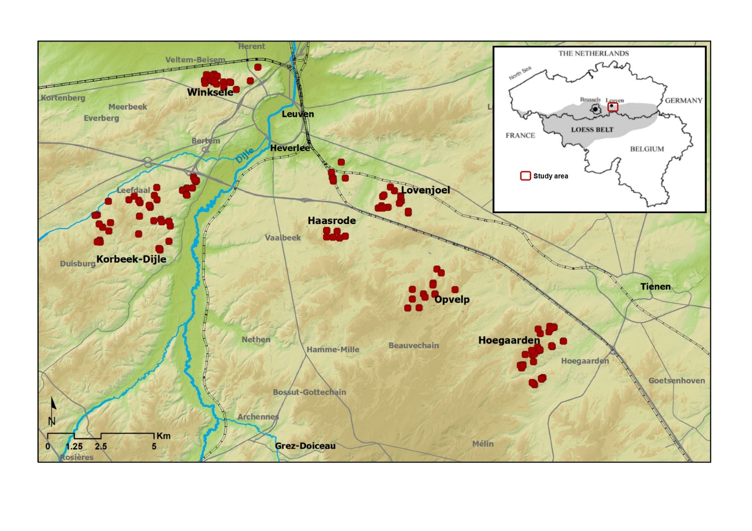 Figure 3: Location of the study area and the surveyed sunken lanes in the loess belt around Leuven, Central Belgium. Each dot represents one sunken lane (n = 132) (based on LIDAR data). Map of the loess belt in Belgium is adapted from Knapen (2007).
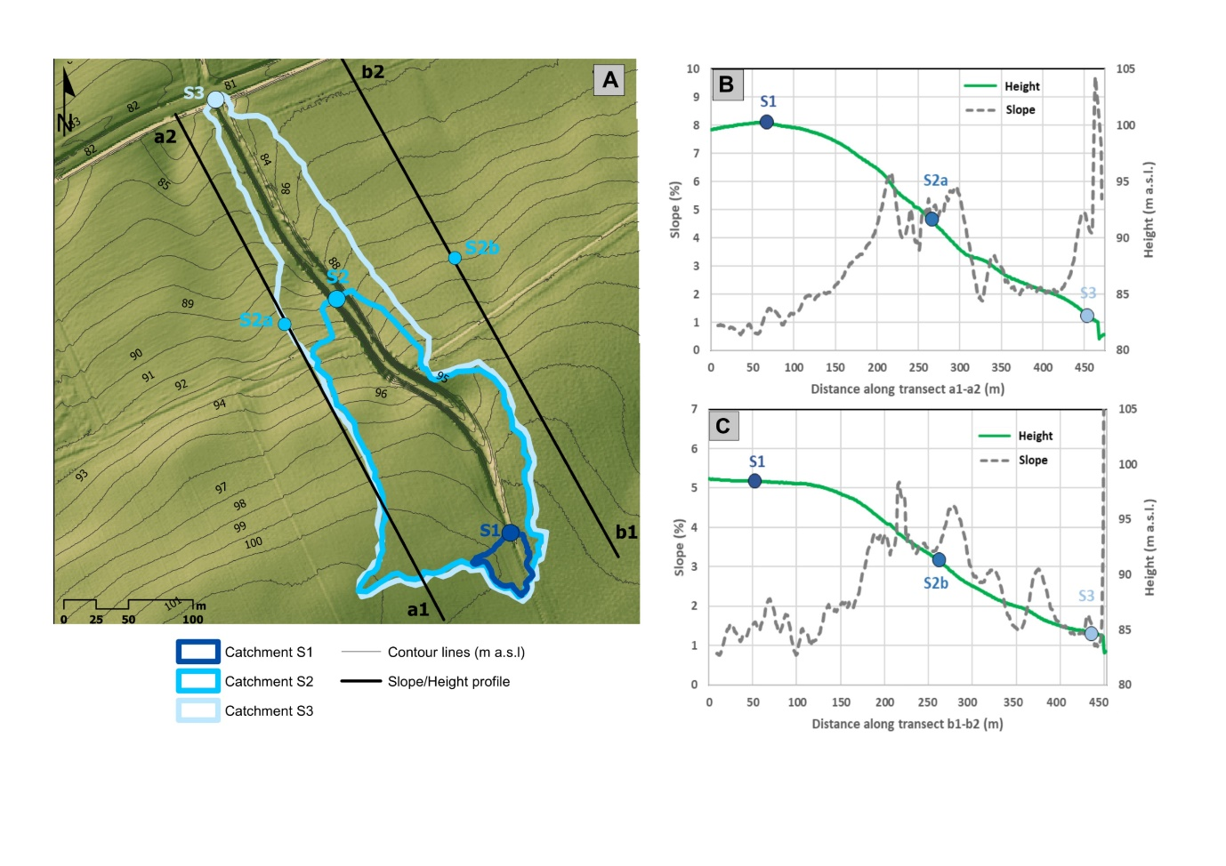 Figure 4: Illustration of the methodology applied for extracting relevant geomorphic properties of a sunken lane in Hoegaarden (see Error: Reference source not found and Figure 5d; coordinates S1: 50°47'24.87"N 4°52'51.08"E). Inset (a): hillshade map (complemented with contour lines with a 1 m interval) showing the sunken lane as well as the catchment areas at the current head (S1), the initiation point (S2) and the sedimentation point (S3) of the sunken lane. Also the transects a1-a2 and b1-b2 used to calculate the average slope at the steepest part of the sunken lane (S2a and S2b) are shown. Inset (b) and (c): slope and height profiles along the transects a1-a2 and b1-b2 as drawn in figure 4a, indicating the location of the steepest slope.
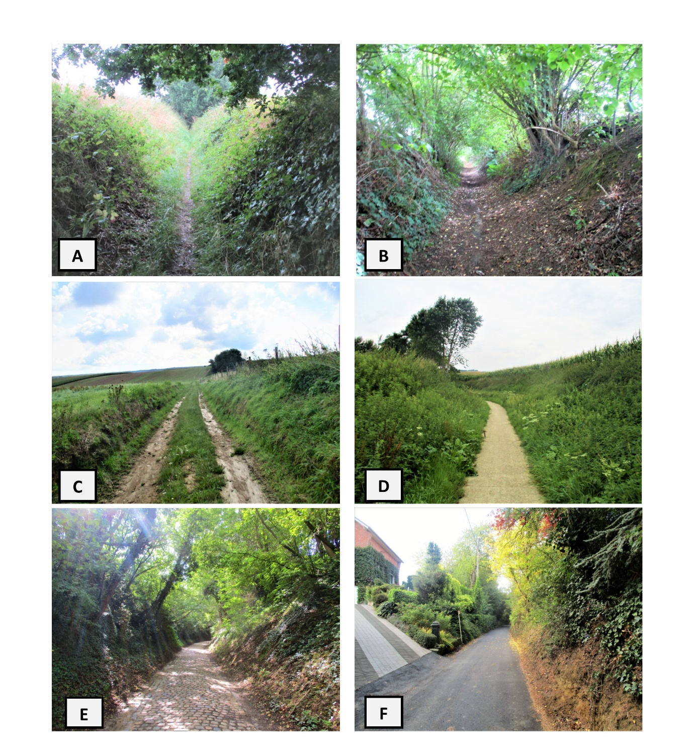 Figure 5: Examples of surveyed sunken lanes in (a) Opvelp, (b) Lovenjoel, (c) Korbeek-Dijle, (d) Hoegaarden, (e) Haasrode, (f) Winksele (All photos are taken in August and September 2017).
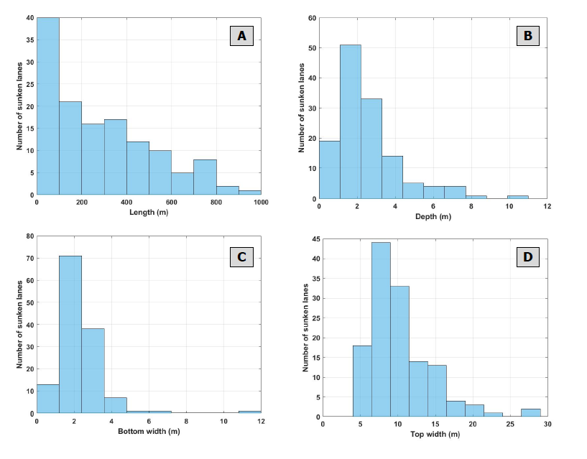 Figure 6: Frequency distributions of the (a) total length of the sunken lanes, and the (b) depth, (c) bottom width and (d) top width of the sunken lanes at the initiation point S2, cf. Figure 1 (n = 132).
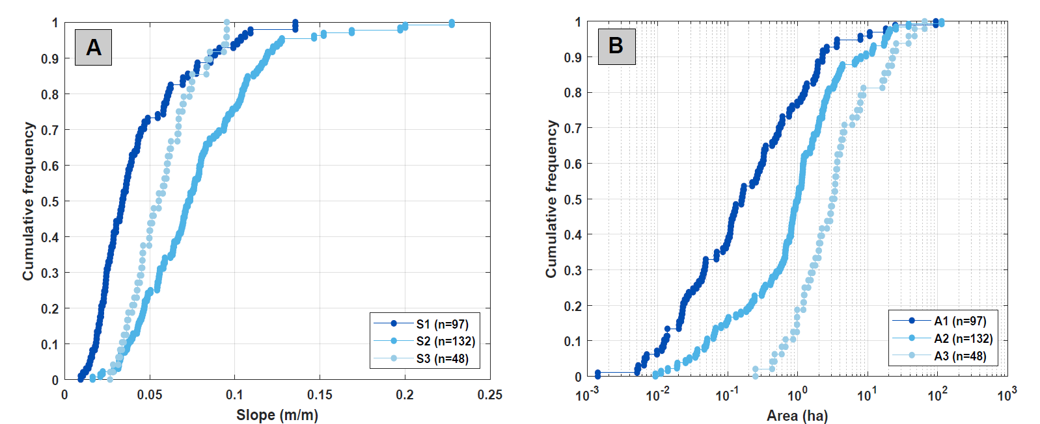
Figure 7: Cumulative frequency diagrams of (a) the soil surface slope steepnesses of the surrounding land over a transect of 10m at the start (S1), the initiation point (S2) and the end (S3) of the sunken lane, and (b) of the contributing areas corresponding to respectively the start (A1), the initiation point (A2) and the end (A3) of the sunken lanes (see also Figure 4).
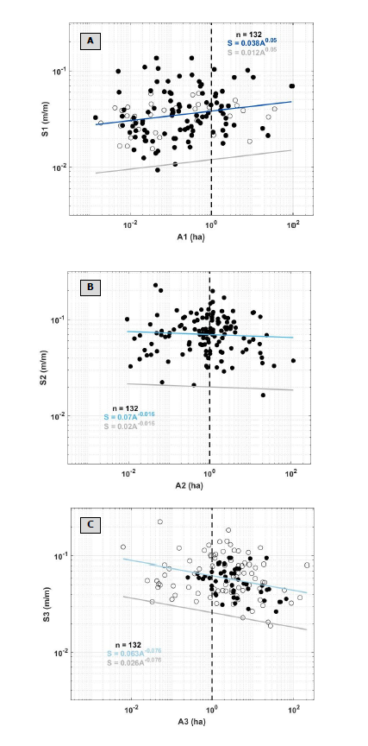
Figure 8: Scatterplots and orthogonal regressions of the contributing area (A) and slope steepness (S) at (a) the beginning of the sunken lanes (A1-S1) (b) the initiation point of the sunken lanes (A2-S2), and (c) the end point of the sunken lanes (A3-S3). The mean orthogonal threshold lines are indicated in blue, while the corresponding lower threshold lines are indicated in grey. Equations of the fits are given in the figure. For the top and lower figures, black dots indicate begin/end points that are undisturbed by other roads (97 for S1-A1, 48 for S3-A3), while white dots indicate sunken lanes where the beginning or endpoint of the sunken lane is affected by another sunken lane (35 for S1-A1, 84 for S3-A3).
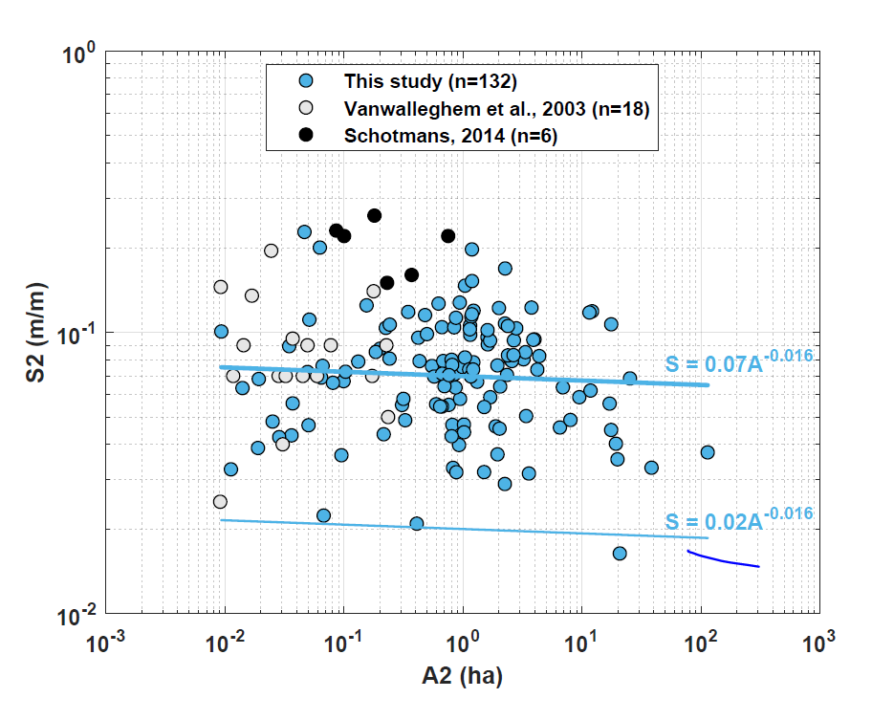
Figure 9: The slope steepness (S2) and contributing area (A2) of the sunken lane initiation points studied in this study, as well as the mean (thick line) and lower (thin line) topographic threshold line. For comparison data points from other studies of road gullies under forest in Central Belgium are added (Vanwalleghem et al., 2003 and Schotmans 2014).
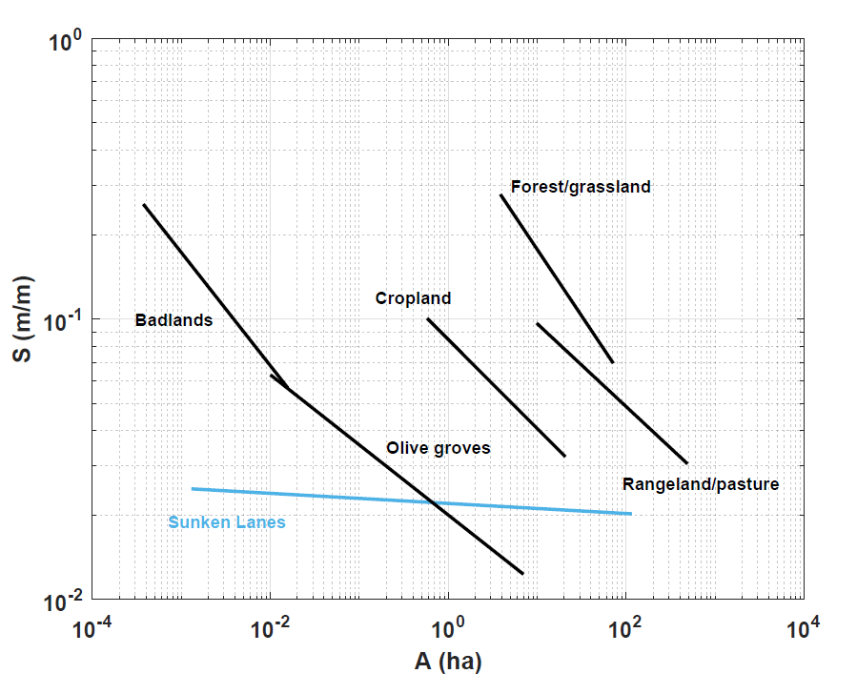
Figure 10: Comparison of the lower topographic threshold lines of gully initiation across different land uses (adapted from Torri and Poesen, 2014) and the lower topographic threshold of sunken lanes at the initiation point (A2-S2; see Figure 1, 4 and 9) identified in this study (in blue).
Table 1: Overview of published research on sunken lanes in Europe and their research focus. The number of each study corresponds to the numbers indicated on Figure 2.
Country | Studies | Research focus
Belgium | (1) Deckers, 2005; (2) DBLH, 2012; (3) Martens, 2013; (4) RLD, 2004; (5) RLH and Proclam, 2009; (6) RLHV, 2017 | Ecology
 | (7) This study; (8) Schotmans, 2014; (9) Vanwalleghem et al., 2003 | Topographic thresholds
 | (10) Poesen, 1989; (11) Poesen, 1993; (12) Poesen et al., 2018; (8) Schotmans, 2014; (9) Vanwalleghem et al., 2003 | Historical origin and spatial distribution
 | (13) Poesen, 2018; (14) Verstraeten et al., 2009 | Soil erosion
Czech Republic | (15) Zlatuska, 2012 | Soil erosion
France | (16) Levavasseur, 2012; (17) Gasceul-Odoux, 2011 | Hydrology
Germany | (18) Baier et al., 1993; (19) Denecke, 1969; (20) Strassman, 2004 | Historical origin and spatial distribution
 | (18) Baier et al., 1993 | Ecology
Hungary | (21) David et al., 2011 | Morphology
Poland | (22) Kroczak, 2012; (23) Kroczak et al., 2016; (24) Nowocien and Podolski, 1992; (25) Rodzik, 2006; (26) Zglobicki and Baran-Zglobicka, 2011; (27) Kołodyńska-Gawrysiak et al., 2011 | Origin and development
 | (28) Froehlich and Walling, 1997 | Hydrology
 | (29) Gardziel and Rodzik, 2001; (30) Rodzik et al., 2015; (31) Superson et al., 2016; (32) Superson et al., 2014 | Morphology
 | (33) Warowna et al., 2016; (34) Zglobicki et al., 2014 | Geotourism
Serbia | (21) David et al., 2011 | Morphology
Switzerland | (20) Strassman, 2004 | Historical origin and spatial distribution
United Kingdom | (35) Way, 1977 | Ecology
 | (36) Barton, 1987; (37) Gallois and Porter, 2006 | Geological and geotechnical aspects
 | (38) Boardman, 2013; (39) Boardman, 2014; (40) White, 1788 | Hydrology

