Land cover changes in SEA of port development in the Vung Tau area (South Vietnam)

Rutten Cindy., Binh Dao Kim Nguyen Thuy & Hens Luc.

Abstract

The Vung Tau area, especially the area near the Thi Vai River downstream of Ho Chi Minh City and Vung Tau City, in the South of Vietnam, is one of the fastest growing and developing areas of the country. Many ports and port related industry (steel industry, food industry etc.) have been developed or are planned for the near future. This has major consequences for the land use in the area.

Using 3 SPOT images (1995, 2000 and 2005), land use changes were studied using ENVI 3.6 and ArcGIS 8.1.
Fifteen different classes of land use have been identified, including aquaculture, settlement, plantation, natural forest, annual crops, etc.

The results show (1) an increase of 62% of the urbanisation areas, especially near the national road, which connects the port developments, but also in Vung Tau City (2) a shift from agricultural land to industrial land (industry, ports, etc.) (3) an increase of planted mangrove forest by 95% and a decrease of the natural forest by 50%.

In conclusion, the port developments have complex and vast impacts on the land use, mainly in the field of urbanisation and industrial land use. The new master plan will strengthen this evolution.

1 Introduction

The Vung Tau area is a very fast developing economic zone East of Ho Chi Minh City, in the South of Vietnam. Many ports and industrial developments including steel companies, storage areas, food processing plants, packaging factories etc. have been built during the recent decade. This area however, is located near one of the most valuable mangrove areas of the country, the Can Gio mangrove forest.

These developments have multiple impacts, which have been assessed separately. However, no integrated assessment, which addresses also the cumulative impacts is already performed. This paper addresses land use changes (LUC) during the period 1995-2005. The results are compared with LUC as they can be forecasted on the basis of the strategic development plan (2005-2020) for the area. The study is part of a strategic environmental assessment (SEA) in which next to LUC also cumulative effects in water, noise and vibrations, air and light, socio-economics, health, safety, fauna and flora, soil, archaeology and cultural history are addressed.

2 Materials and methods

2.1 Study area

The study area is a rectangular zone of 43 by 16 km (figure 1). The rectangle is bordered by the following edges:
- E107°12’/N10°22’
- E107°03’/N10°18’
- E106°54’/N10°41’
- E107°03’/N10°45’

The study area includes mainly the Western part of Ba Ria Vung Tau (part of Tan Thanh district, Ba Ria Town and Vung Tau City), the Can Gio District (Ho Chi Minh City) and the Nhon Trach District (Dong Nai province).

The main industrial developments occurred at the left bank of the Thi Vai River in an area that is bordered by the river in the West and by the national road in the East. Along the road the main changes in urbanisation are found. Along the river, during the period 1995-2005 the ports of Phu My, Ba Ria Serece, Cai Mep Interflour port, Holcim port, Cat Lo Vung Tau fishery port, PTSC petrol port, VietsovPetro port, Vung Tau PV gas port, etc. were established along the river. At the same time industrial zones were developed in between the river and the national road.

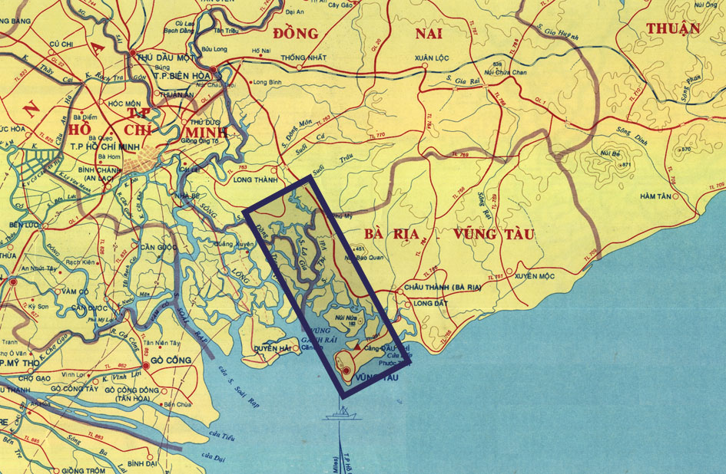

Figure 1: Location of the study area [1]

2.2 Master plan

The Ministry of Transport (MOT) edited in 1999 a general Master Plan for the port developments in the Ho Chi Minh City – Thi Vai – Vung Tau area. Figure 2 shows that there are 4 main port areas [2]:
- Soi Rap River area: situated along the Sai Gon river, contains different general cargo and multipurpose terminals like Vietnam International Container Terminal and Cat Lai port
- Sai Gon Port: along the Soi Rap river (oil terminal, coal and bulk terminal, etc.)
- Vung Tau Port Complex: along the Vung Ganh Rai Bay and Dinh River including ports like Long Son port, Vung Tau International port and Vietson Petro Offshore Supply port
- Thi Vai – Cai Mep area: along the Cai Mep and Thi Vai river, including Baria Serece port, Go Dau port, PMPC PVC Terminal & Port, etc.
This master plan is mainly developed to prevent unplanned development and to support the socio-economic master plan by focusing on important economic areas.
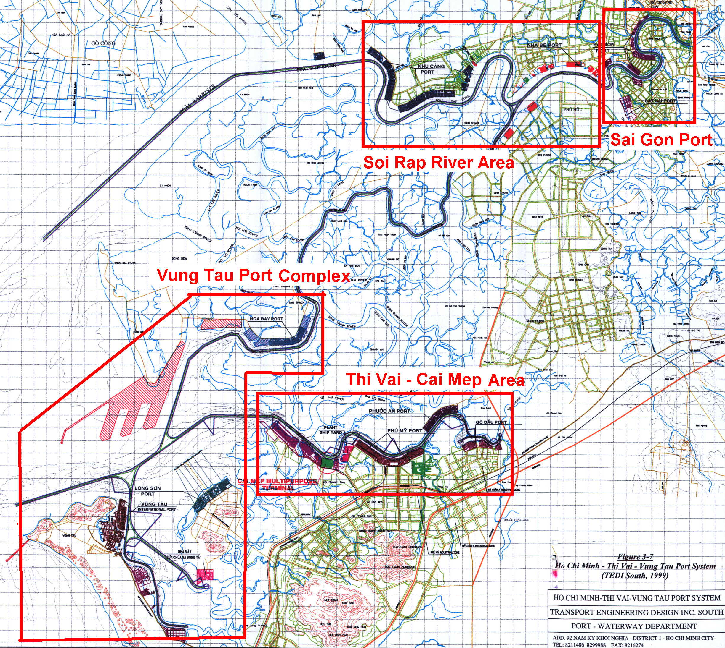

Figure 2: Master plan

On the 12th of August 2005 a new master plan was approved by the Prime Minister for the port developments in Ho Chi Minh City - Dong Nai - Ba Ria - Vung Tau (sea port group no. 5) up to 2010 and development orientation up to 2020. This master plan includes the extention of the already existing ports and a series of new ports (around 21 ports) to be developed in the study area [3].

2.3 Materials and tools

1 topographic map and 3 SPOT images are used in the study:
- Topographic map (1993), Scale 1/50 000, compiled by the Vietnamese Topographic Publishing Department. The land cover has the following classifications: natural forest, shrub, plantation forest, rice field, bare land and long-term tree.
- SPOT 1995: 3 277-329, 95-02-25, 03:18:08, 1 X Level 2A SAT 0
- SPOT 2000: 4 277-329, 00-03-01, 03:23:55, 2 I Level 2A SAT 0
- SPOT 2005: 4 277-329, 05-02-23, 03:25:33, 1 I Level 2A SAT 0

The following software and instruments are used in the project:
- ENVI 3.6: to interpret satellite images and transform raster into vector format.
- ArcGIS 8.1: is used for developing thematic maps
- GPS: Gamin III: to determine the coordinates of sites where land use is surveyed
- Ground truth check: to check the results in the field
- Questionnaires: to find out the land use in the past and present. This is of particular importance for areas of which classification is uncertain and cloud cover is present on the satellite images

2.4 Methods

On the SPOT images, a geometric correction is performed using 2 methods: image-to-image and image-to-map. Image-to-map is used for the SPOT images of 1995 and 2000, because of the lack of a standard SPOT image of the area. Image-to-image is used for the SPOT image of 2005. The reference image is SPOT 1995, which is corrected by the image-to-map method. The images are stretched and filtered to allow visual interpretation.

Visual interpretation of the images is the first step of the analysis. This helps the interpretation of the computer analysis. The main land use categories that can be automatically recognized are forests, aquaculture, rivers, canals, settlements, bare land and humid land.

To analyze the vegetation the Normalized Difference Vegetation Index (NDVI) is used [4]. The values can range between -1 and +1. High NDVI values indicate green vegetation (figure 3). A clear distinction can be made between mangrove forest, coconut plantations, nipa palm (Nipa Fruticans), trees and rice fields. Figure 3 shows that the areas with a light white color have the highest density of vegetation. Black coincides with the sea, rivers, canals and lakes. Dark gray is aquaculture. The others are a combination of settlements, industry, trees or annual crops.

The unsupervised classification is done by the Isodata method [5]. By this method 7 land use categories are identified. Hereafter, the supervised classification is performed with the maximum likelihood classification. The results are 15 categories of land use as shown in figure 4. Finally the classification is tested with the kappa coefficient, which is very good (SPOT 1995: 0,94; SPOT 2000: 0,95; SPOT 2005: 0,97). This means that there is an almost perfect agreement between the ground truth checks and the classified image.

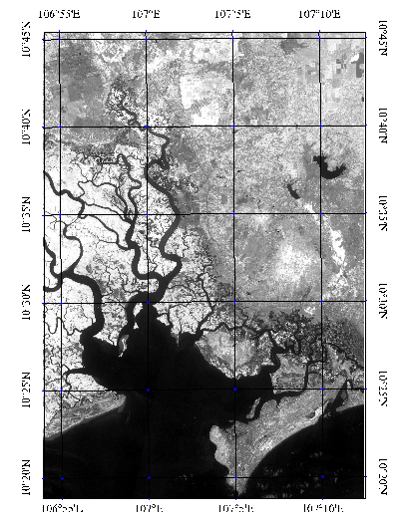
No vegetation
Full vegetation

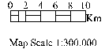

Figure 3: SPOT image after using NDVI analysis (2005)

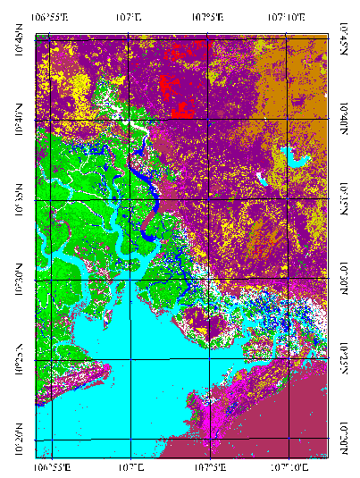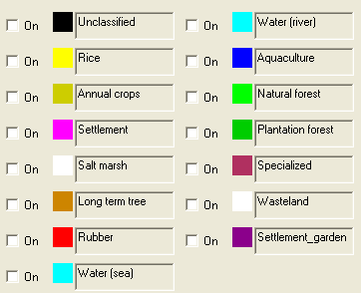
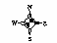

Figure 4: Maximum likelihood classification SPOT (2005) image

Ground truth checks with GPS and questionnaires are performed to distinguish between the various characteristics of the land use categories. Ground truths checks are equally important because of the SPOT image 2000 has a cloud cover of 6.431,5 ha, which is 12,76% of the total study area. On August 8, 2005, 4 land management officers were interviewed using questionnaires to address this problem. The aim of the questionnaires was to define more precisely the land use. The questionnaires deal with 3 aspects of land use: location (such as coordinates of the interviewer, name of communities, etc.), land use (list all land use categories of the study area) and year (1995, 2000 and 2005).

The total study area is 82.055,23 ha. However, due to technical reasons (the SPOT image of 1995 misses part of the study area) 1.762 ha is lost at the top left corner. Therefore this area was not considered in the 2000 and 2005 pictures. The result is that a small part (2%) of the study area is not assessed. However, this has no important impacts on the results in this study. The main areas of development are covered.

Table 1 presents a summary of the above-explained method.

Step | Method | Software
Digital basic map | Digitizer | Auto cad
Interpreting SPOT images  Pre-Processing  - Geometric correction  - Image enhancing  - Processing  Visual interpretation  Unsupervised classification  Supervised classification  Accuracy assessment | Level 1G correction, image to map  Stretching, filter  NDVI, DEM  Experience, questionnaire, GPS  Iso data  Collect sample, maximum likelihood  Kappa confident | ENVI
Transfer to vector |  | ArcGIS
Building of land cover map |  | ArcGIS
Field check | Field trip (questionnaire) | GPS
Building of land cover change maps | Overlay | ArcGIS

Table 1: Summary of the study method

3 Results

The landscape in the study area is diverse: it contains plains, hills and mountains together with canals, rivers and a coastal area.

Land use in the study area can be categorised in 6 main land cover uses:
- Agriculture: rice, annual crops (such as maize, onions, and chilli), long term tree (including industrial trees such as coffee, tea, and fruit trees) and rubber
- Forest (mangroves): forest plantations and natural forest
- Specialized land: specific industrial purposes (such as industrial parks, barracks, ports, salt-marshes and the airport)
- Aquaculture: shrimp monoculture (in ponds) and shrimp forest (mangrove and shrimp simultaneous)
- Settlement: settlement (without garden), settlement-garden (residential houses with garden that contain long term tree or vegetables)
- Wasteland (land that is not used for one of the above listed uses)

Table 2 shows the absolute and percentage values of land use categories in the study area for 1995, 2000 and 2005. Figure 5 shows the change in a visual way for every category.

Category | 1995 |  | 2000 |  | Change 1995-2000 (%) | 2005 |  | Change 2000-2005 (%) | Change 1995-2005 (%)
Category | Area (ha) | % | Area (ha) | % | Change 1995-2000 (%) | Area (ha) | % | Change 2000-2005 (%) | Change 1995-2005 (%)
Annual crops | 2.075,45 | 2,58 | 1.803,42 | 2,25 | -13,11 | 1.090,73 | 1,36 | -39,52 | -47,45
Rice | 3.309,02 | 4,12 | 4.586,87 | 5,71 | 38,62 | 1.842,88 | 2,30 | -59,82 | -44,31
Rubber | 1.764,81 | 2,20 | 1.836,81 | 2,29 | 4,08 | 1.963,24 | 2,45 | 6,88 | 11,24
Long term tree | 13.056,03 | 16,26 | 12.941,48 | 16,12 | -0,88 | 9.568,91 | 11,92 | -26,06 | -26,71
Aquaculture | 2.277,90 | 2,84 | 2.832,75 | 3,53 | 24,36 | 3.851,05 | 4,80 | 35,95 | 69,06
Shrimp forest |  |  |  |  |  | 352,40 | 0,44 | 100,00 | 100,00
Natural forest | 9.764,40 | 12,16 | 6.745,02 | 8,40 | -30,92 | 4.915,05 | 6,12 | -27,13 | -49,66
Planted forest | 5.443,61 | 6,78 | 9.823,00 | 12,23 | 80,45 | 10.622,00 | 13,23 | 8,13 | 95,13
Specialized land | 1.176,69 | 1,47 | 1.337,08 | 1,67 | 13,63 | 4.628,94 | 5,77 | 246,20 | 293,39
Salt marsh | 3.398,96 | 4,23 | 1.252,57 | 1,56 | -63,15 | 1.475,15 | 1,84 | 17,77 | -56,60
Settlement | 1.565,43 | 1,95 | 1.594,23 | 1,99 | 1,84 | 9.422,15 | 11,73 | 491,02 | 501,89
Settlement garden | 5.715,08 | 7,12 | 7.393,00 | 9,21 | 29,36 | 2.406,52 | 3,00 | -67,45 | -57,89
Wasteland | 2.898,61 | 3,61 | 299,00 | 0,37 | -89,68 | 307,00 | 0,38 | 2,68 | -89,41
Hydrology | 9.990,00 | 12,44 | 9.990,00 | 12,44 | 0,00 | 9.990,00 | 12,44 | 0,00 | 0,00
Hydrology (sea) | 17.857,00 | 22,24 | 17.857,00 | 22,24 | 0,00 | 17.857,00 | 22,24 | 0,00 | 0,00
Total | 80.293,00 | 100,00 | 80.292.23 | 100,00 |  | 80.293,00 | 100,00

Table 2: Land use categories for 1995, 2000 and 2005

Figure 5: Evolution in time for every land use category

The data in table 2 and figure 5 show that the most important change concerns the settlements. These increased between 1995 and 2005 with 502%. This change occurred mainly during the last 5 years. The urbanisation especially increased along the national road, near the new ports, and in Vung Tau City.

An additional change concerns the so-called “specialized areas”. Their surface increased between 1995 and 2005 with 293%. Also this change happened predominantly during the last 5 years. It is closely related to the appearance of industrial zones in the Phu My and Tan Thanh districts, in Vung Tau City (Ba Ria Vung Tau province) and in the Nhon Trach district (Dong Nai province) (figure 6).

The areas for annual crops, rice and long term trees decrease during the study period (respectively by -47% or 985 ha, -44% or 1.466 ha, -27% or 3.487 ha). Consequently, agricultural land as a whole declines. Again this mainly happened during the last 5 years. In 1995, agriculture was mainly situated in the Nhon Trach district and partly in the East of the study area, along the national road. In 2005, agriculture is mainly situated in the East (figure 6).

Over the whole study period, the mangrove area increased to a limited extend (329 ha). However during the last 5 years it decreased. Between 1995 and 2005 the natural forest decreased by 50%, or 4.849 ha. However, the planted forest increased by 95% or 5.178 ha. The shift from natural forest to forest plantation occurred mainly between 1995 and 2000. Overall, the forest area increased between 1995 and 2000 by 1.360 ha, as a result of the reformed forest policies. However between 2000 and 2005 the forest area decreased with 1.031 ha. So, in total the forest (mangrove) area increased over the last 10 years, but since the main developments started it decreased again. In 2005 the forests are mainly situated in the West and Northwest of the study area (figure 6).

Wasteland also decreased substantially. Between 1995 and 2005 there was a decrease of 89%, or 2.592 ha. This change mainly happened between 1995 and 2000 (-90%). During this period land that was not used 10 years ago is now mainly used for forest plantations.

In 2005 the mangrove-shrimp farming systems, where shrimp farming in the mangroves is practised, appears as a land use that was not found before. In these areas, mangroves occupy 50% to 70% of the land. The remaining part is used for shrimp farming.

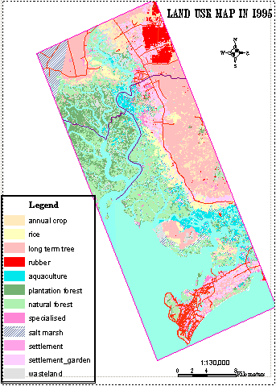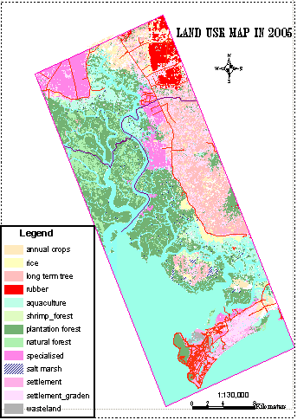

Figure 6: Evolution of land use between 1995 and 2005

4 Discussion and conclusion

The results of the land use changes show that the main impacts of the port development in the study area affect human settlements and “specialised area”.

The human settlements increased fastly mainly during the last 5 years. These results are in line with the results of the socio-economic section of the SEA [6]. Between 1996 and 2003, the population in Ba Ria Vung Tau increased with 23%, mainly as a result of migration. The socio-economic study also showed that most people working in the factories in the study area originate from other Vietnamese provinces (56%). This links a high migration rate with job opportunities, which come along with the port developments.
The area where gardens are combined with settlements decreased, from 5.715 in 1995 ha to 2.407 ha in 2005. More people tend to live in the urban areas characterised by much less green than before. This equally coincides with the data of the socio-economic research, which showed that the urban population increased faster than the rural population (between 1996 and 2003: urban population with 43% and the rural population with 11%) [6]. Especially along the national road, a high urbanisation is obvious. People tend to live close near the port developments, where the job opportunities are located.

In the study area agricultural fields are converted into “specialized land” including ports, factories, storage areas, etc. Industry occupies an important area. The economic performance indicators of the region also show this. Industry has a GDP of more than 80%, while agriculture only counts for 4% [6].

Forest plantations replace natural forest. This is the result of a successful governmental policy to replant mangroves. The net effect of the policy is that the mangroves do not disappear as one might expect on the basis of the clearing of natural mangrove forest. However, caution is needed for the future. It is obvious that the last 5 years a decrease is noticed. This is exactly during the period that the developments started. The new master plan of 2005 has approved more developments, which can contribute to a reduction of mangroves.

When comparing these results with other studies, mainly the same impacts occur. In the coastal zone of the Zhujing Delta in China for example, rapid industrialisation and urbanisation resulted in a decrease of agricultural area. Urban or built-up land increased by 48%, cropland decreased with 48% between 1989 and 1997 [7]. On the Mississippi Gulf Coast in the US, considerable land changes have been described. Over a period of 10 years (between 1990 and 2000), a fast population growth occurred. This resulted in changes of mainly small fishing communities to a complex mixture of residential, commercial and industrial urban area combined with mass tourism. The urban/built up area increased with 53%. Non-forested types of vegetation and wetland or marsh features experienced the greatest reduction (forest vegetation: 30%, coastal marshes: 35%. Forest vegetation also decreased, but only with 9%, which is still limited [8].

Many ports are already built in the study area accompanied with industrial zones. The study area contains or will contain 10 industrial zones of which one in the Dong Nai province and the other 9 in Ba Ria Vung Tau. These ports are mainly built after the approval of the master plan of 1999. The new master plan of 2005, extents the one of 1999. The new master plan describes the extension of the already existing ports and the new ports. Around 21 ports are planned. These will inevitable change the land use in a major way in the years to come. On the basis of the land use analysis over the last 10 years it is expected that the impacts will continue. The urbanisation will continue to increase and the agriculture will continue to decrease. Although, there is still a lot of mangrove area, this new master plan will probably decrease this area significantly, which is in contradiction of the aims of the mangrove reform policy.

References

[1] OSTC (2004). Integrated and Strategic Environmental Impact Assessment of Port Developments in the Vung Tau Area (project proposal).

[2] Rutten C, De Clercq, Hens L, Huygens M (2005). Integrated and Strategic Environmental Environmental Impact Assessment of Port Developments in the Vung Tau Area (South Vietnam): Progress report 1.

[3] Decision 791/QDĐ-TTg: Details of the Master Plan for Seaports Group No.5 by the Year of 2010 and Development Orientation up to the Year of 2020 (2005). Http://www.vpa.org.vn.

[4] Jensen JR (1986). Introductory Digital Image Processing. Prentice-Hall. New Jersey.

[5] Tou JT & Gonzalez RC (1974). Pattern Recognition Principles. Addison-Wesley Publishing Company. Massachusetts.

[6] Rutten C & Hens L (2005). Integrated and Strategic Environmental Impact Assessment of Port Developments in the Vung Tau Area (South Vietnam). Report Socio-Economics. Free University of Brussels.

[7] Qihao Weng (2002). Land Use change analysis in the Zhujiang Delta of China Using Satellite emote Sensing, GIS and Stochastic Modelling. Journal of Environmental Management, 64, 273-284.

[8] Johnson A, Truax DD, O’Hara CG, Cartwright J (2002). Remote Sensing, GIS, and Land Use and Land Cover Mapping Along the I-10 Corridor.

Ms Rutten Cindy. Human Ecology Department. Free University of Brussels (VUB). Laarbeeklaan 103, 1090 Brussels, Belgium. E-mail: Cindy.Rutten@vub.ac.be
Ms Binh Dao Kim Nguyen Thuy. Sub-Institute of Geography. Vietnam. E-mail: daobinh25@yahoo.com
Prof. Dr. Hens Luc. Human Ecology Department. Free University of Brussels (VUB). Laarbeeklaan 103, 1090 Brussels, Belgium. E-mail: Human.Ecology@vub.ac.be

