Electronic Supplementary Information (ESI) for J of Luminescence

Supporting Information
Excitation energy deactivation funnel in 3-substituted BODIPY-porphyrin conjugate
Nguyen Tran Nguyen,^{a,b} Bram Verbelen,^{b} Volker Leen,^{b} Etienne Waelkens,^{c} Wim Dehaen^{*b} and Mikalai Kruk^{*d}
ªChemistry Department, University of Education, The University of Da Nang, Ton Duc Thang 459, Da Nang, Viet Nam
^{b}Molecular Design and Synthesis, Department of Chemistry, KU Leuven, Celestijnenlaan 200F, B-3001 Leuven, Belgium. Email: wim.dehaen@kuleuven.be; Fax: +32 16 32 79 90; Tel.: +32 16 37 25 68
^{c}Department of Cellular and Molecular Medicine, KU Leuven, Herestraat 49, box 901, 3000 Leuven, Belgium
^{d}Belarusian State Technological University, Physics Department, 220006, Sverdlov Str., 13a, Minsk, Belarus. E-mail: m.kruk@belstu.by , krukmikalai@yahoo.com Fax: +375 17 226 14 32; Tel: +375 17 399 49 60;

a | 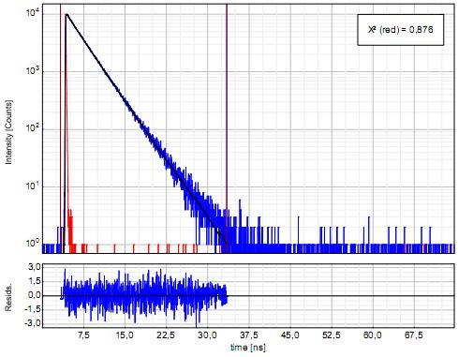
b | 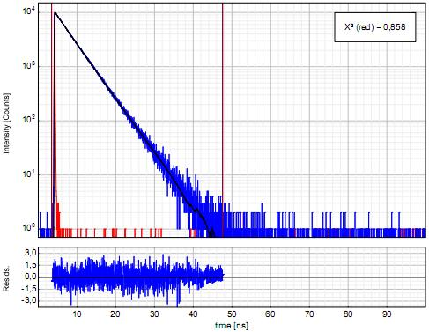
c | 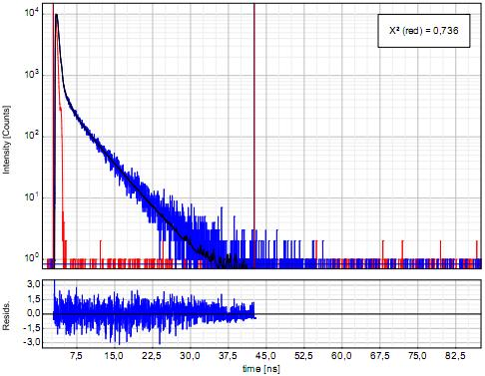
Figure 1S BODIPY fluorescence decays profiles along with corresponding multiexponential fits for: (a) BODIPY 6 in toluene; (b) ZnP-BODIPY conjugate 12 in toluene; (c) ZnP-BODIPY conjugate 12 in THF.

Figure 2S Absorption and fluorescence spectra of porphyrin 11. Visible range of absorption spectrum is multiplied by factor 10. Fluorescence excitation was achieved at 545 nm.

Figure 3S Absorption and fluorescence spectra of BODIPY 7. Fluorescence excitation was achieved at 585 nm.
Synthesis of 8-[4,6-bis(3,5-bis(tert-butyl))phenoxy-pyrimidin-5-yl]BODIPY (3). 8-(4,6-Dichloropyrimidin-5-yl)-BODIPY (1) (100 mg, 0.29 mmol, 1 equiv) and 3,5-di-tert-butylphenol (182 mg, 0.88 mmol, 3 equiv) were dissolved in CH₃CN (5 ml). Then K₂CO₃ (122 mg, 0.88 mmol, 3 equiv) and a catalytic amount of 18-crown-6 (23 mg, 0.3 equiv) were added and the reaction was carried out at 40 ºC under N₂ atmosphere for 6 hours. The reaction mixture was extracted with CH₂Cl₂ and the combined organic layers were washed three times with distilled water, dried over MgSO₄, filtered and evaporated under reduced pressure. The crude product was purified through column chromatography (silica, CH₂Cl₂/petroleum ether 1:1) and recrystallized in CH₃OH to obtain 8-[4,6-bis(3,5-bis(tert-butyl))phenoxy-pyrimidin-5-yl]BODIPY (3) (80%) as an orange solid with a green luster. M.p 190-192 ºC. ¹H NMR (300 MHz, CDCl₃, 25 ºC, TMS): δ = 8.48 (s, 1 H, H-pyrimidine), 7.95 (s, 2 H, H-pyrrole), 7.28 (s, 2 H, H-Ar), 7.13 (d, ³J_{H,H} = 3.78 Hz, 2 H, H-pyrrole), 6.85 (s, 4 H, H-Ar), 6.60 (d, ³J_{H,H} = 3.18 Hz, 2 H, H-pyrrole), 1.30 ppm (s, 36 H, tert-butyl). ¹³C NMR (75 MHz, CDCl₃, 25 ºC, TMS): δ = 158.83, 144.98, 129.83, 120.00, 118.83, 115.45 (CH-Ar), 168.57, 152.44, 151.98, 136.64, 135.46, 99.82 (C-Ar), 34.99 (C, tert-butyl), 31.32 ppm (CH₃, tert-butyl). HRMS (EI): m/z calcd for C₄₁H₄₉BF₂N₄O₂: 678.392 [M⁺]; found: 678.369 [M⁺].
Synthesis of 4-triisopropylsilylethynyl-β-nitrostyrene (5). 4-Triisopropylsilylethynylbenzaldehyde⁸ (300 mg, 1.05 mmol, 1 equiv), nitromethane (320 mg, 5.24 mmol, 5 equiv) and ammonium acetate (80 mg, 1.05 mmol, 1 equiv) were added to glacial acetic acid (3 ml). The resulting solution was refluxed at 100 ºC overnight. The crude product was then purified on a silica column (eluent CH₂Cl₂/petroleum ether 3.5:6.5) and 4-triisopropylsilylethynyl-β-nitrostyrene (4.12) (68%) was obtained as a yellow oil. ¹H NMR (600 MHz, CDCl₃, 25 ºC, TMS): δ = 7.97 (d, ³J_{H,H} = 13.56 Hz, 1 H), 7 .57 (d, ³J_{H,H} = 13.56 Hz, 1 H), 7.52 (d, ³J_{H,H} = 8.28 Hz, 2 H, H-Ar), 7.48 (d, ³J_{H,H} = 8.28 Hz, 2 H, H-Ar), 1.13 ppm (s, 21 H, tert-butyl). ¹³C NMR (100 MHz, CDCl₃, 25 ºC, TMS): δ = 138.14, 137.44 (C=C), 132.88, 128.90 (CH-Ar), 129.73, 127.45 (C-Ar), 105.96, 95.26 (C≡C), 18.65 (CH₃, triisopropyl), 11.28 ppm (CH, triisopropyl). HRMS (EI): m/z calcd for C₁₉H₂₇NO₂Si: 329.181 [M⁺]; found: 329.181 [M⁺].
Synthesis of 3-[(4-triisopropylsilylethynyl)phenylethenyl]-8-[4,6-bis(3,5-bis(tert-butyl))phenoxy-pyrimidin-5-yl]BODIPY (6). 8-[4,6-Bis(3,5-bis(tert-butyl))phenoxy-pyrimidin-5-yl]BODIPY (3) (50 mg, 0.073 mmol, 1 equiv) and 4-triisopropylsilylethynyl-β-nitrostyrene (5) were dissolved in DMF (5 ml) and the resulting solution was stirred at 0ºC for a few minutes. K₂CO₃ (15 mg, 0.11 mmol, 1.5 equiv) and 18-crown-6 (30 mg, 0.11 mmol, 1.5 equiv) were then added. Subsequently, thiophenol (12 μl) was dissolved in DMF (0.5 ml) and added dropwise to the reaction mixture. The reaction was carried out at 0 ºC under N₂ atmosphere for 40 minutes. The reaction mixture was extracted with diethyl ether and the combined organic layers were washed three times with distilled water, dried over MgSO₄ and evaporated under reduced pressure. The crude product was purified by column chromatography (silica, CH₂Cl₂/petroleum ether 4:6) to yield BODIPY 4.13 (39.4 mg, 56%) as a dark blue solid with a copper luster. M.p 130-133 ºC.¹H NMR (600 MHz, CDCl₃, 25 ºC, TMS): δ = 8.47 (s, 1 H, H-pyrimidine), 7.82 (s, 1 H, H-pyrrole), 7.73 (d, ³J_{H,H} = 16.2 Hz, 1 H), 7.55 (d, ³J_{H,H} = 8.4 Hz, 2 H, H-Ar), 7.48 (d, ³J_{H,H} = 8.1 Hz, 2 H, H-Ar), 7.38 (d, ³J_{H,H} = 16.5 Hz, 1 H), 7.28 (s, 2 H, H-Ar), 7.15 (d, ³J_{H,H} = 4.38 Hz, 1 H, H-pyrrole), 7.03 (d, ³J_{H,H} = 4.74 Hz, 1 H, H-pyrrole), 6.98 (d, ³J_{H,H} = 3.3 Hz, 1 H, H-pyrrole), 6.86 (d, ⁴J_{H,H} = 1.5 Hz, 4 H, H-Ar), 6.55 (dd, 1 H, H-pyrrole), 1.30 (s, 36 H, tert-butyl), 1.14 ppm (s, 21 H, isopropyl). ¹³C NMR (75 MHz, CDCl₃, 25 ºC, TMS): δ = 168.76, 158.61, 158.06, 152.41, 152.09, 141.15, 138.43, 137.70, 135.75, 134.49, 132.53, 131.81, 130.71, 127.63, 126.50, 124.83, 119.93, 119.57, 117.99, 117.48, 115.48, 106.87, 100.19, 93.46, 34.99 (C, tert-butyl), 31.46 (CH₃, tert-butyl), 18.68 (CH₃, isopropyl), 11.33 ppm (CH, isopropyl). MALDI-TOF: m/z calcd for C₆₀H₇₅BF₂N₄O₂Si: 960.57 [M⁺], found: 960.59 [M⁺].
Synthesis of 3-[(4-ethynyl)phenylethenyl]-8-[4,6-bis(3,5-bis(tert-butyl))phenoxy-pyrimidin-5-yl]BODIPY (7). BODIPY 6 (39 mg, 0.04 mmol, 1 equiv) was dissolved in THF (6 ml) and the resulting solution was stirred at -78 ºC under N₂ atmosphere for a few minutes. Then TBAF (1 M solution in THF, 0.05 ml, 0.048 mmol, 1.2 equiv) was dissolved in THF (1 ml) and added dropwise to the reaction mixture. The reaction was conducted at -78 ºC for 30 minutes and the crude product was purified through a silica column (eluent CH₂Cl₂/petroleum ether 4:6) to obtain BODIPY-based terminal alkyne 7 (30 mg, 92%) as a dark blue solid with a copper luster. M.p 235-237 ºC. ¹H NMR (600 MHz, CDCl₃, 25 ºC, TMS): δ = 8.48 (s, 1 H, H-pyrimidine), 7.83 (s, 1 H, H-pyrrole), 7.74 (d, ³J_{H,H} = 16.5 Hz, 1 H), 7.57 (d, ³J_{H,H} = 8.46 Hz, 2 H, H-Ar), 7.50 (d, ³J_{H,H} = 8.4 Hz, 2 H, H-Ar), 7.37 (d, ³J_{H,H} = 16.14 Hz, 1 H), 7.28 (s, 2 H, H-Ar), 7.15 (d, ³J_{H,H} = 4.74 Hz, 1 H, H-pyrrole), 7.02 (d, ³J_{H,H} = 4.8 Hz, 1 H, H-pyrrole), 6.99 (d, ³J_{H,H} = 3.66 Hz, 1 H, H-pyrrole), 6.86 (d, ⁴J_{H,H} = 1.44 Hz, 4 H, H-Ar), 6.56 (d, 1 H, H-pyrrole), 3.19 (s, 1 H, ≡CH), 1.30 ppm (s, 36 H, tert-butyl). ¹³C NMR (100 MHz, CDCl₃, 25 ºC, TMS): δ = 168.77, 158.63, 157.82, 152.43, 152.12, 141.43, 137.99, 137.67, 136.34, 134.59, 132.63, 132.09, 130.67, 127.65, 126.73, 123.27, 120.00, 119.93, 117.91, 117.56, 115.48, 100.20 (C & CH-Ar), 83.48, 79.22 (C≡C), 35.00 (C, tert-butyl), 31.34 ppm (CH₃, tert-butyl). MALDI-TOF: m/z calcd for C₅₁H₅₅BF₂N₄O₂: 804.44 [M⁺], found: 804.44 [M⁺].
Synthesis of 5,10,20-tris(3,5-di-tert-butylphenyl)-15-(4-azidomethylphenyl) porphyrin (10). 4-Azidomethylbenzaldehyde (8)¹⁰ (130 mg, 0.80 mmol, 1 equiv), 3,5-di-tert-butylbenzaldehyde (9) (528 mg, 2.42 mmol, 3 equiv) and pyrrole (0.22 ml, 3.23 mmol, 4 equiv) were dissolved in dry CH₂Cl₂ (323 ml) and the solution was purged with N₂ for 15 minutes. BF₃·OEt₂ (0.03 ml, 0.24 mmol, 0.3 equiv), in dry CH₂Cl₂ (1 ml), was added dropwise and the resulting solution was stirred at room temperature for 1 hour (under N₂ atmosphere and protected from light by aluminium foil). Subsequently, p-chloranil (593 mg, 2.42 mmol, 2 equiv) was added in powder form and the mixture was heated at reflux for 1 hour. Et₃N (5 drops) was then added and the solution was stirred a few minutes to quench the excess of BF₃.OEt₂. The solvent was evaporated and then purification was carried out with column chromatography. The first flash column (silica, eluent CH₂Cl₂) was to remove dark tar and the second one (silica, CH₂Cl₂:heptane 3:7) was to separate the different porphyrin fractions. The second fraction was the pure product obtained as a purple solid (17%). ¹H NMR (300 MHz, CDCl₃, 25 ºC, TMS): δ = 8.90 (s, 6 H, H-pyrrole), 8.80 (d, ³J_{H,H} = 4.53 Hz, 2 H, H-pyrrole), 8.26 (d, ³J_{H,H} = 7.74 Hz, 2 H, H-Ar), 8.08 (s, 6 H, H-Ar), 7.79 (s, 3 H, H-Ar), 7.70 (d, ³J_{H,H} = 7.32 Hz, 2 H, H-Ar), 4.71 (s, 2 H, CH₂), 1.52 (s, 54 H, tert-butyl), - 2.70 ppm (s, 2 H, 2×NH). MALDI-TOF: m/z calcd for C₆₉H₇₉N₇: 1005.64 [M⁺], found: 1005.70 [M⁺].
Synthesis of Zn(II)-5,10,20-tris(3,5-di-tert-butylphenyl)-15-(4-azidomethylphenyl)porphyrin (11). 5,10,20-Tris(3,5-di-tert-butylphenyl)-15-(4-azidomethylphenyl)porphyrin (10) (80 mg, 0.08 mmol, 1 equiv) was dissolved in CHCl₃ (40 ml) and THF (2 ml). Zn(OAc)₂.2H₂O (70 mg, 0.32 mmol, 4 equiv) was then added and the solution was stirred at 40 ºC under N₂ atmosphere overnight. The resulting solution was washed three times with distilled water. The combined organic layers were dried over MgSO₄ and evaporated under reduced pressure. The crude product was then recrystallized in CH₃OH to obtain pure product as a purple solid in a quantitative yield. ¹H NMR (300 MHz, THF-d₈, 25 ºC, TMS): δ = 8.84 (s, 6 H, H-pyrrole), 8.80 (d, ³J_{H,H} = 4.32 Hz, 2 H, H-pyrrole), 8.21 (d, ³J_{H,H} = 7.53 Hz, 2 H, H-Ar), 8.09 (s, 6 H, H-Ar), 7.85 (s, 3 H, H-Ar), 7.74 (d, ³J_{H,H} = 7.53 Hz, 2 H, H-Ar), 4.75 (s, 2 H, CH₂), 1.53 ppm (s, 54 H, tert-butyl). ¹³C NMR (75 MHz, THF-d₈, 25 ºC, TMS): δ = 151.24, 151.16, 150.77, 149.21, 144.58, 143.71, 136.00, 135.49, 132.52, 132.47, 132.44, 131.88, 130.56, 130.38, 127.06, 122.62, 122.56, 121.44, 120.36 (C & CH-Ar), 55.36 (CH₂), 35.67 (C, tert-butyl), 32.07 ppm (CH₃, tert-butyl). MALDI-TOF: m/z calcd for C₆₉H₇₇N₇Zn: 1067.55 [M⁺], found: 1067.58 [M⁺].
Synthesis of BODIPY-porphyrin conjugate 12. BODIPY 7 (10 mg, 0.012 mmol, 1 equiv) and Zn(II)-5,10,20-tris(3,5-di-tert-butylphenyl)-15-(4-azidomethylphenyl)porphyrin (11) (20 mg, 0.018 mmol, 1.5 equiv) were dissolved in dry THF (1.5 ml) and the resulting solution was stirred at room temperature for a few minutes. [Cu(NCCH₃)₄][PF₆] (1.39 mg, 0.00375 mmol, 0.3 equiv) and Et₃N (3 drops) were then added to the reaction mixture. The reaction was carried out overnight at 60 ºC under N₂ atmosphere. Pure BODIPY-porphyrin conjugate 12 (19.7 mg, 84%) was obtained as a dark blue solid with a copper luster after column chromatography (silica, CH₂Cl₂ /petroleum ether/ethyl acetate 6:3.8:0.2). ¹H NMR (600 MHz, CDCl₃, 25 ºC, TMS): δ = 9.00 (m, 6 H, H-pyrrole), 8.89 (d, ³J_{H,H} = 4.56 Hz, 2 H, H-pyrrole), 8.48 (s, 1 H, H-pyrimidine), 8.26 (d, ³J_{H,H} = 7.74 Hz, 2 H, H-Ar), 8.08 (s, 6 H, H-Ar), 8.06 (s, 1 H, H-triazole), 7.97 (d, ³J_{H,H} = 8.22 Hz, 2 H, H-Ar), 7.83 (s, 1 H, H-pyrrole, BODIPY), 7.80 (d, 1 H), 7.78 (s, 3 H, H-Ar), 7.73 (d, ³J_{H,H} = 8.22 Hz, 2 H, H-Ar), 7.67 (d, ³J_{H,H} = 7.8 Hz, 2 H, H-Ar), 7.47 (d, ³J_{H,H} = 16.44 Hz, 1 H), 7.29 (s, 2 H, H-Ar), 7.17 (d, ³J_{H,H} = 4.14 Hz, 1 H, H-pyrrole, BODIPY), 7.07 (d, ³J_{H,H} = 4.56 Hz, 1 H, H-pyrrole, BODIPY), 6.98 (d, ³J_{H,H} = 3.66 Hz, 1 H, H-pyrrole, BODIPY), 6.87 (d, ⁴J_{H,H} = 0.9 Hz, 4 H, H-Ar), 6.56 (s,1 H, H-pyrrole, BODIPY), 5.92 (s, 2 H, CH₂), 1.51 (s, 54 H, tert-butyl), 1.31ppm (s, 36 H, tert-butyl). ¹³C NMR (100 MHz, CDCl₃, 25 ºC, TMS): δ = 168.82, 158.61, 152.43, 152.17, 150.56, 150.47, 150.44, 149.81, 148.60, 148.56, 147.85, 143.84, 141.80, 141.77, 140.87, 138.97, 137.79, 135.82, 135.00, 133.83, 132.46, 132.33, 132.23, 131.99, 131.64, 131.39, 130.81, 129.71, 129.59, 128.57, 126.27, 126.13, 122.78, 122.59, 120.83, 120.26,119.93, 119.35, 119.12, 118.08, 117.33, 115.51, 114.07, 100.31 (C & CH-Ar), 54.39 (CH₂), 35.04 (C, tert-butyl), 35.02 (C, tert-butyl), 31.76 (CH₃, tert-butyl), 31.36 ppm (CH₃, tert-butyl). MALDI-TOF: m/z calcd for C₁₂₀H₁₃₂BF₂N₁₁O₂Zn: 1872.995 [M⁺], found: 1873.039 [M⁺].

Compound 6:
Chemical Formula: C₆₀H₇₅BF₂N₄O₂Si
Exact Mass: 960,572
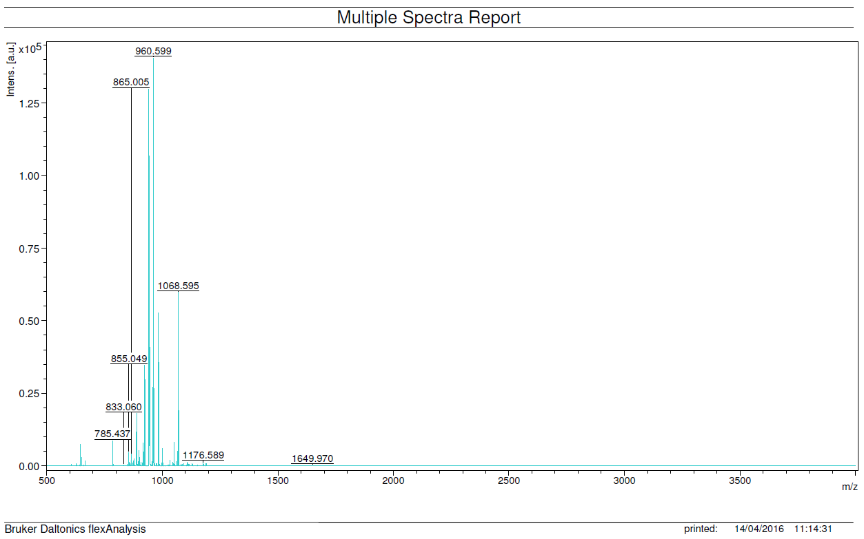

Theoreticalisotopicpattern: Experimentalisotopicpattern:
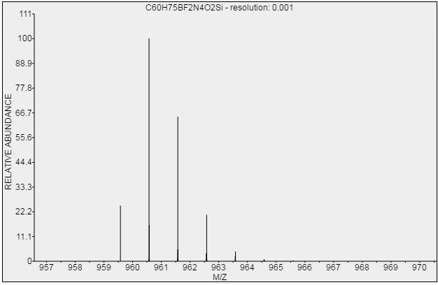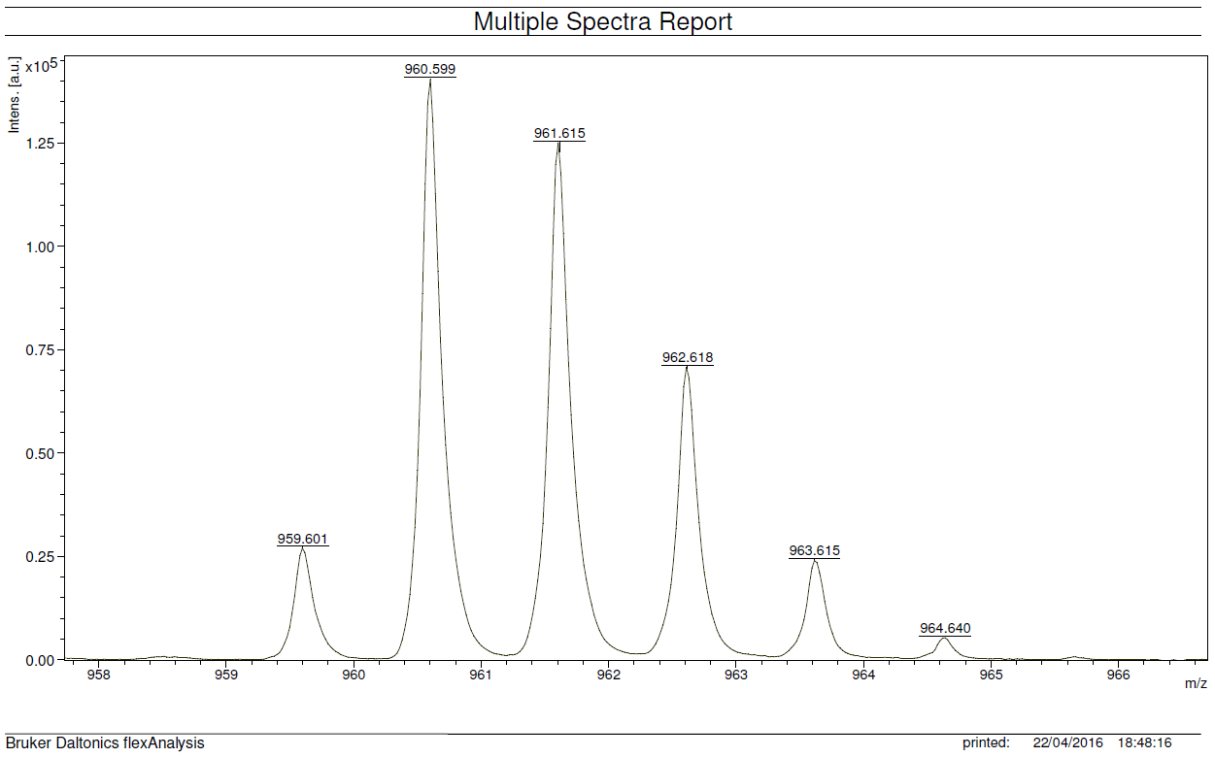

Compound 7:
Chemical Formula: C₅₁H₅₅BF₂N₄O₂
Exact Mass: 804,439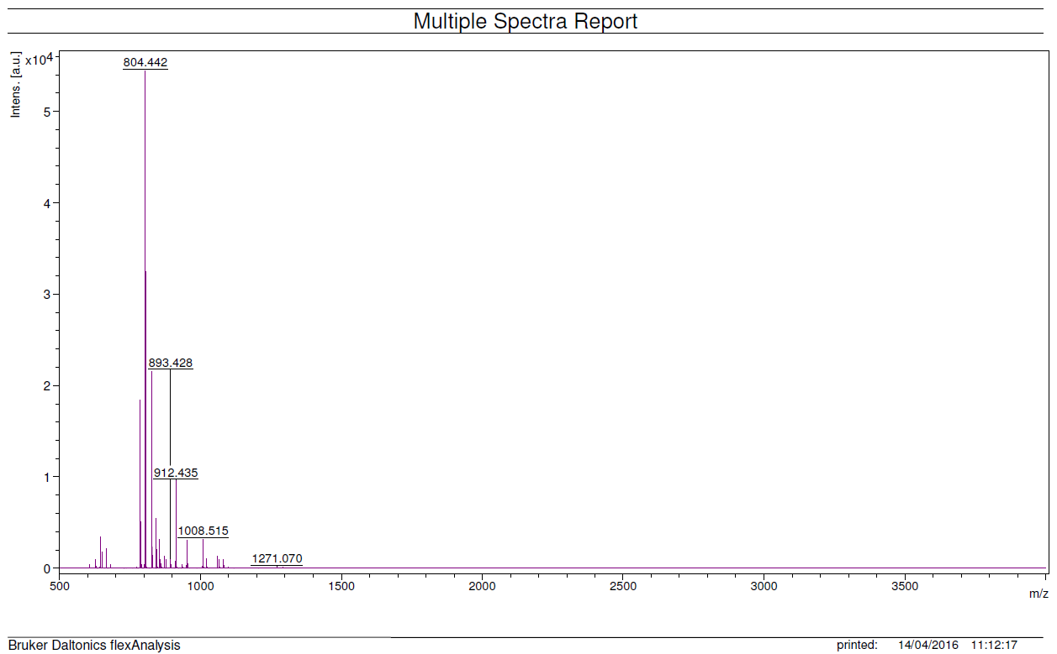

Theoretical isotopic pattern: Experimental isotopic pattern:
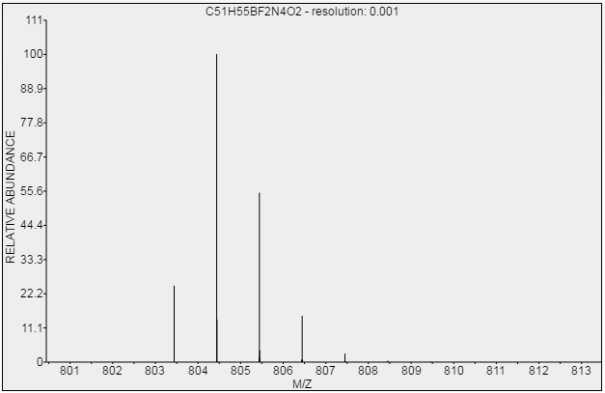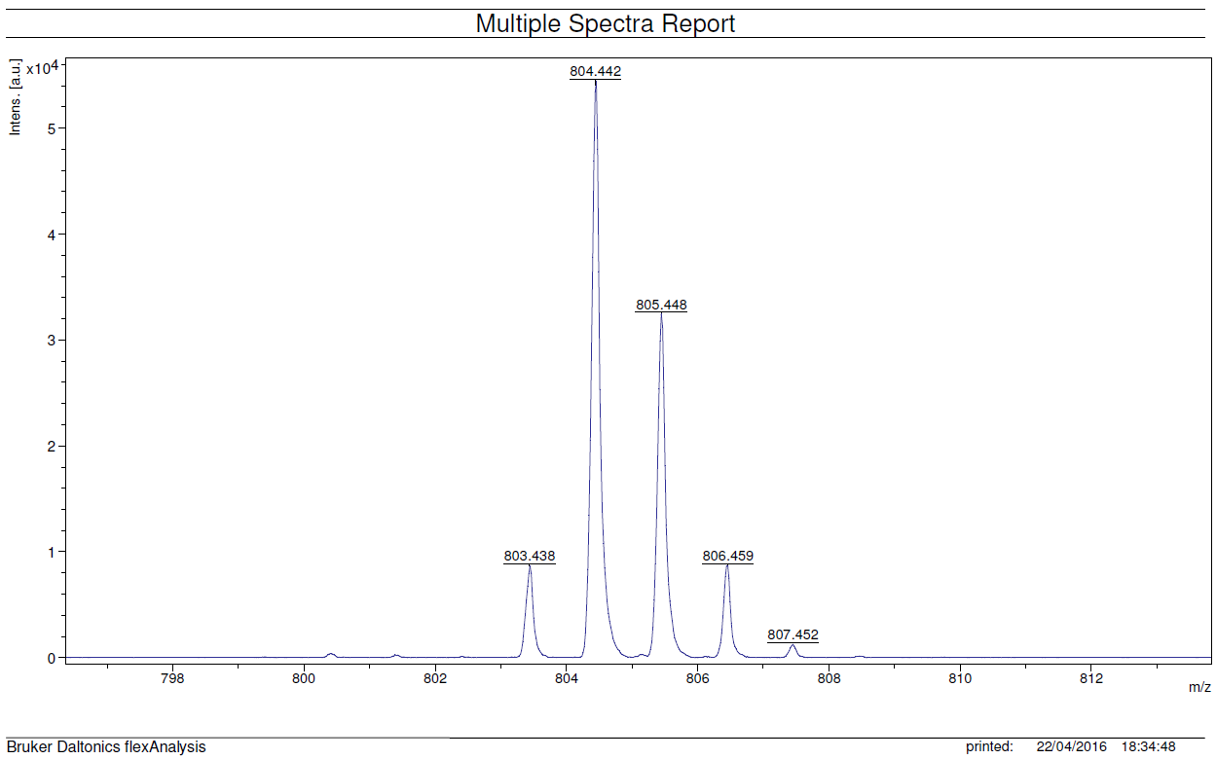

Compound 10:
Chemical Formula: C₆₉H₇₉N₇
Exact Mass: 1005,640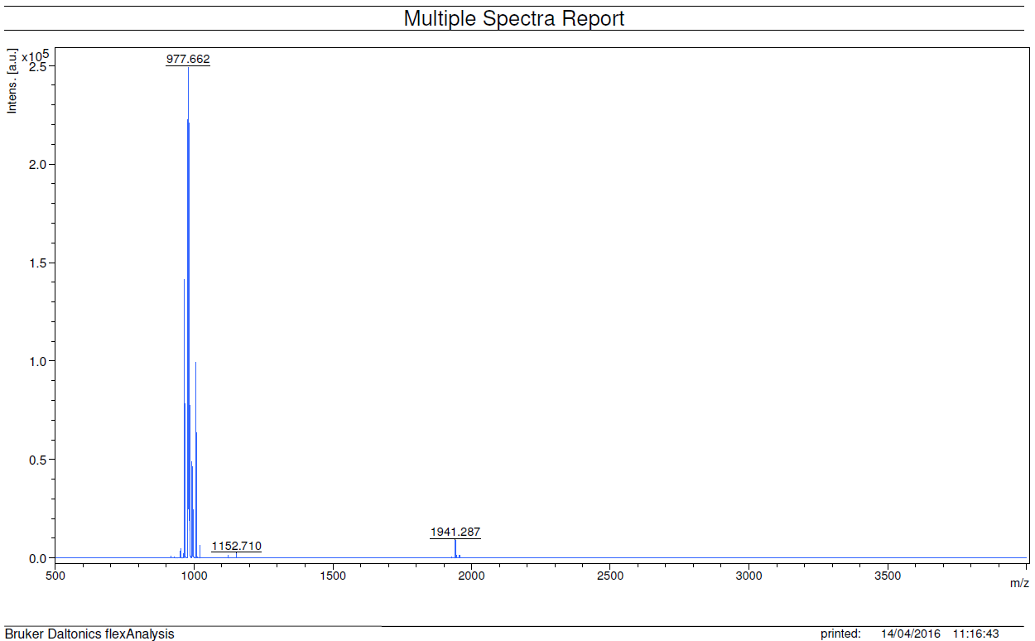

Theoretical isotopic pattern: Experimental isotopic pattern:
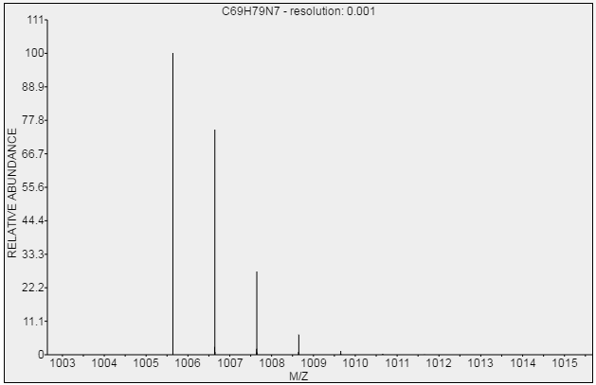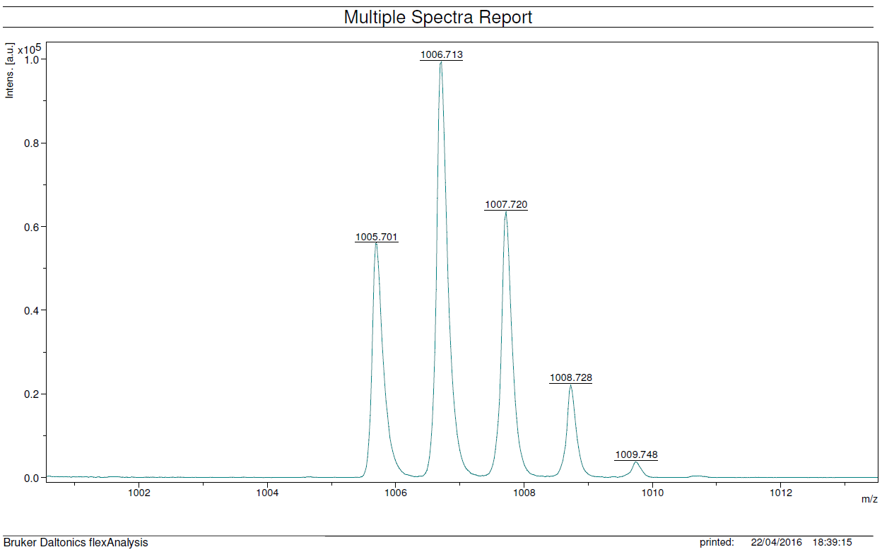

Compound 11:
Chemical Formula: C₆₉H₇₇N₇Zn
Exact Mass: 1067,553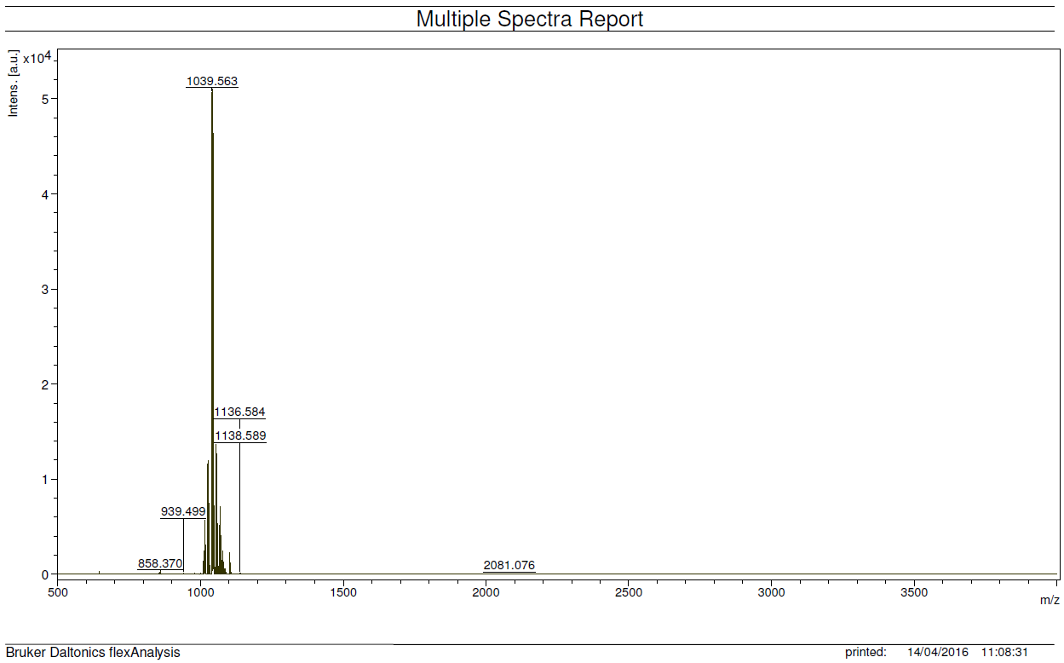

Theoretical isotopic pattern: Experimental isotopic pattern:
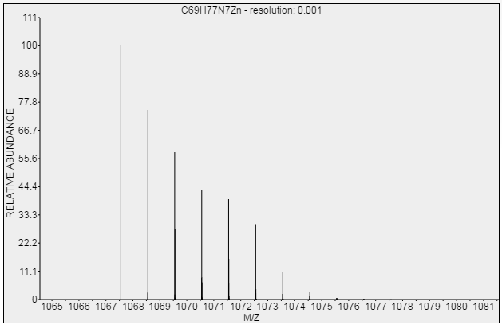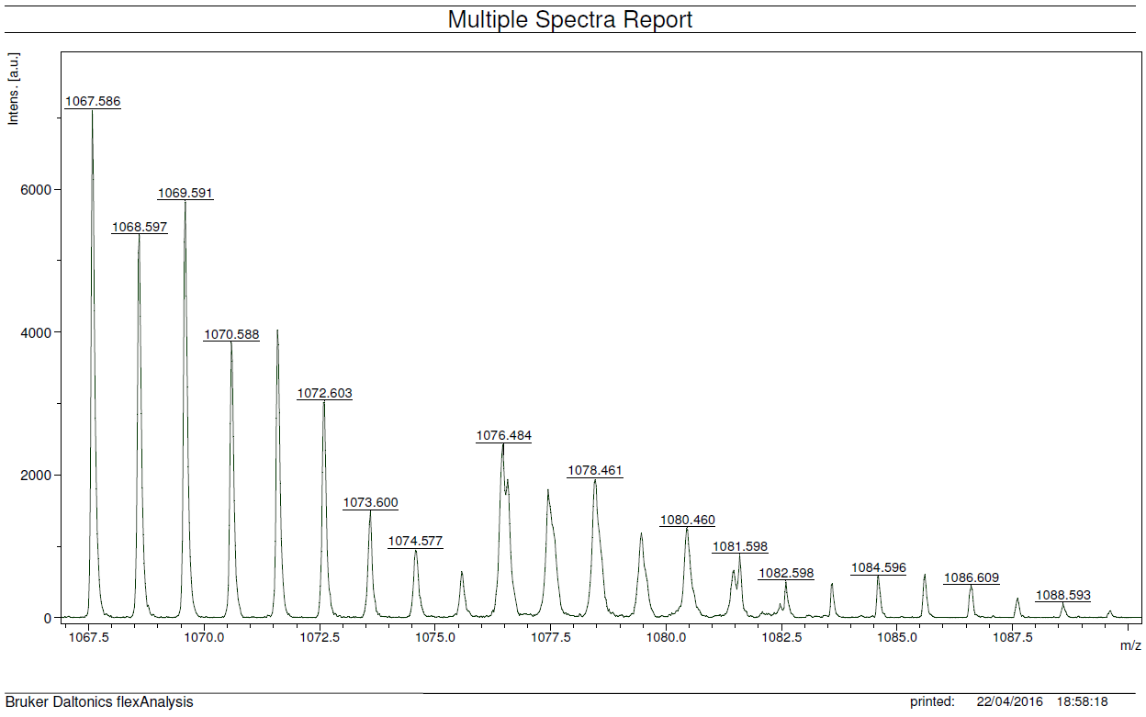

Compound 12:
Chemical Formula: C₁₂₀H₁₃₂BF₂N₁₁O₂Zn
Exact Mass: 1871,992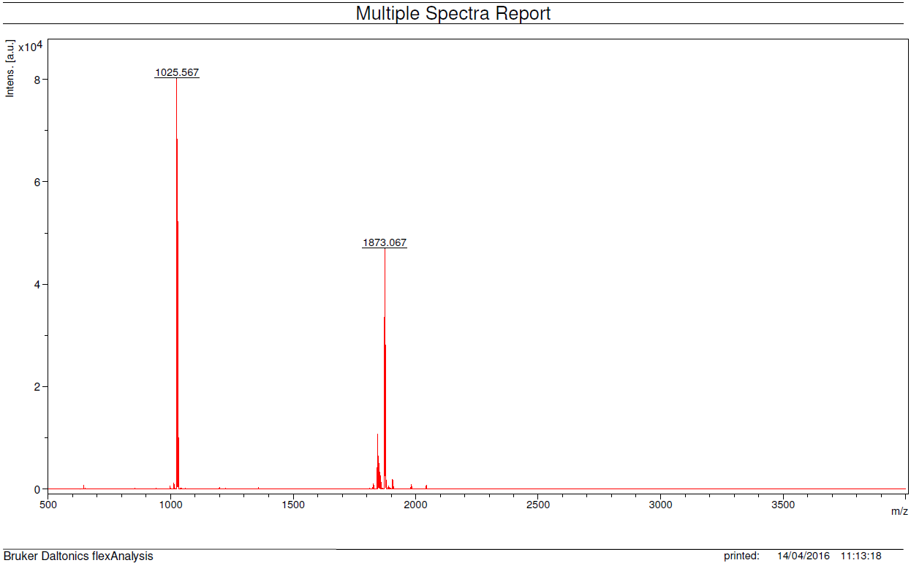

Theoretical isotopic pattern: Experimental isotopic pattern:
