Abstract— This paper describes a fast convolution-based methodology for simulating ultrasound images in a 2D / 3D sector format as typically used in cardiac ultrasound. The conventional convolution model is based on the assumption of a space-invariant Point Spread Function (PSF) and typically results in linear images. These characteristics are not representative for cardiac data sets. The spatial impulse response method (IRM) has excellent accuracy in the linear domain, however calculation time can become an issue when scatterer numbers become significant and when 3D volumetric data sets need to be computed. As a solution to these problems, the current manuscript proposes a new convolution-based methodology in which the data sets are produced by reducing the conventional 2D / 3D convolution model to multiple 1D convolutions (one for each image line). As an example, simulated 2D / 3D phantom images are presented along with their gray scale histogram statistics. In addition, the computation time was recorded and contrasted to a commonly used implementation of IRM (FieldII). It is shown that COLE can produce anatomically plausible images with local Rayleigh statistics but at improved calculation time (1200 times faster than the reference method).
A Fast Convolution-based Methodology to Simulate 2D / 3D Cardiac Ultrasound Images
Hang Gao, Hon Fai Choi, Piet Claus, Steven Boonen, Siegfried Jaecques, G. Harry van Lenthe,
Georges van der Perre, Walter Lauriks and Jan D’hooge
KeyWords— Ultrasound imaging, Simulation, Sector format, Echocardiography.

INTRODUCTION
U
ltrasound imaging continues to expand its role in medical diagnostics and therapy guidance as it is an inexpensive and compact imaging modality that is readily available. In ultrasound research, the simulation of ultrasound (US) images has become a standard tool for the further development and validation of system design and new post-processing techniques. An easy and fast methodology, that has been used extensively, is the so-called convolution model [1]-[3]. In the 1D implementation of this model, the point spread function (PSF) of the imaging system (i.e. the transmitted pulse) is spatially convolved with a Dirac-train which represents the position and the reflectivity of discrete scattering sites along the image line. This method has been used to generate 2D and 3D US data sets by extending the convolution to multiple dimensions and distributing the Dirac-functions in 2D / 3D space. As in several other studies, Meunier et al. applied a 2D convolution of the system PSF with the scatterers’ distribution in Cartesian coordinates resulting in radio frequency (RF) signals of an image in a linear format [3]:
(1)
with
(2)
and
(3)
where x is defined as the axial direction (i.e. the direction of wave propagation), y is the lateral direction, is the echogenicity of scatterer ‘q’,is the 2D Dirac function andand are the variances of the axial and lateral PSF respectively.
With respect to polar images as typically used in intravascular ultrasound, Maurice et al. proposed a 2D convolution model in polar coordinates [4]. In order to account for the changing of PSF with depth, these authors modeled the lateral PSF to increase linearly with depth and approximated this behavior using a piece-wise constant PSF. In this way, the scatterer distribution function was convolved with the dynamic PSF (i.e. lateral PSF variance grows with increasing depth) according to a multi-layer model. As such, the effect of the divergence of the beam profile could be taken into account in a practical manner.
In cardiology, ultrasound images are typically presented in a sector format (2D) or a pyramidal format (3D) as a consequence of the use of phased array transducers. Although the model of Maurice et al. could in theory be applied, a piecewise constant PSF needs to be assumed. Moreover, convolutions in 3D can become rather demanding in terms of memory requirements and computation time. Alternatively, accurate US datasets can be simulated based on the spatial impulse response approach as introduced by Tupholme and Stepanishen [5]-[6]. Its application to 3D volumetric scans containing many scattering sites becomes however rather CPU intensive. Therefore, the purpose of this study was to enable the fast simulation of realistic US images in a sector / pyramidal format using another new approach.

nEW CONVOLUTION mODEL
As the convolution (1) in Cartesian coordinates intrinsically results in linear images, multiple 1D convolutions instead of a 2D or 3D convolution are proposed in our new convolution model. This proposed methodology is referred to as COLE in the remainder of this manuscript. Specifically, RF signals in a pyramidal format are produced by subsequently simulating the reflections of individual image lines. On a single image line determined by its lateral location and elevation location , the RF signal is calculated as a conventional 1D convolution between the axial PSF and the modified distribution function as:
(4)
and
, (5)
where w_{q} is the projection factor for the q^{th} scatterer of total number N, taking into account the distance of the scatterer from the image line relative to the lateral / elevation PSF characteristics. This can be realized in three different manners as follows:
i) from an analytical expression of the beam profile, e.g. the Gaussian PSF defined as:
, (6)

where and are the variances of the lateral and elevation PSF respectively;
ii) from a simulated beam profile look up table (LUT) by its axial distance , its lateral angle and its elevation angle (from scatterer ‘q’ to the image line);
iii) from a measured beam profile LUT by the same indices (i.e.,and ).
In order to account for the discrete sampling of along r, each projection should be attributed to the closest radial sample taken along the image line. Let the voxel V_{i} be defined as the spatial interval between two subsequent radial samples r_{i-1} and r_{i}:
(7)
where M represents total number of axial samples and the inverse left bracket indicates the exclusion of beginning element from the voxel V_{i}. Considering the fact that multiple projections can fall within the same voxel V_{i}, the summed amplitude over the whole voxel V_{i} is attributed to the corresponding radial sample. The final sampled version of is thus defined as:
(8)
Mathematically, this process can be represented through convolution of the modified scatterer distribution function with a bloc-function prior to sampling, where is the spatial sampling distance along the image line:
(9)
Sinceis band-limited through from (4), can be replaced by its discrete form when is considered uniform within the bandwidth of , i.e. when is sufficiently small.
The RF signal of each image line can be obtained by repeating the above process.

METHODS
In order to validate the new convolution-based method, three simulations were performed with the ultrasound system settings as shown in table 1. For 2D US simulations, the LUT of a realistic beam profile produced by a 64 crystal phased array transducer measuring 10x14 mm and transmitting a 2.5 MHz Gaussian pulse with a -6 dB relative bandwidth of 60% was simulated using FieldII [7] on a grid containing 1335×668 points within a region of 60 degree wide and 10-130 mm depth. To generate 3D volumetric datasets, the same LUT was applied assuming an axial symmetric beam profile. As such, the simulated beam profile would correspond to the one produced by a rotating 1D phased array transducer [8].

Statistical properties of the resulting images’ histogram
In order to test the statistical characteristics of the US images generated by COLE, random scatterers were distributed at a density of 600 mm⁻² within a 2D rectangular area of 40x40 mm centered at 76 mm from the transducer. Two-dimensional images were generated using an unfocused beam at transmit and receive. As it is known for such a set-up that the amplitude of the envelope signal follows Rayleigh statistics and its signal to noise ratio (SNR) reaches a theoretical limit of 1.91 [9], a Rayleigh distribution was fit to the histogram of the simulated images and its SNR was calculated. In order to take the stochastic nature of these measurements into account, the experiment was repeated 10 times and the average histogram and SNR were determined.

Evaluation of computational cost
To compare the computation time, the same phantom (70x20 mm) containing 3 cystic regions was generated 10 times at different scatterer densities (10-100-500 mm⁻²) resulting in a total of 30 phantoms. Each phantom was scanned by FieldII and COLE using identical ultrasound system settings focused at a depth of 80 mm during transmit and dynamically focused in receive. The LUT used in COLE is shown in Fig. 1. CPU time was recorded for both models run on the same hardware (AMD Opteron 2220 dual-core processor 2.8GHz, 31.5 GB RAM).

Qualitative evaluation of a 3D cardiac US datasets
In order to simulate 3D US data in a pyramidal format, an existing kinematic model of the left ventricle (LV) was implemented [10]. As physiologic end-diastolic dimensions of the LV, a short and long axis dimension of respectively 88 mm and 50 mm were used with a wall thickness of 10 mm. Scattering sites at a density of 1875 were distributed at random within the LV wall and subsequently moved according to the kinematic model. This density was chosen in order to be above the limit for fully developed speckle, i.e. the Rayleigh limit [11]. As input to the kinematic model, realistic temporal changes over the cardiac cycle of both LV volume (65% ejection fraction) and torsion (15 degrees) were used, which is schematically illustrated in Fig. 2.
Due to the assumption of a symmetric transverse beam profile, the projection factor w_{q} could be determined by its axial distance in combination with its transverse angle from the same 2D look up table as the one shown in Fig. 1. In this way, the transverse angleof scattererer ‘q’ at spatial positionwith the image line can be calculated by use of the Haversine Formula [12]:
(10)
with

Assuming an US acquisition gated over 4 cardiac cycles, a frame rate of 20Hz is obtained when making use of parallel beam forming [13]. The pyramidal RF data set with dimensions 8001×65×65 was converted to a Cartesian image with dimensions 278×260×278 through scan conversion.

Results
The average histogram of the simulated 2D images along with its fitted Rayleigh distribution is shown in Fig. 3. The average SNR of the resulting images was 1.9109 ± 0.0580. Furthermore, one pair of 2D US images simulated by COLE and Field II is presented in Fig. 4. Average processing times are presented in table. 2. Finally some slices through the pyramidal 3D images of the virtual LV by COLE are given in Fig. 5 for the end-diastolic frame having an average computation time of 579.45 seconds / frame.

Discussion
Simulation of cardiac ultrasound data is typically done by either using the spatial impulse response approach or the convolution of the PSF of the ultrasound system with a scatterer distribution function. The former approach is accurate but relatively time consuming while the latter one is fast, typically results linear images and can be rather demanding in computational memory requirements when 3D data sets need to be simulated. With the proposed method, the disadvantages of both approaches are tackled by allowing including realistic beam profiles at a low memory and CPU cost.
The proposed approach showed to produce plausible 2D images (Fig. 4) with realistic statistical image characteristics as expressed by the Rayleigh distribution of their histogram (Fig. 3) and the SNR value. Moreover, 3D volumetric imaging of a LV model represented correct geometrical images with realistic speckle patterns that vary with depth (Fig. 5). Computational load could however dramatically be reduced compared to the impulse response method (table. 2) with higher computational gain for increasing number of scatterers in the model. Despite the visual qualitative similarity of the images shown in Fig. 4, we did not show in this study that both data sets are equivalent. This would require higher order statistical analysis of the images and a thorough spectral analysis of the simulated RF data sets. This remains the topic of future research.
COLE represents a generic approach in which analytic, simulated or measured beam profiles can be used. In this way, diffraction effects are included ‘a priori’. In the same way, attenuation could be included assuming that the pressure field at the position of the scatterer is not influenced by other scatterers.
The examples presented in this manuscript made use of a simulated beam profile which was identical for all lines in the 2D / 3D images. Moreover, for the volumetric data sets, a circle-symmetric beam profile was assumed. The effects of changing beam profile with beam steering and asymmetric 3D beam profiles could be taken into account by adding more dimensions to the LUT. Obviously, such a more realistic characterization of the beam profile would come at the expense of an increase memory load for the LUT.
When comparing the computational load of the method, generation of the LUT was not taken into account in COLE. This was however considered negligible given the high frame rates typically used in cardiac ultrasound and given that the system settings between simulation experiments are often identical. Meanwhile the computation of Field II will become even more time consuming if using exact solutions instead of a far-field rectangular approximation when calculating the spatial impulse response. Moreover, all simulations by COLE were done in Matlab (MathWorks Inc.). Implementing this algorithm in C or C++ is thus an obvious method to improve the computational efficiency further. Finally, as lines are formed independently from one another in COLE, the algorithm could be parallelized in a straight forward manner.

Conclusions
In summary, a new convolution-based methodology was presented in order to produce plausible US images in a 2D / 3D sector format at a computational load several orders of magnitude below the conventionally used methods.
Acknowledgment
The presented research is part of K.U.Leuven project IDO/04/005 (3E050528). Hon Fai Choi is a Research Assistant of the Research Foundation – Flanders (Belgium, FWO-Vlaanderen).

References
- J. C. Bamber and R. J. Dickinson, “Ultrasonic B-scanning: a computer simulation,” Phys Med Biol, vol.25, pp. 463-479, May 1980.
- J. Meunier, “Tissue motion assessment from 3D echographic speckle tracking,” Phys. Med. Biol., vol.43, pp. 1241-1254, 1998.
- J. Meunier and M. Bertrand, “Echographic image mean gray level changes with tissue dynamics: a system-based model study,” IEEE Transactions on Biomedical Engineering, vol. 42, pp. 403-410, Apr 1995.
- R. L. Maurice, J. Ohayon, G. Finet and G. Cloutier, “Adapting the Lagrangian speckle model estimator for endovascular elastography: theory and validation with simulated radio-frequency data,” J. Acoust. Soc. Am., vol. 116, pp. 1276–1286, Aug 2004.
- G. E. Tupholme. “Generation of acoustic pulses by baffled plane pistons,” Mathematika, 16:209-224, 1969. vol. 16, pp.209-224, 1969.
- P. R. Stepanishen. “Transient radiation from pistons in an infinite planar baffle,” J. Acoust. Soc. Am., vol. 49, pp.1629-1638, 1971.
- J.A. Jensen. “A Model for the Propagation and Scattering of Ultrasound in Tissue,” J. Acoust. Soc. Am., vol. 89, pp.182-191, 1991.
- K. K. Djoa., N. de Jong, F. C. van Egmond, J. D. Kasprzak, W. B. Vletter, C. T. Lancée, A. F. van der Steen, N. Bom, J. R. Roelandt, “A fast rotating scanning unit for real-time three-dimensional echo data acquisition,” Ultrasound Med Biol, vol. 26(5), pp. 863-869, Jun 2000.
- R. F. Wagner, M. F. Insana and D. G. Brown, “Statistical properties of radio-frequency and envelop-detected signals with applications to medical ultrasound,” J. Opt. Soc. Am., vol. 4, pp. 910-922, 1987.
- T. Arts, W. C. Hunter, A. Douglas, A.M. Muijtjens and R. S. Reneman, “Description of the deformation of the left ventricle by a kinematical model,” Journal of Biomechanics, vol. 25, pp. 1119-1127, Oct 1992.
- B.J. Oosterveld, J.M. Thijssen, W.A. Verhoef, “Texture of B-mode echograms: 3-D simulations and experiments of the effects of diffraction and scatterer density,” Ultrasound Imaging, vol. 7(2), pp. 142-160, Apr 1985.
- W. Gellert, S. Gottwald, M. Hellwich, H. Kästner, and H. Küstner, “The VNR Concise Encyclopedia of Mathematics,” 2nd ed., ch. 12, New York: Van Nostrand Reinhold, 1989.
- S. W. Smith, 0. T. von Ramm and H. G. Pavy, Jr, “High speed ultrasound volumetric imaging system-Part I: Transducer design and beam steering,” IEEE Transaction on ultrasonics, ferroelectrics and frequency control, vol. 38, pp. 100-108, Mar 1991.
- S. Langeland, “Multi-dimensional quantification of myocardial deformation using echocardiographic imaging,” PhD thesis, Leuven University Press, 2007.

Table. 1. Parameters for the simulation of the ultrasound data sets.
Table. 2. Computation time of US datasets generated by COLE and Field II at different scatterer densities within the same ROI (70×69 mm).
Fig. 1. Look-up table tabulated from realistic Beam Profile generated by FieldII.
Fig. 2. Illustration of the torsion movement of the virtual left ventricle (LV) model [10].
Fig. 3. The simulated distribution of the reflected envelop signals (bar) and the fitted Rayleigh distribution (solid).
Fig. 4. The simulated US images of 2D phantom in FII (a) and COLE (b).
Fig. 5. The 3D surface of LV model based on the 3D US data sets of end diastolic (ED) (a), and likewise the 3D surface of end systolic (ES) (b).

TABLE I
Parameters for the simulation of the ultrasound data sets
Transducer frequency |  | 2.5 MHz
Sampling frequency |  | 50 MHz
Ultrasound velocity |  | 1500 m/s
Tilt Angle |  | 0 degree
Start Depth |  | 10 mm
2D | Depth | 100 mm
2D | Size of ROI | 45 degree
2D | Number of lines | 60
3D | Depth | 130 mm
3D | Size of ROI | 60×60 degree
3D | Number of lines | 65×65

TABLE II
Computation time of US datasets generated by COLE and Field II at different scatterer densities within the same ROI (70×69 mm)
Mean CPU Time (s) | Density 10 mm⁻² | Density 100 mm⁻² | Density 500 mm⁻²
COLE | 0.62 ± 0.01 | 5.56 ± 0.18 | 25.05 ± 0.26
Field II | 799.16 ± 14.05 | 7982.10 ± 120.35 | 39075.21 ± 423.43

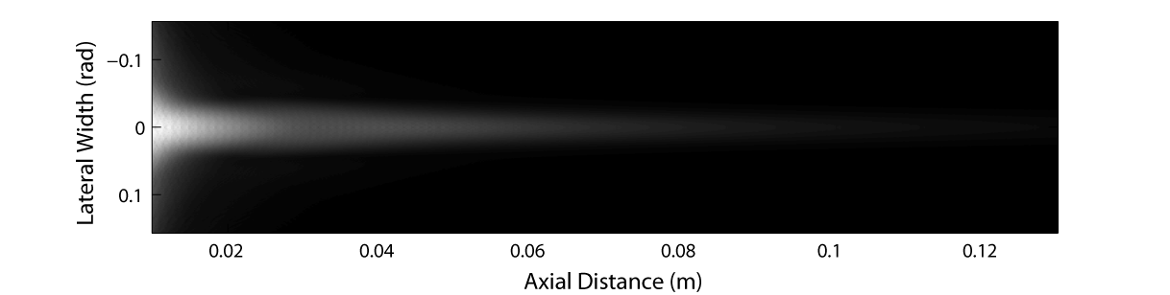
Fig. 1. Look-up table tabulated from realistic Beam Profile generated by FieldII.

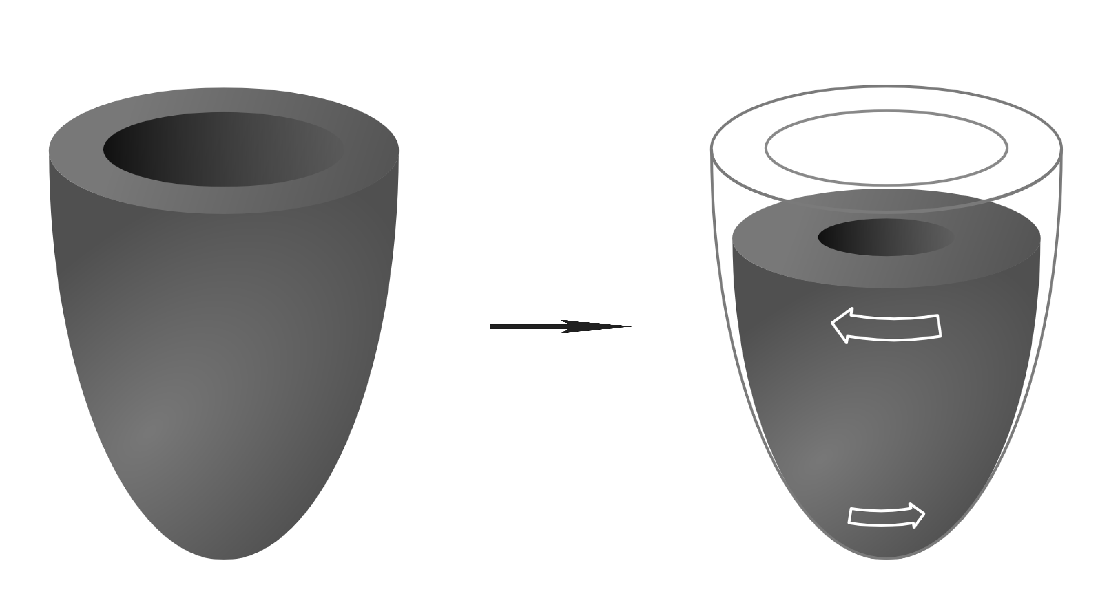
Fig. 2. Illustration of the torsion movement of the virtual left ventricle (LV) model [14].

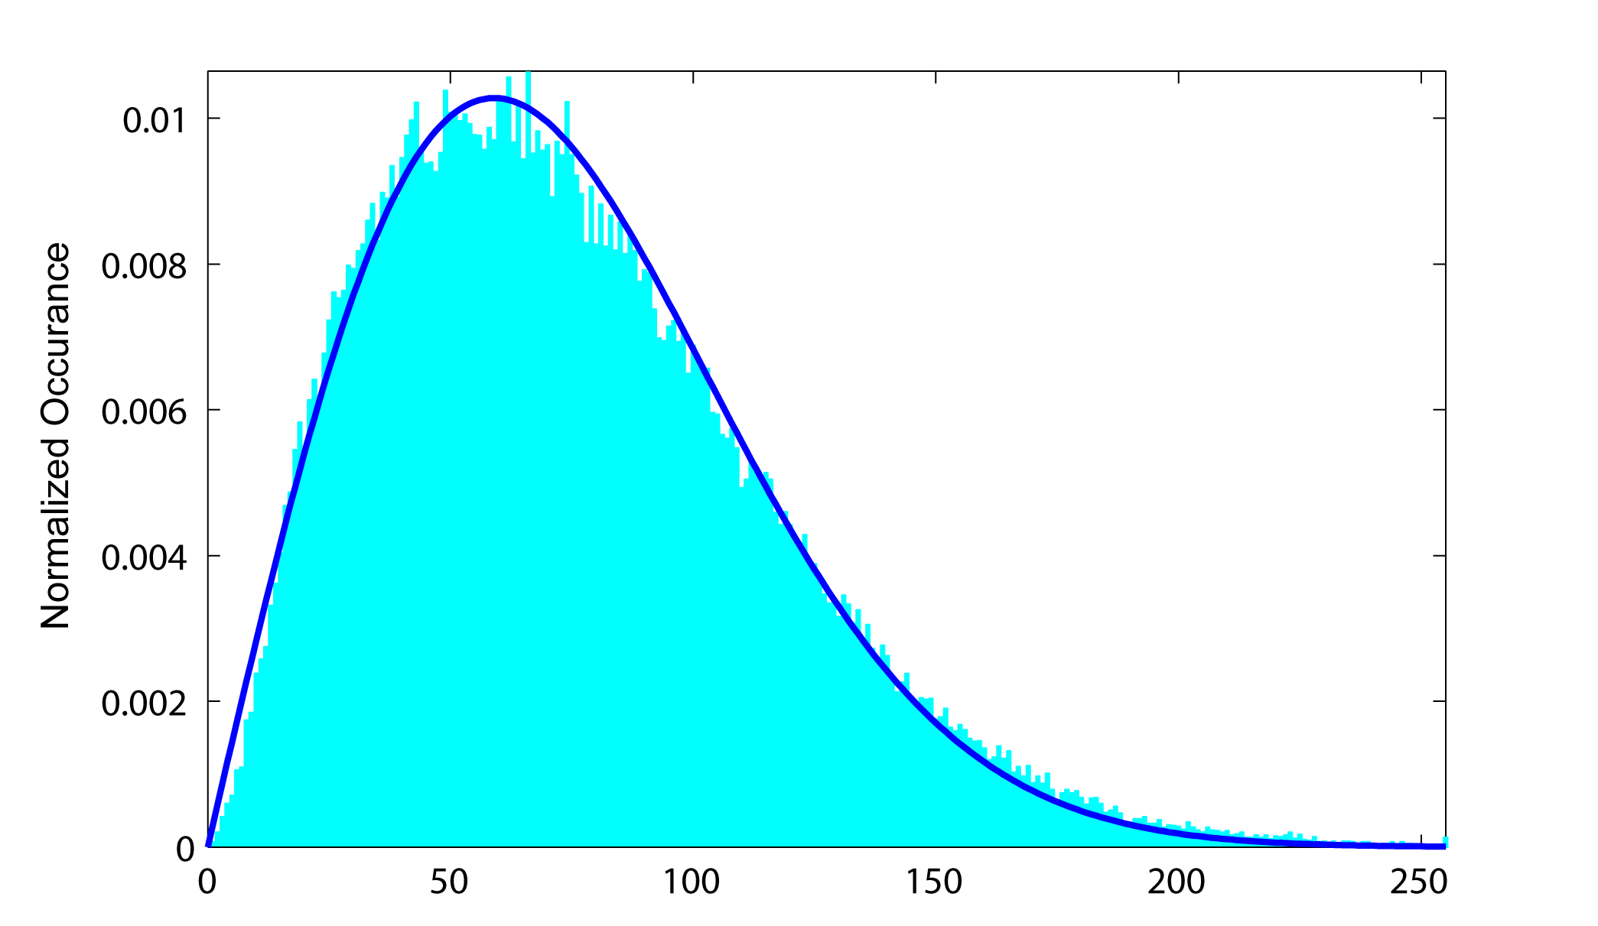
Gray Value

Fig.3. The simulated distribution of the reflected envelop signals (bar) and the fitted Rayleigh distribution (solid)
Axial Distance (mm)
20

30

40

50

60

70

80

90
-30 -20 -10 0 10 20 30
20

30

40

50

60

70

80

90
-30 -20 -10 0 10 20 30
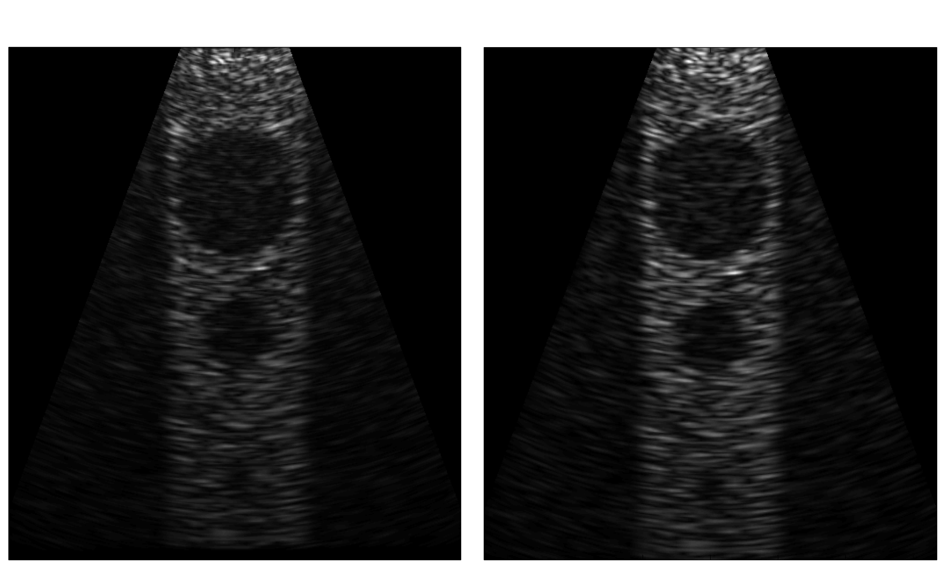

Lateral Distance (mm) Lateral Distance (mm)
- (b)

Fig. 4. The simulated US images of 2D phantom in FII (a) and in COLE (b).

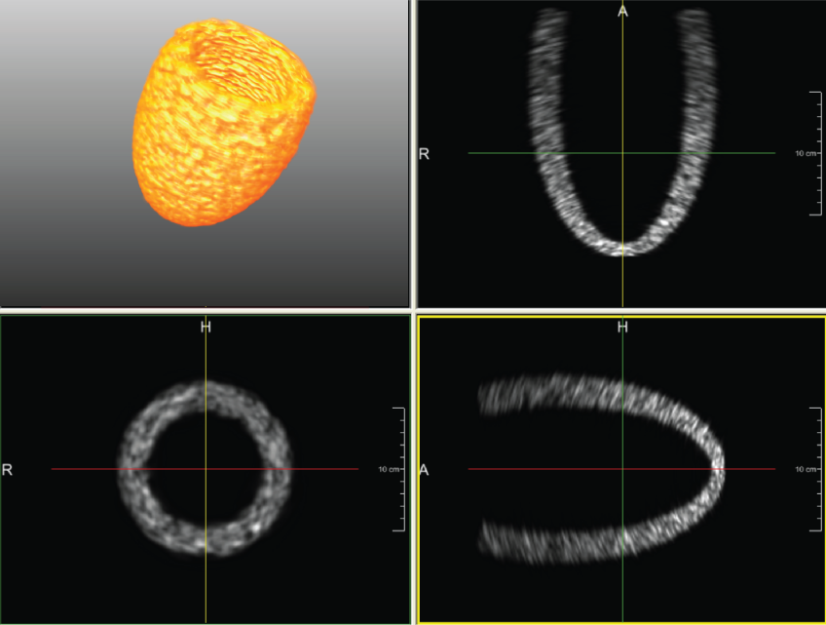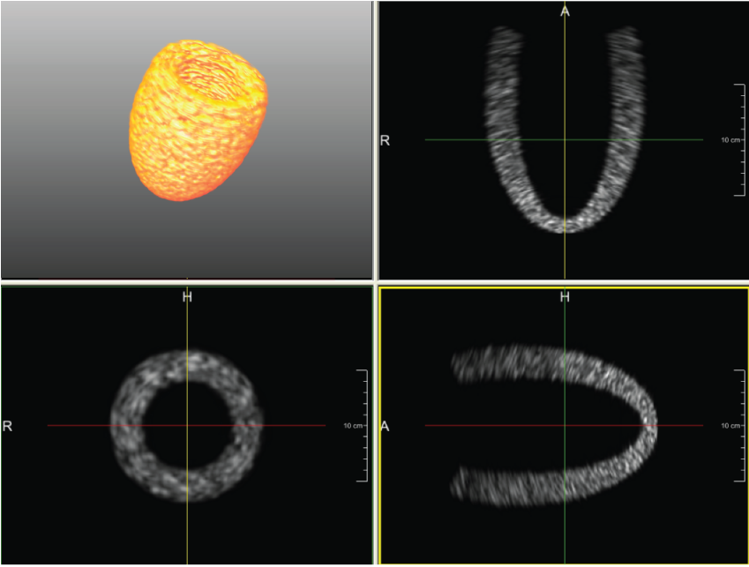
(a) (b)

Fig. 5. The 3D surface of LV model based on the 3D US data sets of end diastolic (ED) (a), and likewise the 3D surface of end systolic (ES) (b).
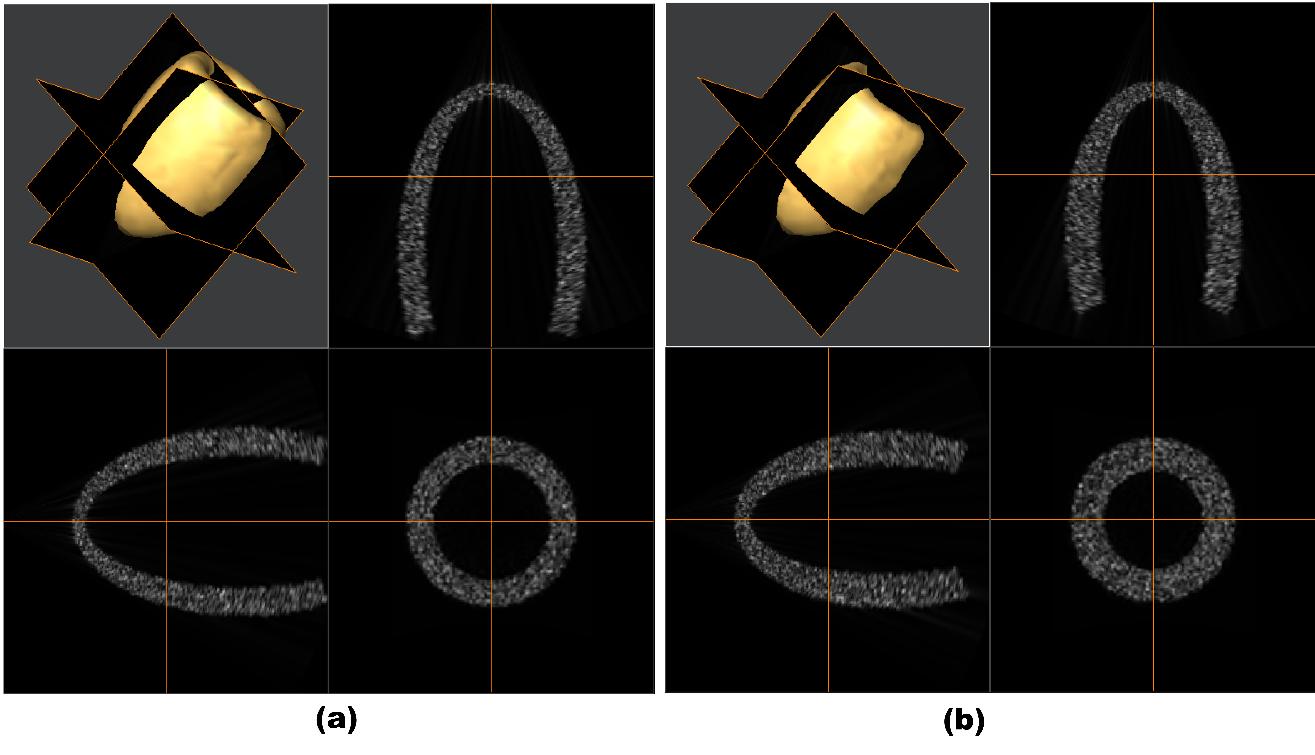
Fig. 5. The 3D surface of LV model based on the 3D US data sets of end diastolic (ED) (a), and likewise the 3D surface of end systolic (ES) (b).

 Manuscript received July, 2008. Hang Gao, Hon Fai Choi, Piet Claus and Jan D’hooge are with the Department of Cardiovascular Diseases, Cardiovascular Imaging and Dynamics, Katholieke Universiteit Leuven, UZ Herestraat 49, 3000 Leuven, Belgium (e-mail: jan.dhooge@uz.kuleuven.ac.be). Steven Boonen is with Department of Experimental Medicine, Katholieke Universiteit Leuven, UZ Herestraat 49, 3000 Leuven, Belgium. Siegfried Jaecques is with Department of Dentistry, Oral Pathology and Maxillo-Facial Surgery, Katholieke Universiteit Leuven,, Kapucijnenvoer 7, 3000, Leuven, Belgium. G. Harry van Lenthe and Georges Van der Perre are with Division of Biomechanics and Engineering Design in Department of Mechanical Engineering, Katholieke Universiteit Leuven, Celestijnenlaan 300c, 3001 Heverlee, Belgium. Walter Lauriks is with Department of Physics and Astronomy, Katholieke Universiteit Leuven, Celestijnenlaan 200d, 3001 Heverlee, Belgium.

