Surfactant assisted emulsion crystallization of hydrogenated castor oil
Niels De Meirleir* † #, Walter Broeckx #, X (leuven), Wim De Malsche †
† Vrije Universiteit Brussel, Department of Chemical Engineering, Pleinlaan 2, 1050 Brussels, Belgium
*KUL
# Procter & Gamble Eurocor N.V., Temselaan 100, 1853 Strombeek-Bever, Belgium
Abstract
In this paper the crystallization of hydrogenated castor oil (HCO) is studied and a mechanism is presented for a surfactant assisted emulsion crystallization. In contrast to what occurs for a classical emulsion crystallization, the surfactant present in the aqueous phase is shown to enable an aqueous phase driven crystallization forming non-spherically, sometimes highly elongated, shaped crystals. The presence of a surfactant is here crucial, as it increases the solubility of HCO and sustains crystal growth of aqueous crystals. In this paper this is demonstrated by linking the formation of these non-spherically shaped crystals with a required relatively high solubility obtained by adding surfactant. This solubility or apparent solubility of HCO versus the crystal shapes is presented for 4 different surfactants in function of the surfactant concentration; amine oxide, sodium –and monoethylamine linear alkylbenzene sulfonate and sodium dodecyl sulfate. Furthermore, at certain conditions the emulsified HCO is shown to completely crystallize in the aqueous phase, even if at the start of the crystallization only part of the HCO is dissolved. This illustrates the presence of a HCO transport mechanism continuously transporting HCO from emulsion to aqueous phase to the growing crystals.
Hydrogenated castor oil, fibrous crystals, Triacylglycerol, rheology modifier
Introduction
Hydrogenated castor oil (HCO) crystals can be found in numerous surfactant rich commercial products as rheology modifier, increasing the low-shear viscosity, and act as a stabilizer, preventing physical separation. The rheological behavior of these suspensions depend strongly on the obtained crystal shape. The crystal shapes commonly found are fibrous, irregular, spherical, dendritic, short needles an star shaped (or rosettes) ^{1–3}. At quiescent conditions the HCO crystals in a surfactant rich aqueous matrix form preferentially an entangled crystal network or a densely packed crystal network, depending on the crystal shape ⁴. Surprisingly considering fat crystal networks usually do not have the tendency of forming entangled crystal network but rather a 3D network consisting of agglomerated crystals ^{5–7}.
To obtain these non-spherically shaped crystals an emulsion crystallization is required. An emulsion crystallization consists of a dispersed oil phase and a continuous aqueous phase. In case of crystallizing a fat, the emulsification provides a way to alter the preferred type of nucleation. Shifting from a heterogeneous impurity driven nucleation in a bulk crystallization to a potential homogeneous nucleation ^{8,9}. This shift can only occurs if the amount of droplets is much higher than the amount of impurities and if no other heterogeneous nucleation mechanisms are present. For example, the presence of surface molecules can act as catalyst or alternatively droplet-crystal collisions may occur which in both cases may lead to a heterogeneous dominant nucleation. A shift to a dominant homogeneous nucleation is characterized by a decrease of the crystallization temperature. This decrease of the crystallization temperature is a result of the higher activation Gibbs energy required for the formation of a stable nucleus as the nucleation barrier is not lowered by any external effects ^{9,10}. Furthermore only applicable for very small droplet sizes, decreasing the emulsion size will reduce the crystallization temperature even more. This is caused by the excess amount of surface free energy which raises the activation Gibbs energy ^{11–13}. Other parameters that are known to impact an emulsion crystallization are temperature, shear rate and surfactant. Some examples of TAG’s where the effect of temperature are well studies are; cacao butter ^{14–16}, palm oil ^{17,18}, hydrogenated castor oil (HCO) ^{1–3} and milk fat ¹⁹. For example, the emulsion crystallization of HCO leads to a broad range of different crystal shapes such as; fibrous shaped crystals (thin and thick), star shaped crystals (or rosettes), short needles and spherically/irregularly shaped crystals. Fibrous and star shaped crystals are obtained at relatively high temperatures, whereas short needles, spherically and irregularly shaped crystals are more favored at relatively low temperature. The amount of shear applied during the crystallization may also influence the crystal shape. Firstly, in some cases the preferred crystal growth direction may change at increasing shear rates, which frequently leads to more elongated structured crystals. Secondly, applying shear may cause the molecules to align with each other making the crystallization entropically more favorable, resulting in an higher nucleation and crystal growth rate ^{20–22}. For the emulsion crystallization of HCO shear has similar effects favoring more elongated structures at higher shear rates, however applying too much shear causes these elongated crystals to break ¹.
In this paper the role of surfactant during the emulsion crystallization of HCO is studied. Several aspects of surfactant addition have already been reported for other systems. While the prominent driver for surfactant addition during an emulsion crystallization is that it grants a more stable emulsion ²³, it also may serve as a template or seed for interface heterogeneous nucleation to occur ²⁴ which may lead to more favorable crystal morphologies^{25,26}. However, for this specific emulsion crystallization, similar to an emulsion polymerization ^{27,28}, the possibility of surfactant enabling a significant part to be dissolved ²⁹ and facilitating enhanced mass transfer from the emulsion to the aqueous phase favoring in this case aqueous phase crystal growth, is studied. The HCO stored in the macro-emulsions is thereby transported to the growing crystals in the aqueous phase. For an emulsion polymerization the increased solubility provided by the surfactant allows for a controlled polymerization of the monomers dissolved in the aqueous phase^{27,28}. The monomers in the aqueous phase are stored in micro-emulsions (swollen micelles), while a water soluble initiator initiates the polymerization. The growing chain is fed by diffusion of monomers from the macro-emulsions. To demonstrate this in the context of the emulsion crystallization of HCO the effect of surfactant on the crystal morphology, crystallization kinetics, solubility of HCO and rheology performance was studied and a first attempt to explain this crystallization mechanism is presented, linking surfactant to the formation of aqueous phase crystals.
Materials and Methods
Hydrogenated castor oil (HCO), Monoethanolamine linear alkylbenzene sulfonate (MEALAS), Amine oxide (AO) & Lauryl sulfate (LS)
The hydrogenated castor oil used in these experiments was a standard factory product supplied by Brasil Olea de Mamona Ltda, BOM (Bahia, Brazil). Monoethanolamine linear alkylbenzene sulfonate (MEALAS) solution was manufactured by Procter and Gamble, P&G (Strombeekbever, Belgium), containing 16.7 wt. % HLAS (linear alkylbenzene sulfonic acid), 3.34 wt. % MEA (monoethanolamine) and 79.96 wt. % water. Sodium linear alkylbenzene sulfonate (NaLAS) solution was manufactured by Procter and Gamble, P&G (Strombeek-bever, Belgium), containing 16 % HLAS, 3 wt. % NaOH and 81 wt. % Water. Amine oxide (AO) solution was manufactured by Procter and Gamble, P&G (Strombeek-bever, Belgium), containing 32 wt. % AO and 68 wt. % Water. Sodium dodecylsulfate (SDS) solution was manufactured by Procter and Gamble, P&G (Strombeek-bever, Belgium), containing 29 wt. % SDS and 71 wt. % Water.
Micro -and meso scale continuous process for the production of HCO crystals
Hydrogenated castor oil (HCO) was crystallized with a meso- and micro scale continuous process. This continuous process comprised of 2 steps: a mixing step and a crystallization step. In the first step 96 wt. % of a MEALAS solution was mixed with 4 wt. % hydrogenated castor oil above 86 °C, this to allow melting of HCO and to avoid clogging. To generate sufficiently small oil droplets, a continuous meso- and micro setup with an 11 step split and recombine mixer with an inner diameter of 0.6 mm was used (Ehrfeld, Wendelsheim, Germany). To provide sufficient residence time for the crystallization step, metal hoses from Swagelock (Ohio, USA) were used as residence time units, which were held at the crystallization temperature by immersing them in warm water baths. Fast cooling was possible with the employed 1/8 inch coils. For relatively large residence times, 3/8 inch coils were used to avoid reaching the upper limit of the pumps (30 bar). The applied temperature after the emulsification was lowered to 41 °C for 2 minutes and afterwards increased again to 71 °C during 14 min. The crystallization kinetics of non-isothermal crystallization conditions was studied by differential scanning calorimetry (DSC), similar as in ². The total flow rate during the emulsification and the crystallization was respectively 10 kg/h and 1.2 kg/h. This set-up was chosen because of the need for fast cooling and heating. To eliminate further re-crystallization or post crystallization phenomena the crystallized HCO was immediately cooled down to room temperature and stored at 20 °C. The stability of the crystals was followed by measuring the viscosity over time.
Rheometer
The viscosity of the crystallized hydrogenated castor samples was measured on an Anton Paar MCR 302 rheometer (Anton Paar, Graz, Austria) using a cone and plate geometry with a gap of 206 µm and an angle of 2°. To anticipate for the shear thinning behavior of crystallized hydrogenated castor oil, the viscosity was measured at different shear rates varying between 0.01 s⁻¹ and 70.00 1 s⁻¹, in order from low to high shear rates as high shear rates can cause damage to the crystals. For the lower shear rates a constant shear rate was held until a steady state viscosity was reached, above 0.1 s⁻¹ the viscosity was measured with one measurement of 10 sec. All measurements were done at 20 °C.
Polarized Light Microscope (PLM) and Atomic Force Microscopy (AFM).
The crystal microstructure was imaged by a polarized light microscope. The microscope was equipped with a digital camera controlled by an imaging control software. The objective had a magnification of 100 or 50 times and the ocular had a magnification of 10 times. For AFM a single side polished Si wafer (<100>, 381 micron thick, 2 nm native oxide, sourced from IDB Technologies, UK) was first cracked or cut into a piece of approximate dimensions 2 x 2 cm. A sample of the crystallized material was applied to the Si wafer, using a cotton bud (Johnson & Johnson, UK). The paste-coated wafer was placed into a lidded poly(styrene) Petri dish (40 mm diameter, 10 mm height, Fisher Scientific, UK) and left for 5 minutes in air under ambient conditions (18ºC, 40-50 % RH). The Petri dish was then filled with H₂O (HPLC grade, Sigma-Aldrich, UK) and the sample was left in the immersed conditions for approximately 1 hour. Following this, a cotton bud was used to remove the paste which had floated up away from the Si wafer surface, whilst the Si wafer was still immersed under HPLC grade H₂O. The Si wafer was then removed from the Petri dish and rinsed with HPLC grade H₂O. Subsequently, the Si wafer was dried in a fan oven at 35 ºC for 10 min. The wafer surface was then imaged as follows: The Si wafer was mounted in an AFM (NanoWizard II, JPK Instruments) and imaged in air under ambient conditions (18ºC, 40-50 % RH) using a rectangular Si cantilever with pyramidal tip (PPP-NCL, Windsor Scientific, UK) in intermittent contact mode. The image dimensions were 20 micron by 20 micron, the pixel density was set to 1024 x 1024, and the scan rate was set to 0.3 Hz, which corresponds to a tip velocity of 12 micron /s.
Linkam shear cell imaging measurements
Microscopic analyses were conducted with a Laborlux 12 Pol S microscope (Leica, Germany) equipped with a Linkam CSS450 shear cell with integrated cooling system (Linkam, Surrey, UK). Liquid samples were loaded at a gap setting of 80 µm. Next, the liquid was heated to 90 °C and kept there for 10 min after which it was cooled down to 60 °C at 10 °C/min for isothermal crystallization during 35 min. A continuous shear of 100 1/s was applied from the start of the cooling step onwards until the end of the isothermal period. Samples were imaged with a Hamamatsu digital camera C4742-95 (Hamamatsu, Japan). Due to the high rotational speed of the bottom disc during shearing, no clear images could be recorded. To resolve this problem, shearing was stopped during 10 s of 2 minutes. The images obtained during this period provide clear views of the crystallizing material. After these 10 s, the shear was immediately brought back to the selected shear rate.
Solubility measurements
Hydrogenated castor oil (HCO) was dissolved at 90 °C (above the melting point of HCO) in an aqueous solution containing a certain amount/type of surfactant; amine oxide (AO) from 1 wt % to 16 wt. %, Sodium/monoethylamine linear alkylbenzene sulfonate (NaLAS & MEALAS) from 0.25 wt. % to 16 wt. % and sodium dodecyl sulfate (SDS) from 0.5 wt. % to 20 wt. %. Samples were shaken and afterwards kept at 90 °C for 5 hours, to allow the two phases to phase split and a steady state to occur. After 5 hours 0.5 ml of the aqueous phase was taken and cooled to 60 °C for 20 min. Samples were subsequently stored at room temperature. UV/VIS absorbance measurements were carried out on a X spectrophotometer (1 cm Quartz cell). The absorbance of each sample was obtained from the mean of three individual readings. Molar extinction coefficients were calculated from a plot from the absorbance versus concentration. The molar extinction coefficient at 500nm for hydrogenated castor oil crystals made with the four different surfactants: amine oxide (AO), Sodium/monoethylamine linear alkylbenzene sulfate (NaLAS & MEALAS) and sodium dodecyl sulfate (SDS), ranged from 211,17 M⁻¹ cm⁻¹ to 261,55 M⁻¹ cm⁻¹.
Results
The emulsion crystallization of hydrogenated castor oil (HCO) contains two crucial steps: an emulsification step and a crystallization step. For both steps a meso-micro continuous process was utilized. For the emulsification the use of a micro mixer enabled a broad range of emulsion sizes with an average emulsion size ranging from 2μm to 20μm, depending on the flow rate, pressure drop and inner diameter of the mixer ^{30,31}. Once emulsified, these droplets are continuously pumped to small coils, ranging from 1/8" to 3/8", the smallest coils were used for fast cooling/heating and to obtain relatively fast a given isothermal temperature to initiate the crystallization. Once a stable isothermal temperature was reached the bigger coils were preferentially used to minimize the overall pressure drop and maintain the emulsion for approximately 16 min until the crystallization is finalized.
HCO can crystallize into unique fat crystal structures such as thin fibers and rosettes ^{2,3}. These structures were obtained when high amounts (16 wt. %) of monoethylamine linear alkylbenzene sulfate (MEALAS) or Sodium linear alkylbenzene sulfate (NaLAS) are present. Using the micro-meso scale continuous process, HCO was crystallized as described in ³ to obtain long thin crystals but with surfactant concentrations varying from 2 wt. % till 16 wt. % depending on the surfactant. For four different surfactants and at various concentrations the final crystal shapes is presented (figure 1). The following surfactants were used; amine oxide (AO), Sodium/monoethylamine linear alkylbenzene sulfate (NaLAS & MEALAS) and sodium dodecyl sulfate (SDS). NaLAS, MEALAS and SDS are ionic surfactants and AO is a non-ionic surfactant. Overall for all surfactants studied, at low concentration the emulsified HCO crystallized into preferentially/solely spherically shaped crystals. More specific, for AO (8 wt. %) and MEALAS (2 wt. %), at the lowest surfactant concentration, only spherically shaped crystals were observed. NaLAS (2 wt. %) and SDS (4 wt. %) also crystallized into large spherically shaped crystals though small amounts of fibrous/rosettes shaped crystal were still present. Reducing the surfactant concentration even more in figure 1 (AO 8 wt%, etc…) increased the possibility of clogging to occur, which prevented a stable continuous flow through the coils. At these conditions large lumps of HCO crystals were formed, this is most likely due to an unstable emulsion and the flocculation of the crystals. In contrast, at higher surfactant concentration more elongated, non-flocculating spherical shaped and/or small crystal shapes where formed. The observed crystal shapes at the highest surfactant concentration presented ranged from rosettes, fibers to small crystals. This resulted for MeaLAS (16 wt. %) and NaLAS (16 wt. %) in the formation of high amounts of fibrous and/or rosette-like structures. When crystallized with AO (16 wt. %) HCO crystallized into preferentially much shorter crystals and last, SDS (16 wt. %) crystallized into all three shapes; rosettes, fibers and short crystals. These observations where confirmed by the AFM images presented in figure 2 A and B for MEALAS (12 wt%) and SDS (8 wt%) respectively.

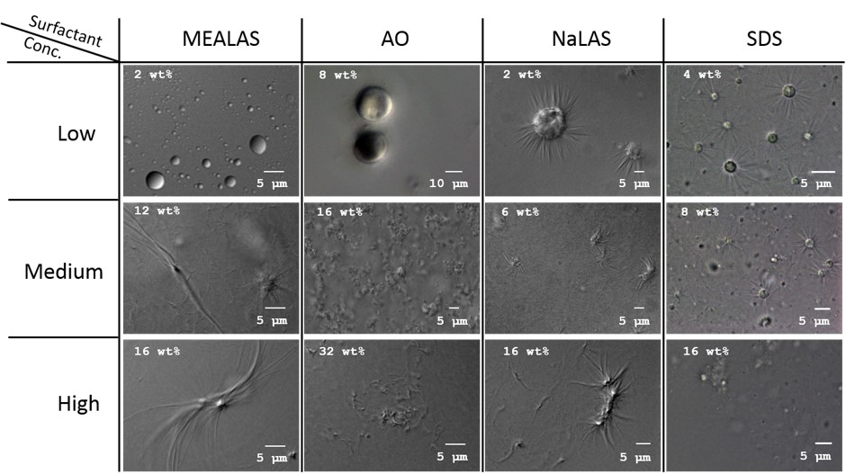
Fig 1. Light microscope images of hydrogenated castor oil crystals obtained by crystallizing with four different surfactants; amine oxide (AO), Sodium/monoethylamine linear alkylbenzene sulfate (NaLAS & MEALAS) and sodium dodecyl sulfate (SDS).
Fig 2. AFM images of hydrogenated castor oil crystals obtained by crystallizing with A. Monoethylamine linear alkylbenzene sulfate (MEALAS) and B. Sodium dodecyl sulfate (SDS).
The shape of the particle is known to have a major impact on the rheological characteristics of a suspension, as the shape determines for example the packing or the amount of particle interactions due to excluded volume effects. Here the shape of the HCO crystals are known to have a significant impact on the low-shear viscosity and the elastic behavior, this is due to the large differences in aspect ratio between the crystal shapes ⁴. This characteristic is used to better quantify the crystal shape transition seen in figure 1 of spherically shaped crystals into one of the larger aspect ratio shapes as function of the amount of surfactant and surfactant type used for the crystallization. The relative viscosities (measured at 0.01 s⁻¹) of a suspension of HCO crystals made with one of the four surfactants (MEALAS, NaLAS, SDS and AO) are presented in figure 3 on the X-axis. These suspensions contained 0.25 wt. % of a certain HCO crystal shape(s) diluted equally in a 12 wt. % MEALAS matrix. Overall for all four surfactants a similar trend was observed, the relative viscosity increased in function of the surfactant concentration present during the crystallization, when and how this increase occurred changed depending on the surfactant type. For MEALAS and NaLAS a clear sudden increase of the relative viscosity in function of the surfactant concentration was observed leading relatively fast to a plateau region. For MEALAS the turn point is seen at 6 wt. %, for NaLAS at 4 wt. %. The relative viscosity of a suspension of HCO crystals made with SDS already reached a plateau region at 4 wt. %, though below 4 wt. % large lumps of HCO crystals where formed, the viscosity for these samples were extremely hard to measure due to these large lumps but varied close to a relative viscosity of 1. Last, the relative viscosity for AO HCO crystals did not drastically increase though a gradually increased in function of the surfactant concentration was still observed. For all of the 4 surfactant the observed trends correlated also remarkably well with the crystal shapes observed in figure 1 with the crystal shape changing at high surfactant concentrations from fibers, rosettes and/or short needles to spherically shaped at low concentration. For SDS this transition of crystal shape was relatively slow, at 4 wt. % large amount of fibrous crystals could still be seen. This corresponded with the high relative viscosity measured at 4 wt. % and higher. Whereas a clear shift from spherically shaped crystals to fibrous shaped and/or rosettes were seen for MEALAS and NaLAS which corresponded to the sudden increase of relative viscosity measured in figure 3. The crystals shapes formed with AO had compared to the other three surfactants the smallest aspect ratio which again was confirmed by the lowest measured relative viscosity. This demonstrates that a right amount of surfactant is essential to obtain high performing crystals. Furthermore as these crystals are frequently used as rheology modifier it is of interest to note that there were large differences in the obtained relative viscosity between the different surfactants. The suspension containing HCO crystals crystallized with 16 wt. % AO had a relative viscosity of 2.34 while MeaLAS and NaLAS (16wt %) had a relative viscosity of 30.65 and 24.91 respectively. The highest low shear viscosity was measured for HCO crystallized with SDS (16 wt %), 31.85.
HCO starts as a liquid droplet which is dispersed in water and ends up potentially as fibrous shaped crystal. This still unknown mechanism is according to previous results a result of the addition of a surfactant during the crystallization. Adding surfactant to a mixture of two immiscible fluids can lead to a significant increase of the solubility of one compound in the other, this may also occur here. In figure 3 on the y-axis the total saturation concentration of HCO in function of the surfactant and surfactant concentration is presented. The total saturation concentration is the sum of the apparent saturation due to the surfactant and the real saturation concentration, because HCO is an insoluble material the real saturation concentration is relatively small compared to the total saturation concentration presented in figure 3. The saturation concentration is measured by first gently mixing an aqueous solution of surfactant (MEALAS, NaLAS, SDS or AO) with HCO at 90 °C. This solution is kept for 5 hours at 90 °C to allow a phase split and steady state to occur. Secondly, a sample from the aqueous phase was cooled down till 60 °C for 20 min. At that temperature the HCO which is potentially dissolved in the aqueous phase crystallizes. Finally, the amount of the crystallized HCO was quantified by UV-VIS spectrophotometry. This is done for all four surfactants and at different surfactant concentrations. Overall the saturation concentration of HCO increased when more surfactant is present. At the highest concentration measured (16 wt %) AO increased the least amount of HCO then MeaLAS then NaLAS, 0.69 wt %, 0.84 wt % and 2.01 wt % respectively. The highest value was obtained with SDS 4.26 wt %. When no surfactant is present no measurable amount of HCO is detected. For all four surfactants the increase of the total saturation concentration in function of the surfactant concentration correlated well with the relative viscosity presented on the X-asis. Only when sufficient amount of surfactant is present and the total saturation concentration is high enough a high relative viscosity and thus fibrous or rosettes shaped crystal were obtained. This indicates that the HCO in the aqueous phase is most likely essential in the formation of these crystal shapes.
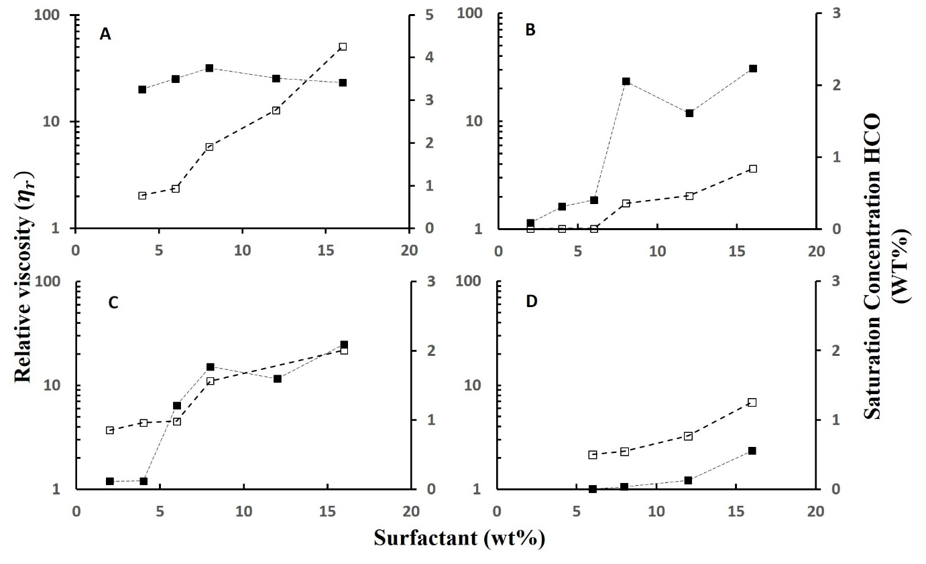
Fig 3. X-axis (■) The relative viscosity of a suspension containing hydrogenated castor oil (0.25 wt. %) crystals measured after the crystallization at steady state condition versus the amount of surfactant (ranging from 2 wt. % to 32 wt. %). Y-axis (□) Saturation concentration of HCO (wt %) in an aqueous phase containing a specific type/amount of surfactant. Surfactant A. Sodium dodecyl sulfate (SDS) from 4 wt. % to 16 wt. %. B. Monoethylamine linear alkylbenzene sulfate (MEALAS) from 2 wt. % to 16 wt. %. C. Sodium linear alkylbenzene sulfate (NaLAS) from 2 wt. % to 16 wt. % D. Amine Oxide (AO) from 6 wt. % to 16 wt. %.
It may thus be possible that the fibrous shaped crystals are formed from the crystallization of the dissolved part of the HCO, resulting in an aqueous phase crystallization. This would partly explain how fibrous shaped crystals can be formed from a HCO droplet with a radius varying between 2 µm and 20 µm. To understand where the crystallization exactly happens the amount of dispersed HCO is followed in function of the time during the crystallization process. For this the crystallization temperature was kept constant at 60 °C with a constant shear rate of 100 1/s, though the shear rate is stopped every 2 min to allow a picture to be taken. These images taken at different time intervals (2 min, 14 min, 20 min, 32 min) are presented in figure 4. At the start of the crystallization HCO was dispersed in an aqueous phase containing 16 wt. % MEALAS. When the temperature was lowered below the T_{cryst} the amount and size of HCO droplets over time were gradually reduced until at 32 min only few small droplets are left (figure 4 F). The decrease of the dispersed HCO concentration in function of the crystallization time indicates that HCO is not crystallized in the dispersed phase but rather in the aqueous phase. Furthermore almost the complete amount of HCO was dissolved during the crystallization while only 0.84 wt. % can be present in the aqueous phase at any time according to the measured total saturation concentration. Quite remarkably it seems that by initiating the crystallization the HCO in the dispersed phase is continuously transported to the aqueous phase. This can only occur if the HCO in the aqueous phase is preferentially crystallized over the dispersed phase. The dispersed phase thereby functions as a reservoir where new material can dissolve from.
Fig 4. Light microscope images of the emulsion crystallization of HCO taken at different times during the crystallization; A 2 min, B 8 min, C 14 min, D 20 min, E 26 min, F 32 min. HCO is dispersed in an aqueous solution containing 16 wt % MEALAS. The crystallization temperature is kept at an isothermal temperature of 60°C and at a shear rate of 100 1/s.
The emulsion crystallization of HCO presented in this paper is thus slightly different compared to other emulsion crystallizations, where the emulsification primarily serves to inhibit the heterogeneous impurity driven crystallization. This is most likely also true for this case but the emulsions here also serve as a reservoir for an aqueous phase crystallization (figure 5). This aqueous phase crystallization is achieved by the addition of surfactant which significantly increases the total saturation concentration, ultimately leading to the formation of non-spherically shaped crystals (fibers, rosettes, short needles) as seen figure 1.
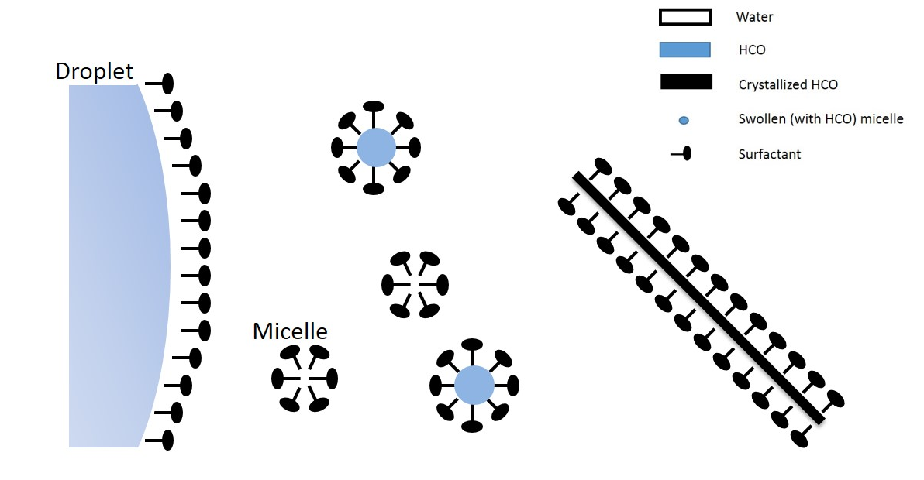
Fig 5. Schematic representation of the HCO transport mechanism during the emulsion crystallization at high concentrations of surfactant. A
Conclusion and discussion
In this paper a mechanism is presented where surfactant during an emulsion crystallization can enable an aqueous phase favored crystallization. This is demonstrated for the emulsion crystallization of HCO. First, the surfactants (MEALAS, NaLAS, SDS and AO) were shown to be able to dissolve relatively large fractions of HCO. This confirmed that at the start of the crystallization large parts of the HCO can be dissolved and that a possible aqueous phase crystallization can occur. Secondly, only when high amounts of HCO can be dissolved the formation of certain types of elongated crystal shapes were obtained. Some of these crystal shapes are demonstrated to have beneficial rheological characteristics ⁴ such as possibly improving the hardness, increasing the pseudo plastic behavior, etc…. Last, if an aqueous phase crystallization is favored the amount of dispersed HCO was shown to gradually decrease during the crystallization process, as is seen in figure 4 for the crystallization of HCO at 16 wt. % MEALAS and at an isothermal crystallization temperature of 60 °C for 20 min. This indicates that the emulsion droplets can act as a reservoir for the aqueous phase crystallization and that HCO is transported from the dispersed phase to the aqueous phase which enables the HCO to be transported continuously to sustain the crystal growth or the formation of new nuclei in the aqueous phase. Finally, an aqueous phase crystallization is most likely to occur at high surfactant concentration, when significant amount of HCO can dissolve and when the crystallization of the dispersed phase is slower than the aqueous phase which is most likely to occur at high temperature below the T_{cryst}. The reversed conditions would result in the crystallization of the dispersed phase or HCO droplets, forming spherically shaped crystals.
AUTHOR INFORMATION
Corresponding Author
Vrije Universiteit Brussel, Department of Chemical Engineering, Pleinlaan 2, 1050 Brussels, Belgium. Phone: 0032-6293237. E-mail: ndemeirl@vub.ac.be
Acknowledgement
The Flemish agency for Innovation through Science and Technology (IWT) is kindly acknowledged for funding this research. Also, the Flemish Research Foundation (FWO-Vlaanderen) is kindly acknowledged for financially supporting WDM.
References
1. Yang, D., Hrymak, A. N. & Kamal, M. R. Crystal Morphology of Hydrogenated Castor Oil in the Crystallization of Oil-in-Water Emulsions: Part II. Effect of Shear. Industrial & Engineering Chemistry Research 50, 11594–11600 (2011).
2. Yang, D. & Hrymak, A. N. Crystal Morphology of Hydrogenated Castor Oil in the Crystallization of Oil-in-Water Emulsions: Part I. Effect of Temperature. Industrial & Engineering Chemistry Research 50, 11585–11593 (2011).
3. De Meirleir, N., Pellens, L., Broeckx, W. & De Malsche, W. The emulsion crystallization of Hydrogenated castor oil into long thin fibers. Journal of Crystal Growth 383, 51–56 (2013).
4. De Meirleir, N., Pellens, L., Broeckx, W. & De Malsche, W. The performance of hydrogenated castor oil crystals as rheology. colloid and polymer science x, x (2014).
5. Narine, S. & Marangoni, A. Fractal nature of fat crystal networks. Physical Review E 59, 1908–1920 (1999).
6. Vreeker, R., Hoekstra, L. L., Den Boer, D. C. & Agterof, W. G. M. The fractal nature of fat crystal networks. Colloids and surfaces 65, 185–189 (1992).
7. Narine, S. S. & Marangoni, A. G. Relating structure of fat crystal networks to mechanical properties : a review. Food Research International 32, 227–248 (1999).
8. Ozilgen, S., Simoneau, C., German, J. B., Mccarthy, M. J. & Reid, D. S. Crystallization Kinetics of Emulsified Triglycerides. J Sci Food Agric 101–108 (1993).
9. Coupland, J. N. Crystallization in emulsions. Current Opinion in Colloid & Interface Science 7, 445–450 (2002).
10. Skoda, W. & Tempel, M. Van den Crystallization of emulsified triglycerides. Journal of colloid science 568–584 (1963).
11. Dickinson, E., McClements, D. J. & Povey, M. J. . Ultrasonic investigation of the particle size dependence of crystallization in n-hexadecane-in-water emulsions. Journal of Colloid and Interface Science 142, 103–110 (1991).
12. Montenegro, R., Antonietti, M., Mastai, Y. & Landfester, K. Crystallization in Miniemulsion Droplets. The Journal of Physical Chemistry B 107, 5088–5094 (2003).
13. Truong, T., Bansal, N., Sharma, R., Palmer, M. & Bhandari, B. Effects of emulsion droplet sizes on the crystallisation of milk fat. Food chemistry 145, 725–35 (2014).
14. Marangoni, A. G. & McGauley, S. E. Relationship between Crystallization Behavior and Structure in Cocoa Butter. Crystal Growth & Design 3, 95–108 (2003).
15. Padar, S., Jeelani, S. a. K. & Windhab, E. J. Crystallization Kinetics of Cocoa Fat Systems: Experiments and Modeling. Journal of the American Oil Chemists’ Society 85, 1115–1126 (2008).
16. Dewettinck, K., Foubert, I., Basiura, M. & Goderis, B. Phase Behavior of Cocoa Butter in a Two-Step Isothermal Crystallization. Crystal Growth & Design 4, 1295–1302 (2004).
17. Ng, W. L. & Oh, C. H. A Kinetic Study on Isothermal Crystallization of Palm Oil by Solid Fat Content Measurements. JAOCS 71, 1135–1139 (1994).
18. Chen, C. W., Lai, O. M., Ghazali, H. M. & Chong, C. L. Isothermal crystallization kinetics of refined palm oil. Journal of the American Oil Chemists’ Society 79, 403–410 (2002).
19. Martini, S., Herrera, M. L. & Hartel, R. W. Effect of processing conditions on microstructure of milk fat fraction/sunflower oil blends. Journal of the American Oil Chemists’ Society 79, 1063–1068 (2002).
20. Macmillan, S. D. & Roberts, K. J. In Situ Small Angle X-ray Scattering ( SAXS ) Studies of Polymorphism with the Associated Crystallization of cacoa butter fat using shearing conditions. Crystal Growth & Design 2, 221–226 (2002).
21. Co, E. & Marangoni, A. G. The Formation of a 12-Hydroxystearic Acid / Vegetable Oil Organogel Under Shear and Thermal Fields. JAOCS 90, 529–544 (2013).
22. Padar, S., Mehrle, Y. E. & Windhab, E. J. Shear-Induced Crystal Formation and Transformation in Cocoa Butter. Crystal Growth & Design 9, 4023–4031 (2009).
23. Palanuwech, J. & Coupland, J. N. Effect of surfactant type on the stability of oil-in-water emulsions to dispersed phase crystallization. Colloids and Surfaces A: Physicochemical and Engineering Aspects 223, 251–262 (2003).
24. Sonoda, T., Takata, Y., Ueno, S. & Sato, K. Effects of Emulsifiers on Crystallization Behavior of Lipid Crystals in Nanometer-Size Oil-in-Water Emulsion Droplets. Crystal Growth & Design 6, 306–312 (2006).
25. Wang, F. et al. Kinetic analysis of isothermal crystallization in hydrogenated palm kernel stearin with emulsifier mixtures. Food Research International 44, 3021–3025 (2011).
26. Garbolino, C., Bartoccini, M. & Flöter, E. The influence of emulsifiers on the crystallisation behaviour of a palm oil-based blend. European Journal of Lipid Science and Technology 107, 616–626 (2005).
27. Crespy, D. & Landfester, K. Miniemulsion polymerization as a versatile tool for the synthesis of functionalized polymers. Beilstein journal of organic chemistry 6, 1132–48 (2010).
28. Smith, W. V. & Ewald, R. H. Kinetics of emulsion polymerization. J. chem. Phys 16, 592 – 599 (1948).
29. Aamodt, M., Landgren, M. & Jonsson, B. Solubilization of Uncharged Molecules in Ionic Surfactant Aggregates . 1 . The Micellar Phase. J. Phys. Chem 96, 945–950 (1992).
30. Walstra, P. Principles of Emulsion Formation. Chemical Engineering Science 48, 333–349 (1993).
31. Garstecki, P. & Whitesides, G. M. Formation of bubbles and droplets in microfluidic systems. Bulletin of the polish academy of sciences technical sciences 53, (2005).

