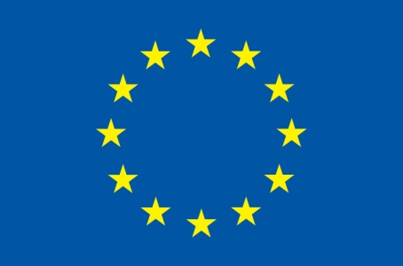
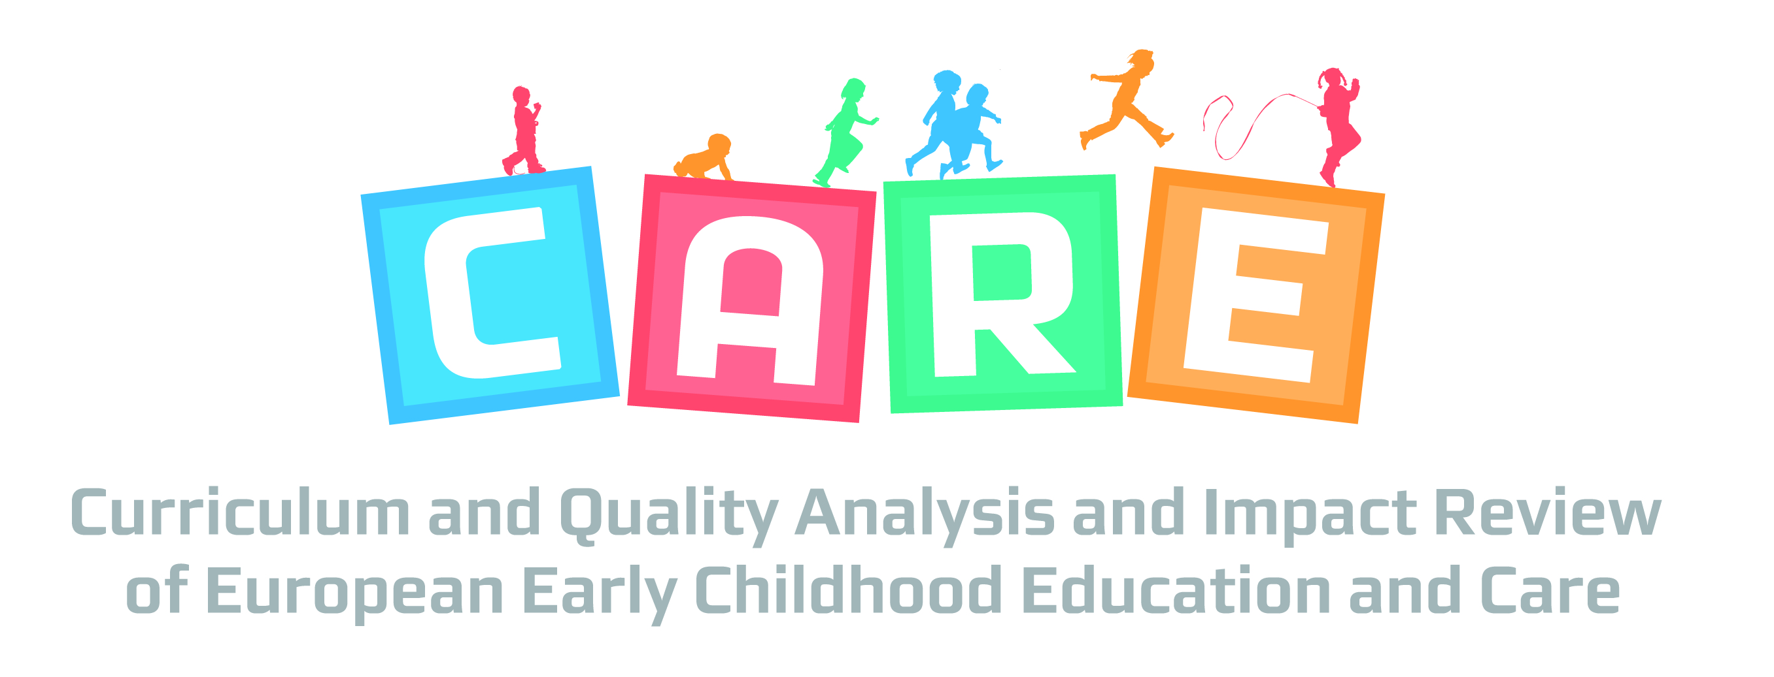

613318

CARE

Curriculum Quality Analysis and Impact Review of European ECEC

Instrument: Collaborative project
Call Identifier: FP7-SSH-2013-2
Early childhood education and care: promoting quality for individual, social and economic benefits

D5.1: The Socio-Economic Dimension of Early Childhood Education and Care in Europe

In this report, we summarise the literature with regard to the effects of ECEC on maternal employment and child development, the two outcomes that are most often cited to justify investments in ECEC. Next, we present the costs and funding of ECEC and show that ECEC services are provided through a variety of mechanisms across European countries. We discuss the effects of these funding systems in terms of costs, quality and inclusiveness. Comparing the advantages and disadvantages of private and public systems along these dimensions can inform policymakers in searching to improve their systems. Our own further research on efficiency, costs and benefits, and inclusiveness will also build on this framework.

Due date of deliverable: 31/12/2014
Actual submission date: 30/01/2015

Start date of project: 01-01-2014 Duration: 36 Months

CARE contractor:
Utrecht University

Title: The Socio-Economic Dimension of Early Childhood Education and Care in Europe

Organisation: Utrecht University
Authors (main authors in bold): Yusuf Emre Akgündüz, Özgün Ünver, Janneke Plantenga, Ides Nicaise
Email: Y.E.Akgunduz@uu.nl
Number of PM:
Dissemination Level:

Version | date | Authors | status | changes
0.1
0.2
0.3

Project co-funded by the European Commission within the Seventh Framework Programme (2014-2017)
Dissemination Level
PU | Public
PP | Restricted to other programme participants (including the Commission Services)
RE | Restricted to a group specified by the consortium (including the Commission Services)
CO | Confidential, only for members of the consortium (including the Commission Services)

Table of contents

Introduction 4
A Review of the Literature on the Effects of ECEC 5
Employment 5
Child development 7
Costs and Methods of ECEC Provision in Europe 10
Efficiency of Child Care Funding Mechanisms: Costs and Quality 13
Inclusiveness of Child Care Funding Mechanisms: Accessibility and Universality 15
Financing ECEC for Equal Opportunities 16
Universal Legal Entitlement and Compulsory ECEC 16
Public versus Market Provision 17
Free Entitlement and Parental Contribution to the ECEC Cost 17
Cost Reduction and Financial Support for Families 19
Financing ECEC for Equal Treatment 19
Scheduling of Services 20
Quality of ECEC Services 20
Geographical Distribution of ECEC Provision 20
Parental Choice, Longer Leave and Child Home Care Allowance 21
Financing ECEC for Equal Outcomes 22
Targeted Programmes 23
Additional Funding within Mainstream ECEC 24
Conclusions 24
References 26

Introduction
Rising female participation rates and the increase in the number of single adult families have led to the widespread use of non-parental child care in most European countries. Recent figures show that around 30% of the children under 3 and over 80% of the children between ages 3 and 5 are in formal child care and pre-schools in the EU-27 countries. With such high non-parental care rates, ECEC services have come to form the early part of education and their effects on children’s wellbeing and human capital has become a topic of interest.
There has been extensive research into the impact of early childhood education and care (ECEC) on maternal employment, gender equality, child well-being, the prevention of educational disadvantage, reduced (child) poverty, increased intergenerational social mobility, as well as favourable outcomes later in life (Heckman 2006; Cunha et al. 2006; Leseman 2009; OECD 2012). High quality ECEC services are presented as having very high rates of return especially for children from disadvantaged backgrounds (Heckman, 2006).
The EU discourse on ECEC is focussed on the provision of quality, holistic, complex, integrated, intersectoral and inclusive education and care to children (Herczog 2012). The European Union has been promoting ECEC provision for more than two decades due to its role in facilitating maternal employment (Mahon 2002). More recently, ECEC has been seen as an investment for the future (children’s well-becoming) rather than a rights-based opportunity for children’s current well-being (Herczog 2012). As such, a balanced approach is needed that takes into account both the costs and benefits of ECEC services.
Not all spending on ECEC services is equivalent. The demand for non-parental child care has led to different institutional arrangements across European countries, ranging from public provision to private and semi-informal markets. These institutions are not set in stone, as examples of privatization in public systems were seen in Sweden in 1990s and in the Netherlands in 2005. A fundamental question from a policy perspective is how to set-up ECEC systems to achieve policy objectives. Public and private systems may have a different impact on the actual effects of ECEC services in terms of quality, accessibility and inclusiveness. These characteristics of the ECEC system will in return affect employment rates and child development.
It is important to note that ECEC is a broad concept that raises a range of questions as to where (at home, caregiver’s home, care centre), by whom (e.g. mother, family members, surrogate mothers, professionals) and how (e.g. socializing children with each other, educating, child minding) it should be given (cf. Kremer 2006). Although we will mostly focus on the public or subsidised ECEC provision – i.e. professional child care and education – we will also touch upon other child care options in order to provide the whole context.

A Review of the Literature on the Effects of ECEC
Since the rise in female employment is what led to large-scale child care provision, it is natural that much of the initial economic literature has focused on the impact of child care policies on female employment. Inevitably, the most important attributes from the perspective of employment are the prices and availability of child care. However, attention has since shifted to the impact of care on child development since early childhood appears to have potential long-term effects on educational attainment, employment, wages and other non-pecuniary indicators of well-being (Heckman 2006). Unlike the issue of parents’ employment, child development highlights the quality aspect of care services rather than the price and availability.
Before continuing with the current state of ECEC in Europe, this section provides an overview of the existing (largely economic and pedagogic) literature on ECEC services, employment and child development. The arguments for public intervention in ECEC coverage and quality rely heavily on the empirical evidence regarding its benefits for parents’ labour force participation and child development.

Employment
ECEC services in general are referred to as child care throughout the economic literature linking ECEC and female employment. The difference in terminology seems to emphasize the main function of earlier ECEC services, which is employment rather than development (Baker 2011). The main purpose of child care in the classical works of Becker (2009) and Heckman (1974) is to decrease the shadow price of employment. Female employment decisions are assumed to be the result of a comparison of the benefits from increased consumption through employment and the costs of child care and leisure time. The so called reservation wage for a mother is then the sum of the (pecuniary) value of child care and leisure. Within the simplest framework, the quality of child care does not matter and parents value non-parental child care by its price.
Since the theory of child care and employment relied exclusively on the assumption that the only difference between non-parental and parental care was child care costs, the empirical studies in the field also focus mostly on the impact of child care prices on female employment. These studies are mostly informative for policies increasing subsidies on child care that result in lower net parental fees. Later studies take quality into account as an unobserved, latent variable by introducing different care-specific effects depending on the mode of child care, which can range from formal day care to informal care and private caregivers (Ribar 1995; Blau and Hagy 1998). In that case, quality is still assumed to be constant across providers but can differ amongst child care types.
In table 1, we show some of the often cited estimates in the literature with regards to the effects of child care prices on maternal employment. The table also shows the methodology used, the country that the estimate relates to, and the reference year of the sample used. Methodology-wise, there are two main categories. The first category is made up of the structural estimates that rely on predicting child care prices and wages for all households. The second consists of natural experiments that rely on changes in subsidies or expansions of child care sectors. The results range between very large negative effects with an elasticity estimate of nearly 1 in Kimmel (1998) and insignificant or small effects as in Lundin et al. (2008) and Havnes and Mogstad (2011a). More recent estimates that rely on changes in policies to identify effects tend to find smaller effects of child care prices on maternal employment. Lundin et al. (2008) suggest that the reason is the already high female participation rates, since their study is based on Sweden. Havnes and Mogstad (2011a) attribute the apparent lack of effects to substitution from informal to formal child care, which results in small net effects on employment.

Table 1: Estimates on the effects of child care prices and subsidies on maternal employment
Authors / Publishing Year | Effect | Method | Country | Year
Blau and Hagy (1998) | -0.2 | Structural | USA | 1990
Tekin (2007) | -0.133 | Structural | USA | 1997
Kimmel (1998) | -0.923 | Structural | USA | 1987
Ribar (1995) | -0.088 | Structural | USA | 1984
Michalopoulos and Robins (2002) | -0.259 | Structural | USA/Canada | 1989
Baker et al. (2008) | -0.236 | Nat. Experiment | Canada | 2005
Kornstad and Thoresen (2007) | -0.12 | Structural | Norway | 1998
Lundin et. al (2008) | 0~ | Nat. Experiment | Sweden | 2002
Some studies based on natural experiments such as Havnes and Mogstad (2011a) do not provide elasticity estimates and are not included in the table.

Since more recent studies, using more sophisticated structural models or natural experiments, tend to find smaller effects of child care prices on employment (Blau and Currie 2006): long-term viability of raising maternal employment through child care subsidies seems limited. As female employment figures and earnings increase, small changes in prices do not seem to affect employment decisions as much. As long as child care is widely accessible, further investments may not cover the costs. Nevertheless, most studies do find large effects on the choice of child care types (Ribar 1995; Havnes and Mogstad 2011a). If formal child care is preferable compared to informal care, due to quality differences or higher educational standards, policies geared towards lower prices may still be worth pursuing. The primary concern in that case is whether or not there are differences in the effects of informal and formal child care on child development. Alternatively, parental care might be most optimal at least in early years, but the impact of parental leave legislation on employment is a different research topic beyond the scope of this paper. Recent studies seem to suggest that parental leave has a small positive effect on employment as long as it is not too long but parental leave can have negative effects on women’s wages (Thevenon and Solaz 2013).

Child development
Interest in high quality child care is not a recent phenomenon. Interventions with randomized designs conducted decades ago in the United States, chiefly the Perry Pre-School Programme in the early 1960s and the STAR project in mid-1980s, constitute the main part of the argument for increased investments in early childhood development. However, it is not easy to measure the child care quality since data are scarce regarding the links between the quality of ECEC services, childhood development indicators and longer term outcomes such as earnings and educational achievement. The long-term effects on earnings and educational achievement of ECEC attendance and quality from these interventions were only relatively recently analysed (Heckman et al. 2010; Chetty et al. 2010).
The positive effects on long-term outcomes from interventions based on high-quality child care have generated a case for higher investments in child care services across the developed countries (Heckman 2006). With growing policy interest, more research has been produced from a larger variety of countries and child care systems that link child care attendance and quality with development outcomes. In this section, we provide a short review of the results from this line of research and discuss the potential causes for the differences in findings.
Employment effects of child care prices are either negative or insignificant with differences only in the size of the effects. In contrast, the literature linking child care attendance and quality with development shows more variation with both positive and negative findings commonly found. The variation seems to suggest that differences in sample, measurements of development and methodology play a major role. We first discuss the differences along these three dimensions and present some of the more recent and influential results in table 2. Next, we try to draw conclusions about the causes of the variation and what policy makers can learn from this varied landscape.
Not all studies in the field can - or aim to - study long-term effects of child care attendance as in the Perry Preschool study (Heckman et al. 2010) or the study of the Norwegian child care expansion by Havnes and Mogstad (2011b). Survey data has been used especially in the psychological literature to determine if there are any effects of the type, extent and quality of child care on child development. Studies based on the large scale panel of NICHD and others such as Votruba-Drzal et al. (2004), Datta Gupta and Simonsen (2010), Herbst (2013) all make use of indicators developed by psychologists to measure cognitive and behavioral functioning. Somewhat less common is the use of medium-term indicators of school achievement at secondary school (Black et al. 2012). Table 2 indicates whether the studies relate to long-term, medium-term or short-term outcomes.
ECEC services are often treated as equalizers. Recent findings of increased intergenerational mobility by Havnes and Mogstad (2014) in Norway seem to confirm the potential role that child care can play in levelling up cognitive development prior to primary school. Intervention studies of both the Heckman et al. (2010) for the Perry Preschool Programme and Melhuish et al. (2008) study from the UK focus on low-income samples. Table 2 indicates whether the sample is made up of children from low-income backgrounds in the third column.

Table 2: Estimates on the effects of child care attendance on child development
Authors (Year) | Outcome | Sample | Method | Effect
Baker et al. (2008) | Short term | Canada | Quasi-experimental | -
Blanden et al. (2014) | Short term | UK | Quasi-experimental | + (small)
Datta Gupta & Simonsen (2010) | Short term | Denmark | Quasi-experimental | 0
Spiess et al. (2003) | Medium term | Germany | Panel | 0  + immigrants
Havnes & Mogstad (2011b) | Long term | Norway - all  Low income | Quasi-experimental | +  ++ Low income
Havnes & Mogstad (2014) | Long term | Norway - all  Low income | Quasi experimental | - High income  + Low income
Black et al. (2012) | Medium term | Norway | Quasi-experimental | +/0
Melhuish et al. (2008) | Short-term | UK Low income | Intervention | +
Herbst (2013) | Short term | US | Instrumental | -
NICHD (2005) | Short term | US | Panel | +
Votruba-Drzal (2004) | Short term | US Low income | Panel | +
Vandell et al. (2010) | Short term | US | Panel | + Cognitive  - Behavioral
Heckman et al. (2010) | Long term | US Low income | Intervention | +
Bernal and Keane (2011) | Short-term | US Low income | Instrumental | -

The final variation between the studies on child care attendance and child development relates to methodology. The impact of child care is not easy to identify. In a bivariate, cross-sectional regression of development outcomes on child care attendance, family characteristics (such as income) are positively correlated with child care attendance, which makes the correlation between child care attendance and development partly spurious. The most common approach to solve endogeneity problems is to use panel (or value added) studies with a large number of control variables (Vandell et al. 2010; Spiess et al. 2003; NICHD 2005). Even in fixed-effects models, there may be unobserved factors that change over time and correlate with both child care attendance and development, leading to biased estimates. An instrumental variables approach could be followed, but it is not easy to find suitable instruments that affect child care attendance decisions but not child development. As a result, IV studies are limited in number so far (Bernal and Keane 2011; Herbst 2013). The most convincing approach to make causality claims is to exploit an intervention study with random assignment. However, these studies are expensive and limited in number. An alternative approach is to exploit changes in policies that affect child care attendance, as was done by Havnes and Mogstad (2011b; 2014), Black et al. (2014) in Norway, Blanden et al. (2014) in UK and Baker et al. (2008) in Canada. Since these policy reforms are independent from individual children’s development, estimates of their effects in later years’ can be argued to be causal. Table 2 indicates whether the studies use a fixed-effect, panel approach (or its variants), instrumental variables, random assignment intervention set-ups or a quasi-experimental approach based on policy changes.
Table 2 shows that the direction of the effects varies across studies with different samples and methodologies. It may nevertheless be possible to draw some conclusions based on common effects. Studies of long-term effects tend to find mixed or weaker positive effects in education (Black et al. 2014) and earnings (Havnes and Mogstad 2014). However, the effects tend to be positive for low-income samples even in the case of long term outcomes, as in the case of Norway analyzed by Havnes and Mogstad (2011b; 2014) and the well-known study of Heckman (2006). In fact, all studies that use samples of children from low-income families appear to find positive effects, with the only exception being the study of Bernal and Keane (2011), who look at a sample of children from single parent families. Results of Spiess et al. (2003) suggest that a similarly strong positive effect might exist for children from immigrant backgrounds since they find no effects from ECEC attendance on average - but do find a significant effect for this subgroup. Studies aiming to find exogenous variation in child care attendance through quasi-experiments and instrumental variables approaches tend to produce more negative results, as seen in Herbst (2013) and Baker et al. (2008), who both study short term outcomes. In contrast, those studies using short-term outcomes without an IV or quasi-experimental approach find positive effects as in the NICHD (2005) panel and Vandell et al. (2010) who find a positive effect on cognitive development. The contrasting results seem to indicate that there may be endogeneity problems in comparing children in and out of formal child care even when a large number of control variables are added and fixed effects estimators are used to subtract unobserved heterogeneity.
For policymakers, there are two lessons to be drawn. The first is that formal child care seems to be largely positive for both short and long-term outcomes of children from low income backgrounds. The second overarching result is that the effects on more inclusive samples are decidedly mixed. Both positive and negative results are found. One potential explanation for the ambiguous results may be the quality of child care on offer in different countries. Child care quality has been linked with better development results in multiple studies (Burchinal and Cryer 2003; Duncan 2003; Chetty 2010). This would also explain the difference found between quasi-experimental studies based on national reforms, which tend to find smaller positive effects than studies based on interventions which are likely to have higher quality of child care. The starkest recent example in that regard is the difference between the findings of Melhuish (2008) and Blanden et al. (2014) from UK: whereas the former finds very large effects from the EPPS study, the latter finds moderate to small effects from the introduction of free child care in 2000. The policy goals from a development perspective might therefore be to improve access to formal child care for low income families and to improve child care quality. The favourable social effects of high-quality ECEC services provide strong arguments for government intervention for disadvantaged groups. This intervention should include quality standards on the one hand, and (means-tested) subsidies on the other. In the next section, we discuss the current status of ECEC services in Europe and the methods of provision.

Costs and Methods of ECEC Provision in Europe
The latest Eurydice (2014) report provides a broad and detailed picture of the current status of ECEC costs, quality and attendance in ECEC in Europe. In this section, we provide a very short summary of that report to give a general idea about the type of funding mechanisms in place in Europe. We make use of the Eurydice (2014) report and the OECD Family Database (2014) to construct the figures.

Figure 1: Public spending in child care and pre-schools: 1998 to 2009
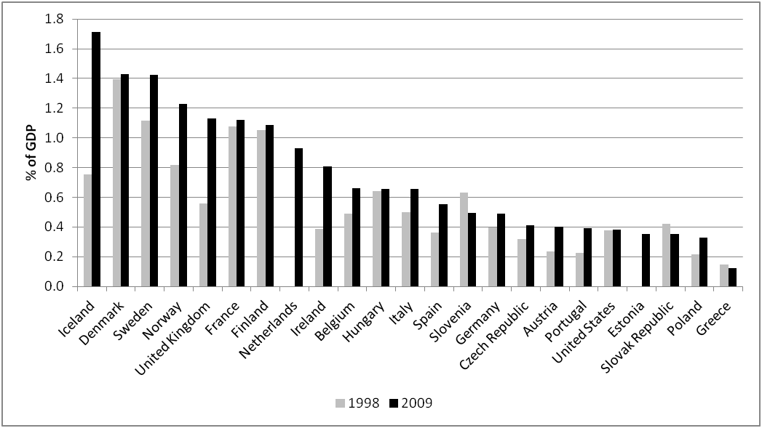
Source: OECD Family Database 2014

Public spending in ECEC as a percentage of GDP has been going up in most European countries as shown in Figure 1. Despite cuts in many other welfare functions, even more liberal welfare states such as the United Kingdom have increased ECEC spending substantially. However, not all ECEC spending is the same. Bennett (2004) argues that a key question in allocating funding in ECEC is whether public funds for early education are allocated indirectly through family cash benefits or directly to ECEC providers as operational grants, like in primary education. In supply-led systems, either the grant is directly given to the provider under certain conditions or the state provides the service itself, while in demand-led systems – where the state has less control over the quality or accessibility of the provision – the users of the service are given vouchers, cash or tax credits (Penn 2009; McLean 2014). In Figure 2, we show the private and public classifications by OECD for various ECEC systems for the age group 0 to 2 in European countries and the United States. The variation is largely in the youngest age group of children as the provision for older children tends to be either mixed or public.

Figure 2: ECEC Provision Methods for Ages 0 to 2
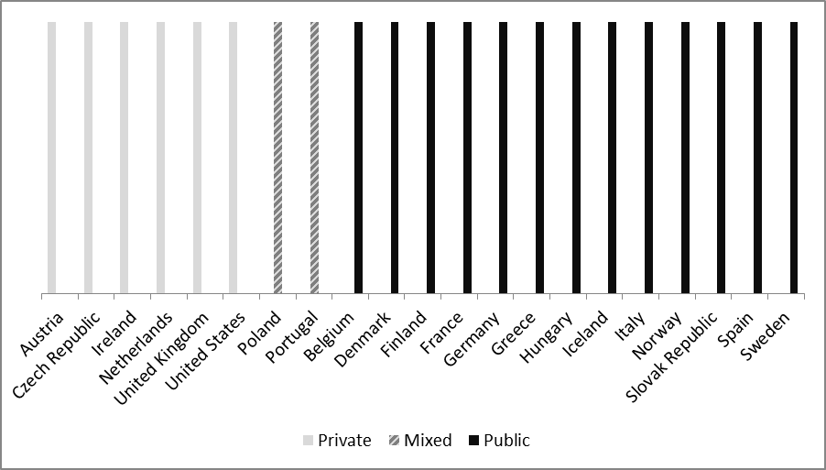
Source: OECD Family Database 2014

Regardless of public or private spending, ECEC investments are highly correlated with the proportion of children in formal ECEC. The rates are over 80% for most OECD countries for the age group 3 to 5, and reach as high as 60% for the age group 0 to 3. Figure 3 plots the proportion of children aged 0 to 3 in formal ECEC against public spending in ECEC as a percentage of GDP. Regardless of private or public systems, the simple fact remains that countries that spend more on ECEC have more children in formal ECEC.

Figure 3: Public Spending on ECEC and Participation for Ages 0 to 3
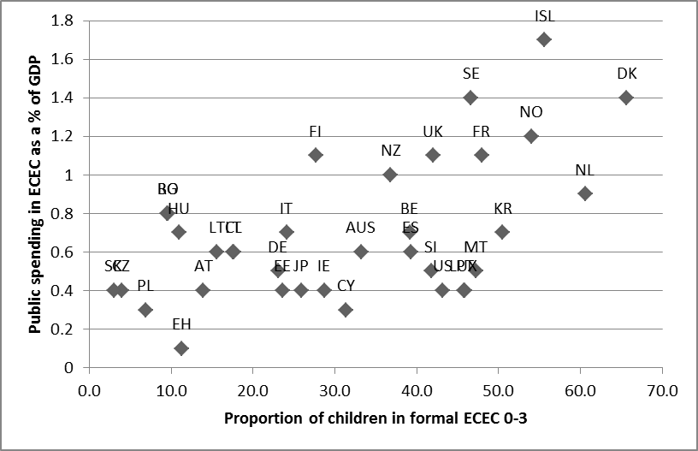
Source: OECD Family Database 2014

It would be an oversimplification to divide children between formal ECEC attendees and those who do not attend formal ECEC, because a large proportion of children attend informal child care. Similarly, states’ support for child care is not limited to formal ECEC. There are a number of countries that do not have ECEC markets with matching demand and supply, according to Eurydice. With the exception of Nordic countries, most countries have a problem of meeting demand in the 0-3 age category. Perhaps partly spurred by the lack of available formal ECEC, there is a large proportion of children in informal child care, as seen in table 3. Furthermore, some countries allow for compensation of parents who do not use formal ECEC. Care allowances are paid to parents who do not make use of ECEC services that they are entitled to. Table 3 presents a general overview of selected countries’ formal and informal child care use and the presence of care allowances for parents who do not use ECEC services.

Table 3: Formal care, informal care and care allowances in Europe
 | Formal child care % (0-3 years old) | Formal child care % (3-5 years old) | Informal child care % (0-2 years old) | Informal child care % (3-5 years old) | Availability of Care Allowance
Austria | 13.9 | 81.9 | 19.8 | 30.3 | local
Belgium | 39.2 | 99.0 | 20.9 | 26.8 | yes
Denmark | 65.7 | 94.1 | 0.6 | 0.1 | local
Finland | 27.7 | 73.0 | 1.3 | 4.2 | yes
France | 48.0 | 101.1 | 17.7 | 19.6 | yes
Germany | 23.1 | 93.9 | 14.5 | 17.4 | no
Greece (pr/pub sector) | 11.3 | 48.3 | 52.5 | 38.7 | no
Italy | 24.2 | 95.7 | 31.5 | 37.0 | no
Netherlands | 60.6 | 95.7 | 51.9 | 47.5 | NA
Norway | 54.0 | 96.2 | 4.3 | 2.3 | yes
Poland | 6.9 | 59.7 | 29.9 | 29.8 | no
Portugal | 45.9 | 84.1 | 25.4 | 35.9 | no
UK | 42.0 | 93.3 | 31.7 | 36.9 | no
Source: OECD Family Database 2014, Eurydice 2014

Whereas the costs of child care for governments and even parents are relatively easy to observe, there are substantial differences in provision methods to take into account. In the following two sections, we discuss the merits of private and public (supply side and demand side financing) ECEC, first in terms of costs and quality and then with regards to inclusiveness. Research comparing public and private systems is rather lacking and the discussion is inevitably based more on theoretical conjecture than empirical research. Research analysing the costs and benefits of reforms in terms of their effects on employment and child development from both public and private systems would be the most optimal approach to analysing the relative efficiency of different systems.

Efficiency of ChilD Care Funding Mechanisms: Costs and Quality
The method of provision of child care largely overlaps with the welfare state types across OECD countries. More liberal welfare states in United Kingdom, United States, Ireland, Australia, the Netherlands and Austria have private provision mechanisms while Scandinavian countries, France and Germany have public or mixed provisions. ECEC policies are subject to the same discussion that primary and secondary schools have undergone about the merits of public or private systems and the role of competition (Friedman 1997). Debates regarding the effects of privatization, and therefore competition, on quality access and costs of ECEC are thus of relevance.
A major argument for privatization and demand side subsidies is the alleged potential for greater dynamism that private markets have to meet ECEC shortages and demands (OECD 2006). While private markets may have an advantage in increasing supply and meeting demand, they tend to cost more for parents and less for governments. Figure 4 shows the public expenditure per child on child care support and the estimated out of pocket spending as a share net income a two parent household with earnings the equivalent of 150% of the average wage for some OECD countries (OECD Family Database 2014). Out of pocket spending by parents is relatively high in private child care markets such as that of the United States, New Zealand and the Netherlands. This is true even for the United Kingdom where public spending is also relatively high. In contrast, Scandinavian countries have high public expenditures per child but limited costs for parents. Worth noting in figure 4 is that the public expenditure is per child rather than per child in child care services, implying that the public expenditure is highly correlated with the use of child care.
A potential worry about private markets is the high cost for parents and consequently the lower use of formal care. Formal child care is preferable especially if informal markets are difficult to regulate and monitor. Datta Gupta and Simonsen (2010) find that formal child care had insignificant effects on child development while informal care had negative effects. Havnes and Mogstad (2011a) show that while maternal employment is not affected by a switch to public child care services, there is a surge in the use of formal care instead of informal care. However, high parental fees are not due to the private system itself. Instead, whereas countries with private systems tend to be the ones with relatively low subsidy rates, higher subsidies can increase ECEC use in these systems. Evidence for high ECEC attendance in private systems with sufficient subsidies is found in the Netherlands by Bettendorf et al. (2012), who show that increasing subsidies in a private child care market led to more formal care use. Overall, introducing a private market through demand side subsidies have the advantage of more market dynamism and therefore increased supply, but most countries with private systems do not have high enough subsidies to actually have parental fees as low as the public systems’.

Figure 4: Public Expenditure on Child Care and Parents’ Out of Pocket Spending
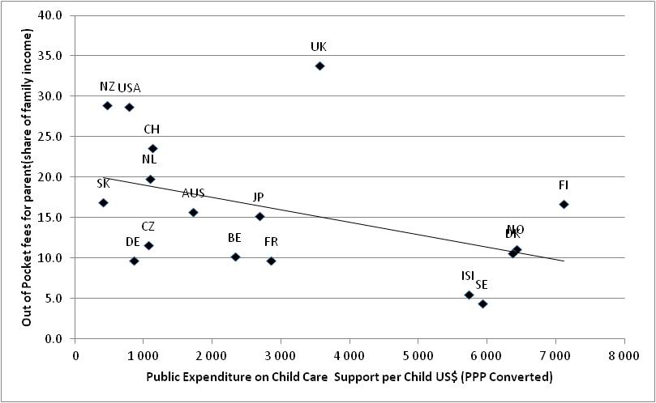
Source: OECD Family Database 2014

The more contentious issue seems to be that of quality. The standard economic reasoning for a normal good is that private markets will outperform public provision in meeting customers’ preferences and providing low costs. Child care centres will ideally have a pecuniary incentive to provide the cheapest and highest possible quality care if parents choose child care based on quality and prices. In the case of child care, there are two market failures that may constrain markets from working optimally. First is the information asymmetry in child care markets. Parents are unlikely to be able to distinguish between different quality levels. Mocan (2007) finds that parents usually base their quality judgments on visible characteristics such as the staff to child ratio or building quality, but these characteristics do not necessarily predict actual quality of child care very well. Correlations are found between parents’ income and the quality of child care they purchase, but the effects are not particularly strong (Burchinal and Nelson 2000). The second potential market failure is the extent of competition among child care centres. If competition is very localized and parents do not travel far for child care, there may be monopoly or oligopoly situations within local markets and little pressure on centres to improve quality (Plantenga 2013). Besides these two issues within the child care market, there are also potential market failures in markets connected to child care provision. An example can be seen in Canada where the shortage of qualified labour leads to concerns over the quality of ECEC services there (Fairholm and Davis 2012).
Without empirical evidence, it is not possible to say whether information asymmetries or local monopolies lead to lower quality in private markets compared to public provision in ECEC services. However, empirical evidence linking privatization or competition to child care quality is rather lacking. Akgunduz and Plantenga (2013) show that competition has modest positive effects on child care quality in the Dutch day-care market, but their study is limited to cross-section analysis and does not directly analyse privatization.
More evidence is available in the schooling sector where the discussion about privatization has a longer history. West and Woessman (2010) use the share of Catholics in 1900 to instrument privatization in schooling across countries and find a positive causal effect from the share of private schools on students’ mathematics, science and reading scores. Belfield and Levin (2002) review 41 studies and find results ranging from insignificant to positive effects. Their conclusion is that competition has a modest but positive effect on educational outcomes. The question is to what extent these findings can be applied to the child care sector. If we believe that schooling and child care sectors have similar problems in information asymmetry and localized monopolies, privatization could also have modest positive effects on ECEC quality. However, information asymmetry problems may be more acute in child care markets where there are no obvious outcomes such as grades and graduation rates for parents to observe. Additionally, child care markets may be less developed and smaller than schooling markets in many OECD countries since schooling is mandatory. As such, more empirical analysis on the role of privatization and competition within child care markets may be needed to make definitive conclusions. Ideally, we would be able to simply compare the costs of ECEC in countries with and without market mechanisms with their effects on employment and development outcomes. However, while costs can be calculated simply, there is no direct way to statistically measure the effects of ECEC on employment and development. Empirically studying the impact of expansions of - or changes to private and public ECEC systems might be a practical way to compare the effects from these two systems on the employment and development outcomes. Both quality and cost aspects however need to take into account equity and inclusiveness of the services offered, which is the topic discussed in the next section.

Inclusiveness of Child Care Funding Mechanisms: Accessibility and Universality
In this section of the paper, we discuss different provision and financing schemes of ECEC services in Europe for accessibility, equity and inclusiveness. Inspired by the article by Nicaise et al. (2000) classifying general educational strategies for disadvantaged children in Europe, we introduce a three-pillar structure to distinguish between various incentives in ECEC financing: equal opportunities, equal treatment and equal outcomes. As used in this paper, equal opportunities relate to exogenous preconditions for children’s equitable access to ECEC services, equal treatment stands for the absence and elimination of negative discrimination in ECEC for all children, and finally equal outcomes strategies aim at bringing all children to the same level through positive discrimination of the disadvantaged (Nicaise et al. 2000). Note that it is difficult to classify financing measures into one of the three pillars exclusively, as each scheme may relate to more than one pillar at the same time.
These three pillars are complementary. Thus, we start with financing strategies for equal opportunities in order to secure initial access, continue with financing strategies for equal treatment to ensure equity when receiving ECEC services, and finally financing strategies for equal outcomes with regard to affirmative action towards the disadvantaged – beyond equal opportunities and equal treatment.

Financing ECEC for Equal Opportunities
As a first step, welfare states aim at equitable access to ECEC services by all. In other words, preconditions for children to enjoy the ECEC services they demand are ensured. In order to do so, these funding mechanisms compensate for disadvantages exogenous to the education system and are rather related to the demand-side (Nicaise et al. 2000). In this section we discuss major financing schemes in order to ensure equal opportunities such as universal entitlement, public versus market provision, cost of services, and financial help for ECEC users.

Universal Legal Entitlement and Compulsory ECEC
In some European countries there is a legal entitlement to ECEC, encouraging providers to secure publicly subsidised ECEC provision for all children living in a catchment area whose parents require a place for their child regardless of their employment, socio-economic or family status (Eurydice 2014:38). Universal legal entitlement to ECEC is a good example of equal opportunity strategies because it guarantees places for every child. Universal legal entitlement also puts the welfare state as a primary agent in ECEC provision as it is responsible for at least the regulations and even the provision as well as financing. Compulsory ECEC from a certain age onwards is another way to ensure places for children, especially when a certain minimum level of school readiness is strived for by the start of the primary school.
Despite the differences in entitlement (age) of children to ECEC across Europe, most European countries guarantee a place in ECEC in the form of legal entitlement or requirement of compulsory attendance. In the countries that offer universal legal entitlement to ECEC, the entitlement usually starts in the 3-6 years period. Exceptions are Denmark, Slovenia, Finland, Sweden, and Norway that offer legal entitlement at the age of one or earlier, and Belgium, Estonia, and Malta where children are entitled to a place in childcare at age one to three (Eurydice 2014). In the Netherlands (which is not entirely covered in the Eurydice report), the legal entitlement to ECEC starts from 4 years of age (den Dulk 2014). In Bulgaria, Greece, Cyprus, Latvia, Luxembourg, Hungary, Austria, Poland, and Switzerland ECEC is compulsory from either 4 or 5 years onwards (Eurydice 2014). On the other hand, in Croatia, Italy, Lithuania, Romania, Slovakia, Iceland and Turkey, there is neither a legal entitlement nor compulsory ECEC (Eurydice 2014).

Public versus Market Provision
Public ECEC provision is an obvious way to ensure equal access to ECEC services. As explained earlier, it is difficult to find ECEC provision that is completely public. However all European countries offer at least some public or publicly subsidised private provision which lowers the costs for users. On the other hand, merely providing public or publicly subsidised private ECEC does not necessarily mean that these services are accessible to all. So we should be looking at the actual costs for parents in order to assess the efficiency of public financing mechanisms in ECEC.
Some countries have a predominantly public provision that is crucial for many families who would otherwise have difficulty in sending their children to ECEC institutions. Good examples are the Nordic countries with their social democratic care regime based on the premises of universality, central role of the state and the social democratic parties and trade unions as the moving forces behind social policy development (Mahon et al. 2012). Next, we have the liberal countries at the other end of the spectrum where the labour market and families have key roles and the state is merely expected to provide assistance to the worst-off (Mahon et al. 2012).

Free Entitlement and Parental Contribution to the ECEC Cost
There is usually a trade-off for governments between high quality ECEC and free provision. In almost all European countries, parents have to pay at least a small financial contribution to ECEC institutions. Even the Scandinavian countries that have the most developed ECEC systems in Europe rely on parental contributions to a certain extent. However this amount varies drastically from one country to another depending the amount of supply-side funding. Only in Denmark, Germany, Estonia, Croatia, Slovenia, Iceland, Turkey and Norway there is no free ECEC entitlement at all (Eurydice 2014). In all other countries, free ECEC is available to varying degrees – starting from different ages and covering different amounts of hours per week (ranging between 10 to 40 hours). In Figure 5, the free weekly ECEC provision for 3 year-olds is presented.

Figure 5: Free ECEC provision for 3 year-olds, by weekly hours, 2012-2013 (Eurydice 2014:84)

Source: Eurydice 2014

In terms of the range of parental fees for 0-3 year olds, we see that institutional ECEC in most Central and Eastern European Countries is more accessible than institutional ECEC in the other parts of Europe (Eurydice 2014). So we can conclude that these countries try to continue offering universal services in line with their socialist background. Currently, only Latvia, Lithuania and Romania offer free-of-charge full-time (40 hours) ECEC from zero to three years of age in Europe; however since ECEC is neither a legal entitlement nor compulsory in these countries, there is no guaranteed access (Eurydice 2014). In countries like Belgium, Germany, Spain, Luxembourg, Malta, Slovenia, Liechtenstein and Switzerland, the range of parental contribution for 0-3 year olds is very wide (Eurydice 2014).

Cost Reduction and Financial Support for Families
Regardless of the availability of supply-side funding, the state may introduce demand-side funding for the families that use ECEC services. As a result, families may be paying means-tested fees/contributions, receive social assistance support for ECEC, or enjoy tax relief or tax credits. According to the Eurydice report (2014), the most commonly used criteria for reduced parental contributions in ECEC are family income, number of children in the household attending ECEC, number of siblings, child’s age, and whether the child is in a single parent household or orphan. Every European country offers cost reductions or exemptions based on at least one of these criteria.
Some European countries offer financial support to families using ECEC services, and the most common form of financial support is tax relief enabling parents to deduct their ECEC costs from their tax liability (Eurydice 2014). On the other hand this practice is not beneficial for very poor households that earn too little to pay taxes. Another way of supporting parents is offering special family allowances or grants based on a child's attendance to ECEC as well as vouchers which can be used as payment for ECEC.
The introduction of the means-tested Working Tax Credit in the UK for low-income working families is an example of demand-side initiative from the state’s part (cf. Vincent, Braun, and Ball 2008). This depends on the household income, number of hours worked and the number of children. Moreover, according to the “childcare element of the Working Tax Credit”, up to 70% of ECEC costs can be covered depending on the household income (Vincent, Braun, and Ball 2008:23). In Germany, in case of hardship in paying ECEC contributions, it is possible for low-income households to waive the fees or have them paid by other public agencies (Schober and Spiess 2013:712).

Financing ECEC for Equal Treatment
Financing for equal treatment in ECEC is rather related to supply-side funding of ECEC services. The welfare state tries to organise the supply equally for everyone upon children’s access to institutional ECEC. Equal treatment depends on factors such as the number of weekly hours allocated to each child, equal quality of services, and geographical distribution of ECEC centres. In this section we also discuss the topic of parental choice, e.g. the possibility to opt for parental leave with home care allowances rather than external care services, or to choose between alternative types of ECEC services.

Scheduling of Services
Even though all children may have access to ECEC in a given country, full-time and year-round services might be inaccessible for disadvantaged children due to additional costs – as in most countries, free provision is limited to a few hours. Moreover, ECEC services being available for only half a day may prevent mothers from taking up employment altogether or force them to comply with part-time employment. On the other hand, part-time ECEC limits the scope for caregivers to compensate for socio-economic and cultural inequalities at home (Hagemann 2006). Moreover, as a practical shortcoming of part-time provision, flexibility of ECEC services is even more important for disadvantaged or immigrant families since they have less access to informal care options and more often work irregular hours (Vandenbroeck and Lazzari 2014).

Quality of ECEC Services
Ensuring minimum quality of ECEC services across the country is another measure to be taken by the welfare state in order to offer equal treatment to children in the ECEC system. Even if overall quality is improved by private markets, Market-based ECEC often brings along inadequate quality for disadvantaged children (Noailly and Visser 2009), and condemns families with lower purchasing power to ECEC with lower qualified professionals (Vandenbroeck 2011). Nordic countries are seen as a benchmark also with regard to the minimum quality regulations as their widely accessible provision is known for not compromising quality services. Qualification of the ECEC staff is an important aspect that needs to be regulated by the welfare state. Achieving this requires a certain amount of investment from the state’s part. In Finland, at least one-third of the staff should have a tertiary education degree while the rest should have at least a secondary-level education from the field (Määttä and Uusiautti 2012).

Geographical Distribution of ECEC Provision
In some countries the ECEC institutions are distributed unevenly across the country and the population. This causes unequal access of children living in rural areas to institutional ECEC services. For example, Austria and Lithuania have a shortage of services in rural areas, while in Bulgaria, Hungary, Latvia, Portugal and Slovenia it is easier to find ECEC places in rural areas (Eurydice 2014). Fewer ECEC places are found in the poorer regions of Poland, and even there, the majority of ECEC centres are located in the city, not in remote areas (Heinen and Wator 2006). This is related to the accelerated closing of ECEC facilities in rural areas where there are less children and more unemployed parents. Heinen and Wator (2006) explain that, although the demand was similar during the socialist period, seasonal ECEC had been available when parents were doing agricultural work.

Longer Leave and Child Home Care Allowance
Some parents may choose to take an extended parental leave or not to take up employment in order to care for their child at home. This choice has financial implications for the household and the welfare state. Parental leave is closely linked to the supply and demand of ECEC especially during the first three years of the child (Ruhm 2011): the longer the (paid) parental leave, the less the ECEC use. As a result, some countries opt for granting lengthy parental leave instead of investing more in institutional ECEC schemes because the cost of supplying ECEC in accordance with the demand is higher than paying for lengthened parental leave. One of the countries that grant the right to take an extended parental leave with full employment security is Finland, where either parent can take a child care leave until the child is 3 years old; during this period the family receives a child home care allowance, after the maternity, paternity and parental leaves are exhausted (Määttä and Uusiautti 2012).
A key factor in parental choice of ECEC is the cost of the service. In the absence of public financial support, ECEC services become inaccessible to most low-income families as the relative burden of parental contribution is higher for them (Magnuson and Shager 2010; Schober and Spiess 2013). This negatively influences both maternal employment and the use of institutional ECEC (Magnuson and Shager 2010). Especially low-income families may welcome child home care allowances as an income supplement (when available) (Sipilä, Repo and Rissanen 2010). In this way, child care allowance may unintendedly turn into a discriminatory policy measure.

Financing ECEC for Equal Outcomes
According to the meritocratic view of education - which is predominant in many societies -, achieving equal opportunities for all should be the main goal, not equal outcomes, because unequal benefits from education depend on the effort and talents of each individual (Nicaise et al. 2000). However, equity in provision (i.e. equal and quality educational services for all) does not necessarily mean that the provision is inclusive for the disadvantaged groups (Horvai 2010). Education may reproduce or transform existing inequalities and social stratification among socio-economic and ethnic groups based on how educational practices are organised and implemented (Ojala 2010).
Currently in Europe, one in four children below the age of six is at risk of poverty or social exclusion, and these children have lower ECEC participation rates (Eurydice 2014). The welfare state should aim to bring all children to the same level of school readiness (Magnuson and Shager 2010). This necessitates more than equal treatment and equal opportunities: it requires additional resources for disadvantaged children who lag behind. In other words, it is necessary to pre-empt the inequalities that may arise in the future instead of mending problems after they become deeply rooted (Horvai 2010).
Research shows that children from low-income families, lone parent families, migrants, Roma, refugee children, children in foster or residential care as well as children with disabilities have lower probabilities of reaching the threshold of necessary skills and preparation for school, and these early disparities tend to persist unless compensatory measures are taken early (Magnuson and Shager 2010; Ojala 2010; Herczog 2012; Johansson and Höjer 2012). For these children, the welfare state should take additional measures (e.g. better equipped centres, better personnel, either free or affordable cost, priority access, etc.) in order to level the educational playing field (Nicaise et al. 2000; OECD 2006; Vandenbroeck 2011).
The benefits from compensatory investments in ECEC for disadvantaged children seem to be widely recognised (cf. Mujica Mota et al. 2006). Research shows that the ECEC interventions towards the disadvantaged children involve substantial costs for the public sector in the short term, but pay off well as the additional earnings of mothers and their partners (even ignoring the subsequent educational gains) outweigh the costs (Mujica Mota et al. 2006; OECD 2006).
These affirmative actions for vulnerable groups should build upon a general, accessible and free-of-charge educational and welfare system as well as targeted efforts within this general welfare model (Johansson and Höjer 2012). Extra funding for disadvantaged children is effective only when it is sufficient to offset the deprivation factors faced by vulnerable groups (Nicaise et al. 2000).
The state may adopt two types of measures: targeted early intervention programmes and extra resources/services within general ECEC programmes (Fallon 2005). An example of a targeted programme was the Irish Rutland Street project started in 1969 and followed up by Early Start in 1994 - which turned out to be effective programmes (Fallon 2005). Among the general programmes for designated disadvantaged schools there are measures such as language stimulation, home/school/community liaison, additional grants, maximum pupil per teacher ratio, etc.

Targeted Programmes
One of the widespread strategies in reaching equal outcomes is providing targeted ECEC programmes in disadvantaged areas or for disadvantaged communities such as migrants, ethnic minorities and low-income families. Targeted ECEC programmes for disadvantaged children appeared in the US in 1960s with Head Start in order to compensate for poverty-related deficiencies (Horvai 2010). This programme inspired many similar ones in Europe such as the European-wide Step by Step programme (SbS) by the Open Society Institute and the Sure Start programme in the UK (Horvai 2010).
European countries also allocate extra resources for minority and immigrant children such as ECEC in mother tongue. In Finland, Cyprus and Latvia, special assistance is offered to children with special needs and children with different ethnic backgrounds for certain areas such as learning the language (Ojala 2010). Similarly, in Sweden, extra support is provided for children whose mother tongue is not Swedish such as a website offering resources to support staff (e.g. pictures, songs, music, drama, dance, etc.), or mother tongue tuition from a native speaker if needed (less preferred due to cost and low efficiency) (Cohen and Pay 2011). Compensatory programmes in Spain also focus on language and other areas of the curriculum and they are implemented in schools with a significant number of children from disadvantaged backgrounds, where children receive this support in the same class as other children in their group in pre-primary education.
Roma and traveller children are one of the most socio-economically disadvantaged groups in Europe. Many countries took measures in order to make their ECEC schemes more inclusive with regard to Roma children. A recent example is the EU-funded ‘A Good Start’ programme (AGS) that was run in Hungary, Macedonia, Romania and Slovakia between 2010 and 2012. For Irish Travellers, the Department of Education and Science of Ireland provides grants for ‘Traveller Preschools’ and visiting teacher service for travellers (Fallon 2005).

Additional Funding within Mainstream ECEC
Giving priority in enrolment and compensatory funding for disadvantaged children are also widespread in Europe. These measures are taken within the mainstream ECEC system without segregating vulnerable groups. In Germany, since mid-2000s, children under the age of three are entitled to enrol in day-care programmes if they are in a household with a lone parent, or with both parents in employment or in education or wanting to take up employment, or if no other support programme promoting the child’s welfare is available (Schober and Spiess 2013:712). Similarly Belgium has introduced priority rules for children belonging to socio-economically disadvantaged families (single-parent and low-income families as well as families referred to ECEC by youth care services) in 2010.
Some countries invest more in ECEC professionals in order to alleviate children’s disadvantages. In Latvia, multicultural ECEC is reinforced by engaging a teacher assistant of Roma background in the classroom (Ojala 2010). Estonia, Lithuania, and Romania are countries that offer financial incentives to professional staff to work with children at risk of exclusion (Eurydice 2009).

Conclusions
European countries all make substantial investments in ECEC and it is not hard to see why. ECEC services have the advantage of bringing together equity objectives through transfers to children in poverty and efficiency objectives by (potentially) increasing maternal employment and assisting child development. As the investment in ECEC services and our understanding of the impact of ECEC on child development grows, it becomes ever more important to optimize European ECEC sectors’ organization and methods of provision.
Our review of the arguments for and against private and public ECEC systems can lead to some tentative conclusions. Both systems appear to have their pros and cons. Greater dynamism in private markets seem to give them an edge in matching demand and responding to shortages. While parental fees are higher in countries with demand side subsidies and private systems, private systems cost much less for states to maintain. Since there appear to be lower (net) benefits for higher income parents’ children and lower effects on maternal employment from child care subsidies in high income countries, private systems may be preferable for high income groups. Theoretically, private systems can also lead to higher quality through competition between providers, but the empirical evidence in this regard does not yet allow us to draw a definitive conclusion. Public systems, on the other hand, are more advantageous in ensuring accessibility and inclusiveness as the state can easily control these services. As a result, public services can reach more disadvantaged groups and are more accessible to low income parents due to lower costs.
It is obvious that, as long as the accessibility, inclusiveness and quality of the services are ensured through market regulation, governments prefer to delegate the provision of services to the market. Key policy concerns relate to the coverage of ECEC services, the level of subsidies, simpler and more accessible financial support and/or cost reduction schemes for families, and state’s encouragement for private for-profit or not-for-profit providers to provide ECEC services in disadvantaged market segments (financially, geographically, etc.). Especially for the disadvantaged children, both targeted programmes and supplementary resource schemes should continue to contribute to equal outcomes.

References
Akgunduz, Y. Emre, and Janneke Plantenga. 2013. Competition for a better future? Effects of competition on child care quality. TKI Working papers: No. 13-14.
Baker, M., Gruber, J., & Milligan, K. (2008). Universal Child Care, Maternal Labor Supply, and Family Well‐Being. Journal of Political Economy, 116(4), 709-745.
Baker, M. (2011). Innis Lecture: Universal early childhood interventions: what is the evidence base?. Canadian Journal of Economics/Revue canadienne d'économique, 44(4), 1069-1105.
Becker, Gary S. 2009. A Treatise on the Family. Harvard University Press.
Belfield, Clive R., and Henry M. Levin. 2002. The effects of competition between schools on educational outcomes: A review for the United States. Review of Educational Research 72.2: 279-341.
Bennett, John. 2004. Early Education Financing: What Is Useful to Know? 23, UNESCO Policy Brief on Early Childhood. http://unesdoc.unesco.org/images/0013/001374/137412e.pdf, accessed September 9, 2014.
Bernal, R., & Keane, M. P. (2011). Child care choices and children’s cognitive achievement: The case of single mothers. Journal of Labor Economics, 29(3), 459-512.

Bettendorf, Leon JH, Egbert LW Jongen, and Paul Muller. 2012. Childcare Subsidies and Labor Supply: Evidence from a large Dutch Reform. No. 12-093/I. Tinbergen Institute Discussion Paper.
Black, S. E., Devereux, P. J., Løken, K. V., & Salvanes, K. G. 2012. Care or cash? The effect of child care subsidies on student performance. Review of Economics and Statistics.
Blanden, J., Del Bono, E., Hansen, K., McNally, S., & Rabe, B. 2014. Early interventions and children’s educational attainment. Evaluating the impact of free part-time pre-school education for 3 year olds in England. Working Paper presented at the ESPE.
Blau, David M., and Alison P. Hagy. 1998. "The demand for quality in child care."Journal of Political Economy 106.1: 104-146.
Burchinal, M. R., & Nelson, L. (2000). Family selection and child care experiences: Implications for studies of child outcomes. Early Childhood Research Quarterly, 15(3), 385-411.
Burchinal, M. R., & Cryer, D. (2004). Diversity, child care quality, and developmental outcomes. Early childhood research quarterly, 18(4), 401-426.
Chetty, R., Friedman, J. N., Hilger, N., Saez, E., Schanzenbach, D. W., & Yagan, D. 2010. How does your kindergarten classroom affect your earnings? Evidence from Project Star. The Quarterly Journal of Economics, 126(4): 1593-1660.
Cohen, Bronwen, and Nicola Pay. 2011. Inspiring Change: An Early Childhood Education and Care Study Visit to Sweden and Poland. King Baudouin Foundation and Children in Scotland. http://www.kbs-frb.be/publication.aspx?id=286676&langtype=1033, accessed September 28, 2014.
Cunha, Flavio, James J. Heckman, Lance Lochner, and Dimitry V. Masterov. 2006. Interpreting the Evidence on Life Cycle Skill Formation. Handbook of the Economics of Education 1: 697–812.
Datta Gupta, Nabanita, and Marianne Simonsen. 2010 Non-cognitive child outcomes and universal high quality child care. Journal of Public Economics 94.1: 30-43.
Den Dulk, Laura. 2014. Country Report: The Netherlands. International Network on Leave Policies and Research. http://www.leavenetwork.org/fileadmin/Leavenetwork/Country_notes/2014/Netherlands.pdf, accessed August 20, 2014.
Duncan, Greg J. 2003. Modeling the impacts of child care quality on children's preschool cognitive development. Child development 74.5: 1454-1475.
Eurydice. 2009. Tackling Social and Cultural Inequalities through Early Childhood Education and Care in Europe. Brussels: Education, Audiovisual and Culture Executive Agency.
Eurydice. 2014. Key Data on Early Childhood Education and Care in Europe. Eurydice and Eurostat Report. Luxembourg: Publications Office of the European Union.
Fairholm, Robert, and Jerome Davis. 2012 Canadian eCeC labour shortages: big, costly and solvable. In “Childcare Markets: Can They Deliver an Equitable Service?” eds Lloyd, Eva and Penn, Helen.
Fallon, Jacqueline. 2005. Targeting Disadvantage among Young Children in the Republic of Ireland: An Overview. Child Care in Practice 11(3): 289–311.
Friedman, M. (1997). Public schools: Make them private. Education Economics, 5(3), 341-344.
Hagemann, Karen. 2006. Between Ideology and Economy: The “Time Politics” of Child Care and Public Education in the Two Germanys. Social Politics: International Studies in Gender, State & Society 13(2): 217–260.
Havnes, Tarjei, and Magne Mogstad. 2011a. Money for nothing? Universal child care and maternal employment. Journal of Public Economics: 1455-1465.
Havnes, Tarjei, and Magne Mogstad. 2011b. No child left behind: Subsidized child care and children's long-run outcomes. American Economic Journal: Economic Policy: 97-129.
Havnes, Tarjei, and Magne Mogstad. 2014. Is universal child care leveling the playing field? Journal of Public Economics.
Heckman, J. J. 2006. Skill Formation and the Economics of Investing in Disadvantaged Children. Science 312(5782): 1900–1902.
Heckman, J. J. 1974. Effects of child-care programs on women's work effort.Marriage, Family, Human Capital, and Fertility. NBER. 136-169.
Heckman, J. J., Moon, S. H., Pinto, R., Savelyev, P. A., & Yavitz, A. (2010). The rate of return to the HighScope Perry Preschool Program. Journal of Public Economics, 94(1), 114-128.
Heinen, Jacqueline, and Monika Wator. 2006. Child Care in Poland Before, During, and after the Transition: Still a Women’s Business. Social Politics: International Studies in Gender, State & Society 13(2): 189–216.
Herbst, Chris M. 2013. The impact of non-parental child care on child development: Evidence from the summer participation “dip”. Journal of Public Economics 105: 86-105.
Herczog, Maria. 2012. Rights of the Child and Early Childhood Education and Care in Europe. European Journal of Education 47(4): 542–555.
Horvai, Anna. 2010. Recognising the Roma and Their Rights: An Analysis of Exclusion and Integration in the Education System. Research in Comparative and International Education 5(4): 394.
Johansson, Helena, and Ingrid Höjer. 2012. Education for Disadvantaged Groups — Structural and Individual Challenges. Children and Youth Services Review 34(6).
Kimmel, J. (1998). Child care costs as a barrier to employment for single and married mothers. Review of Economics and Statistics, 80(2), 287-299.
Kremer, Monique. 2006. The Politics of Ideals of Care: Danish and Flemish Child Care Policy Compared. Social Politics: International Studies in Gender, State & Society 13(2): 261–285.
Kornstad, Tom, and Thor O. Thoresen. 2007. A discrete choice model for labor supply and childcare. Journal of Population Economics 20.4: 781-803.
Leseman, Paul P.M. 2009. The Impact of High Quality Education and Care on the Development of Young Children: Review of the Literature. In “Tackling Social and Cultural Inequalities through Early Childhood Education and Care in Europe” Pp. 17–49. Brussels: Education, Audiovisual and Culture Executive Agency.
Lundin, Daniela, Eva Mörk, and Björn Öckert. 2008. How far can reduced childcare prices push female labour supply? Labour Economics 15.4: 647-659.
Määttä, Kaarina, and Satu Uusiautti. 2012. How Do the Finnish Family Policy and Early Education System Support the Well-Being, Happiness, and Success of Families and Children? Early Child Development and Care 182(3-4): 291–298.
Magnuson, Katherine, and Hilary Shager. 2010. Early Education: Progress and Promise for Children from Low-Income Families. Children and Youth Services Review 32(9).
Mahon, Rianne. 2002. Child Care: Toward What Kind of “Social Europe”? Social Politics: International Studies in Gender, State & Society 9(3): 343–379.
Mahon, Rianne, Anneli Anttonen, Christina Bergqvist, Deborah Brennan, and Barbara Hobson. 2012. Convergent Care Regimes? Childcare Arrangements in Australia, Canada, Finland and Sweden. Journal of European Social Policy 22(4): 419–431.
McLean, Caitlin. 2014. Market Managers and Market Moderators: Early Childhood Education and Care Provision, Finance and Regulation in the United Kingdom and United States. Journal of European Social Policy 24(2): 122–134.
Melhuish, Edward, et al. 2008. Effects of fully-established Sure Start Local Programmes on 3-year-old children and their families living in England: a quasi-experimental observational study. The Lancet 372.9650: 1641-1647.
Michalopoulos, Charles, and Philip K. Robins. 2002. "Employment and child-care choices of single-parent families in Canada and the United States." Journal of Population Economics 15.3: 465-493.
Mocan, Naci. 2007. Can consumers detect lemons? An empirical analysis of information asymmetry in the market for child care." Journal of Population Economics 20.4: 743-780.
Morgan, Kimberly J. 2012. Promoting Social Investment through Work-Family Policies: Which National Do It and Why? In “Towards a Social Investment Welfare State? Ideas, Policies and Challenges”. Nathalie Morel, Bruno Palier, and Joakim Palme, eds. Pp. 153–179. UK: The Policy Press.
Mujica Mota, R., P. K. Lorgelly, M. Mugford, et al. 2006. Out-of-Home Day Care for Families Living in a Disadvantaged Area of London: Economic Evaluation alongside a RCT. Child: Care, Health and Development 32(3): 287–302.
Nicaise, Ides, Mia Douterlungne, Ilse Vleugels, et al. 2000. Success for All? Educational Strategies for Disadvantaged Youth in Six European Countries. In “Combating Social Exclusion through Education: Laissez-Faire, Authoritarianism or Third Way?” G. Walraven, Carl Parsons, Dolf van Veen, and Chris Day, eds. Pp. 271–286. Leuven: Garant.
NICHD Early Child Care Research Network. 2005. Child care and child development: Results from the NICHD study of early child care and youth development. Guilford Press.
Noailly, Joëlle, and Sabine Visser. 2009. The Impact of Market Forces on Child Care Provision: Insights from the 2005 Child Care Act in the Netherlands. Journal of Social Policy 38(03): 477–498.
OECD. 2006. Starting Strong II. Paris: Organisation for Economic Co-operation and Development.
OECD. 2012. Starting Strong III. Paris: Organisation for Economic Co-operation and Development.
OECD. 2014. Family Database. Paris: Organisation for Economic Co-operation and Development.
Ojala, Mikko. 2010. Developing Multicultural Early Childhood Education in a Finnish. International Journal of Child Care and Education Policy 4(1): 13–22.
Penn, Helen. 2009. International Perspectives On Quality in Mixed Economies of Childcare. National Institute Economic Review 207(1): 83–89.
Plantenga, J. (2013). Local providers and loyal parents: Competition and consumer choice in the Dutch childcare market. Lloyd, Eva and Helen Penn, Childcare Markets: can they deliver an equitable service. Bristol: Policy Press

Ribar, David C. 1995. A structural model of child care and the labor supply of married women." Journal of Labor Economics: 558-597.
Ruhm, Christopher J. 2011. Policies to Assist Parents with Young Children. The Future of Children 21(2): 37–68.
Schober, Pia S., and C. Katharina Spiess. 2013. Early Childhood Education Activities and Care Arrangements of Disadvantaged Children in Germany. Child Indicators Research 6(4): 709–735.
Sipilä, Jorma, Katja Repo, and Tapio Rissanen, eds. 2010 Cash for Childcare: The Consequences for Caring Mothers. Northampton, MA: Edward Elgar Pub.
Spiess, C. Katharina, Felix Büchel, and Gert G. Wagner. 2003. Children’s school placement in Germany: does Kindergarten attendance matter? Early Childhood Research Quarterly 18.2: 255-270.
Tekin, Erdal. 2007. Childcare subsidies, wages, and employment of single mothers. Journal of Human Resources 42.2: 453-487.
Thévenon, O., & Solaz, A. 2013. Labour market effects of parental leave policies in OECD countries. Directorate for Employment, Labour and Social Affairs, OECD.
Vandell, Deborah Lowe, et al. 2010. Do effects of early child care extend to age 15 years? Results from the NICHD study of early child care and youth development. Child development 81.3: 737-756.
Vandenbroeck, Michel, and Arianna Lazzari. 2014. Accessibility of Early Childhood Education and Care: A State of Affairs. European Early Childhood Education Research Journal 22(3): 327–335.
Vandenbroeck, Michel. 2011. Diversity in Early Childhood Services. RE Tremblay, M Boivin, and RdeV Peters, eds. Encyclopedia on Early Childhood Development [online]. Montreal, Quebec: Centre of Excellence for Early Childhood Development and Strategic Knowledge Cluster on Early Child Development. http://www.child-encyclopedia.com/pages/PDF/VandenbroeckANGxp1.pdf, accessed August 29, 2014.
Vincent, Carol, Annette Braun, and Stephen J. Ball. 2008. Childcare, Choice and Social Class: Caring for Young Children in the UK. Critical Social Policy 28(1): 5–26.
Votruba‐Drzal, E., & Lindsay chase‐Lansdale, P. (2004). Child Care and Low‐Income Children's Development: Direct and Moderated Effects. Child development, 75(1), 296-312.
West, Martin R., and Ludger Woessmann. 2010. Every Catholic Child in a Catholic School: Historical Resistance to State Schooling, Contemporary Private Competition and Student Achievement across Countries*. The Economic Journal 120.546: F229-F255.

The reported figures in the OECD Family Database are from 2008 to 2010.
Participation values are from 2010 for formal child care and 2011 for informal child care.

