A 3D contour based geometrical model generator for complex-shaped horticultural products

Seppe Rogge ª *, Thijs Defraeye ^{a,b,c}, Els Herremans ª, Pieter Verboven ª, Bart M. Nicolaï ^{a,d}

ª MeBioS, Department of Biosystems, University of Leuven, Willem de Croylaan 42, 3001 Heverlee, Belgium
^{b} Laboratory for Building Science and Technology, Swiss Federal Laboratories for Materials Testing and Research (Empa), Überlandstrasse 129, 8600 Dübendorf, Switzerland
^{c} Chair of Building Physics, Swiss Federal Institute of Technology Zurich (ETHZ), Wolfgang-Pauli-Strasse 15, 8093 Zürich, Switzerland
^{d} VCBT, Flanders Centre of Postharvest Technology, Willem de Croylaan 42, 3001 Heverlee, Belgium
Abstract
A novel geometric model generator for horticultural products is presented, which generates 3D models of fruits using shape description techniques based on shapes obtained experimentally from a measured dataset of fruits by non-destructive X-ray CT imaging. For this purpose, the 3D contour of each fruit in the scanned dataset was represented with a 2D shape signature, obtained after applying the spherical coordinate transformation. After normalisation, these signatures were described with 2D Fourier descriptors. Statistical analysis of these descriptors for all scanned fruits allowed automatic generation of new geometric fruit models, representative of the measured dataset. The accuracy of the generator was validated by means of the distributions of volumes and surface area to volume ratios of fruit scans and the newly generated shapes. This 3D shape description and generation method allows to process the entire 3D contour of the observed objects and can be applied to all star-shaped objects (shapes that do not curve back on themselves with respect to the centre of mass). This way, more accurate geometrical models can be produced compared to similar model generators based on shape description using 2D cross-sections. This generator enables fast generation of geometrical models to be used in numerical simulations of heat or mass transport phenomena within horticultural products or their exchange processes with the surrounding environment.

Keywords
shape description; Fourier descriptors; 2D shape signature; 2D Fourier series; model generation; biological variability; CAD models

1. Introduction
The shape of horticultural products is one of the most important factors that affect heat and mass transport within plant organs or the exchange with the surrounding environment. Therefore, accurate geometrical models are required when applying numerical models to analyse physiological processes such as cooling of produce (Dehghannya et al., 2010), convective drying of food (Kaya et al., 2006), long-term storage of horticultural products (Delele et al., 2010), individual quick freezing (Peralta et al., 2010) and mechanical vibrations occurring during harvesting and handling (Jancsók et al., 2001). Though techniques exist for both modelling (Mebatsion et al., 2009) and virtual generation (Abera et al., 2014) of the microstructure of pome fruit tissue, and software is already available to generate models of some kinds of plants and plant organs (Pradal et al., 2009; Prusinkiewicz and Runions, 2012), this is not yet available to generate macroscale models of common types of fruit or vegetables. This often makes that researchers reduce the complex shape of these products to basic geometries such as spheres, certainly when multiple geometrical entities are required, because the other available techniques are much slower (Ambaw et al., 2012; Delele et al., 2009, 2008). With this method, many important shape features are lost. Further, because the shape of fruit and vegetables is highly variable (even between cultivars), this is not sufficiently accurate for numerical simulations.
Alternatively, shape description methods are often applied to quantify the shape variability (Costa et al., 2011). Many different techniques for describing 2D shapes exist, of which the use of Fourier descriptors (FDs) is one of the most popular techniques (Moreda et al., 2012; Zhang and Lu, 2004). Basically, the contour of a 2D shape is represented with a 1D function or shape signature. An example of a shape signature is the centroid distance function, which expresses the distance to the centre of the image (centroid) as a function of an angle. This periodic function is then approximated with a Fourier series expansion. The coefficients in the expansion are the Fourier descriptors (FDs). FDs have been used, amongst others, to describe the shape of various kinds of fruit such as apple (Paulus and Schrevens, 1999; Currie et al., 2000), starfruit (Abdullah et al., 2006) and citrus unshiu (Blasco et al., 2009); to discriminate split and unsplit shells of pistachio nuts (Ghazanfari et al., 1997); and to detect shape changes in drying fruit slices (Fernández et al., 2005). So far, shape description of horticultural products with FDs has always been done on 2D contours, with 1D FDs. For quasi-axisymmetric 3D shapes, such as those of apples, realistic models can be made by capturing the cross-sectional contour of the object, and subsequently revolving half the contour around the rotational axis (e.g., Dintwa et al., 2008). Shape description, e.g., with FDs, can then be used to describe and reconstruct the cross-sectional contour. Besides the certainty that the resulting surface is smooth, the main advantage is that FDs are easy to handle, so that interpolation between two sets of FDs (and so, two half contours) can easily be performed. This way, asymmetric geometrical models can be made. Additionally, perturbations can be added to the geometry -when generating the 3D model by rotating the 2D contour- to make the geometrical model appear more realistic (Mebatsion et al., 2011).
The most realistic geometric 3D models are obtained using reverse engineering techniques, directly constructing models from data obtained with 2D or 3D imaging techniques, such as photographs of slices (Goñi et al., 2007), photographs at different angles (Moustakides et al., 2000), X-ray CT (Defraeye et al., 2012; Ho et al., 2011) or MRI (Goñi et al., 2008). Because these techniques are time consuming, they are used when only one or a few geometric models are required. However, when a whole set of objects is scanned, statistical methods can be used to analyse biological variability (Bernat et al., 2014). Furthermore, the statistical analysis can be used as basis for a fast algorithm for generating random, accurate geometric models. As a result, an unlimited amount of geometric models can be created, featuring the same biological variability as the original set of shapes. This method has been explored in the past (Jancsók et al., 1997) and recently been refined (Rogge et al., 2014). Because this method is based on the rotation and interpolation of the two halves of one 2D contour, the resulting models will be ‘near-symmetric’.
In order to generalise this method to less-symmetric objects, shape description of the whole 3D surface of the plant organ instead of only a single contour is required, which implies the use of 2D Fourier descriptors. Indeed, 2D Fourier series may be used directly on the 2D shape signature representing the 3D contour instead. 2D Fourier series are used, for example, to describe and match fingerprints (Wang et al., 2007) or for image compression to the JPEG file format (Wallace, 1992), but have not been used before to describe plant organ shapes. Here, we present a new geometrical model generator for constructing 3D geometric models of plant organs with complex shapes such as concave and/or asymmetric shapes. This generator aims to swiftly generate an unlimited number of realistic 3D models, all individually different, by random generation based on an a-priori acquired dataset of 3D shapes. This dataset is obtained by non-destructive imaging using X-ray CT after which the visualised 3D contours are described with a 2D Fourier series. Statistical analysis of the obtained descriptors enabled generation of new descriptors, representative for the original distributions of descriptors. This way, new random 3D geometrical models with the same biological variability as the original dataset were successfully created. By applying shape description on the entire 3D contour, much more detail of the original shapes is included in the newly generated shapes. The resulting geometrical models are, therefore, significantly more accurate than those based on 2D shape description. Apart from this more accurate shape description technique, this model generator also allows generating a large quantity of geometrical models of a plant organ in a short time.

2. Materials and methods
2.1 Fruit
Two datasets of CT scans were used to test the geometrical model generator: 94 scans of apple (cv. ‘Braeburn’) and 66 scans of pear (cv. ‘Conference’). Both the apples and pears were grown on a field of the Centre of Fruit Growing (pcfruit, Sint-Truiden, Belgium) in 2009 and in 2011. All harvesting dates were within the optimal commercial picking window for each cultivar, as determined by the Flanders Centre of Postharvest Technology (VCBT, Belgium).

2.2 Image acquisition
X-ray CT was used to acquire the images required for the development of the statistical geometrical model generator. X-ray CT is an imaging method with which 3D images of an object can be obtained by reconstruction of 2D radiographic images taken under different view angles using an X-ray source and detector. The radiographs are made by rotating the object in discrete steps over an angle of 180°. The difference between two view angles is the angular increment. Cross-sectional slices, in the resulting 3D image stack represent the X-ray attenuation properties of the fruit. In this study, the X-ray CT scans were made on a microfocus X-ray CT (AEA Tomohawk, Philips, The Netherlands) using a Philips HOMX 161 X-ray source. The most important scanning parameters (voltage, current and angular increment) are listed in Table 1. The size of the voxels in the resulting reconstructed 3D images ranged from 81 to 96 µm for the apples and from 110 to 138 µm for the pears.

2.3 Geometrical model generator
The geometrical model generation described below was entirely coded in Matlab (The MathWorks Inc., Natick, MA). The algorithm was optimised to reduce the amount of necessary manual user intervention to a minimum to make the procedure fast and user friendly. All computations were performed on a computer with an Intel Core2 Quad Q9650 @ 3.00 GHz processor with 8 GB RAM. A schematic overview of the followed procedure is given in Figure 1.
2.3.1 Shape description
For each scanned fruit, the 3D contour (which is a point surface) was extracted with Matlab’s edge detection routines. The first step in obtaining 2D Fourier descriptors for this 3D contour is finding a suitable 2D shape signature. We used spherical coordinate transformation for this purpose, because it exploits the available symmetry. The centre of mass was determined with Matlab procedures, and the three original coordinates (x, y, z) were subsequently transformed into a 2D function of the distance to this centre (r), depending on the two angles θ (azimuth) and ϕ (elevation), as shown in Figure 2. The resulting shape signature r is a projection of the apple shape on a rectangle, similar to a projection of the shape of the Earth to a map. In this coordinate frame, the object is rotated, so that the calyx of the fruit is located at ϕ = π (the south pole), and the position of the stem at θ = π. The general formula for the Fourier expansion of a function of two variables is (Shapiro, 1963):
. (1)
Any complete orthogonal family of functions following the above equation can be used. An example is:
with , and , (2)
where a and b define the domain size. In our case, a = 2π and b = π. The expression for the coefficients c_{n,m} is obtained from orthogonality arguments:
, for n, m = 1, 2, 3, ... (3)
Note that in equation 2 the product of sines equals zero at all edges of the domain. The expression is therefore only valid if r = 0 at these edges. Because this is not the case for the 3D contour of a biological product, r needs to be normalised first to r_{n}, before expanding it with a 2D Fourier series. Intuitively, the most logic way to do this is by subtracting the left edge of the 2D signature (which is the same as the right edge, because this is a rotation of 360° in the θ direction). Because the top and the bottom edge represent a single point in Cartesian coordinates (the north and south pole on the map), subtracting the θ = 0 edge at all angles of θ causes r at all edges to approach zero. Therefore, the resulting normalised 2D shape signature r_{n} would be the offset from a complete axisymmetric shape. However, this θ = 0 edge is only a half contour in Cartesian coordinates. For several reasons listed below, we used a whole cross-section contour (both half contours at θ = 0 and θ = π) to normalise the shape signature. This was done by interpolating between the two halves, so that representation of a 3D shape was obtained, and subsequently subtracting this from r to achieve a normalised 2D signature r_{n}. In order to be able to reconstruct the shape, the shape information of the normalisation also has to be determined and stored. For this purpose, common (1D) Fourier descriptors were used. They were obtained after a Fourier series expansion of the centroid distance signature (Kreyszig, 2010):
, (4)
where is the rotation angle. The expressions for the coefficients a_{k} and b_{k} are again determined by orthogonality:
; . (5)
This normalisation (using a whole 2D contour in Cartesian coordinates) was preferred above the alternative which uses only a single half contour, for three reasons. First, because Fourier series are used on periodic functions, describing a whole contour with 1D FD is more straightforward. Because a half contour does not start and end in the same point, discontinuity effects would occur in the reconstruction. Second, when the cavity around the stem is not exactly located at ϕ = 0 the complexity of the normalised 2D signature is vastly reduced with our chosen method, because the cavity around the stem is part of the normalisation. Less variation in the normalised 2D signature improves the quality of the 2D expansion. Third, for generating new models, interpolating between the two halves reduces the amplitude of possible impurities in the 1D expansion (such as oscillatory patterns), instead of revolving them.
In summary, the normalisation method and its expansion with 1D FD can be regarded as a first approximation in describing the 3D contour shape: the shape of a 2D cross-section was described with a 1D Fourier expansion, reduced to 39 coefficients (0 ≤ k ≤ 20). Rotating this 2D contour and interpolating between the two halves, creates a rather symmetric 3D shape. The difference between this shape and the original 3D shape is the normalised contour r_{n}, which was described with a 2D Fourier expansion, consisting of 100 descriptors (1 ≤ n,m ≤ 10). Additional information about Fourier theory can be found in Groemer (1996) and in Kreyszig (2010).
2.3.2 Statistical description and random generation of new fruit shapes
After shape description of a batch of fruit, the covariance decomposition algorithm (Rubinstein, 1981) was applied for random generation of complex 3D shapes, based on the acquired dataset of descriptors. With the average of each descriptor c_{n,m}, a_{k} or b_{k}, and the covariance between the descriptors, this method generates random sets of descriptors, representative for the original distributions. In order to apply this method, all descriptors are required to follow the normal distribution. The Shapiro-Wilk test (Shapiro and Wilk, 1965) was used to test if this requirement was fulfilled for all descriptors. This test indicated that not all distributions were normal, and all distributions were transformed to standard normal distributions, following the procedure described in Hertog et al. (2009). This method extends the appropriateness of the covariance decomposition algorithm to distributions that exhibit skewness and/or kurtosis. After transforming the distributions and applying the covariance decomposition algorithm, new sets of descriptors were obtained. Subsequently, the inverse of the distribution transformations were applied, so that the new distributions would match the original ones. Two-sample Kolmogorov-Smirnov tests (Massey, 1951) were used to verify them. For this purpose, 10000 new sets of descriptors were generated.
The generated sets of descriptors then were transformed into geometric models. The followed procedure was the reverse of that for the shape description: both the 1D and 2D shape signatures were expanded, the 1D signature was rotated and interpolated to form a 3D contour, the expanded 2D signature was added and the result was transformed back to Cartesian coordinates.
2.3.3 CAD model generation
So far, the generated geometrical models were point clouds. Therefore, a NURBS (Non-Uniform Rational B-Spline) surface was fitted to each of these clouds, so that a geometrical object was obtained. The resulting surfaces were exported as IGES files, which can be directly imported as CAD models in most commercial software for numerical simulations. Note that the geometrical models can also be exported in other file types for CAD models. These CAD models are required in numerous applications involving finite element modelling (FEM) (Jancsók et al., 2001) or computational fluid dynamics (CFD) (Verboven et al., 2006).

3. Results
3.1 Shape description
A 3D image of each apple or pear was obtained via X-ray CT and the coordinates of its outer contour were transformed to spherical coordinates. An example of an apple contour and its 2D shape signature can be seen in Figure 3. As mentioned, the first step for shape description of the 2D signature is its normalisation. For the same apple, the 1D shape signature (of the 2D cross-section at y = 0), its expansion with different numbers of FDs and the normalised 2D signature are shown in Figure 4. Because a specific spherical coordinate system was chosen, the y = 0 normalisation plane is the plane going through the calyx, the centre of mass and the position of the stem. This is the plane in which most of the apple’s or pear’s shape variation occurs, maximising the descriptive power of the normalisation. The expansion of this 2D signature with different amounts of 2D FDs can be found in Figure 5, along with the reconstructed 3D contours. The result of the shape description is a database with 139 shape descriptors for each 3D contour. This number of descriptors was determined by a sensitivity analysis: with this number of descriptors, the values of the 2D shape signature can be reconstructed with more than 99% accuracy. The distributions of the first descriptors in the expansions can be seen in Figure 6. Note that b₀ always equals zero.
In order to visualise the shape variation in the observed datasets, a principal component analysis was performed onto the descriptor database. The effect of the first six components of the apple data can be seen in Figure 7. Together, these first six components account for 85% of the total variation in the descriptor database. The first component mostly accounts for the variation in size. Interestingly, all other components show some non-axisymmetric shape variation.

3.2 Random generation
Out of the 139 descriptor distributions, Shapiro-Wilk tests returned 44 and 42 p-values lower than 0.05, respectively for the apple and pear data. This indicates that not all distributions can be regarded as being ‘normal’ (as could already be seen in Figure 6). Therefore, a transformation and its reverse were applied to all descriptor distributions before and after performing the covariance decomposition algorithm. With this transformation method, all two-sample Kolmogorov-Smirnov tests -comparing the original and the newly generated descriptor distributions of 10000 descriptors each- had p-values higher than 0.05, both for the apple and pear distributions. This shows that the transformations were effective.
Each new set of descriptors was then converted to a geometrical model, using the inverse of the Fourier expansions. An example of the process can be seen in Figure 8. The resulting geometrical models were exported as IGES files, enabling direct importation as CAD input in numerical software for modelling transport and physiological processes. Some of these models, imported in ANSYS ICEM CFD 13.0 (Ansys, Canonsburg, PA) and meshed, are shown in Figure 9. To test the accuracy of the generated models matching the biological variability of the original dataset, the distributions of two fruit characteristics (the volume and the surface area to volume ratio) of both the scanned objects and 10000 generated models were calculated and compared. The average and standard deviation of each distribution is listed in Table 2. In Figure 10, histograms of the scanned and generated volume distributions can be seen. Because they are similar, their appearance and differences depend largely on the arbitrarily chosen number of bins (13 in the presented figure). Therefore, cumulative distribution plots of the volumes are also given, as well as the cumulative distribution plot for the surface area to volume ratio. When the scanned and generated distributions were compared with a two-sample Kolmogorov-Smirnov test, the resulting p-values were 0.88 and 0.35 for the apple and pear volume distributions, and 0.86 and 0.22 for the apple and pear surface area to volume ratio distributions, respectively.

3.3 Processing time from X-ray scans to 3D CAD models
One of the important features of the generator is its speed to generate new geometrical models, all the way to CAD models. In theory, the generator works entirely automatic, but it can be useful to check some intermediate results, such as the accuracy of the chosen amount of shape descriptors. The entire process from the X-ray scans to a database of 1000 geometrical models took 24 hours of CPU time for the apple dataset. Most of this time was necessary for analysing the scans; the process from scan to computing the parameters necessary for the covariance decomposition algorithm took 23 hours CPU time. Once this was accomplished, the parameters were stored and geometric models could be produced automatic and rapidly: generating 1000 CAD models only took 0.64 hours CPU time. Though these computation times are low, it should be noted that the main bottleneck was making the X-ray CT scans, which was time consuming and required a lot of manual intervention.

4. Discussion
The most innovative feature of this geometric model generator is its accurate 3D shape description. Such 3D geometric model generation of biological products with 2D FD has not yet been done before. It enables description of complex shapes in a more realistic and accurate way, compared to1D FD which approximate a 2D shape contour. The accuracy of the generator was proven by statistical tests comparing some fruit characteristics, concluding that the distributions of volumes and surface area to volume ratios of the scanned fruit and of the generated models are very similar. However, the shape description method applied in this study is limited to ‘star-shaped’ geometries: in each direction away from the objects centre, the objects boundary may only be crossed once. This prerequisite is necessary to obtain a 2D function (the shape signature) by applying the spherical coordinate transformation. Therefore, models of some biological products such as bananas and mushrooms can not be generated accurately. Nevertheless, many different kinds of biological products (tomato’s, potato’s, mango’s, berries, nuts, ...) are fit for our modelling techniques. The combination of the accurate description method and the fast generation of geometric models make this model generator very appealing for generating databases of CAD models to be used in numerical simulations such as CFD or FEM.
Before applying shape description, the scanned objects were rotated so that specific features aligned at the same position in the coordinate frame. Though the chosen locations were arbitrary, the alignment itself is useful because it improves the shape of the descriptor distributions. Shape description is never perfect. The residual noise often appears as an oscillation around the described line or surface, causing a ‘wavy pattern’ in the reconstructed shapes and generated geometrical models (Figure 4). This effect was strongly reduced by several aspects of the chosen shape description method instead of the alternatives: a logic alternative to our method of combining a 1D and a 2D Fourier series could be a 2D expansion without normalisation. In this case, the 2D expansion in equation 2 should be altered to include the terms with products of cosines and the cross-terms with products of a sine and a cosine. Though this method is intuitively easier, its descriptive power is smaller, increasing the required number of descriptors to obtain the same description accuracy, or decreasing the description accuracy for the same amount of descriptors. The reason for this difference is that the (quasi)symmetry of the object is exploited by using a normalisation in our description method. Section 2.3.1 already mentioned the benefits of the chosen normalisation method, which also included the reduction of oscillatory patterns. It is also important to note that a NURBS surface is fitted to the generated models before exporting them. This operation smoothens the surface, so that no oscillations are apparent in the resulting geometric models.
The modelling techniques used in the presented geometric model generator are similar to existing ones (Goñi et al., 2008; Mebatsion et al., 2011). In addition, our modelling technique is coupled with model generating algorithms, which give the presented generator the ability of fast random model generation, offering the possibility to introduce biological variability into numerical (CFD or FEM) simulations by generating large amounts of CAD models. Note that the variation in our geometrical models is based on the actual observed biological variability in shape, in contrast to more arbitrary random variation which is introduced in some other model generation methods (Ling et al., 2007). In comparison to a similar geometrical model generator, described by Rogge et al. (2013), the new generator has a better shape description accuracy as 2D FD were used instead of 1D FD. To achieve this improved shape description, a higher number of shape descriptors was necessary with the new generator (dependent on the complexity of the shape). This increases the computation time to some extent. The time necessary to calculate the descriptor database is indeed increased compared with the generator of Rogge et al. (2013). However, this is more likely due to extracting and transforming 3D surfaces, compared with the 2D cross-sections in the previous generator. Once the database is stored, the computation time for generating new models is even slightly decreased. Therefore, the new generator can still be regarded as a fast geometrical model generator, and outpaces reverse engineering reconstruction techniques as well.
Considering the total computation time, the main bottleneck was making the X-ray CT scans. This could be largely improved by using another X-ray CT instrument. Medical CT scanners are typically much faster, allowing a whole batch of fruit to be scanned in about one minute. The drawback of this kind of instruments is that they are much more expensive. This geometric model generator was designed to generate models of complex horticultural produce with a low rotational symmetry. In the future, the 2D shape description method will be exploited to model even less symmetric shapes, such as the apple core.

5. Conclusions
In order to improve the accuracy and realism of numerical simulations based on computational fluid dynamics or finite element modelling, a new, fast geometrical model generator was developed to replace the commonly used spheres and other simplified geometries. The model generator is based on 3D shape description of fruit shapes acquired with X-ray CT. By performing statistical analysis on the shape of the 3D outer contours of 94 ‘Braeburn’ apples and 66 ‘Conference’ pears, new geometrical models could be constructed. The model output, which are geometric fruit models including random biological shape variation, can be directly used as a CAD input in numerical modelling software to study transport and physiological processes within or around horticultural products. The novel part of this model generator is the shape description method, describing the entire 3D outer contour of the object using 2D Fourier descriptors. This enabled more detailed description and generation of complex non-symmetrical geometries, compared with previous model generators. Two-sample Kolmogorov-Smirnov tests performed onto the distribution of two fruit characteristics (the volume and the surface area to volume ratio) for both the apple and pear datasets confirmed the accuracy of the presented geometric model generator. Despite its rather complex shape description method, this geometric model generator is a fast algorithm. Its speed is caused by separating image processing and the subsequent shape description from the actual model generation. Since the rather slow first task only needs to be performed once, model generation itself is fast (0.64 hours CPU time for 1000 models), making the generator an ideal instrument for simulations in which many different geometric models are required.

Acknowledgements
Financial support of FWO Vlaanderen (project G.0645.13), IWT (project SBO 120033 and G.A108.10N) and the University of Leuven (project OT 12/055) is gratefully acknowledged. This research was carried out in the context of the European COST Action FA1106 (‘QualiFruit’). Thijs Defraeye is postdoctoral fellow of FWO Vlaanderen and acknowledges its support.
References

Abdullah, M.Z., Mohamad-Saleh, J., Fathinul-Syahir, A.S., Mohd-Azemi, B.M.N., 2006. Discrimination and classification of fresh-cut starfruits (Averrhoa carambola L.) using automated machine vision system. J. Food Eng. 76, 506–523.
Abera, M.K., Verboven, P., Herremans, E., Defraeye, T., Fanta, S.W., Ho, Q.T., Carmeliet, J., Nicolaï, B.M., 2014. 3D Virtual Pome Fruit Tissue Generation Based on Cell Growth Modeling. Food Bioprocess Technol. 7, 542–555.
Ambaw, A., Verboven, P., Delele, M.A., Defraeye, T., Tijskens, E., Schenk, A., Nicolaï, B.M., 2012. CFD Modelling of the 3D Spatial and Temporal Distribution of 1-methylcyclopropene in a Fruit Storage Container. Food Bioprocess Technol. 6, 2235–2250.
Bernat, A., Huysmans, T., Van Glabbeek, F., Sijbers, J., Gielen, J., Van Tongel, A., 2014. The anatomy of the clavicle: A three-dimensional cadaveric study. Clin. Anat. 27, 712–23.
Blasco, J., Aleixos, N., Cubero, S., Gómez-Sanchís, J., Moltó, E., 2009. Automatic sorting of satsuma (Citrus unshiu) segments using computer vision and morphological features. Comput. Electron. Agric. 66, 1–8.
Costa, C., Antonucci, F., Pallottino, F., Aguzzi, J., Sun, D.-W., Menesatti, P., 2011. Shape Analysis of Agricultural Products: A Review of Recent Research Advances and Potential Application to Computer Vision. Food Bioprocess Technol. 4, 673–692.
Currie, A., Ganeshanandam, S., Noiton, D., 2000. Quantitative evaluation of apple (Malus× domestica Borkh.) fruit shape by principal component analysis of Fourier descriptors. Euphytica 111, 219–227.
Defraeye, T., Herremans, E., Verboven, P., Carmeliet, J., Nicolaï, B.M., 2012. Agricultural and Forest Meteorology Convective heat and mass exchange at surfaces of horticultural products: A microscale CFD modelling approach. Agric. For. Meteorol. 162-163, 71–84.
Dehghannya, J., Ngadi, M., Vigneault, C., 2010. Mathematical Modeling Procedures for Airflow, Heat and Mass Transfer During Forced Convection Cooling of Produce: A Review. Food Eng. Rev. 2, 227–243.
Delele, M.A., Schenk, A., Tijskens, E., Ramon, H., Nicolaï, B.M., Verboven, P., 2009. Optimization of the humidification of cold stores by pressurized water atomizers based on a multiscale CFD model. J. Food Eng. 91, 228–239.
Delele, M.A., Tijskens, E., Atalay, Y.T., Ho, Q.T., Ramon, H., Nicolaï, B.M., Verboven, P., 2008. Combined discrete element and CFD modelling of airflow through random stacking of horticultural products in vented boxes. J. Food Eng. 89, 33–41.
Delele, M.A., Verboven, P., Ho, Q.T., Nicolaï, B.M., 2010. Advances in mathematical modelling of postharvest refrigeration processes. Stewart Postharvest Rev. 6, 1–8.
Dintwa, E., Van Zeebroeck, M., Ramon, H., Tijskens, E., 2008. Finite element analysis of the dynamic collision of apple fruit. Postharvest Biol. Technol. 49, 260–276.
Fernández, L., Castillero, C., Aguilera, J.M., 2005. An application of image analysis to dehydration of apple discs. J. Food Eng. 67, 185–193.
Ghazanfari, A., Irudayaraj, J., Kusalik, A., Romaniuk, M., 1997. Machine Vision Grading of Pistachio Nuts Using Fourier Descriptors. J. Agric. Eng. Res. 68, 247–252.
Goñi, S.M., Purlis, E., Salvadori, V.O., 2007. Three-dimensional reconstruction of irregular foodstuffs. J. Food Eng. 82, 536–547.
Goñi, S.M., Purlis, E., Salvadori, V.O., 2008. Geometry modelling of food materials from magnetic resonance imaging. J. Food Eng. 88, 561–567.
Groemer, H., 1996. Geometric applications of Fourier series and spherical harmonics. Cambridge University Press.
Hertog, M.L.A.T.M., Scheerlinck, N., Nicolaï, B.M., 2009. Monte Carlo evaluation of biological variation: Random generation of correlated non-Gaussian model parameters. J. Comput. Appl. Math. 223, 1–14.
Ho, Q.T., Verboven, P., Verlinden, B.E., Herremans, E., Wevers, M., Carmeliet, J., Nicolaï, B.M., 2011. A three-dimensional multiscale model for gas exchange in fruit. Plant Physiol. 155, 1158–68.
Jancsók, P.T., Clijmans, L., Nicolaï, B.M., De Baerdemaeker, J., 2001. Investigation of the effect of shape on the acoustic response of “ conference ” pears by finite element modelling Pa. Postharvest Biol. Technol. 23, 1–12.
Jancsók, P.T., Nicolaï, B.M., Coucke, P., De Baerdemaeker, J., 1997. 3D finite element model generation of fruits based on image processing. Math. Control Appl. Agric. Hortic. 131–135.
Kaya, A., Aydın, O., Dincer, I., 2006. Numerical modeling of heat and mass transfer during forced convection drying of rectangular moist objects. Int. J. Heat Mass Transf. 49, 3094–3103.
Kreyszig, E., 2010. Advanced engineering mathematics. Wiley.com.
Ling, L., Hongzhen, X., Wenlin, S., Gelin, L., 2007. Research on visualisation of fruits based on deformation. New Zeal. J. Agric. Res. 50, 593–600.
Massey, F.J.J., 1951. The Kolmogorov-Smirnov test for goodness of fit. J. Am. Stat. Assoc. 46, 68–78.
Mebatsion, H.K., Boudon, F., Godin, C., Pradal, C., Génard, M., Goz-Bac, C., Bertin, N., 2011. A novel profile based model for virtual representation of quasi-symmetric plant organs. Comput. Electron. Agric. 75, 113–124.
Mebatsion, H.K., Verboven, P., Melese Endalew, A., Billen, J., Ho, Q.T., Nicolaï, B.M., 2009. A novel method for 3-D microstructure modeling of pome fruit tissue using synchrotron radiation tomography images. J. Food Eng. 93, 141–148.
Moreda, G.P., Muñoz, M.A., Ruiz-Altisent, M., Perdigones, A., 2012. Shape determination of horticultural produce using two-dimensional computer vision – A review. J. Food Eng. 108, 245–261.
Moustakides, G., Briassoulis, D., Psarakis, E., Dimas, E., 2000. 3D image acquisition and NURBS based geometry modelling of natural objects. Adv. Eng. Softw. 31, 955–969.
Paulus, I., Schrevens, E., 1999. Shape Characterization of New Apple Cultivars by Fourier Expansion of Digitized Images. J. Agric. Eng. Res. 72, 113–118.
Peralta, J.M., Rubiolo, A.C., Zorrilla, S.E., 2010. Mathematical modeling of the heat transfer and flow field of liquid refrigerants in a hydrofluidization system with a stationary sphere. J. Food Eng. 99, 303–313.
Pradal, C., Boudon, F., Nouguier, C., Chopard, J., Godin, C., 2009. PlantGL: A Python-based geometric library for 3D plant modelling at different scales. Graph. Models 71, 1–21.
Prusinkiewicz, P., Runions, A., 2012. Computational models of plant development and form. New Phytol. 193, 549–569.
Rogge, S., Beyene, S.D., Herremans, E., Hertog, M.L.A.T.M., Defraeye, T., Verboven, P., Nicolaï, B.M., 2014. A Geometrical Model Generator for Quasi-Axisymmetric Biological Products. Food Bioprocess Technol. 7, 1783–1792.
Rubinstein, R., 1981. Simulation and the Monte Carlo method. John Wiley and Sons, New York, USA.
Shapiro, S.S., Wilk, M.B., 1965. Biometrika Trust An Analysis of Variance Test for Normality (Complete Samples). Biometrika 52, 591–611.
Shapiro, V.L., 1963. Fourier series in several variables. Bull. Am. Math. Soc. 70, 48–93.
Verboven, P., Flick, D., Nicolaï, B.M., Alvarez, G., 2006. Modelling transport phenomena in refrigerated food bulks, packages and stacks: basics and advances. Int. J. Refrig. 29, 985–997.
Wallace, G.K., 1992. The JPEG still picture compression standard. IEEE Trans. Consum. Electron. 38, 18–34.
Wang, Y., Hu, J., Phillips, D., 2007. A fingerprint orientation model based on 2D Fourier expansion (FOMFE) and its application to singular-point detection and fingerprint indexing. IEEE Trans. Pattern Anal. Mach. Intell. 29, 573–585.
Zhang, D., Lu, G., 2004. Review of shape representation and description techniques. Pattern Recognit. 37, 1–19.

Figures

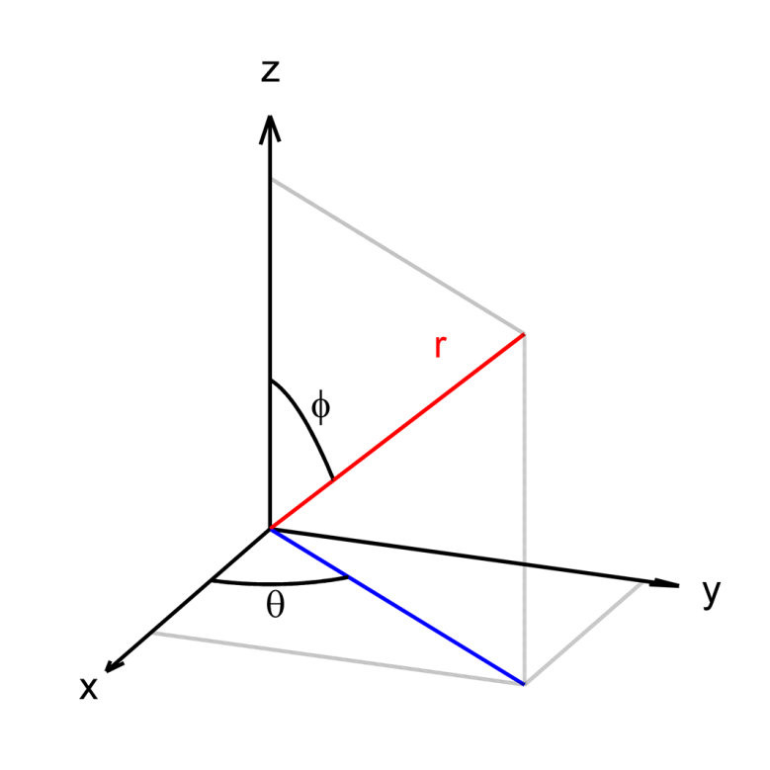
Figure 1: Relation between the Cartesian coordinates (x, y, z), and the used spherical coordinates (r, θ, ϕ).

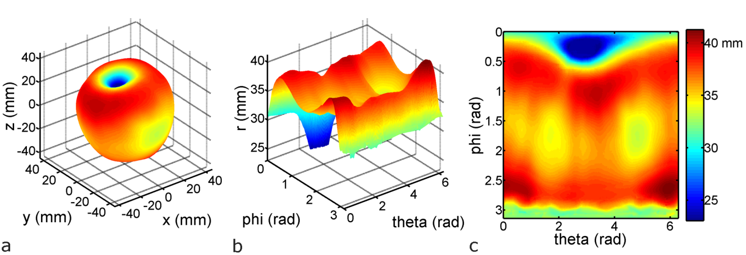
Figure 2: a) 3D contour of an apple b) corresponding (not normalised) 2D shape signature c) colormap of the 2D signature.

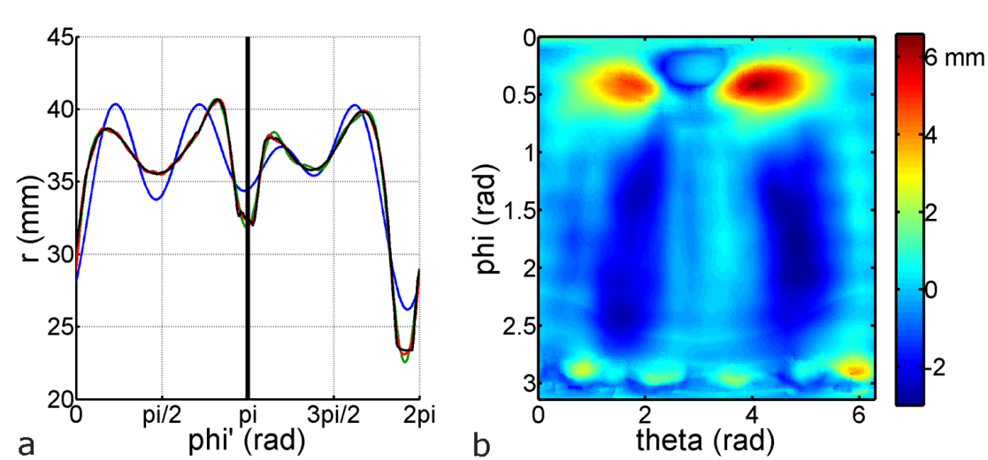
Figure 3: Normalisation of the 2D signature: a) 1D shape signature from the contour of the 2D cross-section in the y = 0 plane of the apple in Figure 2 (black). Reconstructions with 9, 19 and 39 descriptors are shown in blue, green and red, respectively. b) Normalised 2D signature: the reconstruction from a) with 39 descriptors is rotated, interpolated between the left and right half, and subtracted from the 2D signature in Figure 2. This normalised 2D signature shows the asymmetric shape variation additional to the (axi)symmetric shape variation in the 1D signature.
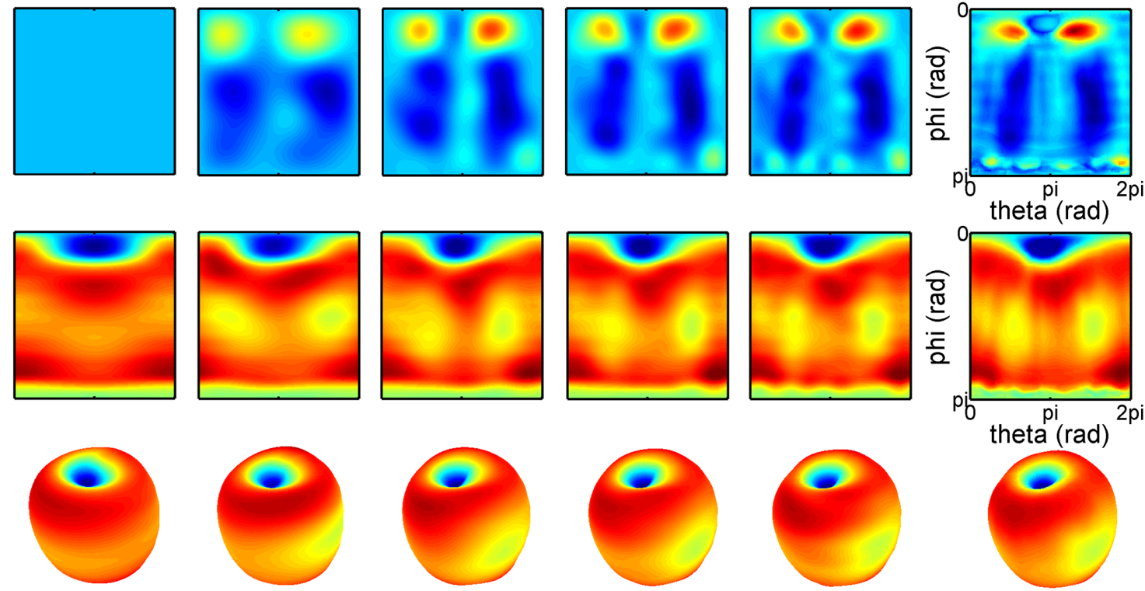
Figure 4: Reconstructions of the 3D contour, all made with a 1D reconstruction of 39 descriptors to undo the applied normalisation. From left to right, the number of 2D descriptors is increased: 0; 4x4; 6x6; 8x8; 10x10. At the far right, the original shape is shown. The top panels are the normalised 2D signatures, in the centre the normalisation is removed by adding the 1D reconstruction, and the bottom panels show the corresponding 3D reconstructions in Cartesian coordinates. The color scales are the same as in Figure 3 for the top panels, and the same as in Figure 2 for the others.

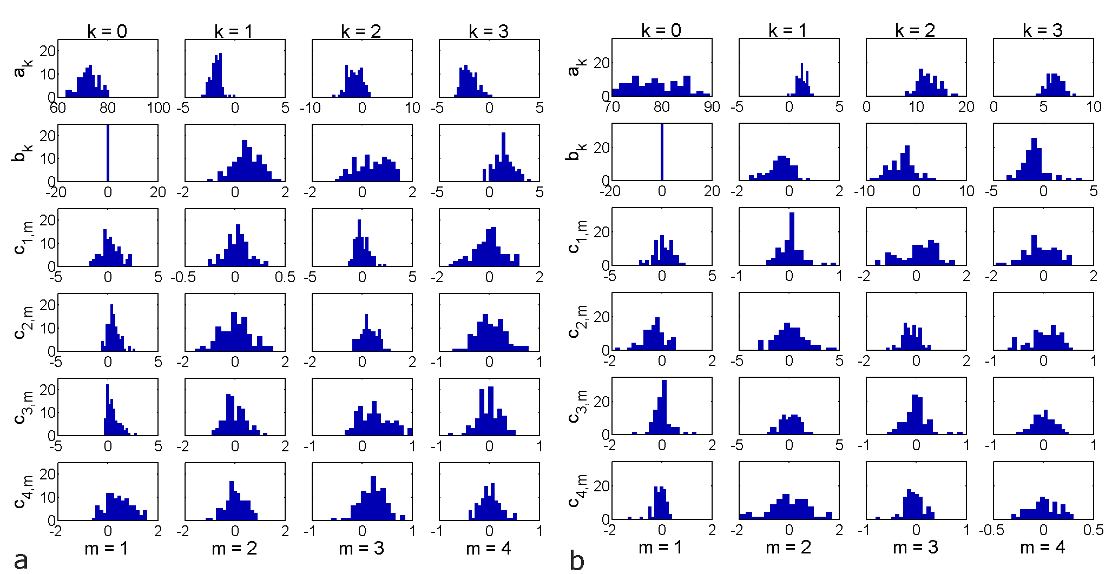
Figure 5: Distributions of the first descriptors in the expansion series. The a_{k} and b_{k} coefficients come from the 1D expansion, while the c_{n,m} coefficients are those of the 2D expansion. a) coefficients of the dataset with 94 Braeburn apples; b) coefficients corresponding to the 66 Conference pears.
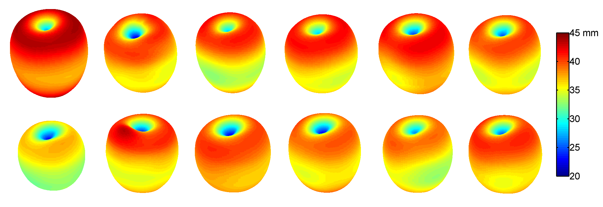
Figure 6: The effect of altering the principal components of the apple descriptor database. Starting from the average of all components, the panels are reconstructions in which a component is either raised (top) or decreased (bottom) with two times the standard deviation of that specific component. From left to right, this effect is shown for the first six principal components.

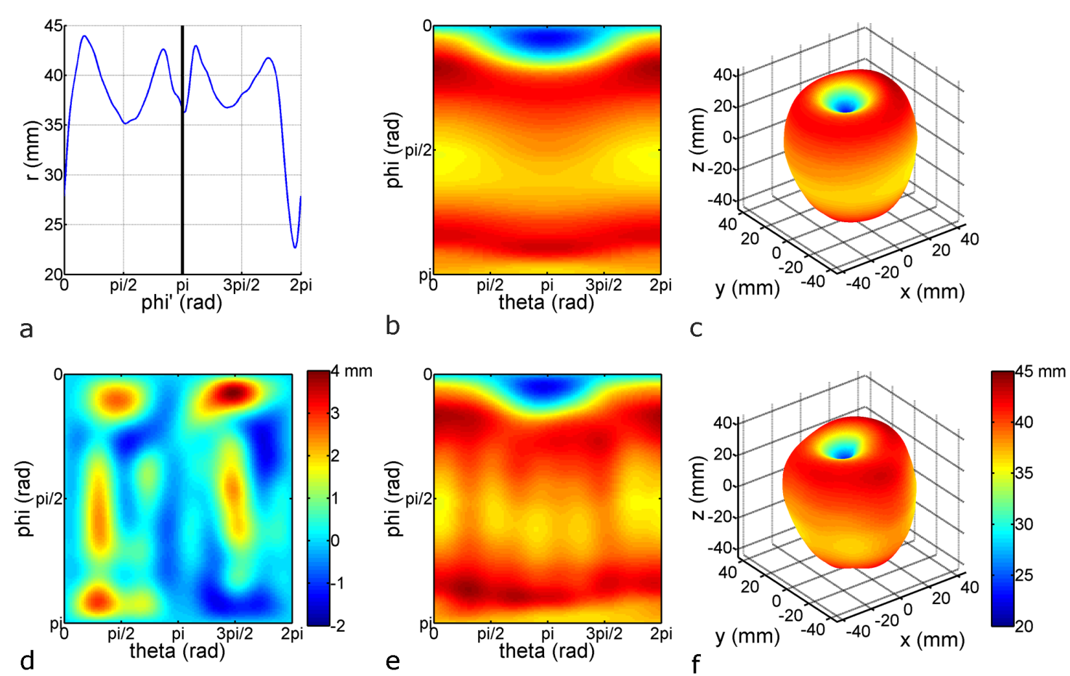
Figure 7: Constructing random 3D models: a) new 1D shape signature, reconstructed from the 1D Fourier series; b) rotation and interpolation of the 1D signature to obtain a 3D contour; c) representation of the 3D contour in Cartesian coordinates; d) new 2D shape signature, obtained from the 2D Fourier series, generated along with the 1D signature; e) adding the 2D signature to the 3D contour; f) Cartesian representation of the final 3D contour.

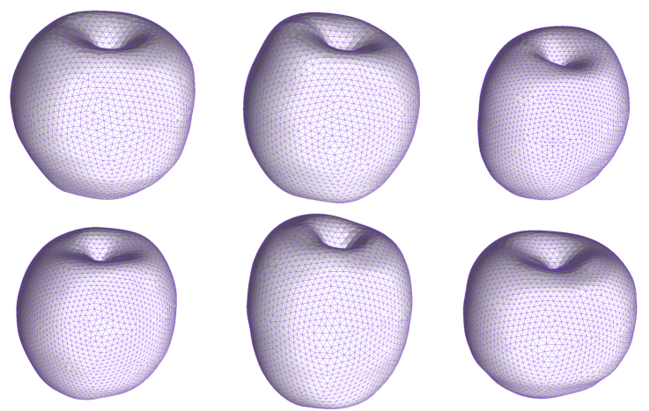
Figure 8: Examples of representative geometrical models of Braeburn apples, randomly generated. The surface meshes were generated with ANSYS ICEM 13.

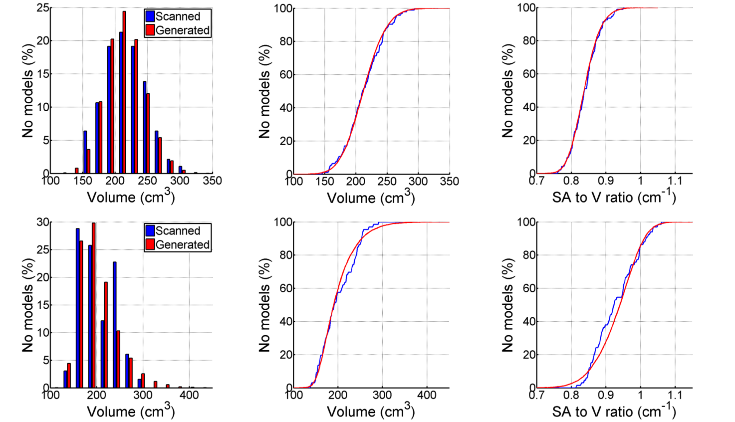
Figure 9: Distributions of two shape characteristics. At the left are volume histograms, in the middle are cumulative distribution plots of the volumes and at the right are cumulative distribution plots of the surface area to volume ratio. The top panels show the apple data, the bottom panels show the pear data.

* Corresponding author. Address: MeBioS, Department of Biosystems, University of Leuven, Willem de Croylaan 42, 3001 Heverlee, Belgium. Tel.: +32 16 377 112 E-mail address: seppe.rogge@biw.kuleuven.be

