Concept mapping in legal documents.
Case study : The translation of family law for Moroccan migrants
.
LaHoussine Id-Youss & Frieda Steurs
KU Leuven

Abstract :
The translation of legal documents is one of the most important activities for many translators. Looking at the internationalization of many activities, mobility of citizens and migration has increased. People migrate for economic reasons, looking for new employments elsewhere. This causes an increased used of new language combinations in all professional contexts, including legal matters. The problem of legal translation, and the problem of translatability of a number of legal concepts, is a major research issue.
Legal terminology is most certainly a key factor in the overall understanding of legal texts and it is crucial in the overall evaluation of the quality of a legal translation. Firstly, most legal terms refer to abstract concepts and are not defined through referential properties (contrary to e.g. machine parts in a technical domain), but rather intentionally, using other abstract concepts. Secondly, because the law deals with all aspects of everyday life, legal terminology shows a considerable overlap with Language for General Purposes (LGP). Thirdly, the legal jargon often uses a number near-synonyms (e.g. violation, breach, infringement or null and void) for the same concept (Gozdz-Roszkowski 2013). These properties potentially cause semantic vagueness and necessitate that an onomasiological approach to legal terminology (first defining a concept and then listing the terms) be supplemented with a semasiological approach that investigates how near-synonymous terms and terms shared with LGP realize their flexible meaning potential in specific contexts. In a translation setting, this problem of semantic instability is further aggravated because the terms’ contextual nuances do not only have to be adequately rendered in other language but the terms’ translational equivalents also have their own ambiguity in a different legal system, whose concepts might be similar but often not completely equivalent.
Language and the law are deeply intertwined and connected. Law expresses itself through language, the law is indeed made of language. Legal language does not only serve a descriptive purpose, it can create and modify reality.
This idea of changing reality is in line with the view of some linguists and lexicographers, who adhere to a dynamic view on words and meaning. “Words are central to the activity of making meanings” (Hanks, 2010). According to his view, words have a meaning potential, thus inferring that every speaker makes a meaning.
If indeed meaning is that flexible a concept, then words may have a number of conventional meanings (the one’s we can usually find in a dictionary), but there may be many more realisations and meaning potentials according to the actual context, the position of the speaker or writer, and many more flexible parameters. A meaning is a possible connection to objects or concepts in the real world. This ambiguity and creativity is exactly an element that is very often played upon in the writing of legal texts, in a prosecutor’s closing speech addressed at the jurors, etc.
The flexible concept of a “meaning potential” in vocabulary stands in direct opposition with the firm belief that in specific professional domains, the concepts have to be defined very explicitly, so that the necessary characteristics of the concept are clear and unique. In specific technical and scientific subdomains of reality, terms are expected to be clearly delineated and linked to a unique concept. This leads to a classification within the subject domain, so that every concept gets a clear place in a hierarchical structure and that the designation (the term) is related in a one-to one correspondence with the concept.
ISO 704:2009 “Terminology work : principles and methods” establishes the basic principles and methods for preparing and compiling terminologies both inside and outside the framework of standardization, and describes the links between objects, concepts, and their terminological representations. It also establishes general principles governing the formation of designations and the formulation of definitions.
The main activities include, but are not limited to, the following:
— identifying concepts and concept relations;
— analysing and modelling concept systems on the basis of identified concepts and concept relations;
— establishing representations of concept systems through concept diagrams;
— defining concepts;
— attributing designations (predominantly terms) to each concept in one or more languages;
It sounds perfectly plausible from a terminologists point of view that these steps can also be taken in the case of the legal domain, where precision in the use of terminology is expected.
Moreover, the legal terminology is linked firmly to a conceptual system, viz. the legal system applicable in a particular country (e.g. France) or a particular organization (e.g. EU-legislation).
The present paper reports on ongoing research in the field of the marital law of Morocco. The Moroccan law relies heavily on the “Code Napoleon” (Code civil des Français) as it was one of the most influential legal systems. It was adopted in many countries occupied by the French during the Napoleonic Wars, and thus formed the basis of the private law systems of a.o. Belgium, and the former French colonies. However, new elements relating to religion and society (a.o. in relation to Sharia Law) have developed in Morocco and these have influences on the national legal system.
This causes major problems when translating documents relating to marriage or divorce for Moroccan migrants in France and Belgium. The only possible solution to the problem of “untranslatability” of particular terms, is the detailed mapping of all the concepts relating to Moroccan family law, building an ontological reference framework. This conceptual mapping will then facilitate the comparison with French and Belgian law. Finally, this research will result in a terminology database including 4 languages in the recordstructure : the Moroccan Standard Arabic term, the Moroccan French equivalent, and the related terms used in France and Belgium.
The paper will describe the data collection, the actual corpus used, the ontological system and detailed analysis of the data in order to make a conceptual description of the different concepts in the marital law.
NAPOLEONTIC INFLUENCE
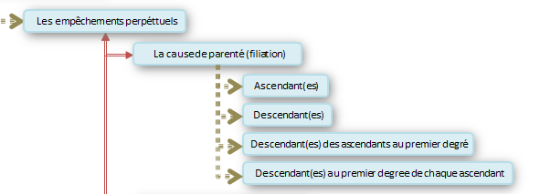
SHARIAH INFLUENCE
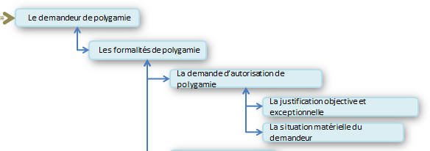

Finally, the terminological database will be presented, and the way the equivalents and translations in the languages under discussion have been listed.

References :
Cheng,L., Sin,K.K & Wagner,A. (2014): The Ashgate Handbook of Legal Translation. Ashgate, Farnham/Burlington
Heylen,K.,Steurs,F. (2014). Translating legal and administrative language: How to deal with legal terms and their flexible meaning potential. Turjuman, 23 (2), 96-146.
Id-Youss, H., Steurs, F., Alsulaiman, A. (2014). Translation technologies: Challenging new tasks and competences for translators. Dragoman, 2 (1), 1-14
Kockaert, H., Steurs, F. (2015). Handbook of Terminology. Amsterdam/New York: John Benjamins Publishing
Kockaert, H., Steurs, F. (2011). Un outil de gestion terminologique pour la traduction juridique en Belgique : état de la question et perspectives. Revue Française de Linguistique Appliquée, 16 (1), 93-104.
Steurs, F., Kockaert, H. (2014). Language planning and domain dynamics: Challenges in term creation. Dragoman,2 (2), 1-14.
Steurs, F., Id-Youss, H. (2013). Functional equivalance and legal dynamism. Dragoman, 1 (2), 1-15.

