Additive manufacturing for concrete: a 3D printing principle
H. Valkenaers¹, D. Jansen¹, A. Voet¹, A. Van Gysel¹, E. Ferraris¹
¹KU Leuven - Department of Mechanical Engineering - Campus De Nayer

hans.valkenaers@kuleuven.be
Keywords: Additive manufacturing, 3D printing, Concrete

Abstract
Additive manufacturing is nowadays a well-known production process for the production of single objects or small series, mostly in plastics or metals. By showing the possibilities of these processes, a growing interest is shown by civil engineering projects. The presented principle should reduce the amount of labor and simplify the creation of concrete structures with complex geometries. Also the possibility to create non solid concrete structures should be a big advantage in material savings and reduced loads. The paper presents the 3D printing possibilities for the selective depositioning of High Performance Concrete for non-loadbearing building components. Starting from a predefined concrete mixture the rheological behaviour of the mixture is studied to develop and optimize a pumping system for the use in a 3D printing depositioning system. Two different pumping systems are selected, the progressive cavity pump and the Archimedes screw pump. A proof of concept is given, resulting in an optimisation cycle to improve the flow behaviour of the concrete. A mixer and excitator is introduced in the design to overcome the thixotropic behavior of concrete. A labo-scale functional prototype is constructed and tested to produce small scale prisms. The compressive and flexural-tensile strength of the printed concrete show an almost equal result compared to traditional compacted concrete.

1. Introduction
3D printing, a subgroup of AM processes fabricating objects through the deposition of a material using a print head, a nozzle or another printing technology [1], is selected as suitable building process. This choice is based on the minimum material that is used in comparison with the powder bed approach. Also the selective depositioning of material has the advantage to create material gradients and multi-material objects. On the other hand the disadvantage of this principle is the need to examine a suitable supporting technique for the creation of complex products.

2. Concrete
The mixture design of the concrete is optimized for the rheological behaviour in relation to the printing process. In order to produce complex geometrical shapes with limited deformations a nozzle diameter of 15mm is selected, resulting in a maximum grain size of 3mm. By using relatively small grains the influence of the small particles is significant. Therefore the influence of silica fume, fly ash, grain size and grain shape is studied in relation to the fresh properties of the mortar.
The following properties are selected to characterize the concrete [2, 3]:
- Workability: i.e. the overall rheological parameters of the fresh mortar and relates to the static as well as the dynamic yield stress. These parameters are needed to design and optimize the transportation of the suspension through the printing head. The plastic viscosity proved not to be influential due to the larger stresses needed to overcome the thixotropic behaviour of the mixture..
- Extrudability: i.e. the property that defines the ability to print a continuous single layer of extrudate. The flow of concrete is assumed to be continuous, therefore the continuity of the extrudate can be determined by measuring the deformation of the extrudate.
- Shelf time: i.e. the time from the end of preparation until the concrete is to viscous to extrude in the 3D printing process.
- Build-ability: i.e. the degree of deformation of the stacked layers of concrete as a result of the mass of the new layer(s) of extrudate .
- Usability: i.e. the mechanical properties of the final hardened concrete part. The compressive and flexural strength are highly influenced by the air-content and the direction (printing path) of the extrudate.

3. Print Head
Based on the rheological behavior of the concrete, a print head is designed. The design for the pump should meet the following requirements:
- The viscosity of the concrete suspension lying between 60-600Pa.s.
- Scalable: the print head is designed as proof of concept. After the validation of the system, the print head should be integrated on an industrial positioning system.
- Continuous process: for the production of large scale objects.
- A simple design: concrete is an abrasive material, therefore the pump should be easy to dismantle for cleaning and part repair..

3.1 Progressive cavity pump
The progressive cavity pump (PCP) ( schematically represented in figure 1a) generates a volumetric flow rate in proportion to rotation speed. It consists of a helical rotor and a stator with a twin helix, twice the wavelength and double the diameter helical hole, forming a set of fixed-size discrete cavities. The cavities move with the rotor rotation but their shape or volume does not change. The behavior and operational characteristics are similar to a piston pump (low rates, high pressure, low shear rate). The created flow leaves the pumping system continuous without pulsing as caused by systems that compress the fluid or pump components. This pump was selected for the continuous flow and the low level of shearing to the pumped fluid, avoiding segregation in the suspension. The dimensions of the designed PCP are: Diameter (D): 20mm, Eccentricity (e): 3mm, Pitch stator / pitch rotor: 1:2, Pitch stator / eccentricity: 16,66
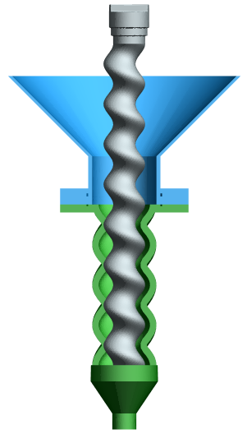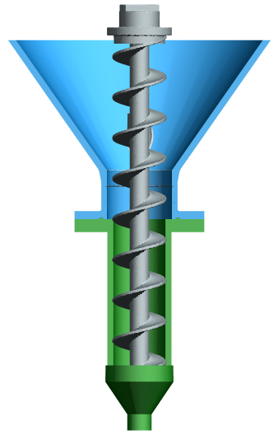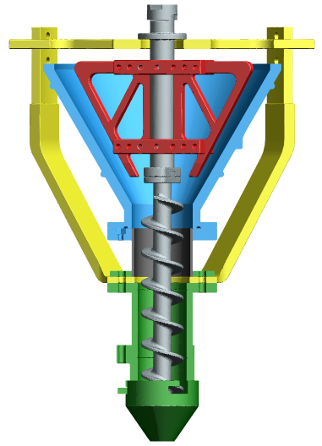
a
b
c

Figure 1: Principle print head: a) progressive cavity pump, b) Archimedes screw pump, c) Final Archimedes screw design with excitatory and mixing blades

  - Archimedes screw pump
An Archimedes screw pump (figure 1b) utilizes an axis with helical blades as rotor and a cylinder as stator. In contrast to the PCP a shear force on the material exists as a result of the rotation causing the material to move. An Archimedes screw pump was constructed with following specifications: Diameter (D) 34mm, Diameter screw axis: 12mm, Length (L): 25mm
After the first initial tests, the design was optimized to improve the flow behavior of the concrete. An excitator is applied to the design to overcome the thixotropic behavior of concrete, the concrete will be kept in constant movement. Furthermore mixing blades are mounted on the rotor, with an additional improvement of the thixotropy and prevent the segregation of the mixture.

3. Preliminary results and conclusion
Each design of the print head was produced in plastic ABS by the use of Fused Deposition Modeling. The prototypes are used to understand the behaviour of concrete in a 3D printing process, resulting in a final design based on an Archimedes screw pump improved with an excitator and mixing blades. With this system test specimens with dimensions: 18x6x6cm (LxBxH) are produced on a RepRap Darwin Frame. These specimens were modified to be tested according to NBN EN 1015-11;1999+ADD1;2007. The printed specimens show a compressive strength between (116-133MPa) and a flexural strength varying between (20-22MP).

References:
[1] ASTM, 2010, Standard Terminology for Additive Manufacturing Technologies, F2792
[2] Le T.T., A. S.,2012, Hardened properties of high-performance printing concrete. Cement and Concrete Research, vol. 42, pp. 558-566
www.fivesgroup.com
[3] Le T.T., Austin S.A., Lim S., Buswell R.A. Gibb A.G.F., Thorpe T., 2012, Mix design and fresh properties for high-performance printing concrete, Materials and Structures, vol.45, pp. 1221-1232.
www.fivesgroup.com

