Production of AlSi10Mg parts with downfacing areas by Selective Laser Melting
R. Mertens, K. Kempen, S. Clijsters, J.-P. Kruth
University of Leuven (KU Leuven), Leuven, Belgium
ABSTRACT: Selective Laser Melting (SLM) is an Additive Manufacturing (AM) technique in which metal products are manufactured in a layer-by-layer manner. Thin layers of metal powder are scanned on predefined places by a laser, which causes the powder to melt locally. One of the main advantages of Selective Laser Melting is the large geometrical design freedom. Due to the layered process, parts with for instance inner cavities can be produced. However, some structures – such as downfacing areas – influence the process behaviour significantly.
In this research, the production of AlSi10Mg parts with downfacing areas is investigated. These shapes need to be produced by using an adapted scan strategy. Here, a distinction is made between horizontal and inclined downfacing areas. For horizontal downfacing areas, a scan strategy is developed in which the layers above the downfacing area are divided into five zones. Each zone is scanned with an optimized parameter set in order to obtain a stable melt pool in each zone. Inclined downfacing areas are produced by using only three different zones with adapted scan parameters. This investigation shows the influence of the laser power on the surface roughness of the downfacing area. This influence is significant for large inclination angles. Parts with small inclination angles suffer from warp due to thermal stresses.

introduction
Selective Laser Melting is a production technique that builds products in a layer-by-layer fashion. Figure 1 shows a schematic overview of the process. First, a layer of powder, with a typical layer thickness of 30µm, is deposited on the build platform. Subsequently, the laser scans predefined areas and melts the powder locally. Once the scanning is finished, the build platform moves down one layer thickness and the cycle repeats until the part is completed.

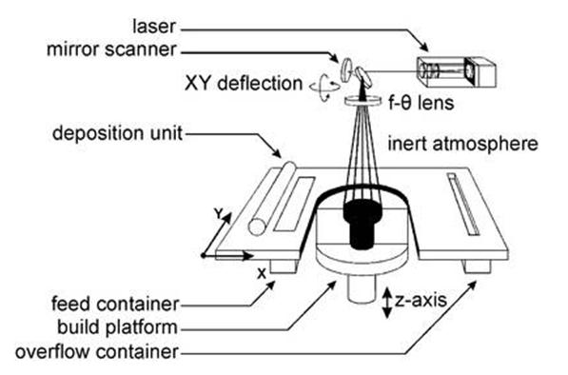
Figure 1. Schematic overview of the SLM process.
The scan strategy consists of two parts, namely the scan parameters or parameter set (laser power, scan speed, scan spacing and layer thickness) and the scan pattern (laser path). The use of different scan strategies determines the nature of the process (Mumtaz et al. 2008, Buchbinder et al. 2011, Vrancken et al. 2012).

The SLM process finds many applications in parts with complex geometries, which often involve downfacing areas. Here, a layer of powder is scanned on top of several layers of non-molten powder. To guarantee a stable melt pool, an adapted scan strategy has to be applied (Clijsters et al. 2012, Wang et al. 2012).
Optimizing the downfacing scan strategy enables the production of qualitative complex parts, thus enlarging the geometrical freedom and the number of applications of the SLM process.

Procedure

Equipment
The SLM machine used in this research is an in-house built machine of KU Leuven - PMA. Table 1 summarizes the properties of the optical set-up. All parts were built in an Ar atmosphere.

Table 1. Laser properties of the in house built SLM machine.
__________________________________
Type Yb fiber laser
Maximal power (P) 300W
Wavelength (λ) 1064 nm
Spot diameter (d_{99%}) 80µm
__________________________________

Material
In this research, the scan strategy is optimized for AlSi10Mg. This aluminium alloy is a casting alloy. Previous research (Kempen et al. 2011, Kempen et al. 2012) shows that AlSi10Mg is an alloy that is suitable for SLM, due to its high amount of silicon that improves the alloy’s ‘fluid life’.
The chemical composition of AlSi10Mg is presented in Table 2.

Table 2. Chemical composition of AlSi10Mg (ISO 3522).
___________________________
Element Weight percentage
___________________________
Al 86.9 - 90.8
Si 9.0 - 11.0
Fe ≤ 0.55
Cu ≤ 0.10
Mn ≤ 0.45
Mg 0.20 - 0.45
Zn ≤ 0.10
Ti ≤ 0.15
Others ≤ 0.30
___________________________

The two most important alloying elements are silicon and magnesium. Silicon has limited solubility and yet undergoes a relatively large volume fraction of isothermal solidification, thus gaining significant strength while undergoing little or no thermal contraction. This is very important to avoid hot cracking issues. The role of magnesium is to strengthen and harden the aluminium alloy. Silicon combines with magnesium to form the hardening Mg₂Si phase.

Parameter Optimization for downfacing structures
Since downfacing areas are scanned on multiple layers of loose powder (instead of on solidified material), their melt pool behaviour is different. Due to the lower (and non-uniform) heat-conductivity of the powder, the melt pool becomes unstable and deep if the scan strategy is not optimized, resulting in random dross formation (Fig. 2).

The parameter optimization is based on experimental tests. These tests focus on the density of the entire part and of the downfacing layers in particular, geometrical accuracy and surface quality. Evaluation is mainly based on microscope images and visual inspection.

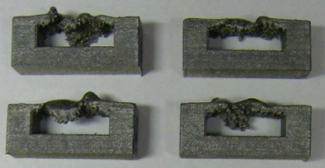
Figure 2. Dross formation due to deep unstable melt pool in downfacing areas with a length of 10 mm.

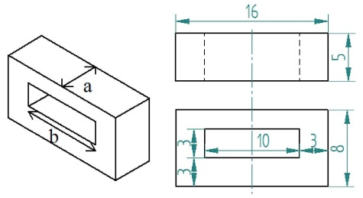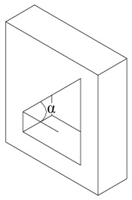
a) Horizontal b) Inclined
Figure 3. Design of downfacing test structures.

Figure 3 shows the geometry and dimensions of the produced parts, containing downfacing areas. Besides horizontal downfacing structures (Fig. 3a), inclined structures are also taken under investigation (Fig. 3b).
To check the angles of the produced parts, a vision measuring system (Quick Vision Pro 202) is used (Mitutoyo 2013). On these images, the upfacing and downfacing edges of the part cavity are fitted by lines through a minimum of 60 points and the angle between these two edge lines is measured.

Results and discussion
The research on downfacing structures is divided into three parts: horizontal downfacing structures, extended/large horizontal downfacing structures and inclined structures.

Horizontal downfacing structures
Previous research on downfacing areas in Ti6Al4V (Clijsters et al. 2012) indicates the successful use of different parameter zones above the downfacing area (Fig. 4). A similar strategy is used in this work.

The area above the downfacing surface is divided into five zones. Each zone consists of multiple layers and they all have an adapted parameter set. In this way, a stable melt pool can be accomplished in each zone.

To find an optimal parameter set for the five adapted zones, first a parameter set for the first zone has to be estimated. Parameters for the following zones are obtained by making a smooth transition from zone 1 to standard parameters (i.e. laser power of 300W, scan spacing of 110µm and scan speed of 1400mm/s).
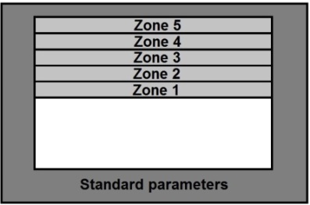
Figure 4. Different zones of a downfacing structure.

The optimal parameter set for the first downfacing zone is determined based on experimental tests.
Two scanning parameters have to be optimized: laser power (P) and scan spacing (h). To guarantee an acceptable productivity, scan speed (v) is kept constant at 1400mm/s.

First the effect of the scan spacing is investigated. Reducing the scan spacing results first in smoother surfaces until it reaches an optimal value. Further reducing the scan spacing leads to rougher surfaces. An optimal scan spacing is found to be 20µm.

To determine the optimal laser power for zone 1, several parts with different laser powers are produced and compared. Figure 5 gives an overview. The power is varied between 40W and 90W. Outside of these values, the production fails due to curling up of the downfacing layers.

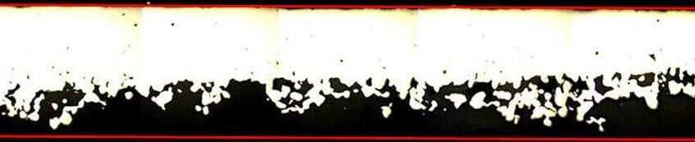
a) 40W

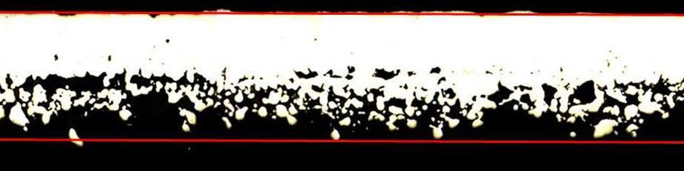
b) 50W

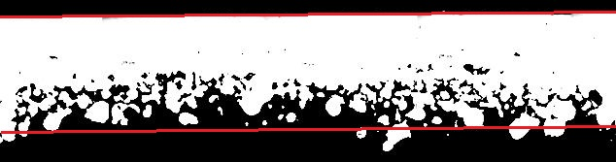
c) 60W

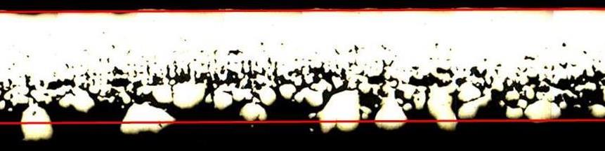
d) 70W
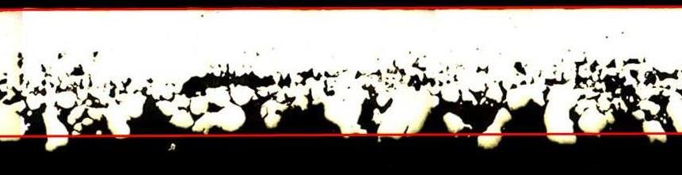
e) 80W

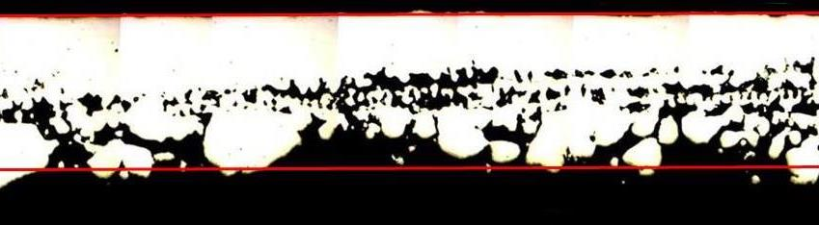
f) 90W

Figure 5. Comparison of the different powers used in zone 1. The lines indicate the borders of a perfect downfacing area. The length of the pieces is 10mm.

When the power of the first zone is too low, no powder is molten. On the other hand, when power is too high, large irregular lumps are formed. These lumps lower the surface quality and can cause problems in post-processing like sandblasting or etching.
Figure 6 compares downfacing surfaces scanned with laser powers of 35W and 85W. In the image of 85W, larger lumps are visible. The conclusion here is that there is a relative large range of applicable powers, but the results show large differences. A power of 60W insures that in the first downfacing layers some powder is already molten while avoiding large lump formation.

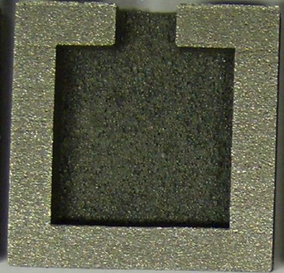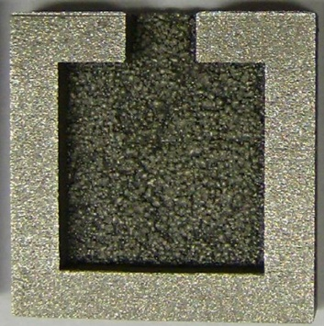
a) 35W b) 85W
Figure 6. Comparison of two downfacing areas of 14mm x 14mm. When using high powers, large lumps are formed.

Now that the parameters for the first zone are determined, parameters for the next zones are obtained by making a smooth transition to standard parameters.
The optimal scan strategy for horizontal downfacing structures is displayed in Table 3. From this table it is clear that the power is increased in every zone. Because of the increase in power, the scan spacing has to be larger for zone 2 in comparison to zone 1.
Every zone consists of ten layers to obtain the required process stability.

Table 3. Optimal parameter set for downfacing structures in AlSi10Mg (v = 1400mm/s).
 | Z1 | Z2 | Z3 | Z4 | Z5 | Standard parameters
Laser power [W] | 60 | 90 | 120 | 150 | 220 | 300
Scan spacing [µm] | 20 | 110 | 110 | 110 | 110 | 110
Number of layers | 10 | 10 | 10 | 10 | 10 | Rest  (here 10)

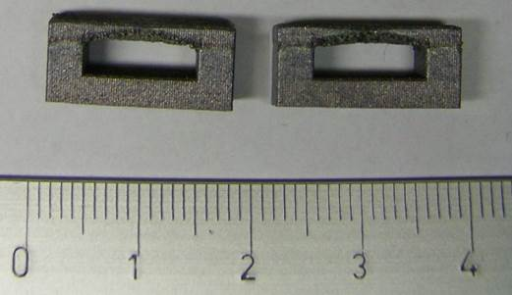
Figure 7. Picture of a downfacing structure with a length of 10mm.

Figure 7 shows the downfacing structures produced with the adapted scan strategy.
Figure 8 shows a cross section that is taken perpendicular to the image of Figure 7. It is clear that there is warp present towards the front and the back of the structure. The warp is a result of thermal stresses that are present in the SLM pieces. On the borders of the downfacing structure, there is no mechanical support. This also implies that there is no heat sink present at these borders which complicates the heat dissipation. This results in curling only at these locations. Figure 8 shows that the sides only have a thickness of about ten layers (300µm) instead of the designed 60 layers (1800µm).

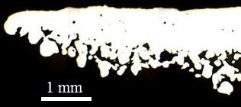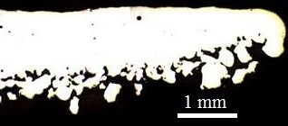
Figure 8. Warp of the downfacing structure.

Extended/larger downfacing structures
When producing larger downfacing areas, results are influenced by the heat transport situation. In a downfacing area, the main direction in which heat is conducted points from the middle of the downfacing structure to the side pillars as shown in Figure 9.
In wide downfacing structures (the width is presented by ‘a’ in Figure 3a), this situation does not change. The path the heat has to travel still has the same length. That is why wide downfacing structures can easily be produced using the scan strategy from Table 3. Figure 10 demonstrates this. Here, a downfacing structure with a width of 40mm is produced.

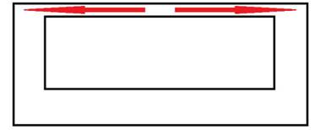
Figure 9. Heat transport situation in downfacing structures.

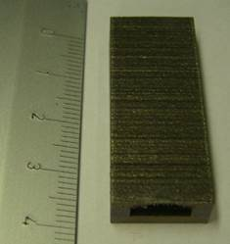
Figure 10. Wide downfacing structure of 40 mm.

Problems however, arise when long downfacing structures are produced (the length is presented by ‘b’ in Figure 3a). The path from the middle of the downfacing structure to the side pillars becomes longer and without extra measures, the downfacing structure will fail.
A part geometry that allows for larger downfacing areas is shown in Figure 11a. In this geometry, extra support pillars are placed at the edges of the downfacing structure. These pillars provide extra channels for heat transport. They also give more mechanical support to the downfacing structure. The result of this geometry scanned with the strategy from Table 3 is displayed in Figure 11b (see also Figure 6). Here length (distance ‘b’) could be enlarged to 20mm, as compared to 10mm for the parts shown in Figure 7.

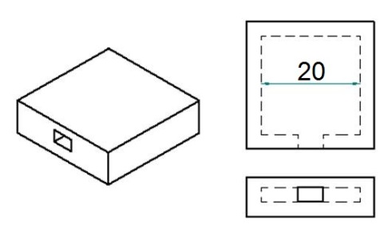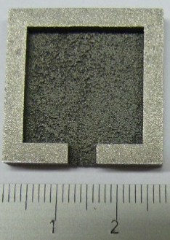
a) Geometry b) Result (bottom)
Figure 11. Adapted geometry to obtain longer downfacing structures with a length of 20mm.

Inclined structures
Because of the less extreme situation, the adapted strategy for inclined downfacing structures is limited to only three zones before using standard parameters (Fig. 12). In this strategy, each zone uses the same scan spacing of 110µm. Parameters are optimized for three inclination angles, namely 60°, 45° and 30°. These angles are defined as shown in Figure 12.

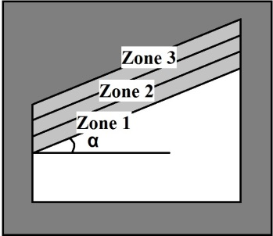
Figure 12. Different zones of an inclined area with angle α.

Inclined angle of 60°
Structures with an inclined angle of 60° can be produced with a laser power of 300W in all zones. The result of such a structure is shown in Figure 16a. The angle of this piece measured by the vision measuring system has a 95% confidence interval of 60.14° ± 0.09° based on five measurements of the same piece.
Though standard parameters can be used in zone 1, it is interesting to look at the influence of the power on the surface quality of the structure. Therefore, different samples are made each time with a different laser power in the first zone of the inclined structure. Figure 13 shows microscope images of these pieces.

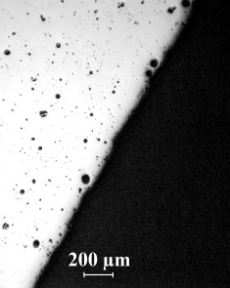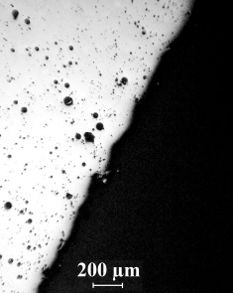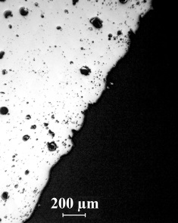
a) 100W b) 200W c) 300W
Figure 13. Microscope images of inclined structures (α = 60°) with different power used in zone 1.

From this figure, it is clear that power affects surface quality. Lower powers result in smoother surfaces whereas larger powers lead to less smooth downfacing surfaces.

Inclined angle of 45°
A structure with an inclined angle of 45° can also be produced with a power of 300W (Fig. 16b). The 95% confidence interval of the angle is 45.07° ± 0.48° based on five measurements of this inclined structure.
In analogy to the previous section, the influence of the power used in the first zone on the surface quality is investigated. Figure 14 gives an overview of the microscope images.

First of all, these surfaces are much less smooth than the surfaces that have an inclined angle of 60°. This confirms the expectations since this downfacing structure is more overhanging. This rough surface also explains the larger confidence interval of the measured angle compared to the previous section. Further, the differences in surface quality for different powers are less significant (or even non-existing) for this angle.

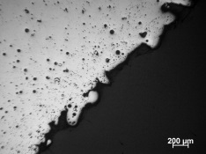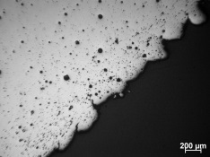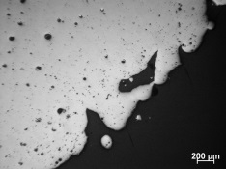
a) 100W b) 200W c) 300W
Figure 14. Microscope images of inclined structures (α = 45°) with different power used in zone 1.

Inclined angle of 30°
An inclined structure of 30° cannot be produced by using only high powers. For this case the strategy of Table 4 is used.

Table 4. Scan strategy for inclined structures with a 30° angle.
 | Zone 1 | Zone 2 | Zone 3 | Standard parameters
Power [W] | 120 | 150 | 180 | 300
Number of layers | 15 | 15 | 15 | rest

Figure 16c displays this structure. The microscope image is shown in Figure 15. The surface of this piece is very rough.

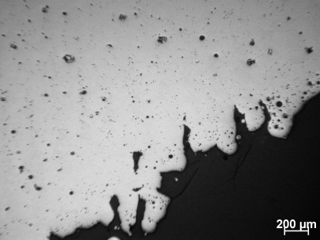
Figure 15. Microscope image of the inclined structure of 30°.

The angle of this inclined structure is again measured by the optical measuring system. The 95% confidence interval based on five measurements is 31.44° ± 0.68°. The angle is clearly too large. This indicates that warp is present due to thermal stresses. During the production of each layer, the end of the piece curls up a little further. Because of the limited size of the inclined structure, the warp did not cause problems during production. When the downfacing length increases, problems concerning the deposition unit are to be expected (the curled up part blocks the deposition unit when placing a new layer of powder).

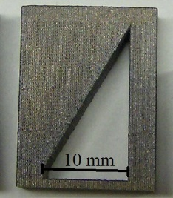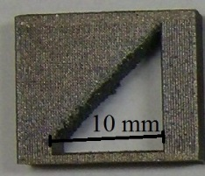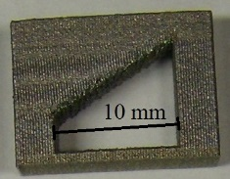
a) 60° b) 45° c) 30°
Figure 16. Parts produced with inclined structures.

Conclusion
In this research, scan strategies for downfacing areas are optimized for AlSi10Mg.
The scan pattern used, is based on a scan pattern developed in previous research (Clijsters et al. 2012). Scan parameters are obtained based on experimental tests. These tests show that no powder is melted when laser powers are too low. On the other hand, when laser powers are too high, lumps are formed.
Table 3 summarizes the scan strategy for downfacing structures.

Larger downfacing areas can be produced by using the parameter set of Table 3, but there are limitations. Long downfacing structures need extra supports on both sides to provide mechanical resistance and extra heat transport channels.

Finally, inclined structures are examined. When the angle between the inclined downfacing surface and a horizontal line is large enough, high powers can be used. Though, these high powers can be negative for surface quality. The research shows that low powers give better surface quality for an inclination angle of 60°.
For small angles, an adapted scan strategy is needed to prevent warp of the structure. Results show that even with this adapted strategy, some warp is still present due to thermal stresses.

Acknowledgments
The authors acknowledge funding from the EU 7th Framework Programme (FP7/2007-2013) under grant agreement number 314055 and from the Flemish SIM initiative within the project “STREAM ICON-2 ExpaMet”.

References
Buchbinder, D., Schleifenbaum, H., Heidrich, S., Meiners, W., Bültmann, J. 2011. High Power Selective Laser Melting (HP SLM) of Aluminum Parts. Physics Procedia 12: 271-278.

Clijsters, S., Craeghs, T., Kruth, J.-P. 2012. A priori parameter adjustment for SLM process optimization. Innovative developments on virtual and physical prototyping 553-560.

Kempen, K., Thijs, L., Yasa, E., Badrossamay, M., Verheecke, W., Kruth, J.-P. 2011. Process optimization and microstructural analysis for selective laser melting of AlSi10Mg.

Kempen, K., Thijs, L., Van Humbeeck, J., Kruth, J.-P. 2012. Mechanical properties of AlSi10Mg produced by Selective Laser Melting. Physics Procedia 39: 439-446.

Mitutoyo American Corporation 2013. Product information, http://ecatalog.mitutoyo.com/Vision-Measuring-Systems-C102.aspx.

Mumtaz, K.A., Erasenthiran, P., Hopkinson, N. 2008. High density selective laser melting of Waspaloy®. Journal of materials processing technology 195: 77-87.

Vrancken, B., Thijs, L., Kruth, J.-P., Van Humbeeck, J. 2012. Heat treatment of Ti6Al4V produced by Selective Laser Melting: Microstructure and mechanical properties. Journal of Alloys and Compounds 541: 177-185.

Wang, D., Yang, Y., Yi, Z., Su, X. 2012. Research on the fabricating quality optimization of the overhanging surface in SLM process. International Journal of Advanced Manufacturing Technology 213: 1734-1742.

