Methodology for systematic analysis and improvement of manufacturing unit process life cycle inventory (UPLCI)
CO₂PE!-Initiative (Cooperative Effort on Process Emissions in Manufacturing)
Part 2: Case Studies

Karel Kellens • Wim Dewulf • Michael Overcash • Michael Hauschild • Joost R. Duflou

Methodology for systematic analysis and improvement of manufacturing unit process life cycle inventory
Part 1: Methodology Description [Int. J. LCA ...] - Part 2: Case Studies [Int. J. LCA ...]
Preamble. The CO₂PE! UPLCI – Initiative aims to document and improve the environmental impact created during the machine tool use phase of a wide range of discrete part manufacturing processes. In addition to the first paper (part 1), which describes the developed methodology comprising two approaches with different levels of detail, this paper provides for both approaches a case study of the Life Cycle Inventory step.

Responsible editor: Karel Kellens
K. Kellens •J.R. Duflou
Department of Mechanical Engineering, K.U.Leuven, Belgium
e-mail: Karel.Kellens@cib.kuleuven.be

W. Dewulf
Group T - International University College Leuven,
K.U.Leuven Association, Belgium

M. Overcash
College of Engineering,
Wichita State University, United States

M. Hauschild
Department of Management Engineering,
Technical University of Denmark

Abstract
Purpose: This report presents two case studies, one for both the screening approach and the in-depth approach, demonstrating the application of the life cycle assessment (LCA) oriented methodology for systematic inventory analysis of the machine tool use phase of manufacturing unit processes, which has been developed in the framework of the CO₂PE! collaborative research programme (CO₂PE! 2011) and is described in Part 1 of this paper (Kellens 2011).
Screening Approach: The screening approach, which provides a first insight into the unit process and results in a set of approximate LCI-data, relies on representative industrial data and engineering calculations for energy use and material loss. This approach is illustrated by means of a case study of a drilling process.
In-Depth Approach: The in-depth approach, which leads to more accurate LCI-data as well as the identification of potential for environmental improvements of the manufacturing unit processes, is subdivided into four modules, including a time study, a power consumption study, a consumables study and an emissions study, in which all relevant process in- and outputs are measured and analysed in detail. The procedure of this approach, together with the proposed CO₂PE!-Template, is illustrated by means of a case study of a laser cutting process.
Results: The CO₂PE!-methodology aims to provide high-quality LCI data for the machine tool use phase of manufacturing unit processes, to be used in life cycle inventory databases and libraries, as well as to identify potential for environmental improvement based on the in-depth analysis of individual manufacturing unit processes. Two case studies illustrate the applicability of the methodology.

Keywords
Unit process life cycle inventory (UPLCI); Energy and resource efficiency; Drilling; Laser Cutting; CO₂PE!
1 Introduction
The CO₂PE!-Initiative (CO₂PE! 2011) has as an objective to coordinate international efforts aiming to document and analyze the environmental impacts of the machine tool use phase of a wide range of current and emerging manufacturing processes, and to provide guidelines to reduce these impacts. A proposed two level Life Cycle Inventory (LCI) approach is aimed at both providing manufacturing unit process datasets for Life Cycle Analyses (LCA) of products and at supporting the diagnosis and optimization of the environmental impact of specific manufacturing unit processes towards machine tool designers.
This paper focuses on the practical documentation of the data collection phase (step C) of the CO₂PE!-methodology described in Part 1 of this paper. (Kellens 2011). As shown in Figure 1, this step starts with a goal and scope definition as required by ISO14040 (2006) and ISO14044 (2006). The actual LCI-data collection effort (step C₂) consists of two alternative approaches with different levels of detail.
The screening approach (illustrated by a case study of a drilling process in Section 2) provides a first insight in the unit process and results in a set of approximate LCI-data, which can be used as starting point for the in-depth approach. It relies on representative general data and theoretical calculations for energy use and material loss.
The in-depth approach (illustrated by a case study of a laser cutting process in Section 3) provides more accurate and complete LCI-data, to be used in LCI-databases, and will help to identify potential improvement of the involved manufacturing unit processes. As shown in Figure 1, the in-depth approach is subdivided into four parts, including a time study, a power consumption study, a consumables study and an emissions study, in which all relevant process in- and outputs are measured and analysed in detail.
2. Screening Approach
In this case study the life cycle inventory (UPLCI) of the use phase of a drilling machine tool is presented with the energy and resource consumption calculations analyzed using the screening approach. In order to simulate an industrial shop floor, processing a wide variety of part geometries and sizes with a limited number of machine tools, a medium sized machine tool (JVH 1500, JEENXI 2010) is selected for this case study. The complete machine tool specifications are listed in the full case study which can be found in the online supporting information and at (UPLCI 2011).
2.1 General process information
Objective and product details
The workpiece (grey cast iron, BHN 180) is a square block of dimensions 100 mm x 100 mm x 50 mm (L x W x H) as shown in Figure 2. The objective of this case study is to analyse the energy and resource consumption in drilling 4 regularly spaced holes of 19.1 mm diameter through the thickness of the workpiece. The weight of the workpiece is 3.6 kg.

Machining Process
During the drilling process, the tool is considered to be at an offset of 5.7 mm (0.3 times the diameter of the tool) above the workpiece. Every time while drilling a hole, the tool comes down from a height of 5.7 mm before drilling a hole. For a 50 mm workpiece thickness, it retracts 61.4 mm (5.7+50+5.7) from the overtravel position (5.7 mm below) back to the offset position (5.7 mm above) after completing the drilling cycle. The cutting parameters such as feeds and speeds are listed in Table 1.
2.2 LCI Energy calculations
Time, Power and Energy calculations per hole
The total processing time can be divided into the three sub groups of basic time (standby), idle time (partial mode), and drilling time (full mode).

Drilling Time:
The time for drilling or enlarging a through hole of length 50 mm is determined by
t_{drilling} [min] = d / (f*N) = d / f_{r}
where d is the workpiece thickness of the given hole in mm, f is the feed in mm/rev, and N is the drill rotational speed in rev/min.
t_{drilling} = 50/111 = 0.45 min/hole = 27 sec/hole

The machining power for each hole is
P_{drilling} [kW] = VRR * Specific cutting energy
The volume removal rate (VRR) = 31800 mm³/min = 530 mm³/sec and the specific cutting energy = 1.3 J/mm³.
P_{drilling} = 530 *1.3 = 0.69 kW
The tip energy required per hole is
E_{drilling} = P_{drilling} * t_{drilling} = 0.69 * 27 = 18.6 kJ/hole

Handling Time:
In between workpieces, the drill retracts to a home position 25 mm above the approach point (which is 5.7 mm above the workpiece) to be used when drilling holes. The time required for the cutter to move from home position to approach point (25 mm) is essentially determined by drilling in air.
The air time of the rapid traverse speed (VTR) to approach is
t_{a1} = 25 / traverse speed = 25/24000 mm/min = 0.001 min = 0.06 sec (negligible)

The air time for a single hole, over and above cutting the workpiece, is the approach plus the over travel distance which are repeated when the drill retracts.
The handling distances are (approach + over travel) + (retraction)
= (0.3D + 0.3D) + (0.3D + 50 mm thickness + 0.3D)
The partial mode or idle time is determined
t_{a}=[0.3*D+0.3*D] / (f_{r}) + [0.3D+d+0.3D] / VTR
t_{a}=[0.3*19.1+0.3*19.1] / (111) + [5.7+50+5.7] / 24000 = 0.106 min = 6.3 sec
For a single hole there is no traverse (HTR) to other workpiece holes.
The idle power of the machine can be calculated based on the individual power specifications of the machine.
P_{idle} = P_{spindle} + P_{coolant} + P_{axis}
Based on the nominal data from the CNC drilling machine tool builder, the assumed values are
P_{coolant} = 1 kW (~1.5 hp); P_{spindle} = 4 kW (~5 hp); P_{axis} = 5 kW (~7 hp).
Therefore the idle power for the process is
P_{idle} = P_{spindle} + P_{coolant} + P_{axis}= 4 + 1 + 5 = 10 kW

The total idle time for 1 hole, being the time during which P_{idle} was to be supplied is
t_{idle} = t_{a} + t_{drilling} = 6.3 + 27= 33.3 sec
In this time, the actual drilling time is included since the idle power also has to be supplied during processing.
Total Energy during the idle process per hole is
E_{idle} = P_{idle} * t_{idle} = 10 * 33.3 = 333 kJ/hole

Load/unload Time:
The total basic time for this case study can be determined based on the following assumptions:
- The work holding device used for clamping the workpiece is a simple vise, so the total time required to mount the workpiece on the vise manually is 9.3 sec. (Fridriksson, 1979)
- After completing the drilling process on a single workpiece, the machine is cleaned using pneumatic cleaners or air blowers. The time required to clean the machine tool is assumed to be 25.4 sec.
- The machined part has to be removed manually from the fixture. The time required to remove the material from the fixture is assumed to be 9.3 sec.

Therefore the load/unload time for this study is
t_{l/u} = loading time + cleaning time + unloading time = 9.3 + 25.4 + 9.3= 44 sec
Basic power of the machine can be assumed as 25% of the machine maximum (30 kW) in the manufacturer specifications. Therefore the power consumed during the basic process (P_{basic}) = 7.5 kW.
Energy consumed during this process is,
E_{basic} = P_{basic} * t_{basic}
The basic time for the process to drill 1 hole can be taken as the sum of idle time (which contains the machining time) and load/unload times, i.e.
t_{basic} = t_{l/u} + t_{idle} = 44 + 33.3 = 77.3 sec
E_{basic per hole} = 7.5 * 77.3 = 579.7 kJ per hole

Total energy required for drilling 1 hole can be determined as
E_{process} = E_{drilling} + E_{idle} + E_{basic} = 18.6 + 333 +579.3 = 930.9 kJ / one hole

Average total power required for machine utilization during drilling per hole is,
P_{mtotal} = E_{process} / t_{total} = 930.9 / 77.3 = 12.0 kW.
2.3 LCI Mass Loss calculations

Waste Material loss
Volume of the material removed from a hole = $V_{\text{removal}}=\frac{{πD}^{2}}{4}∗d$ = 14326 mm³
Chip mass (m_{s}) = V_{removal} * ρ
m_{s} = 14326 * 7300 * 10⁻⁹ = 0.10 kg/hole

Cutting fluid waste
According to Clarens et al. (2008), a single CNC machine tool using cutting fluid requires an individual pump to circulate the fluid from a 55 gallon (208 l) tank to the cutting zone. The 208 l/machine tool is reused within the process until it is disposed off after two weeks. The cutting fluid is used during the actual drilling operation, which takes about 102 hours/week, so the cutting fluid loss is 208 l/ (204*60) per minute, which is 0.017 l/min or about 17 g/min.
The coolant, which is a mixture of water and oil, is about 70 wt% - 95 wt% water, so at 85 wt% water, the oil loss is 15 wt% or 2.5g oil/min. (= 0.042g/sec).
Since the drilling time per hole (t_{m}) is 27 seconds, the mass loss of the coolant = 0.042*27 = 1.1 gram oil/hole.
The fugitive loss is 0.1g cutting oil/min or 0.045g cutting oil/hole.

UPLCI Case Study Summary
This example presents the models, approaches, and measures used to represent the environmental impact of drilling unit operations referred to as the unit process life cycle inventory. The four major environmental-based results are energy consumption, metal chips removed, cutting fluid and lubricant oil. With only the following information the unit process life cycle energy for drilling can be estimated for a given job:
- material of part being manufactured
- diameter, number of holes, and location
- hole depth to be drilled
- loading/unloading time (see full UPLCI)

The life cycle inventory effort of the use phase of drilling is based on a typical high production scenario (on a CNC drilling machine) to reflect industrial manufacturing practices.
3 In-Depth Approach
In this section, the In-Depth approach is demonstrated by a case study of a laser cutting process. Furthermore, the use of the CO₂PE!-Template is illustrated by means of this example.
3.1 Goal and Scope definition
First the goal and scope (machine analysis, parameter selection, system boundaries and functional unit) of the study are clearly defined. The completed input form and created schematic overview (CO₂PE!-Template) of the system boundaries for the case study are shown in Figures 3 and 4, respectively.
As shown in Figure 3, the reference flow of the intended study is automatically defined at the bottom of the input form. First of all, the investigated process as well as the generally applicable reference flow (1 second of processing time) and the corresponding functional unit are indicated. Important settings and process parameters are shown, and finally all included production modes are presented.
3.2 Life Cycle Inventory
As described in Part 1 (Kellens 2011) of this paper and shown in Figure 1, the LCI step of the In-Depth Approach consists of four parts, including a time study, a power consumption study, a consumables study and an emission study. These four studies, in which all relevant process in- and outputs are measured and analysed in detail, are presented below for a case study on the use phase of a laser cutting machine tool.

Time Study
Laser cutting operations were observed for multiple batches in different companies using camera monitoring. As shown in Table 2, based on these observations six different production tasks are distinguished for the laser cutting process. The actual cutting process is responsible for more than 85% of the total time. The remaining time is split up between table changing, program loading, checking products and other short activities.
Since tasks C until F all represent the standby mode of the laser cutting machine tool, ultimately three different production modes are distinguished as shown in Figure 5.

Power Study
The power measurements for all identified sub-processes during the three productive production modes as well as the non-productive modes are listed in Table 3 and shown in Figure 6. The investigated machine tool is equipped with a winter-Off mode in which freezing of the laser cooling unit is avoided by continuously heating and circulating of the coolant. Together with the transformer losses, this results in an energy consumption of 2.07 kW during off mode.
For an overview of the energy consumption for the reference flow of 1 second of effective cutting, the results of the time measurements are combined with the power measurements as described in Equation 1 in Part 1 of this paper (Kellens 2011). The energy consumption in non-productive modes (OFF-mode and Standby mode) is calculated and divided over the actual processing time (2000 hours/year). There is a machine tool start-up (12 minutes) every day before the eight hour shift starts. Table 4 shows the energy consumption per second of effective cutting (kWh/s) for three different loads (5 kW, 2.5 kW and 1 kW).
Consumables Study
Cutting gas: Nitrogen (N₂)
A first input from the techno sphere is the required cutting gas, which is used as assist gas during the laser cutting process. Depending on the material and desired quality of the cut, oxygen, nitrogen and compressed air are often used as cutting gas (Serruys 2002). For this case study, nitrogen (N₂) is applied as cutting gas. Based on the plate thickness there are three levels of N₂ flow rate as shown in Figure 7. For the laser cutting of a 1 mm thick plate, a flow rate of 16 m³/h is used.

Recyclable solid waste
During the laser cutting process, an amount of solid waste is created as output to the techno sphere. This waste is steel with a high purity and thus well recyclable. Since the generation of waste is not a production time related issue, it is described as a percentage of the input material. For this case study we found a nesting efficiency of 86.5 percent. Of course this nesting efficiency will be strongly influenced by the part geometry or combination of clustered part geometries. For laser cutting operations, nesting efficiencies typically range from 80 to 90% with a maximum around 95% for optimally nested (semi-) rectangular parts.
Emission Study
For this case study the emission rates are given based on measurements performed by the Laser Zentrum Hannover which are accessible in their online safety database (LZH, 2011). Sampling took place in a special cubicle in the exhaust duct in which the aerosols were isokinetically extracted using probes (Haferkamp 1992). Table 5 shows the emission rates for aerosols and gaseous emissions of NO and NO₂. The aerosols mainly consist of metal oxides in which elements with low evaporation temperature (e.g. Zinc, Manganese) are overrepresented (Haferkamp 1999).
Figure 8 shows the Results sheet generated with the CO₂PE!-Template based on the goal and scope definition input form, shown in Figure 3.

3.3 LCI datasets
By merging and comparing unit process datasets, such as described in Section 3.2, of similar machine tools of different suppliers and capacities provided by different CO₂PE-Partners, generic unit process datasets and related parametric models will be generated based on the average values of the different studies. Where relevant, further divisions (process capacities, material…) per manufacturing unit process will be made. Based on the reference flow of 1 second of processing time for a specified load level of a unit manufacturing process for a specified material, based on a working scheme of 2000 hours/year (Kellens 2011), all documented in- and output flows (consumptions) will be linked to available LCI datasets from Life Cycle Inventory (LCI) databases, covering the full life cycle, starting from the raw materials extraction to the end of life treatment, of the considered process in- and outputs.
Wherever possible, the complete and accurate data from the in-depth approach are used to develop the generic unit process datasets. In case in-depth analyses are not (fully) available, datasets from the screening approach could be used to replace the missing parts, provided that each step is clearly described and documented.
In order to be compatible with current public as well as commercial LCI databases, the generic unit process datasets will be offered in the EcoSpold data format (EcoSpold 2011), which is the most widespread LCI data exchange format worldwide, supported by all leading LCA software tools.

4 Conclusions / Outlook
By providing a well defined methodology (Kellens 2011), the authors aim to give an impetus to the generation of uniform, complete and robust LCI-datasets of the machine tool use phase of unit manufacturing processes. In order to demonstrate the practical procedure of the Life Cycle Inventory step (Step C) of the methodology, a case study is presented for both approaches. While the screening approach is demonstrated for a drilling process, the in-depth approach is applied on a laser cutting process.
By repeating this study for a range of similar machines (several suppliers and machine capacities), parametric impact estimation models and eco-design rules for machine tools can be established, and estimates of the variability across different machine types generated. Furthermore, in-depth studies on sub-process level will lead to identification of process improvement opportunities directly related to the architecture and control logic of the investigated machine tools. The collected data for a broad range of manufacturing unit processes will lead to an extensive unit manufacturing process database which can be used by LCA-experts, eco-designers and product developers for analysing the environmental impact of individual manufacturing unit processes as well as complete production chains. Finally, the ability to include the production phase in product life cycle studies will be greatly enhanced by completing the CO₂PE! UPLCI – Taxonomy.

5 Acknowledgements
The authors acknowledge the support of the Institute for the Promotion of Innovation through Science and Technology in Flanders (IWT-Vlaanderen) through its PhD grant N°091232, of the European Fund for Regional Development (EFRO - Europees Fonds voor Regionale Ontwikkeling) and the Agentschap Ondernemen (Flemish government) through the D2 project 476, and of the U.S. Department of Energy.
References
Clarens A, Zimmerman J, Keoleian G,Skerlos S (2008) Comparison of Life Cycle Emissions and Energy Consumption for Environmentally adapted Metalworking Fluid Systems. Environmental Science Technology 42 (22): 8534–8540
CO₂PE! (2011) Cooperative Effort on Process Emissions in Manufacturing website. Last Accessed 11 July 2011, http://www.mech.kuleuven.be/co2pe
EcoInvent (2011) Ecoinvent Centre, Swiss Centre for Life Cycle Inventories. Last Accessed, 28 June 2011. http://www.ecoinvent.ch
EcoSpold (2011) Ecoinvent Centre, Swiss Centre for Life Cycle Inventories Last Accessed, 29 June 2011. http://www.ecoinvent.org/database/ecospold-data-format/
Fridriksson L (1979) Non-productive Time in Conventional Metal Cutting. Report No. 3. Design for Manufacturability Program. University of Massachusetts, Amherst.
Haferkamp H, Wittbecker JS, Hampe A (1992) Characterization of emissions resulting from laser material processing and exhaust air cleaning. Journal of Aerosol Science 23:823-826
Haferkamp H, Goede M, Püster T, Barcikowski S (1999) Safe Management of Fumes Generated during Laser Cutting of Metals. Laser Zentrum Hannover e.V., Germany
JEENXI Technology CO, LTD (2010) JHV1500 http://www.jeenxi.com.tw/English/products/jhv1500.php, Last Accessed 24 June 2010
Kellens K, Dewulf W, Overcash M, Hauschild M, Duflou JR (2011) Methodology for systematic analysis and improvement of manufacturing unit process life cycle inventory (UPLCI), Part 1: Methodology Description. International Journal of LCA, DOI: 10.1007/s11367-011-0340-4
LZH (2011) Online Laser Safety Database. Laser Zentrum Hannover. http://www.laser-zentrum-hannover.de/en/publications/db_lasersafety. Last Accessed 9 July June 2011
Serruys W (2002) Sheet metalworking – State of the art. LVD Company
UPLCI (2011) Online database and taxonomy (screening Approach). Last Accessed 9 July 2011 www.wichita,edu/sustainability

Table 1 Cutting Parameters
Drill diameter (D) | 19.1 mm
Cutting speed (v) | 25 m/min
Feed (f) | 0.267 mm/rev
Spindle speed (N) = v / π D | 417 rpm
Feed rate (f_{r}) = f * N | 111 mm/min
Volume removal rate (VRR)  = (π D² / 4) f_{r} | 31800 mm³/min
Depth of hole | 50 mm
Rapid horizontal traverse rate, HTR (horizontal, X, Y) | 30 m/min
Rapid vertical traverse rate, VTR (vertical, Z) | 24 m/min

Table 2 Production tasks and relative time distribution
 | Task | Time (%)
A | Cutting | 85.2
B | Changing Tables | 5.6
C | Loading Program | 3.6
D | Changing Laser Head | 0.4
E | Checking Products | 4.4
F | Standstill | 0.8

Table 3 Power consumption measurements (kW) of the sub-processes in each production mode
 | Laser Source | Chiller | Exhaust System | Servos | Other | Total
OFF-Mode | 0.82 | 0.84 | 0 | 0.28 | 0.13 | 2.07
Start-Up | 16.5 | 6.07 | 0 | 0.28 | 0.13 | 22.98
Standby | 19.5 | 7.24 | 0 | 0.28 | 0.13 | 27.15
Cutting (5kW) | 32.7 | 11 | 2.92 | 0.86 | 0.13 | 47.61
Cutting (2.5 kW) | 30.8 | 11 | 2.92 | 0.86 | 0.13 | 45.71
Cutting (1kW) | 27.4 | 11 | 2.92 | 0.86 | 0.13 | 42.31
Changing Tables | 19.5 | 7.24 | 0 | 0.74 | 0.13 | 27.61

Table 4 Energy consumption per second (kWh/s) for different loads
 | Power (kW) | Time (%) | Time (sec) | Energy (kWh/s) | Energy (%)
Standby | 27.15 | 9.2 | 0.108 | 0.0008 | 4.9
Cutting (5 kW) | 47.61 | 85.2 | 1.000 | 0.0132 | 79.5
Changing Tables | 27.61 | 5.6 | 0.066 | 0.0005 | 3.0
Extra (OFF-mode & Start-up) |  |  |  | 0.0021 | 12.6
Total | - | 100 | 1.174 | 0.0166 | 100
 | Power (kW) | Time (%) | Time (sec) | Energy (kWh/s) | Energy (%)
Standby | 27.15 | 9.2 | 0.108 | 0.0008 | 5.1
Cutting (2.5 kW) | 45,71 | 85.2 | 1.000 | 0.0127 | 78.8
Changing Tables | 27.61 | 5.6 | 0.066 | 0.0005 | 3.1
Extra (OFF-mode & Start-up)- |  |  |  | 0.0021 | 13.0
Total | - | 100 | 1.174 | 0.0161 | 100
 | Power (kW) | Time (%) | Time (sec) | Energy (kWh/s) | Energy (%)
Standby | 27.15 | 9.2 | 0.108 | 0.0008 | 5.4
Cutting (1 kW) | 42.31 | 85.2 | 1.000 | 0.0118 | 77.5
Changing Tables | 27.61 | 5.6 | 0.066 | 0.0005 | 3.3
Extra (OFF-mode & Start-up)- |  |  |  | 0.0021 | 13.8
Total | - | 100 | 1.174 | 0.0152 | 100

Table 5 Emission rates
Emission | Rate (mg/s)
NO | 0.0023
NO₂ | 0.0029
Aerosols | 1.1

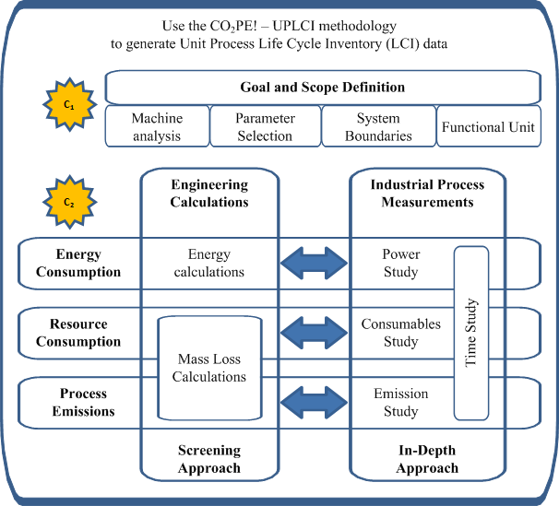

Fig. 1 Overview of the LCI step of the CO₂PE! UPLCI – Framework

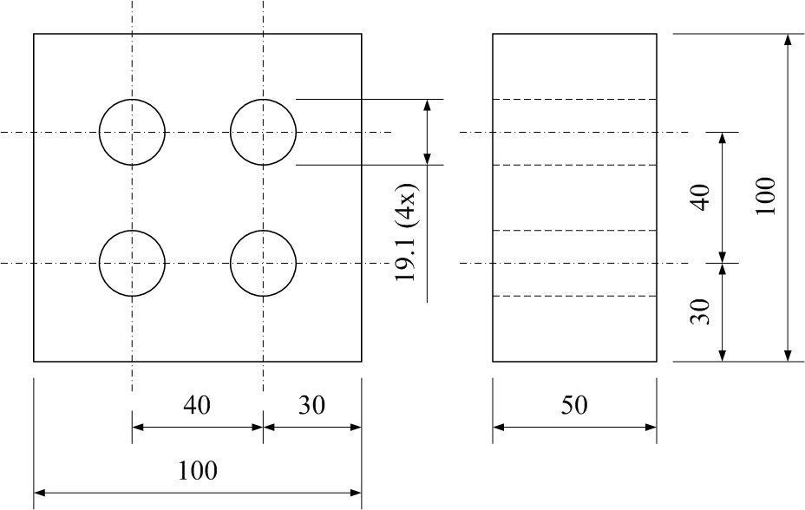

Fig. 2 Dimensions (mm) of the workpiece
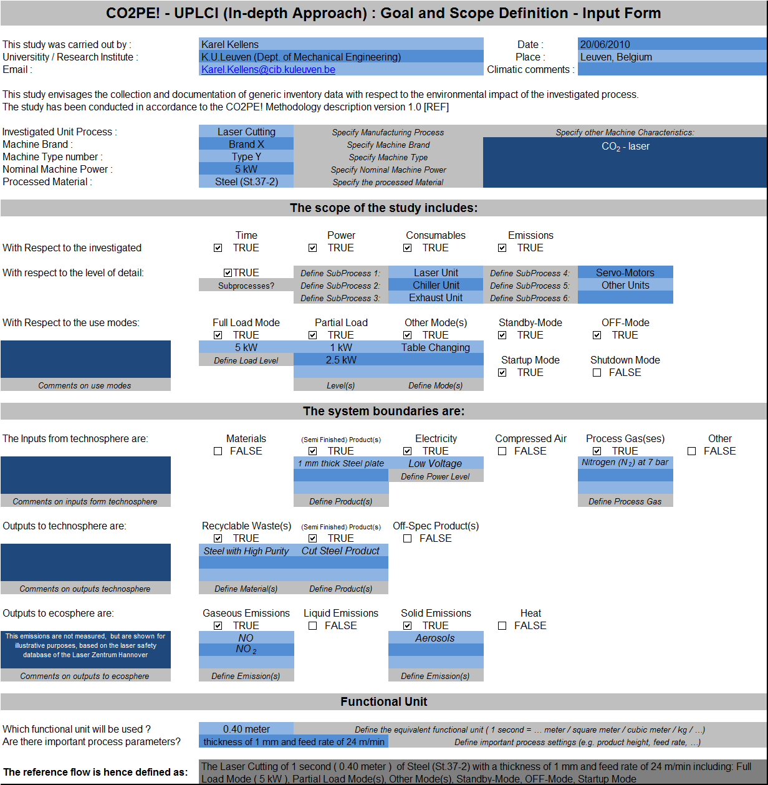

Fig. 3 Input form for the Laser Cutting Case

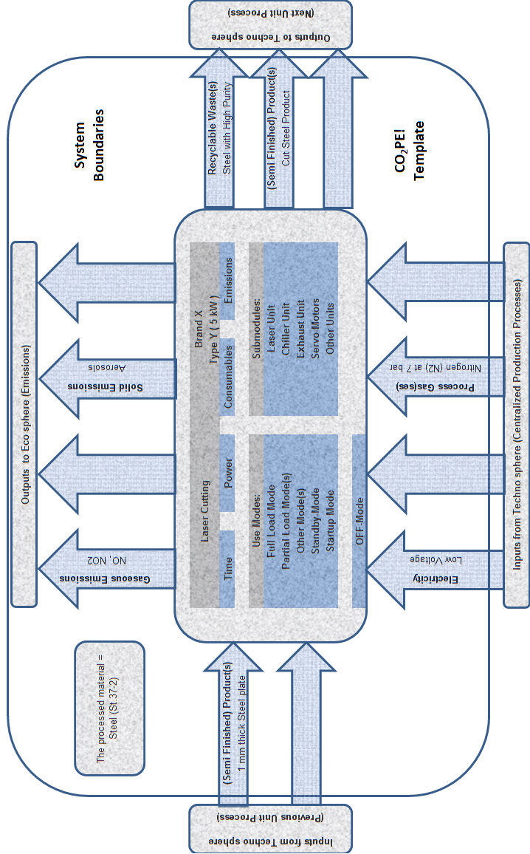

Fig. 4 Schematic overview of the System Boundaries for the Laser Cutting Case

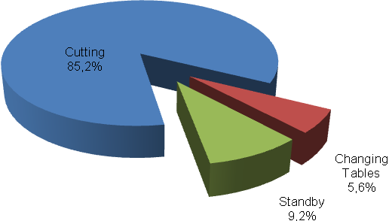
Fig. 5 Time consumption in different production modes

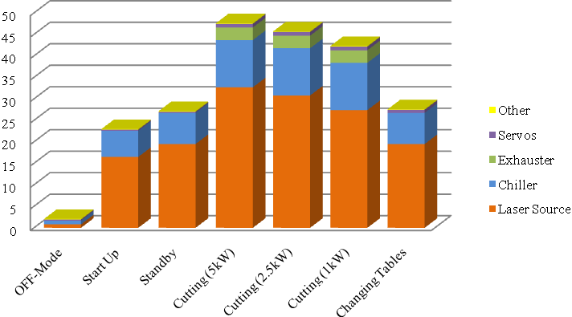
Fig. 6 Overview of the power consumption (kW) of the sub-processes in each production mode

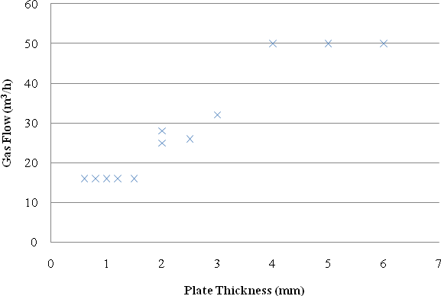
Fig. 7 Flow Rate for N₂ as a function of the plate thickness (Serruys 2002)

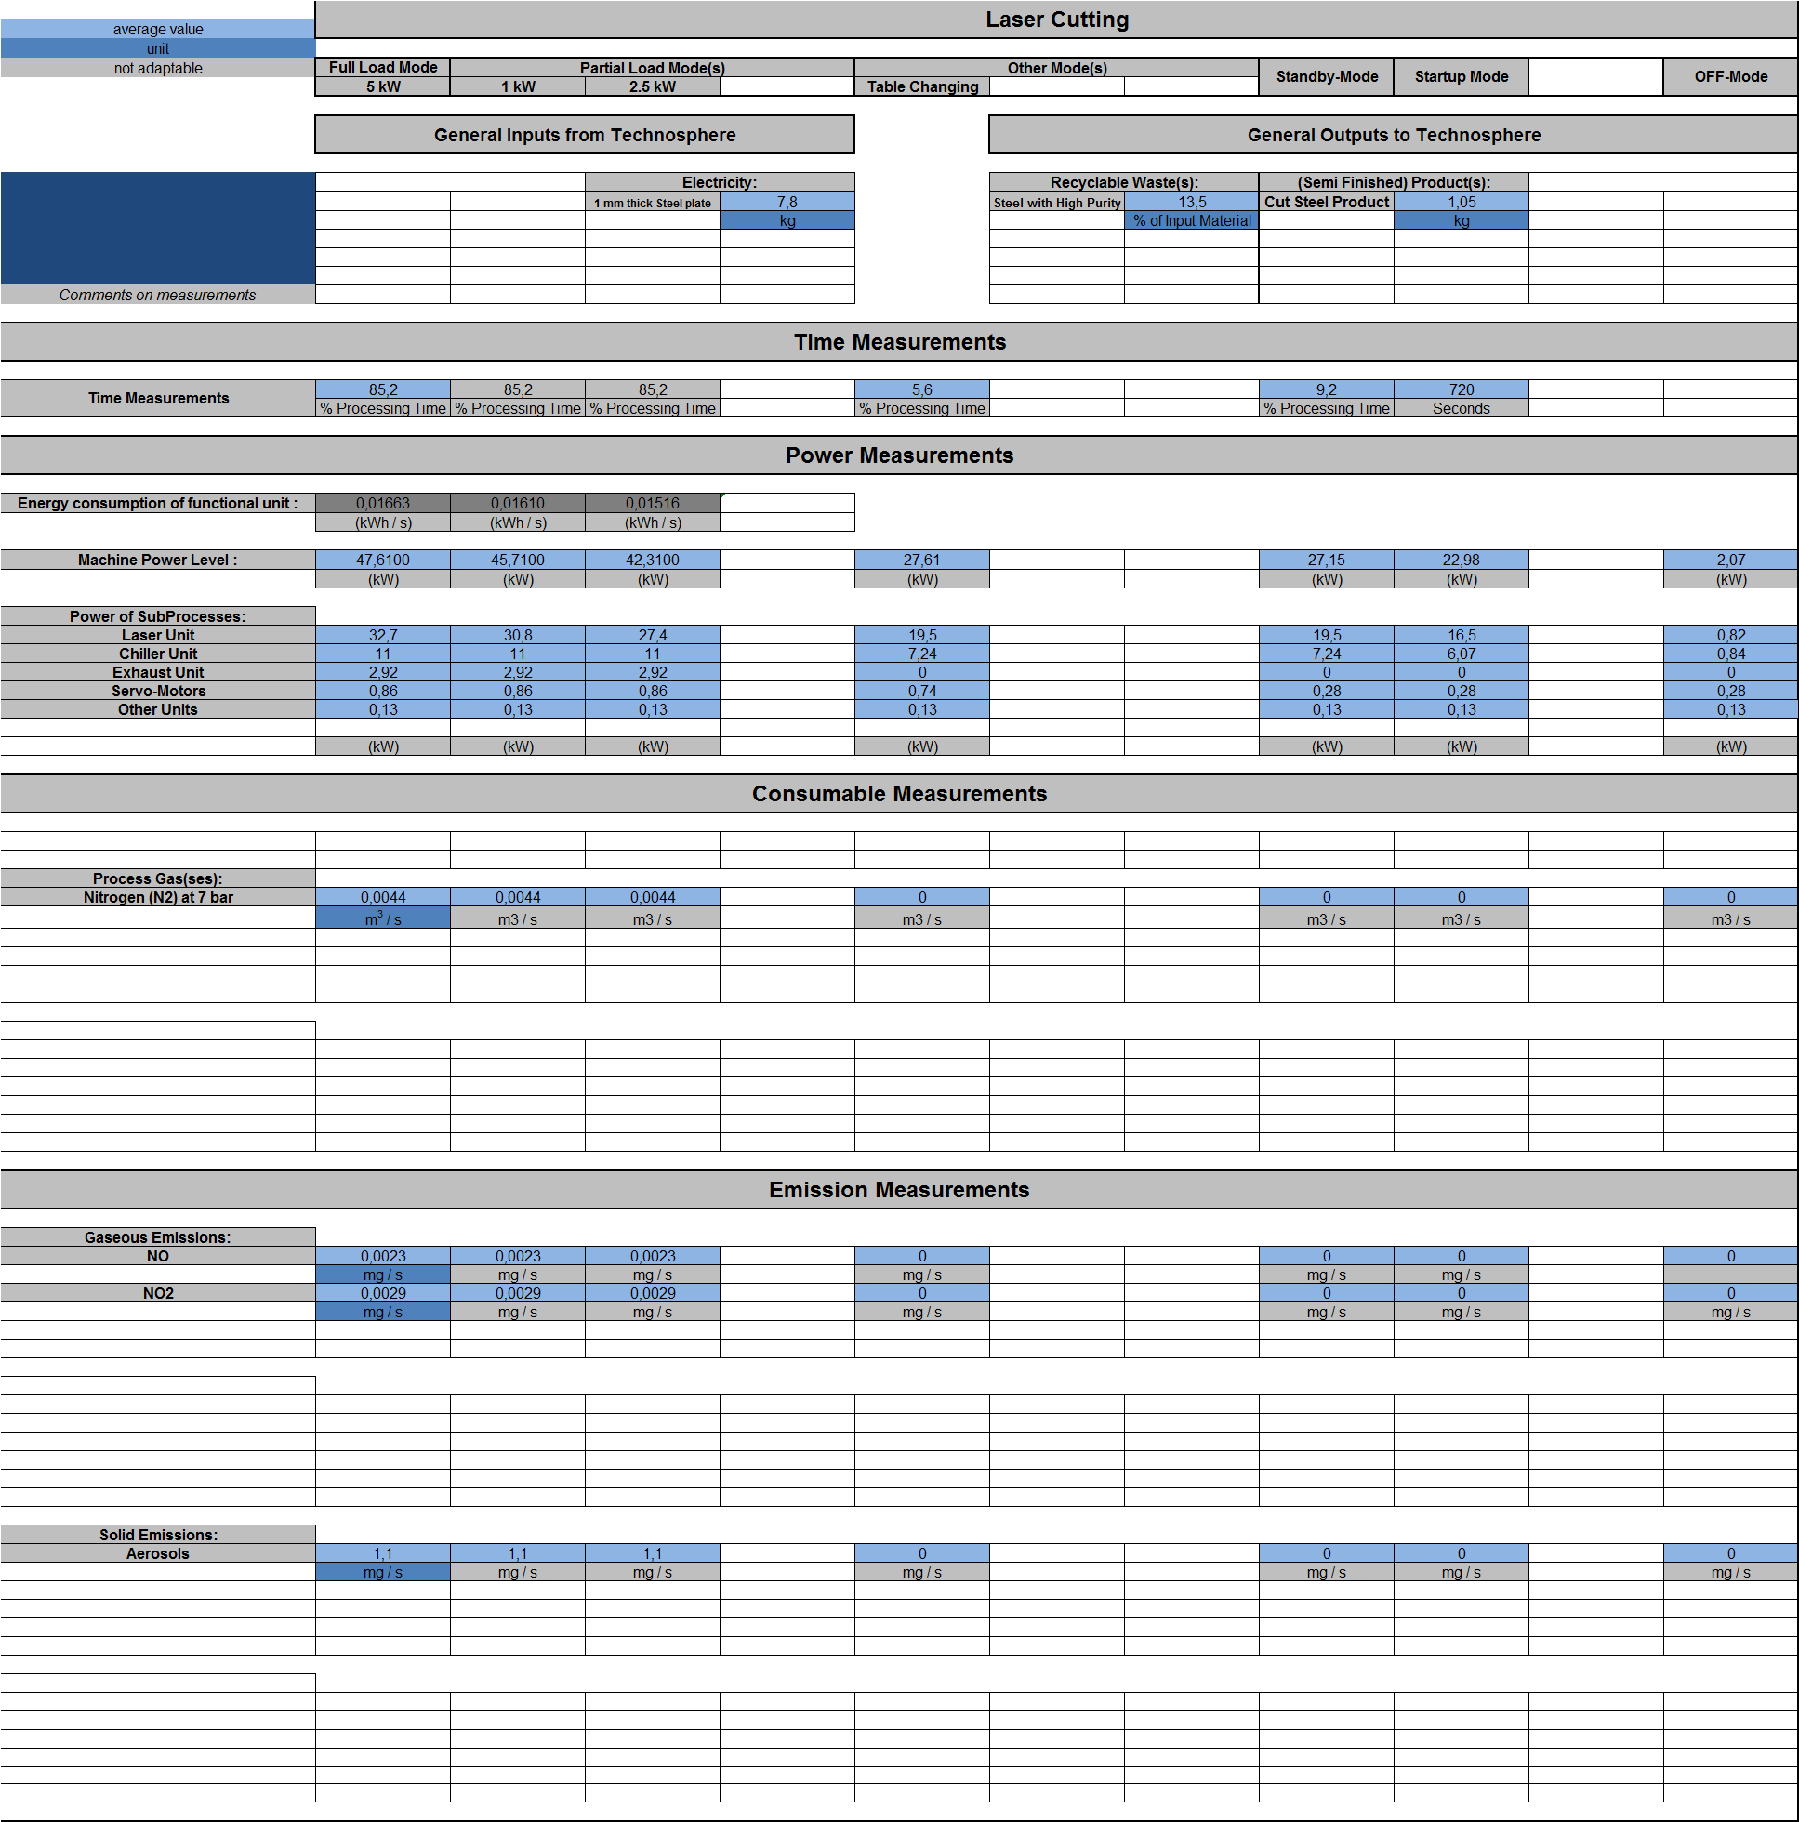
Fig. 8 Results for the laser cutting case study in the CO₂PE!–Template

