Testing research activities at the Noise & Vibration Research Group of the K.U.Leuven

D. Berckmans, B. Pluymers, P. Sas and W. Desmet
K.U. Leuven, Department of Mechanical Engineering, Division PMA,
Noise & Vibration Research Group,
Celestijnenlaan 300B – box 2420, 3001 Heverlee, Belgium
Email: Paul.Sas@mech.kuleuven.be
Url : http://www.mech.kuleuven.be/mod

Abstract

This paper gives an overview of the current testing research topics tackled at the noise and vibration research group of the division PMA of the K.U.Leuven. These include experimental aero-acoustics, vibro-acoustic characterisation of lightweight panels, traffic noise synthesis, multi-axial road load reproductions for durability assessment, measurement of the tire dynamic transfer stiffness, structural damage assessment, development of accelerated durability tests for mechanical components based on scaling laws, on-line lifetime prediction of dynamically loaded machine components, monitoring and lifetime prediction of heavy duty wet clutches and improved acoustic impedance measurement methods.

Keywords: testing research activities, K.U.Leuven, Noise and Vibration Research Group, modal analysis, aero-acoustics, vibro-acoustics, structural dynamics, lightweight materials

1. Introduction

The Noise and Vibration Research Group of the PMA division of the K.U.Leuven, Department of Mechanical Engineering, has a well-established research experience in the field of noise and vibration analysis of mechanical structures. Machine tool stability was the origin of the research in the field of structural dynamics at PMA. In 1973, PMA was one of the first laboratories in Europe to introduce a digital FFT Analyser (HP 5451A) for noise and vibration analysis in the field of mechanical engineering.
The development by PMA researchers of analysis methods (modal analysis) to characterise and optimise the structural dynamic behaviour raised the interest of several European industries and research institutes and led to the creation of a spin-off company called LMS International in 1979. Currently, LMS is one of the major worldwide players in dynamic test solutions.
Challenging and important research projects followed (see http://www.mech.kuleuven.be/mod/ projects) giving the research group worldwide recognition in the field of noise and vibration analysis.
The group is also internationally recognized for its yearly Acoustics (ISAAC) and Modal Analysis (ISMA) courses and for organizing the biennial ISMA International Noise and Vibration Engineering Conference [1].
The Noise and Vibration Research Group currently counts 5 full-time professors, 7 senior post-doc and 46 PhD researchers and is active in various fields of noise and vibration engineering such as NVH, vibro-acoustic analysis, identification and control of (non-)linear systems, active noise and vibration control, numerical modelling and lightweight structure design and analysis.
This paper gives a short overview of some of the ongoing testing research activities and of the available facilities of the research group.

2. Testing Research Activities

2.1 Experimental aero-acoustics [2,3,4]

The presence of a flow field has a dual impact on the noise characteristics of various systems: aerodynamic noise sources are generated and the propagation of acoustic waves is influenced by convective effects. Experimental aero-acoustics research is currently carried out towards both these phenomena using a multipurpose open circuit aero-acoustic wind tunnel. The research mainly focuses on confined subsonic flow applications, commonly encountered in automotive exhaust systems, HVAC-ducts, turbomachinery,… In the test rig the flow can be generated using a Root’s blower (time-uniform flow) or cold engine simulator (pulsating flow fields). A part of the test facility is located inside the semi-anechoic room to carry out research towards on the one hand aero-acoustic source characterization using correlation techniques between aerodynamic flow visualization techniques (PIV) (see figure 1) and in-duct and far-field acoustic pressure measurements; and on the other hand towards the development and validation of aero-acoustic source localization techniques based on advanced beamforming methodologies.
A propagation test rig, presently outside the semi-anechoic room complements the open circuit wind tunnel and is used for the determination of the scatter matrix coefficients of acoustic filters and duct systems in the presence of uniform and time-pulsating mane flow including thermal gradients; and for the characterization of the acoustic properties of sound absorbing materials (liners, perforated plates, porous materials) under grazing flow conditions using impedance eduction techniques.

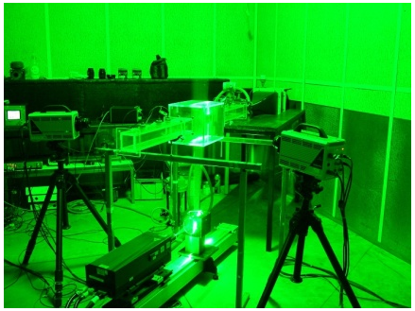
Figure 1: aero-acoustics set-up

2.2 Vibro-acoustic characterisation of lightweight panels [5,6]

To enhance vehicle, aircraft, machine, ... performance and efficiency, designers nowadays look more and more at the application of lightweight material components. However, in the application of such lightweight materials (see figure 2), care must be taken with respect to the associated vibro-acoustic characteristics. The high stiffness to mass ratio of lightweight structures may impair their ability to reduce noise and vibration levels. As a result, often damping material has to be added as troubleshooting eliminating a large part of the weight reduction.
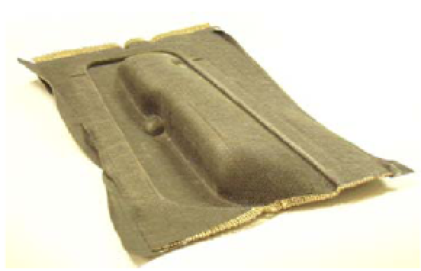
Figure 2: a honeycomb lightweight panel

Current research focuses on two tracks. On the one hand dedicated test and simulation methodologies are developed for tailored analysis of lightweight panel vibro-acoustics (see figure 3). On the other hand, novel lightweight material structure concepts for optimal noise and vibration reduction are investigated, comprising both active and passive components. Active schemes make use of smart components to compensate for the reduced noise and vibration characteristics while passive schemes make use of the engineering of inherent material properties (e.g. dedicated inclusions in meta-materials and (nearly) periodic structures).
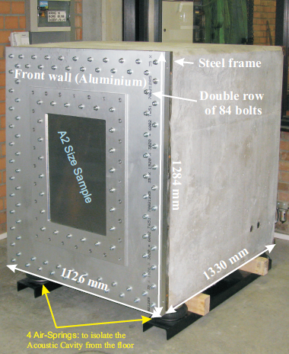
Figure 3 : dedicated test box for the vibro-acoustic characterisation of lightweight panels

2.3 Traffic noise synthesis [7,8]

Traffic noise becomes an ever more important topic in modern society. The related research has to focus on the annoyance as it is perceived by human listeners, rather than on total dB levels that are produced by the noise sources. Since existing sound metrics are often not sufficiently representative, real listening experiences (auralization of the sound) remain essential nowadays. In this context, a synthesis procedure is currently developed. The aim is to achieve a binaural, sound quality equivalent synthesis of different traffic noise events such as aircraft take-off and approach, vehicle or train pass-by. The synthesis procedure must therefore be able to cope with non-stationary sound sources, consisting of multiple (partially) coherent sources, moving sources and receivers and complex acoustical environments.

The developed traffic noise synthesis model (see figure 4) allows identifying the most annoying components in a specific, individual traffic noise event. The impact of changing transfer paths (e.g. engine mounts), as well as sound sources (e.g. turbine in an aircraft) can be evaluated by a real listening experience.

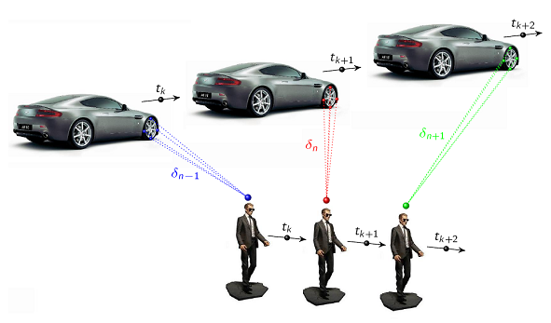
Figure 4: Traffic noise synthesis

2.4 Multi-axial road load reproductions for durability assessment [9,10]

With ever shortening vehicle development times, the pressure increases on the supplier to design, develop and test his products within a short period. This translates in a “design right first time” philosophy, where the use of advanced numerical and experimental methods that account for the product environment is essential. In this research, the four steps of an experimental procedure, using a multi-axial hydraulic test rig are developed (see figure 5). Environmental loads and strain references are acquired on the test track. The measured data is analysed for damage contribution and only those track sections are selected that represent the damage. These sections are reproduced on the test rig, based on target signals for the bracket accelerations and engine motions. During this reproduction, the strain is measured at the reference locations and the damage is calculated.
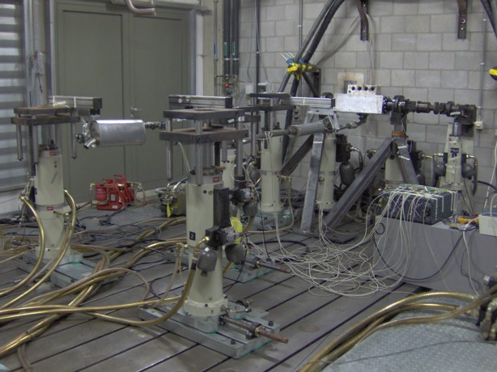
Figure 5: multi-axial road reproductions

2.5 Measurement of the tire dynamic stiffness [11,12]

While driving, the road surface texture excites the tire at the contact patch, resulting in dynamic excitation forces at the vehicle spindle. These excitations cause noise and vibrations in the vehicle interior. The tire dynamic transfer stiffness describes how a displacement enforced at the tire contact patch results in a force at the spindle-wheel interface. Therefore, the tire dynamic transfer stiffness provides insight in the generation of vehicle interior tire/road noise and vibrations.
It is known that the tire dynamic properties depend on the vibration amplitude. The excitation levels during tire dynamic characterization tests should therefore be similar to the excitation levels during operation of the tire. With the developed test setup, which makes use of the CUBE high-frequency 6-DOF hydraulic shaker table, the tire dynamic transfer stiffness can be determined at operational excitation levels in the frequency range 20-235 Hz (see figure 6).

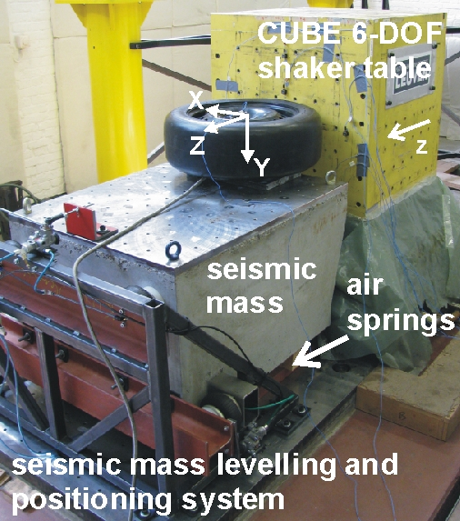
Figure 6: tire dynamic stiffness measurement

2.6 Structural damage assessment [13,14]

The early detection of structural damage generates a wide interest in the civil, mechanical and aerospace engineering fields. While visual inspection fails to assess damage at early stages, vibration measurements are sensitive enough to detect damage even if it is located in hidden or internal areas. The objective of this work is the development of methods for detecting, localizing and quantifying multiple damages in structures (see figure 7).

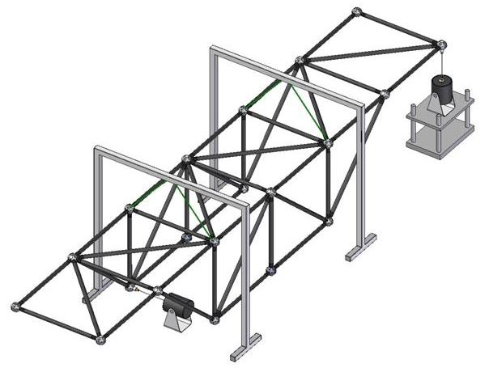
Figure 7: Test structure for damage assessment

A model based method correlates a numerical model with measured data from the structure. A set of variables is updated to obtain the minimum difference between the numerical and experimental data. During this process damage is modelled as a reduction of stiffness in an element, and it is detected by comparing the undamaged and damaged state. A global optimisation approach based on Parallel Genetic Algorithms is implemented to correlate the numerical model with the experimental data. The study considers how to minimize the effect of experimental noise or numerical errors and the incompleteness in the measured degrees of freedom on the damage detection process.

2.7 Accelerated durability testing for mechanical components based on scaling laws [15,16]

Fatigue lifetime testing of large mechanical components is often time and resource consuming due to the specific test rigs and necessary infrastructure. The research objective is to explore the possibilities of lifetime fatigue tests on reduced scale models. Using representative scaling laws, the fatigue life of a component can be determined with experiments on small scale models. Analogue to wind-tunnel testing, these experiments can be performed at lower costs and at higher speed than experiments on full scale components. A novel mechanical test rig is developed to subject plastic and metal cylindrical components at different scales to proportional and non-proportional loading conditions in bending and torsion up to 65Hz. Using this test-setup, the influence of the surface roughness, the stress gradient, the material state and the presence of inclusions and material defects on the fatigue life will be analyzed in order to improve the applicability and accuracy of existing scaling laws for mechanical fatigue behaviour. To facilitate the production of scaled components which are necessary for the experimental work it was decided to concentrate the experimental work on selective laser sintered components.

2.8 On-line prediction of dynamically loaded components [17,18,19,20]

On-line lifetime prediction of dynamically loaded machine components is based on a real time estimation of the accumulated damage in the critically loaded components. Key elements are the actual load history and accurate material data. To increase the accuracy of this process two tracks are explored. The first research track is the incorporation of the inherent variability in the fatigue-related material properties and the load pattern in a non-deterministic concept for on-line lifetime prediction. The second research track is a systematic study of methods to reconstruct the load pattern of critically loaded components out of the operational parameters. Inverse structural dynamic models are being considered for this reconstruction. Critical point of attention is the damage caused by relative small high frequency loads.
The resulting methodology will be applicable to dynamically loaded machine components such as gears, cams, shafts. To validate the results bearing damage will be used as a case study and an advanced test rig is being designed where bearings can be statically and dynamically loaded and this simultaneously in the radial and axial direction.

2.9 Monitoring and lifetime prediction of heavy duty wet clutches [21]

In off-road industrial vehicles there is a need for adequate monitoring techniques to predict the state of wear and the remaining lifetime of heavy duty wet clutches. Those clutches have a finite lifetime such that an optimal maintenance scheme driven by efficient monitoring techniques will result in increased reliability and reduced maintenance costs. The related research is conducted with an industrial partner and focuses on the identification of relevant operational features to predict the remaining lifetime. Full instrumented accelerated lifetime tests are being conducted at the industrial partner and the potential of using dynamic responses (damping, translational and torsional vibrations) as feature is being studied. In addition a systematic series of controlled lab tests is being conducted to study the effect of friction material degradation on tangential and normal contact stiffness as well as the impact of oil degradation.

2.10 Improved acoustic impedance measurement methods [22]

In many acoustic simulations, accurate acoustic impedance or absorption data of damping materials is required. The acoustic impedance is measured in Kundt's tube (see figure 8). The measurement method is the two microphone transfer function method according to the standard ISO 10534-2. The setup consists of a waveguide with at one end an acoustic excitation source and at the other end the sample of which the acoustic impedance or absorption has to be measured. In the duct wall, two microphones are positioned at two distinct locations. The transfer function between the two microphones will be measured and from them, the acoustic impedance or absorption coefficient will be determined. An investigation of the sources of error, such as position of the microphones, internal wave guide damping, amplitude and phase errors of the microphone measurements has resulted in a new design of the measurement setup with superior accuracy compared to the commercially available measurement setups. Those superior characteristics will facilitate advances in ongoing research on elastic properties of porous materials, non-linear acoustic dissipation in slits, micro perforated and weaved metal parts.
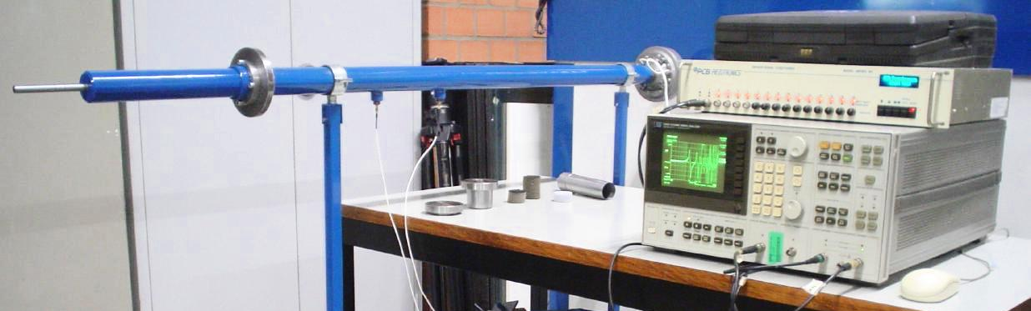
Figure 8: Impedance tube

3. Eperimental facilities

The PMA Noise and Vibration Research Group has a fully equipped noise and vibration laboratory including:

- Various data acquisition systems:
- LMS-DIFA (12ch)
- LMS-SCADASII (12ch)
- LMS-SCADASII (24ch)
- LMS-SCADASIII (44ch in, 8ch out)
- LMS-SCADAS III mobile (16ch)
- LMS-PIMENTO (24ch)
- NI PXI-4472 (32ch)
- NI DSA4551 (2ch in, 2ch out)
- NI Crio (16ch)

- Various dynamic sensors:
- more than 300 accelerometers (PCB)
- more than 100 microphones (PCB, B&K)
- 5 impedance heads (PCB)
- 10 pressure sensors (PCB)
- multi-axial dynamometer (Kistler)
- force and pressure transducers
- displacement probes
- PU probe (Microflown)
- laser vibrometers for translational and torsional vibrations (Polytec)
- acoustic intensity probe and analyser (B&K)
- holographic camera system (Vidispec)
- laser distance sensors (Baumer)

- Exciters:
- 15 electromagnetic shakers ranging from 10 to 2500N (The Modal Shop, B&K, MB, Unholtz-Dickie, Link)
- 6-DOF hydraulic shaker table, 0-300Hz (Team - Cube)
- multi-loudspeaker simulation and reference sources

- Signal conditioning equipment (analog and digital filters, digital signal processors, multi-channel ADC's, wave synthesisers....)

- MIMO Adaptive active noise and vibration control systems (dSpace1102, dSpace1103, dSpace1104, dSpace1006)

- Semi-anechoic measurement room and open circuit aero-acoustic wind tunnel

- Various dedicated test-rigs for dedicated dynamic testing (tire rigs, lightweight panel characterisation setups, impedance tubes, ...)

4. Conclusions

This paper gives a short overview of some of the ongoing testing research activities at and of the available facilities of the Noise and Vibration Research Group of the PMA division of the K.U.Leuven. A full list of research topics ongoing in the group is available at
http://www.mech.kuleuven.be

References

- Braun, S., Sas, P., Desmet, W., Vergote, K. (2010). Editorial for the ISMA 2010 Special Issue. Mechanical Systems and Signal Processing, 24 (7), art.nr. 1, 1921-1923.
- Zavala, P., De Roeck, W., Janssens, K., Arruda, J., Sas, P., Desmet, W. (2010). Generalized inverse beamforming with optimized regularization strategy. Mechanical Systems and Signal Processing.
- De Roeck, W., Sas, P., Baelmans, T., Desmet, W. (2008). Aerodynamic/Acoustic Splitting Technique for Computation Aeroacoustics Applications at Low-Mach Numbers. AIAA Journal, 46 (2), 463-475.
- Toulorge, T., Desmet, W. (2010). Curved Boundary Treatments for the Discontinuous Galerkin Method Applied to Aeroacoustic Propagation. AIAA Journal, 48 (2), 479-489.
- Vivolo, M., Pluymers, B., Vandepitte, D., Desmet, W. (2010). Vibro-acoustic characteristic of TorHex honeycomb sandwich panel. TRA Transport Research Arena Europe2010. TRA Transport Research Arena Europe2010. Brussels, 7-10/06/2010 (art.nr. 13.1.2) (pp. 233-233).
- Stenti, A., Moens, D., Sas, P., Desmet, W. (2010). A three-level non-deterministic modeling methodology for the NVH behavior of rubber connections. Journal of Sound and Vibration, 329 (7), 912-930.
- Berckmans, D., Kindt, P., Sas, P., Desmet, W. (2010). Evaluation of substitution monopole models for tire noise sound synthesis. Mechanical Systems and Signal Processing, 24, 240-255.
- Berckmans, D., Janssens, K., Van der Auweraer, H., Sas, P., Desmet, W. (2008). Model based synthesis of aircaft noise to quantify human perception of sound quality and annoyance. Journal of Sound and Vibration, 311 (3-5), 1175–1195.
- De Coninck, F., Desmet, W., Sas, P., Hansenne, E., Lehaen, B., Dedene, L. (2009). Development of a Procedure for Multi-axial Road Load Reproductions on an Exhaust Test Rig. In SAE (Ed.), SAE Noise and Vibration Conference. SAE 2009 Noise and vibration Conference. St. Charles, Illinois, USA,, May 19-21, 2009 (art.nr. 2009-01-2030).
- De Coninck, F., Desmet, W., Sas, P., Hansenne, E., Lehaen, B., Dedene, L. (2009). Multi-axial road load reproductions for the durability assessment of lightweight stainless steel exhaust systems. In Sonsino, C. (Ed.), Second International Conference on Material and Component Performance under Variable Amplitude Loading: Vol. II. Material and Component Performance under Variable Amplitude Loading. Darmstadt, Germany, Mar 23-26, 2009 DVM.
- Kindt, P., Sas, P., Desmet, W. (2009). Development and Validation of a Three-dimensional Ring-based Structural Tyre Model. Journal of Sound and Vibration, 326 (3-5), 852-869.
- Kindt, P., Berckmans, D., De Coninck, F., Sas, P., Desmet, W. (2009). Experimental Analysis of the Structure-Borne Tyre/Road Noise due to Road Discontinuities. Mechanical Systems and Signal Processing, 23 (8), 2557-2574.
- Meruane Naranjo, V., Heylen, E. (2010). An hybrid real genetic algorithm to detect structural damage using modal properties. Mechanical Systems and Signal Processing.
- Lauwagie, T., Lambrinou, K., Patsias, S., Heylen, W., Vleugels, J. (2008). Resonant-based identification of the elastic properties of layered materials: Application to air-plasma sprayed thermal barrier coatings. Ndt & e international, 41 (2), 88-97.
- Van Hooreweder, B., De Coninck, F., Moens, D., Boonen, R., Sas, P. (2010). Microstructural characterization of SLS-PA12 specimens under dynamic tension/compression excitation. Polymer Testing, 29 (3), 319-326.
- Van Hooreweder, B., Moens, D., Boonen, R., Sas, P. (2011). Novel experimental concept for high frequency multi-axial fatigue analysis of cylindrical specimens. . International Conference on Structural Dynamics. Leuven, 4-6 July 2011.
- Helsen, J., Vanhollebeke, F., De Coninck, F., Vandepitte, D., Desmet, W. (2011). Insights in wind turbine drive train dynamics gathered by validating advanced models on a newly developed 13.2MW dynamically controlled test-rig. Mechatronics.
- Janssens, K., Gajdatsy, P., Mas, P., Britte, L., Desmet, W., Van Der Auweraer, H. (2011). OPAX : a new transfer path analysis method using parametric load models. Mechanical Systems and Signal Processing.
- Gajdatsy, P., Janssens, K., Desmet, W., Van Der Auweraer, H. (2010). Application of the transmissibility concept in transfer path analysis. Mechanical Systems and Signal Processing, 24 (7), 1963-1976.
- Perianu, C., De Ketelaere, B., Pluymers, B., Desmet, W., De Baerdemaeker, J., Decuypere, E. (2010). Finite element approach for simulating the dynamic mechanical behaviour of a chicken egg. Biosystems Engineering, 106 (1), 79-85.
- Pinte, G., Depraetere, B., Symens, W., Swevers, J., Sas, P. (2010). Iterative learning control for the filling of wet clutches. Mechanical Systems and Signal Processing, 24, 1924-1937.
- Boonen, R., Sas, P., Desmet, W., Lauriks, W., Vermeir, G. (2009). Calibration of the two microphone transfer function method with hard wall impedance measurements at different reference sections. Mechanical Systems and Signal Processing, 23 (5), 1662-1671.

