Environmental Analysis of the Air Bending Process
Karel Kellensª, Wim Dewulf^{b} and Joost R. Duflouª
ª Centre for Industrial Management, Dept. of Mechanical Engineering, Katholieke Universiteit Leuven, Celestijnenlaan 300 A, Bus 2422, 3001 Heverlee, Belgium
^{b} Group T - International University College Leuven, K.U.Leuven Association, Andreas Vesaliusstraat 13,
3000 Leuven, Belgium
Abstract. This paper presents the results of a data collection effort, allowing to assess the overall environmental impact of the air bending process using the CO₂PE!-Methodology. First the different modes of the air bending process are investigated, including both productive and non-productive modes. In particular consumption of electric power is recorded for the different modes. Subsequently, time studies allow determining the importance of productive and non-productive modes of the involved process. The study demonstrates that the influence of standby losses can be substantial. In addition to life cycle analysis, in depth process analysis also provides insight in achievable environmental impact reducing measures towards machine tool builders and eco-design recommendations for product developers. The energy consumption of three different machine tool architectures are analysed and compared within this paper.
Keywords: Air Bending, Energy Consumption, Sustainable Manufacturing, CO₂PE!-Initiative.
PACS: 81.20.Hy, 88.05.Vx, 88.05.Hj,

Introduction
Until recently, companies investing in new machine tools primarily took functional performance and the initial purchase price into account as selection criteria. Based on three pillars, a movement towards environmentally benign manufacturing can be determined today. Besides more stringent regulatory mandates, competitive economic advantages and proactive green behavior are also motivating factors to switch to environmental manufacturing [1].
Manufacturing processes, as used for discrete part manufacturing, are responsible for a substantial part of the environmental impact of products, but are still poorly documented in terms of environmental footprint. On the one hand, coverage of the wide range of production processes by LCI databases is limited [2-3]. On the other hand, most such available data are incomplete: their focus is often limited to theoretical energy consumptions and data on the machine tool infrastructure or potential emissions are rarely found. Nevertheless the energy and resource consumption (and related environmental impact) of the manufacturing stage of products is not negligible, as often assumed in LCA-studies. From the industrial electricity consumption for Belgium and Europe (EU-27) in 2007 we can conclude that the metal processing industry is responsible for about 8,3% or 3,3 billion kWh in Belgium and 13,7% or 158 billion kWh in Europe [4]. Assuming a 3500 kWh electricity consumption per 4-member household each year, this equals to approximately the electrical energy consumption of 1 and 45,2 million households, respectively. Despite electricity only represents 30 percent of the total industrial energy consumption, this demonstrates already the non-negligible importance of the manufacturing stage in the general life cycle analysis of a wide range of products. At the same time, a trend can be observed towards more energy intensive unconventional processing techniques, so the impact of the manufacturing sector is in consequence growing steadily [5]. In order to address these shortcomings, a worldwide consortium of universities and institutes launched the CO₂PE!–Initiative (Cooperative Effort on Process Emissions in Manufacturing) [6].
In literature, Gutowski et al. already reported detailed measurements at machine tool level for a number of machine types [7]. They indicated that energy requirements depend on the production rate and are consequently not constant, as often assumed by ecological impact determining software packages. These software tools often assume energy requirements only to be proportional to the physical amount of material processed, thus neglecting the fixed energy consumption due to unloaded motors, coolant pumps, controllers and fans, or other peripheral equipment. For an automated 5-axis milling machine tool, this constant energy requirement is, for example, responsible for 40 to 90% of the total energy consumption. Complementary to this source, some similar studies were conducted by the authors [8-10]. This paper describes the results of an energy related environmental assessment of three different machine tool architectures for air bending processes.

Machine Tools
In this paper, the energetic consumption of four different commercially available air bending machine tools, representing three different machine tool architectures and two different load capacities (80 and 135 ton) are analysed and compared. The characteristics of all involved machine tools are listed in Table 1.

TABLE 1. Overview of machine tools under investigation.
 | Max. Bend Capacity | Technical adjustments
Machine Tool A | 80 ton
Machine Tool B | 135 ton | adjustable flow pump
Machine Tool C  Machine Tool D | 135 ton  80 ton | adjustable flow pump and frequency convertor  adjustable flow pump and frequency convertor

While machine tool A is a conventional hydraulic press brake with a gear pump and a maximum bend capacity of 80 ton, machine tool B is equipped with an adjustable flow pump. The main advantage of this pump is an increase of process flexibility due to the continuous (stepless) control of the hydraulic oil flow and related bend force. In addition to this adjustable flow pump, machine tools C and D have also a frequency convertor which allows a reduction of the pump dimensions for similar bend forces and speeds.

Results and Discussion
This section describes the Life Cycle Inventory (LCI) data collected using the CO₂PE!-methodology [11]. The system boundaries of the analysis are set to include only the operating phase of the involved machine tools. During the first step of the process inventorisation, time studies are performed in order to identify the different use modes of the machine tools and their respective share in the covered time span. The identified time modes start from the machine tool start-up, over the use phase to finally switching off the machine tool, but are determined for periods of full machine occupancy where no idle time due to a lack of orders occurs. The energy consumption of the machine tool is obtained by measuring the power consumption over a specified time period. By measuring individual power consumption patterns for all relevant active energy consuming units (ECU’s) in each production mode, the energy consumption and corresponding ecological footprint optimization potential are identified.

Time Study
Based on 27 distinct orders in three Belgian companies, representing 25 hours of operation, 9 different production modes were identified as shown in Figure 1. An important observation is that the actual bending operation (5a) takes less than 10% of the total production time [8].

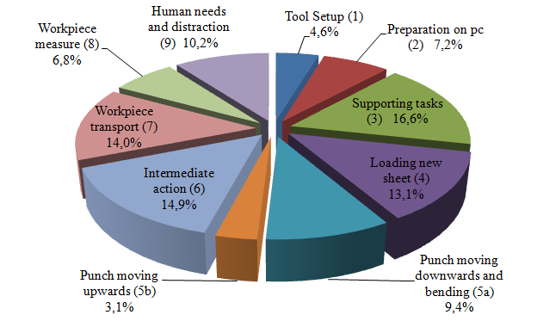
Figure 1. Overview of the different production modes [8].

Power Study
Figures 2, 3 and 4 show the electrical power consumption during one bending cycle on machine tools A, B and C respectively. Each time, the energy consumption for four different load levels and two or three bending speeds are plotted. Based on the power consumption levels, 6 different sub-modes can be distinguished during each bending cycle as listed in Table 2. For each machine tool, the different sub-modes are indicated for the slow approach (a) of the maximum machine tool load (80 and 135 ton respectively).

TABLE 2. Overview of identified sub-modes.
Mode | Action
Sub-mode A | Standby Mode - waiting for new task
Sub-mode B | Punch moving downwards from Upper Dead Point (UPD) to Mute Point (MP)
Sub-mode C  Sub-mode D  Sub-mode E  Sub-Mode F | Actual bending operation  Sheet is clamped for a fixed period (here: 3 seconds)  Decompression (here: 50mm, 10 or 15mm/s)  Punch moving upwards to UPD

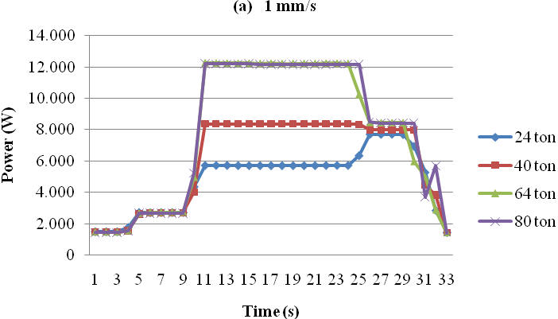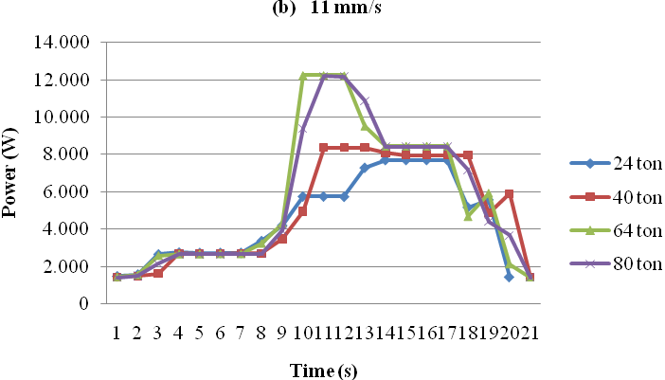
A B C D E F
Figure 2. Power consumption of machine tool A during one bending cycle for four different loads (24, 40, 64 and 80 ton) and two different bending speeds: (a) 1 mm/s and (b) 11 mm/s.

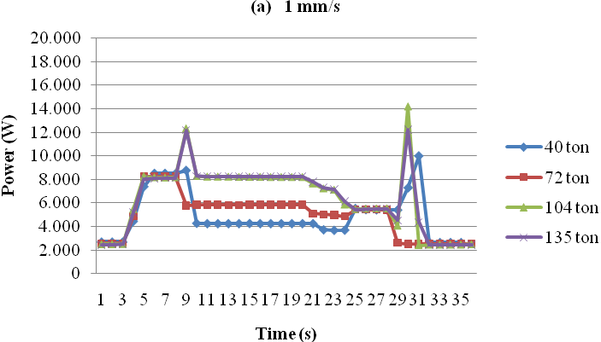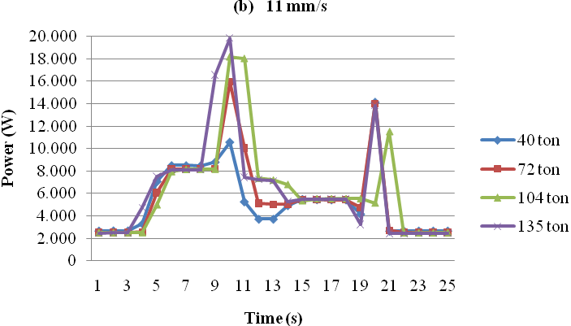
A B C D E F
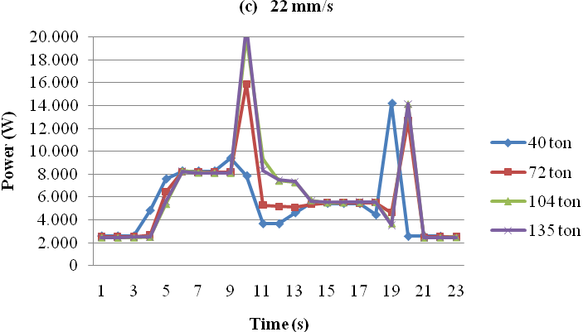
Figure 3. Power consumption of machine tool B during one bending cycle for four different loads (40, 72, 104 and 135 ton) and three different bending speeds: (a) 1 mm/s, (b) 11 mm/s and (c) 22 mm/s.
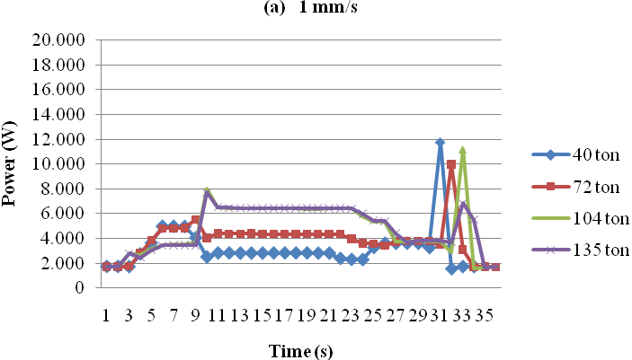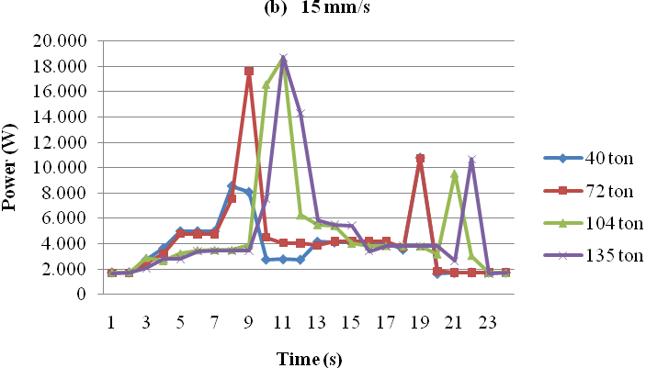
A B C D E F
Figure 4. Power consumption of machine tool C during one bending cycle for four different loads (40, 72, 104 and 135 ton) and two different bending speeds: (a) 1 mm/s and (b) 15 mm/s.

While for the first machine tool architecture (machine A, Fig.2) the highest power consumption occurs during the actual bending operation itself, the adjusted architectures (machines B, Fig.3 and C, Fig.4) have different power consumption patterns. Two peak consumptions, up to 20 and 12 kW respectively, can be identified during the upward and downward movement of the punch. During the actual bending operation itself (sub-mode C), the required power levels are significantly lower with reductions up to 65%. Table 3 lists the energy consumption per bend for four different loads and three different bending speeds on machine tool B.

TABLE 3. Energy consumption/bend of machine tool B for four different loads (40, 72, 104 and 135 ton) and three different bending speeds: 1mm/s, 11 mm/s and 22mm/s
Bending Speed | 1 mm/s |  |  |  | 11 mm/s |  |  |  | 22 mm/s
Load Level [ton] | 40 | 72 | 104 | 135 | 40 | 72 | 104 | 135 | 40 | 72 | 104 | 135
Energy/Bend [kWh] | 0,048 | 0,049 | 0,064 | 0,064 | 0,037 | 0,040 | 0,044 | 0,044 | 0,034 | 0,037 | 0,040 | 0,040
Relative Profit |  |  |  |  | 22% | 20% | 31% | 31% | 29% | 25% | 37% | 37%

Figure 5 shows the comparison of the power consumption for the same task (load of 40 ton, bending speed of 1 mm/s) on the four different machine tools. Average power levels as well as related energy consumption values are listed in Table 4.

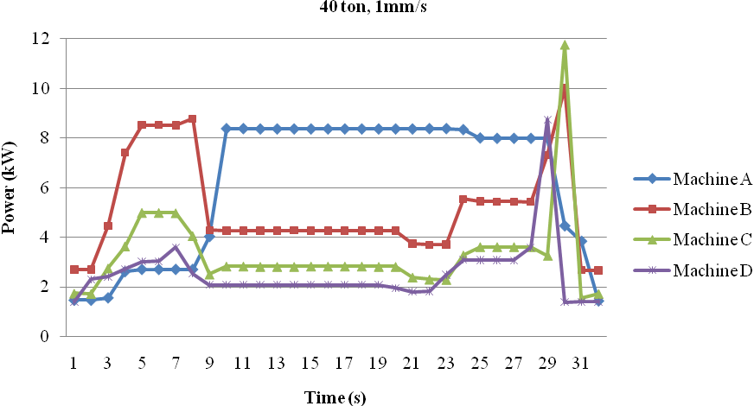
Figure5. Comparison of the power consumed during the same task (load of 40 ton, slow approach: 1 mm/s) on the four machine tools.

TABLE 4. Overview of average power levels and energy consumption values.
 | Machine A | Machine B | Machine C | Machine D
Average Standby Power [kW] | 1,47 | 2,53 | 1,71 | 1,37
Average Bending Power [kW] | 8,36 | 4,26 | 2,83 | 2,08
Bending Energy Consumption / bending cycle [kWh] | 0,055 | 0,046 | 0,029 | 0,022
Standby Energy Consumption / bending cycle [kWh]* | 0,105 | 0,180 | 0,122 | 0,097
Total Energy Consumption / bending cycle [kWh] | 0,160 | 0,226 | 0,151 | 0,119
*Based on the 87,5% standby time of the time study

Following observations can be made from Figures 2, 3, 4 and 5 and Tables 3 and 4:
- The first important observation is that for bending operations the standby mode (87,5% of total time) is responsible for a large amount (65% for machine tool A, 80% for machine tools B,C and D) of the total energy consumption. As can be seen in Table 4, there is a certain fixed power level for each machine tool depending on the machine tool architecture as well as the maximum bend capacity. Hence, optimization of the machine tool design and/or the machine tool selection at a production planning level allows to reduce the “standby” energy significantly. Furthermore, an increase of the throughput (e.g. reduction of the standby time) will not only result in financial gains, but will also lead to an important reduction of the created environmental impact per bent product.
- Despite the temporal higher power requirements, Table 3 shows that an increase of the bending speed leads to a reduction of the required energy per bend as result of the lower operation time. For machine tool B reductions of 20 up to 37% can be observed. Similar analysis of machine tools A and C result in reduction potentials up to 54% and 32%, respectively.
- The influence of the implementation of a frequency convertor to steer the hydraulic pumps can be seen by comparing the power and related energy consumption of machine tools B and C for the same bending operation. A reduction of approximately 35% can be observed here.
- A similar comparison between the energy consumption of machine tools A en D shows a reduction of 59% for systems equipped with an adjustable pump as well as a frequency convertor.
- Machine tools C and D differ only in their maximum bending capacity of 135 and 80 ton respectively. Nevertheless, there is a difference of 24% in the energy consumption for the same bending operation due to the fixed power requirements. Taking into account the energy consumption in standby mode, the difference is slightly reduced, but still 20%. This shows that a proper selection of the right bending machine tool (and corresponding fixed power requirements during standby as well as productive modes) for a bending operation provides a non-negligible potential to reduce the environmental footprint of a bent part. Target here should be to use machine tools as near as possible to their maximum capacity. In other words, bend products on the available machine tool with the lowest adequate maximum load capacity.

One step further towards more sustainable air bending machine tools than the presented hydraulic machine tool architectures can be the use of electro motors as indicated by Devoldere et al. [8] or the change towards all-electric air bending machine tools as described by Santos et al [12]. Therefore, the next step of this research will include the analysis and comparison of the energetic profiles of these types of machine tools.

CONCLUSIONS
Using the CO₂PE!-Methodology, Life Cycle Inventory (LCI) data were collected and the environmental performance regarding energy consumption of three different bending machine tool architectures was investigated.
This paper points out that the energy consumption of bending processes during non-productive modes (e.g. standby modes) is substantial and hence has a large potential for reduction. Furthermore, potential for energy and related environmental impact reduction measures based on design changes in the architecture of a bending machine tool are demonstrated. Finally, also the environmental relevance of optimally selecting the bending machine tool and bending speed for every job is illustrated.
Future work comprises the completion of the environmental LCI data of bending processes as well as the development of parametric models to calculate/predict the environmental impact of bending operations as an impetus towards more reliable coverage of the air bending process within LCI databases.

Acknowledgments
The author acknowledge the support of the Institute for the Promotion of Innovation through Science and Technology in Flanders (IWT-Vlaanderen) through its PhD grant N°091232, and of the European Fund for Regional Development (EFRO - Europees Fonds voor Regionale Ontwikkeling) and the Agentschap Ondernemen (Flemish government) through the D2 project 476.

References
1. T. Gutowski, C. Murphy, D. Allen, D. Bauer, B. Bras, T. Piwonka, P. Sheng, J. Sutherland, D. Thurston, and E. Wolff, “Environmentally benign manufacturing: Observations from Japan, Europe and the United States” in Journal of Cleaner Production, Elsevier, 2005, Vol.13, pp 1-17.
2. R. Steiner and R. Frischknecht, Metals Processing and Compressed Air Supply, Ecoinvent report nr.23 (2007).
3. GaBi databases 2006 documentation, http://documentation.gabi-software.com/XMachiningProcesses.html, last visited in December 2010
4. European Commission, “Energy – Yearly statistics 2007”, Luxembourg: Office for Official Publications of the European Communities, ISBN 978-92-79-12787-8
5. T. Gutowski, J. Dahmus, and A. Thiriez, “Electrical Energy Requirements for Manufacturing Processes”, Proceedings 13th CIRP International Conference on Life Cycle Engineering, Leuven, 2006, pp. 623-628.
6. CO₂PE! (Cooperative Effort on Process Emissions in Manufacturing) – Website and data exchange platform, http://www.mech.kuleuven.be/co2pe! last visited in December 2010
7. J. Dahmus, and T. Gutowski, “An environmental analysis of machining”, Proceedings of IMECE 2004, ASME International Mechanical Engineering Congress and R&D Expo, Anaheim, California USA, 2004.
8. T. Devoldere, W. Dewulf, W. Deprez, and J.R. Duflou, “Improvement potential for energy consumption in discrete part production machines”, Proceedings of LCE2007, the 14th CIRP International Conference on Life Cycle Engineering, Waseda University, Tokyo, Japan, 2007, pp.311-316.
9. J.R. Duflou, K. Kellens, T. Devoldere, W. Deprez and W. Dewulf, “Energy related environmental impact reduction opportunities in machine design: case study of a laser cutting machine” in Int. Journal of Sustainable Manufacturing, Inderscience, 2010, pp 80-98
10. K. Kellens, W. Dewulf, W. Deprez, E. Yasa and J.R. Duflou, “Environmental analysis of SLM and SLS manufacturing processes, Proceedings of the 17th CIRP Int. Conference on Life Cycle Engineering, Anhui-China, 2010, pp. 423-428
11. K. Kellens, W. Dewulf, M. Overcash, M. Hauschild and J.R. Duflou, “Methodology for systematic analysis and improvement of manufacturing unit process life cycle inventory (UPLCI) - CO2PE!-Initiative (Cooperative Effort on Process Emissions in Manufacturing)”, submitted to International Journal of Life Cycle Assessment.
12: J. Santos, M. Oliveira, F.G. Almeida, J. Pereira and A. Reis, “Improving the environmental performance of machine tools: Influence of technology and throughput on the electrical energy consumption of a press-brake” in Journal of Cleaner Production, 2010, article in press

